Lesson 13

Objective: Interpret the quotient as the number of groups or the number of objects in each group using units of 3.

Suggested Lesson Structure

 Fluency Practice (14 minutes)

 Application Problem (5 minutes)

 Concept Development (31 minutes)

 Student Debrief (10 minutes)

**Total Time (60 minutes)**

Fluency Practice (14 minutes)

* Sprint: Divide by 2 **3.OA.7** (9 minutes)
* Group Counting **3.OA.1** (3 minutes)
* Divide **3.OA.7** (2 minutes)

Sprint: Divide by 2 (9 minutes)

Materials: (S) Divide by 2 Sprint

Note: This activity builds fluency with division using units of 2. It works toward students’ ability to divide fluently within 100. See Lesson 2 for the directions for administering a Sprint.

Group Counting (3 minutes)

Note: Group counting reviews interpreting multiplication as repeated addition. Counting by threes and fours in this activity reviews multiplication with units of 3 from Topic C and anticipates using units of 4 in Topic E.

T: Let’s count by threes. (Direct students to count forward and backward to 30.)

T: Let’s count by fours. (Direct students to count forward and backward to 40, emphasizing the 20 to 24 28 to 32, and 36 to 40 transitions.)

Divide (2 minutes)

Materials: (S) Personal white board

Note: This activity builds fluency with multiplication and division. It works toward students knowing from memory all products of two one-digit numbers.

T: (Write 2 × 3 = ___.) Say the multiplication sentence.

S: 2 × 3 = 6.

T: (Write 2 × 3 = 6. Directly below it, write ___ ÷ 3 = 2.) On your personal white board, write the equation and fill in the blank.

S: (Write 6 ÷ 3 = 2.)

Repeat process for the following possible sequence: 3 × 3, 5 × 3, and 9 × 3.

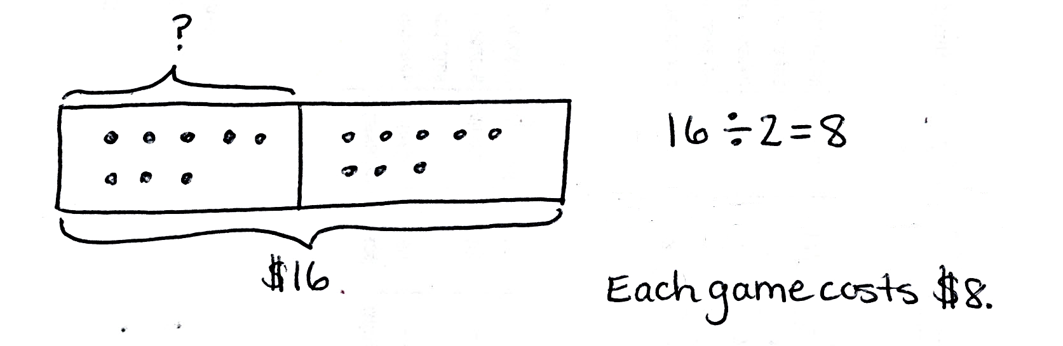Application Problem (5 minutes)

Mark spends $16 on 2 video games. Each game costs the same amount. Find the cost of each game.

Note: This problem reviews equal groups division from Lesson 12 where the unknown is the number of objects in each group.

|  |  |
| --- | --- |
|  | NOTES ON  Multiple Means  of ACTION AND EXPRESSION: |
| This lesson is similar to Lesson 12. Depending on performance levels, modify guidance so that students work through pictorial examples quickly, in pairs or independently, as you meet with groups or individuals who need support. Alternatively, maximize support by skipping the abstract example in favor of slowly working the class through the pictorial. As an additional scaffold, the teacher may choose to model and have students create tape diagrams with drawings inside of each unit to show the value. Students have used tape diagrams drawn with and without this feature in Grade 2. | |

Concept Development (31 minutes)

Materials: (S) Personal white board

Pictorial: Draw and analyze tape diagrams to determine the unknown.

Write or project the following story and the tape diagram drawn below: Three students equally share a pack of 12 pencils.

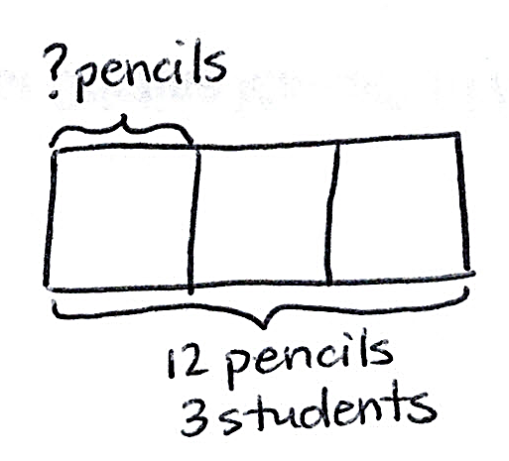

T: What information do we know from reading the story?

S: The total pencils and the number of students.

T: How does the tape diagram show the story?

**MP.4**

S: The whole diagram represents 12 pencils, and it’s divided into 3 parts. Those are the students. We don’t know how many pencils each student gets. That’s what the question mark represents.

T: Write a division equation to find how many pencils each student gets.

S: (Write 12 ÷ 3 = ___.)

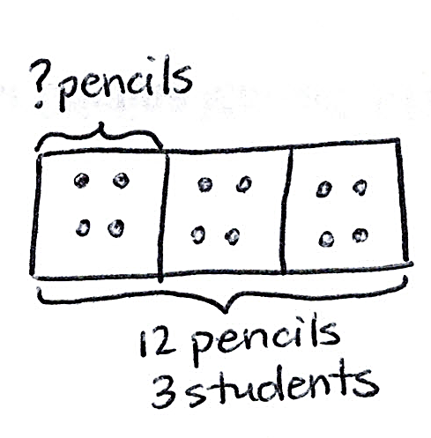T: Draw my tape diagram on your personal white board. Then, draw to share the 12 pencils equally among the 3 students. Fill in your division equation.

**MP.4**

S: (Draw 4 in each unit on the tape diagram. Write 12 ÷ 3 = 4.)

Students can check their work by writing a multiplication sentence.

Write or project the following problem and the first tape diagram drawn below: A school buys 12 boxes of pencils. Each classroom gets 3 boxes. How many classrooms get boxes of pencils?

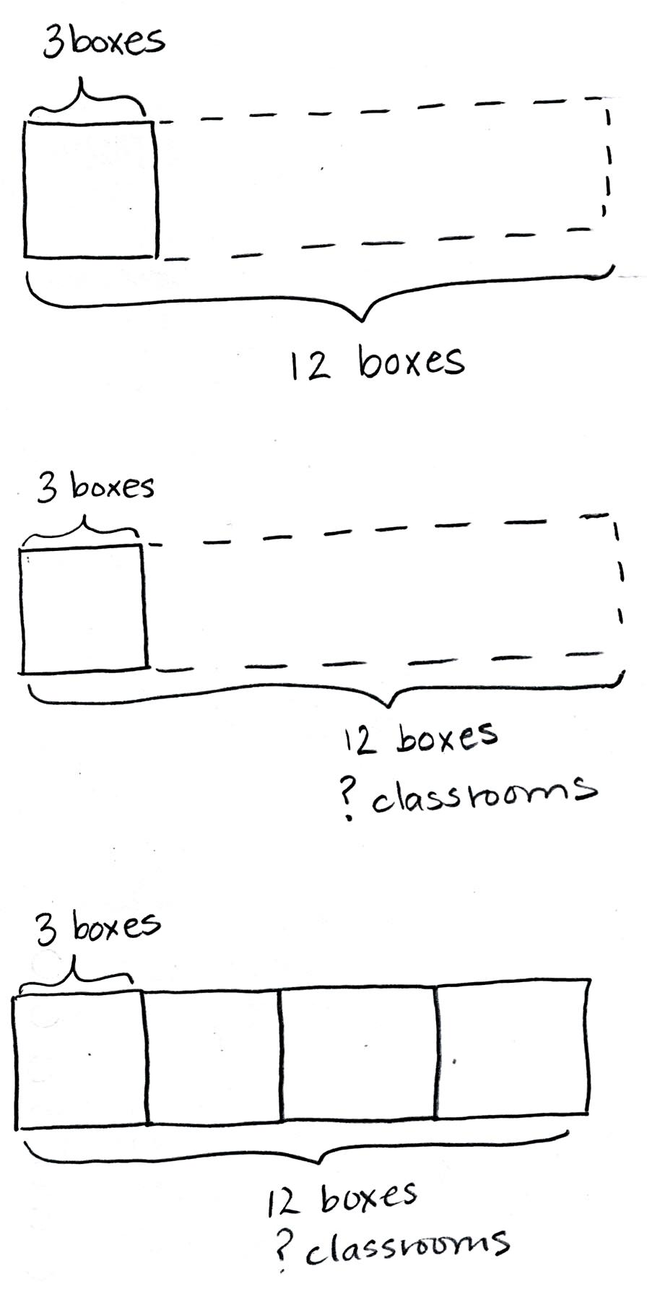T: What information do we know from the problem?

S: The total boxes and the number of boxes each classroom gets.

T: The box drawn with a solid line represents the number of boxes 1 class gets. I used the dotted line to estimate the total boxes. How should I label the unknown on this diagram?

S: It’s the number of classrooms that get boxes.

T: Where can I record my question mark?

S: Under *12 boxes*, write *? Classrooms*.

T: (Label the unknown.) On your board, skip-count by threes to draw more units in the tape diagram. How will you know when to stop?

S: We stop when we get to 12. (Draw and count 6, 9, 12.)

T: Use the tape diagram to write and solve a division equation that represents the problem.

S: (Write 12 ÷ 3 = 4.) It’s the same division problem as before.

T: What does the 4 represent in this problem?

S: It’s the number of classrooms that get boxes of pencils. 🡪 It’s the number of groups.

Repeat the process showing division with both types of unknowns using the following suggested expressions.

* 18 ÷ 3
* 21 ÷ 3

Abstract: Interpret tape diagrams to determine the unknown and write division problems.

|  |  |
| --- | --- |
|  | NOTES ON  Multiple Means  of REPRESENTATION: |
| For the abstract portion of the lesson, some pairs may benefit from looking at word problems completed the previous day to gather ideas and examples upon which to model their work. | |

Draw or project the following tape diagrams. Students work in pairs.

15 _______

______

15 _______

______

|  |  |
| --- | --- |
|  | NOTES ON  Multiple Means  of ENGAGEMENT: |
| Have students who need a challenge add a second step to their word problems. Early finishers should solve each other’s problems and assess the reasonableness of one another’s work. | |

* Write division sentences to represent each diagram. (Division sentences should be the same for both diagrams.)
* Label each tape diagram, including the unknown.
* The tape diagrams and division sentences show solutions. Write a word problem to match each solution.
* Save the word problems to compare with other groups during the Student Debrief.

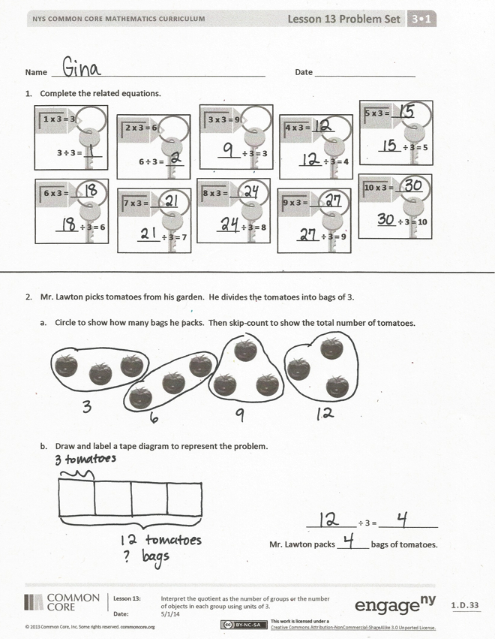Problem Set (10 minutes)

Students should do their personal best to complete the Problem Set within the allotted 10 minutes. For some classes, it may be appropriate to modify the assignment by specifying which problems they work on first. Some problems do not specify a method for solving. Students should solve these problems using the RDW approach used for Application Problems.

Student Debrief (10 minutes)

**Lesson Objective:** Interpret the quotient as the number of groups or the number of objects in each group using units of 3.

The Student Debrief is intended to invite reflection and active processing of the total lesson experience.

Invite students to review their solutions for the Problem Set. They should check work by comparing answers with a partner before going over answers as a class. Look for misconceptions or misunderstandings that can be addressed in the Debrief. Guide students in a conversation to debrief the Problem Set and process the lesson.

You may choose to use any combination of the questions below to lead the discussion.

* Describe how the model in 2(a) helped for drawing a tape diagram in 2(b).

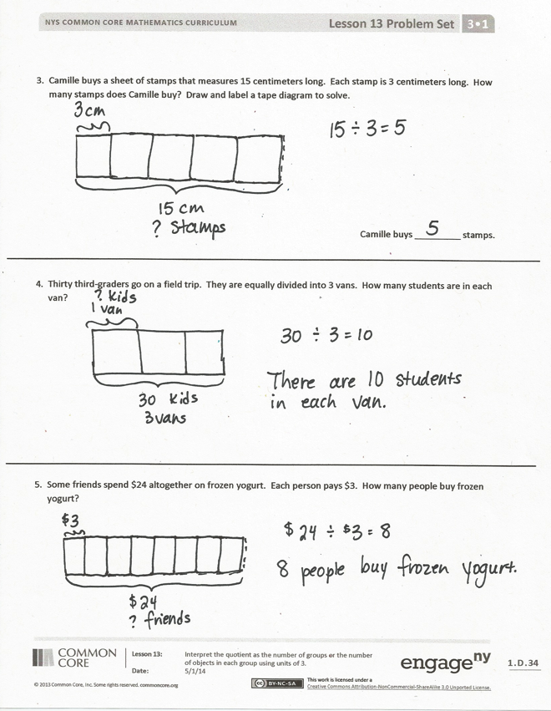

* How does the Application Problem connect the work we did yesterday to what we did today?
* Share work for Problem 5. The language *some friends* rather than a number may have presented a challenge.
* Compare Problems 4 and 5. How did your approach to drawing the tape diagram change? Why?
* Share word problems from the abstract activity in the Concept Development. The class may solve, or simply discuss, which is the unknown factor. (Guide students to notice how different the contexts are, but that each pair of problems always shows the same two unknowns.)

Exit Ticket (3 minutes)

After the Student Debrief, instruct students to complete the Exit Ticket. A review of their work will help you assess the students’ understanding of the concepts that were presented in the lesson today and plan more effectively for future lessons. You may read the questions aloud to the students.

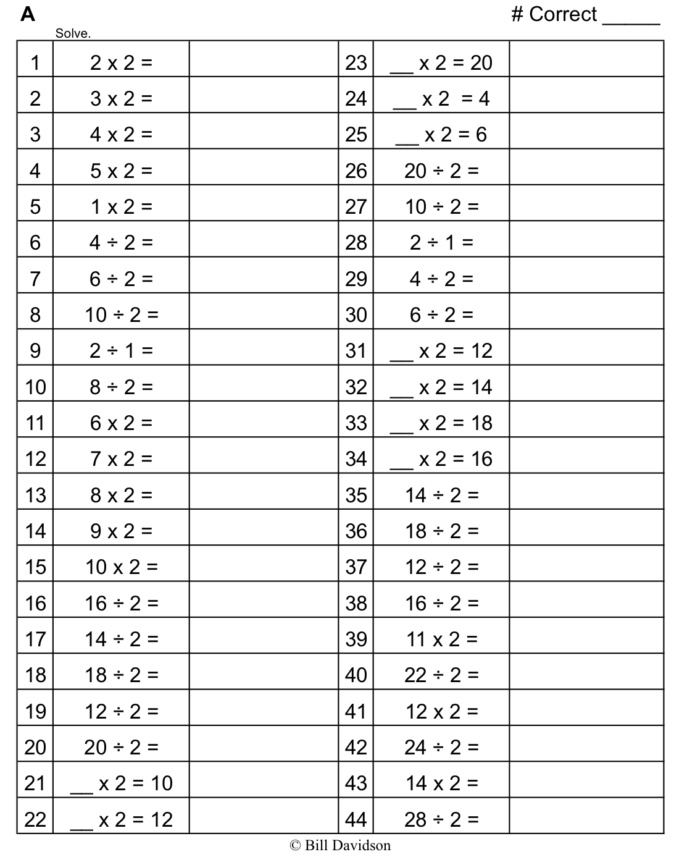

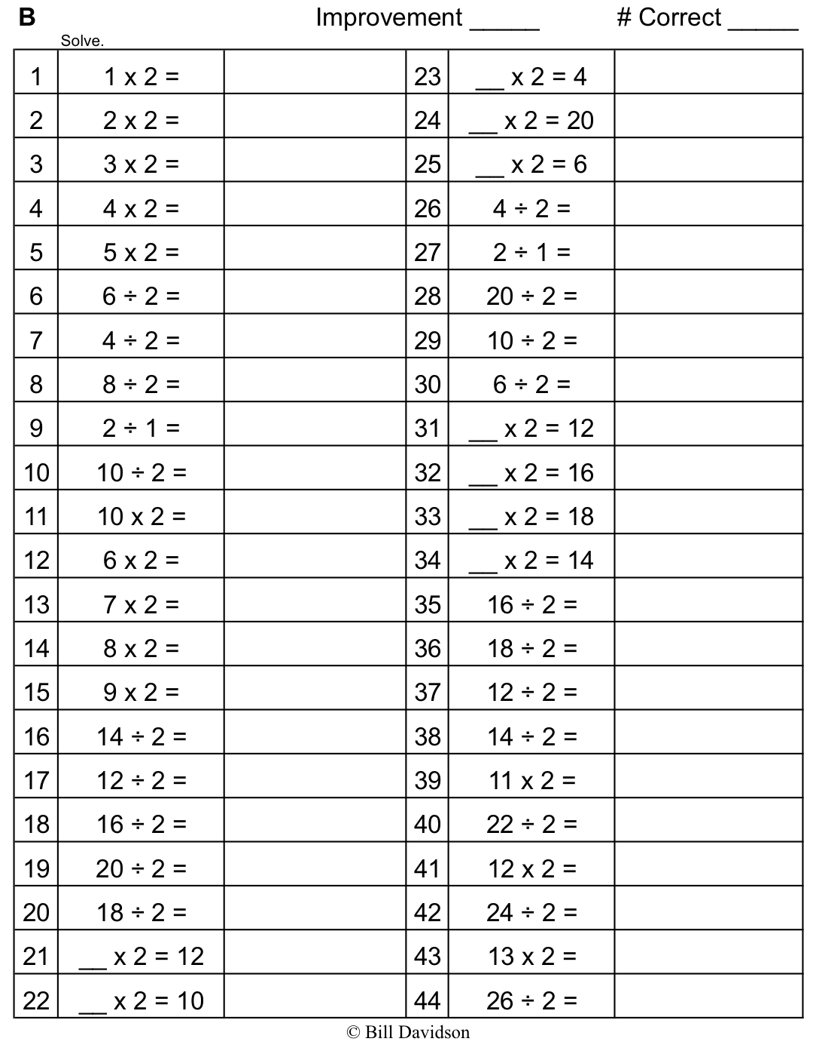

Name Date

1. Fill in the blanks to make true number sentences.



**1** × **3 = 3**

**3 ÷ 3 = ____**

**2** × **3 = 6**

**6 ÷ 3 = ____**

**3** × **3 = 9**

**_____ ÷ 3 = 3**

**4** × **3 = _____**

**_____ ÷ 3 = 4**

**5** × **3 = _____**

**_____ ÷ 3 = 5**

**6** × **3 = _____**

**_____ ÷ 3 = 6**

**7** × **3 = ______**

**_____ ÷ 3 = 7**

**8** × **3 = ______**

**_____ ÷ 3 = 8**

**9** × **3 = _______**

**_____ ÷ 3 = 9**

**10** × **3 = ______**

**____ ÷ 3 = 10**

1. Mr. Lawton picks tomatoes from his garden. He divides the tomatoes into bags of 3.
2. Circle to show how many bags he packs. Then, skip-count to show the total number of tomatoes.



1. Draw and label a tape diagram to represent the problem.

___________ ÷ 3 = _____________

Mr. Lawton packs _______ bags of tomatoes.

3. Camille buys a sheet of stamps that measures 15 centimeters long. Each stamp is 3 centimeters long. How many stamps does Camille buy? Draw and label a tape diagram to solve.

Camille buys _________ stamps.

4. Thirty third-graders go on a field trip. They are equally divided into 3 vans. How many students are in each van?

5. Some friends spend $24 altogether on frozen yogurt. Each person pays $3. How many people buy frozen yogurt?

Name Date

1. Andrea has 21 apple slices. She uses 3 apple slices to decorate 1 pie. How many pies does Andrea make? Draw and label a tape diagram to solve.

2. There are 24 soccer players on the field. They form 3 equal teams. How many players are on each team?

Name Date

1. Fill in the blanks to make true number sentences.

**2** × **3 = 6 1** × **3 = ­­­­­­­­_____ 7** × **3 = _____ 9** × **3 =_____**

**6 ÷ 3 = ______** **_____ ÷ 3 = 1 _____÷ 3 = 7 ____÷ 3 = 9**

1. Ms. Gillette’s pet fish are shown below. She keeps 3 fish in each tank.
2. Circle to show how many fish tanks she has. Then, skip-count to find the total number of fish.





1. Draw and label a tape diagram to represent the problem.

___________ ÷ 3 = __________

Ms. Gillette has _______ fish tanks.

1. Juan buys 18 meters of wire. He cuts the wire into pieces that are each 3 meters long. How many pieces of wire does he cut?

A teacher has 24 pencils. They are divided equally among 3 students. How many pencils does each student get?

1. There are 27 third-graders working in groups of 3. How many groups of third-graders are there?