Lesson 12

Objective: Interpret the quotient as the number of groups or the number of objects in each group using units of 2.

Suggested Lesson Structure

 Fluency Practice (13 minutes)

 Application Problem (5 minutes)

 Concept Development (32 minutes)

 Student Debrief (10 minutes)

**Total Time (60 minutes)**

Fluency Practice (13 minutes)

* Multiply by 3 Pattern Sheet **3.OA.7** (8 minutes)
* Group Counting **3.OA.1**  (3 minutes)
* Divide **3.OA.7** (2 minutes)

Multiply by 3 Pattern Sheet (8 minutes)

Materials: (S) Multiply by 3 (6–10) (Pattern Sheet)

Note: This activity builds fluency with multiplication facts using units of 3. It works toward students knowing from memory all products of two one-digit numbers. See Lesson 9 for the directions for administering a Multiply-By Pattern Sheet.

T: (Write 6 × 3 = ­­­____.) Let’s skip-count up by threes to solve. (Count with fingers to 6 as students count.)

S: 3, 6, 9, 12, 15, 18.

T: Let’s skip-count down to find the answer, too. Start at 30. (Count down with fingers as students count.)

S: 30, 27, 24, 21, 18.

Repeat the process for 8 × 3 and 7 × 3.

T: Let’s practice multiplying by 3. Be sure to work left to right across the page. (Distribute Multiply by 3 Pattern Sheet.)

Group Counting (3 minutes)

Note: Group counting reviews interpreting multiplication as repeated addition. Counting by twos and fours in this activity reviews multiplication with units of 2 from Topic C and anticipates using units of 4 in Topic E.

T: Let’s count by twos. (Direct students to count forward and backward to 20.)

T: Let’s count by fours. (Direct students to count forward and backward to 36, emphasizing the 20 to 24 and 28 to 32 transitions.)

Divide (2 minutes)

Materials: (S) Personal white board

Note: This activity builds fluency with multiplication and division. It works toward the goal of students knowing from memory all products of two one-digit numbers and reviews the objective of Lesson 11.

T: (Project a 2 by 4 array of objects.) Draw an array to match my picture.

S: (Draw 2 by 4 array.)

T: Skip-count by twos to find how many total objects there are. (Point as students count.)

S: 2, 4, 6, 8.

T: How many groups of 2 are there?

S: 4.

T: Say the total as a multiplication sentence starting with the number of groups.

S: 4 × 2 = 8.

T: (Write 4 × 2 = 8. Below it, write 8 ÷ 4 = __.) Fill in the blank to make a true division sentence. Then, divide your array into 4 equal groups to find the answer.

S: (Draw lines separating the array into 4 groups of 2, and write 8 ÷ 4 = 2.)

T: Erase the lines that divided the array.

S: (Erase lines.)

T: Show 8 ÷ 4 by making groups of 4.

S: (Circle 2 groups of 4.)

Repeat process for the following possible sequence: 9 ÷ 3, 12 ÷ 2, and 12 ÷ 3.

Application Problem (5 minutes)

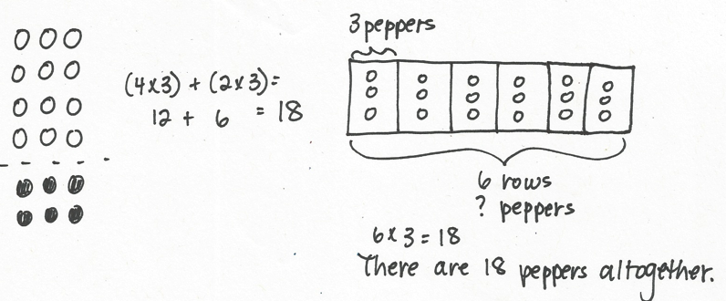

A chef arranges 4 rows of 3 red peppers on a tray. He adds 2 more rows of 3 yellow peppers. How many peppers are there altogether?

Note: Students might solve using an array to model the distributive property (Lesson 10) or a tape diagram (Lesson 11). If they use the latter strategy, it is likely their first use of a tape diagram to solve multiplication. The problem is a review that provides an exploratory opportunity for students to select and use appropriate tools.

**MP.5**

Concept Development (32 minutes)

|  |  |
| --- | --- |
|  | NOTE ON  DRAWING  TAPE DIAGRAMS: |
| Students draw to model before or as they solve problems so that the diagram assists them with analysis. The model provides a place aside from the words to think about the problem. It should guide their understanding of the problem and how to find the unknown. They might ask themselves the following questions as they draw.   * Am I looking for a part? * Am I looking for a number of parts? * Am I looking for the whole amount? * What is my model showing me? | |

Materials: (S) Personal white board

Problem 1: Model division where the unknown represents the number of objects in each group.

T: Two students equally share 8 crackers. How many crackers does each student get? Draw to model and solve the problem. Then, explain your thinking to your partner.

S: (Draw and solve.) I gave 1 cracker to each student until I drew 8. 🡪 4 + 4 = 8, so I drew 4 crackers for each student. 🡪 It’s a multiplication problem with an unknown factor.

T: Write a division sentence to represent your model.

S: (Write 8 ÷ 2 = 4.)

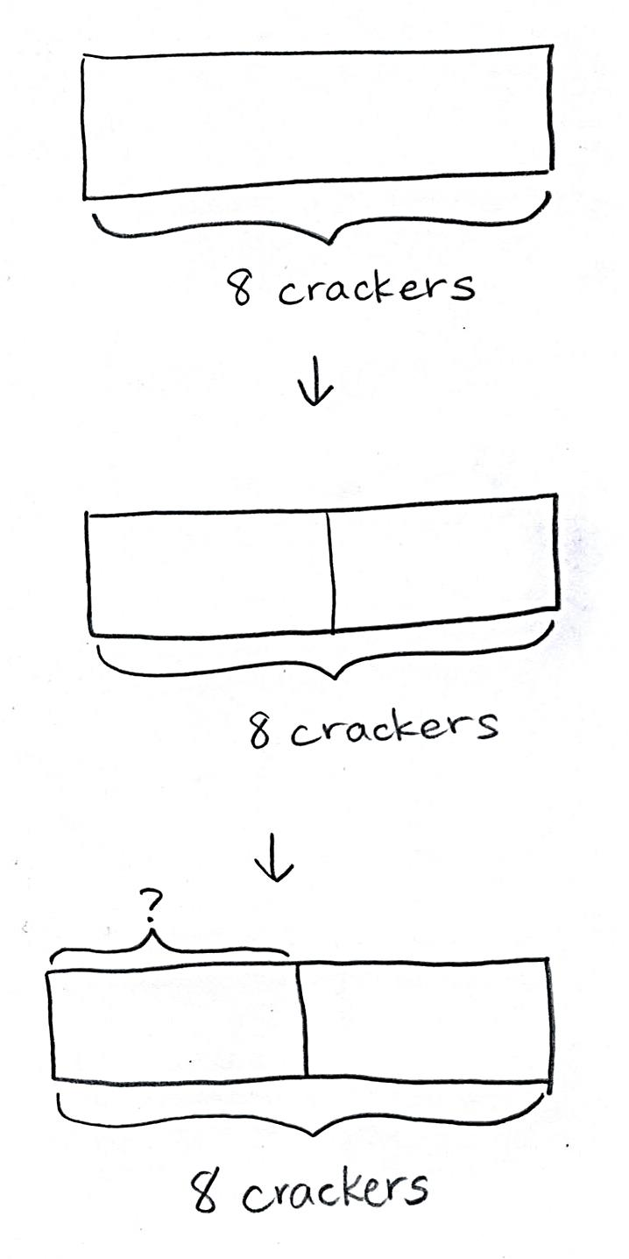T: (Draw a rectangle.) This diagram represents the total, 8 crackers. In your mind, visualize where we would divide it to make 2 equal parts.

S: (Visualize.)

T: Say “Stop!” when I get to the spot you have in mind. (Move finger from left edge toward middle.)

S: Stop!

T: How does the diagram represent the students?

S: 2 students, 2 parts!

T: What is our unknown?

S: The number of crackers each student gets.

T: Watch how I label the unknown on the diagram. (Bracket and label as shown.) Tell your partner a strategy for finding the unknown using the diagram.

|  |  |
| --- | --- |
|  | NOTE ON  Multiple Means  of representation: |
| If a natural opportunity presents itself, teach students the word *bracket* so they have specific language with which to refer to the diagram. This may be especially useful for English language learners. | |

S: I would draw 1 cracker in each part until I drew 8. 🡪 Each part has to be equal. 4 + 4 = 8, so 1 part is 4. 🡪   
I would think 2 × ___ = 8. The question mark is 4.

T: Look at the division sentence you wrote for your first model. Does it represent this diagram too? Explain to your partner.

S: (Discuss.)

Repeat the process with the following suggested expressions to model division where the quotient represents the number of objects in each group.

* 12 ÷ 2

|  |  |
| --- | --- |
|  | NOTE ON  DRAWING  TAPE DIAGRAMS: |
| Erasers are important for drawing tape diagrams to model division where the unknown represents the number of groups. Students may find they have very incorrectly determined the length of the whole. Encourage them to erase and redraw. | |

* 18 ÷ 2

Problem 2: Model division where the unknown represents the number of groups.

T: Let’s go back to our original problem, this time changing it a bit. There are 8 crackers, but this time each student gets 2. How many students get crackers?

T: Do we know the size of the groups or the number of groups?

S: The size of the groups.

T: We can draw 1 unit of the diagram to represent a group of 2 crackers. (Draw 1 unit of two.) What other information does the problem tell us?

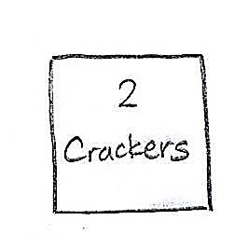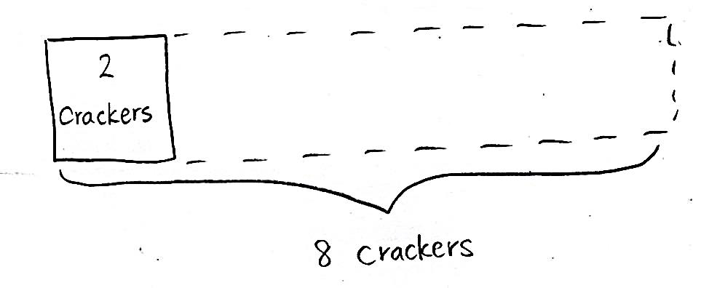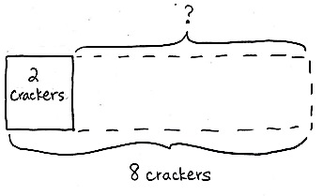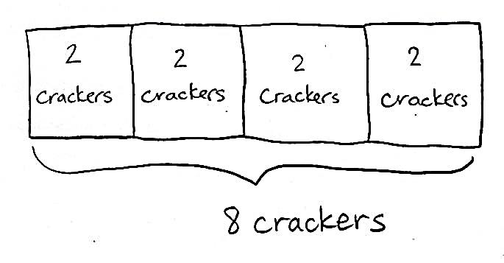

S: The total.

T: (Estimate the whole and label it *8 crackers*.) Notice that I drew a dotted line to show the whole diagram. What is our unknown?

S: The number of groups.

T: (Bracket the top part of the diagram and label with a question mark.) Let’s find the number of groups by drawing more units of 2. How will we know when we’ve drawn enough units?

S: We’ll get to the total, 8.

T: Draw along with me on your personal white board. (Skip-count by two, drawing to add 3 more units.)

S: (Draw.)

T: Whisper to your partner the number of students that get crackers.

S: 4 students.

T: Write a division sentence to match the diagram.

|  |  |
| --- | --- |
|  | NOTE ON  Multiple Means  OF Engagement: |
| Gradually release responsibility to students as you repeat the process with additional examples. By the third example, students should be working nearly independently. | |

S: (Write 8 ÷ 2 = 4.)

Repeat the process with the following suggested expressions to model division where the unknown represents the number of groups.

* 12 ÷ 2
* 18 ÷ 2

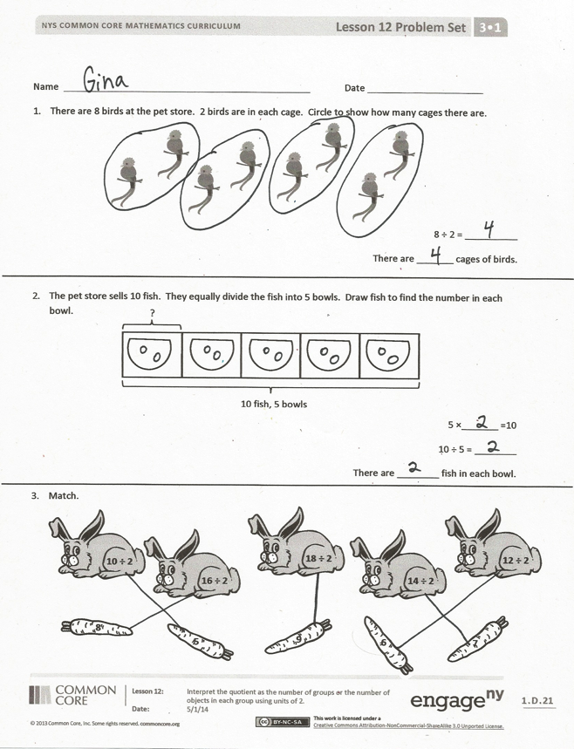In this lesson, three division sentences are each modeled with two types of division. Use one pair of division sentences for the following reflective dialogue. (The dialogue is modeled with 8 ÷ 2 = 4.)

T: The two division sentences for these diagrams are the same, but the tape diagrams are different. Turn and talk to you partner about why.

S: The 2 and the 4 represent different things in each problem. 🡪 In the first diagram, we knew how many groups, and in the second, we knew how many in each group.

T: When we divide, we always know the total number of objects. We divide either to find the size of the groups, like in the first problem, or the number of groups, like in the second problem.

Problem Set (10 minutes)

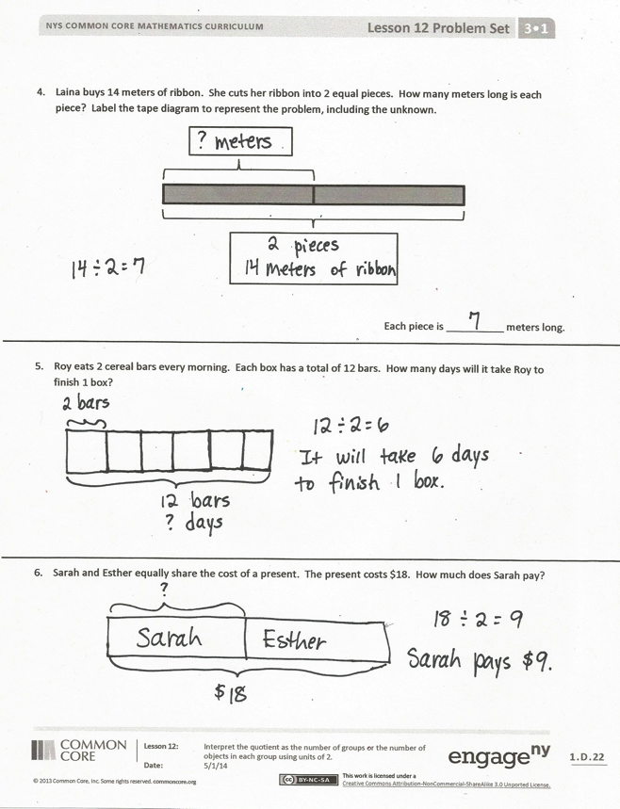Students should do their personal best to complete the Problem Set within the allotted 10 minutes. For some classes, it may be appropriate to modify the assignment by specifying which problems they work on first. Some problems do not specify a method for solving. Students should solve these problems using the RDW approach used for Application Problems.

Student Debrief (10 minutes)

**Lesson Objective**: Interpret the quotient as the number of groups or the number of objects in each group using units of 2.

The Student Debrief is intended to invite reflection and active processing of the total lesson experience.

Invite students to review their solutions for the Problem Set. They should check work by comparing answers with a partner before going over answers as a class. Look for misconceptions or misunderstandings that can be addressed in the Debrief. Guide students in a conversation to debrief the Problem Set and process the lesson.

You may choose to use any combination of the questions below to lead the discussion.

* Describe how you labeled the tape diagram in Problem 4. The number 2 appears in the problem; where do you see it in the diagram?
* Analyze Problems 1 and 2 on the Problem Set to compare different unknowns. (There are 2 birds in each cage in Problem 1, and 2 fish in each bowl in Problem 2.)
* How does what the quotient represents affect the way a tape diagram is drawn?

Exit Ticket (3 minutes)

After the Student Debrief, instruct students to complete the Exit Ticket. A review of their work will help you assess the students’ understanding of the concepts that were presented in the lesson today and plan more effectively for future lessons. You may read the questions aloud to the students.

[1] 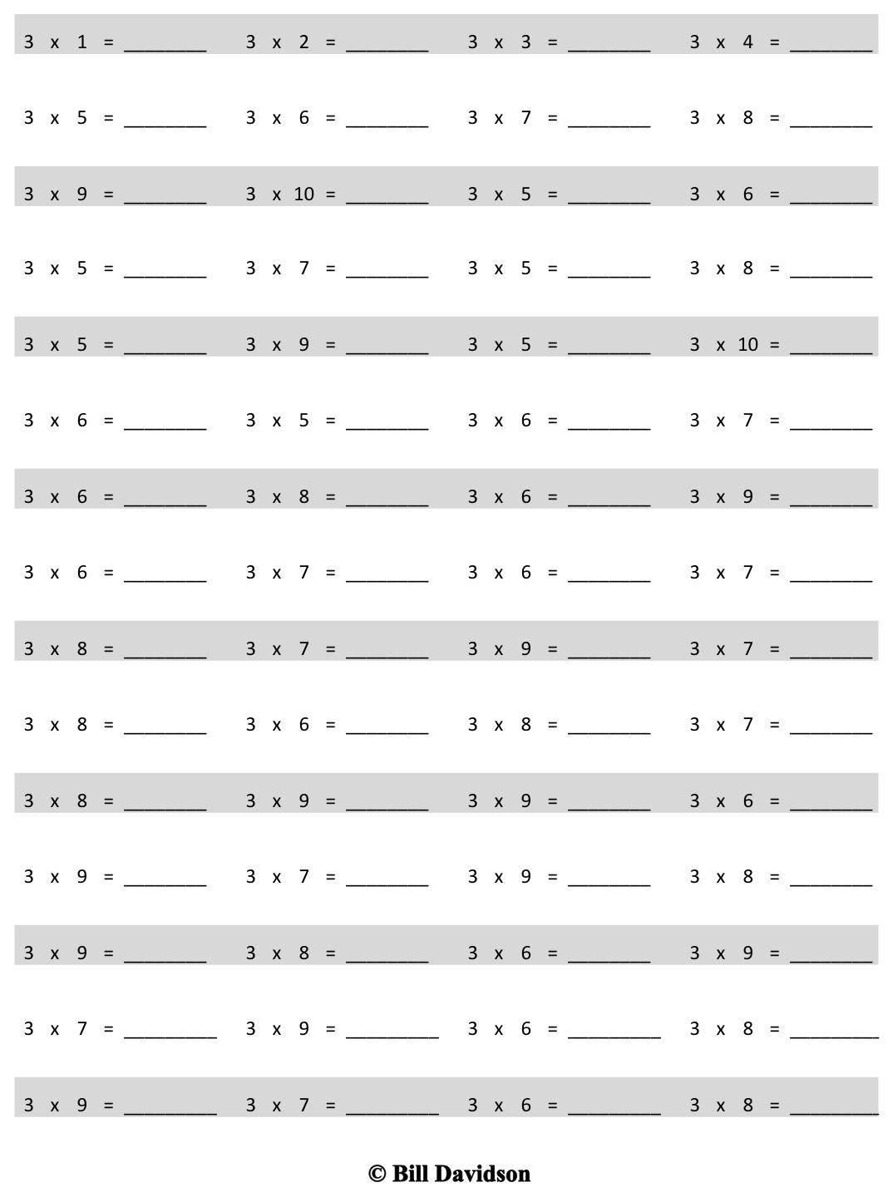

Multiply.

Name Date

1. There are 8 birds at the pet store. Two birds are in each cage. Circle to show how many cages there are.



8 ÷ 2 = __________

There are _______ cages of birds.

1. The pet store sells 10 fish. They equally divide the fish into 5 bowls. Draw fish to find the number in each bowl.

?

10 fish, 5 bowls

5 × _______ = 10

10 ÷ 5 = ________

There are ________ fish in each bowl.

1. Match.



**12 ÷ 2**



**10 ÷ 2**



**16 ÷ 2**



**18 ÷ 2**



**14 ÷ 2**



**5**



**8**



**9**



**6**



**7**

1. Laina buys 14 meters of ribbon. She cuts her ribbon into 2 equal pieces. How many meters long is each piece? Label the tape diagram to represent the problem, including the unknown.

Each piece is __________ meters long.

1. Roy eats 2 cereal bars every morning. Each box has a total of 12 bars. How many days will it take Roy to finish 1 box?

1. Sarah and Esther equally share the cost of a present. The present costs $18. How much does Sarah pay?

Name Date

There are 14 mints in 1 box. Cecilia eats 2 mints each day. How many days does it take Cecilia to eat 1 box of mints? Draw and label a tape diagram to solve.

It takes Cecilia ________ days to eat 1 box of mints.

Name Date

1. Ten people wait in line for the roller coaster. Two people sit in each car. Circle to find the total number of cars needed.

10 ÷ 2 = __________

There are _______ cars needed.

1. Mr. Ramirez divides 12 frogs equally into 6 groups for students to study. Draw frogs to find the number in each group. Label known and unknown information on the tape diagram to help you solve.

6 × _______ = 12

12 ÷ 6 = _______

There are ________ frogs in each group.

1. Match.

  

**16 ÷ 2**

**18 ÷ 2**

**10 ÷ 2**

**14 ÷ 2**

**7**

**8**

**9**

**5**

1. Betsy pours 16 cups of water to equally fill 2 bottles. How many cups of water are in each bottle? Label the tape diagram to represent the problem, including the unknown.

There are __________ cups of water in each bottle.

1. An earthworm tunnels 2 centimeters into the ground each day. The earthworm tunnels at about the same pace every day. How many days will it take the earthworm to tunnel 14 centimeters?

1. Sebastian and Teshawn go to the movies. The tickets cost $16 in total. The boys share the cost equally. How much does Teshawn pay?

1. multiply by 3 (6–10)