Lesson 11
Objective: Model division as the unknown factor in multiplication using arrays and tape diagrams.

Suggested Lesson Structure
 Fluency Practice (11 minutes)
 Application Problem (5 minutes)
 Concept Development (34 minutes)
 Student Debrief (10 minutes)
Total Time (60 minutes)
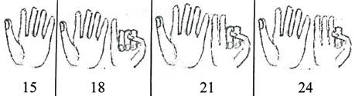
Fluency Practice (11 minutes)

NOTES ON
MULTIPLE MEANS
OF REPRESENTATION:
Use this activity to teach skip-counting as a strategy for building automaticity with multiplication facts. Once students know that 3 × 5 = 15, they can flash 5 fingers to show 15 and then count on the other hand. How solving 3 × 8 looks and sounds is illustrated below.

- Multiply by 3 Pattern Sheet 3.OA.7 (8 minutes)
- Group Counting 3.OA.1 (3 minutes)
Multiply by 3 (8 minutes)
Materials: (S) Multiply by 3 (1–5) (Pattern Sheet)
Note: This activity builds fluency with multiplication facts using units of 3. It works toward students knowing from memory all products of two one-digit numbers. See Lesson 9 for the directions for administering a Multiply-By Pattern Sheet.
T: (Write 5 × 3 = ____.) Let’s skip-count up by threes to solve. (Raise a finger for each number to track the count. Record the skip-count answers on the board.)
S: 3, 6, 9, 12, 15.
T: (Circle 15 and write 5 × 3 = 15 above it. Write 4 × 3 = ____.) Skip-count up by threes to find the answer. (Track with fingers as students count.)
S: 3, 6, 9, 12.
T: Let’s count down to find the answer to 4 × 3, too. Start at 15. (Count down with your fingers as students say numbers.)
S: 15, 12.
T: Let’s practice multiplying by 3. Be sure to work left to right across the page. (Distribute Multiply by 3 Pattern Sheet.)
Group Counting (3 minutes)
Note: Group counting reviews interpreting multiplication as repeated addition. Counting by twos and fours in this activity reviews multiplication with units of 2 from Topic C and anticipates using units of 4 in Topic E.
T: Let’s count by twos. (Direct students to count forward and backward to 20.)
T: Let’s count by fours. (Direct students to count forward and backward to 36, emphasizing the 20 to 24 and 28 to 32 transitions.)
Application Problem (5 minutes)

NOTES ON
MULTIPLE MEANS
OF ENGAGEMENT:
The numbers in the Application Problem may be too simple. They were chosen to compliment the introduction of the tape diagram in the Concept Development. If needed, change the numbers in the Application Problem to meet the needs of the class and adjust the opening language of the Concept Development accordingly.

Rosie puts 2 lemon slices in each cup of iced tea. She uses a total of 8 slices. How many cups of iced tea does Rosie make?
Note: Students may have solved the problem as shown or by using division (8 ÷ 2 = 4). This problem leads into modeling with tape diagrams, which is introduced in the Concept Development.
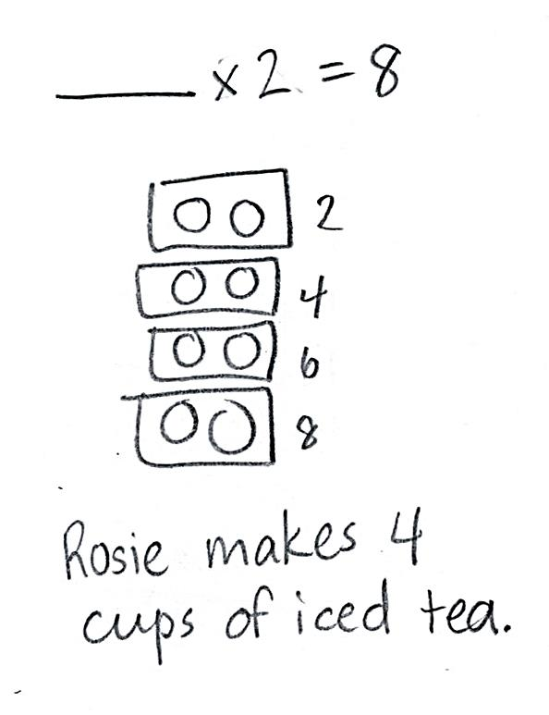

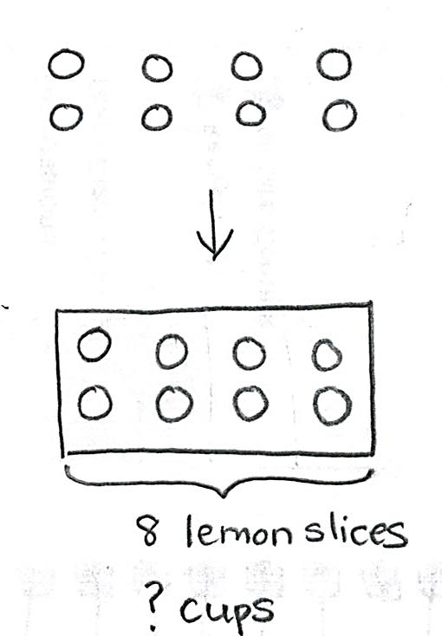
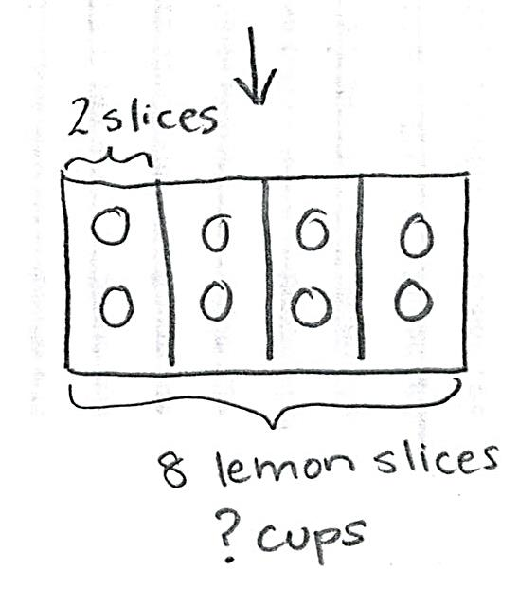
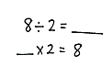

Concept Development (34 minutes)
Materials: (S) Personal white board, Application Problem
Problem 1: Relate arrays to tape diagrams, modeling division where the quotient represents the number of groups.
T: (Draw or project a 2 × 4 array.) The columns in this array show the number of lemon slices in 1 cup of Rosie’s iced tea. Reread the Application Problem, and tell your partner what the unknown represents
S: The unknown is the number of cups, or groups.
T: How might this array help us solve 8 ÷ 2 = ____?
MP.4
S: We can count the number of columns to find how many cups. 2 times 4 equals 8, so 8 ÷ 2 = 4.
T: (Draw a rectangle around the array.) What is the total number of lemon slices?
S: 8 lemon slices.
T: (Bracket the rectangle and label the whole 8 lemon slices.) The question asks how many cups of iced tea Rosie makes. Do the cups represent the number of groups or the number of lemon slices in each group?
MP.4
S: The number of groups.
T: (Under 8 lemon slices, label the unknown as ? cups.)

NOTES ON
TAPE DIAGRAMS:
Students are familiar with tape diagrams from Grade 2. They use tape diagrams to represent the information given in a problem, and then analyze the model to help determine the unknown and solve. As you review tape diagrams, ask why the diagram might have that name. Guide students to make connections that help them remember the name.

T: Watch how I show the number of slices in one cup. (Draw lines to divide columns and label 1 unit as 2 slices.) Where do we see the cups in our diagram?
S: You made 4 glasses with the dividing lines.
T: By adding lines and labels to our array, we made a tape diagram. Each boxed column shows 1 unit. One unit represents 1 cup and has a value of 2 slices. Notice that I labeled the diagram with all of the known and unknown information from the problem as we solved. That made it a helpful tool for understanding the problem.
T: (Write 8 ÷ 2 = ___ and ___ × 2 = 8.) Talk to your partner about how the tape diagram helps you see the unknown in both equations.
S: (Discuss.)
In Problem 1, the quotient represents the number of groups. Repeat the process using the following examples, reminding students to label known and unknown information from the problem on every tape diagram.
- 10 ÷ 2 = 5
- 18 ÷ 3 = 6
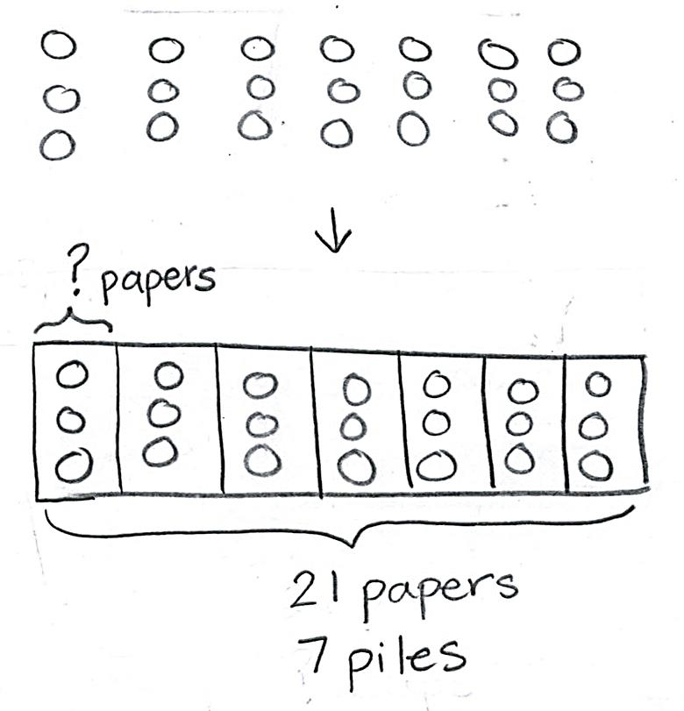
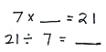
Problem 2: Use arrays to draw tape diagrams, modeling division where the quotient represents the number of objects in each group.
Write or project the following problem: Ms. Alves puts 21 papers in 7 piles. How many papers are in each pile?
T: Read the problem. What is unknown?
S: The number of objects in each group.
T: Model the problem on your personal white board as an array where each column represents 1 pile.
S: (Draw array, shown at right.)
T: Count to find how many papers are in each of Ms Alves’ piles.
S: (Count to find 3 papers.)
T: Work with a partner to model the problem as a tape diagram. Be sure to label the diagram with known and unknown information. Use your array to help.

NOTES ON
MULTIPLE MEANS
OF ENGAGEMENT:
Support students to work at individualized levels by inviting them to choose to work independently or with a partner to solve additional examples.

S: (Draw tape diagram shown on previous page.)
T: Use the tape diagram to write multiplication and division equations that show the unknown.
S: (Write 7 × ___ = 21 and 21 ÷ 7 = ___.)
In Problem 2, the quotient represents the number of objects in each group. Repeat the process using the following examples:
- 16 ÷ 2 = 8
- 24 ÷ 3 = 8
T: Compare models. What are the similarities and differences between arrays and tape diagrams?
S: The tape diagram is like a labeled and boxed array. They both show the 7 piles, 3 papers in each pile, and 21 papers total. The labels make the tape diagram a little easier to use.
Problem Set (10 minutes)
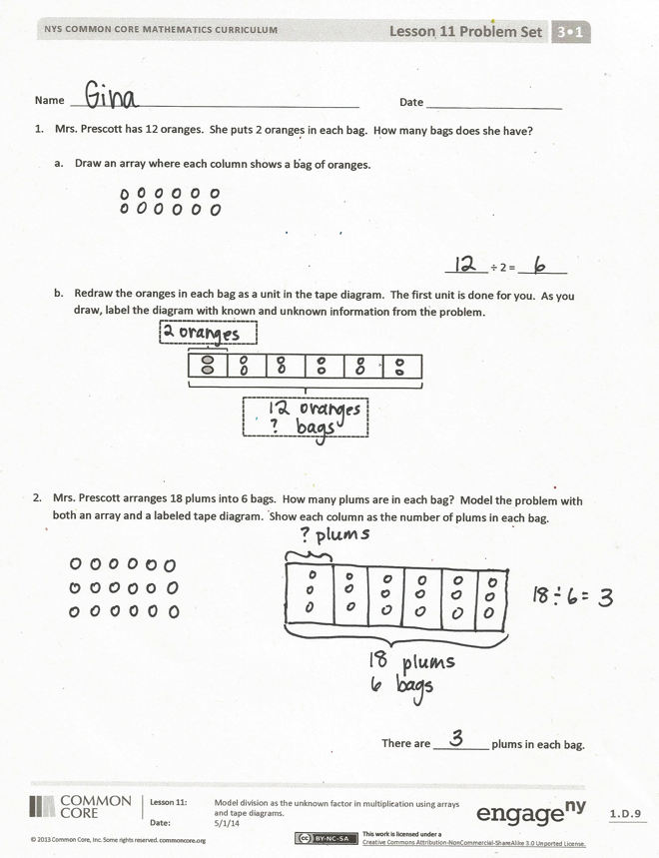
Students should do their personal best to complete the Problem Set within the allotted 10 minutes. Depending on your class, it may be appropriate to modify the assignment by specifying which problems they work on first. Some problems do not specify a method for solving. Students should solve these problems using the RDW approach used for Application Problems.
Student Debrief (10 minutes)
Lesson Objective: Model division as the unknown factor in multiplication using arrays and tape diagrams.
The Student Debrief is intended to invite reflection and active processing of the total lesson experience.
Invite students to review their solutions for the Problem Set. They should check work by comparing answers with a partner before going over answers as a class. Look for misconceptions or misunderstandings that can be addressed in the Debrief. Guide students in a conversation to debrief the Problem Set and process the lesson.

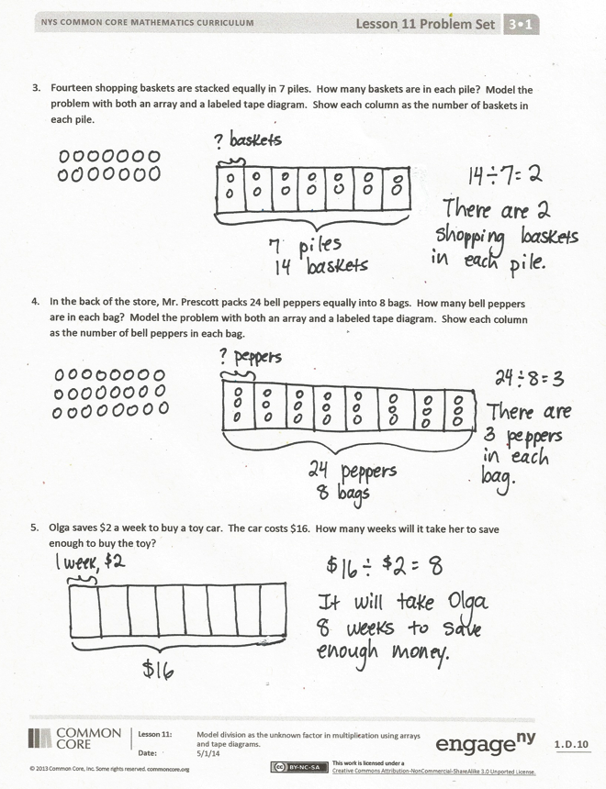
You may choose to use any combination of the questions below to lead the discussion.
- Compare Problems 1 and 2. What does the unknown represent in each problem?
- Compare how units are represented in tape diagrams and in arrays.
- How can each model represent both types of unknowns?
- Compare the way you solved the Application Problem with the tape diagram model we learned today.
Exit Ticket (3 minutes)
After the Student Debrief, instruct students to complete the Exit Ticket. A review of their work will help you assess the students’ understanding of the concepts that were presented in the lesson today and plan more effectively for future lessons. You may read the questions aloud to the students.

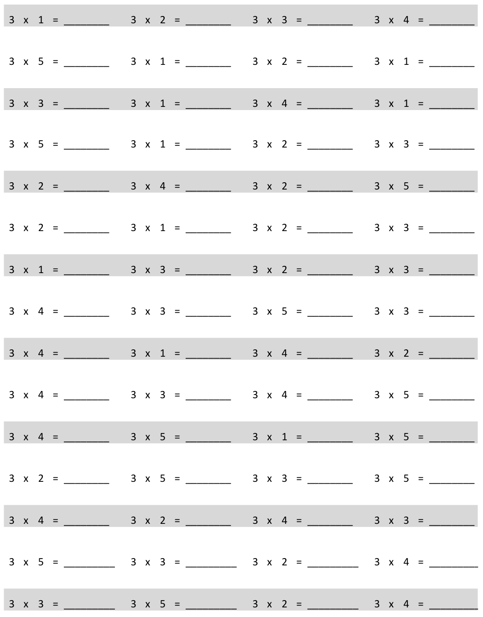
Multiply.

Name Date
- Mrs. Prescott has 12 oranges. She puts 2 oranges in each bag. How many bags does she have?

- Draw an array where each column shows a bag of oranges.

_______ ÷ 2 = ________
- Redraw the oranges in each bag as a unit in the tape diagram. The first unit is done for you. As you draw, label the diagram with known and unknown information from the problem.

- Mrs. Prescott arranges 18 plums into 6 bags. How many plums are in each bag? Model the problem with both an array and a labeled tape diagram. Show each column as the number of plums in each bag.

There are _________ plums in each bag.
- Fourteen shopping baskets are stacked equally in 7 piles. How many baskets are in each pile? Model the problem with both an array and a labeled tape diagram. Show each column as the number of baskets in each pile.

- In the back of the store, Mr. Prescott packs 24 bell peppers equally into 8 bags. How many bell peppers are in each bag? Model the problem with both an array and a labeled tape diagram. Show each column as the number of bell peppers in each bag.

- Olga saves $2 a week to buy a toy car. The car costs $16. How many weeks will it take her to save enough to buy the toy?

Name Date
Ms. McCarty has 18 stickers. She puts 2 stickers on each homework paper and has no more left. How many homework papers does she have? Model the problem with both an array and a labeled tape diagram.

Name Date
      - Fred has 10 pears. He puts 2 pears in each basket. How many baskets does he have?

- Draw an array where each column represents the number of pears in each basket.

_______ ÷ 2 = ________
- Redraw the pears in each basket as a unit in the tape diagram. Label the diagram with known and unknown information from the problem.

- Ms. Meyer organizes 15 clipboards equally into 3 boxes. How many clipboards are in each box? Model the problem with both an array and a labeled tape diagram. Show each column as the number of clipboards in each box.

There are _________ clipboards in each box.
- Sixteen action figures are arranged equally on 2 shelves. How many action figures are on each shelf? Model the problem with both an array and a labeled tape diagram. Show each column as the number of action figures on each shelf.

- Jasmine puts 18 hats away. She puts an equal number of hats on 3 shelves. How many hats are on each shelf? Model the problem with both an array and a labeled tape diagram. Show each column as the number of hats on each shelf.

- Corey checks out 2 books a week from the library. How many weeks will it take him to check out a total of 14 books?

multiply by 3 (1–5)

