Lesson 10
Objective: Model the distributive property with arrays to decompose units as a strategy to multiply.

Suggested Lesson Structure
 Fluency Practice (11 minutes)
 Application Problem (5 minutes)
 Concept Development (34 minutes)
 Student Debrief (10 minutes)
Total Time (60 minutes)

Fluency Practice (11 minutes)
- Multiply by 2 Pattern Sheet 3.OA.7 (8 minutes)
- Group Counting 3.OA.1 (3 minutes)

Multiply by 2 Pattern Sheet (8 minutes)

Materials: (S) Multiply by 2 (6–10) (Pattern Sheet)
Note: This activity builds fluency with multiplication facts using units of 2. It works toward students knowing from memory all products of two one-digit numbers. See Lesson 9 for the directions for administering a Multiply-By Pattern Sheet.
T: (Write 7 × 2 = ____.) Let’s skip-count up by twos. (Count with fingers to 7 as students count.)
S: 2, 4, 6, 8, 10, 12, 14.
T: This time, let’s start from 10 to find our answer more quickly. Show 5 fingers all at once to show 10.
S: (Show 5 fingers.)
T: Now, count by twos from 10. Raise another finger for each two you count. (Model as students count.)
S: 10, 12, 14. (Raise a sixth finger at 12, and a seventh finger at 14.)
T: Let’s see how we can skip-count down to find the answer, too. Start at 20. (Show 10 fingers to represent 20. Hide one finger at a time as student say numbers.)
S: 20, 18, 16, 14.
Repeat the process for 9 × 2 and 8 × 2.
T: (Distribute Multiply by 2 Pattern Sheet.) Let’s get some practice multiplying by 2. Be sure to work left to right across the page.

Group Counting (3 minutes)
Note: Group counting reviews interpreting multiplication as repeated addition. Counting by threes and fours in this activity supports work with units of 3 in this topic and anticipates work using units of 4 in Topic E.
T: Let’s count by threes. (Direct students to count forward and backward to 30, emphasizing the transition from 18 to 21.)
T: Let’s count by fours. (Direct students to count forward and backward to 24, emphasizing the 16 to 20 transition.)

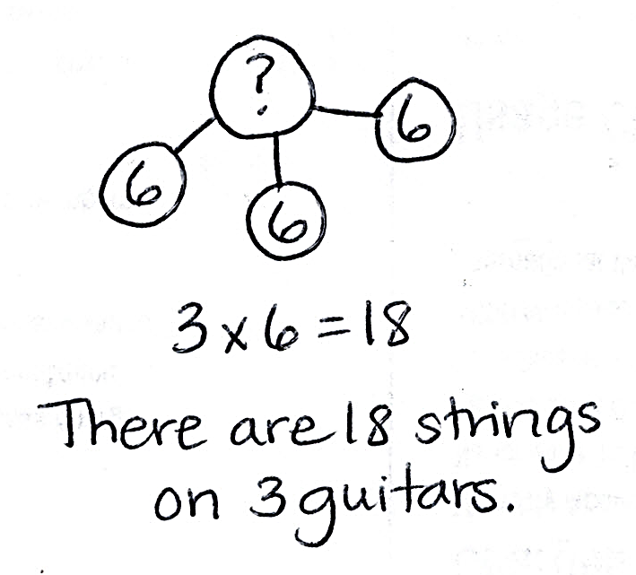
Application Problem (5 minutes)
A guitar has 6 strings. How many strings are there on 3 guitars? Write a multiplication equation to solve.
Note: This problem leads into today’s Concept Development. Students will compare their multiplication equation with the new equations presented in the lesson.

NOTES ON
MULTIPLE MEANS
OF ENGAGEMENT:
This lesson begins at the pictorial level and quickly advances to the more abstract numerical form. Some students may need to begin with concrete materials. If so, have students use linking cubes to show how to distribute the rows of 6.

Concept Development (34 minutes)

Materials: (S) Personal white board, 1 sheet of blank paper
T: On your personal white board, draw an array to represent the total number of guitar strings. Let the number of strings on one guitar be 1 row.
S: (Draw a 3 × 6 array, as shown below.)

T: Make a dotted line below the first row to show just one guitar.

NOTES ON
VOCABULARY:
In this lesson, students are not responsible for the vocabulary distributive property (3.OA.5). They revisit the distributive property as a strategy for multiplication and division in Topics E and F. In those lessons, they begin referring to it as the break apart and distribute strategy.

S: (Draw line, as shown below.)

T: Write and solve a multiplication sentence to describe each part of your array.
S: (Write 1 × 6 = 6 and 2 × 6 = 12, as shown below.)
1 × 6 = 6
2 × 6 = 12

T: (Write 6 + 12 = 3 sixes.) Why is this true?
6 + 12 = 3 sixes
(1 × 6) + (2 × 6) = 3 sixes
(1 × 6) + (2 × 6) = 6 + 12
Sample teacher board
S: 1 six is 6, 2 sixes are 12. When I add 6 and 12, I get 18, which is 3 sixes.
T: (Write (1 × 6) + (2 × 6) = 3 sixes on the board as shown to the right.) How do you know this equation is true?
S: 1 × 6 is the same as 1 six. 2 × 6 is the same as 2 sixes. 1 six plus 2 sixes is the same as 3 sixes. 1 × 6 = 6 and 2 × 6 = 12. 12 + 6 = 18. 3 sixes = 18, so the equation is true.
T: (Write (1 × 6) + (2 × 6) = 6 + ____.) With your partner, discuss what number completes the equation.
S: 1 × 6 equals 6. That’s how the teacher got 6. To get the other number, we do 2 × 6. That’s 12. I know it’s 12 because you need the same amount on each side of the equal sign. On the left, the value is 6 + 12 if you solve the multiplication. That’s what it should be on the right too.
T: (Write 12 to fill in the equation.)
T: Notice the symbols around my multiplication expressions. They are called parentheses. Let’s say that word together.
S: Parentheses.
T: (Write (1 × 6) + (2 × 6) = ___ and (1 + 2) × 6 = ___ below it, as shown to the right.) My parentheses show how I make groups. How did I rearrange the groups?
(1 × 6) + (2 × 6) = 18
(1 + 2) × 6 = 18
3 × 6 = 18

(1 × 6) + (2 × 6) = 3 × 6
Sample teacher board
S: You added the number of rows. Then, you multiplied by 6.
T: Look back at the array you drew. Do the 1 and 2 represent the number of groups or the size of groups?
S: The number of groups.
T: What does the 6 represent?
S: The size of the groups.
MP.4
T: Use that language—the number of groups and the size of groups—to tell your partner about my second equation.

NOTES ON
MULTIPLE MEANS
OF ENGAGEMENT:
Support students to work at their individual levels of comfort by inviting them to choose to work independently or with a partner to solve the equations.

S: The teacher added the number of groups first. That’s 1 + 2. Then, she multiplied the number of groups times the size of the groups, which is 6.
T: 1 + 2 equals…?
S: 3.
T: (Write 3 × 6 = _____ under the second equation.) Look back at the work you did on today’s Application Problem. How does this equation compare with what you did?
S: It’s the same! It’s the number of groups times the size of groups, just like we did.
T: Rewrite each equation on your personal white board, and solve. What is the answer to all three equations?
S: 18.
MP.4
T: (Fill in the equations on the board.) Think back to the problem we’re solving. 18 what?
S: 18 strings.
T: (Write (1 × 6) + (2 × 6) = 3 × 6 on the board.) True or false?
S: True.
T: In your own words, tell your partner how we got 3 × 6 and why it’s equal to (1 × 6) + (2 × 6). Use the three equations you just solved to help you explain.
S: (Retell the steps using the three equations and solutions to guide them.)

Problem Set (10 minutes)
Students should do their personal best to complete the Problem Set within the allotted 10 minutes. For some classes, it may be appropriate to modify the assignment by specifying which problems they work on first. Some problems do not specify a method for solving. Students should solve these problems using the RDW approach used for Application Problems.

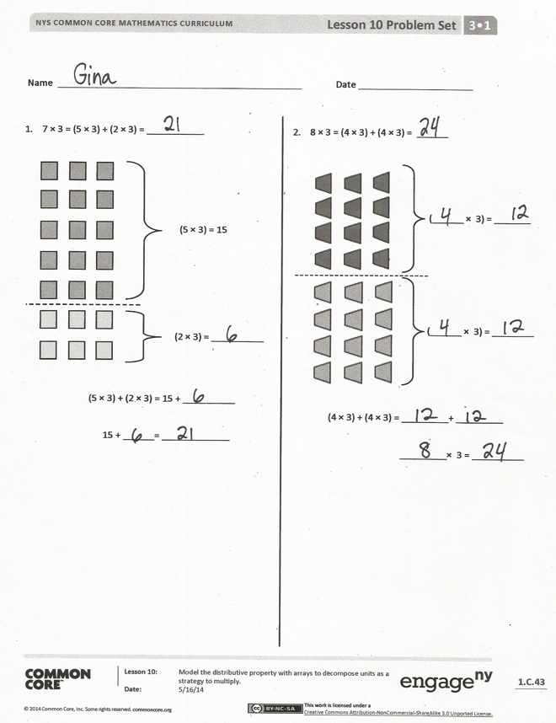
Student Debrief (10 minutes)
Lesson Objective: Model the distributive property with arrays to decompose units as a strategy to multiply.
The Student Debrief is intended to invite reflection and active processing of the total lesson experience.
Invite students to review their solutions for the Problem Set. They should check work by comparing answers with a partner before going over answers as a class. Look for misconceptions or misunderstandings that can be addressed in the Debrief. Guide students in a conversation to debrief the Problem Set and process the lesson.
You may choose to use any combination of the questions below to lead the discussion.
- In Problems 1 and 2, why might breaking an array into two parts to multiply, add, and then solve be easier than just multiplying the total number of groups times their size?
- Check Problem 3(a) by drawing and writing on the board as students give you verbal directions for how to create the page in Ruby’s photo album.

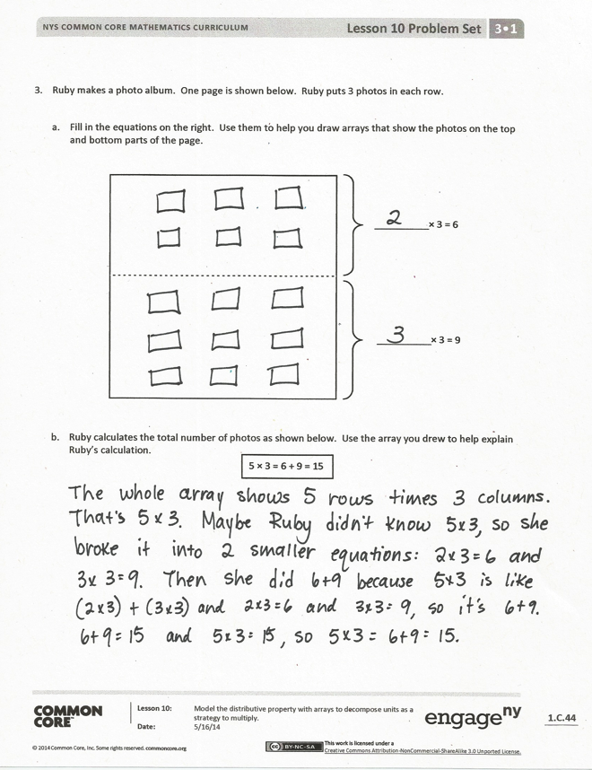
- Invite several students to share their work on Problem 3(b), and guide the class to understand the following points.
- 5 × 3 is the result of the number of groups added together and then multiplied by the size of groups in (2 × 3) + (3 × 3).
- 6 and 9 are the products of each multiplication expression.
- The factors in 5 × 3 relate to the number of groups and size of groups in the array.
- Both sides of the equation 5 × 3 = 6 + 9 have a value of 15.
- Review the vocabulary term parentheses.

Exit Ticket (3 minutes)
After the Student Debrief, instruct students to complete the Exit Ticket. A review of their work will help you assess the students’ understanding of the concepts that were presented in the lesson today and plan more effectively for future lessons. You may read the questions aloud to the students.

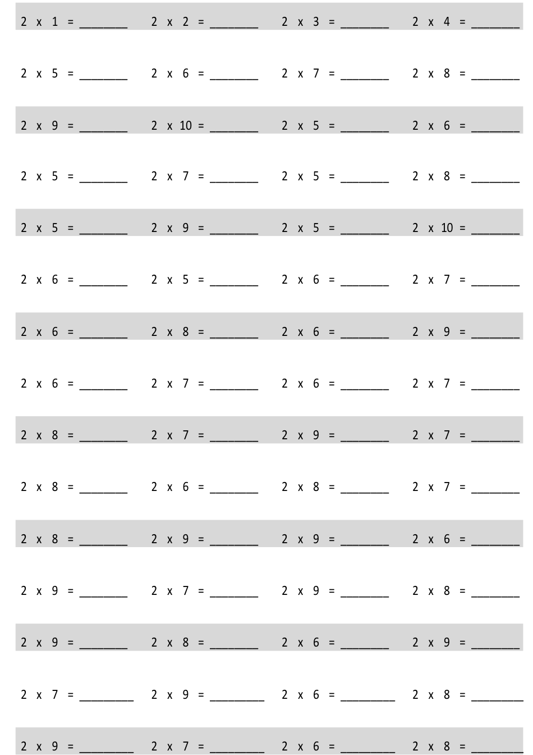
Multiply.

Name Date
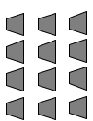
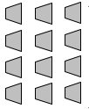
2. 8 × 3 = (4 × 3) + (4 × 3) = ______
(______ × 3) = ________

(______ × 3) = _______

= ____________
(4 × 3) + (4 × 3) = _________ + _________
_________ × 3 = __________

(5 × 3) = 15
(2 × 3) = __________
(5 × 3) + (2 × 3) = 15 + __________
15 + ______ = _____________
1. 7 × 3 = (5 × 3) + (2 × 3) = ___________

- Ruby makes a photo album. One page is shown below. Ruby puts 3 photos in each row.

  - Fill in the equations on the right. Use them to help you draw arrays that show the photos on the top and bottom parts of the page.

__________ × 3 = 9

__________ × 3 = 6

- Ruby calculates the total number of photos as shown below. Use the array you drew to help explain Ruby’s calculation.
5 × 3 = 6 + 9 = 15

Name Date
2.
7 × 3 = ______

1.
6 × 3 = ______

(4 × 3) + (2 × 3) = _________+ _________

6 × 3 = _________ + _________

______ × 3 = ______

(4 × 3) = _____
(2 × 3) = _____

(_____ × 3) = ______

(_____ × 3) = ______

(5 × 3) + (2 × 3) = _________ + _________

7 × 3 = _________ + _________

______ × 3 = ______

Name Date
1. 6 × 3 = __________
3.

(4 × 3) = 12

(2 × 3) = _________

12 + ______ = ______
6 × 3 = ______

2. 8 × 2 = __________

(____ × 2) = ______

(____ × 2) = ______

(4 × 2) + (4 × 2) = ______ + ______
____ × 2 = ________ (4 × 3) + (2 × 3) = 12 + ______
6 × 3 = ________

- Adriana organizes her books on shelves. She puts 3 books in each row.
  - Fill in the equations on the right. Use them to draw arrays that show the books on Adriana’s top and bottom shelves.

__________ × 3 = 15

__________ × 3 = 3

- Adriana calculates the total number of books as shown below. Use the array you drew to help explain Adriana’s calculation.
6 × 3 = 15 + 3 = 18

multiply by 2 (6–10)

