Lesson 9
Objective: Find related multiplication facts by adding and subtracting equal groups in array models.

Suggested Lesson Structure
 Fluency Practice (15 minutes)
 Concept Development (35 minutes)
 Student Debrief (10 minutes)
Total Time (60 minutes)

Fluency Practice (15 minutes)
- Multiply by 2 Pattern Sheet 3.OA.7 (8 minutes)
- Group Counting 3.OA.1 (3 minutes)
- Forms of Multiplication 3.OA.1 (4 minutes)

Multiply by 2 Pattern Sheet (8 minutes)

Materials: (S) Multiply by 2 (1–5) (Pattern Sheet)
Note: This activity builds fluency with multiplication facts using units of 2. It works toward students knowing from memory all products of two one-digit numbers.
T: (Write 5 × 2 = ____.) Let’s skip-count by twos to find the answer. (Count with fingers to 5 as students count. Record skip-count on the board.)
S: 2, 4, 6, 8, 10.
T: (Circle 10 and write 5 × 2 = 10 above it. Write 3 × 2 = ____.) Let’s skip-count up by twos again. (Count with fingers to 3 as students count.)
S: 2, 4, 6.
T: Let’s see how we can skip-count down to find the answer, too. Start at 10 with 5 fingers, 1 for each two. (Count down with your fingers as students say numbers.)
S: 10 (5 fingers), 8 (4 fingers), 6 (3 fingers).
Repeat the process for 4 × 2.
T: Let’s practice multiplying by 2.

Directions for Administration of Multiply-By Pattern Sheet
- Distribute Multiply-By Pattern Sheet.
- Allow a maximum of 2 minutes for students to complete as many problems as possible.
- Direct students to work left to right across the page.
- Encourage skip-counting strategies to solve unknown facts.

Group Counting (3 minutes)
Note: Group counting reviews interpreting multiplication as repeated addition. Counting by threes and fours in this activity supports work with units of 3 in this topic and anticipates work using units of 4 in Topic E.
T: Let’s count by threes. (Direct students to count forward and backward to 30, emphasizing the transition from 18 to 21.)
T: Let’s count by fours. (Direct students to count forward and backward to 24, emphasizing the 16 to 20 transition.)

Forms of Multiplication (4 minutes)

Materials: (S) Personal white board
Note: Students directly relate repeated addition to multiplication in preparation for using the distributive property in this lesson.
T: (Project a 3 × 5 array.) Represent this array as a repeated addition sentence using 5 as the size of the groups.
S: (Write 5 + 5 + 5 = 15.)
T: (Project a 3 × 4 array. Write ____ fours = ____.) Complete the equation on your personal white board.
S: (Write 3 fours = 12.)
T: (Project a 7 × 2 array.) Write two multiplication sentences for 7 groups of 2.
S: (Write 7 × 2 = 14 and 2 × 7 = 14.)
T: (Project a 6 × 3 array.) Write 18 = 6 × ____.) Complete the equation on your personal white board.
S: (Write 18 = 6 × 3.)
T: (Project a 5 × 3 array. Write 5 threes = ___.) Complete the equation on your personal white board.
S: (Write 5 threes = 15.)
T: (Add one more group of 3 to the array. Write 5 threes + 1 three = ____ threes = ____ ones.)
S: (Write 5 threes + 1 three = 6 threes = 18 ones.)

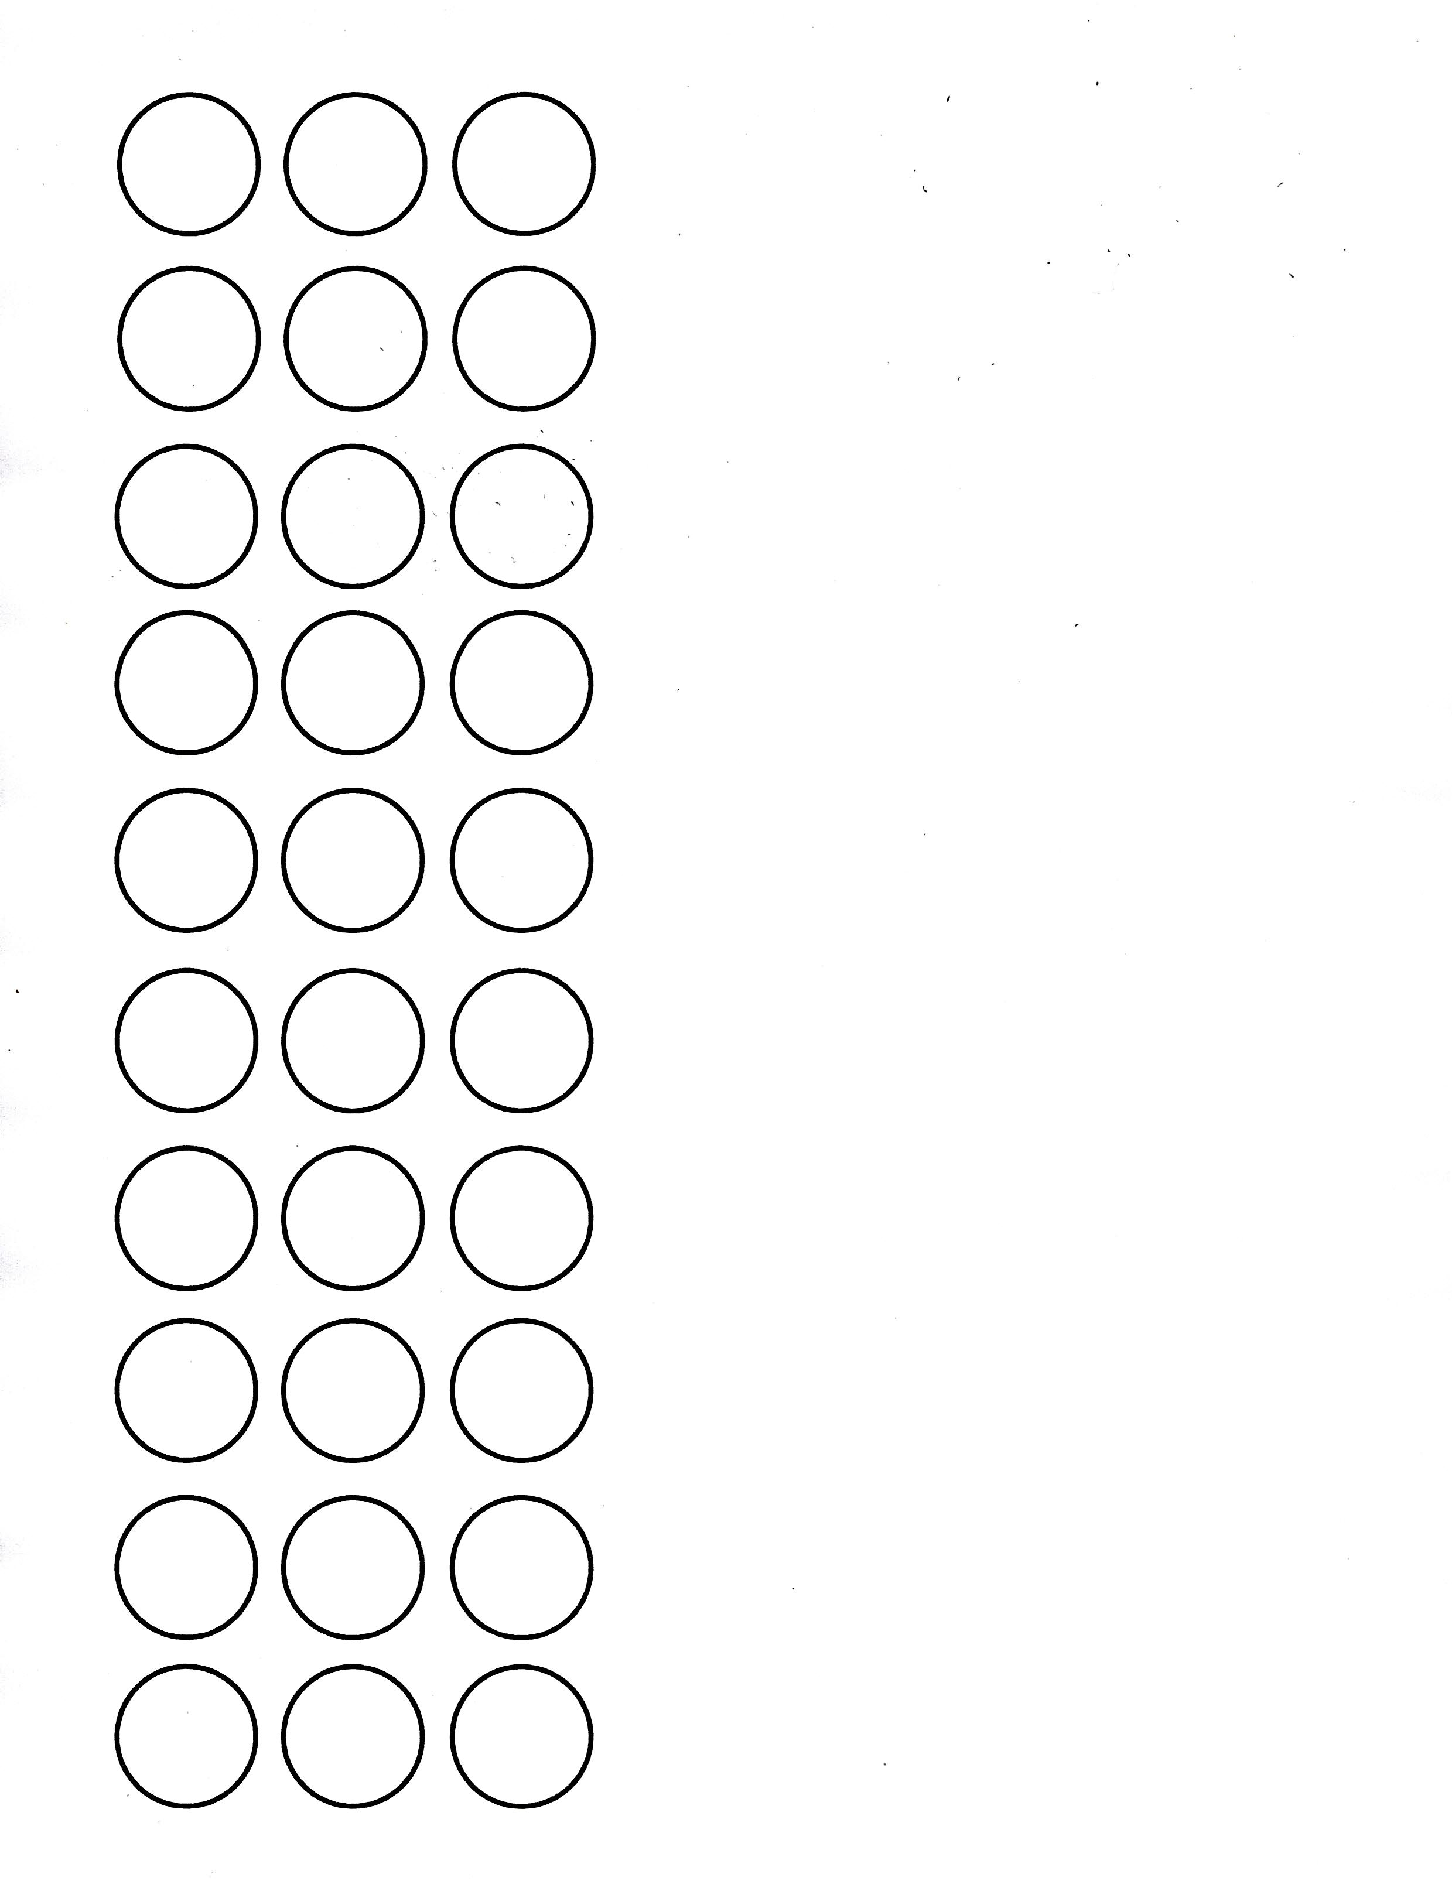
Concept Development (35 minutes)
Threes array no fill template
Materials: (S) Personal white board, threes array no fill (Template) (pictured at right), blank paper

Problem 1: Add two known smaller facts to solve an unknown larger fact.
T: Slip the template into your board. Cover part of the array with blank paper to show 5 rows of 3. Draw a box around the uncovered array. Write and solve a multiplication sentence to describe it.
S: (Cover, then box array, and write 5 × 3 = 15.)

NOTES ON
MULTIPLE MEANS
OF REPRESENTATION:
Decomposing this way naturally relates to the part–whole relationship that students studied in Grades K–2. The vignette implies the relationship, but a more formal connection to prior knowledge may be appropriate for some classes.

T: Move the paper so the array shows 7 × 3. Shade the rows you added.
S: (Shade 2 rows.)
T: Write and solve a multiplication sentence to describe the shaded part of your array.
S: (Write 2 × 3 = 6.)
T: How many threes are in 5 × 3?
S: 5 threes.
T: How many threes did you add to 5 × 3 to make the array show 7 × 3?
S: 2 threes.
7 threes = 5 threes + 2 threes
7 × 3 = 5 × 3 + 2 × 3
21 = 15 + 6

Sample teacher board

T: (Write 7 threes = 5 threes + 2 threes.) So, 7 threes equals 5 threes plus 2 threes. (Write 7 × 3 = 5 × 3 + 2 × 3 as shown to the right.) Do you agree or disagree?
S: I agree. That’s just adding the two parts of the array together. 7 rows of three is the same as 5 rows of three plus 2 rows of three.

NOTES ON
MULTIPLE MEANS
OF ENGAGEMENT:
The second example for subtraction
(8 × 3) is intentionally the same as the second example for addition. Solving the same problem in two ways provides an opportunity for students to compare the strategies. Ask students who benefit from a challenge to analyze the strategies independently or in pairs, and then present their thinking to others during the Debrief.

T: We already wrote totals for the two parts of our array. Let’s add those to find the total for the whole array. What is the total of 5 × 3?
S: 15.
T: (Write 15 + on the board.) What is the total of 2 × 3?
S: 6.
T: (Add to the board so the equation reads ____ = 15 + 6.) Say the total at the signal. (Signal.)
S: 21.
Provide students with another example. Have them use the template to add the totals of 4 × 3 and 4 × 3 to find the answer to 8 × 3. Teach them to double the total for 4 × 3.
T: Explain how we added to find 7 × 3 = 21 and 8 × 3 = 24.
S: We added the totals of smaller facts together to find the whole. We used two facts we already knew to find one we didn’t know.

Problem 2: Subtract two known smaller facts to solve an unknown larger fact.
T: Draw a box around an array that shows 9 × 3. Notice that 9 × 3 is very close to 10 × 3. 10 × 3 is easier to solve because we can count by tens to get the total. Let’s do that now.
S: 10, 20, 30.
T: Let’s use 10 × 3 = 30 to help us solve 9 × 3.
T: Use your finger to trace 10 threes.
T: What should we subtract to show 9 threes instead?
S: 1 three!
T: (Write 10 threes – 1 three = _____ on the board.) 10 threes equals?
S: 30.

NOTES ON VOCABULARY:
Introduce the word distribute into your everyday classroom language. This will help with students’ understanding of the distributive property, which is formally introduced in Lesson 16.
For example, “Paper monitors, please distribute the papers to the class.”

T: 30 – 3 equals?
S: 27.
Provide another example. Have students subtract to find the answer to 8 × 3. 10 × 3 is the basic fact, so the subtraction to find 8 × 3 is 30 – 6.
T: Tell your partner how we used 10 × 3 to help us find the answer to 9 × 3 and 8 × 3.
S: (Discuss.)

Problem Set (10 minutes)
Students should do their personal best to complete the Problem Set within the allotted 10 minutes. For some classes, it may be appropriate to modify the assignment by specifying which problems they work on first. Some problems do not specify a method for solving. Students should solve these problems using the RDW approach used for Application Problems.

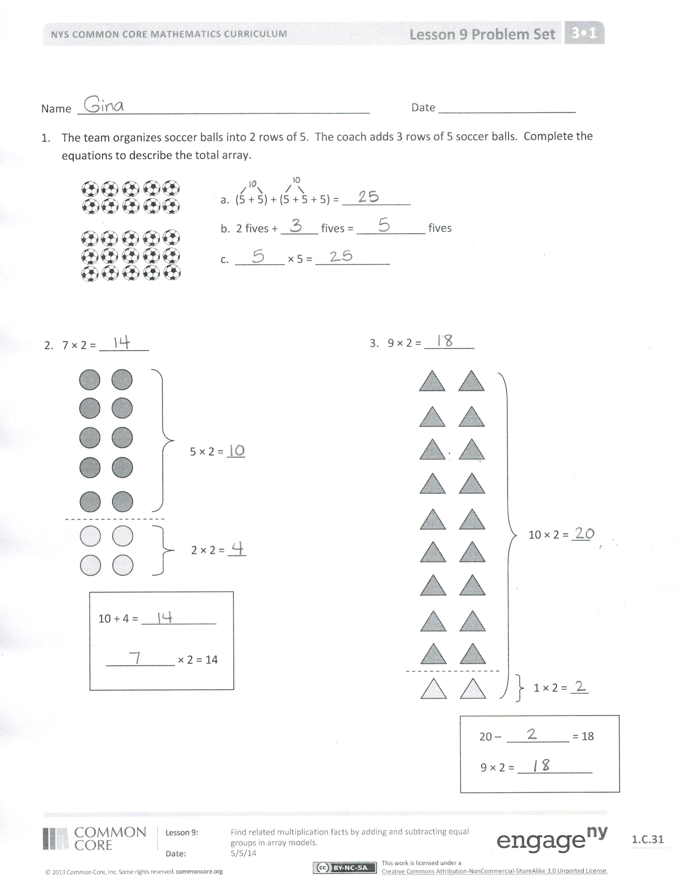
Student Debrief (10 minutes)
Lesson Objective: Find related multiplication facts by adding and subtracting equal groups in array models.
The Student Debrief is intended to invite reflection and active processing of the total lesson experience.
Invite students to review their solutions for the Problem Set. They should check work by comparing answers with a partner before going over answers as a class. Look for misconceptions or misunderstandings that can be addressed in the Debrief. Guide students in a conversation to debrief the Problem Set and process the lesson.
You may choose to use any combination of the questions below to lead the discussion.
- Review the strategy of adding and subtracting the totals of known “easy” facts for solving unknown facts.
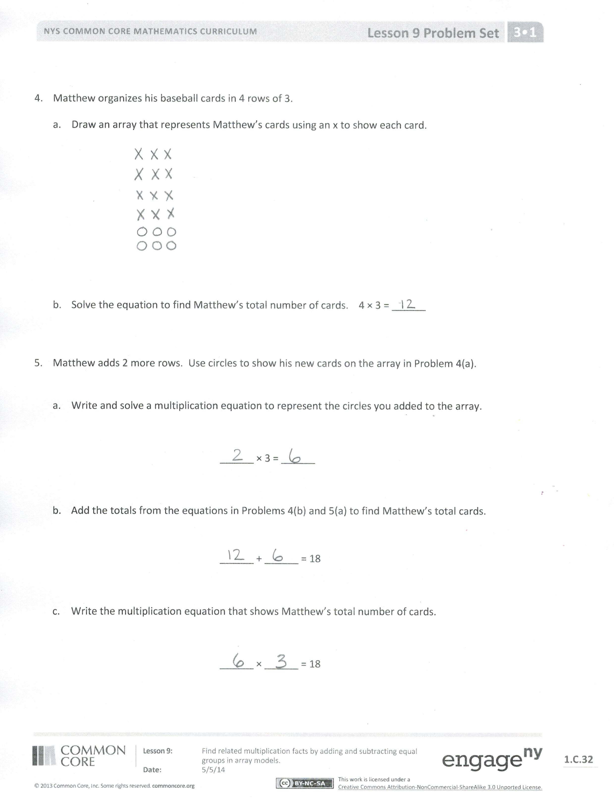
- Differentiate between when to apply addition or subtraction through analysis of the example 8 × 3 from the Concept Development. (Students solved 8 × 3 using both addition and subtraction.) Ask students to apply the strategy to solve 8 × 4.

Exit Ticket (3 minutes)
After the Student Debrief, instruct students to complete the Exit Ticket. A review of their work will help you assess the students’ understanding of the concepts that were presented in the lesson today and plan more effectively for future lessons. You may read the questions aloud to the students.

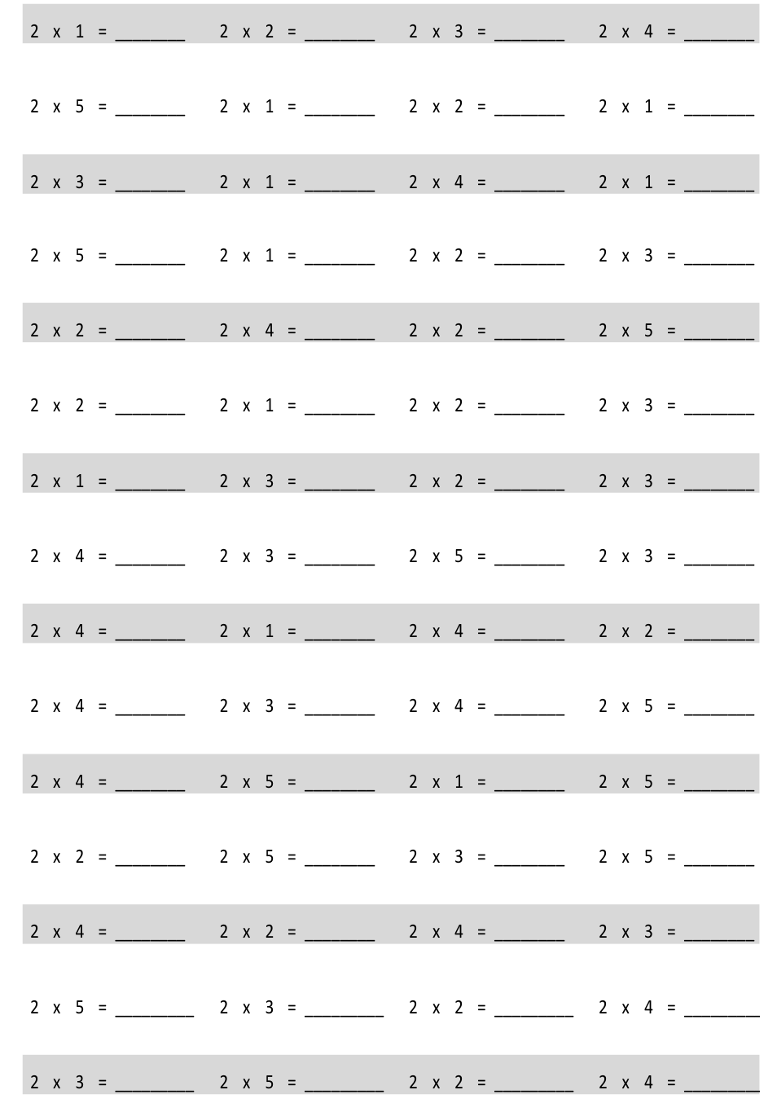
Multiply.

Name Date
- The team organizes soccer balls into 2 rows of 5. The coach adds 3 rows of 5 soccer balls. Complete the equations to describe the total array.
a. (5 + 5) + (5 + 5 + 5) = ___________
b. 2 fives + ______ fives = ___________ fives

c. ________ × 5 = ____________

2. 7 × 2 = ________
10 + 4 = ____________
___________ × 2 = 14
5 × 2 = ___
2 × 2 = ___
3. 9 × 2 = ________

9 × 2 = ____________
20 – __________ = 18

10 × 2 = ___

1 × 2 = ___

- Matthew organizes his baseball cards in 4 rows of 3.
  - Draw an array that represents Matthew’s cards using an x to show each card.

- Solve the equation to find Matthew’s total number of cards. 4 × 3 = ______

- Matthew adds 2 more rows. Use circles to show his new cards on the array in Problem 4(a).

  - Write and solve a multiplication equation to represent the circles you added to the array.

______ × 3 = ______

- Add the totals from the equations in Problems 4(b) and 5(a) to find Matthew’s total cards.

______ + ______ = 18

- Write the multiplication equation that shows Matthew’s total number of cards.

______ × ______ = 18

Name Date

1. Mrs. Stern roasts cloves of garlic. She places 10 rows of two cloves on a baking sheet.
Write an equation to describe the number of cloves Mrs. Stern bakes.
_______ × _______ = _______

2. When the garlic is roasted, Mrs. Stern uses some for a recipe. There are 2 rows of two garlic cloves left on the pan.
a. Complete the equation below to show how many garlic cloves Mrs. Stern uses.
________ twos – ________ twos = ________twos

b. 20 – ________ = 16

c. Write an equation to describe the number of garlic cloves Mrs. Stern uses.
_______ × 2 = ________

Name Date
- Dan organizes his stickers into 3 rows of four. Irene adds 2 more rows of stickers. Complete the equations to describe the total number of stickers in the array.

a. (4 + 4 + 4) + (4 + 4) = ___________
b. 3 fours + ______ fours = ___________ fours

c. ________ × 4 = ____________

- 7 × 2 = ______ 3. 9 × 3 = ______
1 × 3 = ___
30 – ________ = 27
_________ × 3 = 27

10 × 3 = ___
12 + 2 = ____________
___________ × 2 = 14
1 × 2 = ___
6 × 2 = ___

- Franklin collects stickers. He organizes his stickers in 5 rows of four.
  - Draw an array to represent Franklin’s stickers. Use an x to show each sticker.

  - Solve the equation to find Franklin’s total number of stickers. 5 × 4 = ______

- Franklin adds 2 more rows. Use circles to show his new stickers on the array in Problem 4(a).
  - Write and solve an equation to represent the circles you added to the array.

______ × 4 = ______

  - Complete the equation to show how you add the totals of 2 multiplication facts to find Franklin’s total number of stickers.
______ + ______ = 28

- Complete the unknown to show Franklin’s total number of stickers.

_____ × 4 = 28

multiply by 2 (1–5)
threes array no fill

