Lesson 8
Objective: Demonstrate the commutativity of multiplication, and practice related facts by skip-counting objects in array models.

Suggested Lesson Structure
 Fluency Practice (6 minutes)
 Application Problem (10 minutes)
 Concept Development (34 minutes)
 Student Debrief (10 minutes)
Total Time (60 minutes)
Fluency Practice (6 minutes)
- Group Counting 3.OA.1 (3 minutes)
- Commutative Multiplying 3.OA.5 (3 minutes)
Group Counting (3 minutes)
Note: Group counting reviews interpreting multiplication as repeated addition. Counting by twos, threes, and fours in this activity supports work with units of 2 and 3 in this topic and anticipates work using units of 4 in Topic E.
T: Let’s count by twos to 20. Whisper the numbers, then speak them.
T: Let’s count by twos to 20 again. This time, hum the first number, and then speak it. As you hum, think of the number.
T: Let’s count by twos to 20. This time, instead of humming, think every other number.
T: What did we just count by?
S: Twos.
T: Let’s count by fours. (Direct students to count forward and backward to 20, periodically changing directions.)
T: Let’s count by threes. (Direct students to count forward and backward to 30, periodically changing directions. Emphasize the 9 to 12, 18 to 21, and 27 to 30 transitions.)

Commutative Multiplying (3 minutes)
Materials: (S) Personal white board
Note: Practicing this concept, which was taught in Lesson 7, helps students build confidence and automaticity.
T: (Project a 3 × 2 array.) How many groups of 2 do you see?
S: 3 groups of 2.
T: Write two different multiplication sentences for the array.
S: (Write 3 × 2 = 6 and 2 × 3 = 6.)
Continue with following possible sequence: 3 by 5 and 4 by 3.
T: (Write 4 × 2 = 2 × ___.) On your boards, fill in the blank.
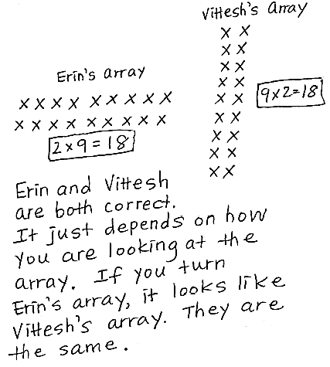
S: (Write 4 × 2 = 2 × 4.)
Repeat the process for 9 × 5 = 5 × ___ and 3 × 6 = 6 × ___.
Application Problem (10 minutes)
Children sit in 2 rows of 9 on the carpet for math time. Erin says, “We make 2 equal groups.” Vittesh says, “We make 9 equal groups.” Who is correct? Explain how you know using models, numbers, and words.
Note: This problem reviews the commutativity of multiplication introduced in Lesson 7 and prepares students for Day 2 of the same concept in today’s lesson.
Concept Development (34 minutes)
Materials: (S) Personal white board

NOTES ON
Multiple Means
of Engagement:
If students are very comfortable with the way an array changes depending on how it is turned, add a bit of complexity by having them imagine turning it horizontal rather than actually doing it.

Problem 1: Rotate arrays 90 degrees.
T: Turn your personal white board so it’s vertical. Skip-count by threes 4 times and write each number.
S: 3, 6, 9, 12.
T: Draw an array to match your count. How many rows and columns does your array show? Why?
S: (Draw a 4 × 3 array. Discuss that there are 4 rows and 3 columns because there are 4 groups of 3 in the count.)

T: Turn your board so it’s horizontal. How many rows and columns does it show now?
S: (Turn boards 90 degrees.) 3 rows and 4 columns.
T: What is the difference between the vertical and horizontal arrays?
S: In the first array, the 4 threes were rows, and in the second, they were columns. It’s the same with the 3 fours. First, they were columns, then rows, but they still show equal groups.
MP.7
T: Did the total number of dots change?
S: No.
T: So, the total and the factors stay the same. The factors just switch places. Yesterday, we learned a special name for that. It’s called…
S: Commutative! The commutative property!
T: Use the commutative property to write two multiplication sentences for the array.
S: (Write 4 × 3 = 12 and 3 × 4 = 12.)
T: To make the array, you skip-counted by threes 4 times. Look at your array horizontally. Tell your partner the directions for another count-by to make the horizontal array. Check your directions by writing out the count-by.
S: Skip-count by fours 3 times. (Write 4, 8, 12.)
Students practice with partners using the following examples. Partner A gives skip-counting directions. Partner B writes the count, draws the array, and writes multiplication sentences. Then, partners switch roles.
- Skip-count by twos 3 times
- Skip-count by threes 6 times
Problem 2: Interpreting rows and columns in rotated arrays.
T: Work with your partner to draw an array that shows 5 rows and 3 columns.

NOTES ON
DRAWING ROWS
AND COLUMNS:
Students may not immediately recognize that they do not need to redraw the corner circle to make 3 columns. After drawing rows, they already have 1 column, and, for this problem, only need to add 2 more columns. If they make a mistake, help them recognize it by encouraging them to recount their total columns.

S: (Demonstrate one possible process.) Let’s draw 5 circles going down to show the start of each row. Then we can draw 3 circles to show the columns across the top. Wait, we already drew 1 column when we made the rows, so we can just draw 2 more columns.
T: Write an equation to match your array. Don’t solve it yet.
S: (Write 5 × 3 = ____.)
T: I’m going to change the problem slightly. Listen carefully and rotate your array to match: 3 rows and 5 columns.
S: (Turn boards 90 degrees.)
T: Write the equation for the new array. Don’t solve it yet.
S: (Write 3 × 5 = ____.)
T: Explain the difference between these problems to your partner.
S: The array turned and the factors switched places. When the array turns, the 3 represents the rows instead of the columns, and the 5 represents columns instead of rows.
T: When we turn the array, columns become rows and rows become columns. We call that the commutative property.

NOTES ON
Multiple Means of Engagement:
If appropriate, provide a challenge for students by having them cover the array as they skip-count to solve.

T: Solve each of your equations by skip-counting. Write each number as you say it.
S: (Write 3, 6, 9, 12, 15 and 5, 10, 15.)
Continue with the following possible examples:
- 7 rows and 2 columns
- 3 rows and 9 columns
T: (Once students have worked through the problem, write the final example in groups language: 3 groups of 9 and 9 groups of 3.) Are these statements equal? Use your array to discuss with your partner how you know.
Problem Set (10 minutes)
Students should do their personal best to complete the Problem Set within the allotted 10 minutes. For some classes, it may be appropriate to modify the assignment by specifying which problems they work on first. Some problems do not specify a method for solving. Students should solve these problems using the RDW approach used for Application Problems.
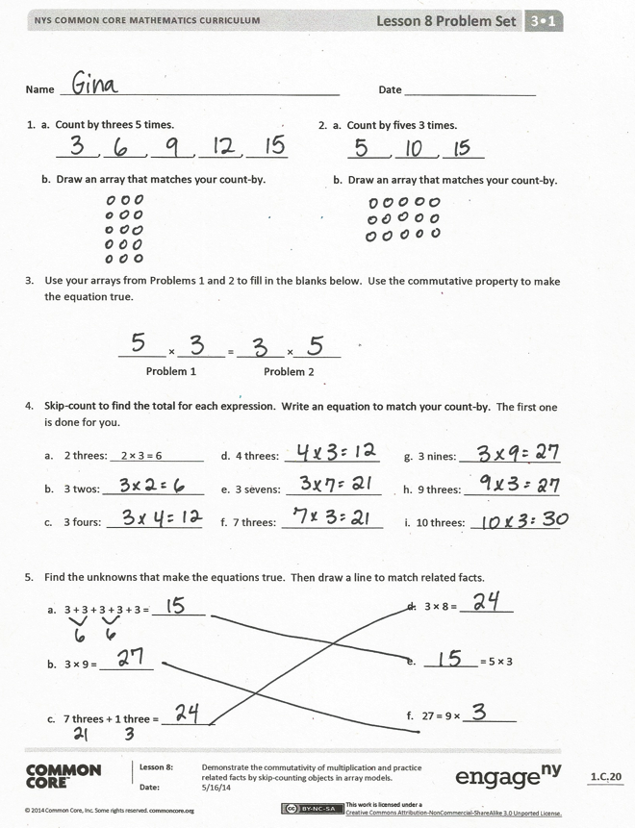
Student Debrief (10 minutes)
Lesson Objective: Demonstrate the commutativity of multiplication and practice related facts by skip-counting objects in array models.
The Student Debrief is intended to invite reflection and active processing of the total lesson experience.
Invite students to review their solutions for the Problem Set. They should check work by comparing answers with a partner before going over answers as a class. Look for misconceptions or misunderstandings that can be addressed in the Debrief. Guide students in a conversation to debrief the Problem Set and process the lesson.
You may choose to use any combination of the questions below to lead the discussion.
- Discuss the usefulness of skip-counting to solve multiplication problems.
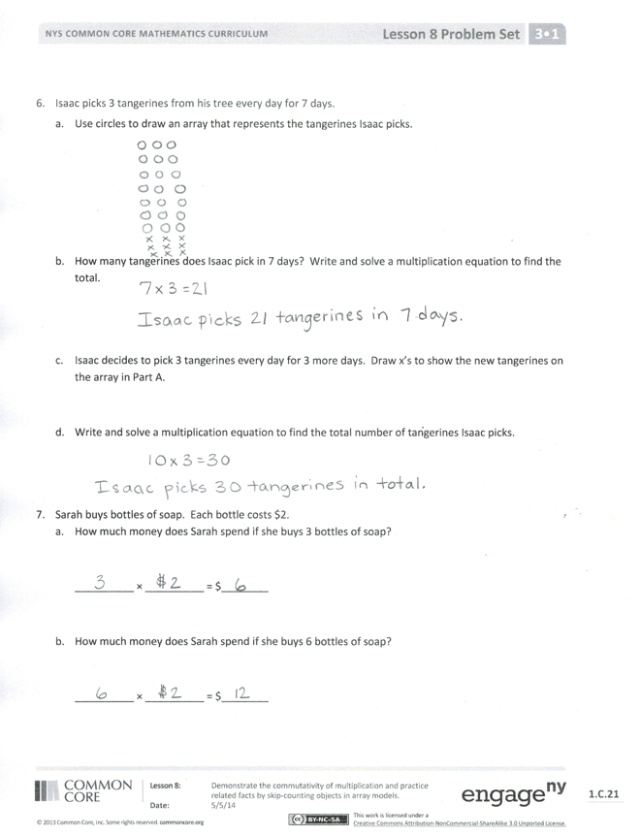
- Build fluency by having students skip-count to find answers to the following expressions without the help of an array. They can keep track of their count using fingers.
- 3 sixes, 6 threes
- 3 eights, 8 threes
- 5 threes, 3 fives
- Discuss the meaning of the commutative property and how it relates to equal groups, columns, rows, and arrays.
Exit Ticket (3 minutes)
After the Student Debrief, instruct students to complete the Exit Ticket. A review of their work will help you assess the students’ understanding of the concepts that were presented in the lesson today and plan more effectively for future lessons. You may read the questions aloud to the students.

Name Date
2. a. Count by fives 3 times.
_______, _______, _______
b. Draw an array that matches your count-by.

1. a. Count by threes 5 times.
_______, _______, _______, _______, _______
b. Draw an array that matches your count-by.

- Use your arrays from Problems 1 and 2 to fill in the blanks below. Use the commutative property to make the equation true.

________ × ________ = ________ × ________
Problem 1 Problem 2

- Skip-count to find the total for each expression. Write an equation to match your count-by. The first one is done for you.

- 2 threes: 2 × 3 = 6 d. 4 threes: ________________ g. 3 nines: _________________

- 3 twos: _________________ e. 3 sevens: ________________ h. 9 threes: ________________

- 3 fours: ________________ f. 7 threes: _________________ i. 10 threes: _______________

- Find the unknowns that make the equations true. Then, draw a line to match related facts.
a. 3 + 3 + 3 + 3 + 3 = _________

b. 3 × 9 = _________

c. 7 threes + 1 three = _________

d. 3 × 8 = _________

e. _________ = 5 × 3

f. 27 = 9 × _________

- Isaac picks 3 tangerines from his tree every day for 7 days.
  - Use circles to draw an array that represents the tangerines Isaac picks.

  - How many tangerines does Isaac pick in 7 days? Write and solve a multiplication equation to find the total.

  - Isaac decides to pick 3 tangerines every day for 3 more days. Draw x’s to show the new tangerines on the array in Part (a).

  - Write and solve a multiplication equation to find the total number of tangerines Isaac picks.

- Sarah buys bottles of soap. Each bottle costs $2.
  - How much money does Sarah spend if she buys 3 bottles of soap?

__________ × __________ = $________

- How much money does Sarah spend if she buys 6 bottles of soap?

__________ × __________ = $________

Name Date
Mary Beth organizes stickers on a page in her sticker book. She arranges them in 3 rows and 4 columns.
a. Draw an array to show Mary Beth’s stickers.

- Use your array to write a multiplication equation to find Mary Beth’s total number of stickers.

- Label your array to show how you skip-count to solve your equation.

- Use what you know about the commutative property to write a different equation for your array.

Name Date
1. a. Count by threes 6 times.
____, ____, ____, ____, ____, ____
b. Draw an array to match your count-by.

2. a. Count by sixes 3 times.
_______, _______, _______
b. Draw an array to match your count-by.

- Use your arrays from Problems 1 and 2 to fill in the blanks below. Use the commutative property to make the equation true.
________ × ________ = ________ × ________
Problem 1 Problem 2

- Skip-count to find the total for each expression. Write an equation to match your count-by. The first one is done for you.

- 5 threes: 5 × 3 = 15 d. 3 sixes: ___________________ g. 8 threes: ________________

- 3 fives: __________________ e. 7 threes: __________________ h. 3 nines: _________________

- 6 threes: ________________ f. 3 sevens: __________________ i. 10 threes: _______________

- Find the unknowns that make the equations true. Then, draw a line to match related facts.
a. 3 + 3 + 3 + 3 + 3 + 3 = _________

b. 3 × 5 = _________

c. 8 threes + 1 three = _________

d. 3 × 9 = _________

e. _________ = 6 × 3

f. 15 = 5 × _________

- Fernando puts 3 pictures on each page of his photo album. He puts pictures on 8 pages.
  - Use circles to draw an array that represents the total number of pictures in Fernando’s photo album.

  - Use your array to write and solve an equation to find Fernando’s total number of pictures.

  - Fernando adds 2 more pages to his book. He puts 3 pictures on each new page. Draw x’s to show the new pictures on the array in Part (a).

  - Write and solve a multiplication equation to find the new total number of pictures in Fernando’s album.

- Ivania recycles. She gets 3 cents for every can she recycles.
  - How much money does Ivania make if she recycles 4 cans?

__________ × __________ = ________ cents

- How much money does Ivania make if she recycles 7 cans?

__________ × __________ = ________ cents

