Lesson 6

Objective: Interpret the unknown in division using the array model.

Suggested Lesson Structure
 Fluency Practice (8 minutes)
 Application Problem (7 minutes)
 Concept Development (35 minutes)
 Student Debrief (10 minutes)
Total Time (60 minutes)

Fluency Practice (8 minutes)
- Group Counting 3.OA.1 (3 minutes)
- Divide Equal Groups 3.OA.2 (5 minutes)

Group Counting (3 minutes)
Note: Group counting reviews interpreting multiplication as repeated addition. Counting by twos and threes in this activity supports work with those factors in Topic B.
T: Let’s count by twos. (Direct students to count forward and backward to 20, emphasizing the 8 to 10, 10 to 12, and 18 to 20 transitions.)
T: Let’s count by threes. (Direct students to count forward and backward to 30, periodically changing directions. Emphasize the 9 to 12, 18 to 21, and 27 to 30 transitions.)

Divide Equal Groups (5 minutes)

Materials: (S) Personal white board
Note: Students directly relate repeated addition to division. They interpret the unknown in division. This activity bridges Lessons 5 and 6.
T: (Project an array with 3 groups of 5.) Say the total as a repeated addition sentence.
S: 5 + 5 + 5 = 15.
T: Write a division sentence for 15 divided into 3 equal groups.
S: (Write 15 ÷ 3 = 5.)
Continue with the following possible sequence: 5 groups of 3, 4 groups of 3, 3 groups of 4, 9 groups of 2, and 2 groups of 9.
Alternate between division sentences where the quotient represents either the number of objects in a group or the number of groups.

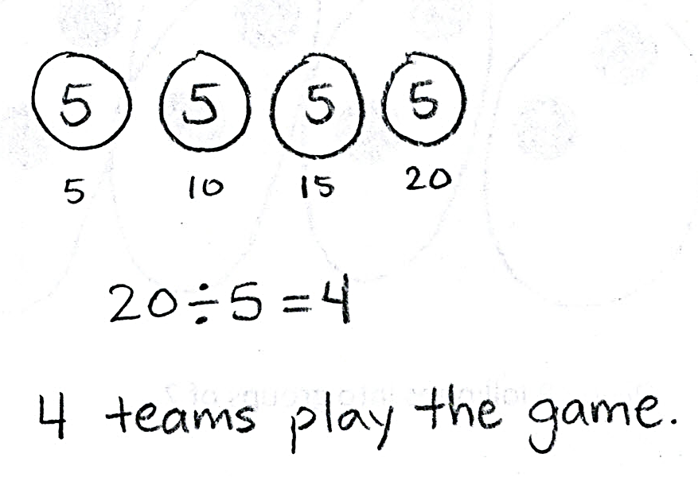
Application Problem (7 minutes)
Twenty children play a game. There are 5 children on each team. How many teams play the game? Write a division sentence to represent the problem.
Note: This problem reviews division from Lesson 5 where the unknown represents the number of groups. It also leads into Problem 1 of the Concept Development, which relates division to the array model.

Concept Development (35 minutes)

NOTES ON
ARRAYS:
Problem 1 in this lesson introduces students to relating division to an array model. In Lesson 2, students related the rows in an array to the number of equal groups and the number of dots in each row to the size the group. The same concept applies for division arrays, but now the problems begin with the total number.

Materials: (S) Personal white board, Application Problem

Problem 1: Relate division to an array model.
Draw an array representing the Application Problem on the board.

Have students analyze the array and describe the following relationships:

NOTES ON
MULTIPLE MEANS
OF REPRESENATION:
Some students may benefit from working with a partner. They may underline each row to literally show division and circle each row to show the size of each group. They should explain each step they take. This may be particularly helpful for students who prefer visual or kinesthetic practice along with auditory.

- Total number of children and total number of dots
- Number of children on each team and number of dots in each row
- Number of teams and number of rows
Repeat the process with the following suggested examples. This time, guide students to draw the array from the division equations below. Alternate between having the quotient represent the size of the groups and the number of groups.
- 8 ÷ 2 = 4
- 18 ÷ 6 = 3

Problem 2: Use an array to relate the unknown factor in multiplication to the quotient in division.
T: Draw an array that shows the equation 15 ÷ 3 = 5 where the quotient—that means the answer—represents the size of the groups.
S: (Draw array below.)

T: Now, write both a division and a multiplication equation for the array.
S: (Write 15 ÷ 3 = 5, 3 × 5 = 15.)
T: Where do you find the quotient in our multiplication equation?
S: It’s the second number. It’s the size of the groups. It’s a factor.
T: Circle the size of the groups in both problems.
S: (Circle the 5 in both problems.)
Repeat the process with the following suggested examples. Alternate between having the quotient represent the size of the groups and the number of groups.
- 4 rows of 2
- 7 rows of 3
T: Use our equations to explain to your partner how the factors in a multiplication problem can help you find the quotient in division.

Problem 3: Relate multiplication and division.

NOTES ON
MULTIPLE MEANS
OF ENGAGEMENT:
Some students may still benefit from the visual of an array in this problem. If necessary, encourage your students to draw an array.

T: (Write ___ × 3 = 24 on the board.) Skip-count and track the number of threes to solve.
S: 3, 6, 9, 12, 15, 18, 21, 24. (Write 8 to complete the equation.)
T: How many threes make 24? Answer in a complete sentence.
S: Eight threes make 24.
T: Write a related division equation where the quotient represents the unknown factor.
S: (Write 24 ÷ 3 = 8.)
T: Twenty-four divided in threes makes how many groups? Answer in a complete sentence.
S: Twenty-four divided in threes makes 8 groups.
T: How are the unknown factor and the quotient related in these equations?
S: The unknown factor is the same number as the quotient.
Repeat the process with the following suggested examples:
- 2 × ____ = 18 and 18 ÷ 2 = ____
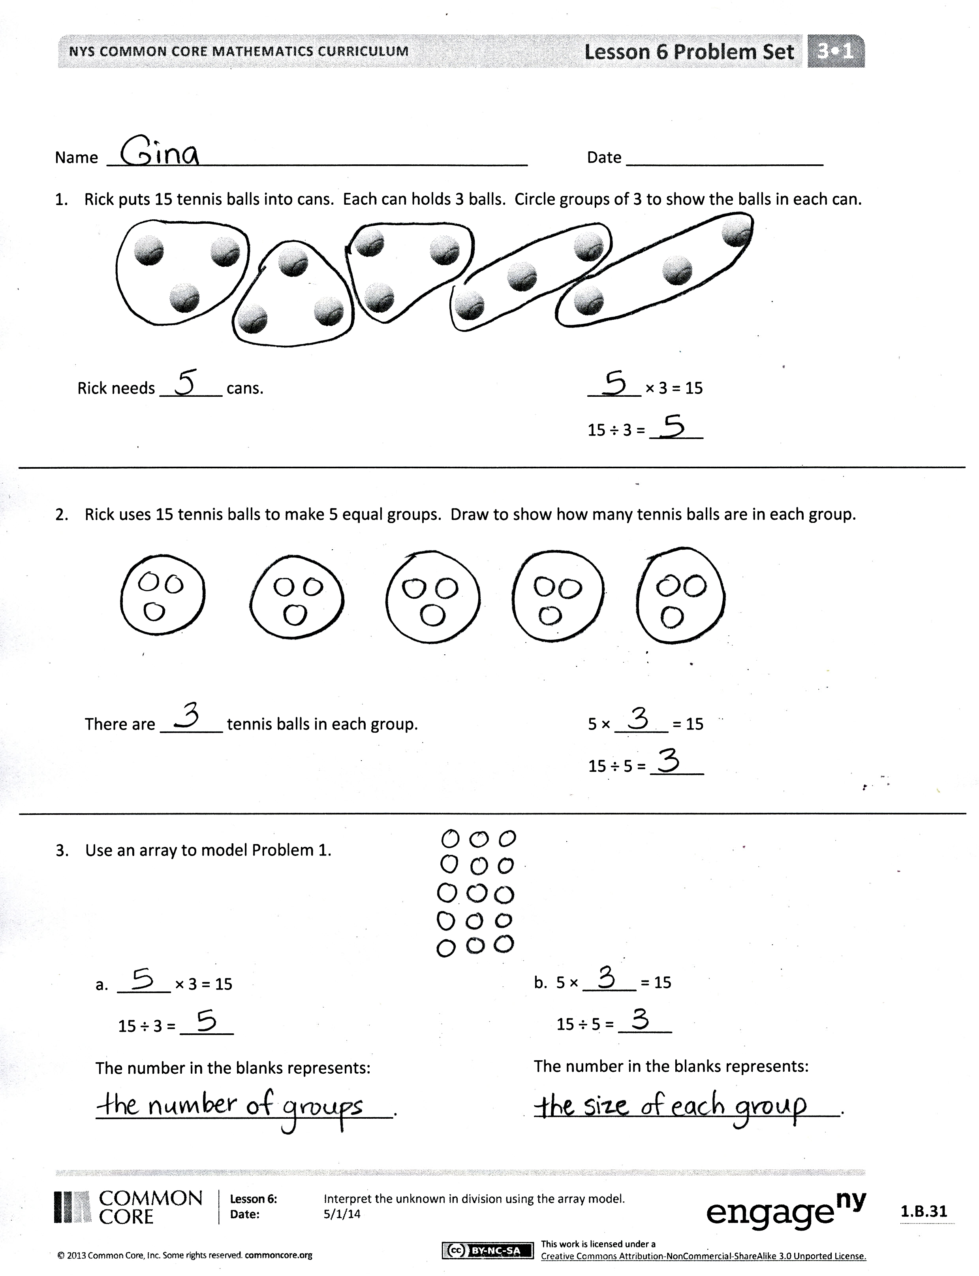
- ____ × 9 = 27 and 27 ÷ 9 = ____

T: (Write __ × 3 = 24 and 24 ÷ 3 = __.) True or false: Both equations ask how many threes are in 24?
S: They look different, but they mean the same thing. In both, we’re talking about 8 groups of 3 and a total of 24. So, it’s true. The quotient in a division equation is like finding the unknown factor in a multiplication equation.

Problem Set (10 minutes)
Students should do their personal best to complete the Problem Set within the allotted 10 minutes. For some classes, it may be appropriate to modify the assignment by specifying which problems they work on first. Some problems do not specify a method for solving. Students should solve these problems using the RDW approach used for Application Problems.

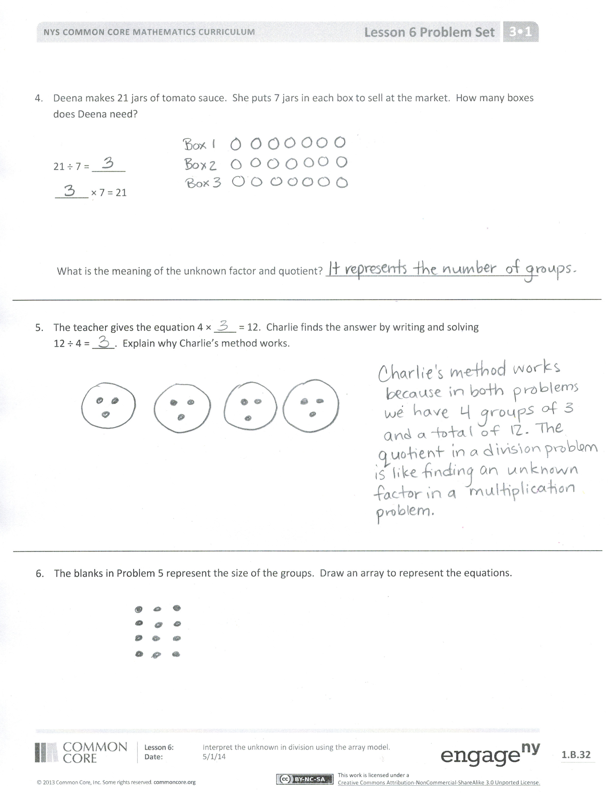
Student Debrief (10 minutes)
Lesson Objective: Interpret the unknown in division using the array model.
The Student Debrief is intended to invite reflection and active processing of the total lesson experience.
Invite students to review their solutions for the Problem Set. They should check work by comparing answers with a partner before going over answers as a class. Look for misconceptions or misunderstandings that can be addressed in the Debrief. Guide students in a conversation to debrief the Problem Set and process the lesson.
You may choose to use any combination of the questions below to lead the discussion.
- Analyze the four equations in Problem 3. Compare the multiplication and division equations, noticing differences in how the problem is represented by each one.
- How do arrays represent both multiplication and division?
- Based on your observation of arrays, what do multiplication and division have in common?
- What is the relationship between the quotient in division and the unknown factor in a related multiplication equation?

Exit Ticket (3 minutes)
After the Student Debrief, instruct students to complete the Exit Ticket. A review of their work will help you assess the students’ understanding of the concepts that were presented in the lesson today and plan more effectively for future lessons. You may read the questions aloud to the students.

Name Date
- Rick puts 15 tennis balls into cans. Each can holds 3 balls. Circle groups of 3 to show the balls in each can.

Rick needs _______ cans. ______ × 3 = 15
15 ÷ 3 = ______

- Rick uses 15 tennis balls to make 5 equal groups. Draw to show how many tennis balls are in each group.

There are _______ tennis balls in each group. 5 × ______ = 15
15 ÷ 5 = ______

- Use an array to model Problem 1.

a. ______ × 3 = 15
15 ÷ 3 = ______
The number in the blanks represents
_________________________________.

b. 5 × ______ = 15
15 ÷ 5 = ______
The number in the blanks represents
__________________________________.

- Deena makes 21 jars of tomato sauce. She puts 7 jars in each box to sell at the market. How many boxes does Deena need?

21 ÷ 7 = ______
______ × 7 = 21

What is the meaning of the unknown factor and quotient? ______________________________________

- The teacher gives the equation 4 × ____ = 12. Charlie finds the answer by writing and solving
12 ÷ 4 = ____. Explain why Charlie’s method works.

- The blanks in Problem 5 represent the size of the groups. Draw an array to represent the equations.

Name Date
Cesar arranges 12 notecards into rows of 6 for his presentation. Draw an array to represent the problem.

12 ÷ 6 = ________
________ × 6 = 12
What do the unknown factor and quotient represent? ____________________________________________

Name Date
- Mr. Hannigan puts 12 pencils into boxes. Each box holds 4 pencils. Circle groups of 4 to show the pencils in each box.

Mr. Hannigan needs _______ boxes. ______ × 4 = 12
12 ÷ 4 = ______

- Mr. Hannigan places 12 pencils into 3 equal groups. Draw to show how many pencils are in each group.

There are _______ pencils in each group. 3 × ______ = 12
12 ÷ 3 = ______

- Use an array to model Problem 1.

b. 3 × ______ = 12
12 ÷ 3 = ______
The number in the blanks represents
__________________________________.

a. ______ × 4 = 12
12 ÷ 4 = ______
The number in the blanks represents
_________________________________.

- Judy washes 24 dishes. She then dries and stacks the dishes equally into 4 piles. How many dishes are in each pile?
24 ÷ 4 = _______
4 × ________ = 24

What is the meaning of the unknown factor and quotient? ______________________________________

- Nate solves the equation _____ × 5 = 15 by writing and solving 15 ÷ 5 = ____. Explain why Nate’s method works.

- The blanks in Problem 5 represent the number of groups. Draw an array to represent the equations.

