Lesson 5
Objective: Understand the meaning of the unknown as the number of groups in division.

Suggested Lesson Structure
 Fluency Practice (8 minutes)
 Application Problem (7 minutes)
 Concept Development (35 minutes)
 Student Debrief (10 minutes)
Total Time (60 minutes)

Fluency Practice (8 minutes)
- Group Counting 3.OA.1 (3 minutes)
- Divide Equal Groups 3.OA.2 (5 minutes)

Group Counting (3 minutes)
Note: Group counting reviews interpreting multiplication as repeated addition. Counting by twos and threes in this activity supports work with those factors in Topic B.
T: Let’s count by twos. (Direct students to count forward and backward to 20, emphasizing the 8 to 10, 10 to 12, and 18 to 20 transitions.)
T: Let’s count by threes. (Direct students to count forward and backward to 27, changing directions. Emphasize the 9 to 12 and 18 to 21 transitions.)
Record the count-by threes up to 24 to use later in the lesson.

Divide Equal Groups (5 minutes)
Materials: (S) Personal white board
Note: Students directly relate repeated addition to division. They interpret the number of groups as the unknown in division. This activity anticipates the lesson objective.
T: (Project an array with 2 groups of 5.) How many groups are there?
S: 2.
T: How many are in each group?
S: 5.
T: Say the total as a repeated addition sentence.
S: 5 + 5 = 10.
T: Write a division sentence for 10 divided into 2 equal groups.
S: (Write 10 ÷ 2 = 5.)
Continue with the following possible sequence: 4 groups of 2, 3 groups of 4, and 2 groups of 6.

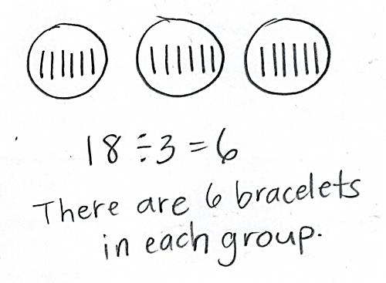
Application Problem (7 minutes)
Stacey has 18 bracelets. After she organizes the bracelets by color, she has 3 equal groups. How many bracelets are in each group?
Note: This problem reviews the meaning of the unknown as the size of the group in division from Lesson 4. It also provides a comparison to Cynthia’s party problem in Problem 1 of the Concept Development where the unknown represents the number of groups in division.

Concept Development (35 minutes)
Materials: (S) Personal white board, 18 counters, student work from Application Problem
Problem 1: Division as fair share with the unknown as the number of groups.
T: Next weekend, my friend Cynthia is having a party. Eighteen people are coming. I told her I’d help her set up tables. We know that 6 people can sit at each table, but we’re not sure how many tables we’ll need. Turn and talk with your partner. What information do Cynthia and I already have?
S: You know the total number of people. It’s 18. Yeah, and you know how many people are sitting together, 6. That’s the size of the group.
T: What information don’t we know?
S: You don’t know how many tables. Tables are like groups. You don’t know the number of groups.
T: Let’s use counters to show the problem and check our thinking. Each of you has 18 counters, 1 for each person coming to the party. Put them into groups of 6.
S: (Make groups of 6.)
MP.2
T: Do you still agree we know the total and the size of each group?
S: Yes!
T: Looking at our models, what else do we now know?
S: We know there are 3 groups. So, that means Cynthia needs 3 tables to fit everyone.
T: (Write 18 ÷ 6 = 3 on the board.) How does this number sentence relate to the problem we just solved?
S: It shows that we divided. We knew the total, 18 people. We divided them into groups with 6 people. Then, we figured out that meant 3 groups of people. We divided the total by the size of the group and found the number of groups.
T: Look back at your work from today’s Application Problem. With your partner, compare the steps you took to solve both the bracelet problem and the party problem. Notice the number sentences too.
S: For the bracelets, I drew circles to show 3 groups first. Then, I shared the bracelets between the groups. In the party problem, we put the people in groups of 6 first. Then, we found how many groups. The 6 and 3 switched places. That’s because in the bracelet problem we had to find the size of the groups, but in the party problem we had to find the number of groups.
T: I’m hearing you notice that the unknown was different in each problem. We divide when we want to find the size of the groups or the number of groups.
14
7
7
Sample number bond
Repeat the process using 14 ÷ 7 = ____ without a story context.
Focus on 7 being the size of the groups. Match the problem to a number bond like the one shown to the right.

Problem 2: Relate finding the number of groups to counting by the divisor.
T: Cynthia plans to buy 15 burgers. Three burgers come in each pack. How many packs should she buy? Whisper to your partner what the numbers 15 and 3 represent in this problem.
S: Fifteen is the total number of burgers. Three is the number of burgers in a pack.
T: Is the unknown the number of groups or the size of the group?
S: The number of groups.
T: On your personal white board, write the equation you would use to find how many packs to buy.
S: (Write 15 ÷ 3 = ____.)
T: Let’s draw to find out how many packs Cynthia needs.

NOTES ON
MULTIPLE MEANS
OF ACTION AND EXPRESSION:
It may be tempting to skip the visual in this segment of the lesson, but for many students who are visual learners, it is an easy way to talk about what may be a common confusion. There are not 6 burgers in the second pack, rather there are 6 burgers in 2 packs. Even for advanced students, the visual helps make clear why the count-by works and also makes the connection to addition very evident.

S: (Draw.)
T: How many packs does Cynthia need?
S: 5 packs.
T: 15 ÷ 3 is?
S: 5.
T: Let’s write the total number of burgers under each pack. How many total burgers does Cynthia have in 1 pack?
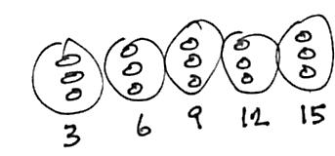

S: 3 burgers.
T: In 2 packs?
S: 6 burgers (repeat the process up to 15).
T: Let’s read our numbers.

NOTES ON
TRACKING A COUNT-BY THE MATH WAY:
Since Kindergarten, students have tracked counts on their fingers the Math Way, that is, by starting with the left pinky and moving across their fingers to the right. This mimics the number line and also facilitates easily recognizing groups of 5. Depending on the class, students may need to be reminded to utilize this familiar strategy as they track the count.

S: 3, 6, 9, 12, 15.
T: Why did we stop at 15?
S: Because Cynthia only needs 15 burgers.
T: What connection can you make between this problem and our fluency (indicate the count-by threes series from earlier)?
S: It’s like counting by threes.
T: Yes. Each time we add a group, we add a three.
T: Count by threes with me, and track the number of threes on your fingers.
S: 3, 6, 9, 12, 15. (Track count using fingers.)
T: How many threes did we count?
S: 5 threes.
T: Skip-counting also shows us that Cynthia needs 5 packs.
Repeat the process with 21 ÷ 3 = ___ and 14 ÷ 2 = ___ without a story context.
T: A count-by can be a quick way to solve division problems when we need to find the number of equal groups, especially if we have a big total like 21!

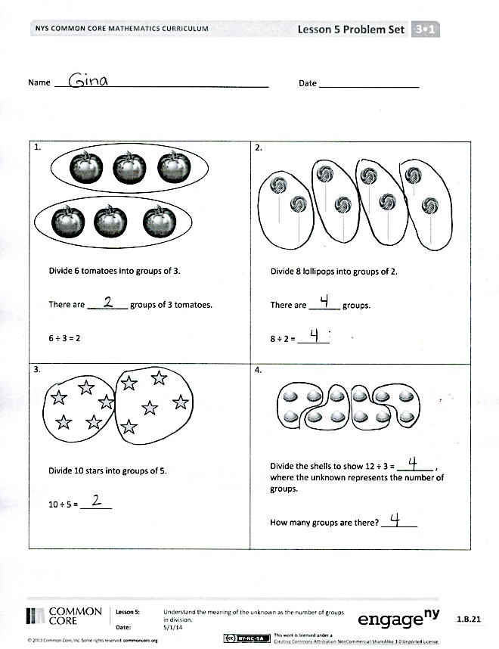
Problem Set (10 minutes)
Students should do their personal best to complete the Problem Set within the allotted 10 minutes. For some classes, it may be appropriate to modify the assignment by specifying which problems they work on first. Some problems do not specify a method for solving. Students should solve these problems using the RDW approach used for Application Problems.

Student Debrief (10 minutes)
Lesson Objective: Understand the meaning of the unknown as the number of groups in division.
The Student Debrief is intended to invite reflection and active processing of the total lesson experience.
Invite students to review their solutions for the Problem Set. They should check work by comparing answers with a partner before going over answers as a class.
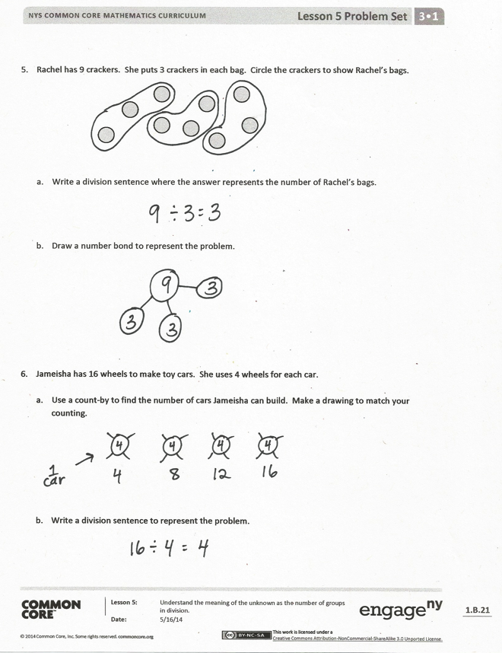
Look for misconceptions or misunderstandings that can be addressed in the Debrief. Guide students in a conversation to debrief the Problem Set and process the lesson.
You may choose to use any combination of the questions below to lead the discussion.
Review the relationship between multiplication and division. Guide students to observe that division is used to find either factor—the unknown can be the size of groups (learned yesterday) or the number of groups (learned today).
- Practice using the count-by strategy to solve Problem 5 on the Problem Set. How is a number bond different from a drawing representing a count-by?
- In Problem 5, what would the division sentence be if we wanted to know the number of crackers in each bag? Why is it the same division sentence as when we found the number of bags?

Exit Ticket (3 minutes)
After the Student Debrief, instruct students to complete the Exit Ticket. A review of their work will help you assess the students’ understanding of the concepts that were presented in the lesson today and plan more effectively for future lessons. You may read the questions aloud to the students.

Name Date

1.  Divide 6 tomatoes into groups of 3.  There are _________ groups of 3 tomatoes.  6 ÷ 3 = 2 | 2.  Divide 8 lollipops into groups of 2.  There are _______ groups.  8 ÷ 2 = _______
3.  Divide 10 stars into groups of 5.  10 ÷ 5 = _______ | 4.  Divide the shells to show 12 ÷ 3 = ________,  where the unknown represents the number of groups.  How many groups are there? ________

- Rachel has 9 crackers. She puts 3 crackers in each bag. Circle the crackers to show Rachel’s bags.

- Write a division sentence where the answer represents the number of Rachel’s bags.

- Draw a number bond to represent the problem.

- Jameisha has 16 wheels to make toy cars. She uses 4 wheels for each car.

- Use a count-by to find the number of cars Jameisha can build. Make a drawing to match your counting.

- Write a division sentence to represent the problem.

Name Date
- Divide 12 triangles into groups of 6.

12 ÷ 6 = _______

- Spencer buys 20 strawberries to make smoothies. Each smoothie needs 5 strawberries. Use a count-by to find the number of smoothies Spencer can make. Make a drawing to match your counting.

Name Date

1.  Divide 4 triangles into groups of 2.  There are _________ groups of 2 triangles.  4 ÷ 2 = 2 | 2.  Divide 9 eggs into groups of 3.  There are _______ groups.  9 ÷ 3 = _______
3.  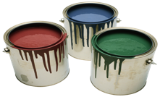  Divide 12 buckets of paint into groups of 3.  12 ÷ 3 = _______ | 4.  Group the squares to show 15 ÷ 5 = _____, where the unknown represents the number of groups.  How many groups are there? ________

- Daniel has 12 apples. He puts 6 apples in each bag. Circle the apples to find the number of bags Daniel makes.

- Write a division sentence where the answer represents the number of Daniel’s bags.

- Draw a number bond to represent the problem.

- Jacob draws cats. He draws 4 legs on each cat for a total of 24 legs.

- Use a count-by to find the number of cats Jacob draws. Make a drawing to match your counting.

- Write a division sentence to represent the problem.

