Lesson 4
Objective: Understand the meaning of the unknown as the size of the group in division.

Suggested Lesson Structure
 Fluency Practice (14 minutes)
 Application Problem (6 minutes)
 Concept Development (30 minutes)
 Student Debrief (10 minutes)
Total Time (60 minutes)

Fluency Practice (14 minutes)
- Sprint: Repeated Addition as Multiplication 3.OA.1 (9 minutes)
- Group Counting 3.OA.1 (3 minutes)
- Array Multiplication 3.OA.1 (2 minutes)

Sprint: Repeated Addition as Multiplication (9 minutes)

Materials: (S) Repeated Addition as Multiplication Sprint
Note: Students relate repeated addition to multiplication. This reviews Topic A’s objectives. See Lesson 2 for the directions for administering a Sprint.

Group Counting (3 minutes)
Note: Group counting reviews interpreting multiplication as repeated addition. Counting by twos and threes in this activity anticipates work with those factors in this lesson.
T: Let’s count by twos. (Direct students to count forward and backward to 20, periodically changing directions, e.g., 2, 4, 6, 8, 10, 8, 10, 12, 10, 12, 14, 16, 18, 20, 18, 20, 18, 16, 14, 12, 10, 12, 10, 8, 10, 8, 6, 4, 2, 0.)
T: Let’s count by threes. (Direct students to count forward and backward to 24, periodically changing directions. Emphasize the 9 to 12 and 18 to 21 transitions, e.g., 3, 6, 9, 12, 9, 12, 9, 12, 15, 18, 21, 18, 21, 18, 21, 24, 21, 18, 21, 18, 15, 12, 15, 12, 9, 12, 9, 6, 3, 0.)

Array Multiplication (2 minutes)
Materials: (S) Personal white board
Note: This activity reviews Topic A’s objectives. Students directly relate repeated addition to multiplication, interpreting products using the array.
T: (Project a picture with 3 groups of 2 circled.) Say the repeated addition equation.
S: 2 + 2 + 2 = 6.
T: (Write 3 × ____ = ____.) On your personal white boards, complete the multiplication equation.
S: (Write 3 × 2 = 6.)
Continue with the following possible sequence: 4 groups of 10, 3 groups of 4, 7 groups of 3, and 8 groups of 2.

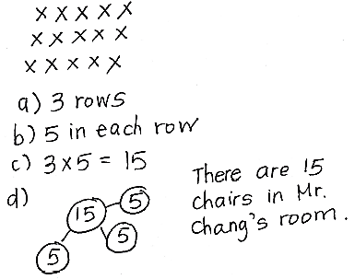
Application Problem (6 minutes)
The student council holds a meeting in Mr. Chang’s classroom. They arrange the chairs in 3 rows of 5. How many chairs are used in all? Use the RDW process.
Note: This problem reviews relating multiplication to the array model from Lesson 2. Students might choose to solve by drawing an array (Lesson 2) or a number bond (Lesson 3) where each part represents the amount of chairs in each row.

Concept Development (30 minutes)

Materials: (S) Personal white board, 18 counters
Concrete to abstract: Division as fair share, relate the answer to the unknown factor.

NOTES ON
Multiple Means
of ACTION AND EXPRESSION:
This may be students’ first time independently dividing in a formal context. Life experience has likely taught them the fair-share strategy of going back and forth to give 1 and 1, 2 and 2, 3 and 3, etc., until there are no more to distribute. Encourage those who are unsure what to do, or who are using a less efficient strategy, toward fair share.

T: Yesterday, Mr. Ziegler bought a new pack of 18 markers. He shared them with me by dividing them into 2 equal groups. Now, I have a bunch of new markers for making our charts! Do you want to know how many he gave me?
MP.2
S: Yes.
T: What are we trying to find, the number of groups or the size of the group?
S: The size of the group.
T: Your 18 counters represent the markers. Divide your 18 counters into 2 equal groups by giving one to Mr. Z, one to me, one to Mr. Z, one to me. (Model partitioning.)
S: (Divide using the fair-share strategy.)
T: Using a complete sentence, tell how many counters are in each group.
S: There are 9 counters in each group.
T: Then, how many markers did Mr. Ziegler give me?
S: 9 markers!
T: Let’s write a number sentence to show our work, starting from the beginning. What is our total number of counters?
MP.2
S: 18 counters.
T: (Write 18 on the board.) We divided our 18 counters into how many equal groups?
S: We divided into 2 equal groups.
T: (Write ÷ 2 = ____ on the board next to the 18.)
T: If 18 is our total and 2 represents our equal groups, then remind me, what does our unknown factor represent? (Point to where the answer will go.)
S: The size of the groups.
T: That is?
S: 9.
T: 18 divided by 2 equals 9. (Finish writing as you read 18 ÷ 2 = 9.)
T: This number sentence shows how Mr. Ziegler gave me…
S: 9 markers!
Repeat the process with 15 ÷ 3 = ___: Suppose Mr. Ziegler had 15 markers and shared fairly with 3 teachers. This time, also review that ÷ means to divide.
T: In what ways does dividing remind you of our work with multiplication?
S: It’s also about the size of groups and the number of groups, but we used a different symbol. It still uses factors and a total. This time the total is not the answer. It’s the beginning! So, the answer has to do with groups, not the total.
T: Right. We multiply when we want to find the total. Here, we divided when we knew the total and wanted to find the size of the groups.
Pictorial to abstract: Analyze a picture to write a division sentence in which the solution tells the size of the group.
T: (Project or draw the following image.) This is how Diana arranges her star stickers.

T: What does 12 represent in the picture?
S: The total number of Diana’s star stickers.
T: What does 3 represent?
S: The number of equal groups.
T: What does 4 represent?
S: The size of each group.
T: Write a number sentence to represent Diana’s stickers where the answer represents the size of the group.
S: (Write 12 ÷ 3 = 4.)
T: (Write 12 ÷ 3 = 4 and 12 ÷ 4 = 3 on the board, even if students have written the correct number sentence.) What is the difference between these division sentences?
S: In the first one, the answer represents the size of each group. In the second one, the answer represents the number of groups.
T: If we’re writing a division sentence where the answer represents the size of the group, then which number sentence should we use?
S: 12 ÷ 3 = 4.
Abstract to pictorial: Analyze equations for the meaning of the solution and represent the equation with a drawing.
Write 8 ÷ 4 = ___.
T: If 8 is the total and 4 is the number of groups, then what does the unknown factor represent?
S: The size of the groups!
T: Draw a picture on your personal white board to go with my division equation. Use your picture to help you find the unknown factor, then write the complete equation.
S: (Draw various pictures that show 8 ÷ 4, then write 8 ÷ 4 = 2.)
Repeat the process with 10 ÷ 2. As you design examples, keep in mind that Lesson 5 introduces students to division where the unknown factor represents the number of groups.

Problem Set (10 minutes)
Students should do their personal best to complete the Problem Set within the allotted 10 minutes. For some classes, it may be appropriate to modify the assignment by specifying which problems they work on first. Some problems do not specify a method for solving. Students should solve these problems using the RDW approach used for Application Problems.

Student Debrief (10 minutes)
Lesson Objective: Understand the meaning of the unknown as the size of the group in division.
The Student Debrief is intended to invite reflection and active processing of the total lesson experience. Invite students to review their solutions for the Problem Set. They should check work by comparing answers with a partner before going over answers as a class. Look for misconceptions or misunderstandings that can be addressed in the Debrief. Guide students in a conversation to debrief the Problem Set and process the lesson.

You may choose to use any combination of the questions below to lead the discussion.
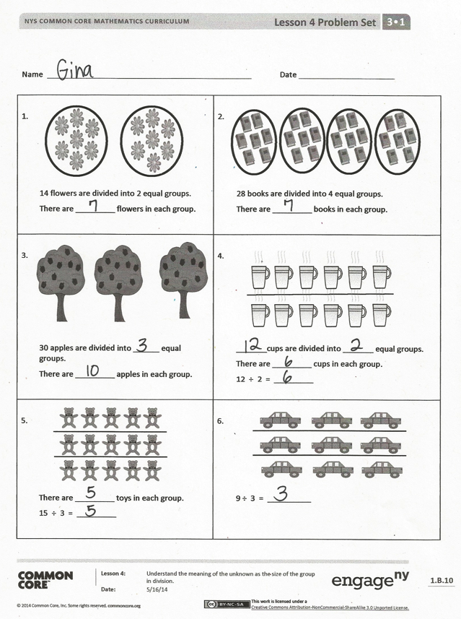
- Ask students to share their division sentences for Problem 9. Because of the way the question is worded, answers will likely include 15 ÷ 5 = 3 (answer is the size of the group) and 15 ÷ 3 = 5 (answer is the number of groups). This presents an opportunity to begin a discussion in which students compare the division sentences by analyzing the meaning of the factors.
- Guide students to articulate the similarities and differences between multiplication and division so that they are clear that division is used to find the total number of groups or objects in a group. Students can think of division problems as having a known factor and an unknown factor.
- Review phrases that include new vocabulary such as unknown factor and divided by.
Exit Ticket (3 minutes)
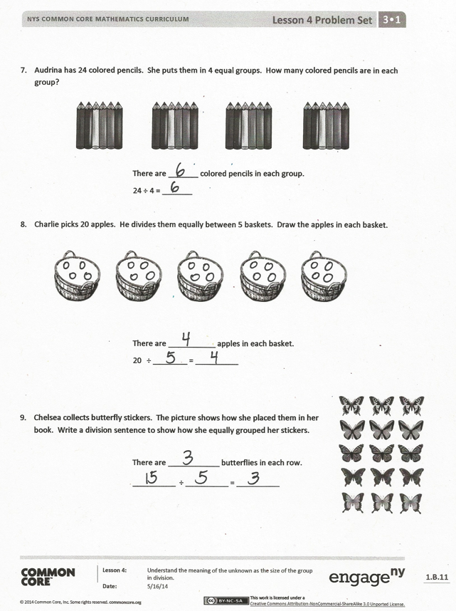
After the Student Debrief, instruct students to complete the Exit Ticket. A review of their work will help you assess the students’ understanding of the concepts that were presented in the lesson today and plan more effectively for future lessons. You may read the questions aloud to the students.

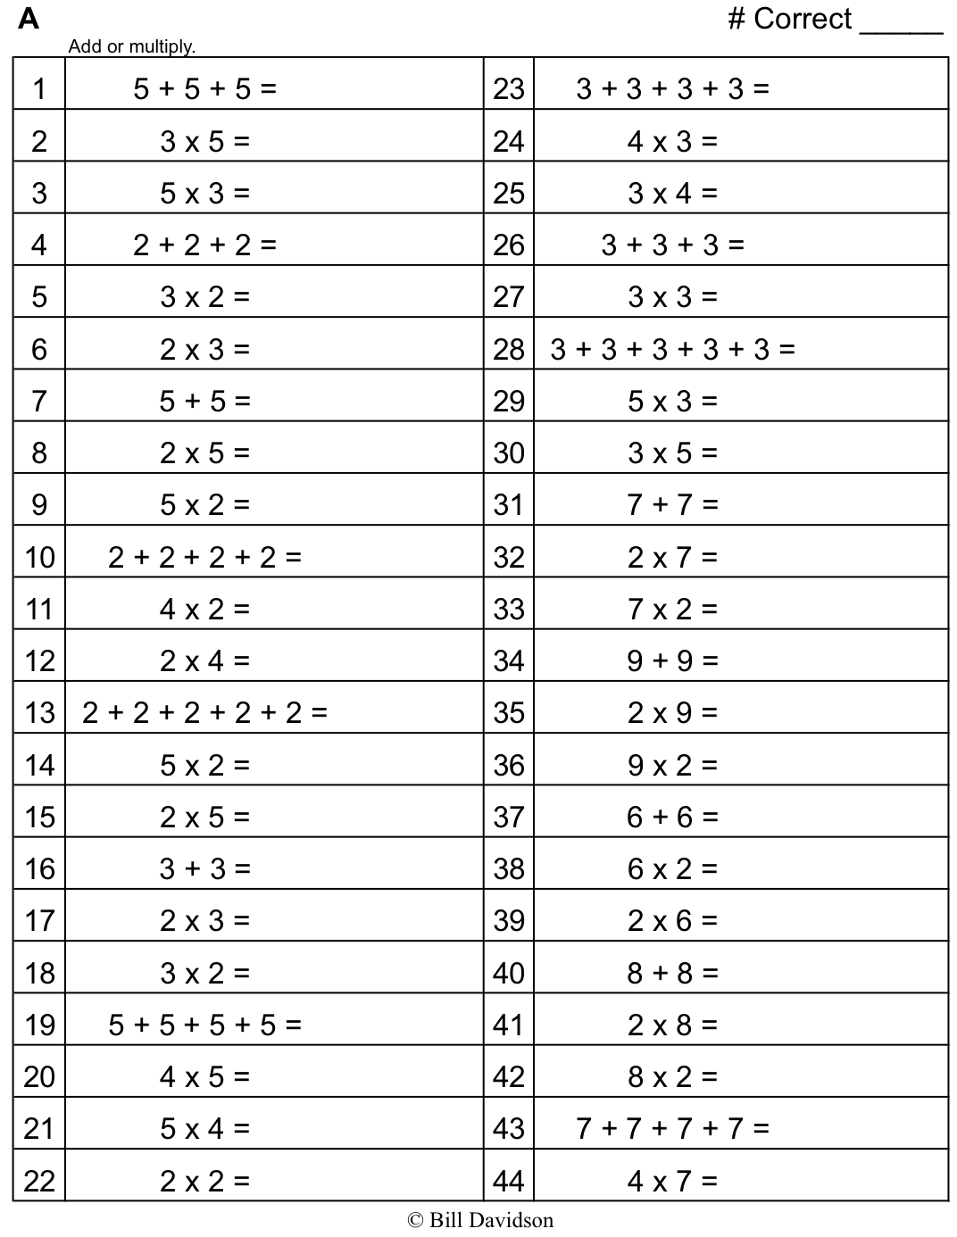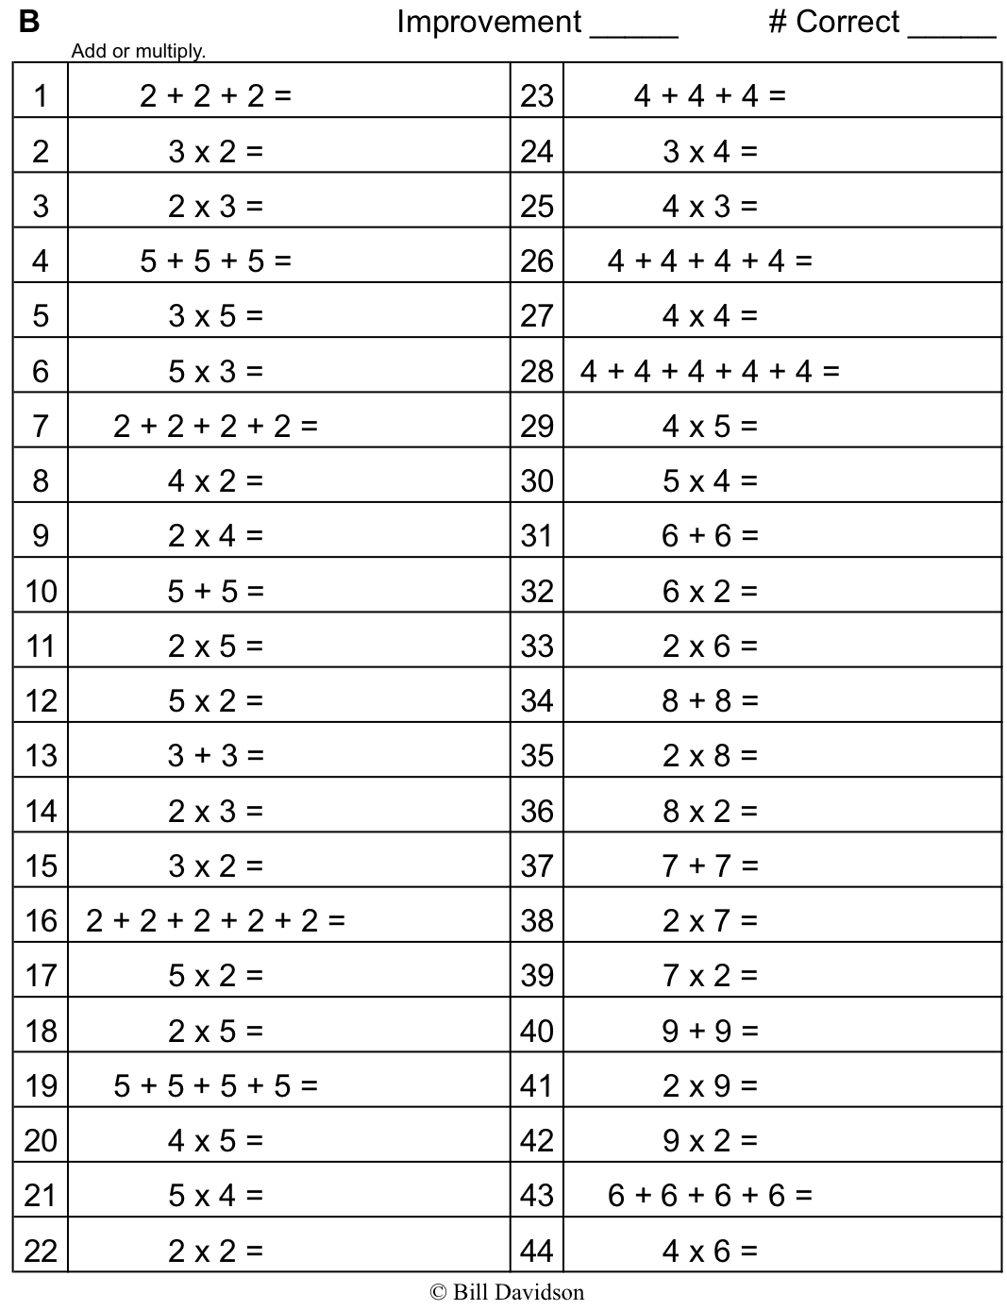

Name Date

1.  14 flowers are divided into 2 equal groups.  There are _________ flowers in each group. | 2.  28 books are divided into 4 equal groups.  There are _________ books in each group.
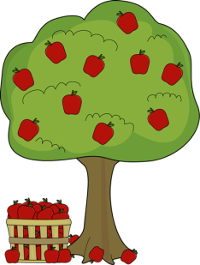  3.  30 apples are divided into ______ equal groups.  There are _________ apples in each group. | 4.  _______ cups are divided into _______ equal groups.  There are _________ cups in each group.  12 ÷ 2 = _________
5.  There are _________ toys in each group.  15 ÷ 3 = _________ | 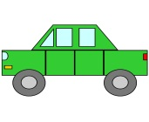  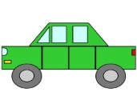  6.  9 ÷ 3 = __________

- Audrina has 24 colored pencils. She puts them in 4 equal groups. How many colored pencils are in each group?

There are _______ colored pencils in each group.
24 ÷ 4 = _______

- Charlie picks 20 apples. He divides them equally between 5 baskets. Draw the apples in each basket.

There are ___________ apples in each basket.
- ÷ ________ = __________

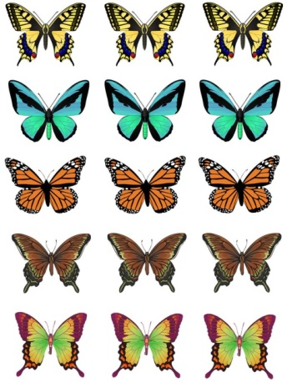
- Chelsea collects butterfly stickers. The picture shows how she placed them in her book. Write a division sentence to show how she equally grouped her stickers.
There are ____________ butterflies in each row.
__________ ÷ __________ = __________

Name Date
- There are 16 glue sticks for the class. The teacher divides them into 4 equal groups. Draw the number of glue sticks in each group.

There are ___________ glue sticks in each group.
- ÷ ________ = __________

- Draw a picture to show 15 ÷ 3. Then, fill in the blank to make a true division sentence.

15 ÷ 3 = __________

Name Date

1.  12 chairs are divided into 2 equal groups.  There are _________ chairs in each group. | 21 triangles are divided into 3 equal groups.  There are _________ triangles in each group.
3.  25 erasers are divided into ______ equal groups.  There are _________ erasers in each group. | 4.  _______ chickens are divided into _______ equal groups.  There are _________ chickens in each group.  9 ÷ 3 = __________
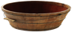  5.  There are _________ buckets in each group.  12 ÷ 4 = __________ | 6.  16 ÷ 4 = __________

- Andrew has 21 keys. He puts them in 3 equal groups. How many keys are in each group?

There are _______ keys in each group.

21 ÷ 3 = __________

- Mr. Doyle has 20 pencils. He divides them equally between 4 tables. Draw the pencils on each table.

There are ___________ pencils on each table.

20 ÷ ________ = __________

- Jenna has markers. The picture shows how she placed them on her desk. Write a division sentence to represent how she equally grouped her markers.
There are ____________ markers in each row.

__________ ÷ __________ = __________

