Lesson 3

Objective: Interpret the meaning of factors­—the size of the group or the number of groups.

Suggested Lesson Structure

 Fluency Practice (15 minutes)

 Application Problem (5 minutes)

 Concept Development (30 minutes)

 Student Debrief (10 minutes)

**Total Time (60 minutes)**

Fluency Practice (15 minutes)

* Sprint: Add Equal Groups **3.OA.1** (9 minutes)
* Group Counting **3.OA.1** (3 minutes)
* Add to Multiply **3.OA.1** (3 minutes)

Sprint: Add Equal Groups (9 minutes)

Materials: (S) Add Equal Groups Sprint

Note: This Sprint reviews Lesson 1. See Lesson 2 for the directions for administering a Sprint.

Group Counting (3 minutes)

Note: Basic skip-counting skills from Grade 2 shift focus in this Grade 3 activity. Group counting reviews interpreting multiplication as repeated addition. Counting by twos and threes in this activity anticipates work with those factors in Topic B.

T: Let’s count by twos. (Direct students to count forward and backward to 20, periodically changing directions.)

T: Let’s count by threes. (Direct students to count forward and backward to 21, periodically changing directions. Emphasize the 9 to 12 and 18 to 21 transitions.)

Add to Multiply (3 minutes)

Materials: (S) Personal white board

Note: This activity reviews Lesson 2. Students directly relate repeated addition to multiplication. They interpret products using the array.

T: (Project a picture with 3 groups of 5 circled.) How many groups are circled?

S: 3.

T: How many are in each group?

S: 5.

T: Write it as an addition sentence.

S: (Write 5 + 5 + 5 = 15.)

T: Write a multiplication sentence representing *3 fives equals 15*.

S: 3 × 5 = 15.

Continue with possible sequence: 3 groups of 10, 3 groups of 4, and 7 groups of 2.

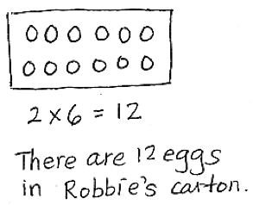Application Problem (5 minutes)

Robbie sees that a carton of eggs shows an array with 2 rows of 6 eggs. What is the total number of eggs in the carton? Use the RDW process to show your solution.

Note: This problem reviews writing multiplication sentences from arrays learned in Lesson 2. The egg carton provides a natural array for students to see 2 rows of 6.

Concept Development (30 minutes)

|  |  |
| --- | --- |
|  | NOTES ON  OPENING ACTIVITY: |
| Adjust the directions for the opening activity depending on the total number of students in your class. Avoid having students make four groups. Instead of using corners in the classroom, use an adult, teddy bear, etc., for students to stand near when forming equal groups. | |

Materials: (S) Personal white board

The following opening activity should take about 5 minutes.

T: Here are the rules for our opening activity.

1. **Divide** yourselves into 4 equal groups.
2. Each group will stand in a corner of the room.
3. Divide silently. You can use body movements to gesture, but no words.

T: Show thumbs up when your group is ready. Be sure to look around the room to double check that all 4 groups are equal before showing you’re ready.

S: (Move around the room silently until there are 4 equal groups, 1 in each corner.)

T: At the signal tell how many equal groups we’ve made. (Signal.)

|  |  |
| --- | --- |
|  | NOTES ON  NUMBER BONDS: |
| The number bond is a pictorial representation of part–part–whole relationships and shows that within a part–whole relationship, smaller numbers (the parts) make up larger numbers (the whole). (Excerpted from “How to Implement *A Story of Units*.*”*) | |

S: 4 equal groups.

T: (Write 4 × ___ = ­­­___.) At the signal tell the size of each group. (Signal.)

S: (Respond depending on class numbers.)

T: (Fill in the equation on the board.) These numbers—the number of groups and the number in each group—are called **factors**.

Students transition back to their seats.

T: Use the multiplication equation on the board to draw an array. Make sure that your board is vertical.

*Sample number bond (class of 24):*

24

6

6

6

6

S: (Draw a 4 × ____ array.)

T: Let’s draw a number bond for our equation. Draw a circle with our class total.

S: (Draw.)

T: Draw partscoming from the total. Make 1 part to represent each row in our array.

S: (Draw 4 circles coming from the total.)

T: Show the size of 1 row with your fingers.

S: (Show fingers.)

|  |  |
| --- | --- |
|  | NOTES ON  MULTIPLE MEANS  OF ACTION AND EXPRESSION: |
| The number bond is another way for students to explore the relationship between factors in multiplication. Suggested explorations and questions:   * Let's count the groups to make sure the number bond matches our number sentence. (1 six, 2 sixes, etc.) * What is the number of groups? * What is the size of each group? * What multiplication sentence represents the number bond? | |

Another option is to have students compare how the number bond can represent multiplication and addition to distinguish the importance of equal groups in multiplication.

T: Write the factor representing the size of the group inside the circles.

S: (Write 6 inside each circle.)

T: Look back at the equation. How is the factor 4 represented in the number bond?

S: It’s in the number of parts. 🡪 Groups are like parts. 🡪 In the number bond the part circles actually represent equal groups, so there are 4. The number inside is the size of the group.

T: Here is an analysis of our equation.

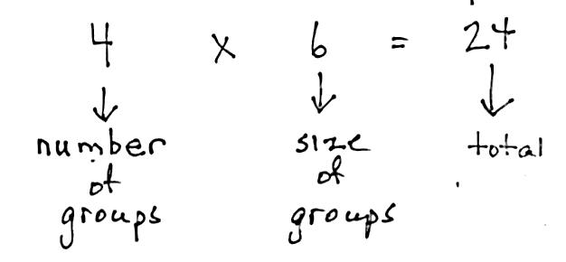

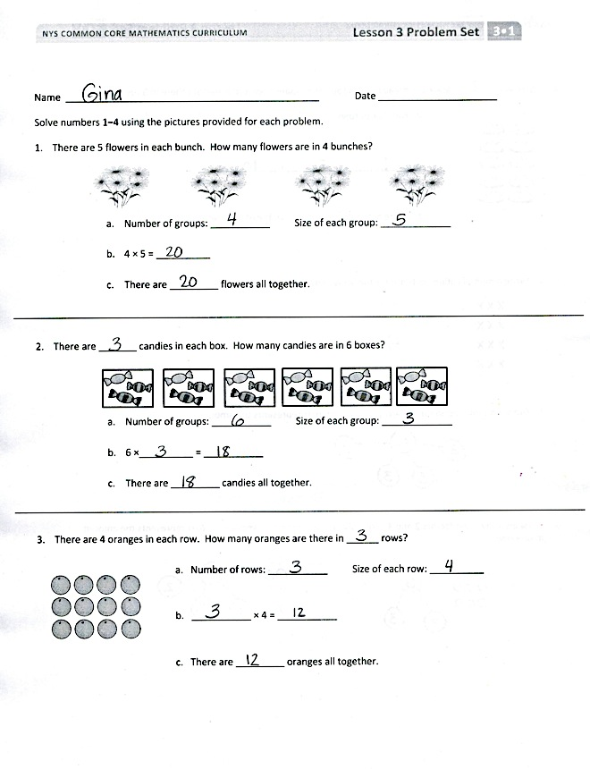As time allows, continue with the following possible suggestions:

* 2 groups of 8
* 3 rows of 5
* Number bond showing 6 groups of 3
* The equation 5 × 4 = 20

Problem Set (10 minutes)

Students should do their personal best to complete the Problem Set within the allotted 10 minutes. For some classes, it may be appropriate to modify the assignment by specifying which problems they work on first. Some problems do not specify a method for solving. Students should solve these problems using the RDW approach used for Application Problems.

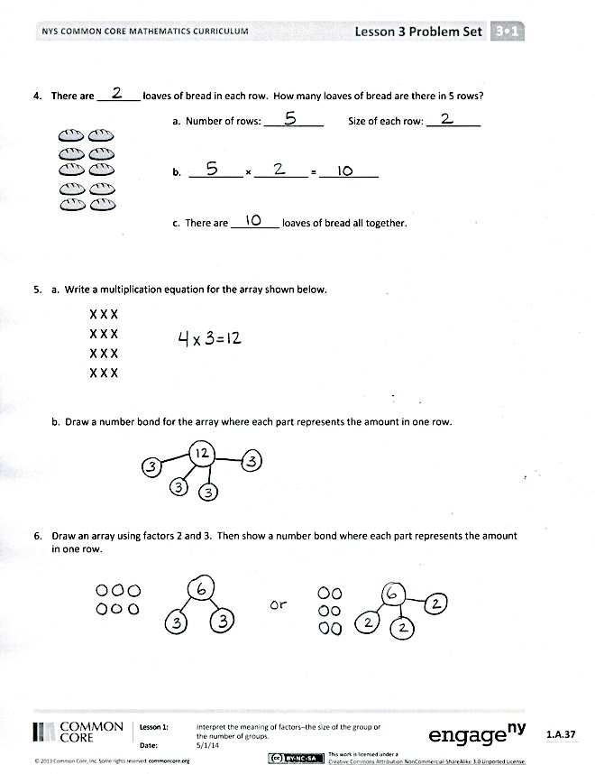Student Debrief (10 minutes)

Lesson Objective: Interpret the meaning of factors—the size of the group or the number of groups.

The Student Debrief is intended to invite reflection and active processing of the total lesson experience. Invite students to review their solutions for the Problem Set. They should check work by comparing answers with a partner before going over answers as a class. Look for misconceptions or misunderstandings that can be addressed in the Debrief. Guide students in a conversation to debrief the Problem Set and process the lesson.

You may choose to use any combination of the questions below to lead the discussion.

* Why do you think I started the lesson by asking you to **divide** yourselves into equal groups in the corners of the room?
* Identify the **factors** and their meanings from each image in Problems 1–5.
* In Problem 6, discuss the two ways to draw the array and number bond with factors 2 and 3.
* Module 1 introduces many new vocabulary words: r*ow, array, multiply, multiplication, number of groups, size of groups, divide, factor,* etc. Consider having students make a vocabulary page in their math journals.
* Relate factors to their meaning: the size of the group or the number of groups. Have students share the definition in pairs. Then, ask students to write the word and a definition or example next to it in their journals.

Exit Ticket (3 minutes)

After the Student Debrief, instruct students to complete the Exit Ticket. A review of their work will help you assess the students’ understanding of the concepts that were presented in the lesson today and plan more effectively for future lessons. You may read the questions aloud to the students.

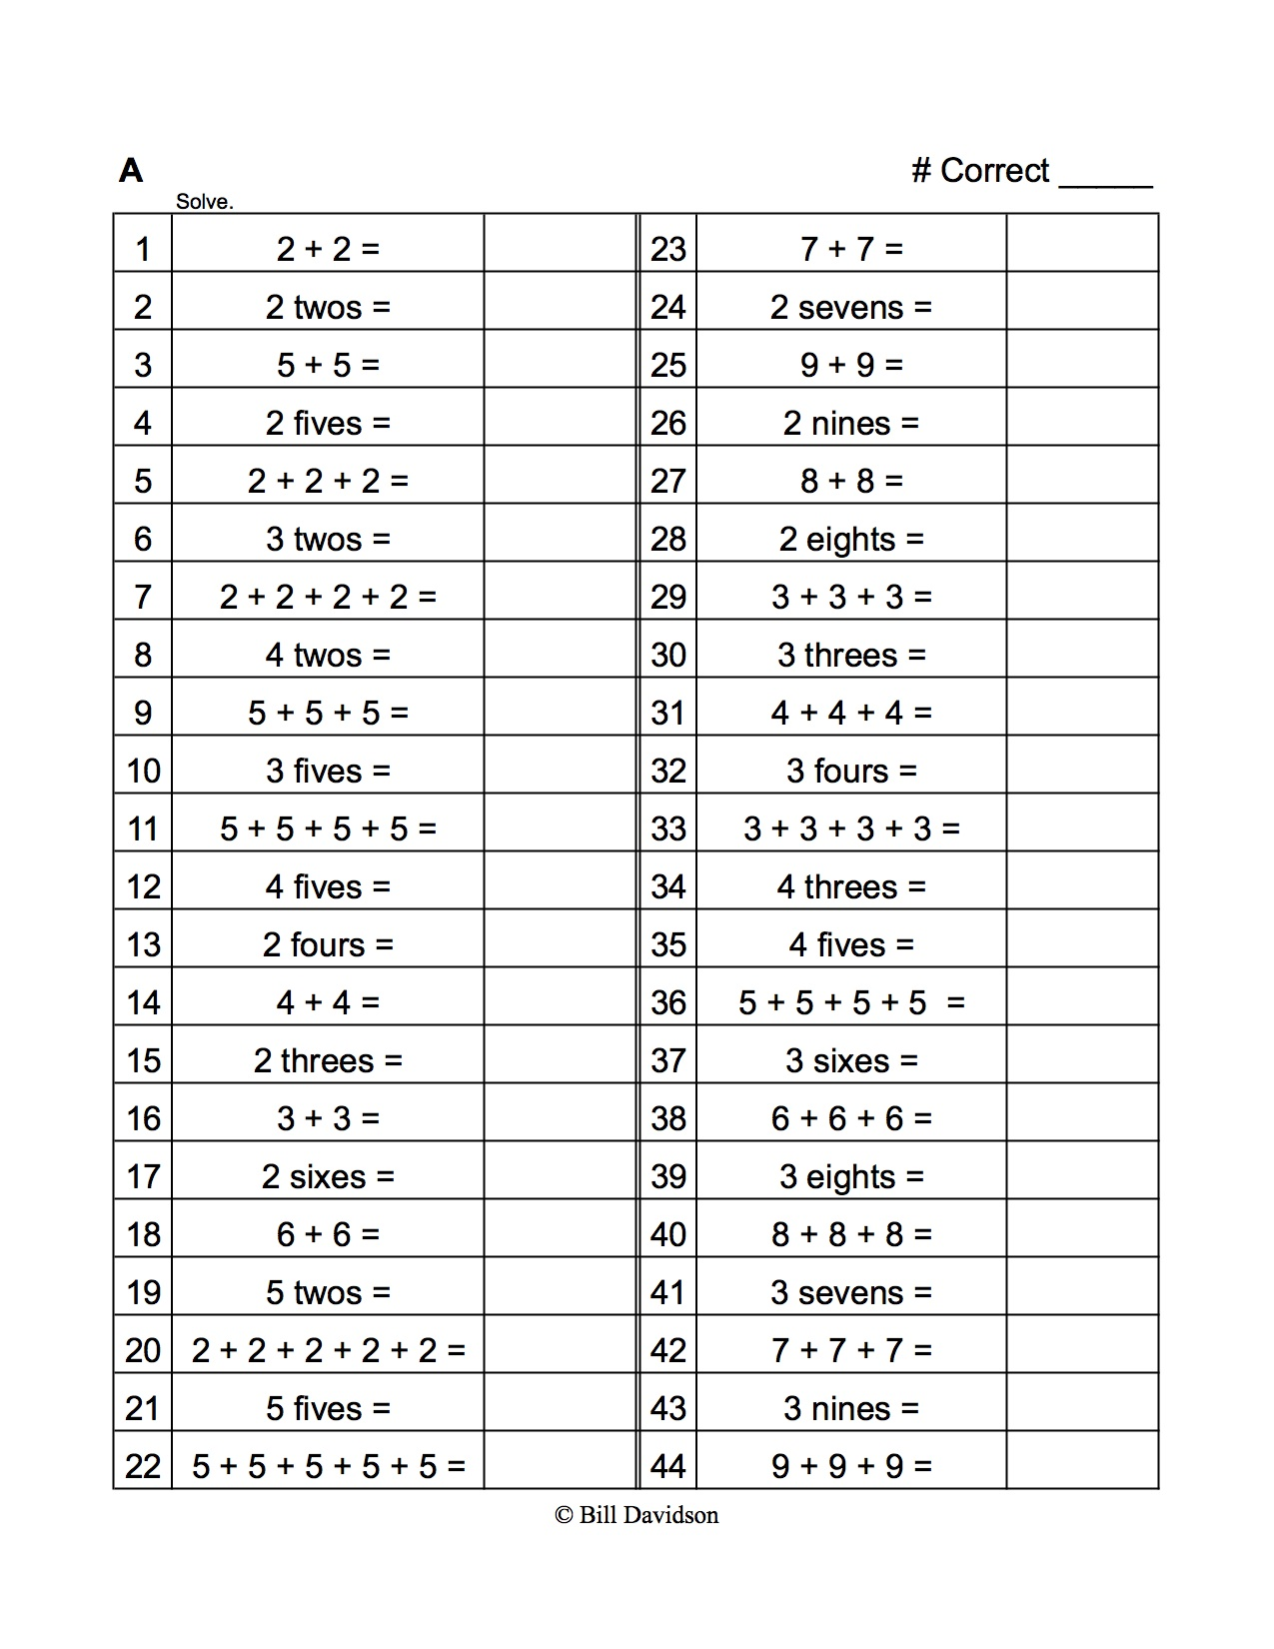 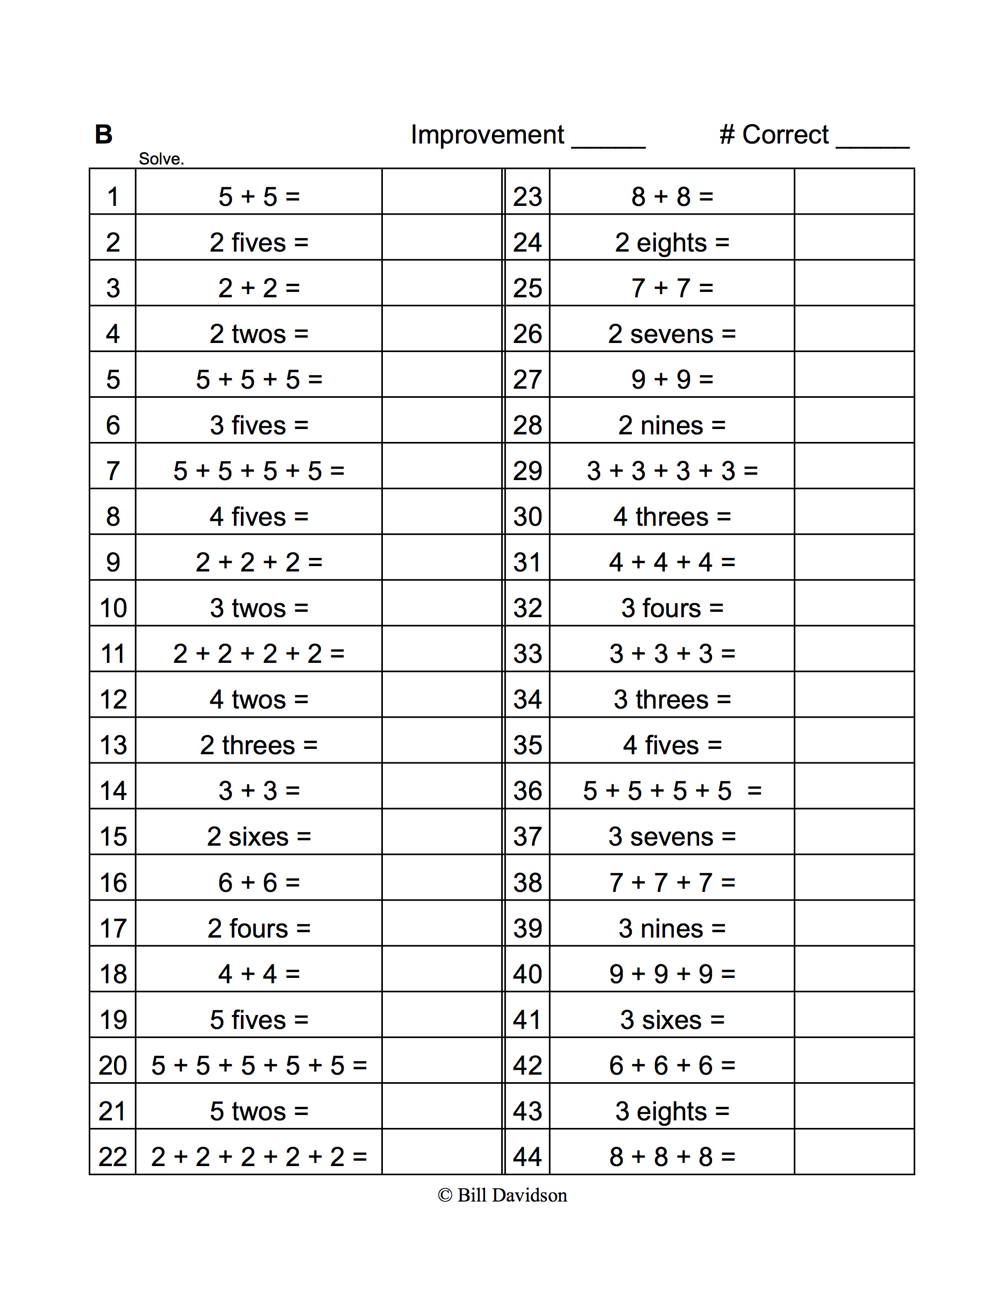

Name Date

Solve Problems 1–4 using the pictures provided for each problem.

1. There are 5 flowers in each bunch. How many flowers are in 4 bunches?

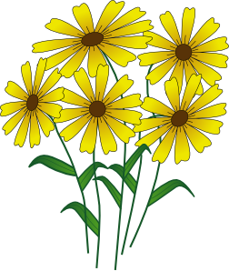

1. Number of groups: ___________ Size of each group: _____________
2. 4 × 5 = __________
3. There are _________ flowers all together.
4. There are _______ candies in each box. How many candies are in 6 boxes?

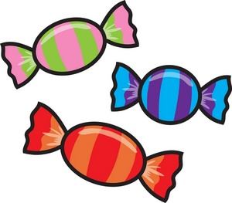

1. Number of groups: ___________ Size of each group: _____________

**size**

**number**

1. 6 × __________ = ___________
2. There are _________ candies all together.
3. There are 4 oranges in each row. How many oranges are there in ______ rows?

a. Number of rows: ___________ Size of each row: __________

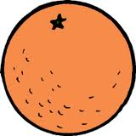

b. ___________ × 4 = ___________

c. There are _________ oranges all together.

1. There are ________ loaves of bread in each row. How many loaves of bread are there in 5 rows?

a. Number of rows: ___________ Size of each row: __________



b. __________ × __________ = ___________

c. There are _________ loaves of bread altogether.

1. a. Write a multiplication equation for the array shown below.

X X X

X X X

X X X

X X X

1. Draw a number bond for the array where each part represents the amount in one row.
2. Draw an array using factors 2 and 3. Then, show a number bond where each part represents the amount in one row.

Name Date

Draw an array that shows 5 rows of 3 squares. Then, show a number bond where each part represents the amount in one row.

Name Date

Solve Problems 1–4 using the pictures provided for each problem.

1. 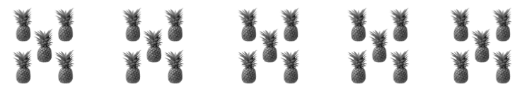There are 5 pineapples in each group. How many pineapples are there in 5 groups?
2. Number of groups: _____________ Size of each group: ____________
3. 5 × 5 = ____________
4. There are __________ pineapples all together.
5. There are _______ apples in each basket. How many apples are there in 6 baskets?



1. Number of groups: _____________ Size of each group: ____________
2. 6 × __________ = ____________
3. There are __________ apples all together.
4. There are 4 bananas in each row. How many bananas are there in ________ rows?



1. Number of rows: ___________ Size of each row: __________

1. _________ × 4 = __________

1. There are __________ bananas all together.
2. There are ___________ peppers in each row. How many peppers are there in 6 rows?

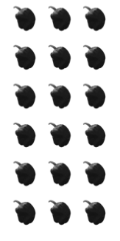

1. Number of rows: ___________ Size of each row: __________

1. _________ × __________ = __________

1. There are __________ peppers all together.
2. Draw an array using factors 4 and 2. Then, show a number bond where each part represents the amount in one row.