Lesson 4

Objective: Identify, define, and draw parallel lines.

Suggested Lesson Structure

 Fluency Practice (12 minutes)

 Application Problem (6 minutes)

 Concept Development (32 minutes)

 Student Debrief (10 minutes)

**Total Time (60 minutes)**

Fluency Practice (12 minutes)

* Divide Mentally **4.NBT.6**  (4 minutes)
* Identify Two-Dimensional Figures **4.G.1** (4 minutes)
* Physiometry **4.G.1**  (4 minutes)

Divide Mentally (4 minutes)

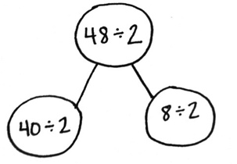Note: This activity reviews G4–M3 content.

T: (Write 40 ÷ 2.) Say the completed division sentence in unit form.

S: 4 tens ÷ 2 = 2 tens.

T: (To the right, write 8 ÷ 2.) Say the completed division sentence in unit form.

S: 8 ones ÷ 2 = 4 ones.

T: (Above both number sentences, write 48 ÷ 2. Draw a number bond to connect the 2 original problems to this problem.) Say the completed division sentence in unit form.

S: 4 tens 8 ones ÷ 2 = 2 tens 4 ones.

T: Say the division sentence in standard form.

S: 48 ÷ 2 = 24.

Continue with the following possible sequence: 48 ÷ 3, 96 ÷ 3, and 96 ÷ 4.

Identify Two-Dimensional Figures (4 minutes)

Materials: (S) Personal white board, straightedge

Note: This fluency activity reviews terms learned in Lessons 1─3.

T: (Project . Trace .) Name the figure.

S: .

T: (Point to point .) Say the term.

S: Point .

T: (Point to point .) Say the term.

S: Point .

T: Use your straightedge to draw on your personal white boards.

S: (Draw a ray with endpoints and on the ray.)



Continue with the following possible sequence: , , and acute , obtuse , and right .

T: What’s the relationship between and ?

S: The line segments are perpendicular.

T: Draw that is perpendicular to .

S: (Draw a line segment with endpoints and . Draw a line with endpoints and that is perpendicular to .)

Physiometry (4 minutes)

Note: Kinesthetic memory is strong memory. This fluency activity reviews terms from Lessons 1─3.

T: Stand up.

S: (Stand up.)

T: Model a ray.

S: (Extend arms straight so that they are parallel with the floor. Clench one hand in a fist, and leave the other hand open, pointing to a side wall.)

T: Model a ray pointing in the other direction.

S: (Open clenched hand, and clench open hand. Point with open hand.)

T: Model a line.

S: (Extend arms straight so that they are parallel with the floor. Open both hands, and point at the side walls.)

T: Model a point.

S: (Clench one hand in a fist, and extend arm forward.)

T: Model a line segment.

S: (Extend arms straight so that they are parallel with the floor. Clench both hands into fists.)

T: Model a right angle.

S: (Stretch one arm up, directly at the ceiling. Stretch another arm directly toward a wall, parallel to the floor.)

T: Model a different right angle.

S: (Stretch the arm pointing toward a wall directly up toward the ceiling. Move the arm pointing toward the ceiling so that it points directly toward the opposite wall.)

T: Model an acute angle.

S: (Model an acute angle with arms.)

T: Model an obtuse angle.

S: (Model an obtuse angle with arms.)

Next, move between figures with the following possible sequence: right angle, point, line, obtuse angle, line segment, acute angle, and right angle.

T: (Stretch one arm up, pointing directly at the ceiling. Stretch another arm directly pointing toward a wall, parallel to the floor.) Which type of angle do you think I’m modeling?

S: Right angle.

T: What is the relationship of the lines formed by right angles?

S: Perpendicular lines.

T: (Point at a wall to the side of the room.) Point at the walls that run perpendicular to the wall I’m pointing to.

S: (Point at the front and back walls.)

T: (Point at the back wall.)

S: (Point at the side walls.)

Continue pointing to the other side wall and front wall.

Application Problem (6 minutes)

R E A L

Observe the letters *R*, *E*, *A*, and *L*.

1. How many lines are perpendicular? Describe them.
2. How many acute angles are there? Describe them.
3. 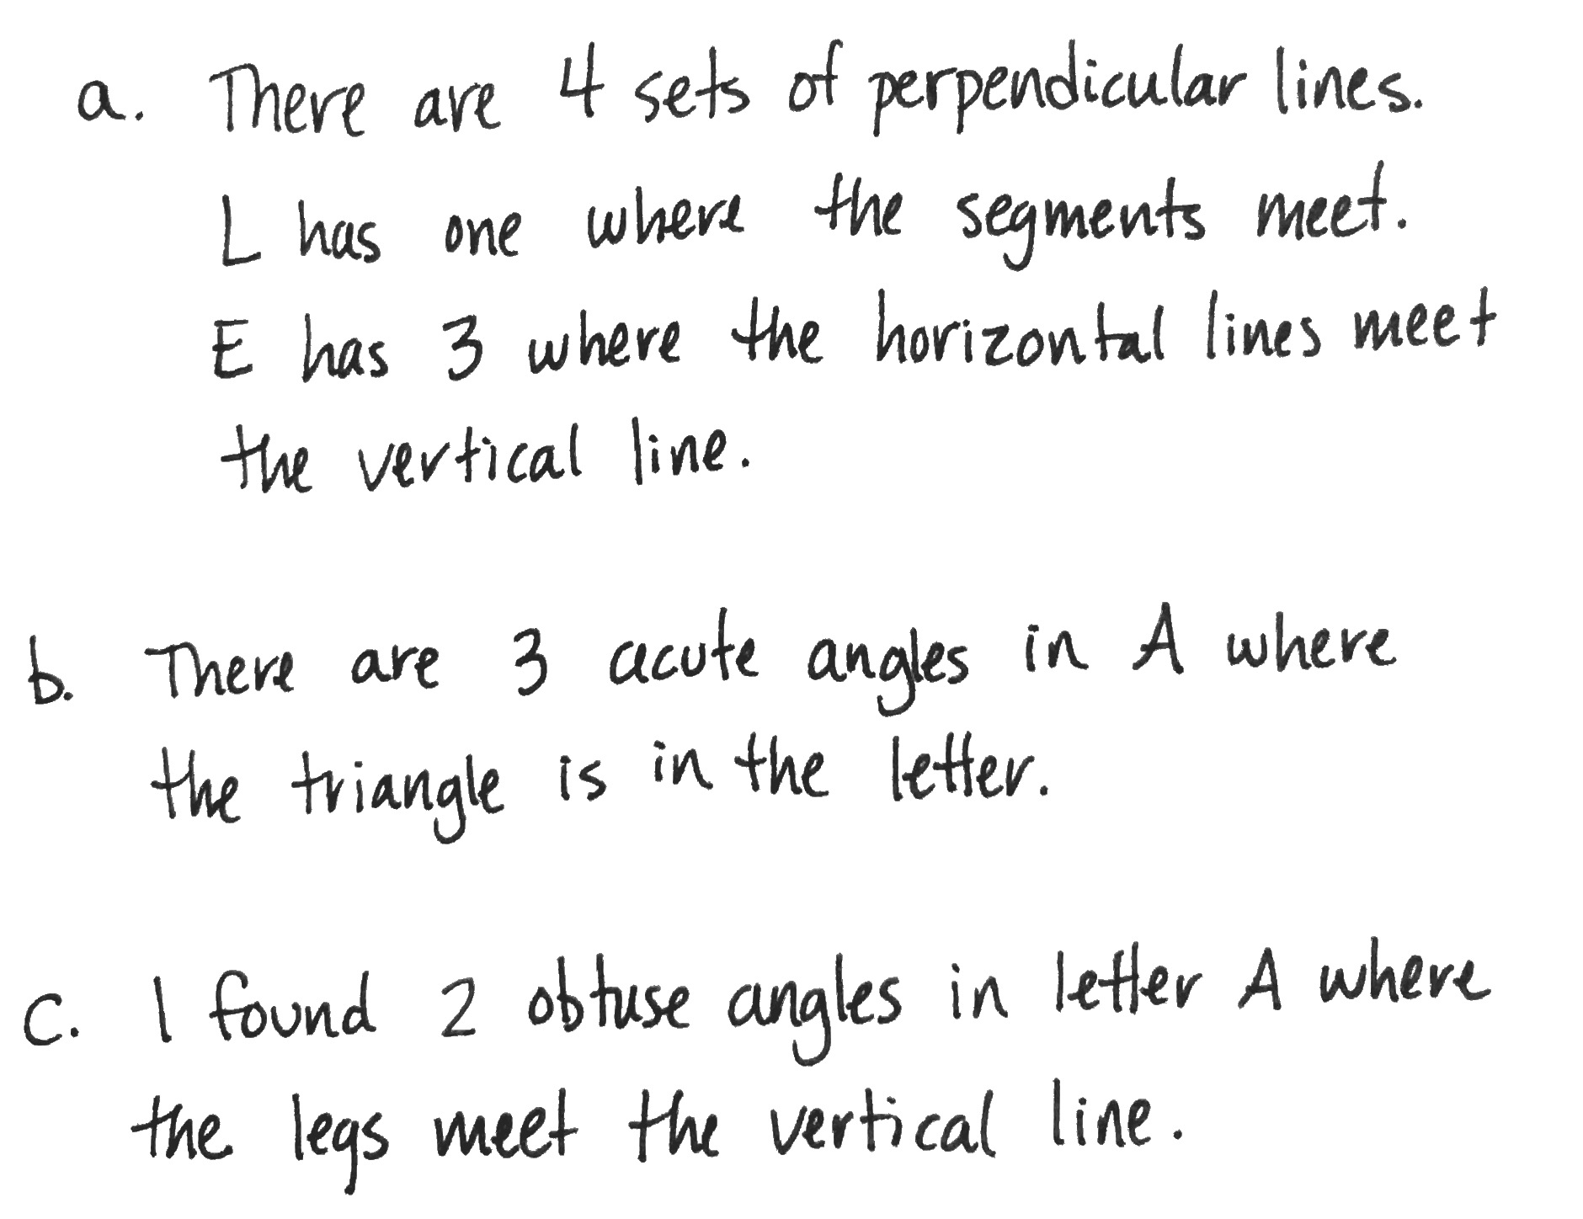How many obtuse angles are there? Describe them.

|  |  |
| --- | --- |
|  | NOTES ON MULTIPLE MEANS  OF ACTION AND EXPRESSION: |

Help learners keep their response to the Application Problem organized with a graphic organizer, such as the table below:

|  |  |  |  |
| --- | --- | --- | --- |
| Letter | Number of Perpendicular Lines | Number of Acute Angles | Number of Obtuse Angles |
| R |  |  |  |
| E |  |  |  |
| A |  |  |  |
| L |  |  |  |

Note: This Application Problem reviews perpendicular and intersecting lines from Lesson 3. The problem can be extended in the Debrief by having students find letters with parallel lines.

Concept Development (32 minutes)

|  |  |
| --- | --- |
|  | NOTES ON MULTIPLE MEANS  OF REPRESENTATION: |
| Students have learned a significant amount of new vocabulary and math symbols in a short amount of time. Support English language learners and others by providing tools such as a word wall or dictionaries (in first and second languages in addition to pictures and symbols) that students can refer to throughout the lesson. Include bolded words, as well as familiar words, such as *horizontal.* | |

Materials: (T/S) Straightedge, personal white board, square grid paper, right angle template (created in Lesson 2)

Problem 1: Define and identify parallel lines.

T: Partners, lay your two straightedges on your desk. The straightedges cannot touch each other. Work with your partner to position your two straightedges like two roads that will never intersect.

T: Are your straightedges touching?

S: No!

T: If a car continued down your straightedge road, would it ever be on your partner’s straightedge road?

S: No!

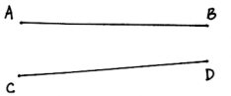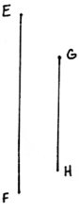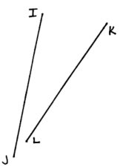

T: What do you notice?

S: Our straightedges are lined up perfectly. 🡪 Our straightedges are not perpendicular because they don’t make right angles. They don’t make *any* angles because they don’t touch!

T: You’ve discovered **parallel** lines. Two lines that never touch no matter how far you extend them are parallel.

T: Look on your desk. Can you find parallel lines?

S: The opposite sides of my personal white board, desk, and book are parallel.

T: In our classroom, can you find parallel lines?

S: The repeating ridges in the heater are parallel. 🡪 The shelves of the bookcase are parallel.

T: (Project the letter *N*. Trace and label with arrowheads parallel segments.) Are these segments of letter *N* parallel?

S: Yes!

T: (Project segments and as pictured to the right.) Are these segments parallel?

S: No!

T: Why not? I don’t see an intersection?

S: If you made each one longer, they’d run into each other off to the right.

T: (Project segments and as pictured to the right.) Are these segments parallel?

S: Yes!

T: (Project segments and as pictured to the right.) Are these segments parallel?

S: No!

Problem 2: Identify parallel lines using a right angle template.

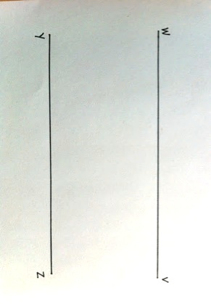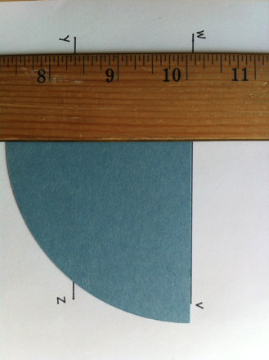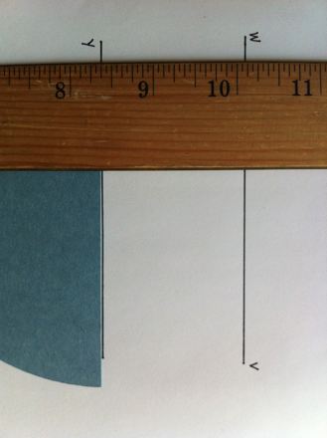

T: Partner 1, position your straightedge flat on your desk anyway you like—horizontal, vertical, slanted to the right, slanted to the left. Partner 2, place your straightedge parallel to your partner’s. Switch roles, and try again.

T: Use the word *parallel* in a sentence that describes your observations.

S: Parallel lines look like train tracks. 🡪 Parallel lines are side by side without touching. 🡪 Two lines that do not touch each other and are the same distance from each other at every point are parallel. 🡪 Parallel lines are not perpendicular.

T: (Project parallel segments and .) Are these segments parallel? They look parallel, but to be precise, we measure with a right angle template.

1. First, place a straightedge perpendicular across both segments.
2. Then, slide the right angle template along the straightedge to check the alignment.

T: Are these segments parallel?

S: Yes!

Repeat activity with a set of non-parallel lines following the process above.

Problem 3: Represent parallel lines with symbols.

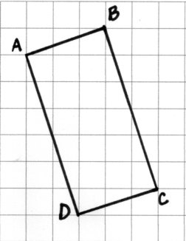T: On your grid paper, use your straightedge to draw rectangle like mine*.* (Model drawing rectangle Write on the board.)

When modeling, point out ways to confirm the lines are correctly drawn, without inferring parallelism yet, such as moves across three columns and up one row, as well as . and move down six rows and across two columns. Segments can be extended and erased as needed.

T: Do you see a segment that is parallel to ? Use symbols to record your answer.

S: (Show .) Segment !

T: Let’s check with our right angle template. (Model.)

S: (Check alignment using right angle template.)

T: (Assist as needed.) Are and parallel?

S: Yes.

T: (Write ). is parallel to .) Use symbols like mine to record another parallel pair in the rectangle.

S: .

T: What do you notice about sides of a rectangle and parallel lines?

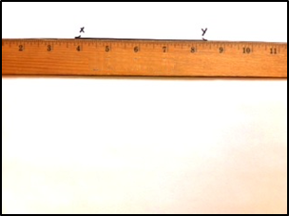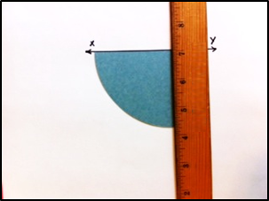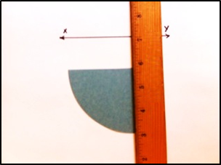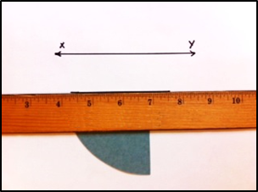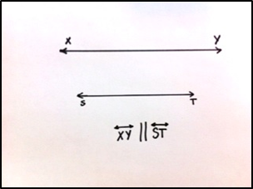

S: Opposite sides of the rectangle are parallel.

T: Is this true for all rectangles? With your partner, draw rectangles of different sizes and shapes. Use your right angle template to check for parallel segments.

**MP.3**

S: (Draw and verify.)

T: Does the length of the opposite sides of a rectangle change the fact that they are parallel?

S: No. Opposite sides of *all* rectangles are parallel.

T: As you work on the Problem Set, consider if this is true for other shapes.

Problem 4: Draw parallel lines.

T: Use your straightedge to draw horizontal line .

S: (Draw.)

T: We found that opposite sides of all rectangles are parallel. We also discovered in Lesson 2 that rectangles also have four right angles using our right angle template. We can use right angles to help us draw parallel lines.

T: (Model a step at a time, checking on student progress.)

1. First, place your right angle template on .
2. Second, align your straightedge along the template.
3. Next, slide your right angle template down the straightedge.
4. Align the straightedge against the other straight side of your template, and draw a line parallel to .
5. Lastly, label it as .

T: Use the parallel symbol to write a statement about these two lines. Draw arrowheads on each line to signify these two lines are parallel to each other.

T: Partner 1, draw a straight line—horizontal, vertical, slanted to the right, or slanted to the left. Partner 2, draw a line parallel to your partner’s. Remember to draw arrowheads on the parallel lines to signal that they are, in fact, parallel. Switch roles and try again.

S: (Draw.)

T: What do you notice?

S: Parallel lines are the same distance from each other at every point. 🡪 It’s tricky to draw a line that is parallel to a slanted line. 🡪 Turn the paper so the line is horizontal or vertical, and it’s easier to draw a parallel line.

Problem Set (10 minutes)

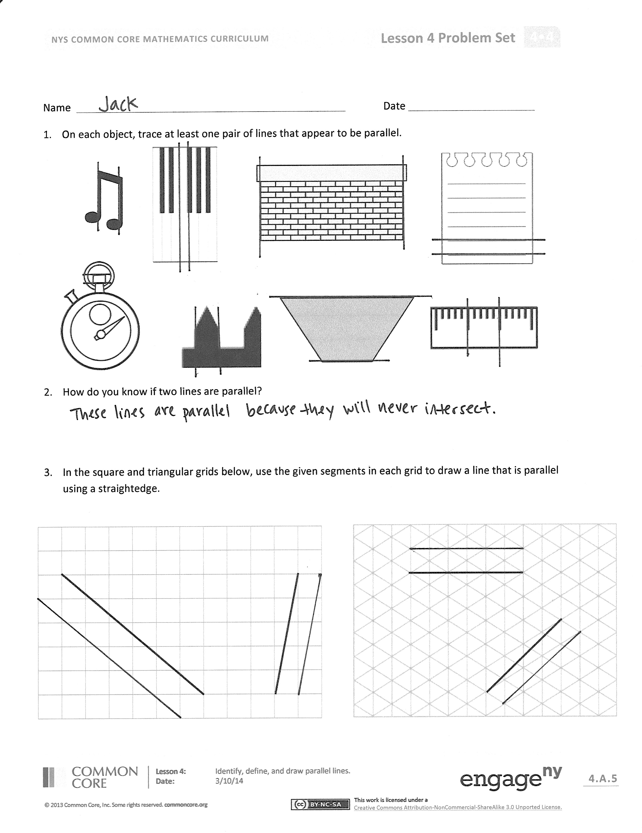

Students should do their personal best to complete the Problem Set within the allotted 10 minutes. For some classes, it may be appropriate to modify the assignment by specifying which problems they work on first. Some problems do not specify a method for solving. Students should solve these problems using the RDW approach used for Application Problems.

Student Debrief (10 minutes)

**Lesson Objective:** Identify, define, and draw parallel lines.

The Student Debrief is intended to invite reflection and active processing of the total lesson experience.

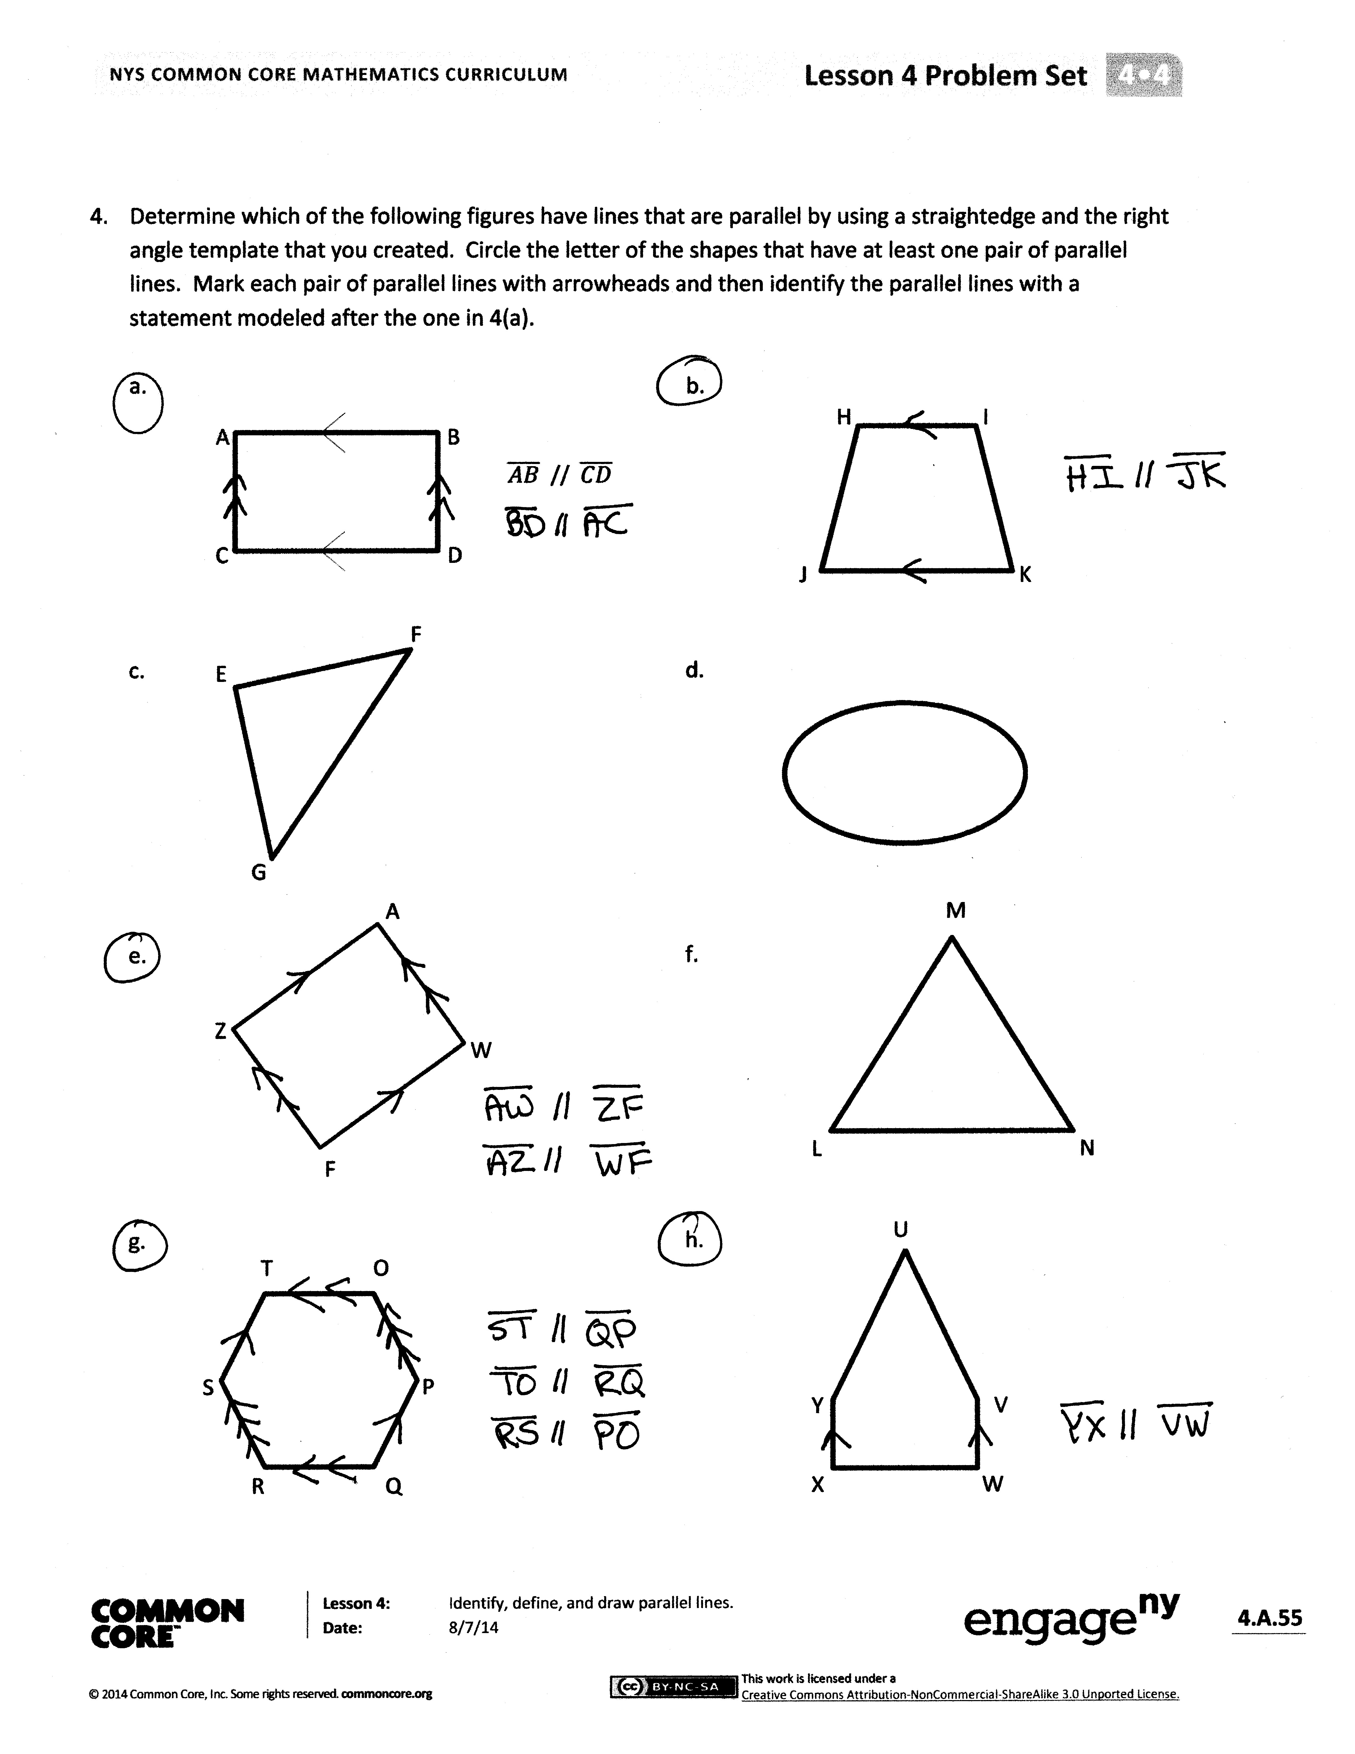Invite students to review their solutions for the Problem Set. They should check work by comparing answers with a partner before going over answers as a class. Look for misconceptions or misunderstandings that can be addressed in the Debrief. Guide students in a conversation to debrief the Problem Set and process the lesson.

You may choose to use any combination of the questions below to lead the discussion.

* In Problem 1, how could your right angle template serve as a guide for identifying parallel lines?
* How do you know if two lines are **parallel** (Problem 2)?
* In Problem 3, the given line segments were not drawn on gridlines. What challenge did this pose in drawing lines parallel to the segments? What patterns did you find in the grids to help you analyze if your lines were, in fact, parallel?
* Which shapes in Problem 4 had parallel lines? Are opposite sides always parallel?
* How do parallel lines differ from perpendicular lines?
* Two segments that don’t intersect must be parallel. True or false? Explain.

Exit Ticket (3 minutes)

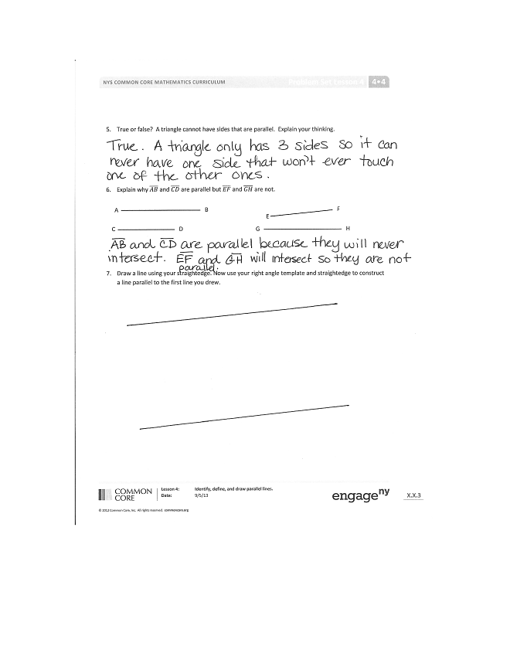

After the Student Debrief, instruct students to complete the Exit Ticket. A review of their work will help you assess the students’ understanding of the concepts that were presented in the lesson today and plan more effectively for future lessons. You may read the questions aloud to the students.

Name Date

1. On each object, trace at least one pair of lines that appear to be parallel.



♫

1. How do you know if two lines are parallel?

|  |  |  |  |  |  |  |  |  |  |  |  |
| --- | --- | --- | --- | --- | --- | --- | --- | --- | --- | --- | --- |
|  |  |  |  |  |  |  |  |  |  |  |  |
|  |  |  |  |  |  |  |  |  |  |  |  |
|  |  |  |  |  |  |  |  |  |  |  |  |
|  |  |  |  |  |  |  |  |  |  |  |  |
|  |  |  |  |  |  |  |  |  |  |  |  |
|  |  |  |  |  |  |  |  |  |  |  |  |
|  |  |  |  |  |  |  |  |  |  |  |  |
|  |  |  |  |  |  |  |  |  |  |  |  |

1. In the square and triangular grids below, use the given segments in each grid to draw a line that is parallel using a straightedge.



1. Determine which of the following figures have lines that are parallel by using a straightedge and the right angle template that you created. Circle the letter of the shapes that have at least one pair of parallel lines. Mark each pair of parallel lines with arrowheads, and then identify the parallel lines with a statement modeled after the one in 4(a).

|  |  |
| --- | --- |
| A  B    E  F  G  D  C | K  J  I  H |
| Z  W  A  F | N  L  M |
|  | W  V  X  U  Y |
| T  O  S  P  R  Q |  |

1. True or false? A triangle cannot have sides that are parallel. Explain your thinking.
2. Explain why and are parallel, but and are not.

E

F

A

B

G

H

C

D

1. Draw a line using your straightedge. Now, use your right angle template and straightedge to construct a line parallel to the first line you drew.

Name Date

Look at the following pairs of lines. Identify if they are parallel, perpendicular, or intersecting.

2. ____________________

1. ____________________

3. ____________________

4. ____________________

Name Date

1. On each object, trace at least one pair of lines that appear to be parallel.

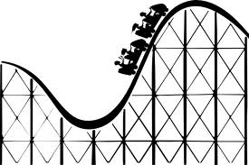

1. How do you know if two lines are parallel?
2. In the square and triangular grids below, use the given segments in each grid to draw a line that is parallel using a straightedge.



|  |  |  |  |  |  |  |  |  |  |  |  |
| --- | --- | --- | --- | --- | --- | --- | --- | --- | --- | --- | --- |
|  |  |  |  |  |  |  |  |  |  |  |  |
|  |  |  |  |  |  |  |  |  |  |  |  |
|  |  |  |  |  |  |  |  |  |  |  |  |
|  |  |  |  |  |  |  |  |  |  |  |  |
|  |  |  |  |  |  |  |  |  |  |  |  |
|  |  |  |  |  |  |  |  |  |  |  |  |
|  |  |  |  |  |  |  |  |  |  |  |  |
|  |  |  |  |  |  |  |  |  |  |  |  |

1. Determine which of the following figures have lines that are parallel by using a straightedge and the right angle template that you created. Circle the letter of the shapes that have at least one pair of parallel lines. Mark each pair of parallel lines with arrows, and then identify the parallel lines with a statement modeled after the one in 4(a).

|  |  |
| --- | --- |
| A  D  B  C    D | J  I  H  K |
| Z  Y  X  O  G | O |
|  | N  P  M |
| T  U  S  P  R  Q | W  V  X  U  Y  T  Z |

1. True or false? All shapes with a right angle have sides that are parallel. Explain your thinking.
2. Explain why and are parallel, but and are not.

F

E

G

H

C

D

A

B

1. Draw a line using your straightedge. Now, use your right angle template and straightedge to construct a line parallel to the first line you drew.