Lesson 3
Objective: Identify, define, and draw perpendicular lines.

Suggested Lesson Structure
 Fluency Practice (12 minutes)
 Application Problem (6 minutes)
 Concept Development (32 minutes)
 Student Debrief (10 minutes)
Total Time (60 minutes)
Fluency Practice (12 minutes)
- Multiply Mentally 4.NBT.4 (3 minutes)
- Identify Two-Dimensional Figures 4.G.1 (4 minutes)
- Physiometry 4.G.1 (5 minutes)
Multiply Mentally (3 minutes)
Materials: (S) Personal white board
Note: This fluency activity reviews the Concept Developments from G4–M3–Lessons 34─38.
T: (Write 34 × 2.) Say the multiplication sentence.
S: 34 × 2 = 68.
T: (Write 34 × 2 = 68. Below, write 34 × 20 = .) Say the multiplication sentence.

NOTES ON
MULTIPLE MEANS
OF REPRESENTATION:
The Identify Two-Dimensional Figures fluency activity provides English language learners and other students a valuable opportunity to speak and review meanings and representations of recently introduced geometry terms. If necessary, allow extra time for students to respond.

S: 34 × 20 = 680.
T: (Write 34 × 20 = 680. Below, write 34 × 22 = .) On your personal white board, solve 34 × 22.
S: 748.
Continue with the following possible sequence:
23 × 2, 23 × 30, and 23 × 32.
Identify Two-Dimensional Figures (4 minutes)
Materials: (S) Personal white board
Note: This fluency activity reviews terms learned in Lessons 1─2.
T: (Project a line $AB$. Trace line $AB$.) Write the symbol for what I’m pointing to.
S: $\overset{⃡}{AB}$.
T: (Point to point $A$.) Say the term.
S: Point $A$.
T: (Point to point $B$.) Say the term.
S: Point $B$.
T: On your board, draw $\overset{⃡}{CD}$.
S: (Draw a line with points $C$and $D$ on the line.)
Continue with the following possible sequence: $\overline{EF}$, $∠GIH$, and $\overset{⃑}{JK}$.
T: (Project a right angle $LNM$.) Name the angle.
S: $∠LNM$.
T: What type of angle is it?
S: Right angle.
T: (Project an acute angle $OQP$.) Name the angle.
S: $∠OQP$.
T: Is it greater than or less than a right angle?
S: Less than.
T: What’s the term for an angle that’s less than a right angle?
S: Acute angle.
T: (Project an obtuse angle $RTS$.) Name the angle.
S: $∠RTS$.
T: Is it greater than or less than an acute angle?
S: Greater than.
T: Is it greater than or less than a right angle?
S: Greater than.
T: What’s the term for an angle greater than a right angle but less than a straight angle?
S: Obtuse angle.
Physiometry (5 minutes)
Note: Kinesthetic memory is strong memory. This fluency activity reviews terms from Lessons 1─2.
T: Stand up.
S: (Stand up.)
T: Model a line segment.
S: (Extend arms straight so that they are parallel with the floor. Clench both hands into fists.)
T: Model a line.
S: (Extend arms straight so that they are parallel with the floor. Open both hands and point at side walls.)
T: Model a point.
S: (Clench one hand in a fist and extend arm forward.)
T: Model a ray.
S: (Extend arms straight so that they are parallel with the floor. Clench one hand in a fist, and leave the point with a finger on the other hand.)
T: Model a ray pointing in the other direction.
S: (Clench open hand, and open clenched hand. Point with a finger on the open hand.)
T: (Stretch one arm up directly at the ceiling. Stretch the other arm directly toward a wall parallel to the floor.) What type of angle do you think I’m modeling with my arms?
S: Right angle.
T: Model a right angle with your arms.
S: (Stretch one arm up directly at the ceiling. Stretch another arm directly toward a wall parallel to the floor.)
T: (Stretch the arm pointing toward a wall directly up toward the ceiling. Move the arm pointing toward the ceiling so that it points directly toward the opposite wall.) Model another right angle.
S: (Stretch the arm pointing toward a wall directly up toward the ceiling. Move the arm pointing toward the ceiling so that it points directly toward the opposite wall.)
T: Model an acute angle.
S: (Model an acute angle with arms.)
T: Model an obtuse angle.
S: (Model an obtuse angle with arms.)
Next, move between figures with the following possible sequence: right angle, ray, line segment, acute angle, line, obtuse angle, point, and right angle.
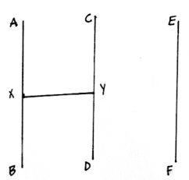
Application Problem (6 minutes)
Materials: (S) Straightedge
- Use a straightedge to draw and label $\overline{AB},\overline{CD}$, and $\overline{EF}$ as modeled on the board.
- Estimate to draw point $X$ halfway up $\overline{AB}$ .
- Estimate point $Y$ halfway up $\overline{CD}$.
- Draw horizontal line segment $XY$. What word do the segments create?
- Erase segment $XY$. Draw segment $CF$. What word do the segments create?
Note: This Application Problem reviews Lessons 1’s introduction to and application of points and line segments. This Application Problem also transitions into today’s lesson, during which students discover types of lines or line segments present in letters of the English alphabet.
Concept Development (32 minutes)
Materials: (T/S) Straightedge, right angle template (created in Lesson 2), paper, Problem Set
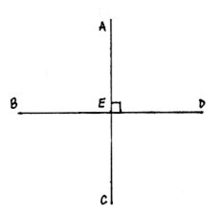
Problem 1: Define perpendicular lines.
T: (Draw perpendicular lines using the right angle template and a straightedge.) What do you see?
S: A right angle! Two line segments and four right angles. A cross. The lowercase letter t. A plus sign.
T: (Label central point $E$ and endpoints $A$, $B$, $C$, and $D$.) $\overline{AE}$ and $\overline{ED}$make right angles. (Mark a right angle.) With your partner, list two more segments that form a right angle.
S: $\overline{AE}$ and $\overline{BE}$. $\overline{EB}$ and $\overline{EC}.$ $\overline{EC }$and $\overline{ED.}$ $\overline{AC }$and $\overline{BD}$.
T: Can you find examples of right angles in the room?
S: Yes! In my square grid paper! In the heating grate! I see them in the floor tiles.
T: (Point to perpendicular lines.) These lines are perpendicular. They intersect to make right angles. (Draw an X.) Are these lines perpendicular? Share your thoughts with your partner.
S: Those lines cross, but they don’t make right angles. They’re not perpendicular.
T: No, they are not perpendicular. They are intersecting lines. (Point to an acute angle). What type of angle?
S: Acute.
MP.6
T: (Point to an obtuse angle). What type of angle?
S: Obtuse.
T: (Draw the capital letters T, L, and V.) Discuss with your partner whether the segments in these letters are perpendicular.
S: The lines of T and L meet to make a right angle. The segments in T and L are perpendicular.
Letter V doesn’t have a right angle. So, those lines are not perpendicular.
Use the right angle template to verify student responses.
T: List three more capital letters of the alphabet with perpendicular lines.
S: H, F, E.
Problem 2: Identify perpendicular lines by measuring right angles with a right angle template.
T: Hold up your right angle template, and trace the right angle with your finger. (Model.) Let’s use this right angle to find perpendicular lines in our room. On your desk, which objects have perpendicular lines?
S: My personal white board, rectangular eraser, straightedge, and the blank paper all have perpendicular lines. My nametag, iPad screen, and the edges of my desk have perpendicular lines.
T: On our classroom wall, which objects have perpendicular lines?
S: Our rules poster, the calendar, the white board, the door, and the windows have perpendicular lines.
T: Take a look at Figure B on your Problem Set. Place your right angle edge on the lines of the shape. Do they match up? Does this pentagon have perpendicular lines?
S: No. The lines form obtuse angles. The lines cross, but they do not make right angles. They are not perpendicular lines.
Problem 3: Recognize and write symbols for perpendicular segments.

NOTES ON
LINES IN THE REAL WORLD:
Challenge students to search for upright and diagonal perpendicular lines in their natural and man-made environments. This activity may best be prepared beforehand with photographs of examples. Prompt observation, analysis, and discovery with the following questions:
Are perpendicular lines found in nature? Intersecting lines?
How are upright perpendicular lines used by people? Diagonal perpendicular lines? Intersecting lines?

T: Take a look at Problem 4(a) on the Problem Set. Trace your finger across $\overline{AC}$. (Write $\overline{AC}$.) Tell your partner the name of two segments that are perpendicular to segment $\overline{AC}$.
S: $\overline{AC}$is perpendicular to $\overline{AB}$. $\overline{CD}$is also perpendicular to $\overline{AC}$.
T: (Write $\overline{AC}⊥$ $\overline{AB}$ and point.) $\overline{AC}$ is perpendicular to $\overline{AB}$. Use symbols to write $\overline{CD}$is perpendicular to $\overline{AC}$.
S: $\overline{CD}⊥$ $\overline{AC}$.
Problem 4: Draw perpendicular line segments.
T: A line can be drawn in any direction. (Draw.) Here is a diagonal $\overline{AB}$. I can use my right angle template to draw a line perpendicular to $\overline{AB}$. (Model.)
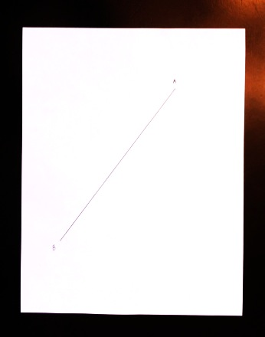
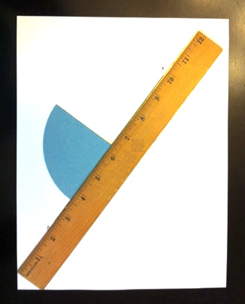
T: What do you notice about the angles?
S: I notice there are two right angles. You marked one right angle with a small square.
T: On your blank paper, use your pencil and straightedge to draw $\overline{CD}$. Now, use your right angle template to draw a line perpendicular to $\overline{CD}$. Check for perpendicularity with your right angle template.
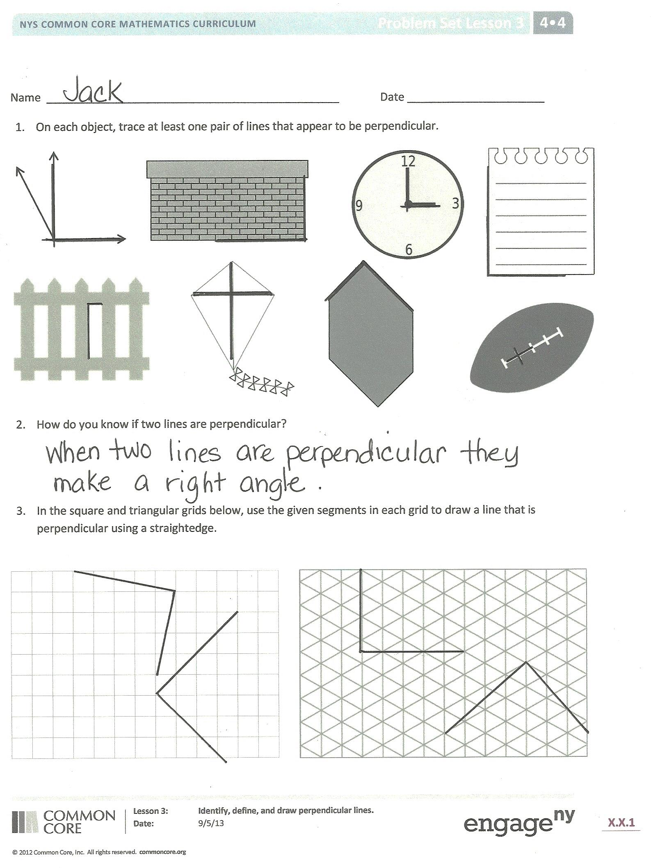
S: It’s easier to draw a line perpendicular to a horizontal line. When you drew the diagonal line, I thought it would be hard to draw a perpendicular line. So, I turned the paper to make the diagonal line horizontal to me.
T: When you’re drawing or using the right angle template to identify perpendicular lines, you can turn the paper for ease, if you want. What’s another helpful tip?
S: Steady the straightedge, and hold the right angle template still while you’re drawing.
Problem Set (10 minutes)
Students should do their personal best to complete the Problem Set within the allotted 10 minutes. For some classes, it may be appropriate to modify the assignment by specifying which problems they work on first. Some problems do not specify a method for solving. Students should solve these problems using the RDW approach used for Application Problems.
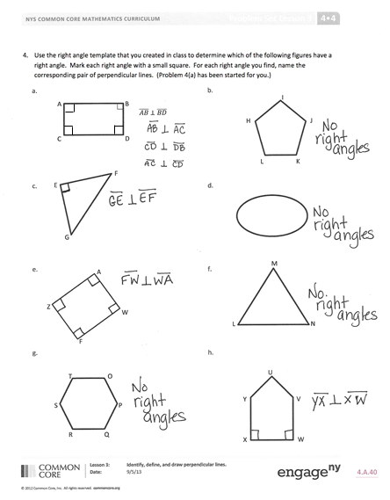
Student Debrief (10 minutes)
Lesson Objective: Identify, define, and draw perpendicular lines.
The Student Debrief is intended to invite reflection and active processing of the total lesson experience.
Invite students to review their solutions for the Problem Set. They should check work by comparing answers with a partner before going over answers as a class. Look for misconceptions or misunderstandings that can be addressed in the Debrief. Guide students in a conversation to debrief the Problem Set and process the lesson.
You may choose to use any combination of the questions below to lead the discussion.
- How did your knowledge of right angles prepare you to identify perpendicular lines in the figures for Problem 1?
- How can you tell if two lines are perpendicular (Problem 2)?
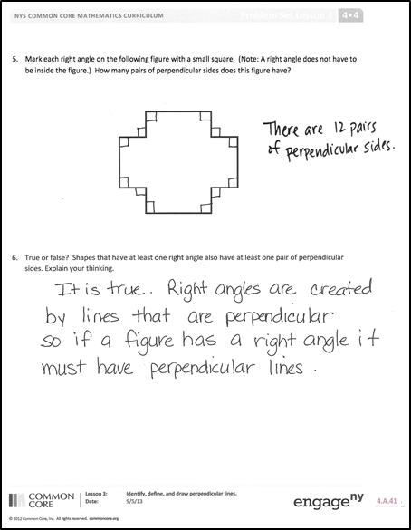
- In Problem 3, what was your strategy for drawing the segments perpendicular to the given segments? In what ways did the grids help you? How were the grids challenging?
- Look at the grid lines in Problem 3. Are the grid lines perpendicular or intersecting? Or both?
- In Problem 4, which figures had no perpendicular lines? Explain.
- In Problem 5, I only located eight right angles (on the interior of the figure). How many more right angles are there? What did this problem show you about locating angles on figures?
- How are perpendicular lines related to right angles? Acute angles? Obtuse angles?
- How might you use your understanding of perpendicular lines to solve a problem in real life? How might you use perpendicular lines when building something, for example?
- As you search for lines in your environment, notice if you find perpendicular or intersecting lines in nature. Analyze upright perpendicular lines, diagonal perpendicular lines, and intersecting lines as used by human beings.
Exit Ticket (3 minutes)
After the Student Debrief, instruct students to complete the Exit Ticket. A review of their work will help you assess the students’ understanding of the concepts that were presented in the lesson today and plan more effectively for future lessons. You may read the questions aloud to the students.

Name Date
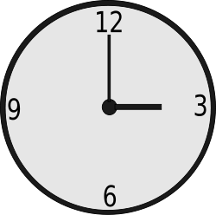
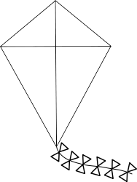
- On each object, trace at least one pair of lines that appear to be perpendicular.

- How do you know if two lines are perpendicular?

- In the square and triangular grids below, use the given segments in each grid to draw a line that is perpendicular using a straightedge.

- Use the right angle template that you created in class to determine which of the following figures have a right angle. Mark each right angle with a small square. For each right angle you find, name the corresponding pair of perpendicular lines. (Problem 4(a) has been started for you.)

A  D  B  C  $\overline{AB}$ $⊥\overline{BD}$ | J  I  H  L  K
E
F
G
Z  W  A  F | N  L  M  W  V  X  U  Y
T
O
S
P
R
Q
- Mark each right angle on the following figure with a small square. (Note: A right angle does not have to be inside the figure.) How many pairs of perpendicular sides does this figure have?

- True or false? Shapes that have at least one right angle also have at least one pair of perpendicular sides. Explain your thinking.

Name Date
For each figure, mark perpendicular lines with the right angle symbol. Then, name the perpendicular lines. Use your right angle template as your guide.
D
E
C
A
B
- $\overline{BC} ⊥$ _______

M
N
O
P
- $\overline{MN} ⊥$ _______

Name Date
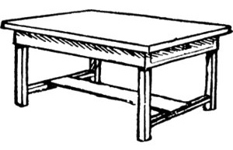
- On each object, trace at least one pair of lines that appear to be perpendicular.
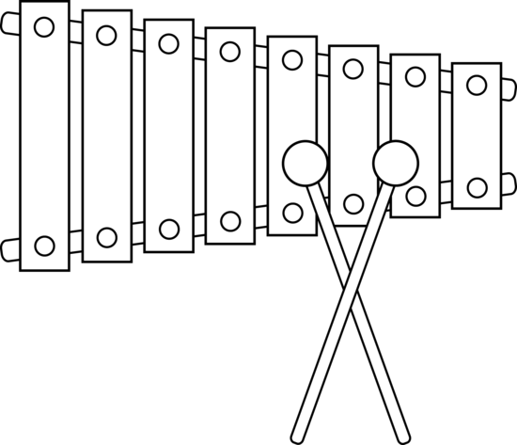
- How do you know if two lines are perpendicular?

- In the square and triangular grids below, use the given segments in each grid to draw a line that is perpendicular. Use a straightedge.

- Use the right angle template that you created in class to determine which of the following figures have a right angle. Mark each right angle with a small square. For each right angle you find, name the corresponding pair of perpendicular lines. (Problem 4(a) has been started for you.)

D  A  D  B  C  $\overline{AB}$ $⊥\overline{BD}$ | J  I  H  K
Z  Y  X  O  G | O
N

P

M

T  U  S  P  R  Q | W  V  X  U  Y  T  Z
- Use your right angle template as a guide, and mark each right angle in the following figure with a small square. (Note: A right angle does not have to be inside the figure.) How many pairs of perpendicular sides does this figure have?

- True or false? Shapes that have no right angles also have no perpendicular segments. Draw some figures to help explain your thinking.

