Lesson 2

Objective: Use right angles to determine whether angles are equal to, greater than, or less than right angles. Draw right, obtuse, and acute angles.

Suggested Lesson Structure

 Fluency Practice (12 minutes)

 Application Problem (4 minutes)

 Concept Development (34 minutes)

 Student Debrief (10 minutes)

**Total Time (60 minutes)**

Fluency Practice (12 minutes)

|  |  |
| --- | --- |
|  | NOTES ON MULTIPLE MEANS  OF REPRESENTATION: |
| Scaffold the Multiply Using Partial Productsfluency activity by giving a clear example with a simpler problem, followed immediately by a similar two-digit problem.  T: (Write 32 × 7.) Say 32 in unit form.  T: 3 tens × 7 + 2 ones × 7 is a two-product addition expression in unit form. What are the two products?  T: (Write 43 × 6.) Say 43 in unit form.  T: Write 43 × 6 as a two-product addition expression in unit form.  Once students are successful at the simpler level, move forward to three-digit examples. | |

* Multiply Using Partial Products **4.NBT.4** (3 minutes)
* Identify Two-Dimensional Figures **4.G.1** (4 minutes)
* Physiometry  **4.G.1**  (5 minutes)

Multiply Using Partial Products (3 minutes)

Materials: (S) Personal white board

Note: This fluency activity serves as a review of the Concept Development in G4–M3–Lessons 7–8.

T: (Write 322 × 7.) Say 322 in unit form.

S: 3 hundreds 2 tens 2 ones.

T: Say it as a three-product addition expression in unit form.

S: 3 hundreds × 7 + 2 tens × 7 + 2 ones × 7.

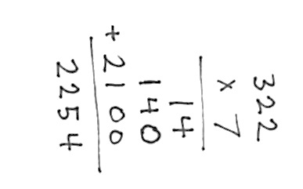T: Write 322 × 7 vertically and solve using the partial product strategy.

Continue with the following possible sequence:   
5 thousands 1 hundred 3 tens 2 ones × 3 and 4 × 4,312.

Identify Two-Dimensional Figures (4 minutes)

Materials: (S) Personal white board, straightedge

Note: This fluency activity reviews terms learned in Lesson 1.

****T: (Project . Point to point .) Say the term for what I’m pointing to.

S: Point .

T: (Point to point .) Say the term.

S: Point .

T: (Point to .) Say the term.

S: .

T: Use your straightedge to draw on your personal white boards.

S: (Draw a segment with endpoints and .)

Continue with the following possible sequence: , , and .

Physiometry (5 minutes)

Note: Kinesthetic memory is strong memory. This fluency activity reviews Lesson 1 terms.

T: Stand up.

S: (Stand up.)

T: (Extend arms straight so that they are parallel with the floor. Clench both hands into fists.) What kind of figure do you think I’m modeling?

S: A line segment.

T: What do you think my fists might represent?

S: Points.

T: Make a line segment with your arms.

S: (Extend arms straight so that they are parallel with the floor. Clench both hands into fists.)

T: (Keep arms extended. Open fists, and point to side walls.) What kind of figure do you think I’m modeling now?

S: A line.

T: What do you think my pointing fingers might represent?

S: Arrows.

T: Make a line.

S: (Keep arms extended, but open hands and point to the side walls.)

T: (Clench one hand in a fist, and extend arm forward to students.) Say the figure that you think I’m modeling.

S: A point.

T: Make a point.

S: (Clench one hand in a fist, and extend arm forward.)

T: (Extend arms straight so that they are parallel with the floor. Clench one hand in a fist, and leave the other hand open, pointing to a side wall.) Say the figure you think I’m modeling.

S: A ray.

T: Make a ray.

S: (Extend arms straight so that they are parallel with the floor. Clench one hand in a fist, and leave the other hand open, pointing to a side wall.)

T: (Extend arms in an acute angle.) Say the figure I’m modeling.

S: An angle.

T: Make an angle.

S: (Extend arms in an acute angle.)

Next, move between figures with the following possible sequence: ray, angle, line segment, point, angle made of two segments, and line.

Close the session by quickly cautioning students against the incorrect idea that lines and points are as thick as arms and fists when they are actually infinitely small.

Application Problem (4 minutes)

1. Figure 1 has three points. Connect points , , and with as many line segments as possible.
2. 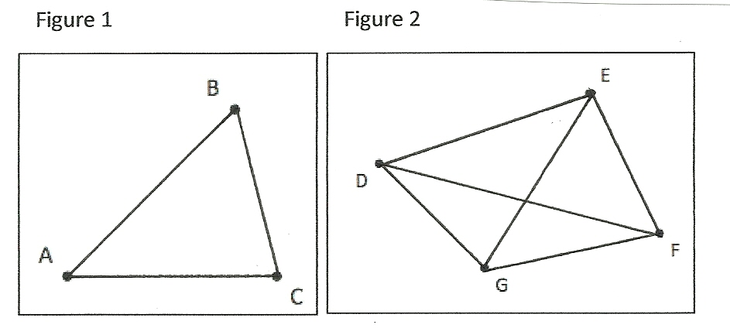Figure 2 has four points. Connect points , , , and with as many line segments as possible.

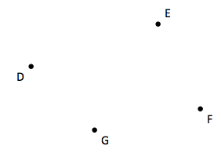

Figure 2

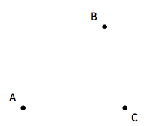

Figure 1

Note: This Application Problem builds on the previous lesson in that students use points to draw line segments. Review Lesson 1 by engaging students in a discussion about the representation of a point and how segments are related to lines and rays.

Concept Development (34 minutes)

Materials: (T/S) Paper, straightedge, angles (Template)

Note: The following activity and images for the paper folding activity are modeled using a large circle. Any sized paper and any shaped paper is sufficient for this activity. Include a variety of papers for this activity. Students find that any paper folded twice results in a right angle template.

Problem 1: Create right angles through a paper folding activity.

T: Everyone, hold your circle, and fold it in half like this. (Demonstrate.)

T: Then, fold it in half again, like this. (Demonstrate.)

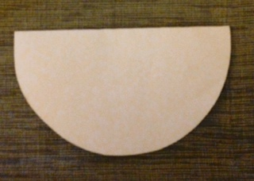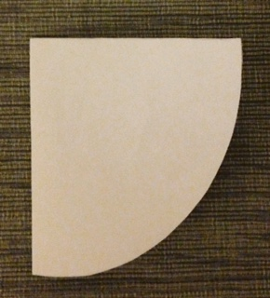

T: Do you notice any angles in our folded circle?

S: Yes! This corner right here!

T: Yes, that shared endpoint is where these two lines meet to form an angle.

T: Now, trace both lines with your fingers, starting at their shared endpoint.

T: Point to the angle we formed. This is called a **right angle**.

T: Using your folded circle as a reference, look around the room for right angles. With your partner, create a list of objects that have right angles.

S: Door, book, desk, floor tile, window, paper, and white board.

T: Use the words *equal to* for describing the relationship between your right angle template and the other right angles you found around the room.

S: The angles on the corners of the floor tile are equal to the right angle on my folded paper.   
🡪 The corner of the door is equal to a right angle.

Problem 2: Determine whether angles are equal to, greater than, or less than a right angle.

T: Use your right angle template to find all of the right angles on the angles template. How will you know if it’s a right angle?

S: The sides of the right angle template will match exactly with the sides of the angles. (Find the right angles on the angles template.)

T: Let’s identify the right angles with a symbol. We put a square in the corner of the angle, or the **vertex**, to show that it is a right angle (demonstrate). It’s your turn.

Students identify each right angle by putting a right angle symbol at the vertex.

T: What do you notice about the other angles on the angles Template?

S: They are not right angles. 🡪 Some are less than right angles. 🡪 Some are greater than right angles.

T: But what if one looks *almost, but not quite like* a right angle?

S: It would be hard to tell. 🡪 We can use our right angle template!

T: Place your right angle template on so that the corner of the template and one of the sides lines up with the corner and side of the angle. What do you notice?

S: The two rays make an opening that is smaller than the right angle. 🡪 I can only see one ray of the angle. 🡪 This angle fits inside the right angle.

T: Find the other angles that are less than a right angle. Write *less* next to them.

Students identify other angles that are less than a right angle.

T: Are the remaining angles greater or less than a right angle?

**MP.5**

S: Greater!

T: Place your right angle template on so that the corner of the template and one of the sides lines up with the corner and side of the angle. What do you notice?

S: My right angle fits inside of it. 🡪 When I line up my right angle along this side, the other side of the angle is outside my right angle. 🡪 It’s greater than a right angle.

T: Verify that each of the other remaining angles is greater than a right angle using your template. Write *greater* next to each angle.

T: We just identified three groups of angles. What are they?

|  |  |
| --- | --- |
|  | NOTES ON MULTIPLE MEANS  OF REPRESENTATION: |
| To assist with building math vocabulary for English language learnersand other students, point to a picture of acute, right*,* andobtuse angles eachtime they are mentioned during today’s lesson. Consider building into your instruction additional checks for understanding. Additionally, learners may benefit from adding these new terms and corresponding pictures to their personal math dictionaries before or after the lesson. | |

S: Some are right angles. Some are less than right angles. Some are greater than right angles.

T: , and are right angles. and are examples of another type of angle. We call them **acute angles**. Describe an acute angle.

S: An acute angle is an angle that is less than a right angle.

T: Look around the classroom for acute angles.

S: I see one by the flagpole.

T: What two objects represent the rays or sides of your acute angle?

S: The flagpole and the wall.

T: When we align the right angle template against the wall and follow the flagpole, it goes inside the interior of the right angle. (Demonstrate.)

T: , and are examples of another type of angle. We call them **obtuse angles**. Describe an obtuse angle.

S: An obtuse angle is an angle that is greater than a right angle.

T: Look around the classroom for obtuse angles.

S: The door is creating an obtuse angle right now.

T: What two objects represent the sides composing your obtuse angle?

S: The wall and the bottom of the door.

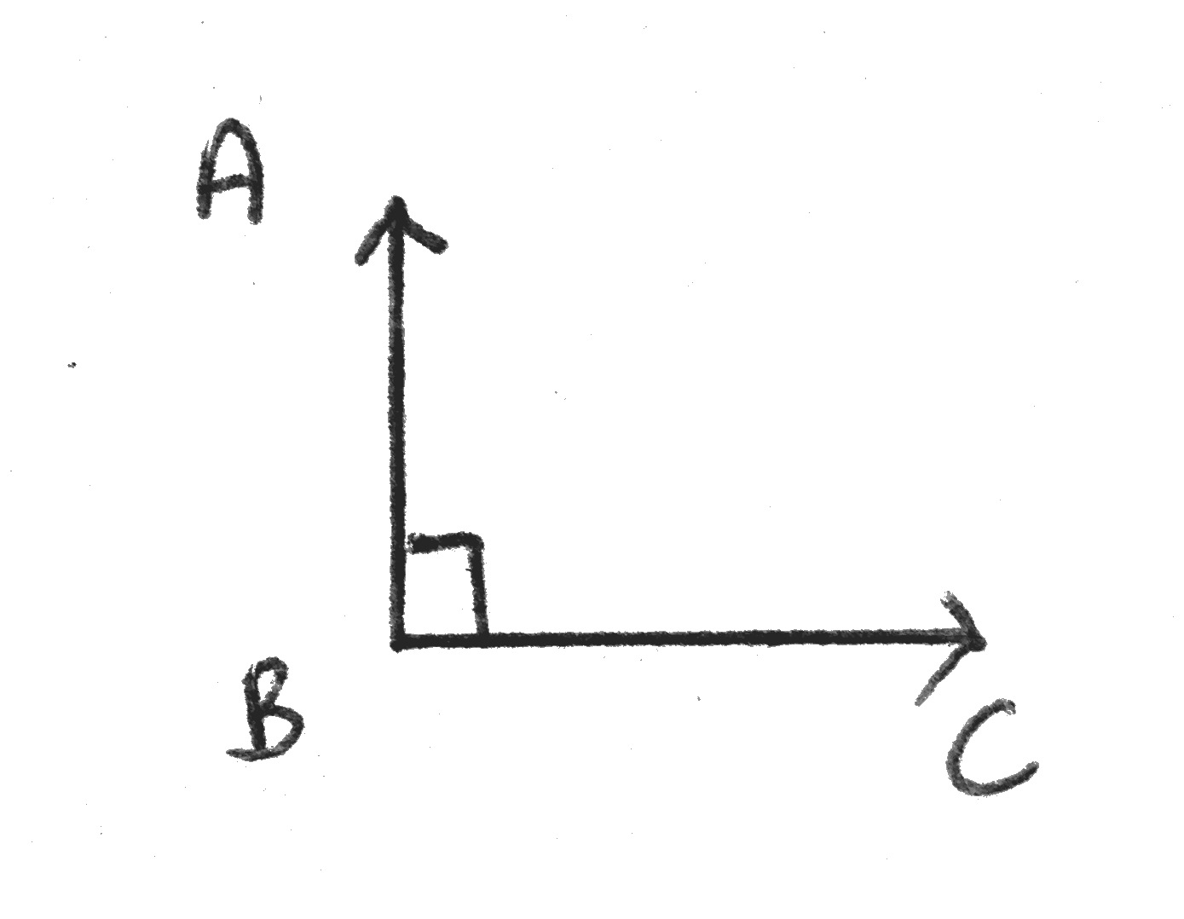Problem 3: Draw right, acute, and obtuse angles.

T: Using your straightedge, draw one ray. Use your right angle template as a guide. Then, draw a second ray, creating right angle Will you label the two rays’ shared endpoint , , or ?

S: The shared endpoint should be labeled because it is. Point is in the middle.

T: When you are finished drawing your angle, use your template to check your partner’s angle. Did everyone’s right angles look exactly the same?

S: Not all of them. 🡪 Our angles were facing different directions, but the angle looks exactly the same.

T: Right angles are represented with a little square in the angle. (Demonstrate). Add one to your angle.

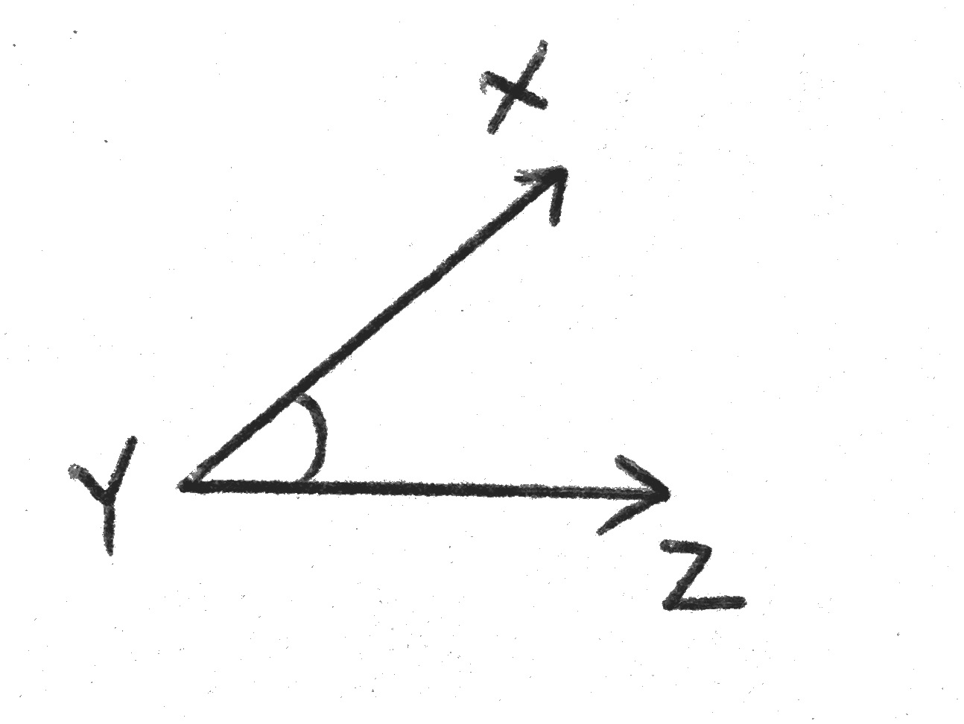T: Next, using the same process, draw an acute angle labeled. When you are finished, check your partner’s angle.

T: What did you notice?

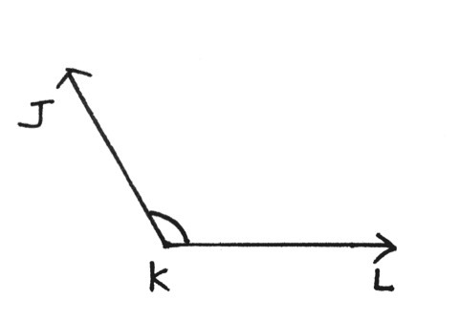S: This time, they all looked different. 🡪 I noticed that our angles were facing different directions, but also, the size of the angle looked different. 🡪 All were different sizes, but all were less than a right angle. 🡪 Right angles are exactly the same, but acute angles can be anything less than a right angle, so there are a lot of them.

T: *Acute* indicates less than a right angle, so everyone in our class may have drawn a different angle!

T: For all angles that are not equal to a right angle, we can draw an arc to show the angle. (Demonstrate.) Add one to your angle.

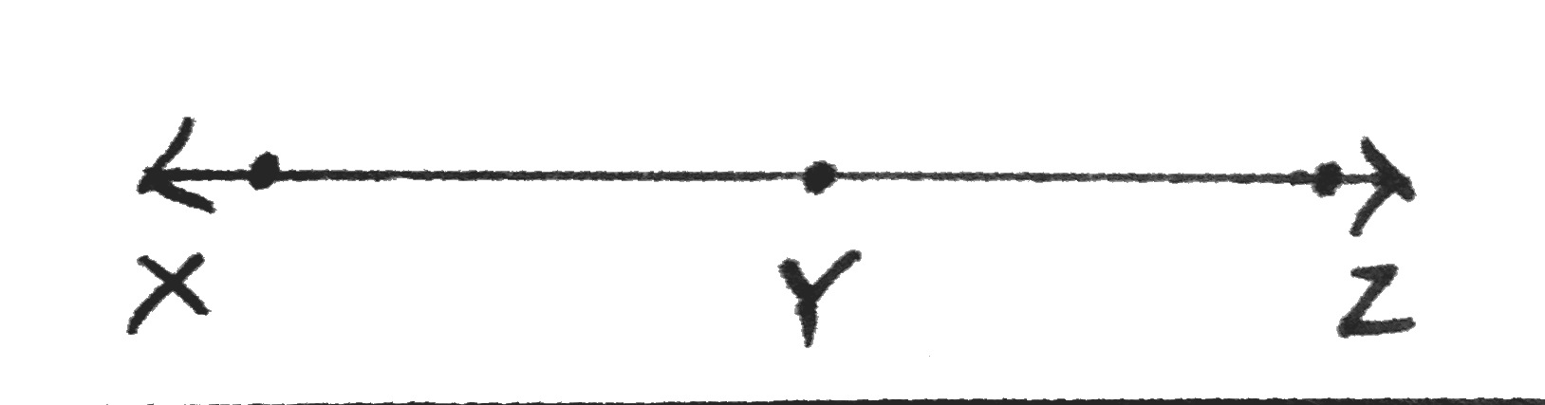T: Lastly, draw an obtuse angle labeled , and draw an arc to show the angle.

T: (Draw a straight line and label points , , and on the line.) Identify this angle.

S: I don’t see an angle. 🡪 Isn’t it just a line? .

T: There are two rays, and . So yes, it is . However, since all three points lie on a line, we have a special angle. We call this a **straight angle**. Obtuse angles are smaller than a straight angle, but larger than a right angle. Check your partner’s work. Use your right angle template and straightedge as guides.

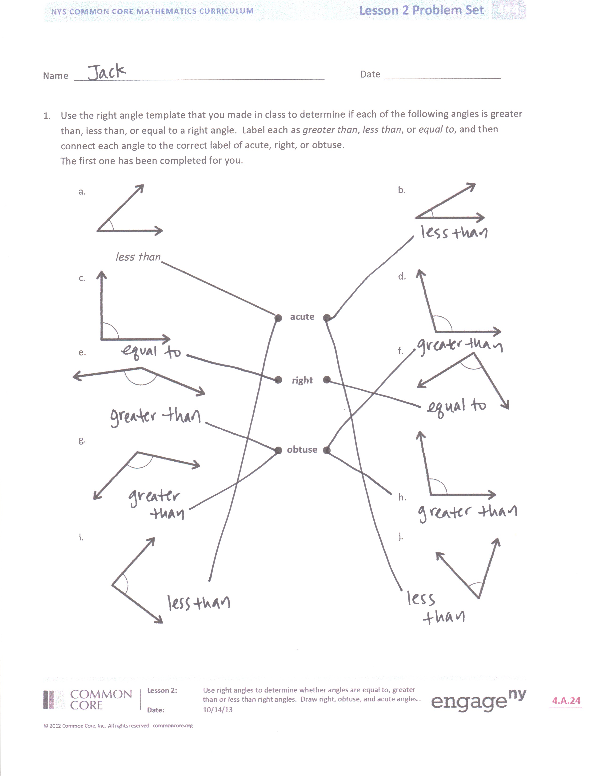Problem Set (10 minutes)

Students should do their personal best to complete the Problem Set within the allotted 10 minutes. For some classes, it may be appropriate to modify the assignment by specifying which problems they work on first. Some problems do not specify a method for solving. Students should solve these problems using the RDW approach used for Application Problems.

Student Debrief (10 minutes)

**Lesson Objective:** Use right angles to determine whether angles are equal to, greater than, or less than right angles. Draw right, obtuse, and acute angles.

The Student Debrief is intended to invite reflection and active processing of the total lesson experience.

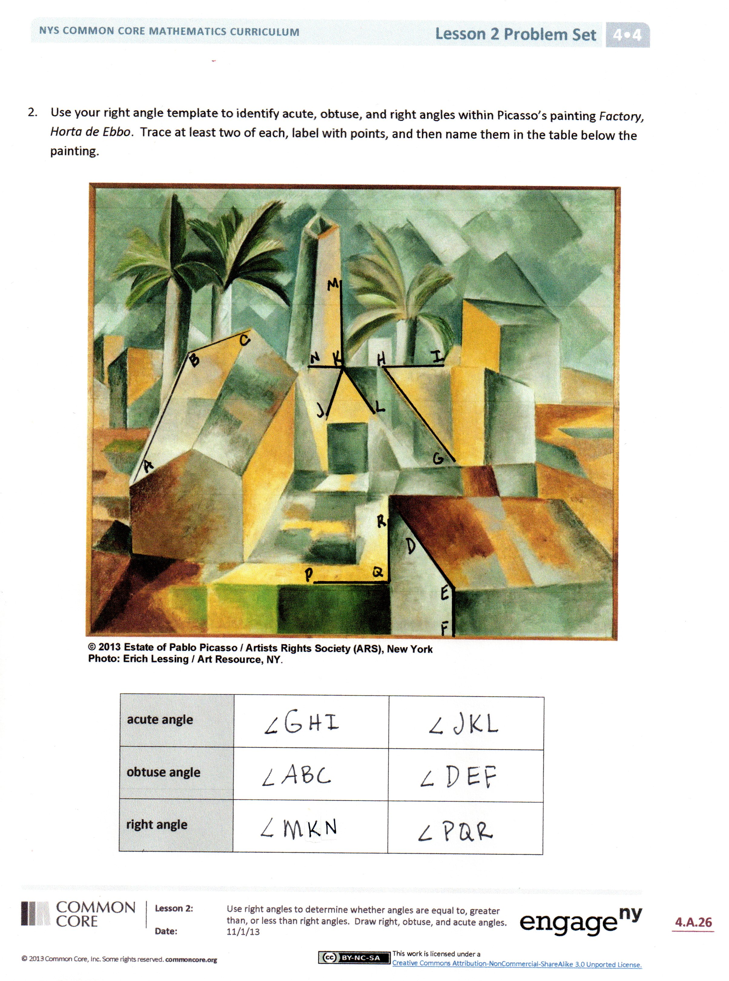Invite students to review their solutions for the Problem Set. They should check work by comparing answers with a partner before going over answers as a class. Look for misconceptions or misunderstandings that can be addressed in the Debrief. Guide students in a conversation to debrief the Problem Set and process the lesson.

You may choose to use any combination of the questions below to lead the discussion.

* Problems 1(c) and 1(f) are both **right angles**. Describe their position. Does the orientation of an angle determine whether it is right, acute, or obtuse?
* In Problem 3(a), each ray shared the same endpoint. The shared endpoint is called a **vertex.**  Label the points on your angles in Problem 3. Identify the vertex in Problems 3(b) and 3(c) with your partner.
* When we first found **obtuse angles**, we said that all of our examples were angles greater than a right angle, but then you learned a **straight angle** is a straight line. How did your understanding of the term *obtuse angle* grow? How did that understanding help you draw your angle for Problem 3(c)? What is the difference between a straight angle and a line?
* Where else in your environment have you seen right angles?

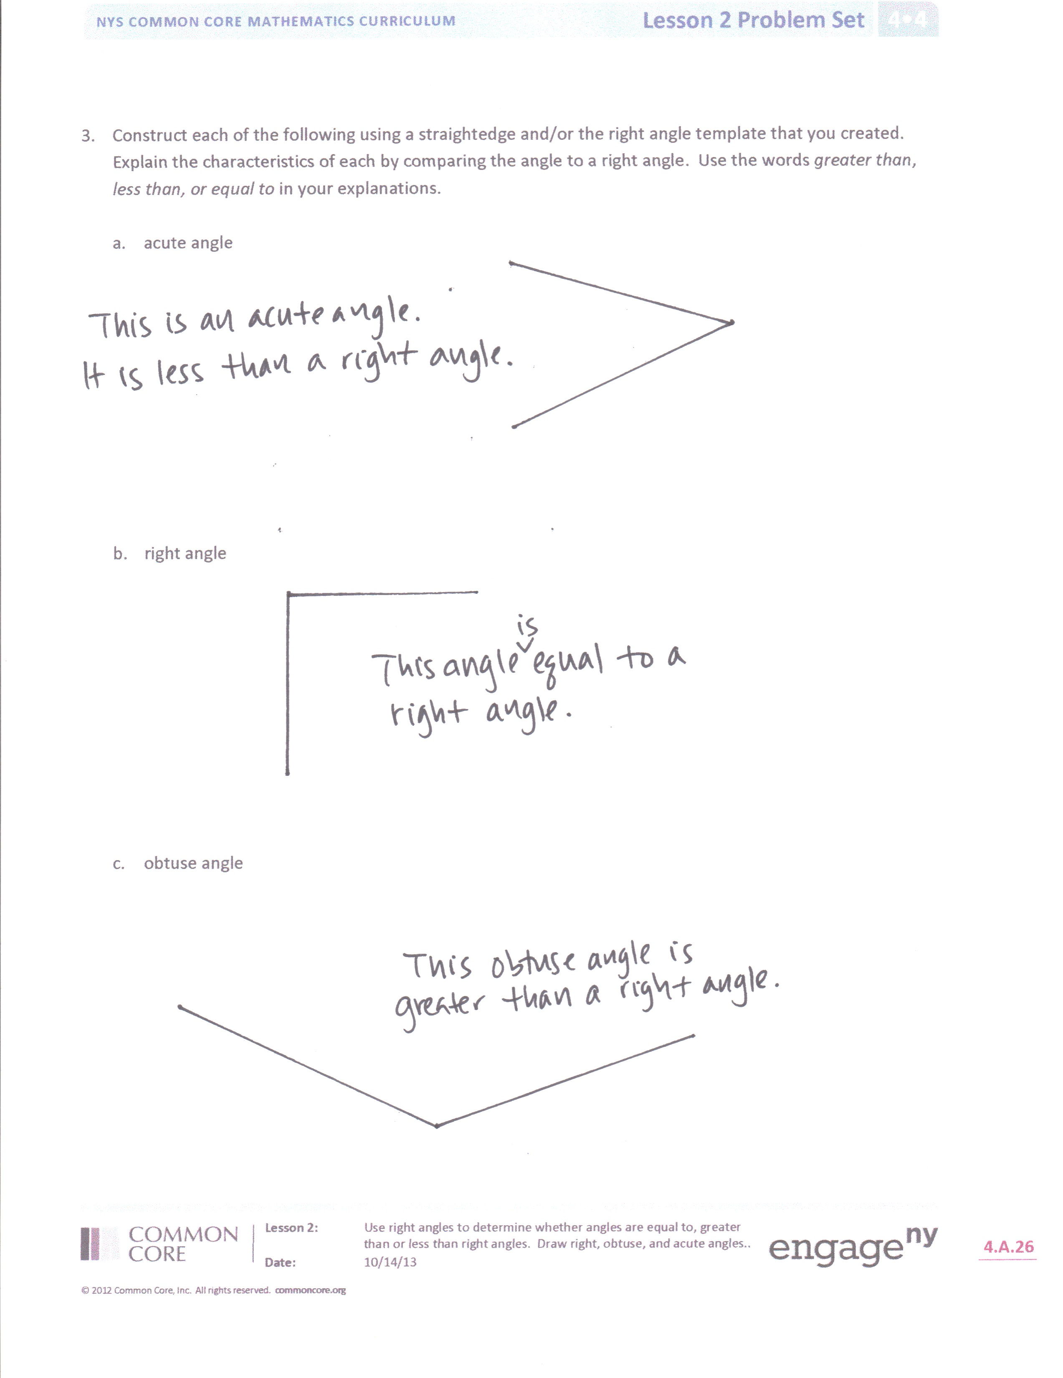

* How did the right angle template help you recognize and draw angles? How can a right angle template help you recognize an **acute angle**?
* How does the right angle template help you visualize the **interior of an angle**? Where would I find the interior of an angle that I’ve drawn? What does the exterior of an angle refer to?

Exit Ticket (3 minutes)

After the Student Debrief, instruct students to complete the Exit Ticket. A review of their work will help you assess the students’ understanding of the concepts that were presented in the lesson today and plan more effectively for future lessons. You may read the questions aloud to the students.

Name Date

1. Use the right angle template that you made in class to determine if each of the following angles is greater than, less than, or equal to a right angle. Label each as *greater than*, *less than*, or *equal to*, and then connect each angle to the correct label of acute, right, or obtuse.

The first one has been completed for you.

|  |  |  |
| --- | --- | --- |
| 1. Macintosh HD:Users:hapless:Documents:! Common Core, Inc:! G4-M4:Some Angles:45.png   *Less than* |  | 1. Macintosh HD:Users:hapless:Documents:! Common Core, Inc:! G4-M4:Some Angles:30.png |
| 1. Macintosh HD:Users:hapless:Documents:! Common Core, Inc:! G4-M4:Some Angles:90.png | **Acute**  **Right**  **Obtuse** | 1. Macintosh HD:Users:hapless:Documents:! Common Core, Inc:! G4-M4:Some Angles:105.png |
| 1. Macintosh HD:Users:hapless:Documents:! Common Core, Inc:! G4-M4:Some Angles:150.png |  | 1. Macintosh HD:Users:hapless:Documents:! Common Core, Inc:! G4-M4:Some Angles:90.png |
| 1. Macintosh HD:Users:hapless:Documents:! Common Core, Inc:! G4-M4:Some Angles:120.png |  | 1. Macintosh HD:Users:hapless:Documents:! Common Core, Inc:! G4-M4:Some Angles:100.png |
| 1. Macintosh HD:Users:hapless:Documents:! Common Core, Inc:! G4-M4:Some Angles:85.png |  | 1. Macintosh HD:Users:hapless:Documents:! Common Core, Inc:! G4-M4:Some Angles:60.png |
|  |  |  |

1. Use your right angle template to identify acute, obtuse, and right angles within Picasso’s painting *Factory, Horta de Ebbo*. Trace at least two of each, label with points, and then name them in the table below the painting.



**© 2013 Estate of Pablo Picasso / Artists Rights Society (ARS), New York**

**Photo: Erich Lessing / Art Resource, NY**.

|  |  |  |
| --- | --- | --- |
| **Acute angle** |  |  |
| **Obtuse angle** |  |  |
| **Right angle** |  |  |

1. Construct each of the following using a straightedge and the right angle template that you created. Explain the characteristics of each by comparing the angle to a right angle. Use the words *greater than*, *less than,* or *equal to* in your explanations.
   1. Acute angle
   2. Right angle
   3. Obtuse angle

Name Date

1. Fill in the blanks to make true statements using one of the following words: *acute, obtuse, right, straight.*
2. In class, we made a __________________ angle when we folded paper twice.
3. An __________________ angle is smaller than a right angle.
4. An __________________ angle is larger than a right angle, but smaller than a straight angle.
5. Look at the following angles.

|  |  |  |  |  |  |  |  |
| --- | --- | --- | --- | --- | --- | --- | --- |
| A | B | C | D | E | F | G | H |
| Macintosh HD:Users:hapless:Documents:! Common Core, Inc:! G4-M4:Some Angles:45.png | Macintosh HD:Users:hapless:Documents:! Common Core, Inc:! G4-M4:Some Angles:150.png | Macintosh HD:Users:hapless:Documents:! Common Core, Inc:! G4-M4:Some Angles:90.png | Macintosh HD:Users:hapless:Documents:! Common Core, Inc:! G4-M4:Some Angles:30.png | Macintosh HD:Users:hapless:Documents:! Common Core, Inc:! G4-M4:Some Angles:120.png |  | Macintosh HD:Users:hapless:Documents:! Common Core, Inc:! G4-M4:Some Angles:90.png |  |

1. Which angles are right angles? _________________________________________________
2. Which angles are obtuse angles? _________________________________________________
3. Which angles are acute angles? _________________________________________________
4. Which angles are straight angles? _________________________________________________

Name Date

1. Use the right angle template that you made in class to determine if each of the following angles is greater than, less than, or equal to a right angle. Label each as *greater than*, *less than,* or *equal to*, and then connect each angle to the correct label of acute, right, or obtuse. The first one has been completed for you.

|  |  |  |
| --- | --- | --- |
| 1. Macintosh HD:Users:hapless:Documents:! Common Core, Inc:! G4-M4:Some Angles:30.png   *Less than* |  | 1. Macintosh HD:Users:hapless:Documents:! Common Core, Inc:! G4-M4:Some Angles:85.png |
| 1. Macintosh HD:Users:hapless:Documents:! Common Core, Inc:! G4-M4:Some Angles:120.png | **Acute**  **Right**  **Obtuse** | 1. Macintosh HD:Users:hapless:Documents:! Common Core, Inc:! G4-M4:Some Angles:150.png |
| 1. Macintosh HD:Users:hapless:Documents:! Common Core, Inc:! G4-M4:Some Angles:60.png |  | 1. Macintosh HD:Users:hapless:Documents:! Common Core, Inc:! G4-M4:Some Angles:105.png |
| 1. Macintosh HD:Users:hapless:Documents:! Common Core, Inc:! G4-M4:Some Angles:90.png |  | 1. Macintosh HD:Users:hapless:Documents:! Common Core, Inc:! G4-M4:Some Angles:45.png |
| 1. Macintosh HD:Users:hapless:Documents:! Common Core, Inc:! G4-M4:Some Angles:150.png |  | 1. Macintosh HD:Users:hapless:Documents:! Common Core, Inc:! G4-M4:Some Angles:85.png |

1. Use your right angle template to identify acute, obtuse, and right angles within this painting.

Trace at least two of each, label with points, and then name them in the table below the painting.



|  |  |  |
| --- | --- | --- |
| **Acute angle** |  |  |
| **Obtuse angle** |  |  |
| **Right angle** |  |  |

1. Construct each of the following using a straightedge and the right angle template that you created. Explain the characteristics of each by comparing the angle to a right angle. Use the words *greater than*, *less than,* or *equal to* in your explanations.
   1. Acute angle
   2. Right angle
   3. Obtuse angle

B

J

F

D

H

I

C

A

G

E

[1]

1. angles