Lesson 38
Objective: Transition from four partial products to the standard algorithm for two-digit by two-digit multiplication.

Suggested Lesson Structure
 Fluency Practice (10 minutes)
 Application Problem (5 minutes)
 Concept Development (35 minutes)
 Student Debrief (10 minutes)
Total Time (60 minutes)
Fluency Practice (10 minutes)
- Decompose 90 and 180 4.MD.7 (4 minutes)
- Multiply by Multiples of 10 Written Vertically 4.NBT.5 (6 minutes)

Decompose 90 and 180 (4 minutes)
Materials: (S) Personal white board
Note: This fluency activity prepares students for composing and decomposing benchmark angles of 90 and 180 degrees in Module 4.
T: (Project a number bond with a whole of 90 and a part of 10.) On your personal white boards, fill in the unknown part in the number bond.
S: (Fill in 80.)
T: (Write 90 – 10 = .) Say the subtraction sentence.
S: 90 – 10 = 80.
Continue decomposing 90, taking away the following possible suggested parts: 20, 30, 85, 40, 45, 25, 35, and 15.
Repeat the process, taking away the following possible suggested parts from 180: 10, 100, 90, 70, 150, 60, 5, 15, 75, 65, and 45.

Multiply by Multiples of 10 Written Vertically (6 minutes)
Materials: (S) Personal white board
Note: This fluency activity reviews Lesson 35's content.
T: Solve 20 × 67 vertically as you say the unit form: 2 tens times 7 ones plus 2 tens times 6 tens. You have one minute. If you finish early, go on to 20 × 78.
T: (Allow students a minute to work.) 2 tens times 7 ones is?
S: 14 tens. (Write 140.)
T: 2 tens times 6 tens is?
S: 12 hundreds. (Write 1,200.)
T: The sum of 140 and 1,200 is?
S: 1,340.
T: 20 groups of 67 is?
S: 1,340.
Continue with the following possible sequence: 20 × 78, 30 × 45, 30 × 67, and 40 × 75.
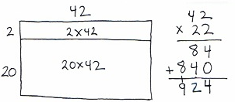
Application Problem (5 minutes)
Sandy’s garden has 42 plants in each row. She has 2 rows of yellow corn and 20 rows of white corn.
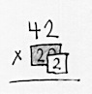
Draw an area model (representing two partial products) to show how much yellow corn and white corn has been planted in the garden.

NOTES ON
MULTIPLE MEANS
OF ACTION AND EXPRESSION:
When multiplying two-digit by two-digit numbers, use place value cards (e.g., Hide Zero cards) to represent the factors. The cards provide a concrete representation of the place value of each digit within the factors and are another way to promote understanding of the multiplication algorithm.

Note: This problem revisits the area model that focuses on two partial products in preparation for work with the standard algorithm. The area model used in the Application Problem will be used in Problem 1 of the Concept Development.
Concept Development (35 minutes)
Materials: (S) Personal white boards
Problem 1: Represent 22 × 42 with the distributive property and connect the two partial products to the standard algorithm.
T: Look at the model you drew in the Application Problem. We found the total for 22 rows of 42, or 22 forty-twos. What multiplication expression is that?
S: 22 × 42.
T: Write 22 × 42 vertically. 22 units of 42.
T: Which expression represents the first of the two partial products that we recorded?
S: 2 × 42.
T: 2 ones times 2 ones equals?
S: 4 ones.
T: Let’s record the 4 ones in the ones place.
T: 2 ones times 4 tens equals?
S: 8 tens.
T: Let’s record the 8 tens in the tens place. What’s the first partial product?
S: 84.
T: Draw an arrow to the area model to show where the partial product is represented.
T: In unit form, which expression represents the second of the two partial products that we recorded?
S: 2 tens × 4 tens 2 ones.
T: Let’s solve.
T: What is 2 tens times 2 ones?
S: 4 tens.
T: Let’s record 4 tens as 40 to start the second partial product. (Model.)
T: 2 tens times 4 tens equals how many hundreds?
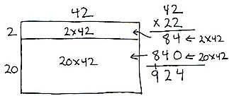
S: 8 hundreds.
T: Record 8 hundreds in the hundreds place. Draw an arrow to the area model to show where the partial product is represented.
T: What’s the second partial product?
S: 840.
T: Find the sum of the two partial products.
T: What is 22 × 42? Say the equation.
S: 22 × 42 = 924.
Problem 2: Represent 29 × 62 involving a regrouping in the first partial product.
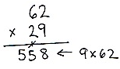
T: We want to find the value of 29 sixty-twos using the algorithm.
T: What multiplication expression will I use?
S: 29 × 62.
T: First, let’s find the value of 9 sixty-twos.
T: 9 ones times 2 ones is?
S: 18 ones.
T: Let’s record the new groups below just as we have done in the past. (Write the 1 on the line under the tens place first and the 8 in the ones place second.)
T: 9 ones times 6 tens is?
S: 54 tens.
T: (Point to the regrouped ten.) 54 tens plus 1 ten is?
S: 55 tens. Now we need to cross off the 1 ten that we regrouped.
T: What is 9 × 62?
S: 558.
T: Now let’s find the value of the second partial product, 20 sixty-twos.
T: 2 tens times 2 ones is?
S: 4 tens.
T: Record the 4 tens as 40 ones. 2 tens times 6 tens is?
S: 12 hundreds.
T: Record 12 hundreds in the second partial product. What is our second partial product?
S: 1,240.

NOTES ON
MULTIPLE MEANS
OF REPRESENTATION:
Use graph paper or a template that allows for wide rows to show how the regrouping is within the same partial product and how it relates to the value of that row. Students can then see the regrouped number is intentionally placed in the next column within the same partial product. Relate back to the place value disk model of representation as needed.
T: What is the sum of our partial products?
S: 1,798.
T: What is 29 × 62? Say the complete equation.
S: 29 × 62 = 1,798.
T: Yes, 9 sixty-twos plus 20 sixty-twos is 29 sixty-twos. The product is 1,798.
Problem 3: Solve 46 x 63 involving a regrouping in the second partial product.
T: Let’s find the value of 46 sixty-threes. Write the multiplication expression.
MP.8
S: (Write 46 × 63.)
T: Which partial product do we find first?
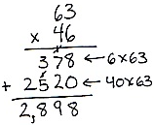
S: 6 × 63.
T: 6 ones times 3 ones is?
S: 18 ones.
T: Let’s record. (Write the 1 on the line under the tens place first and the 8 in the ones place second.)
T: What do we multiply next?
S: 6 ones times 6 tens. That’s 36 tens. When I add the 1 ten, I get 37 tens.
T: Record 37 tens. Did you remember to cross off the 1 ten? The value of 6 sixty-threes is?
S: 378.
T: Now, let’s find the value of 40 sixty-threes. What do we do first?
S: 4 tens times 3 ones equals 12 tens.
MP.8
T: 12 tens is 1 hundred 2 tens. Record the 1 hundred in the hundreds column of the second partial product. Record 2 tens as 20.
T: What do we multiply next?
S: 4 tens times 6 tens. That’s 24 hundreds.
T: The total number of hundreds is?
S: We had 24 hundreds, plus one more hundred is 25 hundreds.
T: Cross out the 1 hundred and record 25 hundreds.
T: What is the second partial product?
S: 2,520.
T: Turn and tell your partner what the next step is.
S: We add the partial products.
T: What is 46 sixty-threes?
S: 46 × 63 = 2,898.
Problem Set (10 minutes)
Students should do their personal best to complete the Problem Set within the allotted 10 minutes. For some classes, it may be appropriate to modify the assignment by specifying which problems they work on first. Some problems do not specify a method for solving. Students should solve these problems using the RDW approach used for Application Problems.
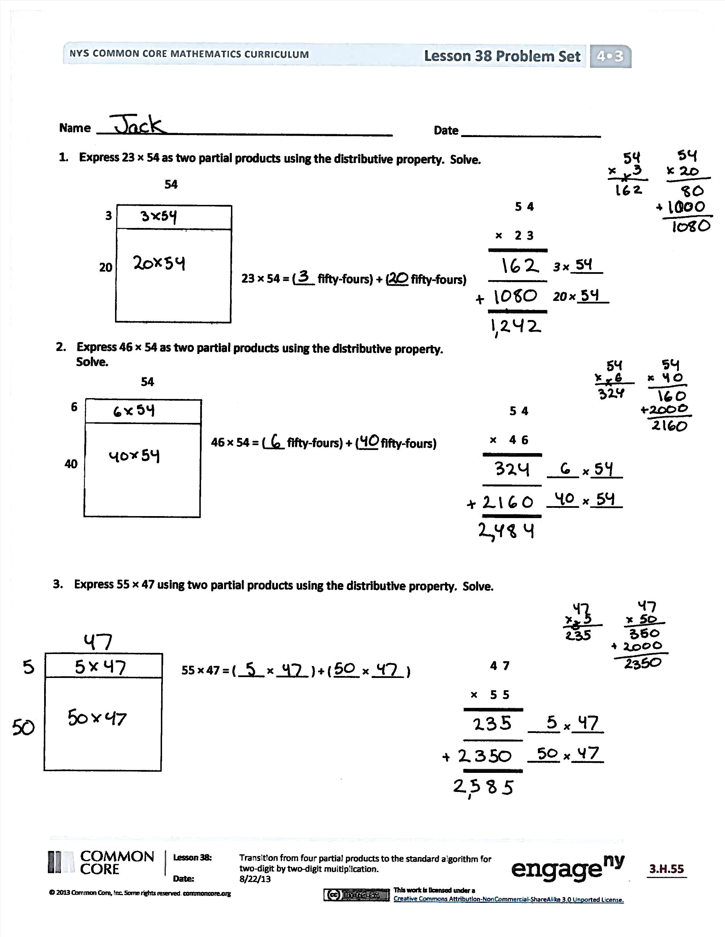
Student Debrief (10 minutes)
Lesson Objective: Transition from four partial products to the standard algorithm for two-digit by two-digit multiplication.
The Student Debrief is intended to invite reflection and active processing of the total lesson experience.
Invite students to review their solutions for the Problem Set. They should check work by comparing answers with a partner before going over answers as a class. Look for misconceptions or misunderstandings that can be addressed in the Debrief. Guide students in a conversation to debrief the Problem Set and process the lesson.
You may choose to use any combination of the questions below to lead the discussion.
- What is the relationship between the product for Problem 1 and Problem 2 of the Problem Set?
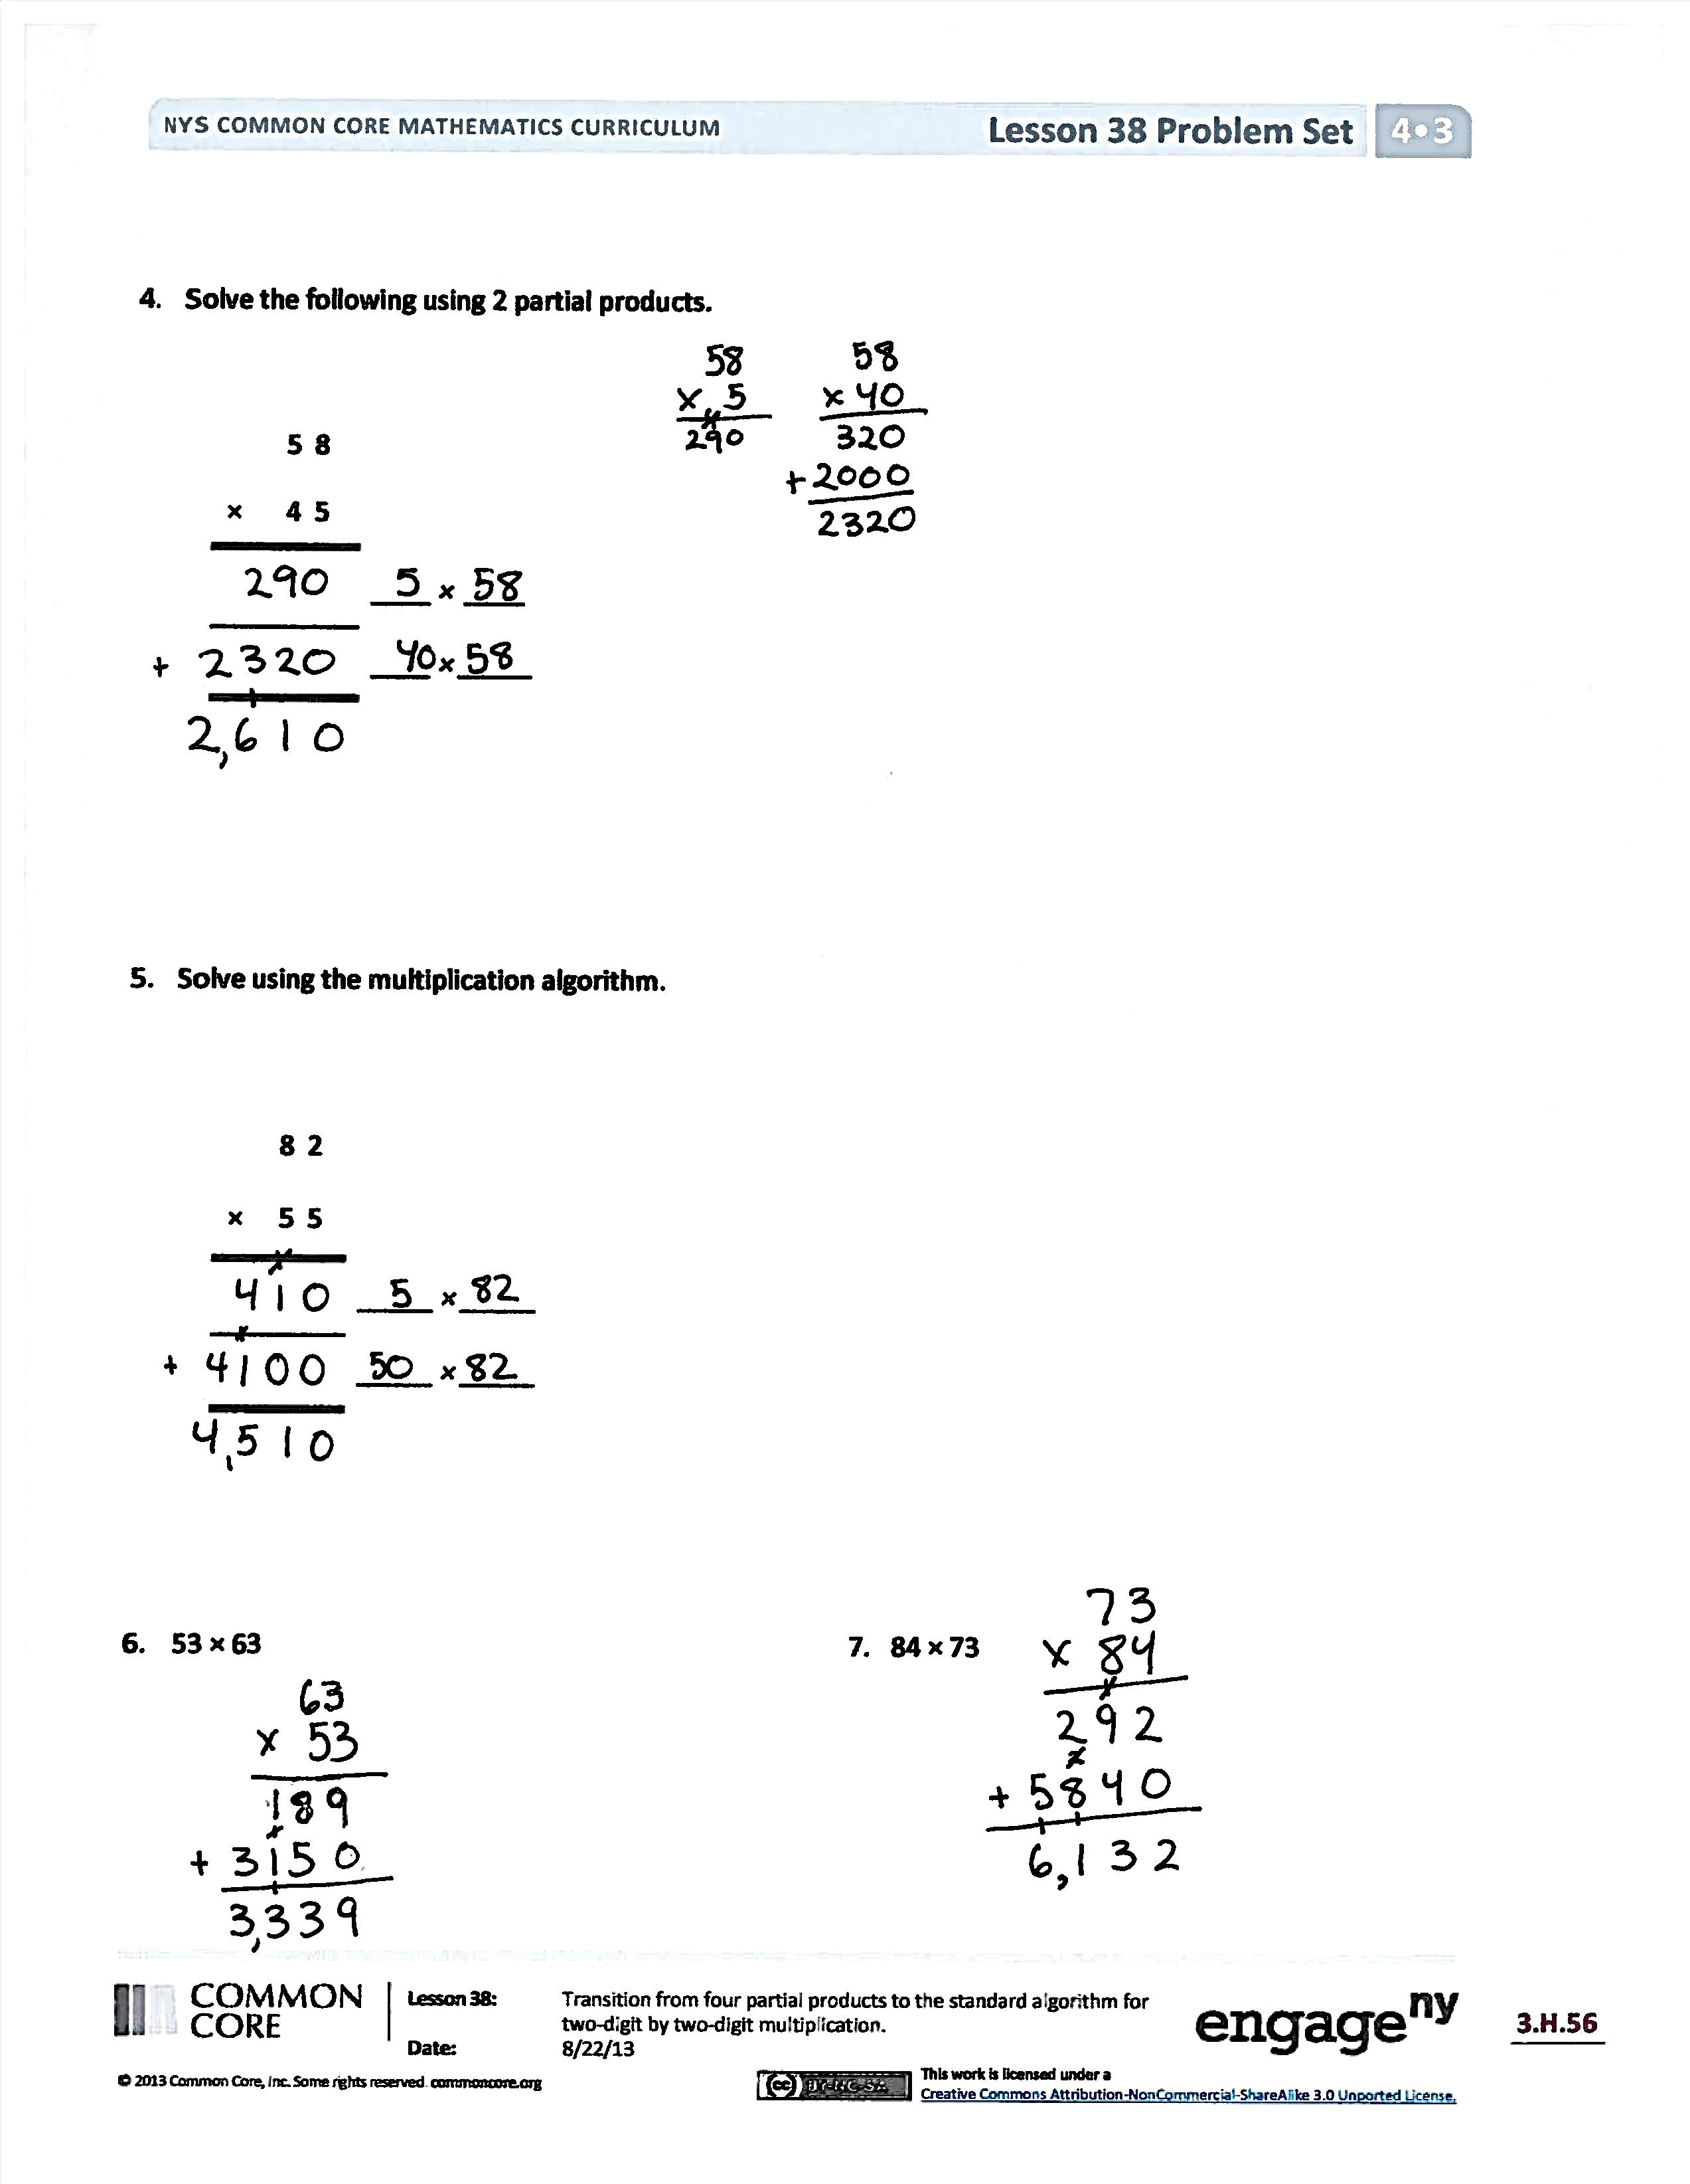
- How does the structure of determining the answers to Problems 1 and 2 help you to solve Problem 3?
- How is recording multiplication using the multiplication algorithm the same as when we solved using two partial products? How is it different?
- How did your understanding of two partial products help you to learn the multiplication algorithm?
- How is the multiplication algorithm similar to the algorithm for addition? How is it different?
- What might be an advantage of using the multiplication algorithm to multiply?
- Explain to your partner how to multiply using the multiplication algorithm.
- What new (or significant) math vocabulary did we use today to communicate precisely?
- How did the Application Problem connect to today’s lesson?
Exit Ticket (3 minutes)
After the Student Debrief, instruct students to complete the Exit Ticket. A review of their work will help you assess the students’ understanding of the concepts that were presented in the lesson today and plan more effectively for future lessons. You may read the questions aloud to the students.

Name Date
- Express 23 × 54 as two partial products using the distributive property. Solve.
 | 5 4
× | 2 3
 |  | 3 × _____
 |  | 20 × _____
20
3
54

23 × 54 = (___ fifty-fours) + (___ fifty-fours)

- Express 46 × 54 as two partial products using the distributive property. Solve.
40
6
54
 | 5 4
× | 4 6
 |  | _____ × _____
 |  | _____ × _____

46 × 54 = (___ fifty-fours) + (___ fifty-fours)

 | 4 7
× | 5 5
 |  | _____ × _____
 |  | _____ × _____

3. Express 55 × 47 as two partial products using the distributive property. Solve.

55 × 47 = ( ____ × _____ ) + ( ____ × _____ )

- Solve the following using 2 partial products.
 | 5 8
× | 4 5
 |  | ____ × ____
 |  | ____ × _____

- Solve using the multiplication algorithm.

 | 8 2
× | 5 5
 |  | _____ × _____
 |  | _____ × _____

- 53 × 63 7. 84 × 73

Name Date
Solve using the multiplication algorithm.

 | 7 2
× | 4 3
 |  | ____ × ____
 |  | ____ × _____

- 35 × 53

Name Date
- Express 26 × 43 as two partial products using the distributive property. Solve.
 | 4 3
× | 2 6
 |  | 6 × _____
 |  | 20 × _____
20
6
43

26 × 43 = (_____ forty-threes) + (____ forty-threes)

- Express 47 × 63 as two partial products using the distributive property. Solve.
 | 6 3
× | 4 7
 |  | _____ × _____
 |  | _____ × _____
40
7
63

47 × 63 = (____ sixty-threes) + (____ sixty-threes)

- Express 54 × 67 as two partial products using the distributive property. Solve.
 | 6 7
× | 5 4
 |  | _____ × _____
 |  | _____ × _____

54 × 67 = (___×____) + (___×____)

- Solve the following using two partial products.

 | 5 2
× | 3 4
 |  | ____ × ____
 |  | ____ × _____

- Solve using the multiplication algorithm.

 | 8 6
× | 5 6
 |  | _____ × _____
 |  | _____ × _____

- 54 × 52 7. 44 × 76

- 63 × 63 9. 68 × 79

