Lesson 36

Objective: Multiply two-digit by two-digit numbers using four partial products.

Suggested Lesson Structure

 Fluency Practice (12 minutes)

 Application Problem (6 minutes)

 Concept Development (32 minutes)

 Student Debrief (10 minutes)

**Total Time (60 minutes)**

Fluency Practice (12 minutes)

* Draw a Unit Fraction **3.G.2**  (4 minutes)
* Divide Three Different Ways **4.NBT.6** (4 minutes)
* Multiply by Multiples of 10 Written Vertically **4.NBT.5** (4 minutes)

Draw a Unit Fraction (4 minutes)

Materials: (S) Personal white board

Note: This fluency activity reviews Grade 3 geometry and fraction concepts in anticipation of Modules 4 and 5. Accept reasonable drawings. Using rulers is not necessary to review the concept and will take too long.

T: On your personal white boards, write the name for any four-sided figure.

S: (Write *quadrilateral*.)

T: Draw a quadrilateral that has 4 right angles and 4 equal sides.

S: (Draw a square.)

T: Partition the square into 4 equal parts.

S: (Partition.)

T: Shade in 1 of the parts.

S: (Shade.)

T: Write the fraction of the square that you shaded.

S: (Write .)

Continue with the following possible sequence: Partition a rectangle into 5 equal parts, shading ; partition   
a rhombus into 2 equal parts, shading ; partition a square into 12 equal parts, shading ; and partition a rectangle into 8 equal parts, shading .

Divide Three Different Ways (4 minutes)

Materials: (S) Personal white board

Note: This fluency activity reviews Lessons 32 and 33.

T: (Write 406 ÷ 7.) Find the quotient using place value disks.

T: Find the quotient using the area model.

T: Find the quotient using the standard algorithm.

Repeat using 3,168 ÷ 9.

Multiply by Multiples of 10 Written Vertically (4 minutes)

Materials: (S) Personal white board

Note: This fluency activity reviews Lesson 35’s content.

T: (Write 30 × 23 vertically.) When I write 30 × 23, you say "3 tens times 3 ones plus 3 tens times 2 tens." (Point to the corresponding expressions as students speak.)

S: 3 tens times 3 ones + 3 tens times 2 tens.

T: Write and solve the entire equation vertically.

T: What is 30 times 23?

S: 690.

Continue with the following possible sequence: 30 × 29, 40 × 34, and 50 × 45.

Application Problem (6 minutes)

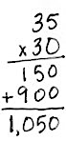

Mr. Goggins set up 30 rows of chairs in the gymnasium. If each row had 35 chairs, how many chairs did Mr. Goggins set up? Draw an area model to represent and to help solve this problem. Discuss with a partner how the area model can help you solve 30 × 35.

Note: This Application Problem builds on prior learning from Lesson 35 where students used an area model and partial products to multiply a two-digit multiple of 10 by a two-digit number using an area model. This Application Problem also helps bridge to today’s lesson in that students will apply prior knowledge of the area model and partial products to represent and solve two-digit by two-digit multiplication.

Concept Development (32 minutes)

|  |  |
| --- | --- |
|  | NOTES ON MULTIPLE MEANS OF ENGAGEMENT: |

Lead a discussion with students in order to deepen their understanding of representing expressions in numerical form and unit form. Be sure that students understand that there are different ways to express numbers in both written and oral form.

Materials: (S) Personal white board

Problem 1: Use the distributive property to represent and solve two-digit by two-digit multiplication.

T: (Use the context of the Application Problem to continue with today’s lesson.) Mr. Goggins set up an additional 4 rows of chairs with 35 chairs in each row. Let’s change our area model to represent the additional rows. (Revise the area model.)

T: What is the length of this entire side? (Point to the vertical length.)

S: 34.

T: And the length of this side? (Point to the horizontal length.)

S: 35.

T: Use the area formula. What expression is shown by the area model now?

S: 34 × 35.

T: We can use the area model to help us represent two-digit times two-digit multiplication. Write the expressions that represent the areas of the two smaller rectangles that we just created.

**MP.4**

S: 4 × 5 and 4 × 30.

T: Let’s say the expressions in unit form to help us understand their value. Using the units for each factor, say 4 × 5 and 4 × 30 in unit form.

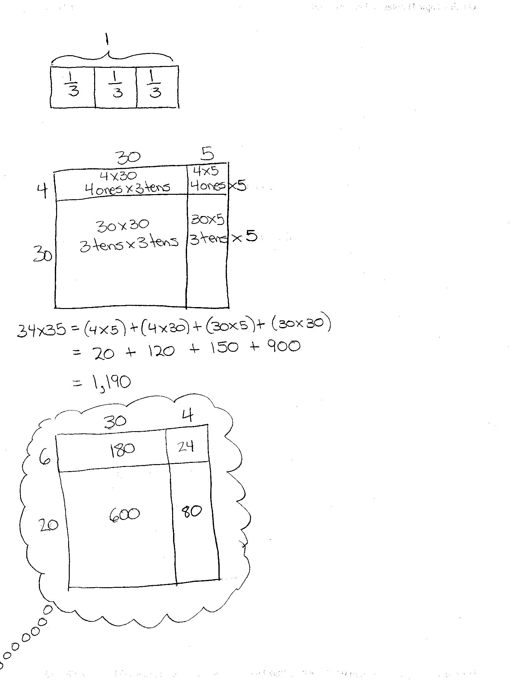

S: 4 ones × 5 ones and 4 ones × 3 tens.

T: Write those unit expressions in each rectangle. How can we use these expressions and the expressions of the other two rectangles to find the area of the whole rectangle?

S: We can find the sum of all of the smaller areas.

T: Let’s represent this using the distributive property. We are going to move from top to bottom, right to left to represent the areas of the smaller rectangles. You tell me the numerical expressions as I point to each of the smaller rectangles. I will write what you say. 34 × 35 equals…?

S: 34 × 35 = (4 × 5) + (4 × 30) + (30 × 5) + (30 × 30).

T: Now, express this same number sentence in unit form (without rewriting).

S: 34 × 35 = (4 ones × 5 ones) + (4 ones × 3 tens) + (3 tens × 5 ones) + (3 tens × 3 tens).

T: Now, we are ready to solve! First, let’s find each of the four partial products. Then, we can add the four partial products to find 34 × 35.

S: 20 ones + 12 tens + 15 tens + 9 hundreds = 20 + 120 + 150 + 900 = 1,190.

Problem 2: Find the product of 23 and 31 using an area model and partial products to solve.

T: Let’s solve 23 × 31 using area to model the product.

T: (Draw a rectangle.) Break down the length and width according to place value units.

S: 2 tens 3 ones and 3 tens 1 one. 🡪 20 and 3. 30 and 1.

T: (Draw one vertical and one horizontal line subdividing the rectangle.) Turn and tell your partner the length and width of each of the 4 smaller rectangles we just created.

S: 3 and 1, 3 and 30, 20 and 1, and 20 and 30.

T: Using the area model that you just drew, write an equation that represents the product of 23 and 31 as the sum of those four areas.

|  |  |
| --- | --- |
|  | NOTES ON MULTIPLE MEANS OF REPRESENTATION: |
| Students working below grade level may benefit from continuing to write out the expressions used to find each of the partial products. Students may write the expressions in numerical form or in unit form.  To help solidify place value, it might also be helpful to have students shade, in different colors, the rectangles that represent the ones, tens, and hundreds.  Students working above grade level may be ready to use the four partial product algorithm and can be encouraged to do so. | |

S: 23 × 31 = (3 × 1) + (3 × 30) + (20 × 1) + (20 × 30).

T: Now, we are ready to solve!

T: Let’s look at a way to record the partial products. (Write 23 × 31 vertically.) Recall that when we multiplied a one-digit number by a two-, three-, or four-digit number, we recorded the partial products. We also recorded partial products when we multiplied a two-digit number by a multiple of 10. Let’s put it all together and do precisely the same thing here.

T: (Point to the area model and the expression showing the distributive property.) What is the product of 3 ones and 1 one?

S: 3 ones.

T: Record the product below. Draw an arrow connecting the rectangle with the corresponding partial product. How about 3 ones times 3 tens?

S: 9 tens.

T: Record the product below the first partial product. Draw an arrow connecting the rectangle with the corresponding partial product. What is 2 tens times 1 one?

S: 2 tens or 20.

T: As before, record the partial product below the other two and do the same with 2 tens times 3 tens.

T: Draw arrows to connect the new partial products with the corresponding rectangles. Now, let’s add the partial products together. What is the sum?

S: The sum is 713. That means that 23 × 31 = 713.

Problem 3: Find the product of 26 and 34 using partial products. Verify partial products using the area model.

T: Draw an area model to represent 26 × 34.

T: How do I find the area of the smallest rectangle?

S: Multiply 6 ones times 4 ones.

T: Point to 6 ones times 4 ones in the algorithm. What is 6 ones times 4 ones?

S: 24 ones.

T: Record 24 beneath the expression and in the corresponding area.

T: Point to the next area to solve for. Tell me the expression.

S: 6 ones times 3 tens.

T: Locate those numbers in the algorithm. Solve for 6 ones times 3 tens.

S: 18 tens.

T: Record 18 tens under the expression.

S: We can also record 18 tens in this rectangle.

Continue connecting the width and length of each rectangle in the model to the location of those units in the algorithm. Record the partial products first under the expression and then inside the area.

T: What is the last step?

S: Add together all of the partial products. 24 + 180 + 80 + 600 = 884. 🡪 26 × 34 = 884.

Problem 4: Find the product of 26 and 34 without using an area model. Record the partial products to solve.

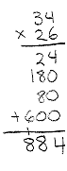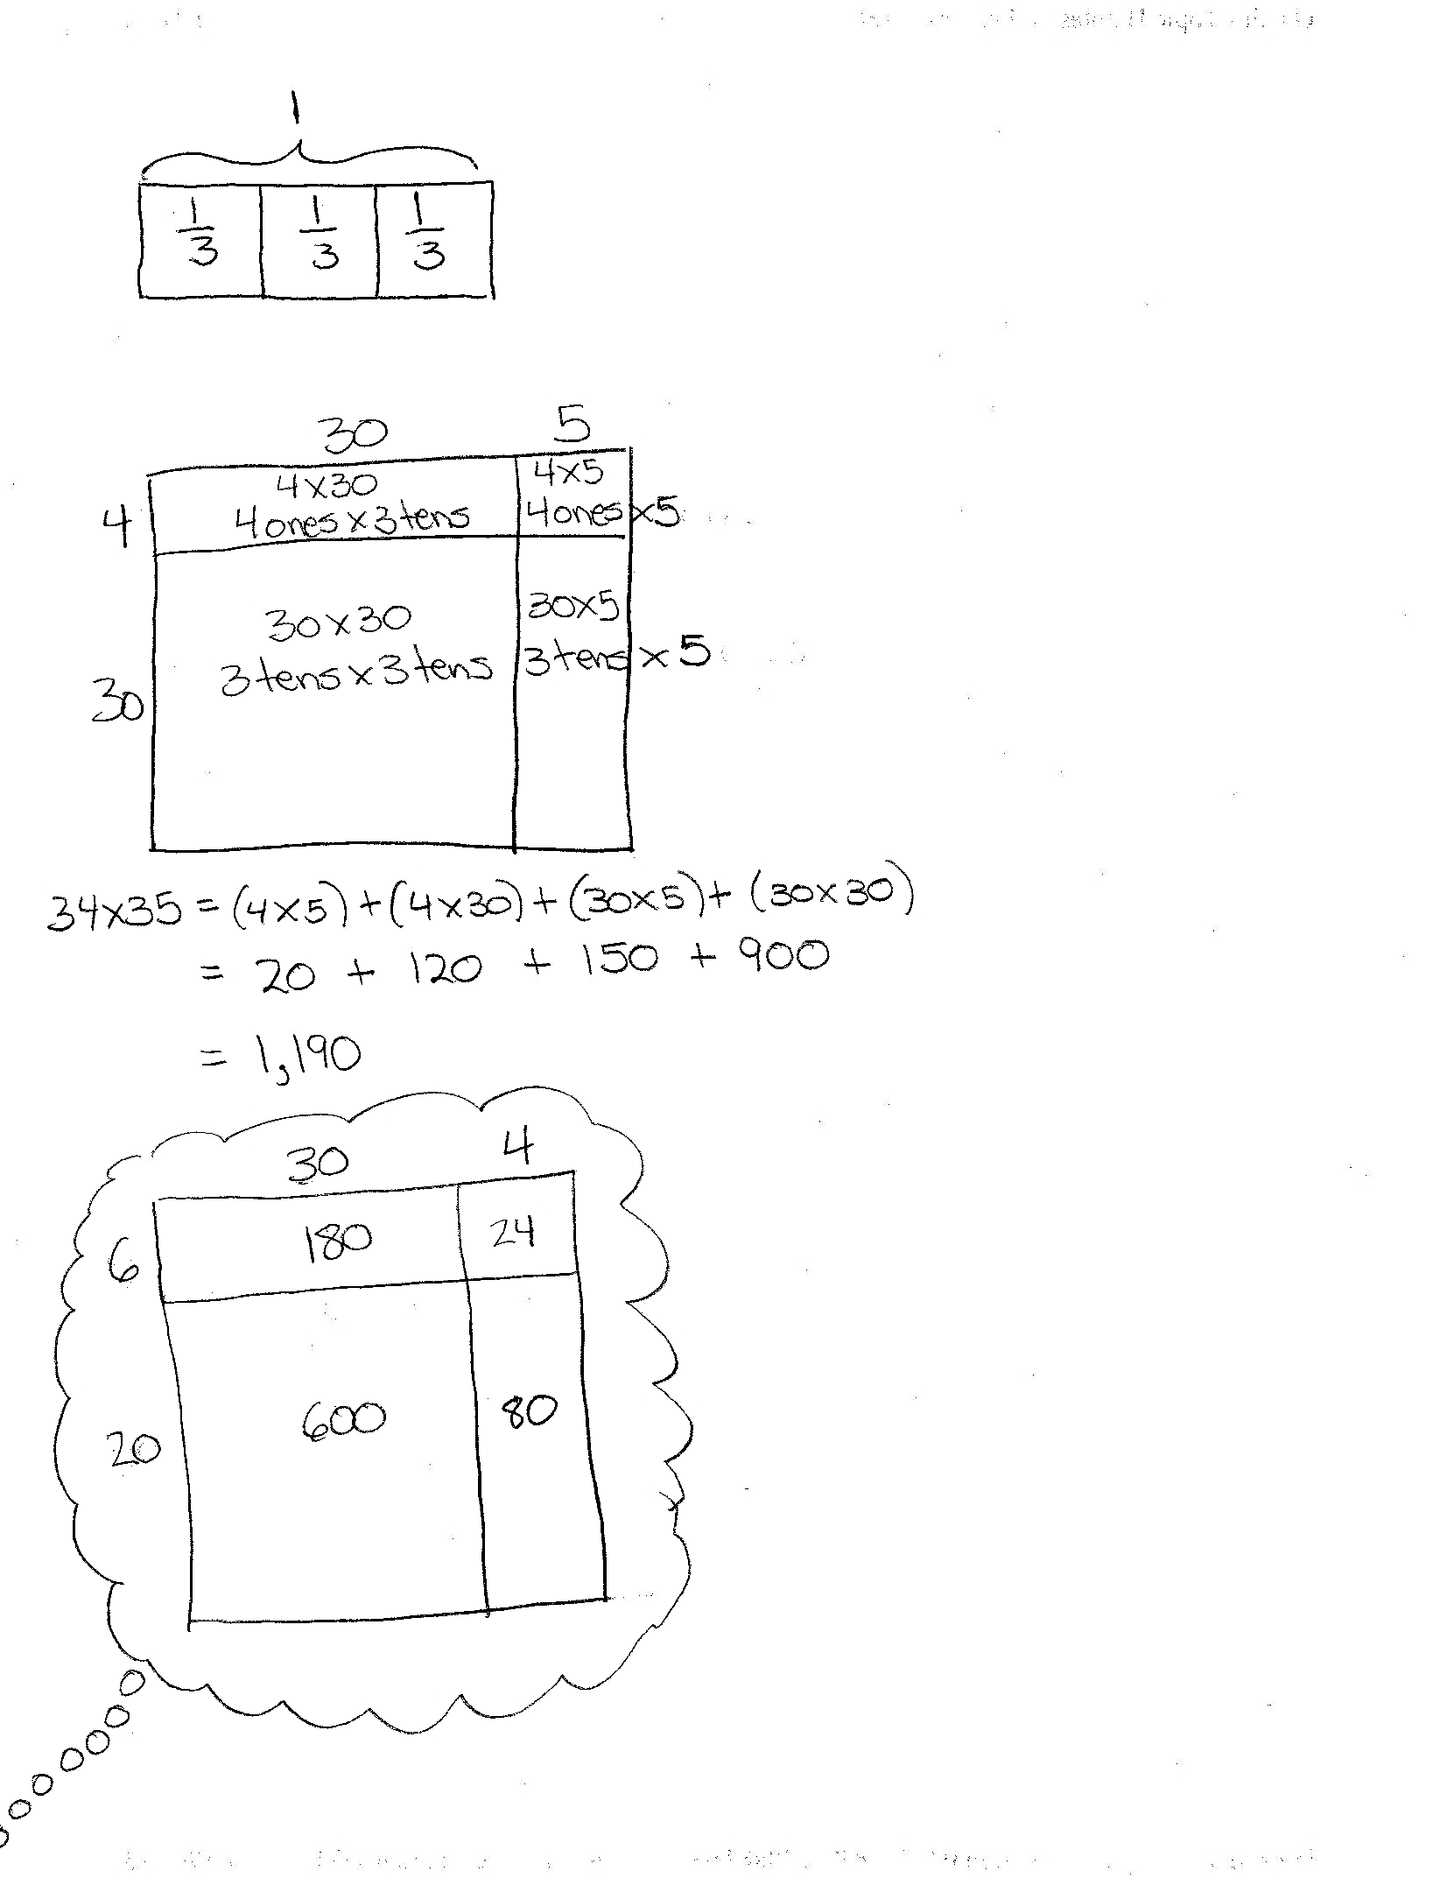

T: Take a mental picture of your area model before you erase it, the partial products, and the final product.

T: When we multiplied these numbers before, with what did we start?

S: 6 ones × 4 ones.

T: Do you see 6 ones × 4 ones?

S: Yes.

Students point to 6 ones × 4 ones. You might model on the board as students also record.

T: What is 6 ones × 4 ones?

S: 24 ones.

T: Record 24 ones as a partial product.

T: What did we multiply next?

S: 6 ones × 3 tens. That’s 18 tens or 180.

T: Where do we record 180?

S: Below the 24.

T: Now what?

S: We multiply the tens. 2 tens × 4 ones and then 2 tens × 3 tens.

T: What are 2 tens × 4 ones and 2 tens × 3 tens?

S: 8 tens and 6 hundreds.

T: Let’s record these as partial products. Notice that we have four partial products. Let’s again identify from where they came. (Point to each part of the algorithm as students chorally read the expressions used to solve the two-digit by two-digit multiplication.)

S: 6 ones × 4 ones = 24 ones. 6 ones × 3 tens = 18 tens. 2 tens × 4 ones = 8 tens. 2 tens × 3 tens = 6 hundreds.

T: What is their sum?

S: 24 + 180 + 80 + 600 = 884. 🡪 26 × 34 = 884.

T: Visualize to relate this back to the area model that we drew earlier.

Repeat for 38 × 43. You might first draw the area model (without multiplying out the partial products) and then erase it so that students again visualize the connection.

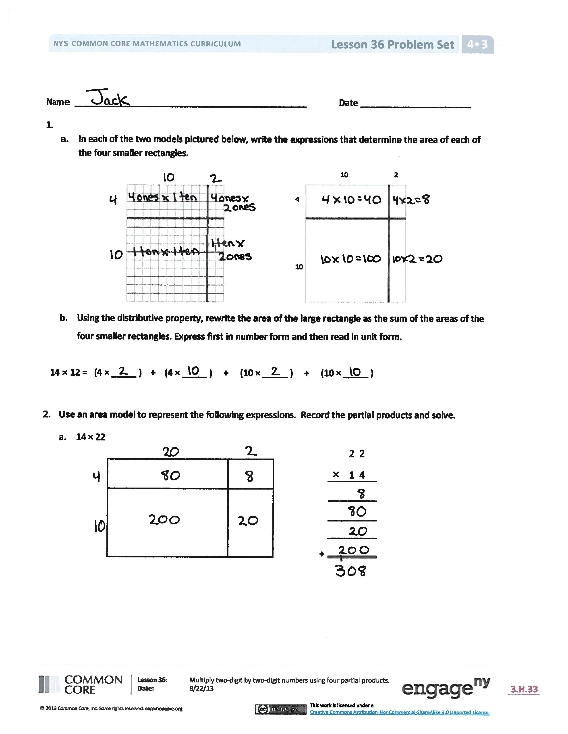Problem Set (10 minutes)

Students should do their personal best to complete the Problem Set within the allotted 10 minutes. For some classes, it may be appropriate to modify the assignment by specifying which problems they work on first. Some problems do not specify a method for solving. Students should solve these problems using the RDW approach used for Application Problems.

Student Debrief (10 minutes)

**Lesson Objective:** Multiply two-digit by two-digit numbers using four partial products.

The Student Debrief is intended to invite reflection and active processing of the total lesson experience.

Invite students to review their solutions for the Problem Set. They should check work by comparing answers with a partner before going over answers as a class. Look for misconceptions or misunderstandings that can be addressed in the Debrief. Guide students in a conversation to debrief the Problem Set and process the lesson.

You may choose to use any combination of the questions below to lead the discussion.

* How does Problem 1(a) support your understanding of the distributive property and partial products?
* 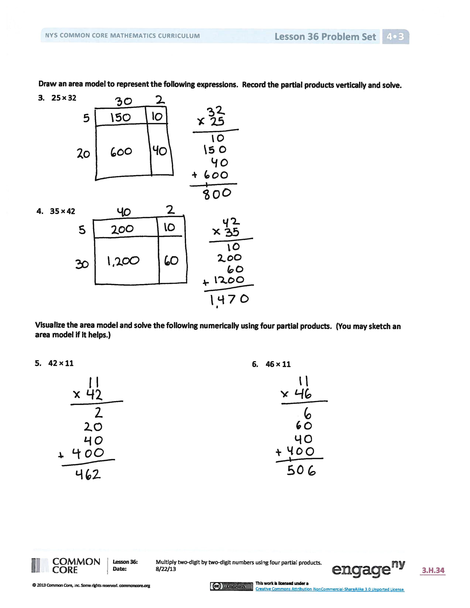How do Problems 1 and 2 help to prepare you to solve Problems 3, 4, 5, and 6?
* How did our previous work with area models and partial products help us to be ready to solve two-digit by two-digit multiplication problems using partial products?
* How is it helpful to think about the areas of each rectangle in terms of *units*?
* How could you explain to someone that   
  *ones* × *tens* equals *tens* but *tens* × *tens* equals *hundreds*?
* What significant math vocabulary did we use today to communicate precisely?
* How did the Application Problem connect to today’s lesson?

Exit Ticket (3 minutes)

After the Student Debrief, instruct students to complete the Exit Ticket. A review of their work will help you assess the students’ understanding of the concepts that were presented in the lesson today and plan more effectively for future lessons. You may read the questions aloud to the students.

Name Date

* 1. In each of the two models pictured below, write the expressions that determine the area of each of the four smaller rectangles.

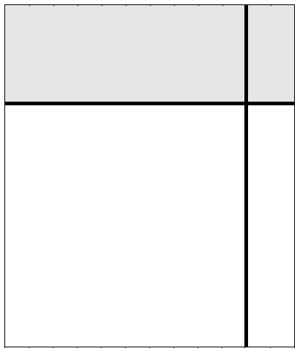

10 2

4

10

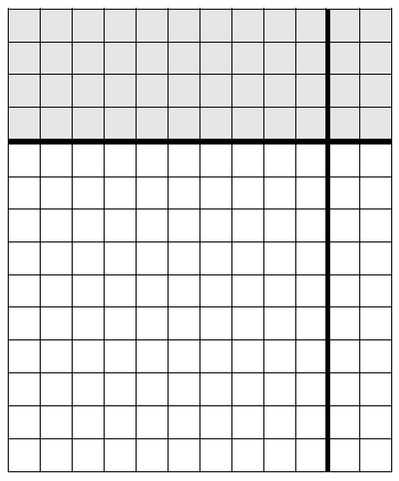

* 1. Using the distributive property, rewrite the area of the large rectangle as the sum of the areas of the four smaller rectangles. Express first in number form and then read in unit form.

14 × 12 = (4 × _____ ) + (4 × _____ ) + (10 × _____ ) + (10 × _____ )

1. Use an area model to represent the following expression. Record the partial products and solve.

|  |  |
| --- | --- |
|  | 2 2 |
| × | 1 4 |
|  |  |
|  |  |
|  |  |
|  |  |
|  |  |

* 1. 14 × 22

+

Draw an area model to represent the following expressions. Record the partial products vertically and solve.

1. 25 × 32
2. 35 × 42

Visualize the area model and solve the following numerically using four partial products. (You may sketch an area model if it helps.)

1. 42 × 11 6. 46 × 11

Name Date

Record the partial products to solve.

Draw an area model first to support your work, or draw the area model last to check your work.

1. 26 × 43
2. 17 × 55

Name Date

* 1. In each of the two models pictured below, write the expressions that determine the area of each of the four smaller rectangles.



10 2

3

10

* 1. Using the distributive property, rewrite the area of the large rectangle as the sum of the areas of the four smaller rectangles. Express first in number form and then read in unit form.

13 × 12 = (3 × _____ ) + (3 × _____ ) + (10 × _____ ) + (10 × _____ )

Use an area model to represent the following expression. Record the partial products and solve.

1. 17 × 34

|  |  |
| --- | --- |
|  | 3 4 |
| × | 1 7 |
|  |  |
|  |  |
|  |  |
|  |  |
|  |  |

+

Draw an area model to represent the following expressions. Record the partial products vertically and solve.

1. 45 × 18 4. 45 × 19

Visualize the area model and solve the following numerically using four partial products. (You may sketch an area model if it helps.)

1. 12 × 47 6. 23 × 93

7. 23 × 11 8. 23 × 22