Lesson 32
Objective: Interpret and find whole number quotients and remainders to solve one-step division word problems with larger divisors of 6, 7, 8, and 9.

Suggested Lesson Structure
 Fluency Practice (12 minutes)
 Application Problem (7 minutes)
 Concept Development (31 minutes)
 Student Debrief (10 minutes)
Total Time (60 minutes)
Fluency Practice (12 minutes)
- Quadrilaterals 3.G.1 (4 minutes)
- Multiply Units 4.NBT.1 (4 minutes)
- Group Counting 4.OA.1 (4 minutes)
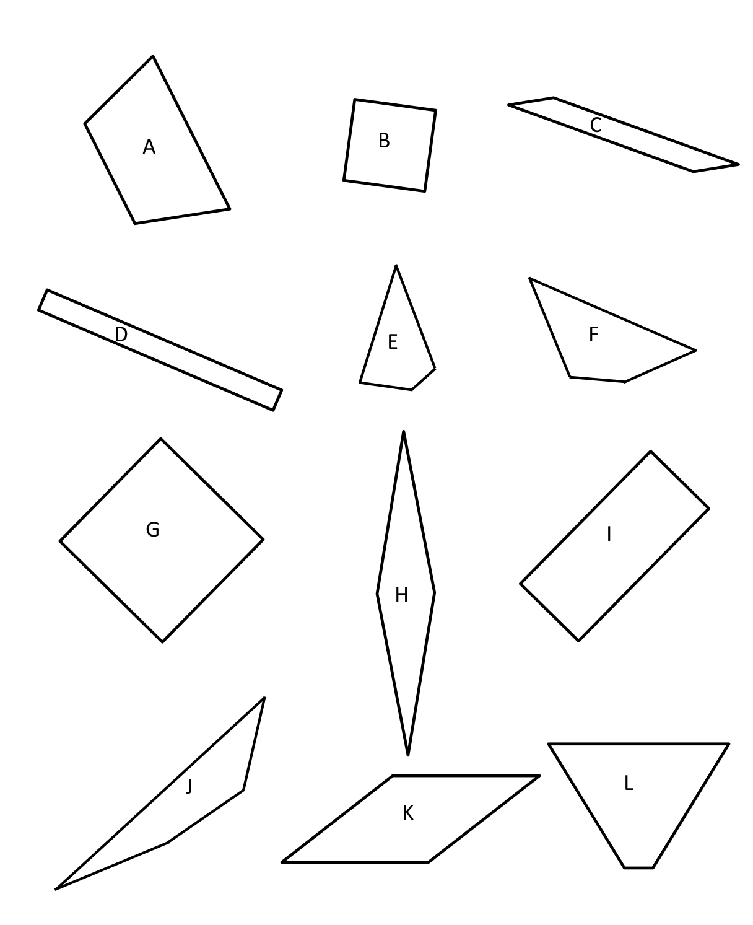
Quadrilaterals (4 minutes)
Attributes
Number of Sides
Length of Sides
Size of Angle
Right Angle

Shapes
Quadrilateral
Rhombus
Square
Rectangle
Parallelogram
Trapezoid

Materials: (T) Shapes (Fluency Template)
Note: This fluency activity reviews Grade 3 geometry concepts in anticipation of Module 4 content. The sheet can be duplicated for the students if you prefer.
T: (Project the quadrilaterals template and the list of attributes.) Take one minute to discuss the attributes of the shapes you see. You can use the list to support you.
S: Some have right angles. All have straight sides. They all have 4 sides. B and G and maybe H and K have all equal sides. I’m not really sure.
T: If we wanted to verify whether the sides are equal, what would we do?
S: Measure!
T: What about the angles? How could you verify that they’re right angles?
S: I could compare it to something that I know is a right angle.
T: (Post the shape names.) Now, look at the shape names. Determine to the best of your ability which shapes might fall into each category.
S: B and G might be squares. All of them are quadrilaterals. H and K might be rhombuses. It’s hard to know if their sides are equal. D and I are rectangles. Oh yeah, and B and G are, too.
L and A look like trapezoids.
T: Which are quadrilaterals?
S: All of them.
T: Which shapes appear to be rectangles?
S: B, D, G, and I.
T: Which appear to have opposite sides of equal length but are not rectangles?
S: C, H, K. A and L have one pair of opposite sides that look the same.
T: Squares are rhombuses with right angles. Do you see any other shapes that might have four equal sides without right angles?
S: H and K.
Multiply Units (4 minutes)
Materials: (S) Personal white board
Note: This fluency activity reviews Lesson 4’s content.
T: (Write 2 × 4 = .) Say the multiplication sentence in unit form.
S: 2 ones × 4 = 8 ones.
T: Write the answer in standard form.
S: (Write 8.)
T: (Write 20 × 4 = .) Say the multiplication sentence in unit form.
S: 2 tens × 4 = 8 tens.
T: Write the answer in standard form.
S: (Write 80.)
Continue with the following possible sequence: 2 hundreds × 4, 2 thousands × 4, 3 ones × 5, 3 tens × 5,
3 thousands × 5, 3 thousands × 4, 5 tens × 6, 5 ones × 4, 5 thousands × 8, and 9 tens × 6.
Group Counting (4 minutes)
Note: This fluency activity prepares students for this lesson’s Concept Development.
Direct students to count forward and backward, occasionally changing the direction of the count.
- Sixes to 60
- Sevens to 70
- Eights to 80
- Nines to 90
Application Problem (7 minutes)

NOTES ON
MULTIPLE MEANS
OF ACTION AND EXPRESSION:
Allot extra time and a moment for discussion for English language learners before they write. Make available a list of measurement units, (e.g., dollars) and everyday units, (e.g., marbles).
Students working below grade level may benefit from a review. Ask, “What is the whole amount? 4,194 what? How many are in each group according to our tape diagram? How can we group our unit? In a can? A basket? A measurement? Do we know the number of groups? How can we find out?”

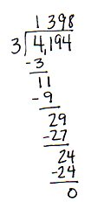
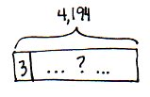
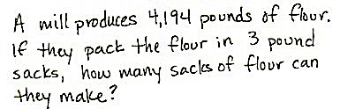
Use the tape diagram to create a division word problem that solves for the unknown, the total number of threes in 4,194. Switch word problems with a partner and solve.
They can make 1,398 sacks of flour.

Note: This problem extends understanding from Lesson 31 about solving for an unknown number of groups. Extend this problem in the Debrief using a divisor of 6, which connects to this lesson’s Concept Development.
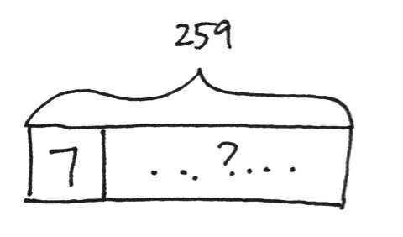
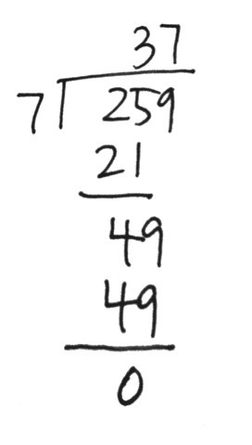
Concept Development (31 minutes)
There are 37 weeks in 259 days.
Materials: (S) Personal white board
Problem 1
We all know there are 7 days in a week. How many weeks are in 259 days?
T: Draw what we know and what we need to know on a tape diagram.
S: I labeled the whole as 259 days. Then, I put a 7 in one part because there are 7 days in each week. We don’t know how many groups of 7 days there are.
T: How did you represent the number of weeks that are unknown?
S: I labeled the rest of the tape diagram with a question mark.
T: Solve for how many weeks there are in 259 days.
S: There are 37 weeks in 259 days.
T: The divisor in this problem is larger than in many division problems we have solved. Tell your partner a strategy you can use to find the quotient when dividing by 7.
S: 25 tens divided by 7 is easy. It’s 3 tens with 4 tens left over. I counted by sevens, 10 at a time: 10 sevens is 70, 20 sevens is 140, 30 sevens is 210, and 40 sevens would be too big. So, I got 30 sevens with 49 left over. That’s still means you get 3 tens in the quotient. One way is like we did with place value disks. The other is like we did with the area model. But they’ll both give the same answer.
T: Either way of thinking will work for finding the quotient. When our divisor is large, how do I check to see if my quotient and remainder are correct?
S: The same way we always do! It’s no different for big divisors than for small divisors—multiply the number of groups times the size of each group. And, don’t forget to add the remainder.
Multiply the divisor by the quotient and add the remainder.
T: So, what we learned about small divisors still helps us now!
Problem 2
Everyone is given the same number of colored pencils in art class. If there are 249 colored pencils and 8 students, how many pencils does each student receive?
T: Draw a tape diagram to represent the problem. Describe the parts of your tape diagram to your partner.
S: I recorded and labeled the total of 249 pencils. Then, I made 8 equal parts because there are 8 students. I need to solve for how many in each group, so I put a question mark in one part to show that I need to solve for how many pencils each student will get.
T: Solve for how many pencils each student will receive. (Allow students time to work.)
S: Each student will receive 31 colored pencils. There will be 1 pencil left over.
T: Does your drawing of the tape diagram account for the remaining pencil? Let’s revise our tape diagram to show the remainder.
S: I can shade a small portion at the end of the tape diagram to represent the remaining pencil. I will have to resize each of the eight parts to make them equal.
T: Discuss a strategy you might have used when dividing by a larger divisor, like 8.
S: I counted by 8 tens. 8 tens, 16 tens, 24 tens. I know there are 2 fours in each eight. There are 6 fours in 24. So, half of 6 is 3. There are 3 eights in 24. I used my facts. I know 8 times 3 tens is 24 tens.
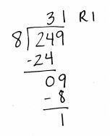
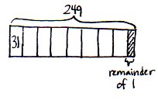
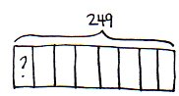

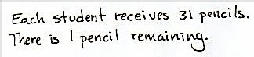

Problem 3
Mr. Hughes has 155 meters of volleyball netting. How many nets can he make if each court requires 9 meters of netting?

NOTES ON
MULTIPLE MEANS
OF REPRESENTATION:
English language learners and others may benefit from a brief explanation of the terms volleyball, netting, and court.

T: Draw a tape diagram to represent the problem. Describe the parts of your tape diagram to your partner.
S: My tape diagram shows a total of 155. I partitioned one section for 9 meters. I don’t know how many nets he can make, but I do know the length of each.
T: Solve for how many nets can be made using long division.
S: Seventeen nets can be made, but 2 meters of netting will be left over.
T: Does your drawing of the tape diagram account for the remaining netting? Let’s revise our tape diagram to show the remainder.
S: I can shade a small portion at the end of the tape diagram to represent the remaining 2 meters.
T: What strategy did you use for dividing with the divisor of 9?
S: I counted by 9 tens. 9 tens, 18 tens. One hundred eighty was too big. I used a special strategy. I made 10 nets which meant I used 90 meters of netting. That left 65 meters. Nine times 7 is 63 so that meant 7 more nets and 2 meters left over. I used my nines facts.

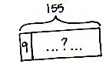
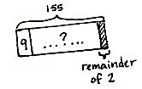
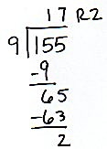
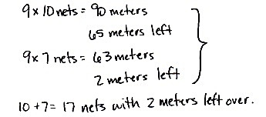
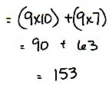
Mr. Hughes can make 17 nets.

Problem Set (15 minutes)
Students should do their personal best to complete the Problem Set within the allotted 15 minutes. For some classes, it may be appropriate to modify the assignment by specifying which problems they work on first. Some problems do not specify a method for solving. Students should solve these problems using the RDW approach used for Application Problems.

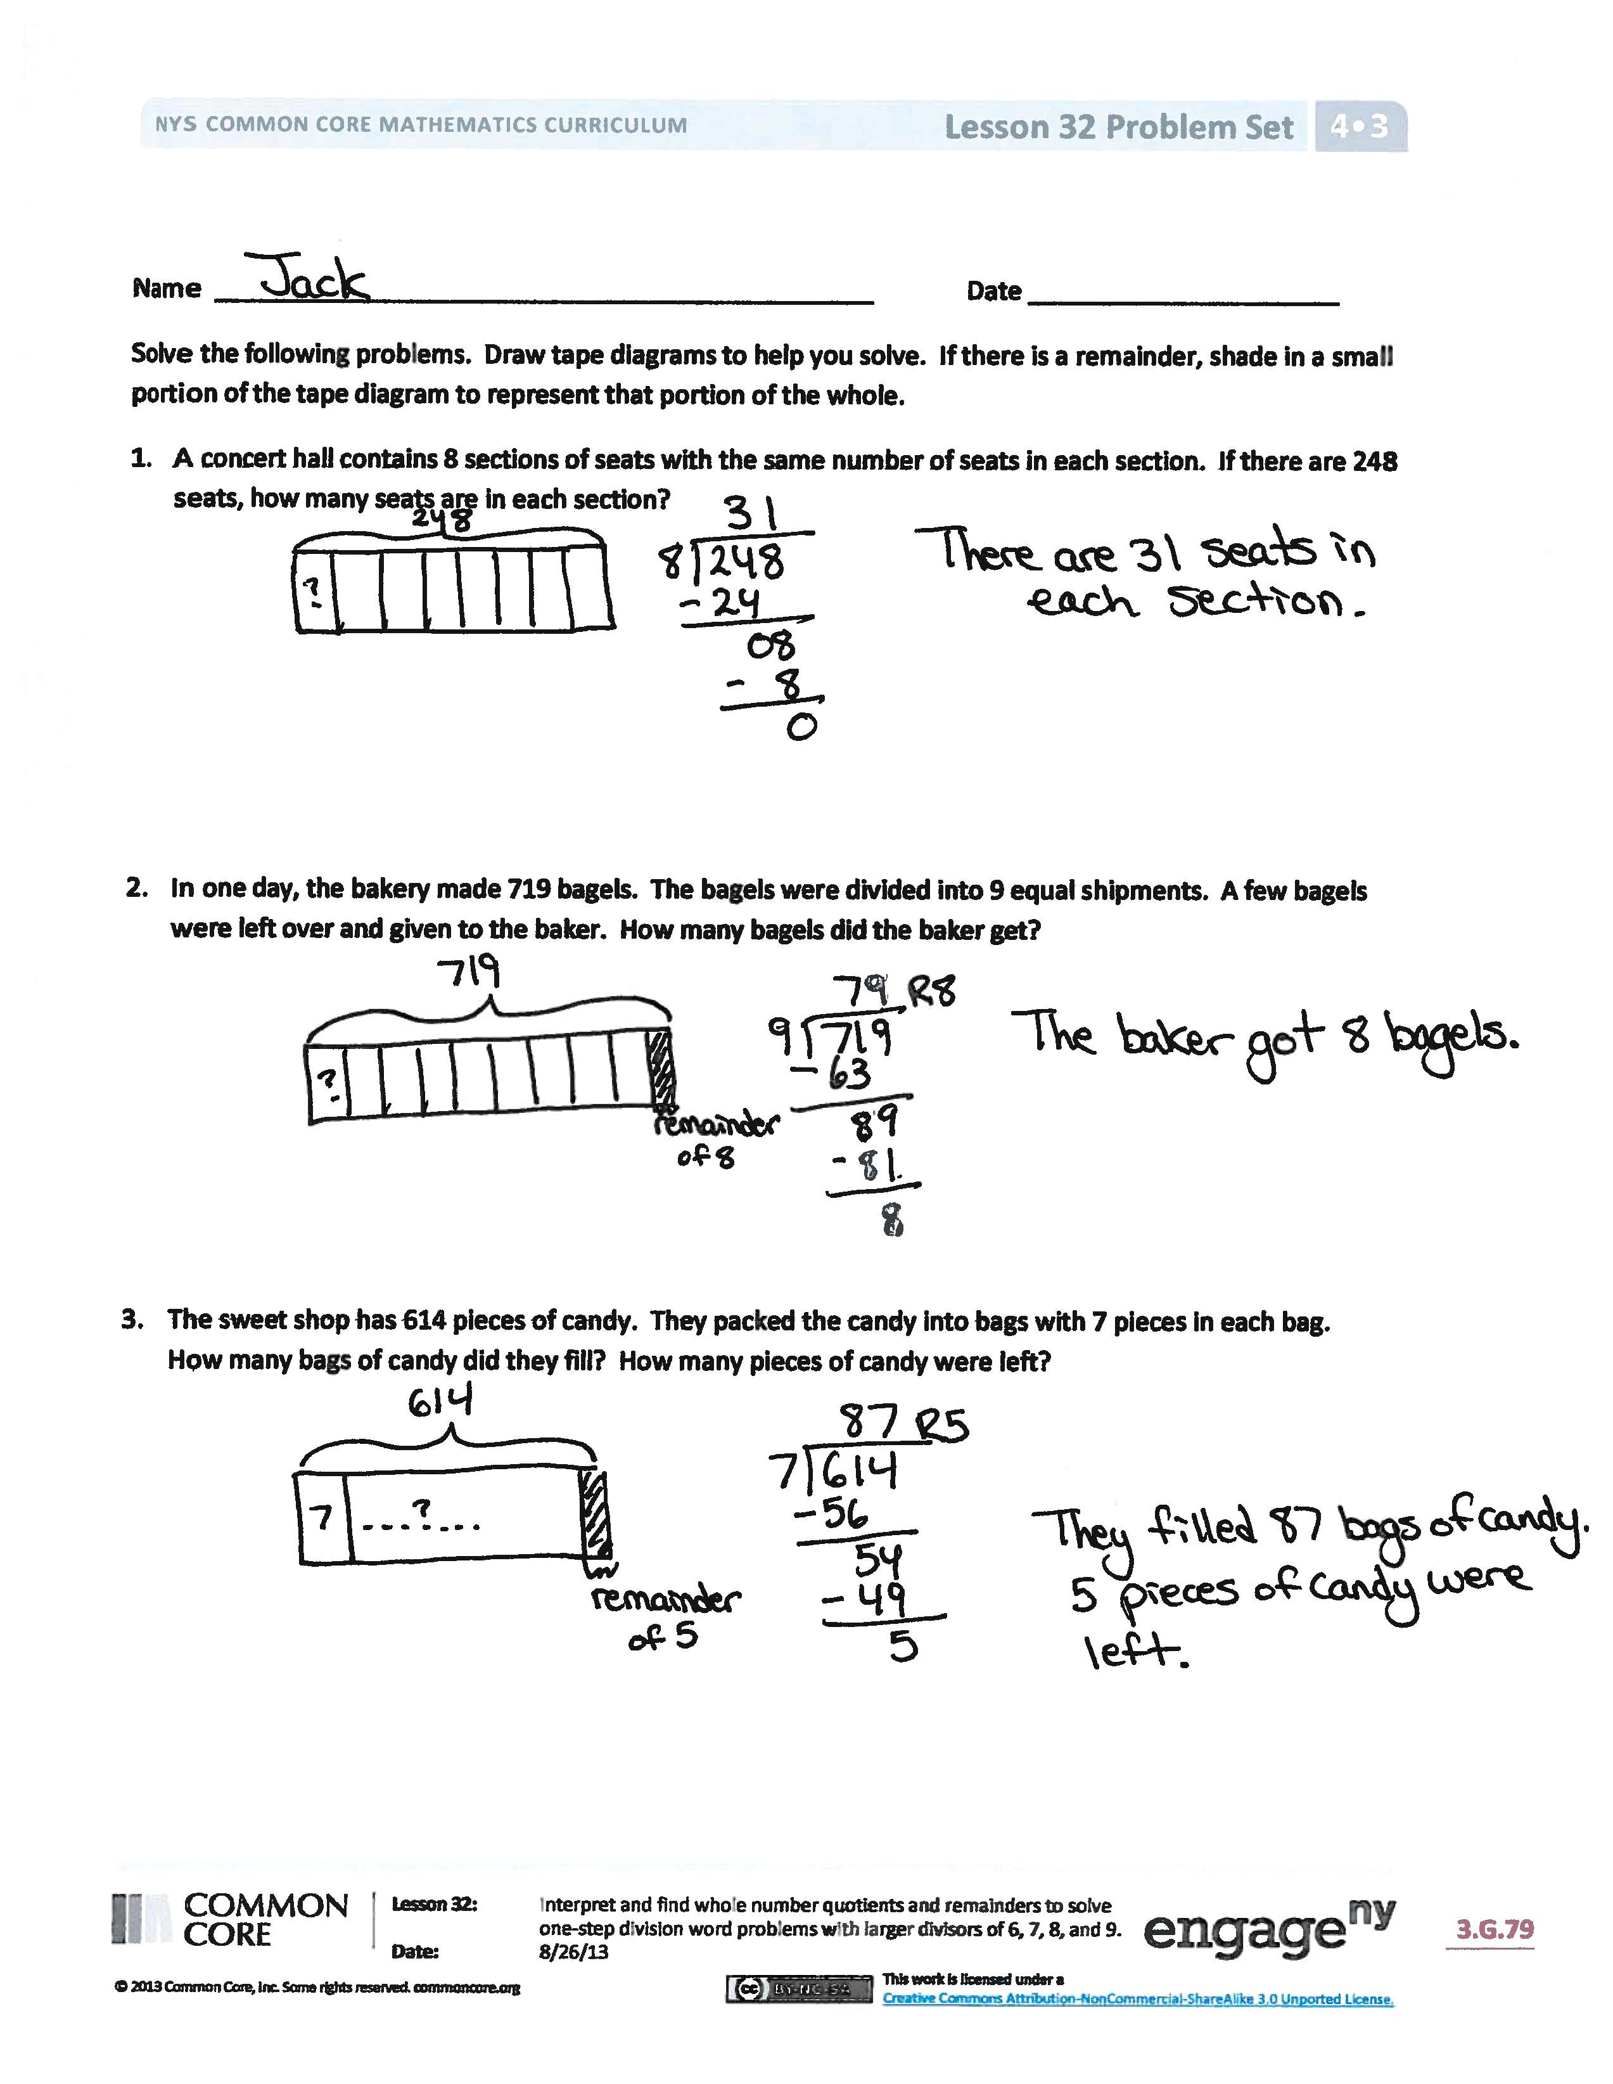
Student Debrief (10 minutes)
Lesson Objective: Interpret and find whole number quotients and remainders to solve one-step division word problems with larger divisors of 6, 7, 8, and 9.
The Student Debrief is intended to invite reflection and active processing of the total lesson experience.
Invite students to review their solutions for the Problem Set. They should check work by comparing answers with a partner before going over answers as a class. Look for misconceptions or misunderstandings that can be addressed in the Debrief. Guide students in a conversation to debrief the Problem Set and process the lesson.
You may choose to use any combination of the questions below to lead the discussion.
- In Problem 2, are you solving for the quotient, the remainder, or both? Why?
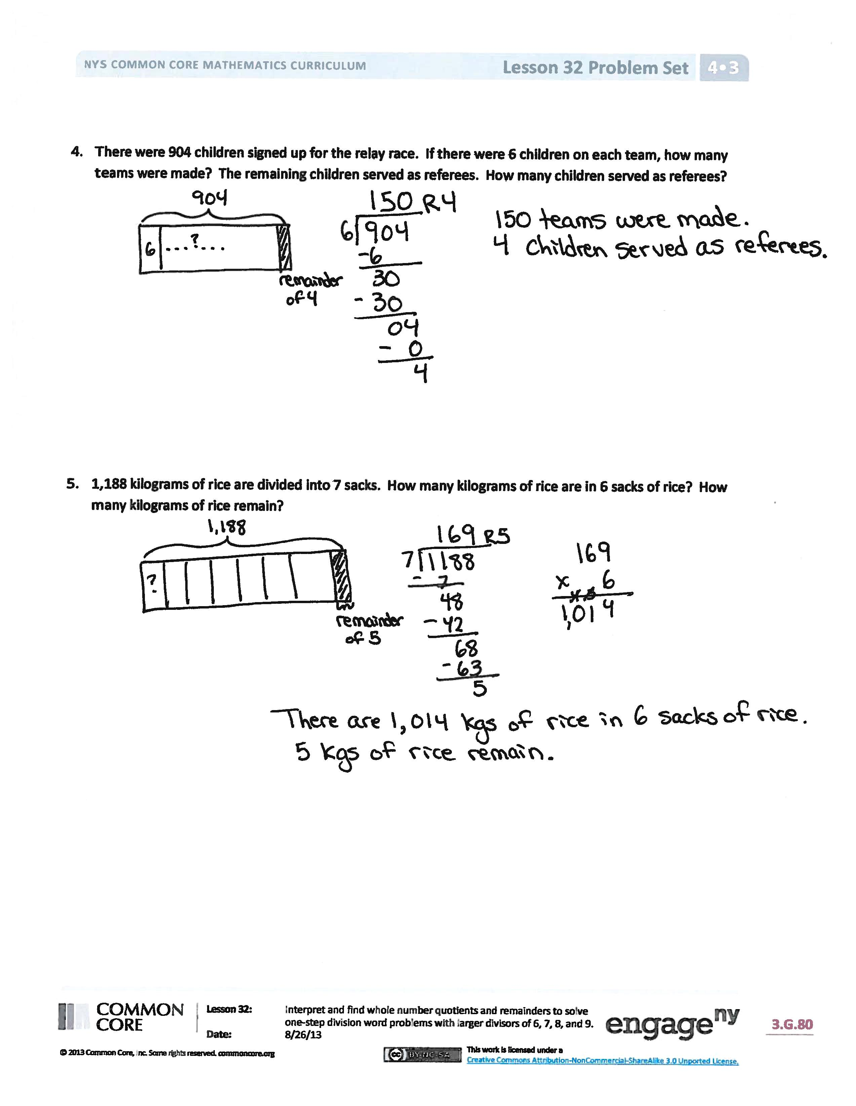
- Did you have to revise your tape diagram for any of the problems? If so, which one(s), and why?
- In Problem 4, did anyone get 15 teams? Why would that be an easy mistake to make?
- How could a special strategy be used to solve Problem 1?
- How did yesterday’s lesson prepare you for today’s lesson?
- Revisit the Application Problem. Revise the word problems using a divisor of 6 and solve. Compare the quotients. Do you see a relationship between the quotients? Did you need to divide 4,194 by 6, or could you have gotten the new quotient directly from the previous quotient (1,398)?
Exit Ticket (3 minutes)
After the Student Debrief, instruct students to complete the Exit Ticket. A review of their work will help you assess the students’ understanding of the concepts that were presented in the lesson today and plan more effectively for future lessons. You may read the questions aloud to the students.

Name Date
Solve the following problems. Draw tape diagrams to help you solve. If there is a remainder, shade in a small portion of the tape diagram to represent that portion of the whole.
- A concert hall contains 8 sections of seats with the same number of seats in each section. If there are 248 seats, how many seats are in each section?

- In one day, the bakery made 719 bagels. The bagels were divided into 9 equal shipments. A few bagels were left over and given to the baker. How many bagels did the baker get?

- The sweet shop has 614 pieces of candy. They packed the candy into bags with 7 pieces in each bag. How many bags of candy did they fill? How many pieces of candy were left?

- There were 904 children signed up for the relay race. If there were 6 children on each team, how many teams were made? The remaining children served as referees. How many children served as referees?

- 1,188 kilograms of rice are divided into 7 sacks. How many kilograms of rice are in 6 sacks of rice? How many kilograms of rice remain?

Name Date
Solve the following problems. Draw tape diagrams to help you solve. If there is a remainder, shade in a small portion of the tape diagram to represent that portion of the whole.
- Mr. Foote needs exactly 6 folders for each fourth-grade student at Hoover Elementary School. If he bought 726 folders, to how many students can he supply folders?

- Mrs. Terrance has a large bin of 236 crayons. She divides them equally among four containers. How many crayons does Mrs. Terrance have in each container?

Name Date
Solve the following problems. Draw tape diagrams to help you solve. If there is a remainder, shade in a small portion of the tape diagram to represent that portion of the whole.
- Meneca bought a package of 435 party favors to give to the guests at her birthday party. She calculated that she could give 9 party favors to each guest. How many guests is she expecting?

- 4,000 pencils were donated to an elementary school. If 8 classrooms shared the pencils equally, how many pencils did each class receive?

- 2,008 kilograms of potatoes were packed into sacks weighing 8 kilograms each. How many sacks were packed?

- A baker made 7 batches of muffins. There was a total of 252 muffins. If there was the same number of muffins in each batch, how many muffins were in a batch?

- Samantha ran 3,003 meters in 7 days. If she ran the same distance each day, how far did Samantha run in 3 days?
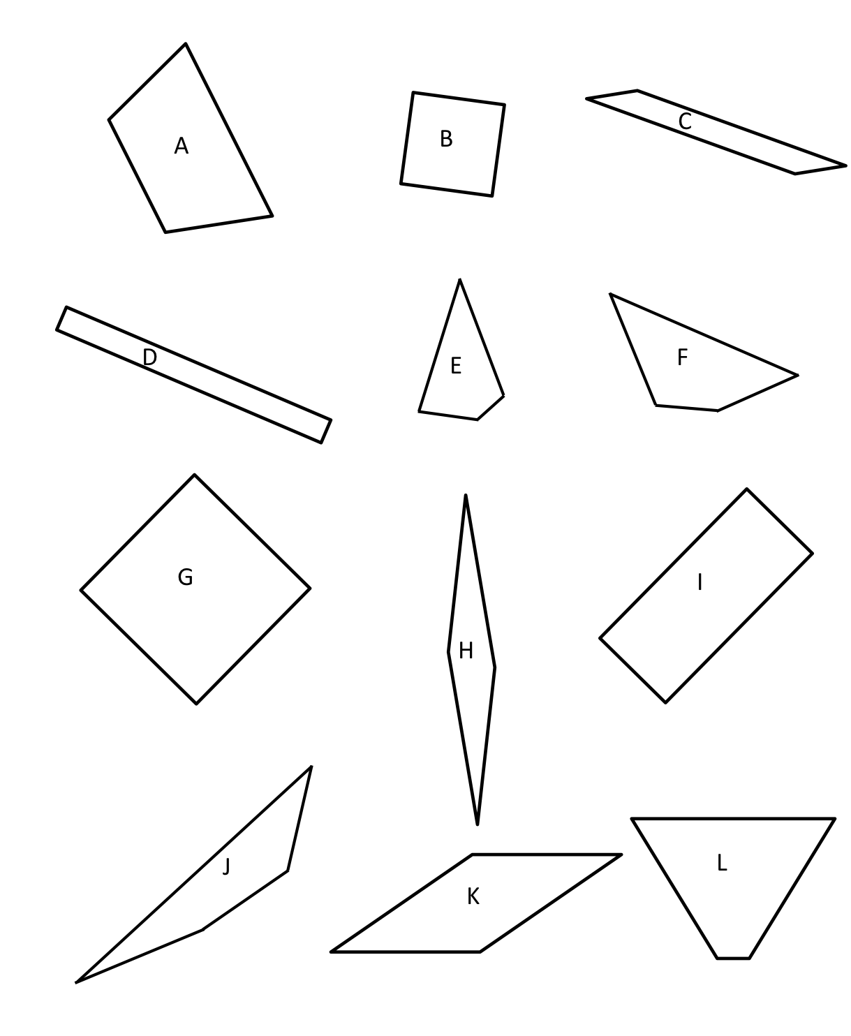

shapes

