Lesson 24
Objective: Determine whether a whole number is a multiple of another number.

Suggested Lesson Structure
 Fluency Practice (12 minutes)
 Application Problem (5 minutes)
 Concept Development (33 minutes)
 Student Debrief (10 minutes)
Total Time (60 minutes)
Fluency Practice (12 minutes)
- Group Counting 4.OA.1 (5 minutes)
- Prime or Composite? 4.OA.4 (2 minutes)
- Test for Factors 4.OA.5 (5 minutes)
Group Counting (5 minutes)
Note: Group counting reviews factors and patterns that students use during the Concept Development.
Direct students to count forward and backward, occasionally changing the direction of the count.
- Twos to 20
- Threes to 30
- Fours to 40
- Fives to 50
- Sixes to 60
- Tens to 100
Prime or Composite? (2 minutes)
Materials: (S) Personal white board
Note: This fluency activity reviews Lesson 22’s Concept Development.
Repeat the process from Lesson 23 for the following possible sequence: 5, 15, 12, 19, and 24.

Test for Factors (5 minutes)
Materials: (S) Personal white board
Note: This fluency activity reviews Lesson 23’s content.
T: (Project 30, 45, 48, and 56.) On your personal white boards, write the number that has 10 as a factor.
S: (Write 30.)
T: Write the division equations that prove both 5 and 2 are factors of 30.
S: (Write 30 ÷ 5 = 6 and 30 ÷ 2 = 15.)
T: Write the numbers that have 6 as a factor.
S: (Write 30 and 48.)
T: Prove that both 3 and 2 are factors of 30 and 48 using the associative property.
S: (Write 30 ÷ 3 = 10, 30 ÷ 2 = 15, 48 ÷ 3 = 16, and 48 ÷ 2 = 24.)
T: Write the numbers that have 8 as a factor.
S: (Write 48 and 56.)
T: Prove that both 4 and 2 are factors of 48 and 56 using the associative property.
Application Problem (5 minutes)
8 cm × 12 cm = 96 square centimeters. Imagine a rectangle with an area of 96 square centimeters and a side length of 4 centimeters. What is the length of its unknown side? How will it look when compared to the 8 centimeter by 12 centimeter rectangle? Draw and label both rectangles.

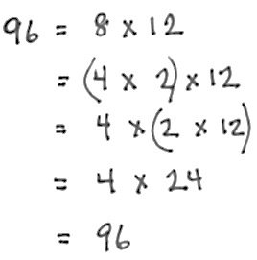
Note: This Application Problem relates finding factors (Lessons 22 and 23) to multiples (Lesson 24). You might lead students to visualize the columns of 4 or 8 square centimeters. When we count by the number of squares in those columns, will we arrive exactly at 96? When we count by the number of squares in one row, 24 or 12, will we also arrive exactly at 96? (You may choose to use graph paper to demonstrate for those students who would benefit from pictorial representation.)
Also, you might show students how the associative property beautifully illustrates how as the 8 is split in two, the 12 doubles (pictured to the right).
Concept Development (33 minutes)
Materials: (S) Personal white board, crayons
Problem 1: Determine the meaning of the word multiple.
T: Turn to your partner and count by fours, taking turns with each new number. So, for example, you start by saying 0, your partner says 4, then you say 8. You have one minute. Ready? Begin.
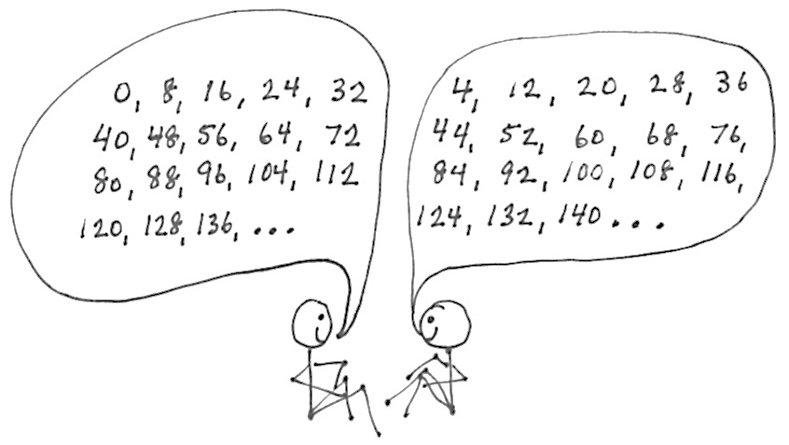
S: (Skip-count with partners for one minute.)
T: Stop. What number did you count up to?
S: (Responses will vary.)
T: Good! Tell me some things you noticed.
S: We started by saying the 4 times table, then kept adding on 4. There was a pattern with how the numbers ended. When we got to 100, the counting started over again. Just like we started with 0, 4, 8, 12, after 100 it was 104, 108, 112, and so on.
T: Those are nice observations. Let’s try that again, beginning where you left off. This time, as you count, think about what patterns there are. Ready? Begin.
S: (Skip-count with their partners for another minute.)
T: When we skip-count by a whole number, the numbers that we say are called multiples.
T: Talk to your partner about what you noticed.
S: All of the multiples of 4 were even numbers. No matter how high we counted, we kept adding on 4 more. The digit in the ones place of every number followed its own pattern. It went 0, 4, 8, 2, 6, over and over again.
T: Excellent discoveries! This pattern in the ones place continues forever! Why?
S: Because it is always 4 more. If that’s what has been happening, then the same things will keep happening. It worked up to 1 hundred, and the ones and tens place will continue with the same pattern, so it will even work in the two hundreds and three hundreds. Four times 25 is 100, so then in every hundred it repeats, so it just keeps going in a cycle!
MP.8
T: How is a multiple different from a factor?
S: When we found the factors of a number, we listed them and then we were done. With multiples, we could keep going forever and ever!

Problem 2: Determine if one number is a multiple of another number, and list multiples of given numbers.
T: Why is 24 a multiple of 4?
S: When we count by fours we get to 24. 4 times 6 is 24. Four is a factor of 24.
T: Is 24 a multiple of 5?
S: No, because we can’t skip-count by five to 24.
No, because 24 divided by 5 has a remainder.
No, because 5 is a not a factor of 24.
T: What about 8? Is 24 a multiple of 8?
S: Yes! Eight times 3 is 24. Well, 8 is a factor of 24, so 24 must be a multiple of 8.
T: We know 96 is a multiple of 4 from our Application Problem, since 4 times 24 is 96. What did we do to figure that out?
S: I used long division. I used the associative property.
T: Yes, because for some it is beyond mental math. How can we find out if 96 is a multiple of 3?
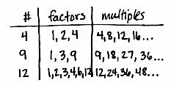
S: We can divide to see if 96 is divisible by 3. We might use the associative property since we know that 8 times 12 and 4 times 24 are 96 from the Application Problem.

NOTES ON
MULTIPLE MEANS
OF REPRESENTATION:
Students who struggle with the difference between a factor and a multiple might benefit from creating a three-column chart that lists numbers in the first column, factors in the second, and then multiples in the third, always followed by an ellipsis to remember the infinite number of multiples of any number. Students can refer to this visual representation as they complete the lesson and as they think about how factors and multiples are related.
T: Try that.
Allow time for students to divide or use the associative property.
T: What did you discover?
S: There was no remainder, so 3 is a factor of 96. That makes 96 a multiple of 3.
T: What is the factor pair of 3?
S: 32!
T: If you count by 32 three times, will you get to 96?
S: Yes?
T: Is 96 a multiple of both 3 and 32?
S: Yes!
T: List the first five multiples of 3.
S: (Write 3, 6, 9, 12, 15.)
T: What number did you begin with?
S: 3.
T: But isn’t 0 a multiple of 3? Should we start with 0 first?
S: No. It’s less. But 0 times 3 is 0, so maybe?
T: Since zero times any number is zero, zero is a multiple of every number, so we could consider it the first multiple of every number. However, when we skip-count, we usually start with the number we’re counting by. So, we usually think of the number itself, in this case 3, as the first multiple, instead of 0. That way, the first multiple is 1 × 3, the second is 2 × 3, and so on.
(Optional) Problem 3: Use the associative property to see that any multiple of 6 is also a multiple of 3 and 2.
T: Shout out a multiple of 6.
S: 12. 30. 60. 24. 600!
T: Is any multiple of 6 also a multiple of 2 and 3?
T: Let’s use the associative property (and commutative property) to find out.
T: 60 = 10 × 6
= 10 × (2 × 3)

NOTES ON
MULTIPLE MEANS
OF REPRESENTATION:
When using the associative property, you might bring the word to life by asking three students to stand at the front of the class in a line. Ask the person in the middle to associate with the person on the right. Ask them to associate with the person on their left. Ask those on the ends to associate.
- What changed? (The associations.)
Next, give each person an identity as a factor, perhaps 9, 2, and 5 respectively. Have the factor of 2 first associate with the 9 and then with the five. Then, have the 9 and 5 associate.
- Which is easiest: 18 times 5, 9 times 10, or 45 times 2?
= (10 × 2) × 3= 20 × 3
Yes, 60 is a multiple of 3. If we count by 3 twenty times, we get to 60.
= (10 × 3) × 2= 30 × 2
Yes, 60 is a multiple of 2. If we count by 2 thirty times, we get to 60.
T: Let’s use a letter to represent the number of sixes to see if this is true for all sixes. (Write the following three equations on the board.)
n × 6 = n × (2 × 3)
n × 6 = (n × 2) × 3
n × 6 = (n × 3 ) × 2
T: Discuss with your partner why these equations are true. You might try plugging in 4 or 5 as the number of sixes, n, to help you understand.
S: Wow! These equations are true. It’s just that it takes twice as many threes to get to the multiple as sixes.
Yeah, it’s double the number of multiples of six,
2 × n. And it’s three times as many twos to get there! It’s because twos are smaller units so it takes more.
T: So, maybe the multiples of a number are also the multiples of its factors.
If there is time, you might repeat the process with the multiples of 8 being multiples of both 2 and 4. The students might approach the generalization that the multiples of a given number include the multiples of the number’s factors.

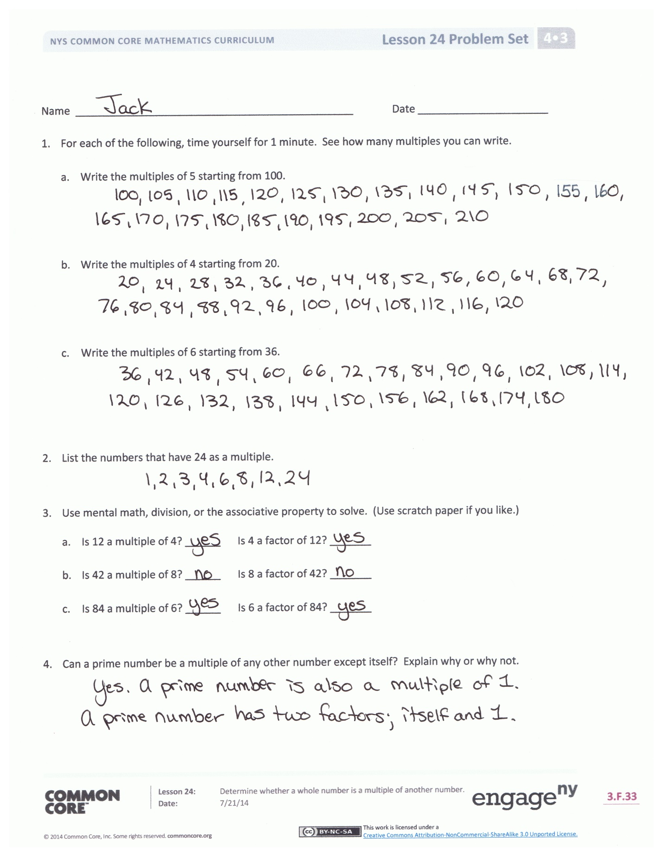
Problem Set (10 minutes)
Students should do their personal best to complete the Problem Set within the allotted 10 minutes. For some classes, it may be appropriate to modify the assignment by specifying which problems they work on first. Some problems do not specify a method for solving. Students should solve these problems using the RDW approach used for Application Problems.
Student Debrief (10 minutes)
Lesson Objective: Determine whether a whole number is a multiple of another number.
The Student Debrief is intended to invite reflection and active processing of the total lesson experience.
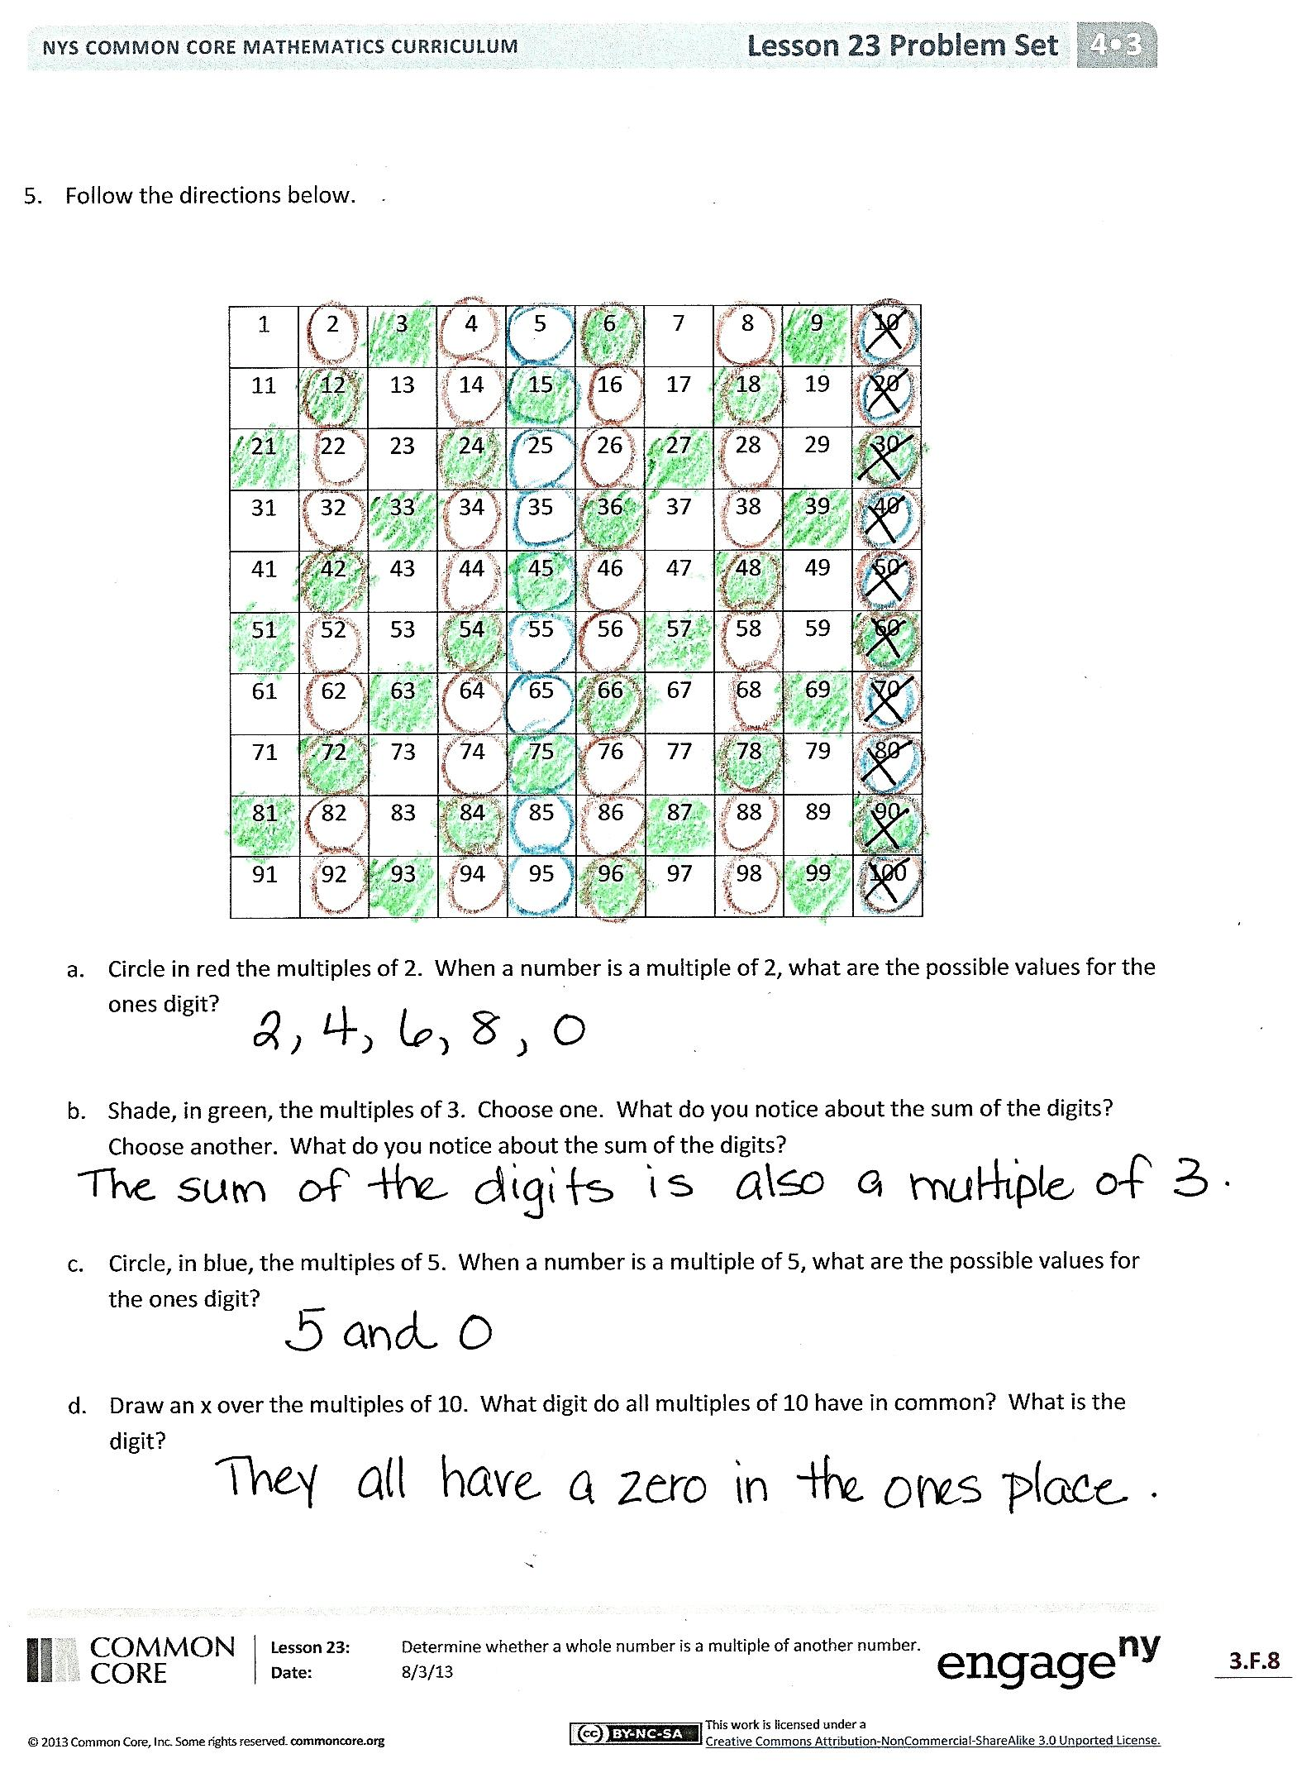
Invite students to review their solutions for the Problem Set. They should check work by comparing answers with a partner before going over answers as a class. Look for misconceptions or misunderstandings that can be addressed in the Debrief. Guide students in a conversation to debrief the Problem Set and process the lesson.

You may choose to use any combination of the questions below to lead the discussion.
- What strategy did you use in Problem 2?
- In Problem 5, Parts (c) and (d), what patterns did you discover about multiples of 5 and 10?
- Explain the difference between factors and multiples.
- Which number is a multiple of every number?
- In Problem 1, which multiples were the easiest to write: the fives, fours, or sixes? Why?
- How can the associative property help you to know if a number is a multiple of another number?
- Did anybody answer no on Problem 4? What about 1? Are prime numbers multiples of 1?
- In the lesson, we found that when counting by fours, the multiples followed a pattern of having 0, 4, 8, 2, and 6 in the ones digit. Does that mean any even number is a multiple of 4?
- Are the following true?
  - 3 is a factor of 12.
  - 12 is a multiple of 3.
  - 12 is divisible by 3.
Exit Ticket (3 minutes)
After the Student Debrief, instruct students to complete the Exit Ticket. A review of their work will help you assess the students’ understanding of the concepts that were presented in the lesson today and plan more effectively for future lessons. You may read the questions aloud to the students.
Name Date
- For each of the following, time yourself for 1 minute. See how many multiples you can write.

  - Write the multiples of 5 starting from 100.

  - Write the multiples of 4 starting from 20.

  - Write the multiples of 6 starting from 36.

- List the numbers that have 24 as a multiple.

- Use mental math, division, or the associative property to solve. (Use scratch paper if you like.)
  - Is 12 a multiple of 4? ______ Is 4 a factor of 12? _______

  - Is 42 a multiple of 8? ______ Is 8 a factor of 42? _______

  - Is 84 a multiple of 6? ______ Is 6 a factor of 84? _______

- Can a prime number be a multiple of any other number except itself? Explain why or why not.

- Follow the directions below.

1 | 2 | 3 | 4 | 5 | 6 | 7 | 8 | 9 | 10
11 | 12 | 13 | 14 | 15 | 16 | 17 | 18 | 19 | 20
21 | 22 | 23 | 24 | 25 | 26 | 27 | 28 | 29 | 30
31 | 32 | 33 | 34 | 35 | 36 | 37 | 38 | 39 | 40
41 | 42 | 43 | 44 | 45 | 46 | 47 | 48 | 49 | 50
51 | 52 | 53 | 54 | 55 | 56 | 57 | 58 | 59 | 60
61 | 62 | 63 | 64 | 65 | 66 | 67 | 68 | 69 | 70
71 | 72 | 73 | 74 | 75 | 76 | 77 | 78 | 79 | 80
81 | 82 | 83 | 84 | 85 | 86 | 87 | 88 | 89 | 90
91 | 92 | 93 | 94 | 95 | 96 | 97 | 98 | 99 | 100

  - Circle in red the multiples of 2. When a number is a multiple of 2, what are the possible values for the ones digit?

  - Shade in green the multiples of 3. Choose one. What do you notice about the sum of the digits? Choose another. What do you notice about the sum of the digits?

  - Circle in blue the multiples of 5. When a number is a multiple of 5, what are the possible values for the ones digit?

  - Draw an X over the multiples of 10. What digit do all multiples of 10 have in common?
Name Date
- Fill in the unknown multiples of 11.

5 × 11 = _____

6 × 11 = _____

7 × 11 = _____

8 × 11 = _____

9 × 11 = _____

- Complete the pattern of multiples by skip-counting.

7, 14, ______, 28, ______, ______, ______, ______, ______, ______

  - List the numbers that have 18 as a multiple.

  - What are the factors of 18?

  - Are your two lists the same? Why or why not?

Name Date
- For each of the following, time yourself for 1 minute. See how many multiples you can write.

  - Write the multiples of 5 starting from 75.

  - Write the multiples of 4 starting from 40.

  - Write the multiples of 6 starting from 24.

- List the numbers that have 30 as a multiple.

- Use mental math, division, or the associative property to solve. (Use scratch paper if you like.)

  - Is 12 a multiple of 3? ______ Is 3 a factor of 12? _______

  - Is 48 a multiple of 8? ______ Is 48 a factor of 8? _______

  - Is 56 a multiple of 6? ______ Is 6 a factor of 56? _______

- Can a prime number be a multiple of any other number except itself? Explain why or why not.

- Follow the directions below.

1 | 2 | 3 | 4 | 5 | 6 | 7 | 8 | 9 | 10
11 | 12 | 13 | 14 | 15 | 16 | 17 | 18 | 19 | 20
21 | 22 | 23 | 24 | 25 | 26 | 27 | 28 | 29 | 30
31 | 32 | 33 | 34 | 35 | 36 | 37 | 38 | 39 | 40
41 | 42 | 43 | 44 | 45 | 46 | 47 | 48 | 49 | 50
51 | 52 | 53 | 54 | 55 | 56 | 57 | 58 | 59 | 60
61 | 62 | 63 | 64 | 65 | 66 | 67 | 68 | 69 | 70
71 | 72 | 73 | 74 | 75 | 76 | 77 | 78 | 79 | 80
81 | 82 | 83 | 84 | 85 | 86 | 87 | 88 | 89 | 90
91 | 92 | 93 | 94 | 95 | 96 | 97 | 98 | 99 | 100

  - Underline the multiples of 6. When a number is a multiple of 6, what are the possible values for the ones digit?

  - Draw a square around the multiples of 4. Look at the multiples of 4 that have an odd number in the tens place. What values do they have in the ones place?

  - Look at the multiples of 4 that have an even number in the tens place. What values do they have in the ones place? Do you think this pattern would continue with multiples of 4 that are larger than 100?

  - Circle the multiples of 9. Choose one. What do you notice about the sum of the digits? Choose another one. What do you notice about the sum of the digits?

