Lesson 23
Objective: Use division and the associative property to test for factors and observe patterns.

Suggested Lesson Structure
 Fluency Practice (12 minutes)
 Application Problem (5 minutes)
 Concept Development (33 minutes)
 Student Debrief (10 minutes)
Total Time (60 minutes)
Fluency Practice (12 minutes)
- Use Arrays to Find Factors 4.OA.4 (6 minutes)
- Multiply Two Factors 4.NBT.5 (4 minutes)
- Prime or Composite? 4.OA.4 (2 minutes)
Use Arrays to Find Factors (6 minutes)
Materials: (S) Personal white board
Note: This fluency activity reviews Lesson 22’s content. To challenge students, have them construct the arrays instead of having them projected.
T: (Project a 1 × 8 array.) What is the width of the array?
S: 1 unit.
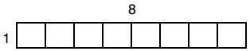
T: (Write 1.) What’s the length of the array?
S: 8 units.
T: (Write 8.) Write the multiplication sentence.
S: (Write 1 × 8 = 8.)
Repeat process for a 2 × 4 array.
T: List the factors of 8.
S: (Write factors of 8: 1, 2, 4, 8.)
Continue with following possible sequence: factors of 12, factors of 16, and factors of 18.

Multiply Two Factors (4 minutes)
Materials: (S) Personal white board
Note: This fluency activity reviews the Concept Development from Lessons 9, 10, and 22.
T: (Write 174 × 2 = .) On your personal white boards, solve the multiplication sentence using the standard algorithm.
S: What are 4 factors of 348 you know right away?
S: 1 and 348, 2 and 174.
Repeat the process using the following possible sequence: 348 × 2, 696 × 2, and 1,392 × 2. Students may realize that if 348 is a factor of 696, then 174 is, too!
Prime or Composite? (2 minutes)

NOTES ON
MULTIPLE MEANS
OF ENGAGEMENT:
Allow English language learners and others more time to compose their written response. Alternatively, have students discuss their reasoning with a partner.
Challenge students working above grade level to identify the prime and composite numbers in the seventies and sixties. Ask, “What do you notice?”

Materials: (S) Personal white board
Note: This fluency activity reviews Lesson 22’s Concept Development.
T: (Write 7.) Is it prime or composite?
S: Prime.
T: Write the factor pair of 7.
S: (Write 1 and 7.)
T: (Write 12.) Is it prime or composite?
S: Composite.
T: Write the factor pairs of 12.
S: (Write 1 and 12, 2 and 6, 3 and 4.)
Repeat the process for the following possible sequence: 15, 17, and 21.
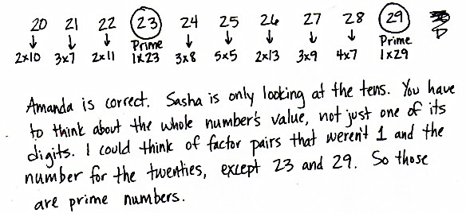
Application Problem (5 minutes)
Sasha says that every number in the twenties is a composite number because 2 is even. Amanda says there are two prime numbers in the twenties. Who is correct? How do you know?
Note: This Application Problem bridges Lesson 22’s work with using division to determine prime and composite numbers to this lesson’s objective of using division patterns to determine factors of numbers.

Concept Development (33 minutes)
Materials: (S) Personal white board
Problem 1: Use division to find factors of larger numbers.
T: Find the unknown factor: 28 = 7 × ___.
S: 4.
T: How did you find the unknown factor?
S: I know my fours facts. I divided 28 by 7.
T: Is 10 a factor of 28?
S: No.
T: How do you know?
S: Two times 10 is 20, and 3 times 10 is 30. If you divide 28 by 10, you get a remainder.
T: How can I find out if 3 is a factor of 54?
S: We can divide 54 by 3.
T: What if I get a remainder?
S: If there is a remainder, then 3 isn’t a factor. As long as there’s no remainder, you can write 54 as 3 times a whole number. Yeah, it’s 3 times the quotient.
Allow time for students to divide with their partner.
S: Fifty-four can be divided by 3 evenly. Three is a factor of 54 because there is no remainder.
T: How can we determine if 2 is a factor of 54?
S: We can divide like we did for 3. Two is an even number, so it goes evenly into 54. Two is a factor of every even number and 54 is even, so 2 has to be one of its factors.
T: Use division to find out if 3 is a factor of 78, if 4 is a factor of 94, and if 3 is a factor of 87.
Quickly debrief the questions to ascertain that 3 is a factor of 78 and 87, but 4 is not a factor of 94.
Problem 2: Use the associative property to find additional factors of larger numbers.
T: Talk to your partner. Is it necessary to divide to figure out if 5 is a factor of 54?
S: Fifty-four can’t be divided by 5 exactly. There is a remainder. When you count by fives, each number ends with 5 or 0. Fifty-four does not end with 0 or 5. Five isn’t a factor of 54.
T: We divided to determine if 3 was a factor of 54, but for 2 and 5 we don’t need to divide. Explain to your partner why not.
S: The even numbers all have 2 for a factor. If the digit in the ones place is odd, the number doesn’t have 2 as a factor. Numbers with 5 as a factor have 0 or 5 as a digit in the ones place. We can use patterns for 2 and 5.
T: How can we know if 6 a factor of 54?
S: Six times 9 equals 54.
T: Earlier we saw that 2 and 3 are both factors of 54. Talk to your partner. Is this number sentence true?
T: (Write 54 = 6 × 9 = (2 × 3) × 9.)
S: (Share ideas.)
T: Let’s write it vertically so that it is very easy to see how the factor 6 is related to 2 times 3.
T: (Write the problem as modeled to the right.) Now let’s move the parentheses so that 3 associates with 9 rather than 2. Three times 9 is?
S: 27.
T: Find the product of 2 and 27. (Pause.) Is it true that 2 times 27 equals 54?
S: Yes!
T: We used the associative property to show that both 2 and 3 are factors of 54.
T: Let’s test this method to see if it works with a number other than 54. Forty-two is 6 times?
S: 7.
T: Let’s use the associative property to see if 2 and 3 are also factors of 42.
T: (Write 42 = 6 × 7.) How will we rewrite 6?
S: 2 × 3.
T: (Beneath 6 × 7, write = (2 × 3) × 7.) Let’s now move the parentheses to first multiply 3 times 7, to associate 3 with 7 rather than 2. 3 times 7 is?
S: 21.
T: Find the product of 2 and 21. (Pause.) Is it true that 2 times 21 equals 42?
S: Yes!
Record thought process as shown at right. Have students use the associative property to prove that since 6 is a factor of 60, both 2 and 3 are also factors.
Problem 3: Use division or the associative property to find factors of larger numbers.
T: Multiply 6 times 12. (Pause.) The answer is?
S: 72.
T: Using either division or the associative property, work with your partner to prove that since 6 is a factor of 72, 2 and 3 are also factors.
S: Seventy-two is even, so 2 is a factor. I can use long division to find 72 divided by 3 is 24, so 3 is a factor. I wrote 72 equals 6 times 12 as 72 equals 2 times 3 times 12. Using the associative property works. I know 2 and 3 are factors of 72 because 6 is a factor of 72.
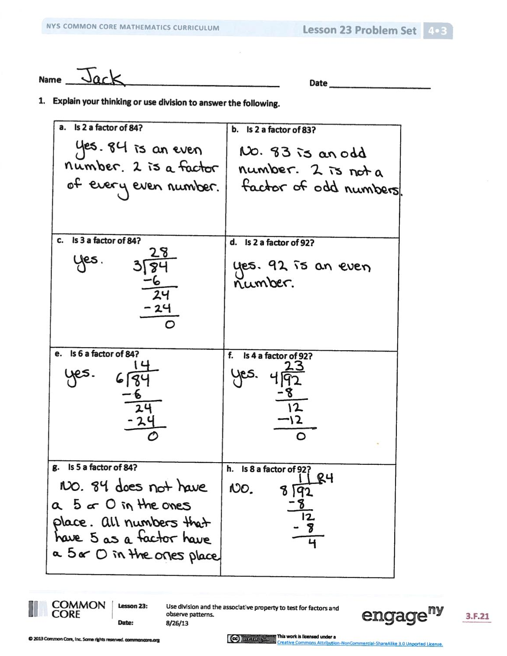
Problem Set (10 minutes)
Students should do their personal best to complete the Problem Set within the allotted 10 minutes. For some classes, it may be appropriate to modify the assignment by specifying which problems they work on first. Some problems do not specify a method for solving. Students should solve these problems using the RDW approach used for Application Problems.
Student Debrief (10 minutes)
Lesson Objective: Use division and the associative property to test for factors and observe patterns.
The Student Debrief is intended to invite reflection and active processing of the total lesson experience.
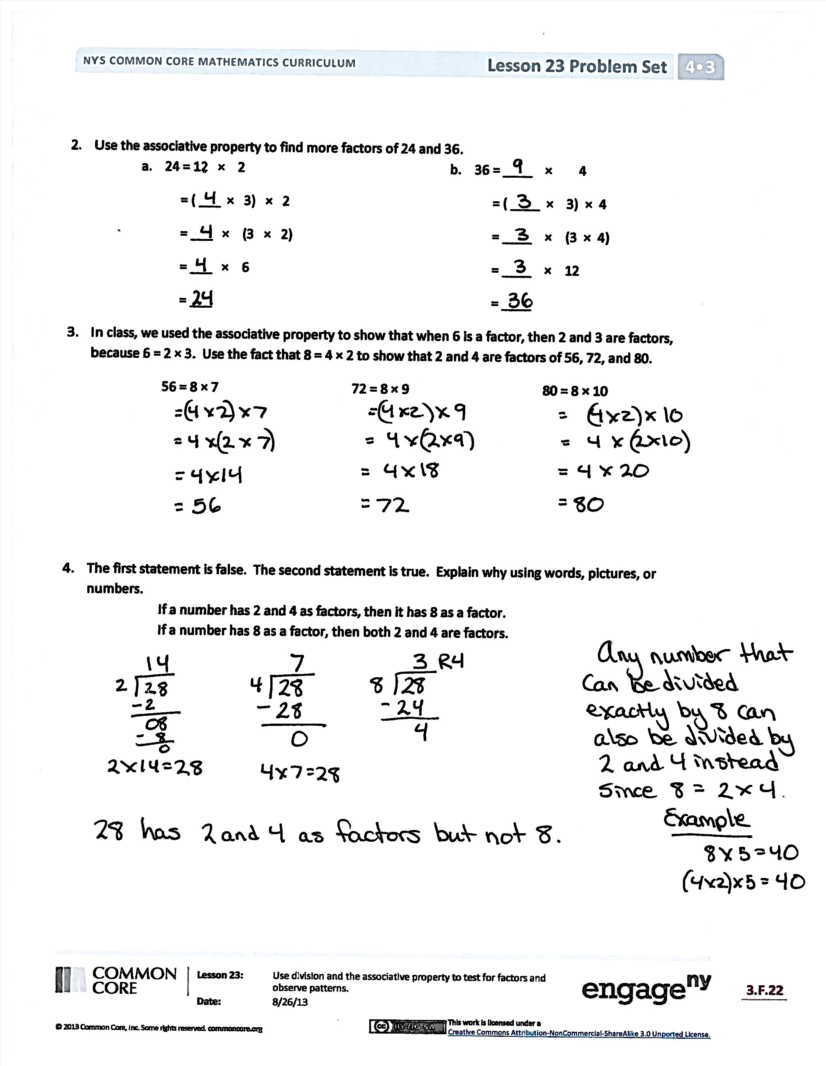
Invite students to review their solutions for the Problem Set. They should check work by comparing answers with a partner before going over answers as a class. Look for misconceptions or misunderstandings that can be addressed in the Debrief. Guide students in a conversation to debrief the Problem Set and process the lesson.
You may choose to use any combination of the questions below to lead the discussion.
- How did answering Problem 1, Part (a) help you answer Problem 1, Part (b)? Was it necessary to divide?
- What relationship do you notice between Problem 1, Parts (a), (c), and (e)? What about between Problem 1, Parts (d), (f), and (h)?
- Discuss with your partner what is similar and what is different about Problem 1, Parts (a), (c), and (e) and Problem 1, Parts (d), (f), and (h).
- What’s the difference between the statements in Problem 4? Why is one false and the other true?
- When we divided 72 by 3, we saw that there was no remainder. Another way to say that is “72 is divisible by 3.” Is 24 divisible by 3? Is 25 divisible by 3?

- We can use number patterns to determine if 2 and 5 are factors of other numbers. What other numbers do you think have patterns? Do you see a pattern for determining which numbers 3 is a factor of? Can you describe one?
- If 8 is a factor of 96, what other numbers must also be factors of 96? How can we use the associative property to prove this?
- Once someone tried to tell me that the two statements in Problem 4 say the same thing. How would you explain that the two statements are different?
Exit Ticket (3 minutes)
After the Student Debrief, instruct students to complete the Exit Ticket. A review of their work will help you assess the students’ understanding of the concepts presented in the lesson today and plan more effectively for future lessons. You may read the questions aloud to the students.
Name Date
- Explain your thinking or use division to answer the following.
- Is 2 a factor of 84? | - Is 2 a factor of 83?
- Is 3 a factor of 84? | - Is 2 a factor of 92?
- Is 6 a factor of 84? | - Is 4 a factor of 92?
- Is 5 a factor of 84? | - Is 8 a factor of 92?
- Use the associative property to find more factors of 24 and 36.
  - 24 = 12 × 2 b. 36 = ____ × 4
= ( ___ × 3) × 2 = ( ____ × 3) × 4
= ___ × (3 × 2) = ____ × (3 × 4)
= ___ × 6 = ____ × 12
= ___ = ____
- In class, we used the associative property to show that when 6 is a factor, then 2 and 3 are factors, because 6 = 2 × 3. Use the fact that 8 = 4 × 2 to show that 2 and 4 are factors of 56, 72, and 80.
56 = 8 × 7 72 = 8 × 9 80 = 8 × 10

- The first statement is false. The second statement is true. Explain why, using words, pictures, or numbers.
If a number has 2 and 4 as factors, then it has 8 as a factor.
If a number has 8 as a factor, then both 2 and 4 are factors.

Name Date
- Explain your thinking or use division to answer the following.
- Is 2 a factor of 34? | - Is 3 a factor of 34?
- Is 4 a factor of 72? | - Is 3 a factor of 72?

- Use the associative property to explain why the following statement is true.
Any number that has 9 as a factor also has 3 as a factor.
Name Date
  - Explain your thinking or use division to answer the following.
- Is 2 a factor of 72? | - Is 2 a factor of 73?
- Is 3 a factor of 72? | - Is 2 a factor of 60?
- Is 6 a factor of 72? | - Is 4 a factor of 60?
- Is 5 a factor of 72? | - Is 8 a factor of 60?
- Use the associative property to find more factors of 12 and 30.
  - 12 = 6 × 2 b. 30 = ____ × 5
= ( ___ × 2) × 2 = ( ____ × 3) × 5
= ___ × (2 × 2) = ____ × (3 × 5)
= ___ × ___ = ____ × 15
= ___ = ____

- In class, we used the associative property to show that when 6 is a factor, then 2 and 3 are factors, because 6 = 2 × 3. Use the fact that 10 = 5 × 2 to show that 2 and 5 are factors of 70, 80, and 90.
70 = 10 × 7 80 = 10 × 8 90 = 10 × 9

- The first statement is false. The second statement is true. Explain why, using words, pictures, or numbers.
If a number has 2 and 6 as factors, then it has 12 as a factor.
If a number has 12 as a factor, then both 2 and 6 are factors.

