Lesson 22
Objective: Find factor pairs for numbers to 100, and use understanding of factors to define prime and composite.

Suggested Lesson Structure
 Fluency Practice (12 minutes)
 Application Problem (5 minutes)
 Concept Development (33 minutes)
 Student Debrief (10 minutes)
Total Time (60 minutes)
Fluency Practice (12 minutes)
- Divide Using the Area Model 4.NBT.6 (4 minutes)
- Find the Unknown Factor 4.OA.4 (5 minutes)
- Mental Multiplication 4.NBT.5 (3 minutes)
Divide Using the Area Model (4 minutes)
Materials: (S) Personal white board
Note: This fluency activity reviews content from Lesson 20.
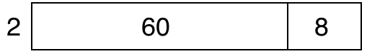
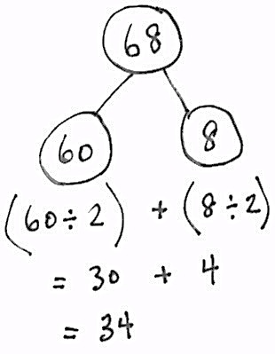
T: (Project an area model that shows 68 ÷ 2.) Write a division expression for this area model.
S: (Write 68 ÷ 2.)
T: Label the length of each rectangle in the area model.
S: (Write 30 above the 60 and 4 above the 8.)
T: Solve using the standard algorithm or the distributive property with a number bond.
Continue with the following possible sequence: 96 ÷ 3, 72 ÷ 3, and 72 ÷ 4.
Find the Unknown Factor (5 minutes)
Note: This fluency activity prepares students for the Concept Development.
Repeat the process from Lesson 20 for 3 × __ = 9, 4 × __ = 16, 5 × ___ = 45, 6 × ___ = 42, 7 × ___ = 56,
9 × ___ = 72, 6 × ___ = 54, 7 × ___ = 63, and 9 × ___ = 54.
Mental Multiplication (3 minutes)
Note: This fluency activity reviews content taught earlier in the module.
Repeat the process from Lesson 20 with the following possible sequence: 4 × 2, 4 × 20, 2 × 40, 20 × 40, 3 × 3, 3 × 30, 30 × 30, 3 × 4, 3 × 40, and 30 × 40.
Application Problem (5 minutes)
8 × ____ = 96. Find the unknown side length, or factor. Use an area model to solve the problem.
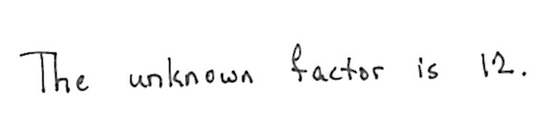

Note: This Application Problem applies the Topic E skill of dividing a two-digit dividend using an area model and serves as a lead-in to this lesson’s Concept Development by using area models to illustrate the concept of factor pairs.
Concept Development (33 minutes)

NOTES ON
MULTIPLE MEANS
OF ACTION AND EXPRESSION:
Provide or guide students to make a table to find and organize the factor pairs of 8 and 18. Challenge students working above grade level to identify and present a method of finding factor pairs to their peers. Assist students working below grade level or those who need further concrete understanding of factor pairs to use tiles, creating arrays to find all of the factors of a given number.

Materials: (S) Personal white board
Problem 1: Identify the factors and product represented in an array.
Display a 1 × 8 array and a 2 × 4 array.
T: Tell your partner the multiplication sentences that are represented by these arrays.
S: 1 × 8 = 8 and 2 × 4 = 8.
T: Yes, both arrays show a product of 8. The factors 1 and 8 and the factors 2 and 4 are multiplied to give a product of 8.
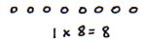
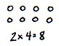
T: 1, 2, 4, and 8 are all factors of 8.
factors
product
factors
product

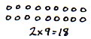
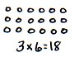
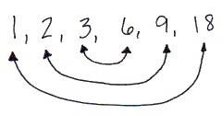
Display arrays for 1 × 18 and 2 × 9.
T: What product is represented in both arrays?
S: 18.
T: Record the multiplication sentences for each array.
S: 1 × 18 = 18 and 2 × 9 = 18.
T: Circle the factors. Write the factors of 18 that are represented in order from least to greatest.
S: (Write 1, 2, 9, 18.)
T: With your partner, draw an array to represent another pair of factors with the product of 18.
T: (Pause while students work.) What new factors of 18 did you find?
S: 3 and 6.
T: Revise your list of factors of 18.
S: 1, 2, 3, 6, 9, and 18.
T: How can we make sure we found all of the factors of 18?
S: I can use my multiplication chart. I can think through my multiplication facts. But what if the number is really big, like 92? I don’t know all the factors of 92. I could draw arrays to find all the factors, making rows of 3, then 4, then 5, and all the way to 92. That will take a long time.
T: Look at the list of factors for 18. Draw an arrow from 1 to 18. These are factor pairs because 1 × 18 = 18. With your partner, draw the rest of the arrows to connect the factor pairs.
S: (Draw as pictured to the right above.)
T: Notice that 3 and 6 are the middle pairs. We’ve checked everything up to 3, and the counting numbers between 3 and 6 are not factors of 18, so we found all the pairs. Try that with the factors of 8.
Problem 2: Identify factors to define prime and composite numbers.
Display the number sentence 2 × 8 = 16.
T: What are the factors?
S: 2 and 8.
T: What other multiplication sentences can you write using different factors that will give us the same product?
S: 1 × 16 = 16. 4 × 4 = 16.
T: So, what are all of the factors of 16?
S: 1, 2, 4, 8, and 16.
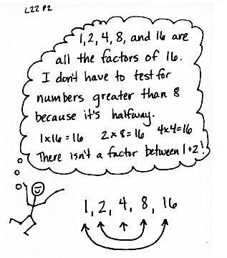
T: How do you know those are all of the factors of 16?
S: I listed them in order. When I got to 8, I noticed I already had its factor pair. Two times 8 is 16, so I didn’t have to go any further. I stopped at 8, too, because it was half of 16. There isn’t a factor between 1 and 2, so I guess we never need to go beyond the halfway point.
Display the equation 1 × 7 = 7.
T: What are the factors in this equation?
S: 1 and 7.
T: Find another factor pair for 7.
S: 7 × 1? Those are the same factors. If we drew arrays to represent factors of 7, the array for
1 × 7 and 7 × 1 would look the same. I can’t find another pair. There can’t be another pair. 2, 3, 4, 5, and 6 don’t work.
T: I hear you saying that 1 and 7 are the only factors. Talk to your partner. How is that different from the factors of 8, 10, 16, and 18?
S: There are more factor pairs for 8, 10, 16, and 18 than there are for 7. Seven has only one pair of factors, but the other numbers we looked at had more than one pair.
T: That’s right! Now think about the number 5. Name a pair of factors that will give us a product of 5.
S: 1 and 5.
T: Are there any other factor pairs?
S: Nope. One times 5 makes 5 just like 1 times 7 is seven. They both only have only one set of factors.
T: Numbers like 5 and 7 that have exactly two factors, 1 and the number itself, are called prime numbers.
T: With your partner, list at least two more prime numbers. (Allow time for students to discover and list. Review their findings for numbers such as 11, 13, and 17.)
T: (Refer to list just created.) If these are prime numbers, can you name a number that is not prime?
S: (Responses will vary.)
T: Yes! The numbers you mentioned have at least one factor other than 1 and the number itself. They are called composite numbers.
T: Let’s use 6 as an example. Does 6 have more than two factors?
S: Yes! One and 6 are factors, but 2 and 3 are also factors.
T: So, what can we say about the number 6?
S: It is composite. It has more than two arrays to represent it. It has more than two factors.
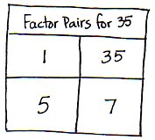
Problem 3: Identify factors of numbers and determine if they are prime or composite.
Display the numbers 23, 35, and 48.
T: Let’s use a table to record the factor pairs for 35. Say the first factor pair.
Guide students to complete the table as a class, using their multiplication facts.
T: Is 35 a prime or composite number? Why?
S: Composite, because it has more than one factor pair.
T: With your partner, use a table to list factors of 23 and 48 and tell if each one is prime or composite.
Allow three minutes for students to work.
T: Are any of these numbers prime numbers? How do you know?
S: Twenty-three is prime because we thought about all the possible factors, other than one, up to 11 and none worked.
T: Why can we stop at the number 11?
S: Eleven is the closest whole number to half of 23. Once I get halfway, I have found all of the factor pairs. After that, they just keep repeating.
T: Why is 48 composite?
S: There are more than two factors. It has 6 and 8 as factors. It also has 4 and 12. I found 10 factors! It sure isn’t prime!
Problem Set (10 minutes)

NOTES ON
MULTIPLE MEANS
OF ACTION AND EXPRESSION:
Provide concrete manipulatives for students to explore arrays as they classify each number in Problem 1 of the Problem Set as prime or composite. Numbers that can be arranged in more than one array pattern are composite.

Students should do their personal best to complete the Problem Set within the allotted 10 minutes. For some classes, it may be appropriate to modify the assignment by specifying which problems they work on first. Some problems do not specify a method for solving. Students should solve these problems using the RDW approach used for Application Problems.

Student Debrief (10 minutes)

NOTES ON
PRIME NUMBERS:
Since 0 times any number is 0, it behaves differently than other numbers. Because of this difference, we do not classify it as prime or composite.
Many students might reason that 1 should be prime since its only factors are 1 and itself. In fact, their logic is sound, and throughout history, many mathematicians would have agreed! However, choosing to define 1 as neither prime nor composite leads to simpler statements of theorems regarding the structure of the number system. This choice has become universally accepted in more recent times.

Lesson Objective: Find factor pairs for numbers to 100, and use understanding of factors to define prime and composite.
The Student Debrief is intended to invite reflection and active processing of the total lesson experience.
Invite students to review their solutions for the Problem Set. They should check work by comparing answers with a partner before going over answers as a class. Look for misconceptions or misunderstandings that can be addressed in the Debrief. Guide students in a conversation to debrief the Problem Set and process the lesson.
You may choose to use any combination of the questions below to lead the discussion.
- Compare the factors in Problem 1(e) and 1(l). Twenty-four is double 12. What do you notice about their factors? Compare the factors in Problem 1(d) and 1(i). Eighteen is double 9. What do you notice about their factors?
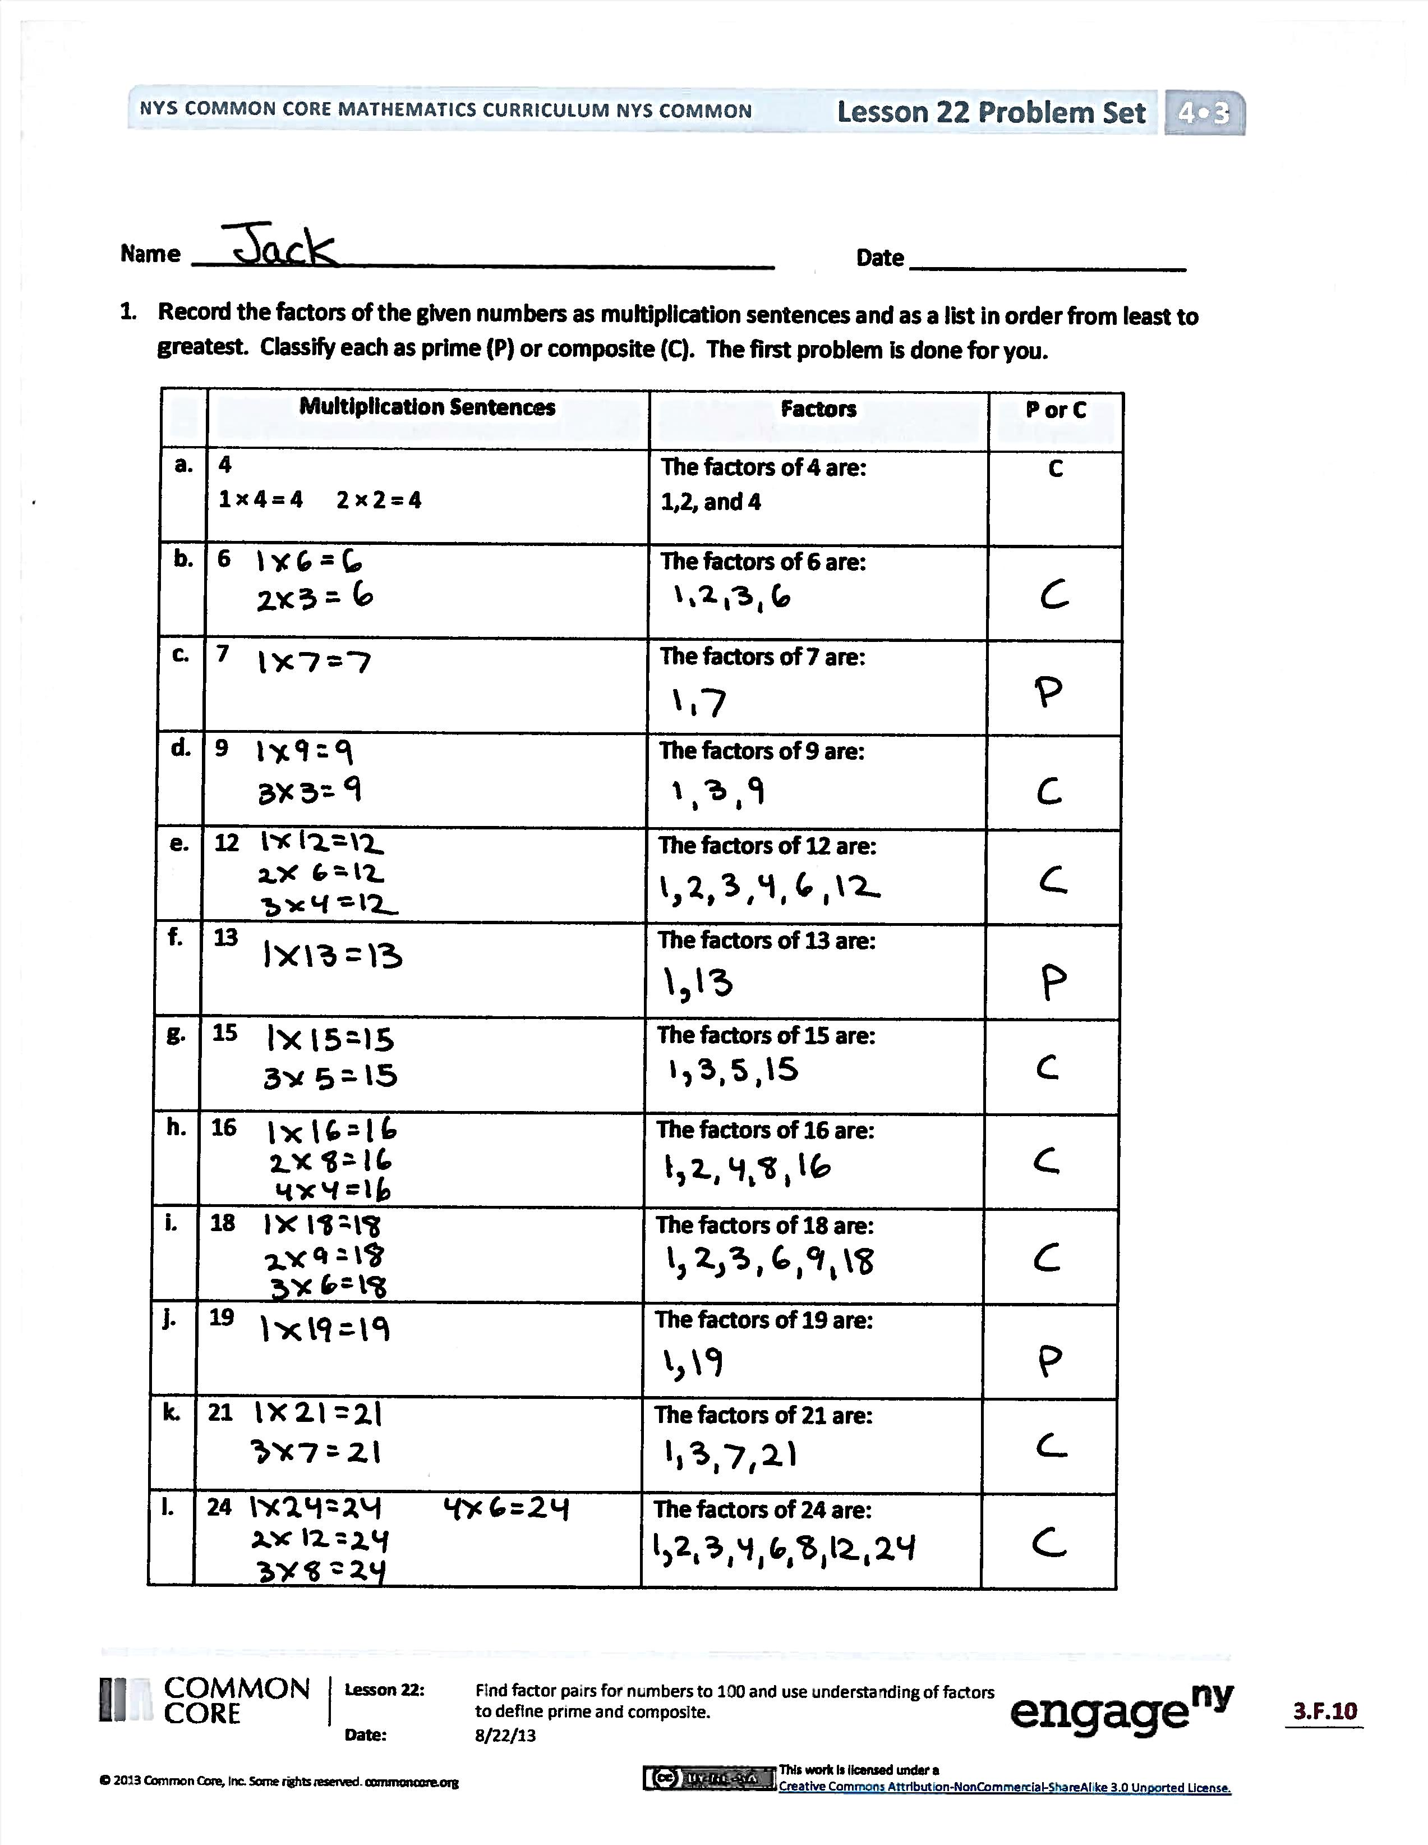
- In Problem 1, what numbers have an odd number of factors? Why is that so?
- Are all prime numbers odd? Explain what you would tell Bryan in Problem 3.
- Explain your answer to Problem 3(b). Are all even numbers composite? How many even numbers are not composite?
- We talked a lot about the number 1 today as being a factor of other numbers, but we have not classified it as prime or composite. Can 1 be composite? (No.) It turns out that it’s not considered prime either!

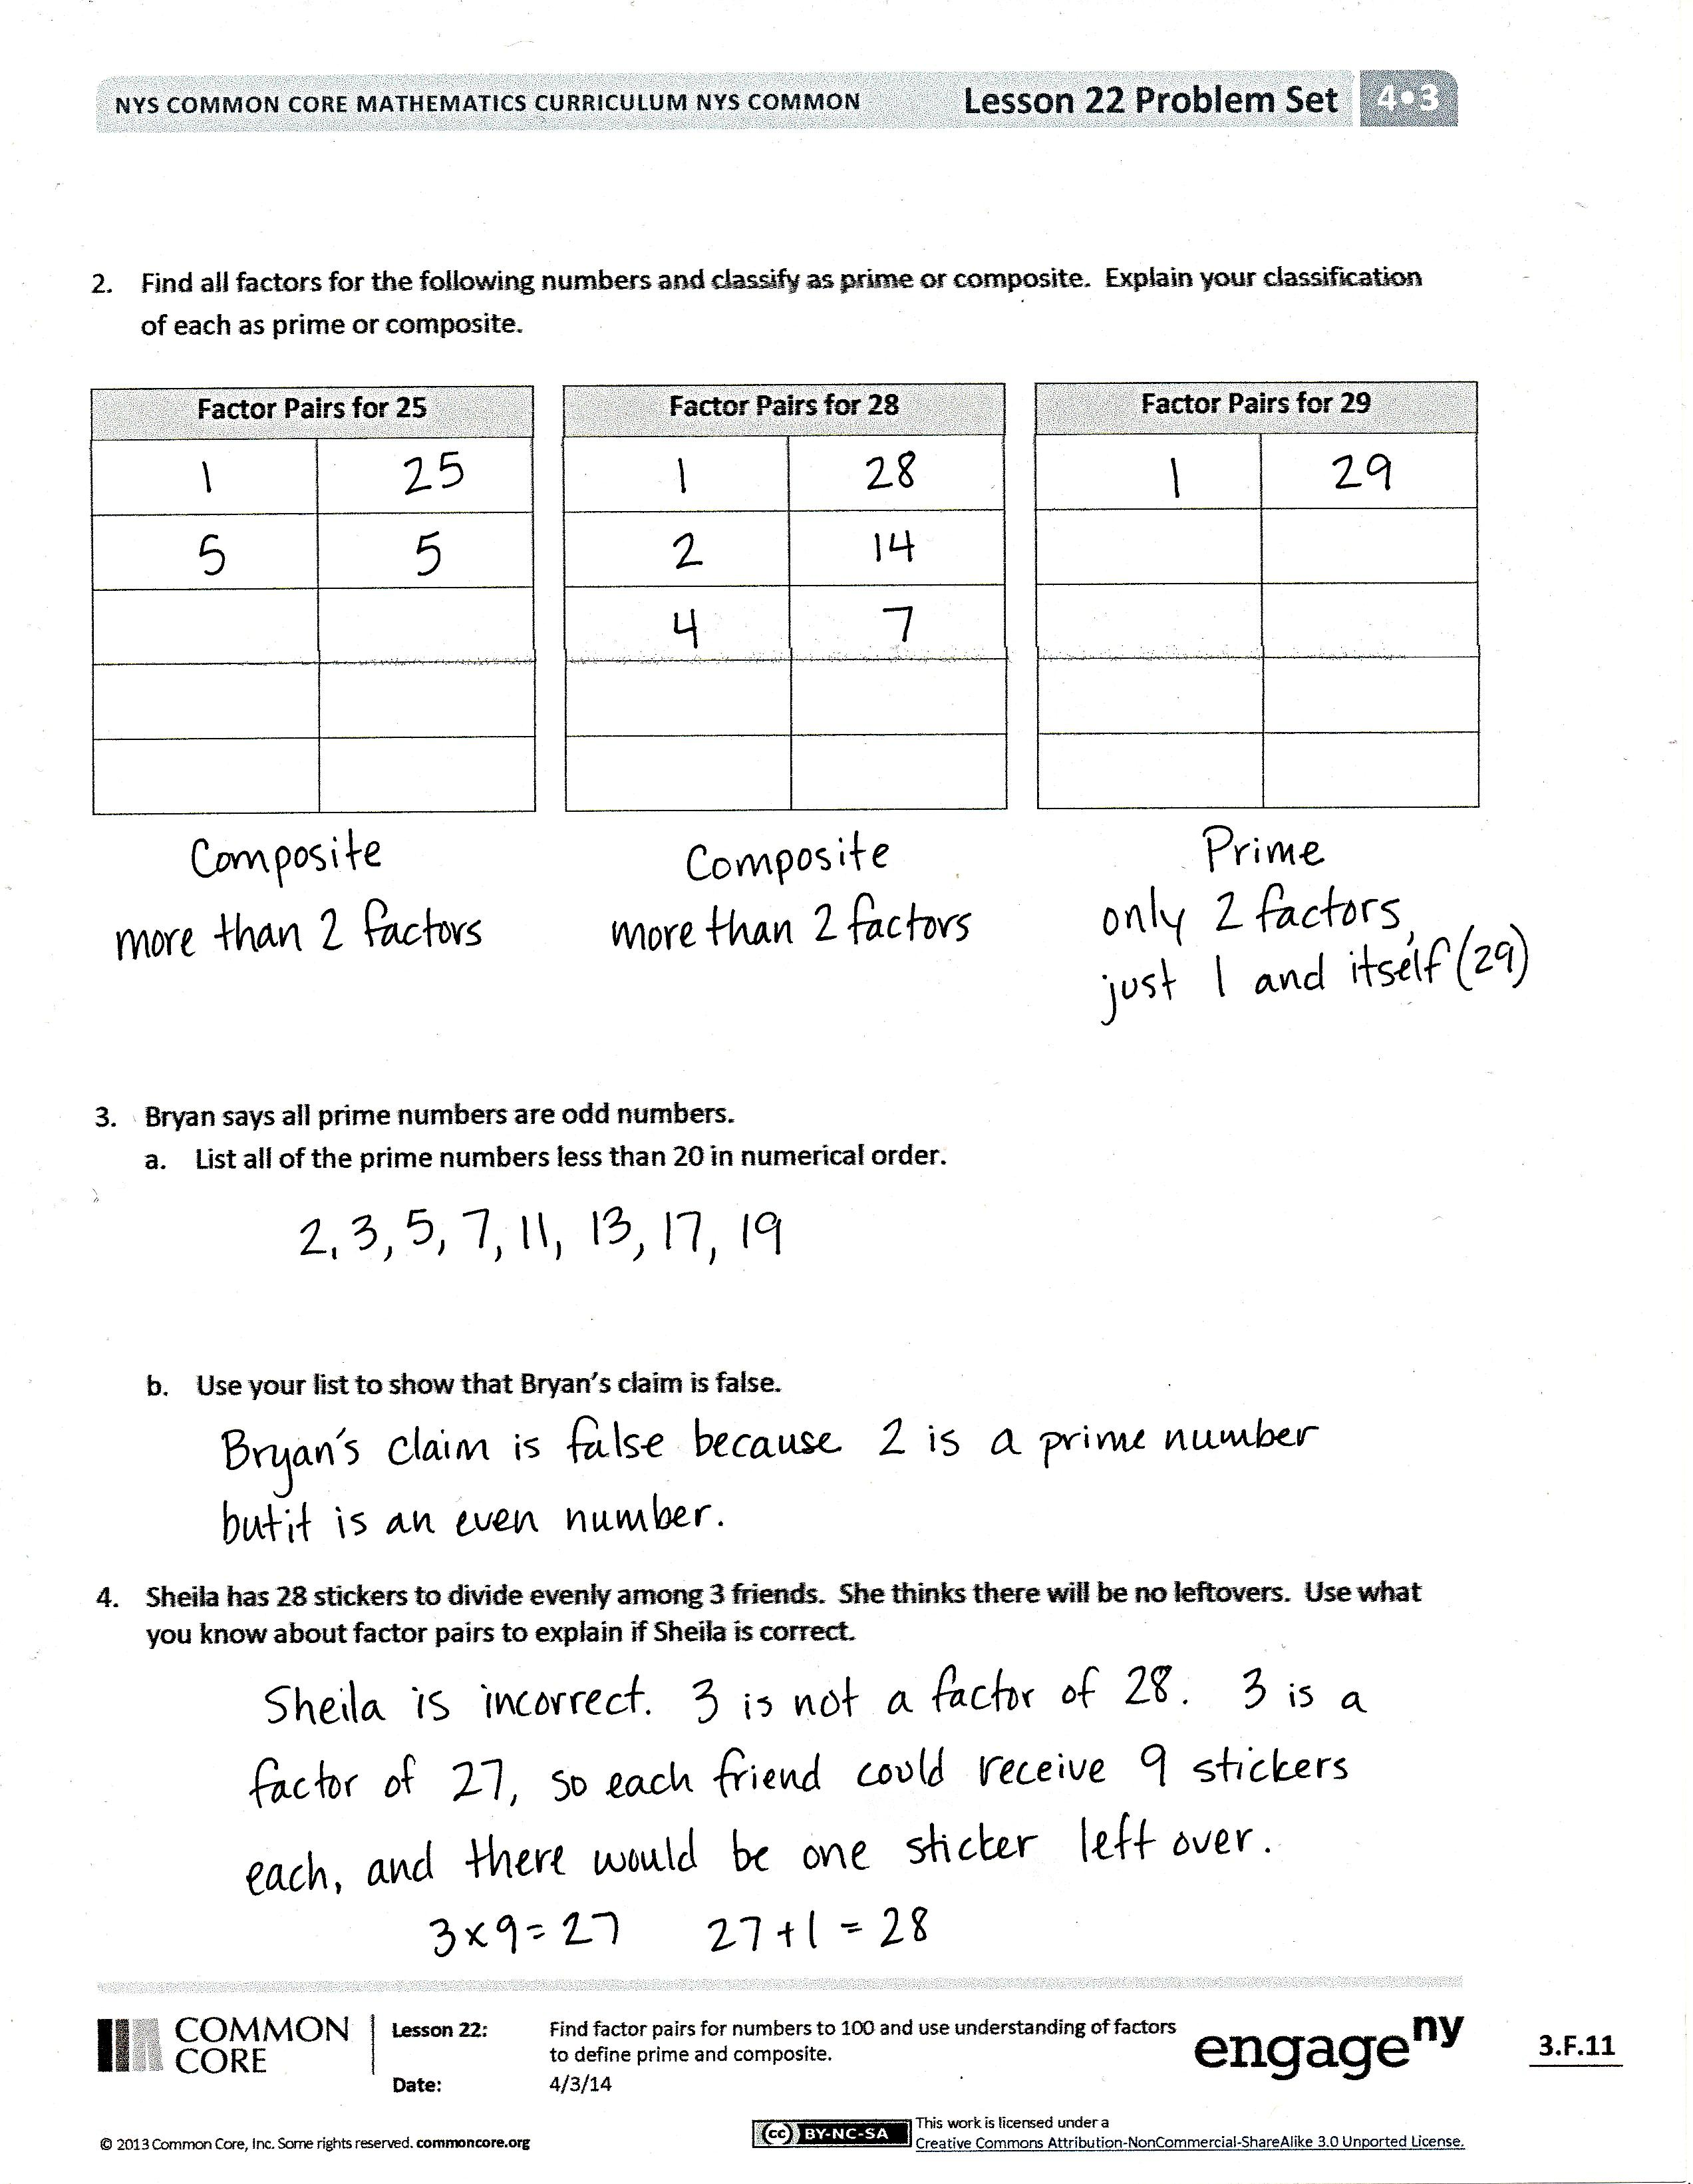
Exit Ticket (3 minutes)
After the Student Debrief, instruct students to complete the Exit Ticket. A review of their work will help you assess the students’ understanding of the concepts that were presented in the lesson today and plan more effectively for future lessons. You may read the questions aloud to the students.

Name Date
- Record the factors of the given numbers as multiplication sentences and as a list in order from least to greatest. Classify each as prime (P) or composite (C). The first problem is done for you.
 | Multiplication Sentences | Factors | P or C
a. | 4  1 × 4 = 4 2 × 2 = 4 | The factors of 4 are:  1, 2, 4 | C
b. | 6 | The factors of 6 are:
c. | 7 | The factors of 7 are:
d. | 9 | The factors of 9 are:
e. | 12 | The factors of 12 are:
f. | 13 | The factors of 13 are:
g. | 15 | The factors of 15 are:
h. | 16 | The factors of 16 are:
i. | 18 | The factors of 18 are:
j. | 19 | The factors of 19 are:
k. | 21 | The factors of 21 are:
l. | 24 | The factors of 24 are:
Factor Pairs for 25
- Find all factors for the following numbers, and classify each number as prime or composite. Explain your classification of each as prime or composite.

Factor Pairs for 28
Factor Pairs for 29

- Bryan says all prime numbers are odd numbers.
  - List all of the prime numbers less than 20 in numerical order.

  - Use your list to show that Bryan’s claim is false.

- Sheila has 28 stickers to divide evenly among 3 friends. She thinks there will be no leftovers. Use what you know about factor pairs to explain if Sheila is correct.

Name Date
Record the factors of the given numbers as multiplication sentences and as a list in order from least to greatest. Classify each as prime (P) or composite (C).
 | Multiplication Sentences | Factors | Prime (P)  or  Composite (C)
a. | 9 | The factors of 9 are:
b. | 12 | The factors of 12 are:
c. | 19 | The factors of 19 are:

Name Date
- Record the factors of the given numbers as multiplication sentences and as a list in order from least to greatest. Classify each as prime (P) or composite (C). The first problem is done for you.
 | Multiplication Sentences | Factors | P or C
a. | 8  1 × 4 = 8 2 × 4 = 8 | The factors of 8 are:  1, 2, 4, 8 | C
b. | 10 | The factors of 10 are:
c. | 11 | The factors of 11 are:
d. | 14 | The factors of 14 are:
e. | 17 | The factors of 17 are:
f. | 20 | The factors of 20 are:
g. | 22 | The factors of 22 are:
h. | 23 | The factors of 23 are:
i. | 25 | The factors of 25 are:
j. | 26 | The factors of 26 are:
k. | 27 | The factors of 27 are:
l. | 28 | The factors of 28 are:
- Find all factors for the following numbers, and classify each number as prime or composite. Explain your classification of each as prime or composite.

Factor Pairs for 19

Factor Pairs for 24

Factor Pairs for 21
- Bryan says that only even numbers are composite.
  - List all of the odd numbers less than 20 in numerical order.

  - Use your list to show that Bryan’s claim is false.

- Julie has 27 grapes to divide evenly among 3 friends. She thinks there will be no leftovers. Use what you know about factor pairs to explain whether or not Julie is correct.

