Lesson 20

Objective: Solve division problems without remainders using the area model.

Suggested Lesson Structure

 Fluency Practice (12 minutes)

 Application Problem (8 minutes)

 Concept Development (30 minutes)

 Student Debrief (10 minutes)

**Total Time (60 minutes)**

Fluency Practice (12 minutes)

* Divide Using the Standard Algorithm **4.NBT.6** (4 minutes)
* Find the Unknown Factor **4.OA.4**  (5 minutes)
* Mental Multiplication **4.NBT.5**  (3 minutes)

Divide Using the Standard Algorithm (4 minutes)

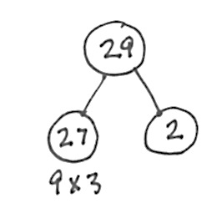Materials: (S) Personal white board

Note: This fluency activity reviews Lesson 17’s content.

Repeat the process from Lesson 17 using the following possible sequence: 67 ÷ 2, 60 ÷ 4, 29 ÷ 3, and 77 ÷ 4.

Find the Unknown Factor (5 minutes)

Materials: (S) Personal white board

Note: This fluency activity prepares students for Lesson 22’s Concept Development

T: (Write 5 × ___ = 15.) Say the unknown factor.

S: 3.

T: (Write 15 ÷ 5.) On your personal white board, write the division problem.

S: (Write 15 ÷ 5 = 3.)

Continue with the following possible sequence: 3 × ___ = 12, 4 × ___ = 12, 5 × ___ = 35, 6 × ___ = 36,   
7 × ___ = 49, 9 × ___ = 81, 6 × ___ = 48, 7 × ___ = 42, and 9 × ___ = 54.

Mental Multiplication (3 minutes)

Note: This fluency activity reviews content taught earlier in the module.

|  |  |
| --- | --- |
|  | NOTES ON MULTIPLE MEANS OF EXPRESSION: |
| As with any mental math, some students do better when having the option to write. This aids in their processing of the oral commands and reduces stress, which, though beneficial to some, may be crippling to others. | |

T: (Write 3 × 2 = .) Say the complete multiplication sentence in unit form.

S: 3 ones × 2 = 6 ones.

T: (Write 3 × 2 = 6. To the right, write 30 × 2 = .) Say the complete multiplication sentence in unit form.

S: 3 tens × 2 = 6 tens.

T: (Write 30 × 2 = 60. To the right, write 30 × 20 = .) Say the complete multiplication sentence in unit form.

S: 3 tens × 2 tens = 6 hundreds.

T: (Write 30 × 20 = 600.)

Continue with the following possible sequence: 4 × 2, 40 × 2, 40 × 20, 5 × 3, 50 × 3, and 50 × 30.

Application Problem (8 minutes)

Write an expression to find the unknown length of each rectangle. Then, find the sum of the two unknown lengths.

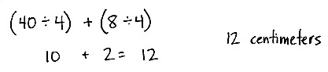

16 square cm

4 cm

80 square cm

4 cm in

40 square cm

8

square cm

a.

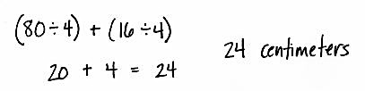

b.

Note: This Application Problem serves as an introduction to today’s Concept Development, in which the students find the total unknown length of a rectangle with an area of 48, corresponding to Part (a), and 96, corresponding to Part (b).

Concept Development (30 minutes)

Materials: (S) Personal white board

Problem 1: Decompose 48 ÷ 4 from whole to part.

T: Draw a rectangle with an area of 48 square units and a width of 4 units.

S: (Draw.)

T: Draw a new rectangle with the same area directly below but partitioned to match the areas of the rectangles in Part (a) of the Application Problem.

T: Let’s draw a number bond to match the whole and parts of the rectangle.

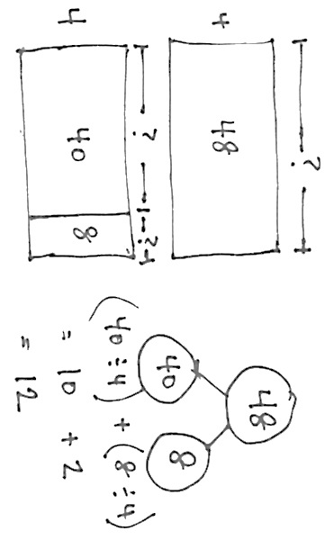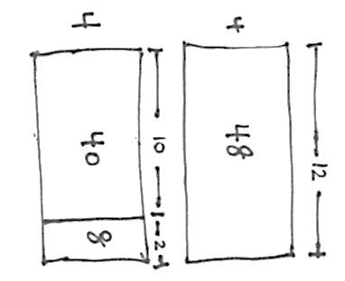

S/T: (Students and teacher draw bond as pictured below.)

T: Let’s find the unknown side lengths of the smaller rectangles and add them. (Show as the distribution of the quotients shown above.) What is 40 ÷ 4?

S: 10.

T: What is 8 ÷ 4?

S: 2.

T: What is 10 and 2?

S: 12.

T: What is 48 divided by 4?

S: 12.

T: What is the length of the unknown side?

S: 12 units.

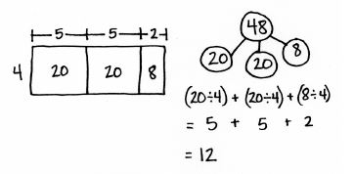T: Take a moment to record the number sentences, reviewing with your partner their connection to both the number bond and the area model.

T: Work with your partner to partition the same area of 48 as 2 twenties and 8. When you are finished, try to find another way to partition the area of 48 so it’s easy to divide.

T: (Allow students to work for about four minutes.) Did anyone find another way to partition the area of 48 so it’s easy to divide?

S: Yes! 24 + 24. 24 divided by 4 is 6. 6 + 6 is 12. 🡪 30 and 18 don’t work well because 30 has a remainder when you divide it by 4. 🡪 I did it by using 4 rectangles, each with an area of 12 square units. 🡪 Oh, yeah, 12 + 12 + 12 + 12.

T: Explain to your partner why different ways of partitioning give us the same correct side length.

S: You are starting with the same amount of area but just chopping it up differently. 🡪 The sum of the lengths is the same as the whole length. 🡪 You can take a total, break it into parts, and divide each of them separately. 🡪 I use the same break apart and distribute strategy to find the answer to 56 ÷ 8. 40 ÷ 8 is 5. 16 ÷ 8 is 2. 5 and 2 makes 7.

Problem 2: Decompose 96 ÷ 4 from whole to part.

Repeat the same process with Part (b) from the Application Problem.

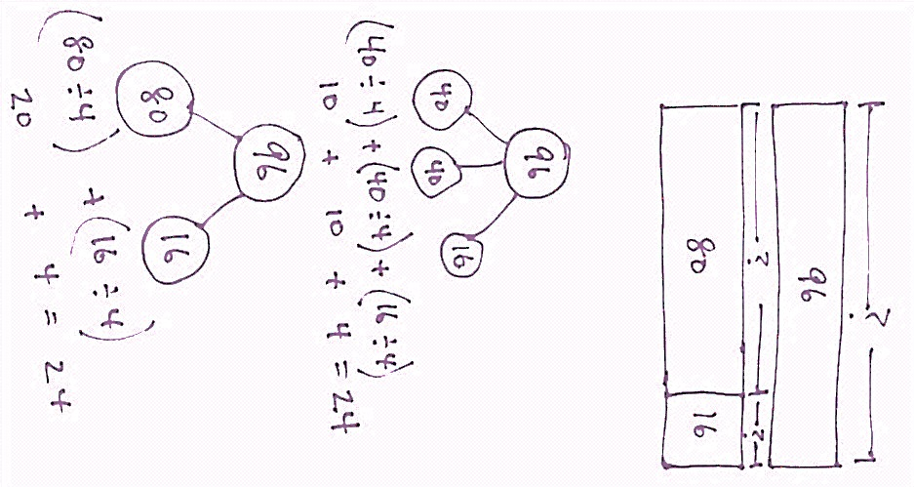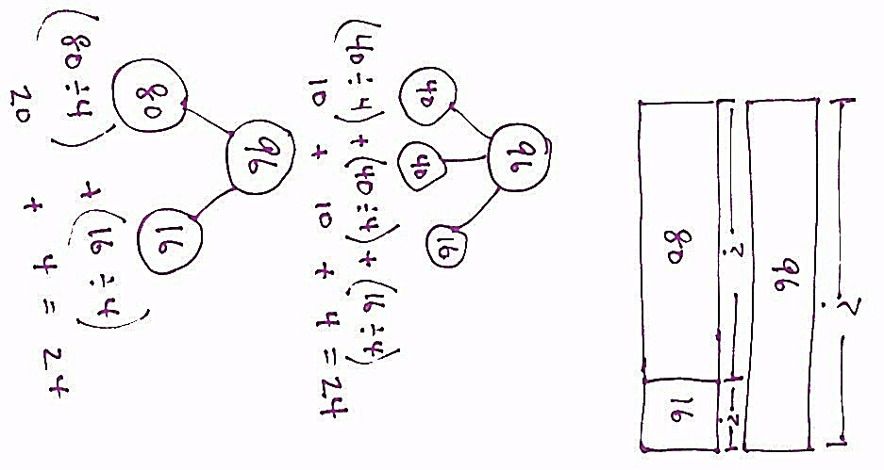

T: How did you partition the area of 96?

S: We chopped 96 into 40 + 40 + 16. 🡪 It was just like 48 ÷ 4. We saw that we could partition 96 into 4 twenties and 2 eights. 🡪 We made 96 into 2 forty-eights and used our answer from 48 ÷ 4! All we had to do was double it.

T: Discuss with your partner why we do not decompose 96 as 90 and 6.

S: 9 tens ÷ 4 gives a remainder.

T: True!

Problem 3: Compose 96 ÷ 4 from part to whole.

T: (Write 96 ÷ 4.) Thinking about area, let’s try a new way to divide. The expression 96 ÷ 4 can describe a rectangle with an area of 96 square units. We are trying to find out the length of the unknown side.

T: What is the known side width?

S: 4.

T: (Draw a rectangle with a width of 4.) Four times how many tens gets us as close as possible to an area of 9 tens? (Point to the 9 tens of the dividend.)

S: 2 tens.

T: Let’s give 2 tens to the length. (Label 2 tens above the rectangle.) Let’s record the 2 tens in the tens place.

T: What is 4 times 2 tens?

S: 8 tens. (Record 8 below the 9 tens.)

T: How many square units is that?

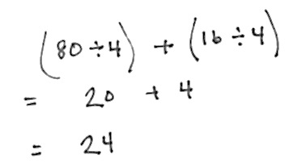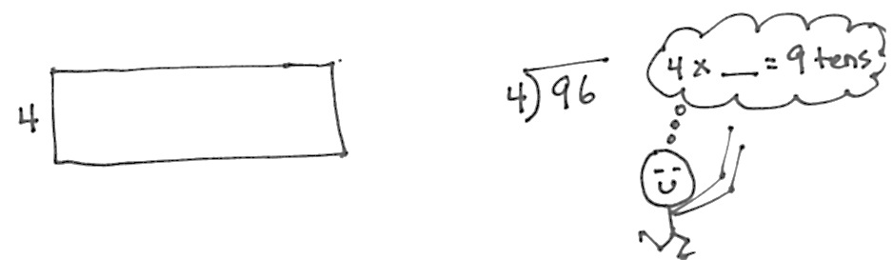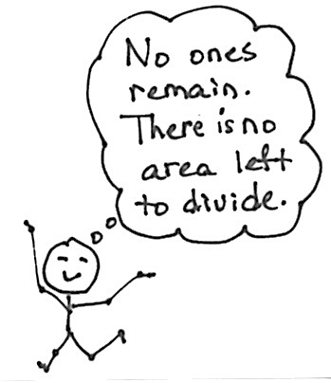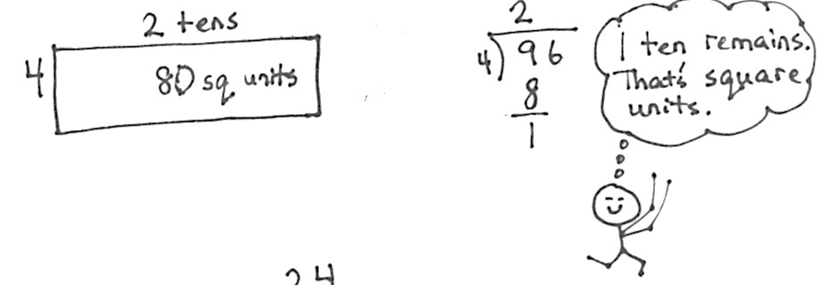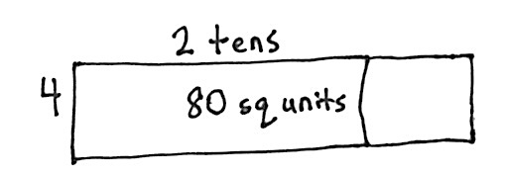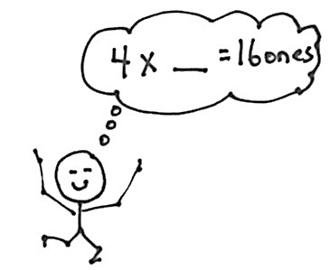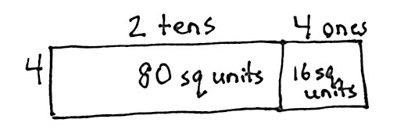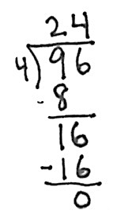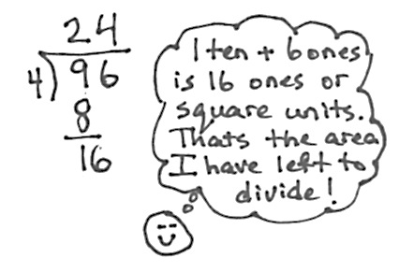

S: 80 square units. (Record 80 square units in the rectangle.)

T: How many tens remain?

S: 1 ten.

T: (Record 1 ten below the 8 tens.) Let’s add the remaining ten to the 6 ones. What is 1 ten + 6 ones? (Record the 6 ones to the right of the 1 ten.)

S: 16.

T: We have 16 square units remaining with a width of 4. (Point to the 16 in the problem.) four times how many ones gets us as close as possible to an area of 16 square units?

S: 4 ones.

T: Let’s give 4 ones to the length.

T: What is 4 times 4?

S: 16. We have 16 square units.

T: (Record 16 square units in the rectangle.) We had 16 square units to divide and we did. (Record 16 in the problem and subtract to get zero.) We have no more area to divide.

T: Tell me the length of the unknown side.

S: 24!

T: Our quotient tells us that length.

T: How can we express the length of the unknown side using the distributive property?

S: (80 ÷ 4) + (16 ÷ 4).

T: With your partner, draw arrows to connect the distributive property and the area model.

T: Review our four drawings and our process with your partner. Try to reconstruct what we did step-by-step before we try another one.

T: (Allow time for students to review.) We solved 96 divided by 4 in two very different ways using the area model. First, we started with the whole rectangle and partitioned it. The second way was to go one place value at a time and make the whole rectangle from parts.

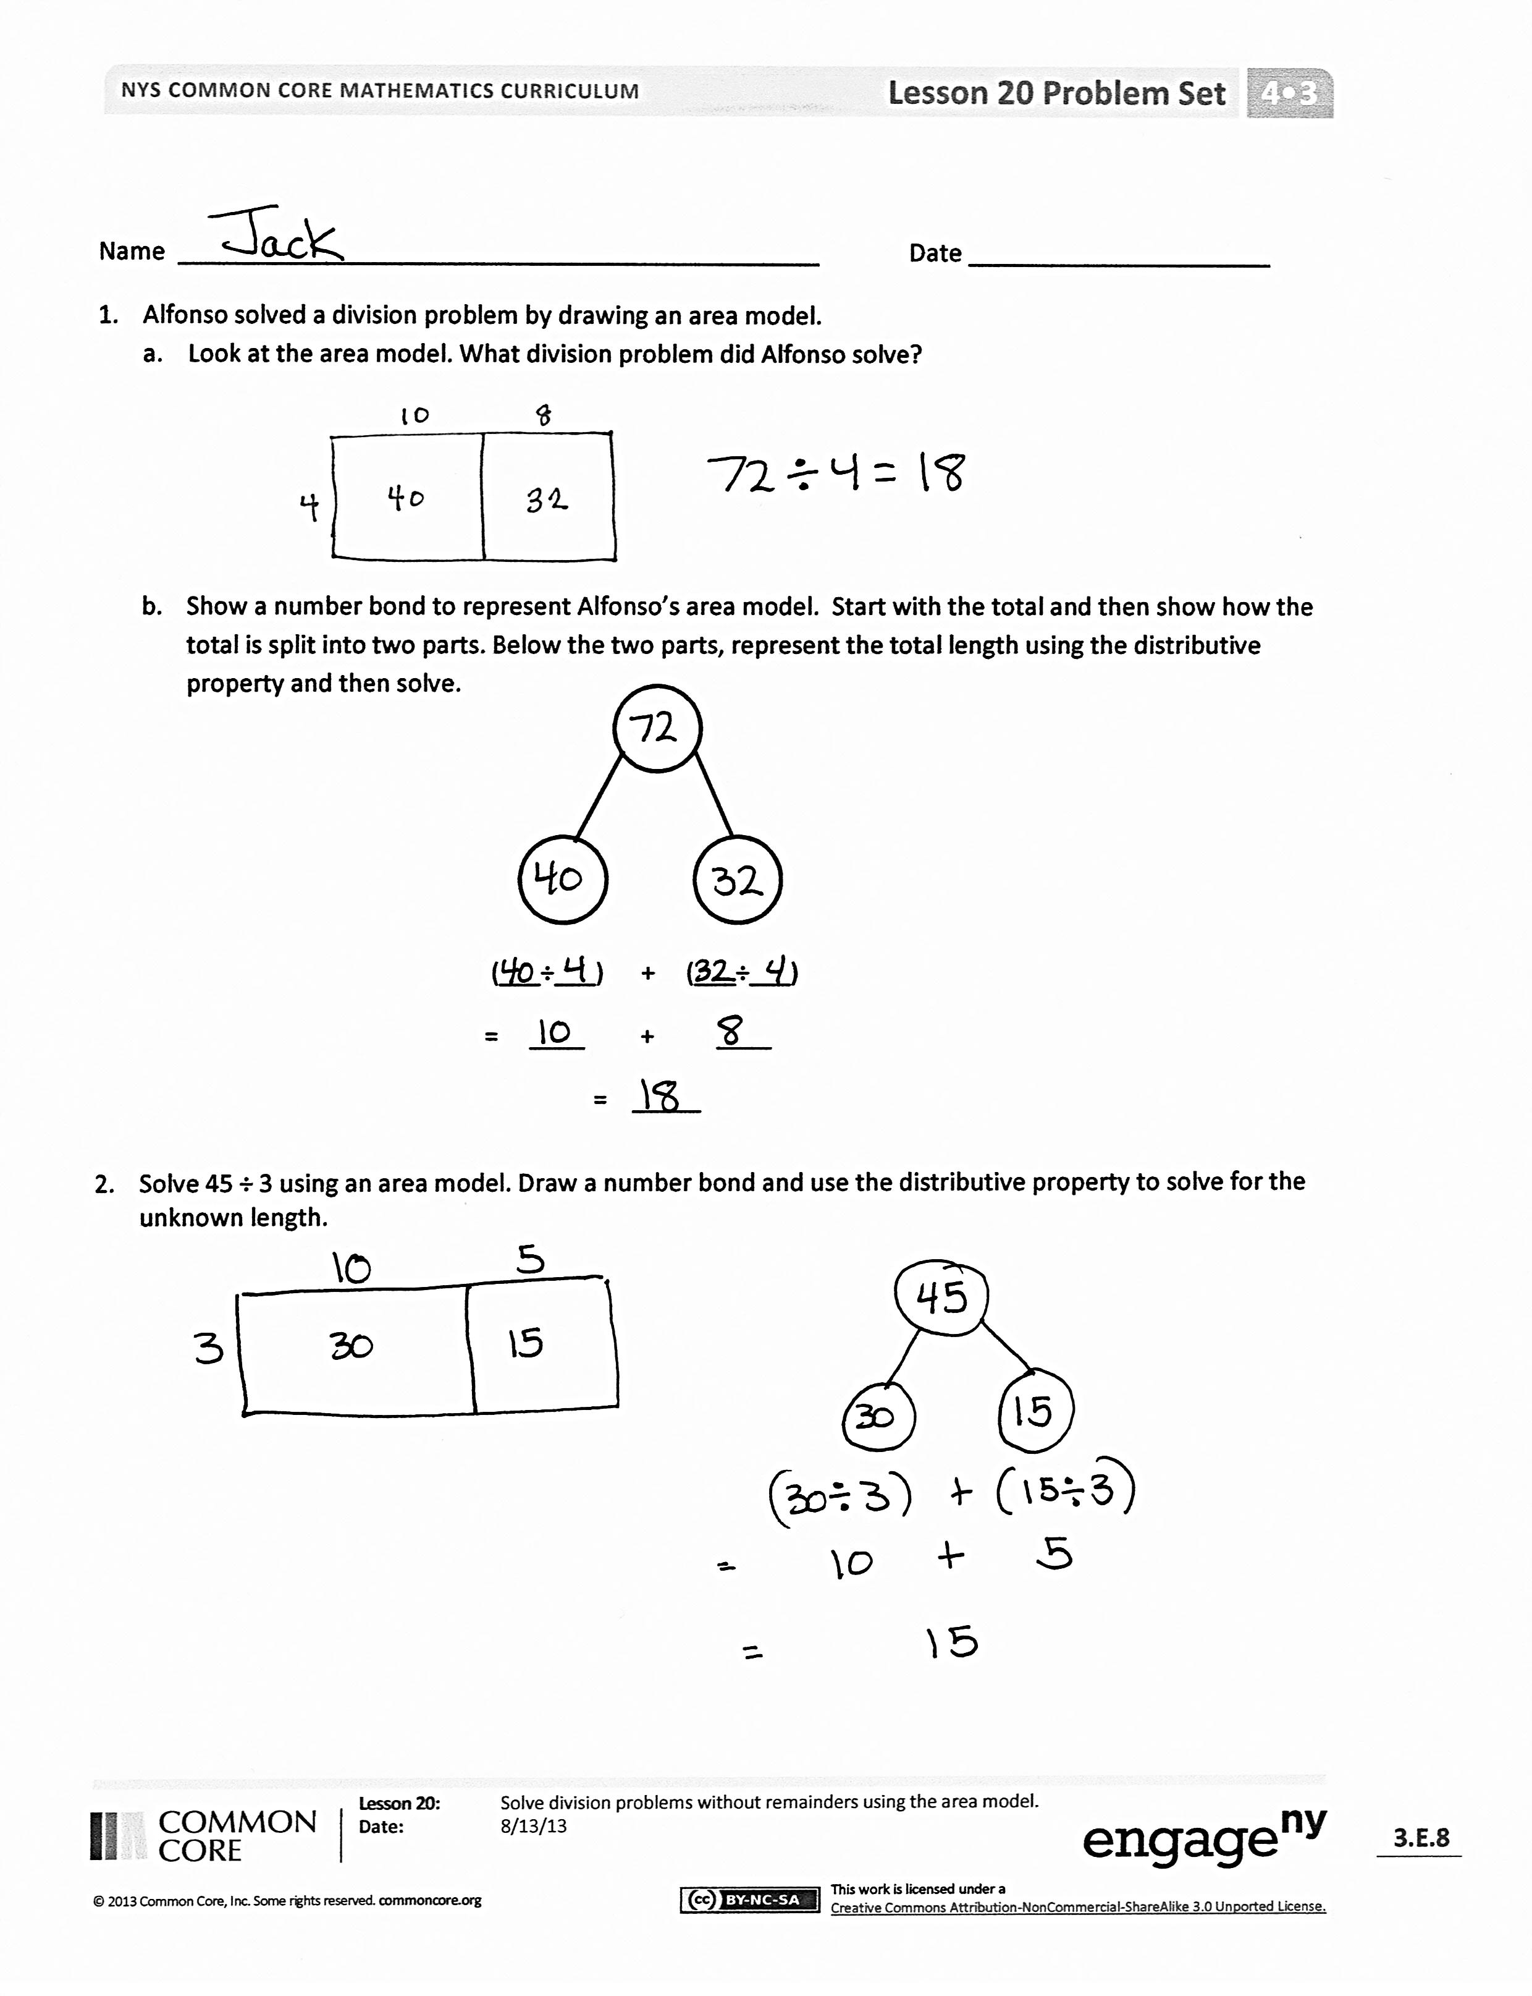Problem Set (10 minutes)

Students should do their personal best to complete the Problem Set within the allotted 10 minutes. For some classes, it may be appropriate to modify the assignment by specifying which problems they work on first. Some problems do not specify a method for solving. Students should solve these problems using the RDW approach used for Application Problems.

Student Debrief (10 minutes)

**Lesson Objective:**  Solve division problems without remainders using the area model.

The Student Debrief is intended to invite reflection and active processing of the total lesson experience.

Invite students to review their solutions for the Problem Set. They should check work by comparing answers with a partner before going over answers as a class. Look for misconceptions or misunderstandings that can be addressed in the Debrief. Guide students in a conversation to debrief the Problem Set and process the lesson.

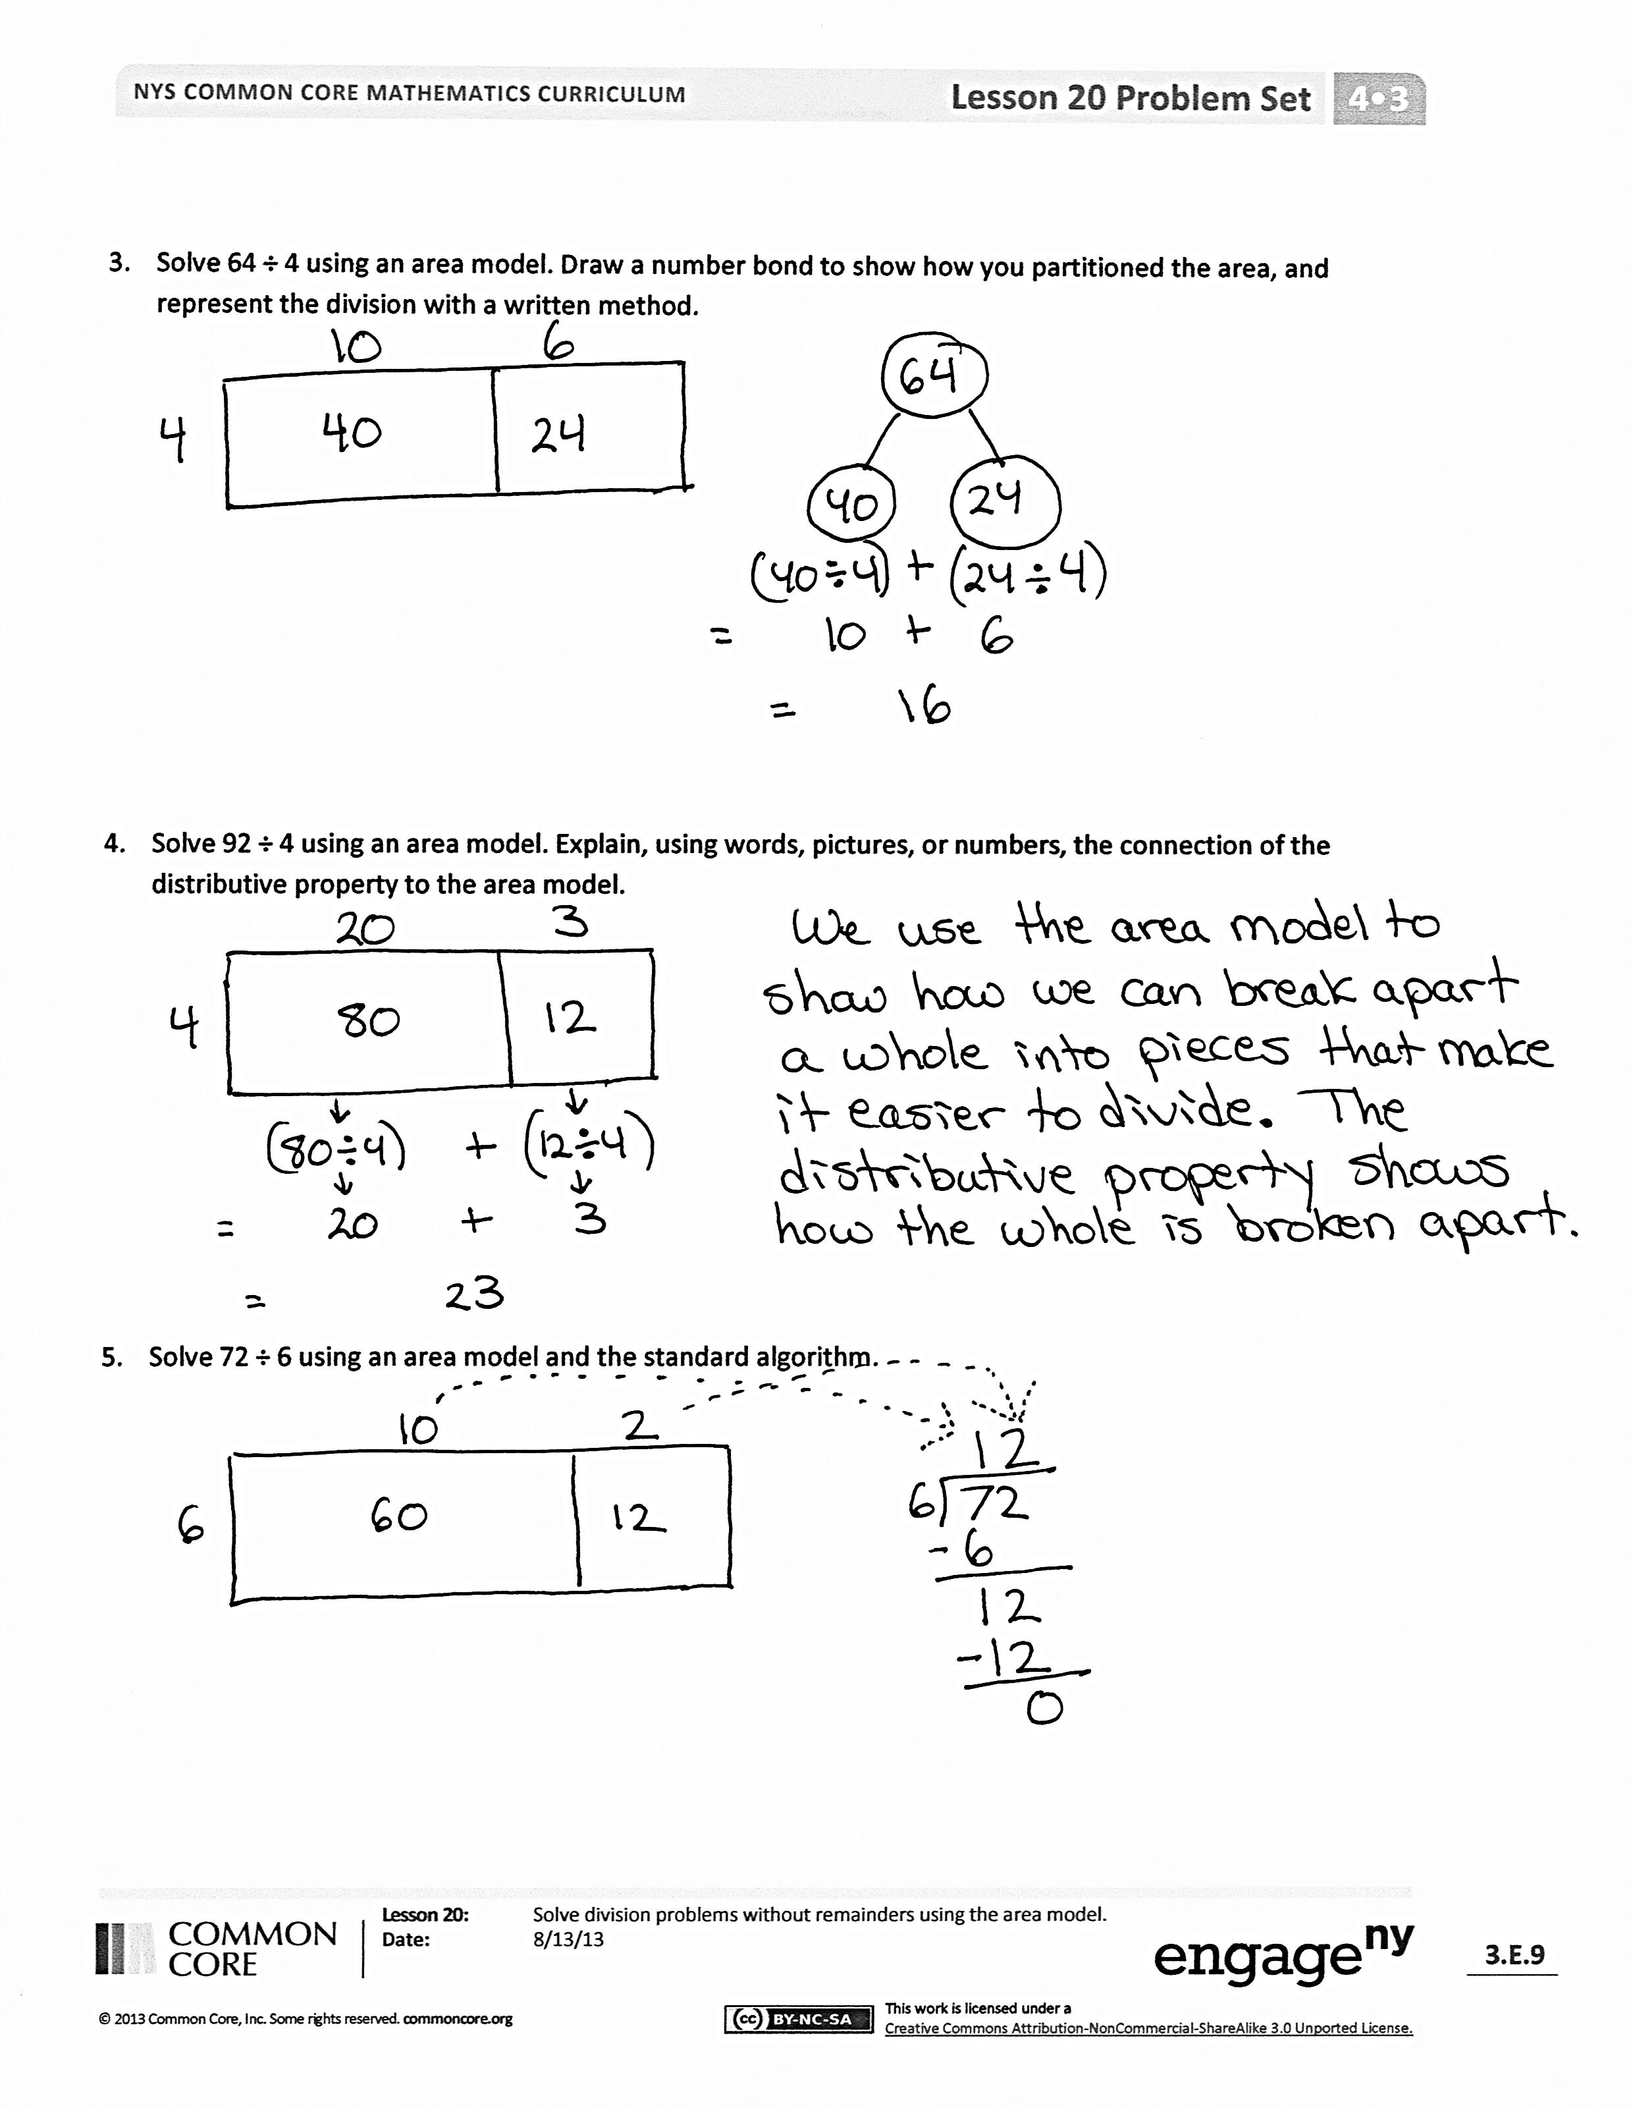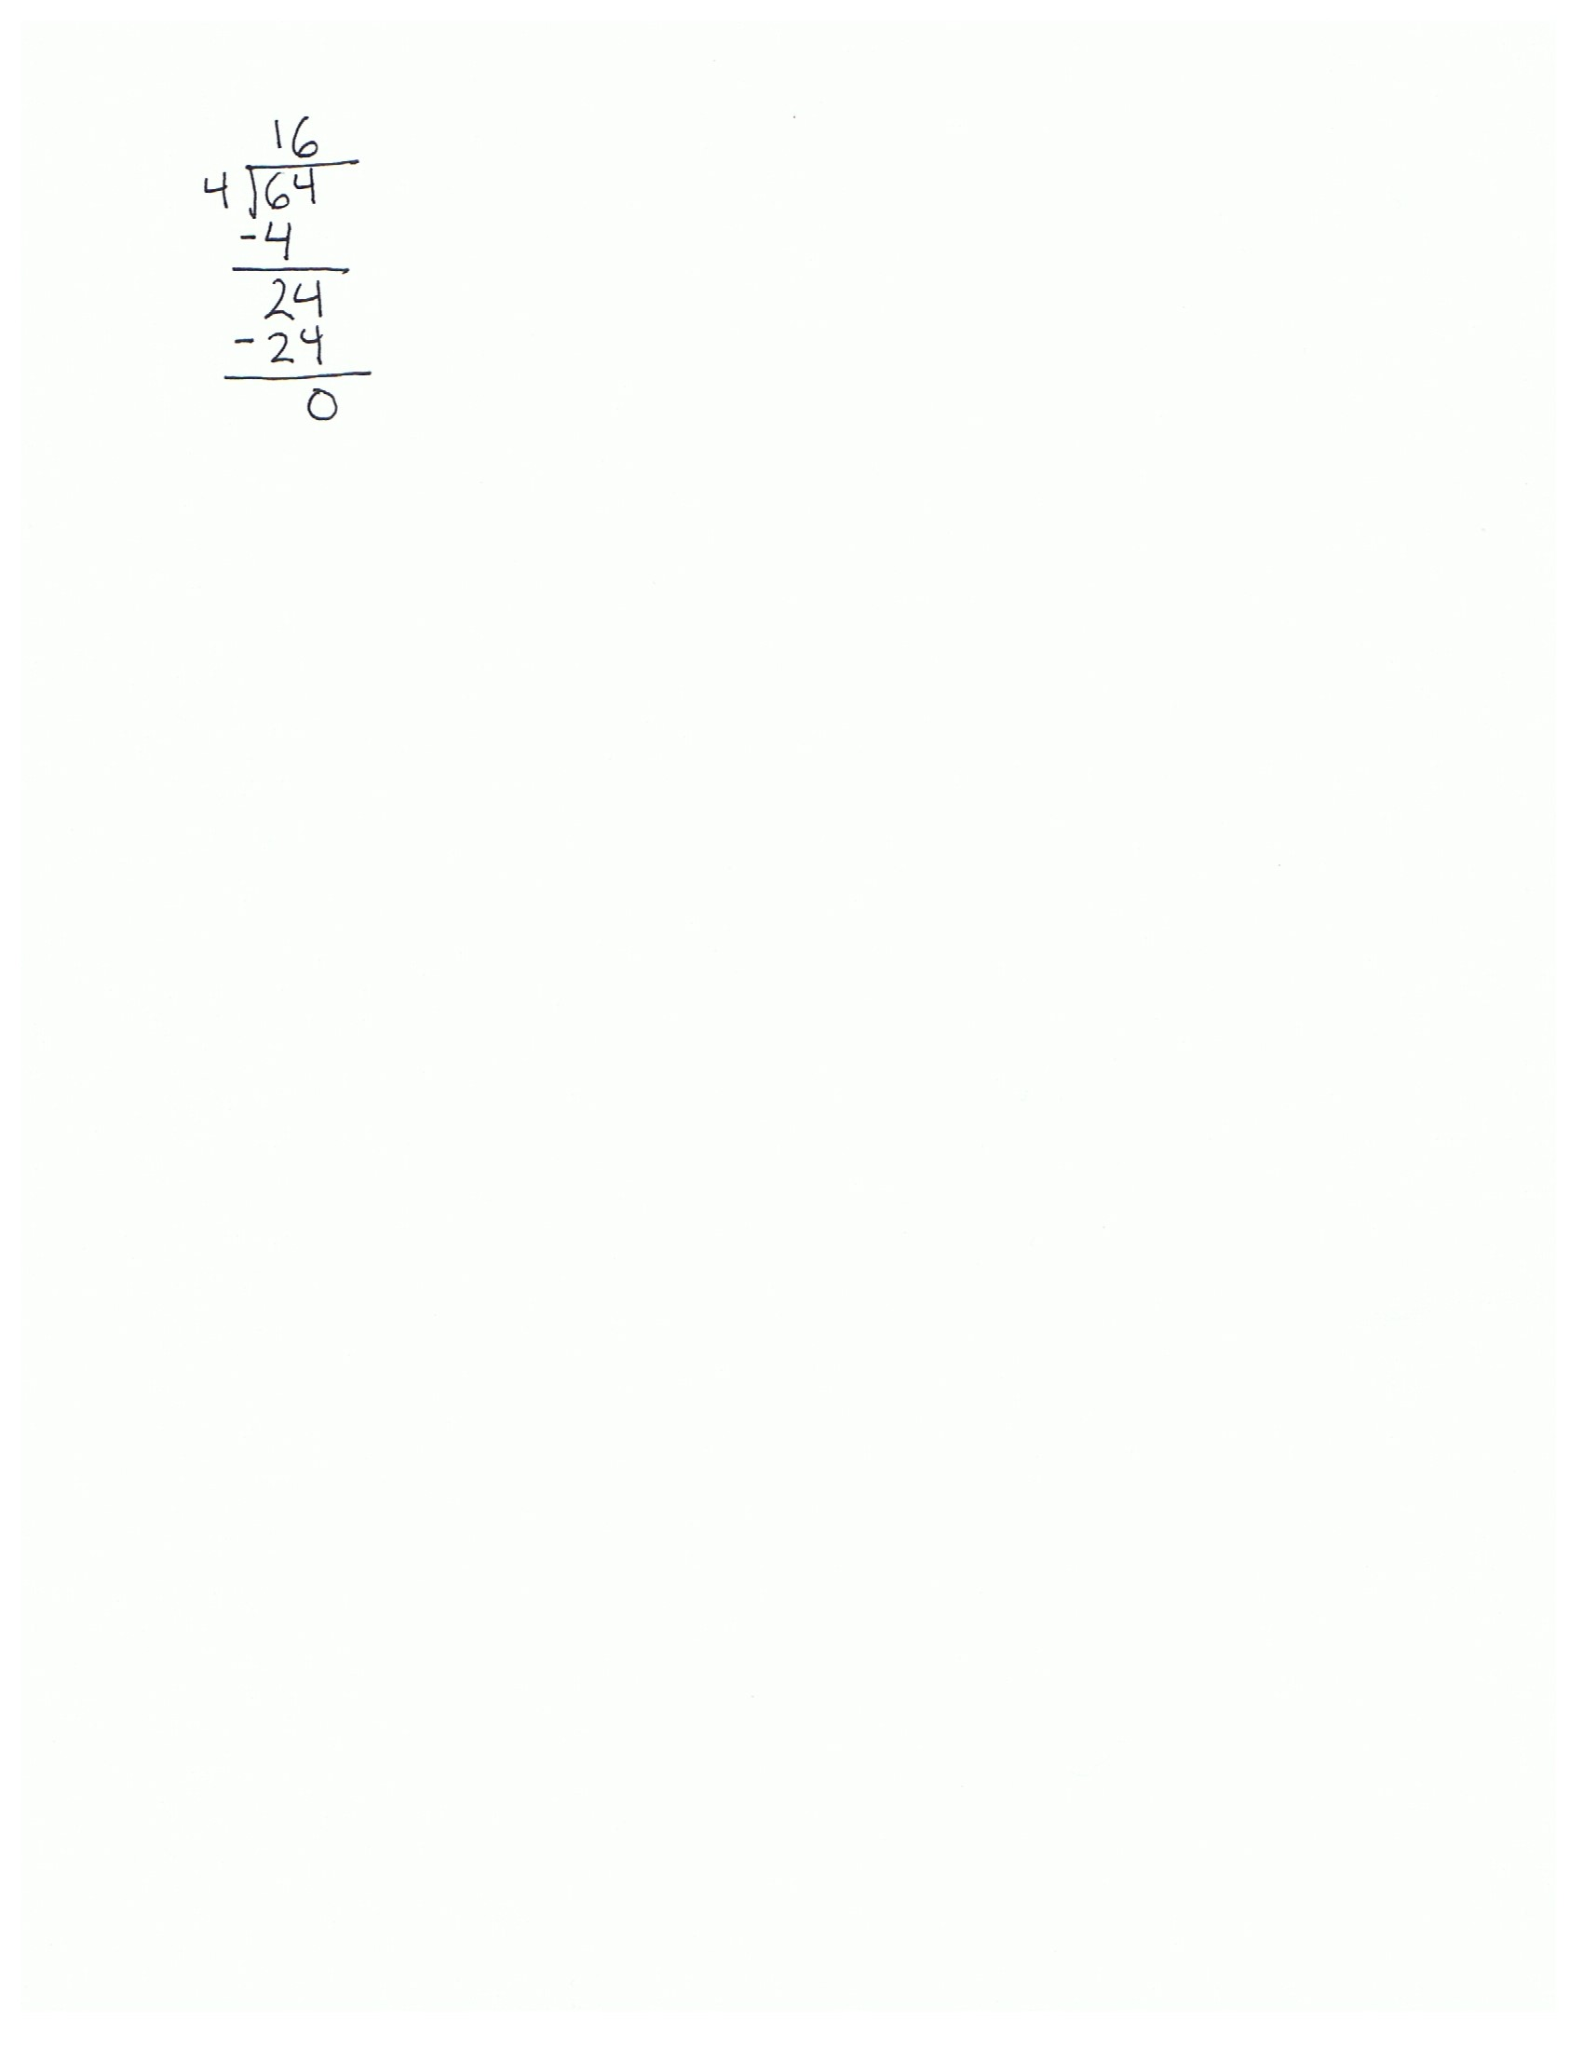

You may choose to use any combination of the questions below to lead the discussion.

* In Problem 2, did you partition the rectangle the same way as your partner? Why were we able to go from whole to part?
* Explain the connection between the written method, the number bond, and the area model in Problem 3.
* In the last problem, explain the connection between the algorithm and the area model.
* Each time we divide, what happens to the amount of area we still have left to divide?
* Even though division is messy, I think it is the most interesting operation of all because, imagine this–sometimes that little piece that is left to divide is always there, even though it gets infinitely small! Talk to your partner about what you think I might mean by that.

Exit Ticket (3 minutes)

After the Student Debrief, instruct students to complete the Exit Ticket. A review of their work will help you assess the students’ understanding of the concepts presented in the lesson today and plan more effectively for future lessons. You may read the questions aloud to the students.

Name Date

1. 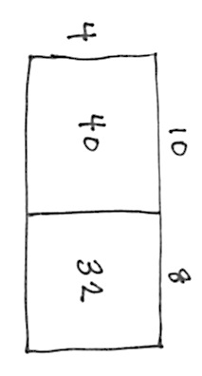Alfonso solved a division problem by drawing an area model.
2. Look at the area model. What division problem did Alfonso solve?
3. Show a number bond to represent Alfonso’s area model. Start with the total and then show how the total is split into two parts. Below the two parts, represent the total length using the distributive property and then solve.

(___÷___) + (___÷___)

= ____ + ____

= _____

1. Solve 45 ÷ 3 using an area model. Draw a number bond and use the distributive property to solve for the unknown length.
2. Solve 64 ÷ 4 using an area model. Draw a number bond to show how you partitioned the area, and represent the division with a written method.
3. Solve 92 ÷ 4 using an area model. Explain, using words, pictures, or numbers, the connection of the distributive property to the area model.
4. Solve 72 ÷ 6 using an area model and the standard algorithm.

Name Date

1. Tony drew the following area model to find an unknown length. What division equation did he model?

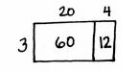

2. Solve 42 ÷ 3 using the area model, a number bond, and a written method.

Name Date

1. Maria solved the following division problem by drawing an area model.
   1. 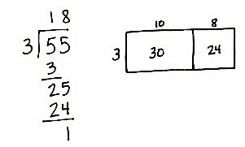Look at the area model. What division problem did Maria solve?
   2. Show a number bond to represent Maria’s area model. Start with the total and then show how the total is split into two parts. Below the two parts, represent the total length using the distributive property and then solve.

(___÷___) + (___÷___)

= ____ + ____

= _____

1. Solve 42 ÷ 3 using an area model. Draw a number bond and use the distributive property to solve for the unknown length.
2. Solve 60 ÷ 4 using an area model. Draw a number bond to show how you partitioned the area, and represent the division with a written method.
3. Solve 72 ÷ 4 using an area model. Explain, using words, pictures, or numbers, the connection of the distributive property to the area model.
4. Solve 96 ÷ 6 using an area model and the standard algorithm.