Lesson 17
Objective: Represent and solve division problems requiring decomposing a remainder in the tens.

Suggested Lesson Structure
 Fluency Practice (11 minutes)
 Application Problem (5 minutes)
 Concept Development (34 minutes)
 Student Debrief (10 minutes)
Total Time (60 minutes)
Fluency Practice (11 minutes)
- Group Count 4.OA.1 (2 minutes)
- Divide Mentally 4.NBT.6 (4 minutes)
- Divide Using the Standard Algorithm 4.NBT.6 (5 minutes)
Group Count (2 minutes)
Note: This fluency activity prepares students to divide with remainders during the Concept Development.
Direct students to count forward and backward, occasionally changing the direction of the count.
- Twos to 20
- Threes to 30
- Fours to 40
- Fives to 50
Divide Mentally (4 minutes)
Note: This fluency activity reviews Lesson 16’s content.
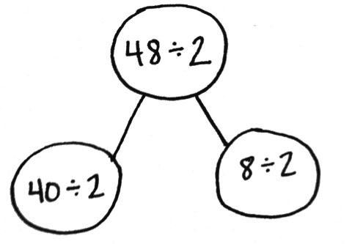
T: (Write 40 ÷ 2.) Say the completed division sentence in unit form.
S: 4 tens divided by 2 equals 2 tens.
T: (To the right, write 8 ÷ 2.) Say the completed division sentence in unit form.
S: 8 ones divided by 2 equals 4 ones.
T: (Above both equations, write 48 ÷ 2. Draw a number bond to connect the two original problems to this new problem.) Say the completed division sentence in unit form.
S: 4 tens 8 ones divided by 2 equals 2 tens 4 ones.
T: Say the division sentence in standard form.
S: 48 divided by 2 equals 24.
Continue with the following possible sequence: 93 ÷ 3 and 88 ÷ 4.
Divide Using the Standard Algorithm (5 minutes)
Materials: (S) Personal white board
Note: This fluency activity reviews Lesson 16’s content.
T: (Write 24 ÷ 2.) On your boards, solve the division problem using long division.
Continue with the following possible sequence: 36 ÷ 3, 37 ÷ 3, 55 ÷ 5, 57 ÷ 5, 88 ÷ 4, 87 ÷ 4, 96 ÷ 3,
and 95 ÷ 3.
Application Problem (5 minutes)
Audrey and her sister found 9 dimes and 8 pennies. If they share the money equally, how much money will each sister get?

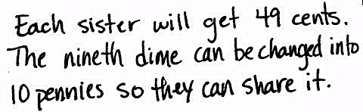
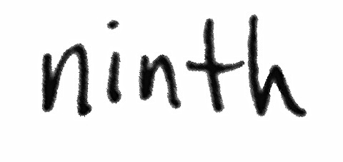

Note: This Application Problem reviews division of ones. Sharing 9 dimes connects to Problems 1 and 2 of today’s Concept Development, asking students to decompose 1 ten for 10 ones.
Concept Development (34 minutes)
Materials: (T) Tens place value chart (Lesson 16 Template) (S) Personal white board, tens place value chart (Lesson 16 Template)
Problem 1: Divide two-digit numbers by one-digit numbers using number disks, regrouping in the tens.
3 ones ÷ 2
3 tens ÷ 2
Display 3 ÷ 2 on the board.
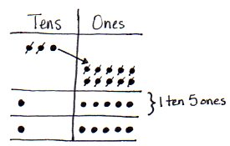
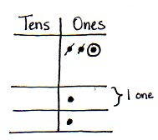
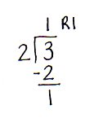
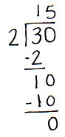
T: (Have students model on the place value chart.) 3 ones divided by 2 is?
S: One with a remainder of 1.
MP.4
T: Record 3 ÷ 2 as long division.
Students complete the problem. Encourage the students to share the relationship of their model to the steps of the algorithm.
Display 30 ÷ 2 on the board.
T: Using mental math, tell your partner the answer to 30 ÷ 2.
S: Thirty divided by 2 is 15.
T: Let’s confirm your quotient. Represent 30 on the place value chart. Tell your partner how many groups below are needed.
S: Two. (Draw.)
T: 3 tens divided by 2 is? Distribute your disks and cross off what what’s been distributed. The answer is?
S: 1 ten with a remainder of 1 ten. That’s an interesting answer.
T: Can we rename the leftover ten?
S: Yes! Change 1 ten for 10 ones.
T: Let’s rename 1 ten. Now rename and distribute the 10 ones with your partner.
S: Our answer is 1 ten 5 ones, or 15.
T: Why didn’t we stop when we had a remainder of 1 ten?
S: Because 1 ten is just 10 ones, and you can keep dividing.
T: So why did we stop when we got a remainder of 1 one?
S: The ones are the smallest unit on our place value chart, so we stopped there and made a remainder.
T: Let’s solve 30 ÷ 2 using long division.
T: 3 tens divided by 2?
S: 1 ten.
T: (Record 1 ten. Point to the place value chart.) You recorded 1 ten, twice. Say a multiplication equation that tells that.
S: 1 ten times 2 equals 2 tens.
As students say the multiplication equation, refer to the problem, pointing to 1 ten, the divisor, and record 2 tens.
T: (Point to the place value chart.) We started with 3 tens, distributed 2 tens, and have 1 ten remaining. Tell me a subtraction equation for that.
S: 3 tens minus 2 tens equals 1 ten.
As students say the subtraction equation, refer to the problem, pointing to the tens column, drawing a subtraction line and recording 1 ten.
T: (Point to the place value chart.) How many ones remain to be divided?
S: 10 ones.
T: Yes. We changed 1 ten for 10 ones. Say a division equation for how you distributed 1 ten or 10 ones.
S: 10 ones divided by 2 equals 5 ones.
As students say the division equation, refer to the problem, pointing to the 10 ones, the divisor, and record 5 ones.
T: (Point to the place value chart.) You recorded 5 ones, twice. Say a multiplication equation that tells that.
S: 5 ones times 2 equals 10 ones.
As students say the multiplication equation, refer to the problem, pointing to 5 ones, the divisor, and record 10 ones.
T: (Point to the place value chart.) We renamed 10 ones, distributed 10 ones, and have no ones remaining. Say a subtraction equation for that.
S: 10 ones minus 10 ones equals 0 ones.
As students say the subtraction equation, refer to the problem, drawing a subtraction line and record 0 ones.
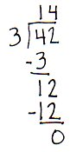
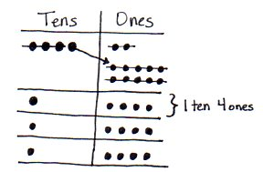
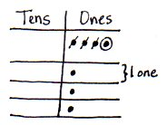
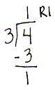
Have students share with a partner how the model matches the steps of the algorithm. Note that both show equal groups and how both can be used to check their work using multiplication.
Problem 2
4 ones ÷ 3
4 tens 2 ones ÷ 3
Display 4 ÷ 3 on the board.
T: Represent 4 ones on the place value chart. With your partner, solve 4 ÷ 3 using number disks and long division.
S: The quotient is 1 and the remainder is 1.

Display 42 ÷ 3 on the board.
T: Represent 4 tens 2 ones on the place value chart and get ready to solve using long division.
T: 4 tens divided by 3 is? Distribute your disks and cross off what is used. The answer is?
S: 1 ten with a remainder of 1 ten. Oh! I remember from last time, we need to change 1 ten for 10 ones.
T: (With students, draw an arrow to show 1 ten decomposed as 10 ones in the place value chart and show 12 ones in the algorithm.) How many ones remain?
S: 12.
T: Yes. 10 ones + 2 ones is 12 ones.
T: Show 12 ones divided by 3. Complete the remaining steps. What is the quotient?
S: Our quotient is 1 ten 4 ones, or 14.
Have students share with a partner how the model matches the steps of the algorithm, paying particular attention to the decomposition of 1 ten and how it is combined with the ones. Note that this is just the same process the students use in subtraction. We decompose a larger unit into smaller units.
Problem 3
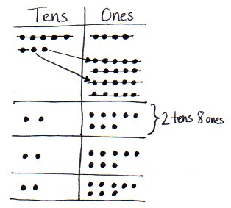
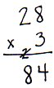
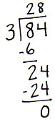
8 tens 4 ones ÷ 3
Display 84 ÷ 3 on the board.
T: Solve for 84 ÷ 3 by using number disks and long division.
S: The quotient is 28.
T: What was different about the place value chart with this problem?
S: There were a lot more disks! We had to decompose 2 tens this time.

NOTES ON
MULTIPLE MEANS
OF ENGAGEMENT:
Students working above grade level and others can be encouraged to solve without place value charts to become more efficient at solving long division problems. Allow them to share and explain their method with others.

T: How many ones did you have after decomposing your 2 tens?
S: 24 ones.
T: Show your partner where to find 24 ones in the numerical representation.
S: (Students point to the 2 tens remaining that were bundled, as ones, with the 4 ones.)
T: Check your answer using multiplication.
S: 28 times 3 is 84. Our answer is right!
Problem Set (10 minutes)

NOTES ON
MULTIPLE MEANS
OF ACTION AND EXPRESSION:
As learners model with number disks to complete the Problem Set, encourage the following to minimize mistakes:
- Whisper-count as you distribute.
- Cross out to track the number distributed.
- Draw dots in arrays. The “hands way” array may be helpful.
- Circle the remainder.
- Try disks, dots, numbers, etc. Use what is most efficient for you.
Students should do their personal best to complete the Problem Set within the allotted 10 minutes. For some classes, it may be appropriate to modify the assignment by specifying which problems they work on first. Some problems do not specify a method for solving. Students should solve these problems using the RDW approach used for Application Problems.
Student Debrief (10 minutes)
Lesson Objective: Represent and solve division problems requiring decomposing a remainder in the tens.
The Student Debrief is intended to invite reflection and active processing of the total lesson experience.
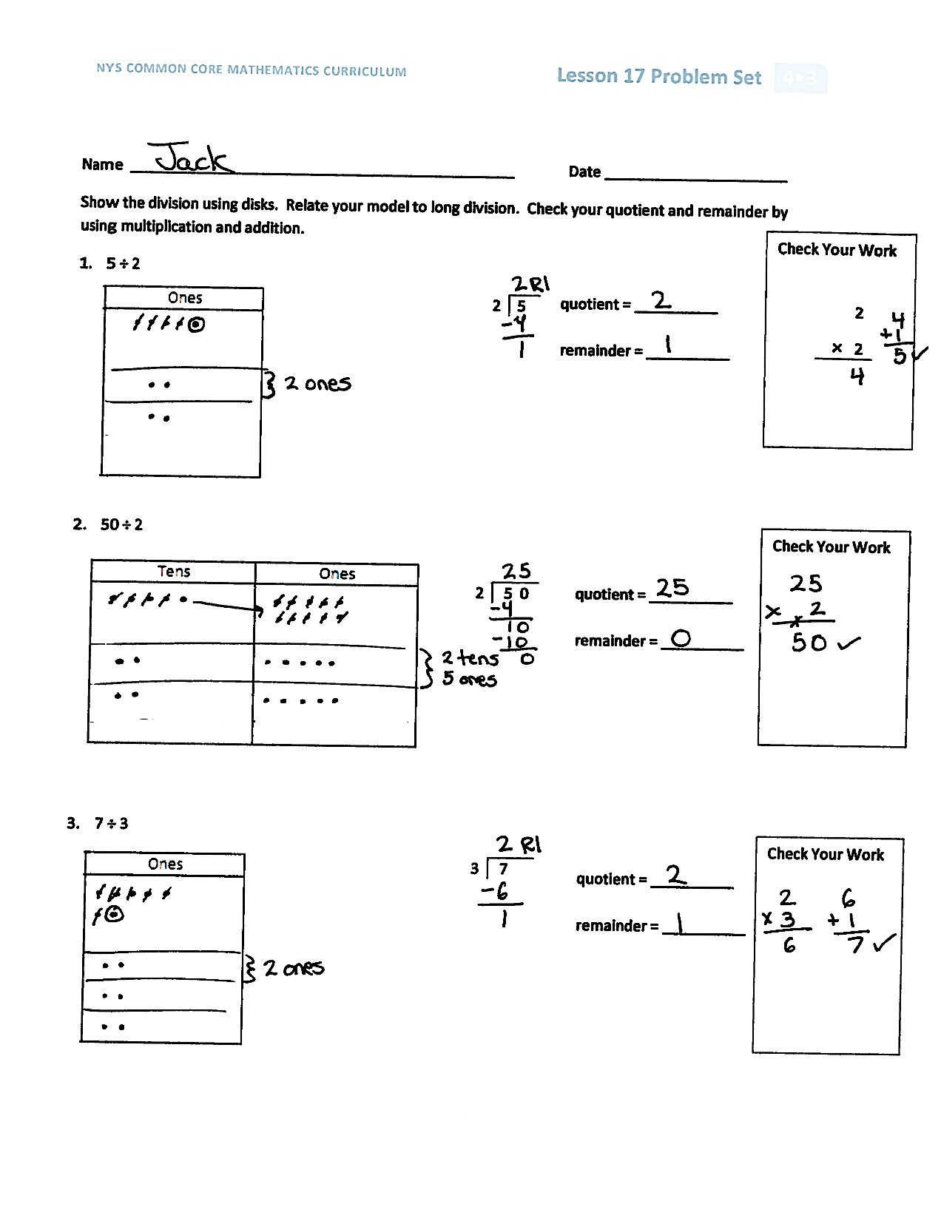
Invite students to review their solutions for the Problem Set. They should check work by comparing answers with a partner before going over answers as a class. Look for misconceptions or misunderstandings that can be addressed in the Debrief. Guide students in a conversation to debrief the Problem Set and process the lesson.
You may choose to use any combination of the questions below to lead the discussion.
- How did Problem 2 allow you to see only the remaining 1 ten in the ones column?
- Explain why 1 ten remains in Problem 4?
- How is the long division recording different in today’s lesson compared to yesterday’s lesson?
- What different words are we using to describe what we do when we have a remaining ten or tens? (Break apart, unbundle, change, rename, decompose, regroup.) Which of these words are you most comfortable using yourself?
- What other operation involves changing 1 ten for 10 ones at times? (Subtraction.) What operations involve the opposite, changing 10 ones for 1 ten at times?
- What would happen if we divided the ones before the tens?
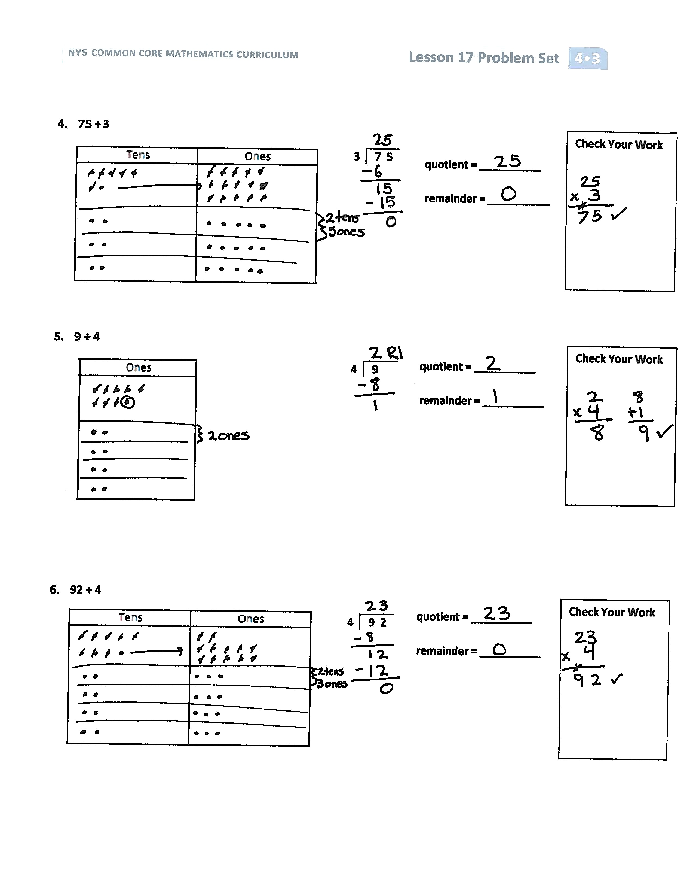
- What connection can you find between the written division and the multiplication you used to check your work?
- Why are we learning long division after addition, subtraction, and multiplication?
- How did the Application Problem connect to today’s lesson?
Exit Ticket (3 minutes)
After the Student Debrief, instruct students to complete the Exit Ticket. A review of their work will help you assess the students’ understanding of the concepts that were presented in the lesson today and plan more effectively for future lessons. You may read the questions aloud to the students.
Name Date
Show the division using disks. Relate your model to long division. Check your quotient and remainder by using multiplication and addition.
Check Your Work
2 | 5
- 5 ÷ 2
2
× 2
quotient = __________

remainder = __________

- 50 ÷ 2
Check Your Work
quotient = _______

remainder = ______
2 | 5 0

- 7 ÷ 3
quotient = __________

remainder = __________
Check Your Work
3 | 7

- 75 ÷ 3
Check Your Work
quotient = _________

remainder = ________
3 | 7 5

- 9 ÷ 4
quotient = __________

remainder = __________
Check Your Work
4 | 9

- 92 ÷ 4
quotient = ______

remainder = _____
Check Your Work
4 | 9 2

Name Date
Show the division using disks. Relate your model to long division. Check your quotient by using multiplication and addition.
4 | 5
- 5 ÷ 4
quotient = __________

remainder = __________
Check Your Work

- 56 ÷ 4
Check Your Work
quotient = ______

remainder = _____
4 | 5 6

Name Date
Show the division using disks. Relate your model to long division. Check your quotient and remainder by using multiplication and addition.
Check Your Work
- 7 ÷ 2
quotient = __________

remainder = __________
2 | 7

Check Your Work
- 73 ÷ 2
quotient = ________

remainder = _______
2 | 7 3

Check Your Work
4 | 6
- 6 ÷ 4
quotient = __________

remainder = __________

- 62 ÷ 4
quotient = _______

remainder = ______
Check Your Work

4 | 6 2

- 8 ÷ 3
quotient = __________

remainder = __________
Check Your Work

3 | 8

3 | 8 4
- 84 ÷ 3
quotient = _______

remainder = ______
Check Your Work

