Lesson 16
Objective: Understand and solve two-digit dividend division problems with a remainder in the ones place by using place value disks.

Suggested Lesson Structure
 Fluency Practice (8 minutes)
 Concept Development (42 minutes)
 Student Debrief (10 minutes)
Total Time (60 minutes)
Fluency Practice (8 minutes)
- Group Counting 4.OA.1 (4 minutes)
- Divide with Remainders 4.NBT.6 (4 minutes)
Group Counting (4 minutes)
Note: This fluency activity prepares students to divide with remainders during today’s Concept Development.
Direct students to count forward and backward, occasionally changing the direction of the count.
- Twos to 20
- Threes to 30
- Fours to 40
- Fives to 50
Divide with Remainders (4 minutes)

NOTES ON
MULTIPLE MEANS
OF ACTION AND EXPRESSION:
Since learners differ in their physical abilities, provide options for modeling and crossing out small dots such as concrete place value disks in an enlarged place value chart, drawing larger circles, drawing tick marks, or using fingerprints. Adjust response time accordingly.

Note: This fluency activity prepares students for today’s Concept Development.
Repeat the process from Lessons 14 and 15 using the following possible sequence: 6 ÷ 2, 20 ÷ 5, 16 ÷ 4, 18 ÷ 3, 15 ÷ 2, 18 ÷ 5, 11 ÷ 3, 13 ÷ 4, and 33 ÷ 4.

Concept Development (42 minutes)
Materials: (T) Tens place value chart (Template) (S) Personal white board, tens place value chart (Template)
Problem 1
6 ones ÷ 3
3 tens 6 ones ÷ 3
Display 6 ÷ 3 on the board.
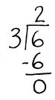
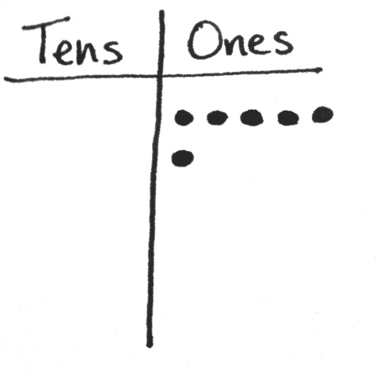
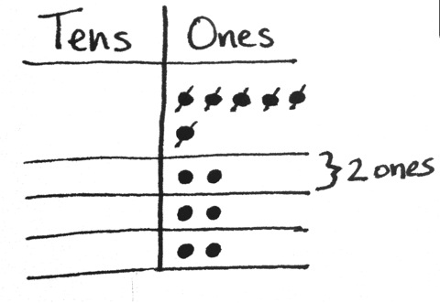
T: 6 ones represents what?
S: The whole. The total. What you are dividing.
T: Show 6 using place value disks. What is the number we are dividing by?
S: 3.
T: Let’s assume it’s telling us how many groups to make. Draw 3 groups below. Can we distribute 6 ones into 3 groups? Think of it like dealing cards evenly among 3 players. (Model as students follow along.) First, put one in each group. Cross off the ones one at a time as you distribute them evenly. Next, put another one in each group if you are able. Continue this until all of the ones are distributed.
S: We can put 2 ones in each group.
T: Are there any ones left over?
S: No.
T: How many ones are in each of our 3 groups?
S: 2 ones.
T: What is 6 ones ÷ 3? Give me the number sentence.
S: 6 ones ÷ 3 equals 2 ones.
T: Let’s represent 6 ÷ 3 in a new way. Let’s record the whole and the divisor (record with long division symbol as shown above). Look back to your model. 6 ones divided by 3 is?
S: 2 ones.
T: (Record 2 ones.)
T: (Point to the place value chart.) You distributed 2 ones, 3 times. 2 ones times 3 is?
S: 6 ones.
T: (Refer to the numbers carefully, pointing to 2 ones, the divisor, and recording 6 ones.)
T: (Point to the place value chart.) We divided 6 ones and have no ones remaining. 6 ones minus 6 ones equals 0 ones. (Write the subtraction line.) What does this zero mean?
S: There is no remainder. All the ones were divided with none left over. We subtracted the total number distributed from the total number of ones.
T: We can see the 3 groups of 2 both in our model and in our numbers and know our answer is correct since 3 times 2 equals 6.
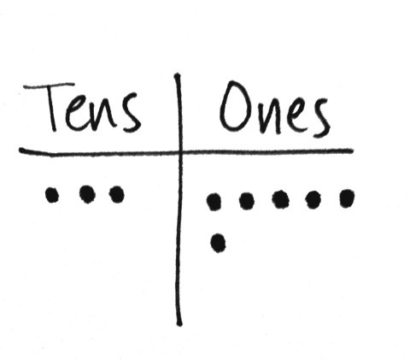
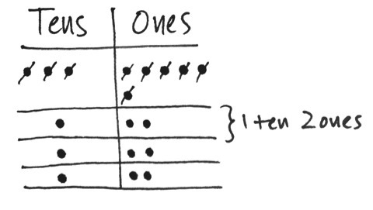
Display 36 ÷ 3 on the board.
T: 3 tens and 6 ones represents what?
S: The whole.
T: Show 36 using place value disks. What is the number we are dividing by?
S: 3.
T: Make room for 3 groups below. Let’s start dividing with the largest units. What is the largest unit?
S: The tens.
T: 3 tens divided by 3 is?
S: 1 ten.
T: Distribute the 3 tens and cross them off to show they are now divided equally into the 3 groups.
T: Are there any tens left over?
S: No.
T: 6 ones divided by 3 is?
S: 2 ones. We did that in the last problem. We distribute the ones evenly, one at a time, into each group. We cross off the ones, one at a time, as we distribute them.
T: Are there any ones left over?
S: No.

NOTES ON
MULTIPLE MEANS
OF ENGAGEMENT:
A student whose pace is ahead of the class may be engaged by journaling a response to the following:
- Compare the quotients of 36 ÷ 3 and 6 ÷ 3. What do you notice?
- Write three equations to check
36 ÷ 3 = 12.
- Compare the models of division, i.e., array, area model, etc.

T: How many tens and ones are in each of our 3 groups?
S: 1 ten and 2 ones.
T: What is 36 ÷ 3?
S: 12.
T: Let’s represent 36 ÷ 3 using numbers. Record the whole and the divisor.
T: Look back to your model. 3 tens divided by 3 is?
S: 1 ten.
T: (Record 1 ten. Point to the place value chart.) You distributed 1 ten, 3 times. Give a multiplication sentence that says that.
S: 1 ten times 3 equals 3 tens. (As students speak, refer to the algorithm.)
T: (Point to the place value chart.) How many tens are remaining to be distributed?
S: None. Zero.
T: 3 tens minus 3 tens equals 0 tens. (Refer to the written problem.)
T: What of our whole amount remains to be divided?
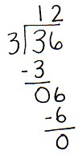
S: 6 ones.
T: (Record 6 ones next to 0 tens.) Say a division sentence to divide 6 ones into 3 groups.
S: 6 ones divided by 3 equals 2 ones. (As students speak, refer to the problem.)
T: (Point to the place value chart.) You recorded 2 ones, 3 times. Say a multiplication sentence that tells that.
S: 2 ones times 3 equals 6 ones. (As students speak, refer to the problem.)
T: (Point to the place value chart.) We started with 6 ones, distributed 6 ones, and have no ones remaining. Say a subtraction sentence for that.
S: 6 ones minus 6 ones equals 0 ones.
Have the students notice the 3 groups of 12 and relate that to the checking equation of 3 twelves or
3 times 12.
Problem 2
5 ones ÷ 4
4 tens 5 ones ÷ 4
Display 5 ÷ 4 on the board.
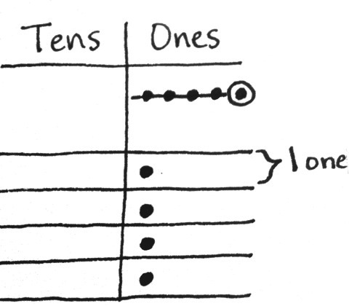
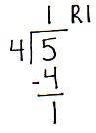
T: With your partner, represent the whole and the divisor, 4, on the place value chart, and record the written problem.
S: (Draw 5 ones and draw 4 groups below in the place value chart, and record the written problem.)
T: 5 ones divided by 4 equals?
S: It doesn’t divide evenly. I can place 1 one in each group, but I will have 1 one left over.
T: Distribute as many ones as you can, crossing off the ones you use. What is the quotient for 5 ones divided by 4?
S: 1 one.
T: Record your quotient numerically. Say a multiplication sentence for how many ones were distributed.
S: 1 one times 4 equals 4 ones.
T: Record 4 ones numerically and subtract.
S: 5 ones minus 4 ones is 1 one.
T: Record 1 one numerically. How many ones are remaining in the place value chart?
S: 1 one.
T: Circle 1 one. Tell your partner why 1 one is a remainder.
S: It is what is left over after we made our groups. Our groups must be equal. If we put this 1 one into a group, the groups will not be equal.
T: Watch as I record the remainder numerically using R1.
Display 45 ÷ 4 on the board.
T: Represent 45 using place value disks. Prepare to represent 45 ÷ 4 numerically.
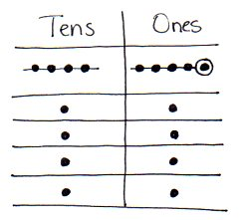
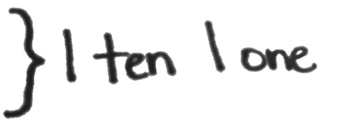
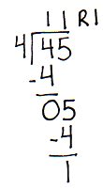
T: 4 tens divided by 4 equals?
S: 1 ten.
T: Cross off and distribute your tens below in each of the 4 groups. Record 1 ten in the tens column. Tell your partner the next numerical steps.
S: 1 ten times 4 is 4 tens. We subtract 4 tens from 4 tens and get 0 tens. We have 5 ones remaining, so we record those next to the 0 tens.
T: 5 ones divided by 4 equals?
S: 1 one. We can place 1 one in each group. But we will have 1 one remaining.
T: Distribute the disks, crossing off the 4 you use. Then tell your partner how to record that using numbers.
S: 5 ones divided by 4 is 1 one. 1 one times 4 is 4 ones. 5 ones minus 4 ones is 1 one. Hey, we have 1 one left in the place value chart!
T: Correct. Circle that 1 one. It is your remainder. Show your partner how to record the remainder.
T: What is 45 ÷ 4?
S: 11 with a remainder of 1.
T: What do you notice about using numbers, or long division, and place value disks?
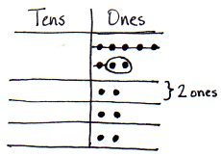
S: Both help us get to the same answer. In the place value chart, we can see the remainder of 1. Then, we can write out all of the steps we did with the disks and still show the quotient of 11 and the remainder of 1. We started with the largest units and went to the smallest with the disks and the numbers.
Problem 3
8 ones ÷ 3
6 tens 8 ones ÷ 3
Display 8 ÷ 3 on the board.
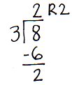
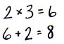
T: Solve for 8 ÷ 3 using place value disks. Represent the problem using long division with your partner.
Circulate. Listen for students using place value as they divide, multiply, and subtract.
S: The quotient is 2 and the remainder is 2.
T: How do we use multiplication and addition to check our quotient and remainder in division?
S: Two times 3 is 6. Six plus 2 is 8. We multiply the quotient times the divisor and add the remainder. We multiply the number in each group by the number of groups and then add the remainder.
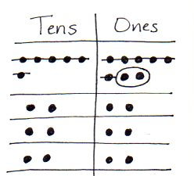
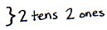
Display 68 ÷ 3 on the board.
T: Solve for 68 ÷ 3 using place value disks. Represent the problem using numbers, or long division, with your partner.
S: I got 22 with a remainder of 2.
T: How can we check if 22 with a remainder of 2 is the correct answer?
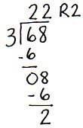
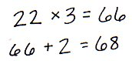
S: We can multiply to check because we know that multiplication and division are related. We can multiply 22 × 3 to check and then we need to add 2.
MP.4
T: 22 × 3 is?
S: 66.
T: Plus 2?
S: 68. Our answer was right!
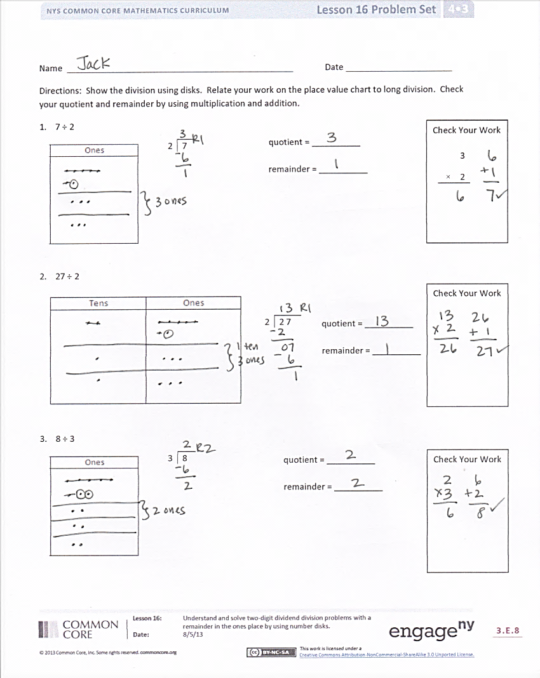
Problem Set (10 minutes)
Students should do their personal best to complete the Problem Set within the allotted 10 minutes. For some classes, it may be appropriate to modify the assignment by specifying which problems they work on first. Some problems do not specify a method for solving. Students should solve these problems using the RDW approach used for Application Problems.
Student Debrief (10 minutes)
Lesson Objective: Understand and solve two-digit dividend division problems with a remainder in the ones place by using place value disks.
The Student Debrief is intended to invite reflection and active processing of the total lesson experience.
Invite students to review their solutions for the Problem Set. They should check work by comparing answers with a partner before going over answers as a class. Look for misconceptions or misunderstandings that can be addressed in the Debrief. Guide students in a conversation to debrief the Problem Set and process the lesson.
You may choose to use any combination of the questions below to lead the discussion.
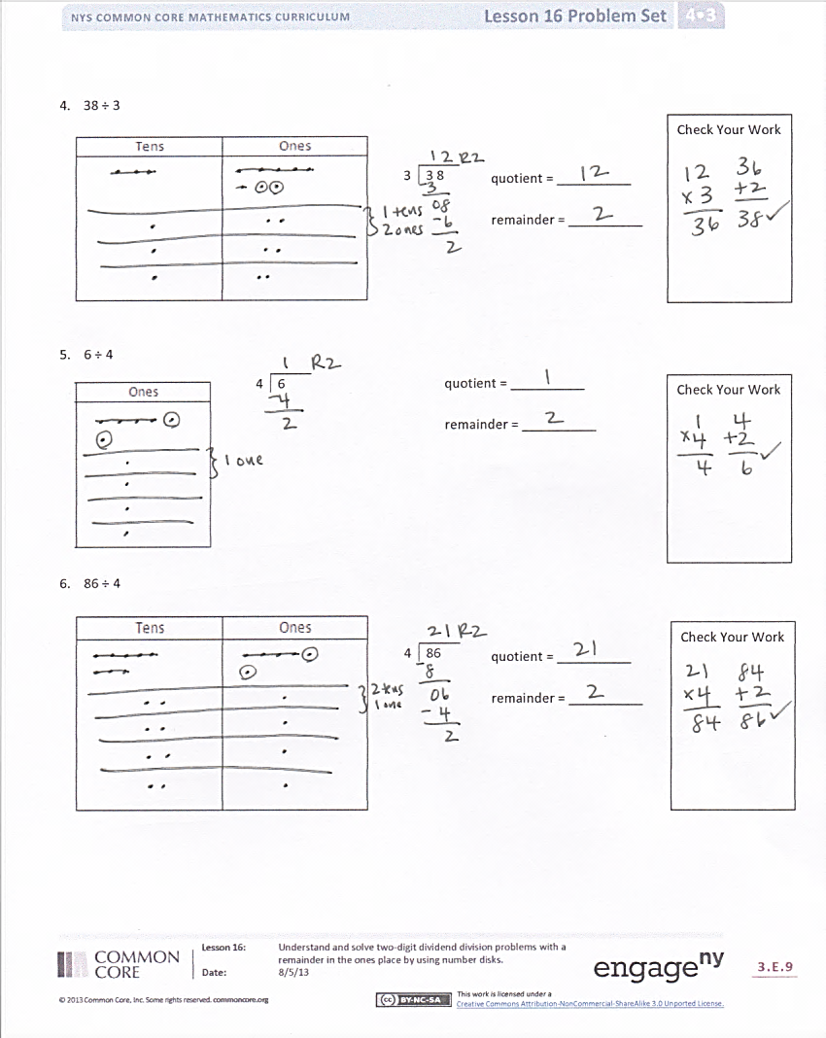
- How did solving Problem 1 prepare you for solving Problem 2?
- Explain to your partner why only 6 ones could be distributed in Problem 3. What happens to the remaining ones?
- Solve 12 divided by 3. Solve 12 divided by 4. As a divisor gets larger, what will happen to the quotient if the whole stays the same?
- Was the remainder ever larger than the divisor? Why not?
- In the Problem Set, we only had remainders of 1 and 2. Give me an example of a problem that might have a larger remainder.
- Explain the connection between using place value disks and long division. Why do you think it is called long division?
- What new math vocabulary did we use today to communicate precisely?
Exit Ticket (3 minutes)
After the Student Debrief, instruct students to complete the Exit Ticket. A review of their work will help you assess the students’ understanding of the concepts that were presented in the lesson today and plan more effectively for future lessons. You may read the questions aloud to the students.

Name Date
Show the division using disks. Relate your work on the place value chart to long division. Check your quotient and remainder by using multiplication and addition.
- 7 ÷ 2
Check Your Work
quotient = __________

remainder = __________

2 | 7

3
× 2

- 27 ÷ 2
Check Your Work
quotient = __________

remainder = __________

2 | 2 7

- 8 ÷ 3
Check Your Work
quotient = __________

remainder = __________

3 | 8

- 38 ÷ 3
Check Your Work
quotient = __________

remainder = __________

3 | 3 8

- 6 ÷ 4
Check Your Work
quotient = __________

remainder = __________
4 | 6

- 86 ÷ 4
quotient = __________

remainder = ________
Check Your Work

4 | 86

Name Date
Show the division using disks. Relate your work on the place value chart to long division. Check your quotient and remainder by using multiplication and addition.

- 5 ÷ 3
Check Your Work
quotient = __________

remainder = __________
3 | 5

- 65 ÷ 3
quotient = __________

remainder = ________
Check Your Work

3 | 65

Name Date
Show the division using disks. Relate your work on the place value chart to long division. Check your quotient and remainder by using multiplication and addition.

- 7 ÷ 3
Check Your Work
3 | 7
2
× 3
quotient = __________

remainder = __________

3 | 6 7
Check Your Work
- 67 ÷ 3
quotient = _________

remainder = _______

Check Your Work
2 | 5
- 5 ÷ 2
quotient = __________

remainder = __________

2 | 8 5
- 85 ÷ 2
Check Your Work
quotient = __________

remainder = ________

Check Your Work
- 5 ÷ 4
quotient = __________

remainder = __________
4 | 5

- 85 ÷ 4
Check Your Work
4 | 8 5
quotient = ________

remainder = _______

ones
tens

tens place value chart

