Lesson 14
Objective: Solve division word problems with remainders.

Suggested Lesson Structure
 Application Problem (8 minutes)
 Fluency Practice (12 minutes)
 Concept Development (32 minutes)
 Student Debrief (8 minutes)
Total Time (60 minutes)
Application Problem (8 minutes)
Tyler planted potatoes, oats, and corn. He planted 23 acres of potatoes. He planted 3 times as many acres of oats as potatoes, and he planted 4 times as many acres of corn as oats. How many acres did Tyler plant with potatoes, oats, and corn in all?

NOTES ON
MULTIPLE MEANS
OF REPRESENTATION:
English language learners and others may benefit from a brief explanation of the term acre.

Note: This Application Problem reviews the objective of Lesson 13: Use multiplication, addition, or subtraction to solve multi-step word problems. It precedes the Fluency Practice and Concept Development as a review of multiplication skills prior to work with division in Grade 4, which starts in this lesson.
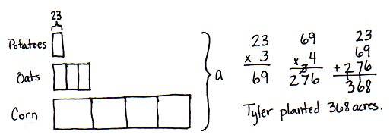
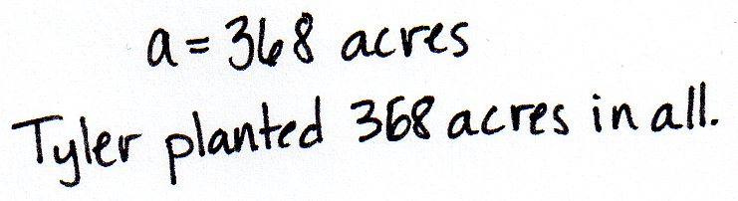

Fluency Practice (12 minutes)
- Group Count to Divide 4.OA.1 (4 minutes)
- Number Sentences in an Array 4.NBT.5 (4 minutes)
- Divide with Remainders 4.NBT.6 (4 minutes)
Group Count to Divide (4 minutes)
Note: This fluency activity prepares students to divide with remainders during this lesson’s Concept Development.
T: (Write 8 ÷ 2 = .) Let’s find the quotient, counting by twos. Show a finger for each multiple you count by.
S: 2 (show 1 finger), 4 (show 2 fingers), 6 (show 3 fingers), 8 (show 4 fingers).
T: What’s 8 ÷ 2?
S: 8 ÷ 2 = 4.
Continue with the following possible sequence: 12 ÷ 2, 18 ÷ 2, 14 ÷ 2, 15 ÷ 5, 25 ÷ 5, 40 ÷ 5, 30 ÷ 5, 9 ÷ 3,
15 ÷ 3, 27 ÷ 3, 21 ÷ 3, 16 ÷ 4, 24 ÷ 4, 32 ÷ 4, and 36 ÷ 4.
Number Sentences in an Array (4 minutes)
Materials: (S) Personal white board
Note: This fluency activity prepares students for Lesson 15’s Concept Development.
T: (Project a 3 × 4 array.) How many boxes do you see altogether?
S: 12.
T: Let’s count by threes to check. (Point at columns as students count.)
S: 3, 6, 9, 12.
T: Let’s count by fours to check. (Point at rows as students count.)
S: 4, 8, 12.
T: On your personal white boards, write two multiplication sentences to show how many boxes are in this array.
S: (Write 3 × 4 = 12 and 4 × 3 = 12.)
T: (Write 12 ÷ __ =__ . Write 12 ÷ __ =__.) Write two division sentences for this array.
S: (Write 12 ÷ 3 = 4 and 12 ÷ 4 = 3.)
Continue with the following possible sequence: 5 × 2 array and 7 × 3 array.
Divide with Remainders (4 minutes)
Note: This fluency activity prepares students for this lesson’s Concept Development.
T: How many groups of 2 are in 10?
S: 5.
T: Let’s prove it by counting by twos. Use your fingers as you count.
S: (Show one finger for each multiple.) 2, 4, 6, 8, 10.
T: Show and say how many groups of 2 are in 10.
S: (Show 5 fingers.) 5.
T: (Write 11 ÷ 2.) Let’s find out how many groups of 2 are in 11. Count with me.
S: (Show one finger for each multiple.) 2, 4, 6, 8, 10.
T: How many groups?
S: 5.
T: How many left?
S: 1.
Continue with the following possible sequence: 8 ÷ 4 and 9 ÷ 4, 12 ÷ 3 and 13 ÷ 3, 15 ÷ 5 and 17 ÷ 5, 20 ÷ 4 and 23 ÷ 4, and 50 ÷ 10 and 55 ÷ 10.
Concept Development (32 minutes)

NOTES ON
MULTIPLE MEANS
OF REPRESENTATION:
Some learners may want to model
12 ÷ 4 as a tape diagram. At times, we celebrate autonomy, creativity, and diversity in modeling; in this case, however, we have chosen a specific instructional model for representing the quotient and the remainder. This model could also be represented concretely by having the students in the class simulate the actions of the students in Problems 1 and 2.

Materials: (S) Personal white board
Problem 1: Divide a two-digit number by a one-digit number modeled with an array.
There are 12 students in PE class separated into 4 teams. How many students are on each team?
T: Read the problem and draw an array to represent the division.
S: (Draw an array as pictured to the right.)
T: Tell me a division expression that matches the situation.
S: 12 ÷ 4.
T: What is the quotient?
S: The quotient is 3.
T: How many students are on each team?
S: There are 3 students on each team.
T: How can you check to make sure your division was correct?
S: I can count by three 4 times to get 12. I can multiply 3 times 4 to get 12.
T: Does this quotient tell us the size of the group or the number of groups?
S: The size of the group.
T: Let’s revise the story a bit. Again there are 12 students in PE class but now 3 students are needed on each team. How many teams can be made? (Point to the same array.) What is the division expression for this new story?
S: 12 ÷ 3.
T: Does the quotient tell us the size of the group or the number of groups?
S: The number of groups.
T: The same array can represent a situation with the group size unknown or number of groups unknown.
Problem 2: Divide a two-digit number by a one-digit number with a remainder modeled with an array.
13 ÷ 4

A NOTE ON
THE RECORDING
OF QUOTIENTS AND REMAINDERS:
When writing 13 ÷ 4 = 3 R1, one may conclude that since 7 ÷ 2 = 3 R1, the following must be true: 7 ÷ 2 = 13 ÷ 4. However, this translates into$\text{ 3}\frac{\text{1}}{\text{2}}\text{=3}\frac{\text{1}}{\text{3}}$ which is a false number sentence. To avoid this incorrect use of the equal sign, and the misconceptions it creates, we state the remainder separately from the quotient and do not use the R notation directly following the equal sign.

T: One more student joined the class described at the beginning of Problem 1. There are now 13 students to be divided into 4 teams. Draw an array to find how many students are on each team. What did you find?
S: I can represent 13 in four groups. Four groups of 3 make 12, but I have 1 left over. One student won’t be on a team.
T: Tell me an expression to represent this problem.
S: 13 ÷ 4.
T: When we divide a number into equal groups, sometimes there is an amount leftover. We call the number that we have left a remainder.
T: What is the quotient?
S: The quotient is 3.
T: What is the amount left over, the remainder?
S: 1.
T: We state our answer by saying the quotient and then the remainder. The quotient is 3. The remainder is 1. We can also say or write, “The quotient is 3 with a remainder of 1.”
T: Discuss with your partner how you can use multiplication to check your work for this answer.
S: Four threes is 12. That doesn’t prove our answer is right. We can add the remainder to the product. Four times 3 is 12. Add 1 to get 13.
T: Let’s return again to a second story. There are 13 students in PE class. Exactly 3 students are needed on each team. How many teams can be made?
T: Tell me the new expression.
S: 13 ÷ 3.
T: State the quotient and remainder.
T: The quotient is 4, and the remainder is 1.
T: Talk to your partner. What do the quotient and the remainder mean in the second story?
S: Four teams can be made, and there is 1 extra person.
Draw the number bond as shown and have students compare it with the quotient and the remainder. Notice the part on the left represents the equal groups and the part on the right is the remainder.
Problem 3: Divide a two-digit number by a one-digit number with a remainder modeled with a tape diagram.
Kristy bought 13 roses. If she puts 6 roses in each vase, how many vases will she use? Will there be any roses left over?
T: Draw an array. Solve for 13 ÷ 6.
S: I can’t because 13 is an odd number and 6 + 6 = 12. An even number plus an even number won’t give you an odd number. You can divide by 6, but there will be 1 extra flower left over. I can fill 2 vases and have 1 flower left over.
T: Tell your partner a statement that tells the quotient and remainder for this problem.
S: The quotient is 2, and the remainder is 1.
T: Describe to your partner what that statement tells us.
S: We started with 13 and made groups of 6. We made 2 groups with 1 rose remaining. Kristy can fill 2 vases. She will have 1 rose left over.
T: Again, let’s revise our story a bit. Now Kristy bought 13 roses and wants to put them in 2 vases. How many roses will be in each vase? Is this the same array?
S: Yes.
T: Talk to your partner. How has our interpretation of the array changed?
S: In the first story, we didn’t know the number of vases. In the second story, we didn’t know the number in each vase. We changed the story from finding the number of groups to finding the size of the group.
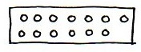
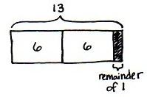
T: How can we check our work for both situations?
S: We can draw a number bond to show 2 groups of 6, and then 1 more. Two times 6 is 12, and 12 plus 1 is 13.
T: Let’s turn our array into a tape diagram to show 13 in 2 groups of 6 with a remainder of 1. (Demonstrate.)
T: Using the array, draw a rectangle around the flowers. Erase the flowers and label the diagram.
S: You should divide the bar into two parts. I know each part is worth 6, but 6 plus 6 isn’t 13.
T: Our tape diagram must have a third part to represent the remainder. Let’s separate the bar into two equal parts and make a very small third part. Shade to show the remaining flower. (Demonstrate.)
T: With your partner, draw a tape diagram to show 13 roses divided equally into 4 vases.
Students draw a tape diagram, dividing it into four parts. Using their basic facts, they know 13 cannot be divided into four equal parts. They shade a fifth part of the tape diagram to show the remainder.
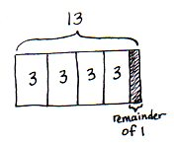
S: The quotient is 3. The remainder is 1. We can check our work by drawing a number bond and adding the parts or multiplying 4 times 3 and adding 1. Whatever method we use, we get back to the original total when our quotient and remainder are correct.
T: Look at your tape diagram. Is the model the same when we don’t know the number of groups, when we know that there are 3 flowers in each vase but we don’t know the number of vases?
S: Yes!
Problem 4: Divide a two-digit number by a one-digit number, interpreting the remainder.
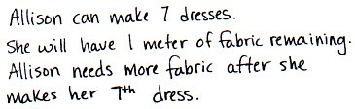
Allison has 22 meters of fabric to sew dresses. She uses 3 meters of fabric for each dress. After how many dresses will Allison need to buy more fabric?
T: Let’s represent this problem using a tape diagram together. (Model for the students as you talk.) We don’t know the number of groups or the number of dresses she will make. We know each dress uses 3 meters, so let’s draw one group and label it as fabric for 1 dress. We don’t know how many dresses she can make or how many threes there are, so we label that with a question mark. We do know there will be a remainder because we know our facts of 3. 22 isn’t a multiple of 3. Solve this problem.
MP.4
S: Twenty-two divided by 3 is 7 with a remainder of 1.
T: With your partner, discuss your answer to the question. After how many dresses will Allison need to buy more fabric?
S: Well, she can make 7 dresses. I guess she’ll have only 1 meter to make her next dress. No, the problem says she must have 3 meters of fabric for each dress, so after 7 dresses she will have to buy more fabric. She can make 7 dresses, but to make an eighth dress, she will need to buy 2 more meters of fabric. I can prove that my tape diagram is correct by drawing an array. See, there are 7 threes. Each group represents 1 dress. That means that there are 7 dresses. The 1 left over means, to make the eighth dress, she will need 2 more meters. I can see that by looking at the array.

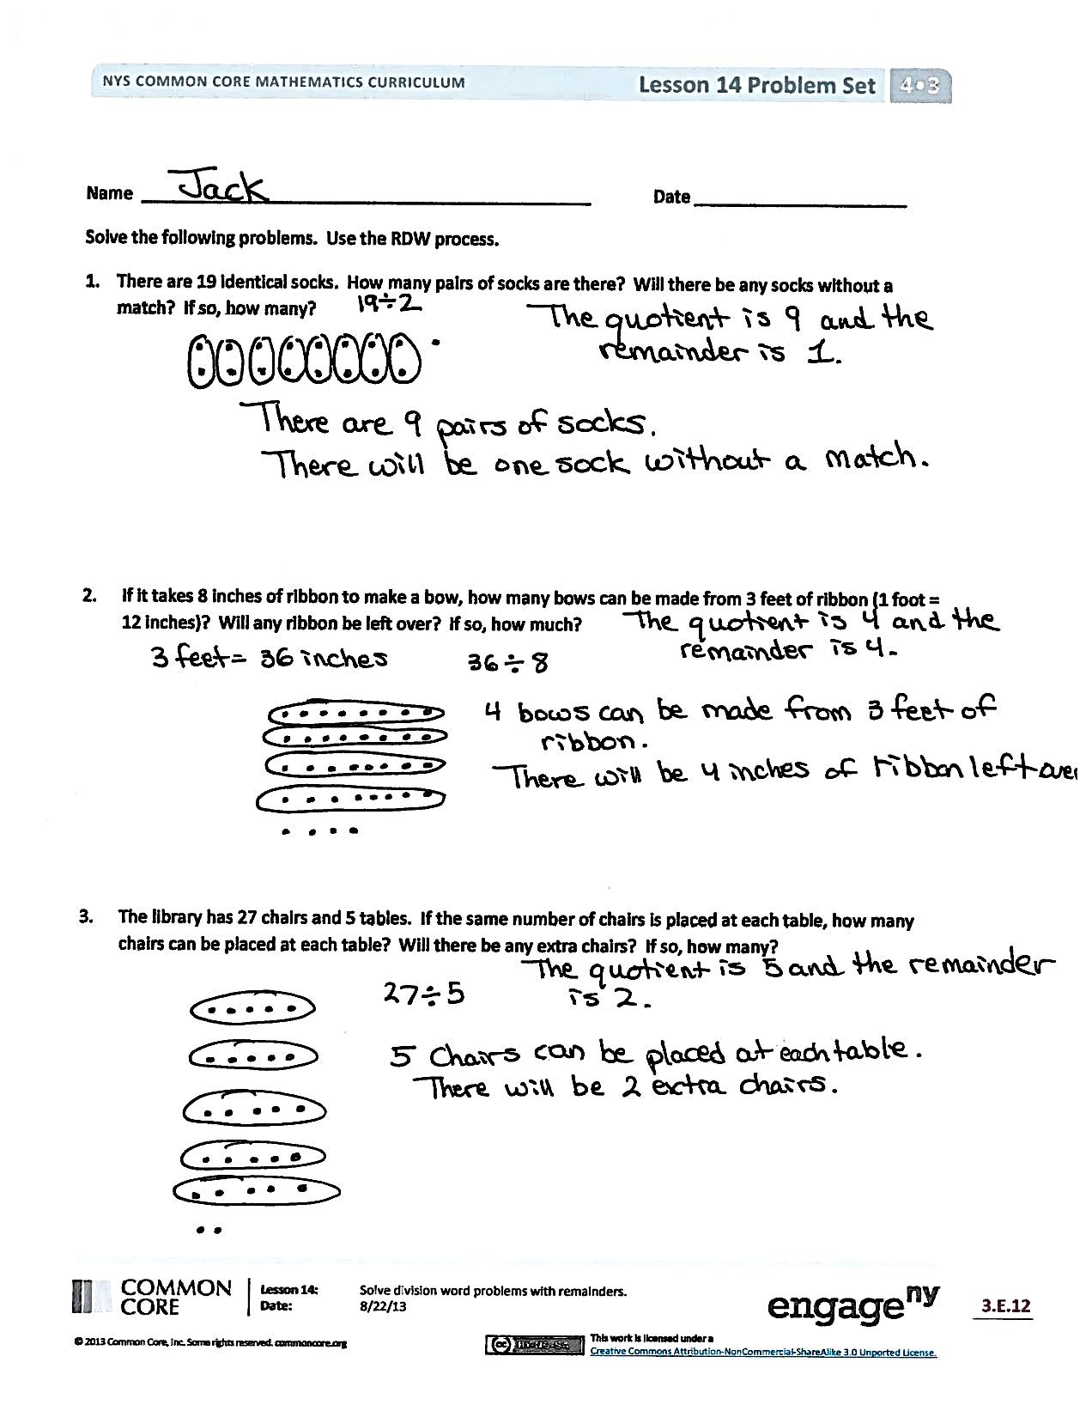
Problem Set (10 minutes)
Students should do their personal best to complete the Problem Set within the allotted 10 minutes. For some classes, it may be appropriate to modify the assignment by specifying which problems they work on first. Some problems do not specify a method for solving. Students should solve these problems using the RDW approach used for Application Problems.
Student Debrief (8 minutes)
Lesson Objective: Solve division word problems with remainders.
The Student Debrief is intended to invite reflection and active processing of the total lesson experience.
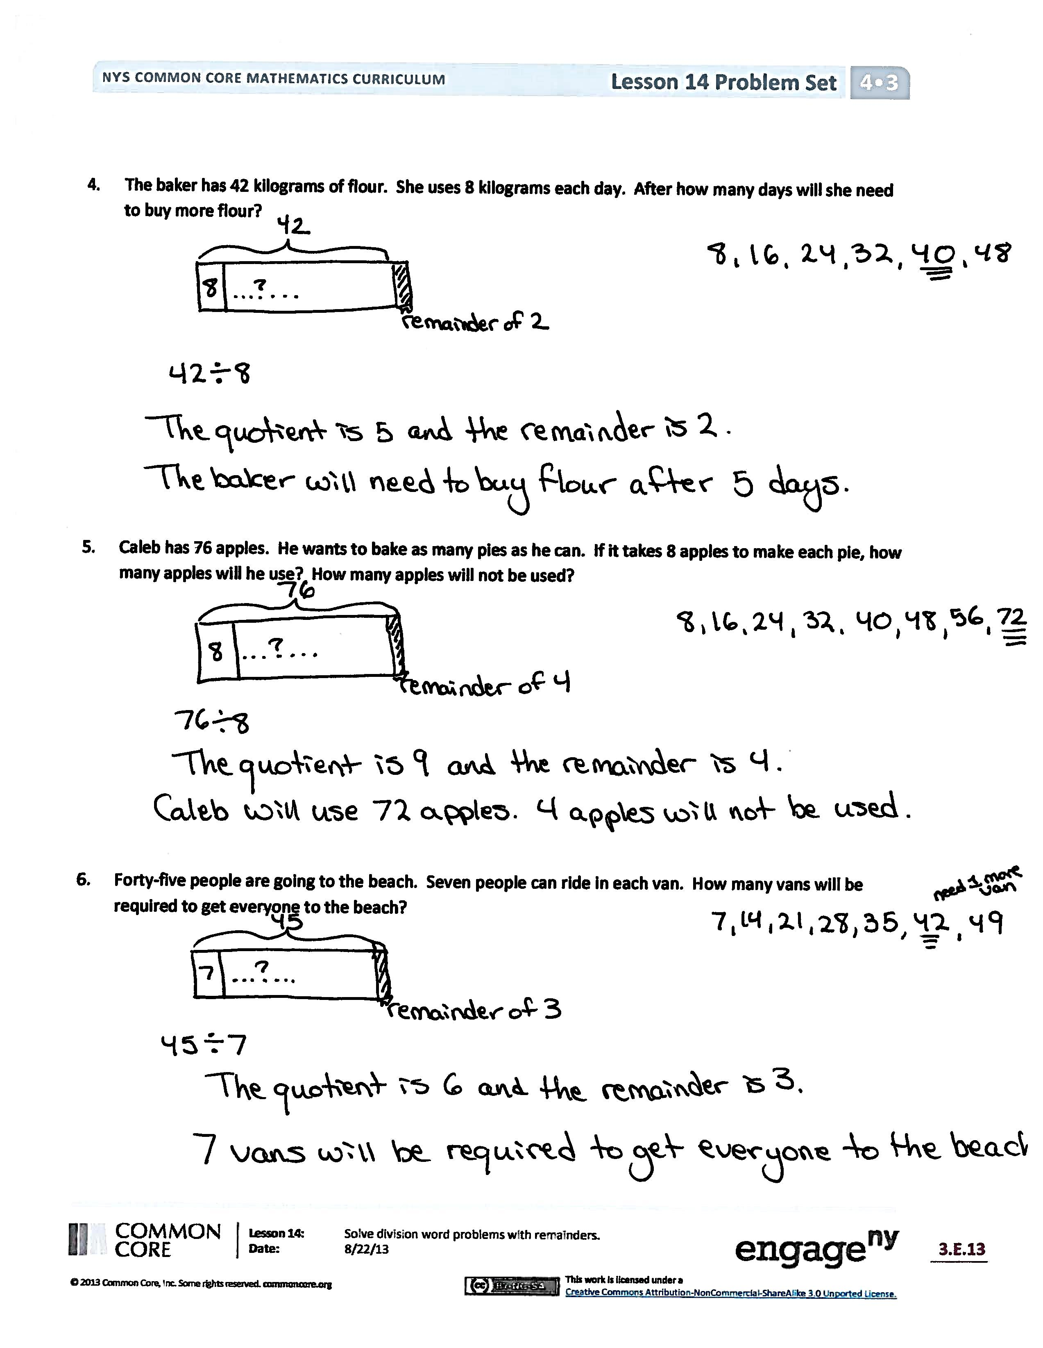
Invite students to review their solutions for the Problem Set. They should check work by comparing answers with a partner before going over answers as a class. Look for misconceptions or misunderstandings that can be addressed in the Debrief. Guide students in a conversation to debrief the Problem Set and process the lesson.

You may choose to use any combination of the questions below to lead the discussion.
- In Problem 3, there are 2 extra chairs. How can the remainder help you to find how many more chairs are needed to set up 1 more complete table?
- In Problem 4, how many full days of baking can be done? How much more flour is needed to bake on the sixth day?
- In Problem 6, 45 ÷ 7 equals 6 with a remainder of 3. What do the quotient and remainder represent in this problem? If 6 vans are full with 3 people remaining, why do we need 7 vans? Does the quotient always give the final answer? Why is it important to think carefully about the remainder? How would a model support your answer of 7 vans?

- How does an array help you to determine a remainder? Use the problems 12 ÷ 3, 13 ÷ 3, and 13 ÷ 2 in your conversation. How do the arrays with the whole 12 and 13 differ?
- What complications are there in modeling a division problem with a remainder using a tape diagram?
- What new math vocabulary did we use today to communicate precisely?
Exit Ticket (3 minutes)
After the Student Debrief, instruct students to complete the Exit Ticket. A review of their work will help you assess the students’ understanding of the concepts presented in the lesson today and plan more effectively for future lessons. You may read the questions aloud to the students.

Name Date
Use the RDW process to solve the following problems.
- There are 19 identical socks. How many pairs of socks are there? Will there be any socks without a match? If so, how many?

- If it takes 8 inches of ribbon to make a bow, how many bows can be made from 3 feet of ribbon (1 foot = 12 inches)? Will any ribbon be left over? If so, how much?

- The library has 27 chairs and 5 tables. If the same number of chairs is placed at each table, how many chairs can be placed at each table? Will there be any extra chairs? If so, how many?

- The baker has 42 kilograms of flour. She uses 8 kilograms each day. After how many days will she need to buy more flour?

- Caleb has 76 apples. He wants to bake as many pies as he can. If it takes 8 apples to make each pie, how many apples will he use? How many apples will not be used?

- Forty-five people are going to the beach. Seven people can ride in each van. How many vans will be required to get everyone to the beach?

Name Date
Use the RDW process to solve the following problem.
Fifty-three students are going on a field trip. The students are divided into groups of 6 students. How many groups of 6 students will there be? If the remaining students form a smaller group and one chaperone is assigned to every group, how many total chaperones are needed?

Name Date
Use the RDW process to solve the following problems.
- Linda makes booklets using 2 sheets of paper. She has 17 sheets of paper. How many of these booklets can she make? Will she have any extra paper? How many sheets?

- Linda uses thread to sew the booklets together. She cuts 6 inches of thread for each booklet. How many booklets can she stitch with 50 inches of thread? Will she have any unused thread after stitching up the booklets? If so, how much?

- Ms. Rochelle wants to put her 29 students into groups of 6. How many groups of 6 can she make? If she puts any remaining students in a smaller group, how many students will be in that group?

- A trainer gives his horse, Caballo, 7 gallons of water every day from a 57-gallon container. How many days will Caballo receive his full portion of water from the container? On which number day will the trainer need to refill the container of water?

- Meliza has 43 toy soldiers. She lines them up in rows of 5 to fight imaginary zombies. How many of these rows can she make? After making as many rows of 5 as she can, she puts the remaining soldiers in the last row. How many soldiers are in that row?

- Seventy-eight students are separated into groups of 8 for a field trip. How many groups are there? The remaining students form a smaller group of how many students?

