Lesson 13
Objective: Use multiplication, addition, or subtraction to solve multi-step word problems.

Suggested Lesson Structure
 Fluency Practice (12 minutes)
 Concept Development (35 minutes)
 Student Debrief (13 minutes)
Total Time (60 minutes)

Fluency Practice (12 minutes)
- Sprint: Mental Multiplication 4.NBT.5 (9 minutes)
- Multiply Using the Standard Algorithm 4.NBT.4 (3 minutes)

Sprint: Mental Multiplication (9 minutes)

Materials: (S) Mental Multiplication Sprint
Notes: This Sprint reinforces partial product multiplication strategies.

Multiply Using the Standard Algorithm (3 minutes)

Materials: (S) Personal white board
Note: This fluency activity reviews the Concept Development from Lessons 10 and 11.
T: (Write 773 × 2.) On your boards, solve the expression using the standard algorithm.
Repeat the process for the following possible sequence: 147 × 3, 1,605 × 3, and 5,741 × 5.

Concept Development (35 minutes)

NOTES ON
MULTIPLE MEANS
OF REPRESENTATION:
Depending on your English language learners’ needs, it may be helpful to provide today’s Problem Set in students’ first language.

Materials: (S) Problem Set
Note: For this lesson, the Problem Set comprises word problems from the Concept Development and is therefore to be used during the lesson itself.
Students may work in pairs to solve Problems 1─4 below using the RDW approach to problem solving.

1. Model the problem.
Have two pairs of students you think can be successful with modeling the problem work at the board while the others work independently or in pairs at their seats. Review the following questions before beginning the first problem.
- Can you draw something?
- What can you draw?
- What conclusions can you make from your drawing?
As students work, circulate. Reiterate the questions above.
After two minutes, have the two pairs of students share only their labeled diagrams.
For about one minute, have the demonstrating students receive and respond to feedback and questions from their peers.

2. Calculate to solve and write a statement.

NOTES ON
MULTIPLE MEANS
OF ENGAGEMENT:
Extend the problems for students working above grade level.
Problem 1: If Kate also deposited $36 of each paycheck into her savings, how much money does she have left to spend after buying the computer and clothes?
Problem 2: Construct a graph or chart that shows Sylvia’s weight over the years.
Problem 3: Use our classroom resources to find out about how many kilograms the crate of apples weighed.

Give everyone two minutes to finish work on that question, sharing their work and thinking with a peer. All should then write their equations and statements of the answer.

3. Assess the solution.
Give students one to two minutes to assess the solutions presented by their peers on the board, comparing the solutions to their own work. Highlight alternative methods to reach the correct solution.

Problem 1
Over the summer, Kate earned $180 each week for 7 weeks. Of that money, she spent $375 on a new computer and $137 on new clothes. How much money did she have left?
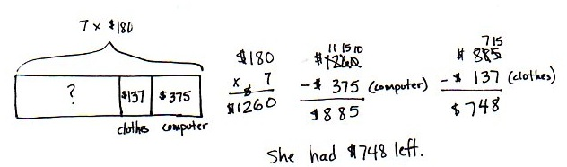
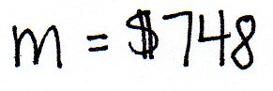

This multi-step problem requires students to apply their knowledge of multiplication of a multi-digit number by a single-digit number. While most students may apply the multiplication algorithm, they should be encouraged to use whichever strategy they are most comfortable with to complete the multiplication. The sum of $375 and $137 may be found before subtracting it from Kate’s total salary, or the two amounts may be subtracted separately.

Problem 2

NOTES ON
MULTIPLE MEANS
OF ACTION AND EXPRESSION:
Learners differ in their solution strategies, and classroom discussion is enriched with the sharing of diverse innovative, efficient, thoughtful solutions.
Students may choose to omit the modeling part of a multi-step problem. For example, the work to the left does not show the tripling of 8. Therefore, the sharing of student work when solving multi-step problems can be even more interesting.
It is best to be prepared to model each step of the problem since students may be overwhelmed by the simplest words when they are embedded within a multi-step problem.

Sylvia weighed 8 pounds when she was born. By her first birthday, her weight had tripled. By her second birthday, she had gained 12 more pounds. At that time, Sylvia’s father weighed 5 times as much as she did. What was Sylvia and her dad’s combined weight?
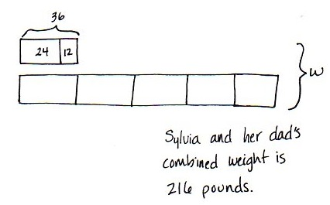
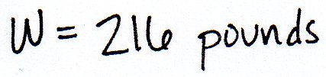

In this problem, students need to compute Sylvia’s weight at two separate points in time. Some students may gravitate to calculations. Others may use tape diagrams or other models to represent the problem. Either is acceptable. Then, they may multiply Sylvia’s current weight by 6 to find her and her father’s combined weight.
Problem 3
Three boxes weighing 128 pounds each and one box weighing 254 pounds were loaded onto the back of an empty truck. A crate of apples was then loaded onto the same truck. If the total weight loaded onto the truck was 2,000 pounds, how much did the crate of apples weigh?
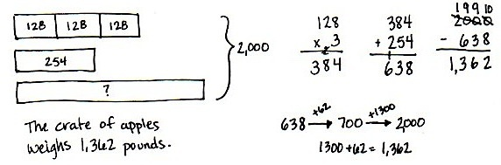
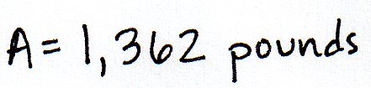

This multi-step problem may be modeled or simply solved using algorithms. Students need to recognize that 128 must be tripled before that total is added to 254. To arrive at the answer to the problem, this new sum must be subtracted from 2,000, requiring students to use a simplifying strategy or to regroup across multiple zeros (a skill they mastered in Module 1).
Problem 4
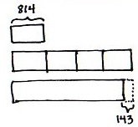
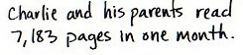
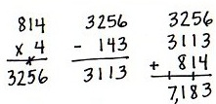
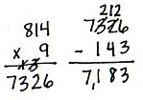
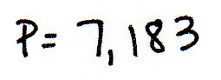
In one month, Charlie read 814 pages. In the same month, his mom read 4 times as many pages as Charlie, and that was 143 pages more than Charlie’s dad read. What was the total number of pages read by Charlie and his parents?
Solution B:
Solution A:

In this multi-step problem, students may find that each calculation is dependent upon the following calculation. Encourage students to use simplifying strategies when solving, such as seeing in the model that there are 9 equal-size rectangles worth 814 pages, minus 143 pages.

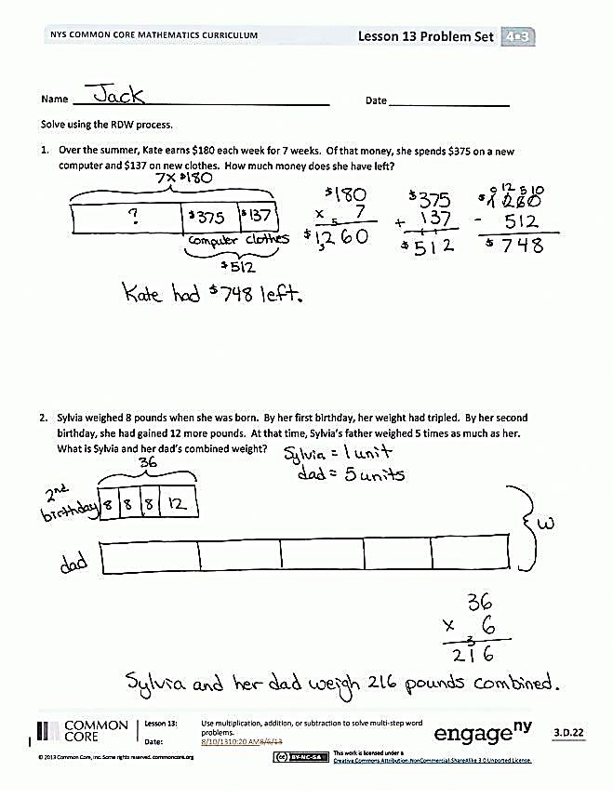
Problem Set
Please note that the Problem Set for Lesson 13 comprises the problems from the Concept Development, as stated in the introduction.

Student Debrief (13 minutes)
Lesson Objective: Use multiplication, addition, or subtraction to solve multi-step word problems.
The Student Debrief is intended to invite reflection and active processing of the total lesson experience.
Invite students to review their solutions for the Problem Set. They should check work by comparing answers with a partner before going over answers as a class. Look for misconceptions or misunderstandings that can be addressed in the Debrief. Guide students in a conversation to debrief the Problem Set and process the lesson.
You may choose to use any combination of the questions below to lead the discussion.
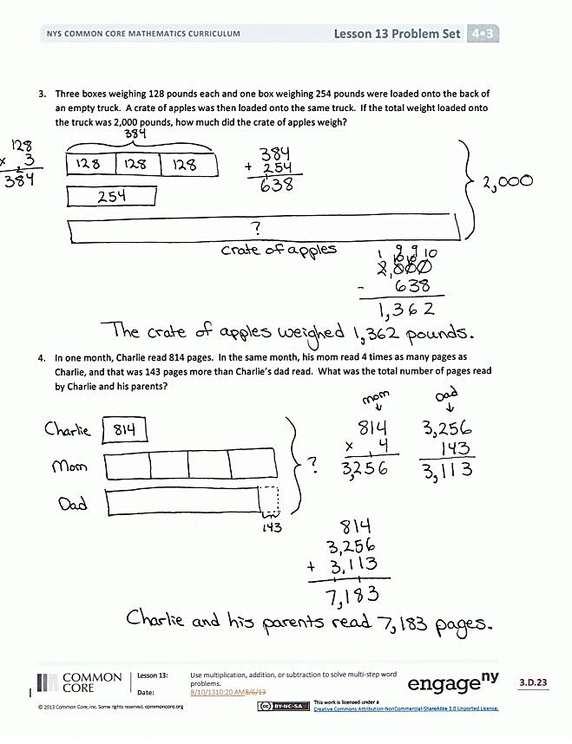
- Explain to your partner how you solved Problem 1. If you used different strategies, discuss how you arrived at the same answer.
- Let’s look at how two different students modeled Problem 2. How are they similar? How are they different?
- Student A, in Problem 4, why did you multiply 814 by 9 and subtract 143? From the model, I only see 5 units of 814. (Also, draw out the alternate strategies from Problem 3.)
- Student B, would you present your solution. (Student presents.) Does anyone have comments or questions for Student B?
- How did you know what to do when you saw the word tripled in Problem 2?
- When might it be better to use multiplication rather than addition?
- What are the advantages of knowing several methods for solving a multiplication problem?

Exit Ticket (3 minutes)
After the Student Debrief, instruct students to complete the Exit Ticket. A review of their work will help you assess the students’ understanding of the concepts that were presented in the lesson today and plan more effectively for future lessons. You may read the questions aloud to the students.

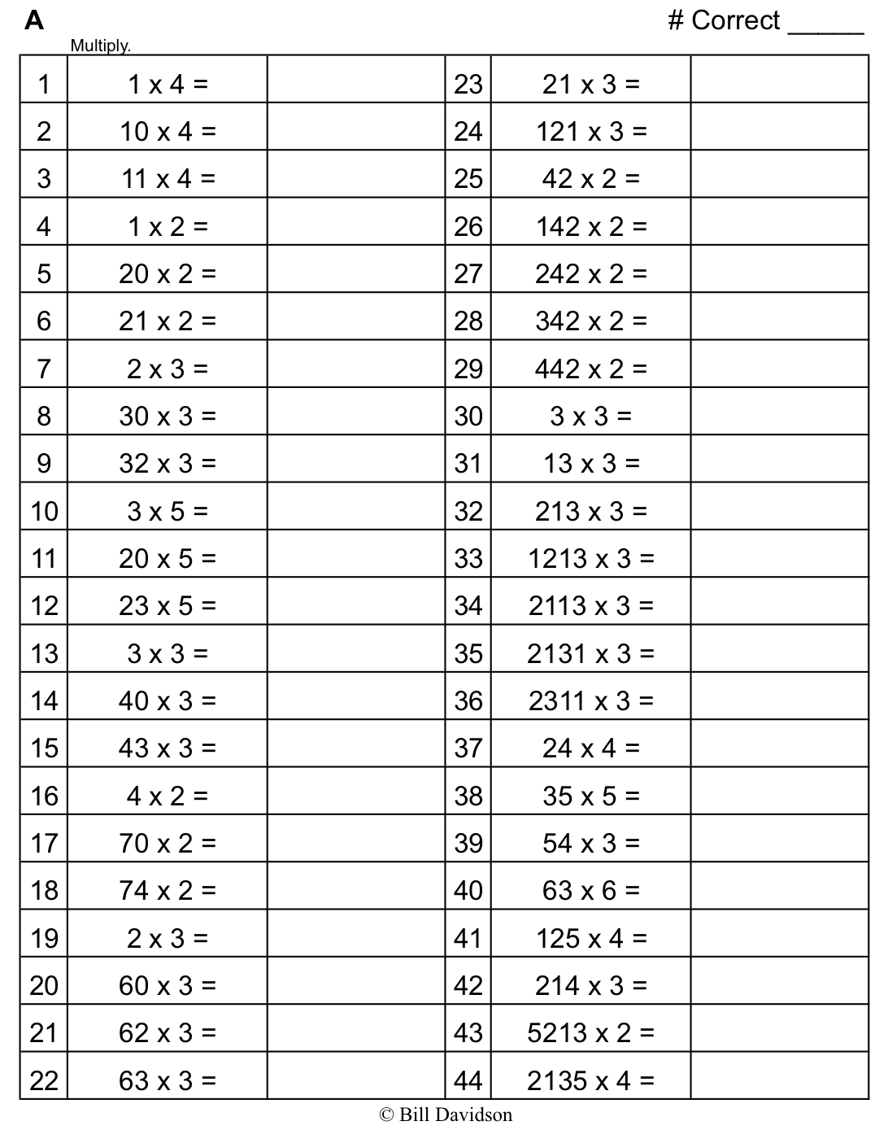
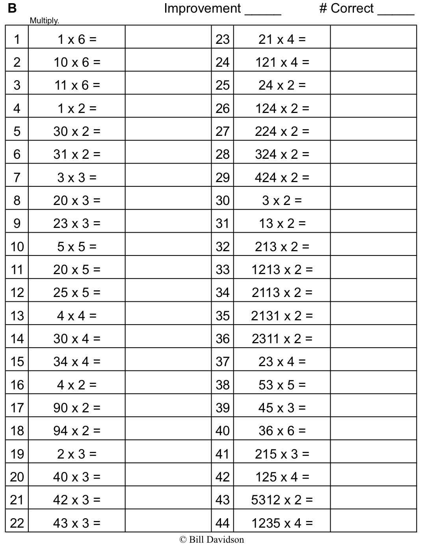
Name Date
Solve using the RDW process.
- Over the summer, Kate earned $180 each week for 7 weeks. Of that money, she spent $375 on a new computer and $137 on new clothes. How much money did she have left?

- Sylvia weighed 8 pounds when she was born. By her first birthday, her weight had tripled. By her second birthday, she had gained 12 more pounds. At that time, Sylvia’s father weighed 5 times as much as she did. What was Sylvia and her dad’s combined weight?

- Three boxes weighing 128 pounds each and one box weighing 254 pounds were loaded onto the back of an empty truck. A crate of apples was then loaded onto the same truck. If the total weight loaded onto the truck was 2,000 pounds, how much did the crate of apples weigh?

- In one month, Charlie read 814 pages. In the same month, his mom read 4 times as many pages as Charlie, and that was 143 pages more than Charlie’s dad read. What was the total number of pages read by Charlie and his parents?
Name Date
Solve using the RDW process.
- Michael earns $9 per hour. He works 28 hours each week. How much will he earn in 6 weeks?

- David earns $8 per hour. He works 40 hours each week. How much will he earn in 6 weeks?

- After 6 weeks, who earned more money? How much more money?

Name Date
Solve using the RDW process.
- A pair of jeans costs $89. A jean jacket costs twice as much. What is the total cost of a jean jacket and 4 pairs of jeans?

- Sarah bought a shirt on sale for $35. The original price of the shirt was 3 times that amount. Sarah also bought a pair of shoes on sale for $28. The original price of the shoes was 5 times that amount. Together, how much money did the shirt and shoes cost before they went on sale?

- All 3,000 seats in a theater are being replaced. So far, 5 sections of 136 seats and a sixth section containing 348 seats have been replaced. How many more seats do they still need to replace?

- Computer Depot sold 762 reams of paper. Paper Palace sold 3 times as much paper as Computer Depot and 143 reams more than Office Supply Central. How many reams of paper were sold by all three stores combined?

