Lesson 8
Objective: Culminating task—review selected topics to create a cumulative year-end project.

Suggested Lesson Structure
 Fluency Practice (5 minutes)
 Concept Development (40 minutes)
 Student Debrief (5 minutes)
Total Time (50 minutes)
Fluency Practice (5 minutes)
- My Favorite Fluency (5 minutes)
My Favorite Fluency (5 minutes)
Materials: (S) Summer materials from previous lesson
Note: Today’s activity is a fluency celebration.
Using their Getting Ready for First Grade packets, students practice their favorite fluency activity, or teach it to a guest attending the Math Olympics. If available, invite Pre-K students to learn a fluency activity from their older kindergarten buddies.
Application Problem
There will be no Application Problem today in order to allow more time for the cumulative project.
Concept Development (40 minutes)
Materials and Note: Today’s lesson is a celebratory Math Olympics. There are activities set up in five different “events” or stations around the classroom through which small groups of students rotate, for seven minutes each. At each station, the students have paper, pencils, and markers in addition to many copies of the half-page recording sheets. (Some students may be able to complete more than one at each station in the time allotted.) Teachers might wish to supply popcorn, ribbons, or small prizes for the participants during the end of the lesson Student Debrief celebration. The students use the materials they create at the stations to make a book reviewing some of the main concepts that they learned this year.
In addition to the recording sheets and writing tools, individual station materials are as follows:
- Make-10 Mania: Linking cube 10-sticks
- Five-Group Frenzy: Digit cards 1–20
- Shape Shifters: Pattern blocks and markers
- The Weigh Station: 2 pan balances, bags of pennies, mystery bag of small objects to weigh
- Awesome Authors: Large foam die, linking cubes to serve as addition support if necessary
Fun signs for the individual stations may be made up in advance, if desired. It is suggested that, if possible, older students, parents, administrators, or community volunteers be enlisted to help oversee the individual events in the Math Olympics. That way, the following lengthy explanation can be omitted and students can instead receive the directions for a particular station upon arrival.
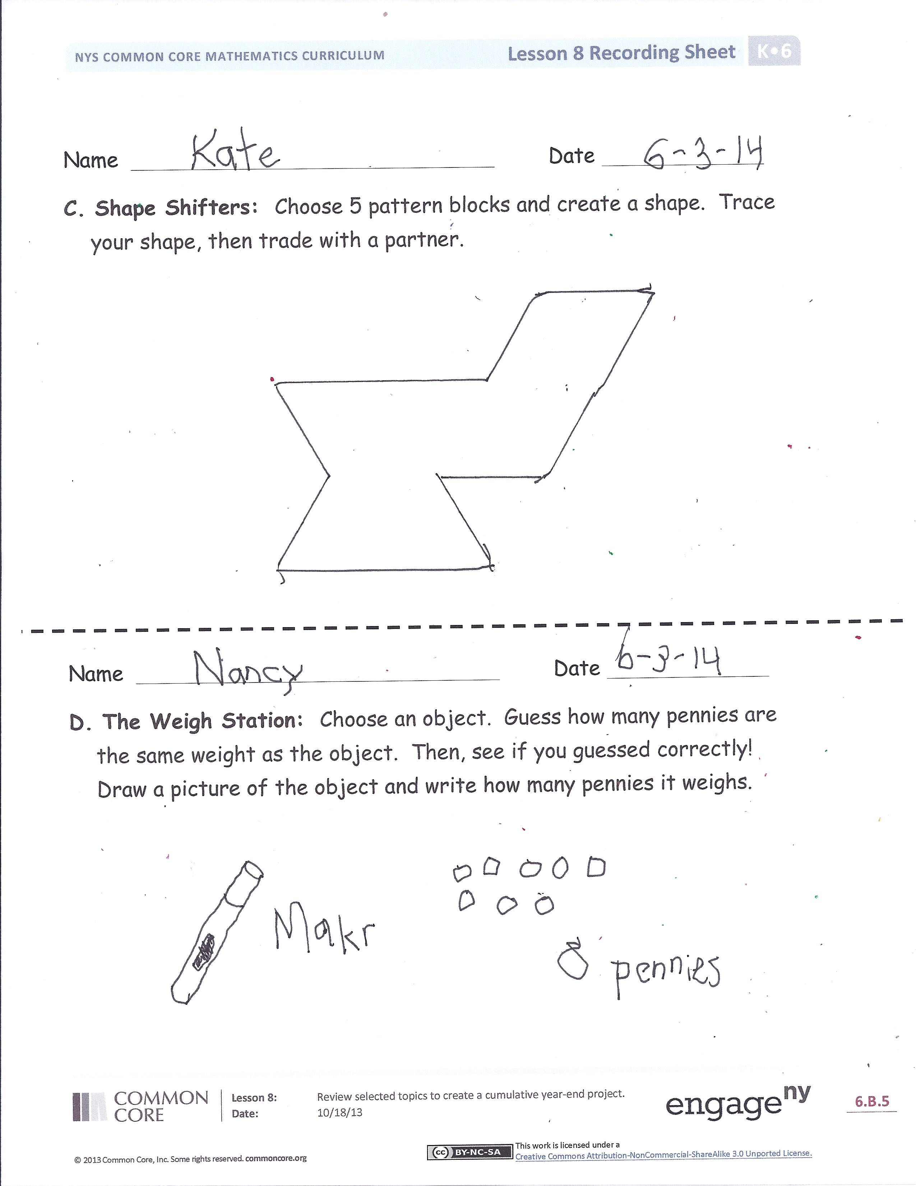
T: We are going to have a special Math Olympics celebration today! You are going to use many of the things that you learned to make your own math book to take home for the summer. We have several special stations set up today. (Demonstrate.)
T: (Station A, Make Ten Mania.) Here, you break apart 10-sticks and create number bonds and number sentences showing different ways to make 10. Find as many different pairs as you can and write them on the recording sheets.
T: (Station B, Five-Group Frenzy.) Here, you choose digit cards, write the numbers in your best penmanship, and show them on recording sheets the 5-group way. In the last box, show your number in another way, too!
T: (Station C, Shape Shifters.) Here, you choose up to 5 pattern blocks, make a shape with them on your paper, and trace the outline. If you have time, you trade with a friend and see if you can fill in their outline with the blocks!
T: (Station D, The Weigh Station.) Here you choose an object from the mystery bag. After you’ve held it and tested its weight with your hands, guess how many pennies are the same weight as your object. Then, check your guess and record your work! If you have time, you can weigh more objects.
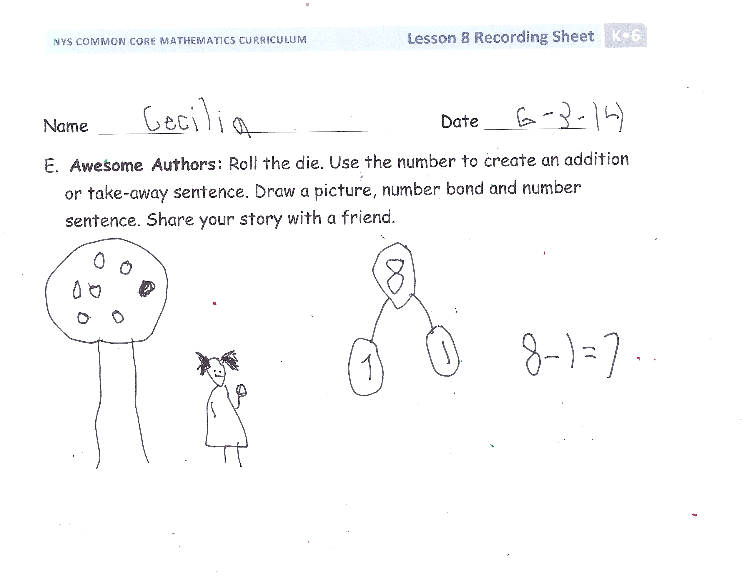
T: (Station E, Awesome Authors.) At the last station, you are a math author! You roll the die to get a number. You use this number as part of an addition or subtraction sentence. Think of a story that includes your number. Draw your picture and your number bond, and then write the number sentence. Make sure that you will be able to share your story with a friend or someone at home!
T: You have seven minutes at each of the stations, and then, when you hear this sound (flute, bell, whistle, clap, or other signal) you will switch. When you have finished all of the stations, make sure your initials are on all of your recording sheets and give them to me. I will make them into a math book of your very own! We will gather together at the end for a special celebration.
Student Popcorn Celebration Debrief (5 minutes)
Lesson Objective: Culminating task—review selected topics to create a cumulative year-end project.
- Which station did you find to be the most challenging? Why?
- Which station did you like best today? Why?
- What was the best thing about math this year?
- What are you looking forward to learning about next year?
- Let’s have some popcorn!

Name Date
A. Make 10 Mania: Show how you made 10!

Name Date
B. Five-Group Frenzy: Write the number, draw the number in the 5-group way, and draw the number in any other configuration.

Name Date
C. Shape Shifters: Choose 5 pattern blocks and create a shape. Trace your shape, then trade with a partner.

Name Date
D. The Weigh Station: Choose an object. Guess how many pennies are the same weight as the object. Then, see if you guessed correctly! Draw a picture of the object, and write how many pennies it weighs.

Name Date
E. Awesome Authors: Roll the die. Use the number to create an addition
or take-away sentence. Draw a picture, number bond, and number
sentence. Share your story with a friend.

