Lesson 6
Objective: Decompose flat shapes into two or more shapes.

Suggested Lesson Structure
 Fluency Practice (12 minutes)
 Application Problem (5 minutes)
 Concept Development (25 minutes)
 Student Debrief (8 minutes)
Total Time (50 minutes)
Fluency Practice (12 minutes)
- Sprint: Make 10 K.OA.4 (12 minutes)
Sprint: Make 10 (12 minutes)
Materials: (S) 2 copies of the Make 10 Sprint per student
Note: This Sprint maintains students’ knowledge of making 10 from GK─Module 4.
T: It’s time for a Sprint!
Briefly recall previous Sprint preparation activities, and distribute Sprints facedown.
T: Take out your pencil and one crayon of any color. For this Sprint, you are going to write the missing number needed to make 10. (Demonstrate one example if needed.)
Continue to follow the Sprint procedure as outlined in GK–M4–Lesson 3. Have students work on the Sprint for a second time. Continue to emphasize that the goal is simply to do better than the first time and celebrate improvement.

NOTES ON
MULTIPLE MEANS OF ACTION AND EXPRESSION:
Encourage English language learners to use the words in their native language to name the shapes they find in the classroom. For instance, a native Spanish speaker can say triángulo and rectángulo instead of triangle and rectangle. Ask the student to share with the class, and then ask everyone else to say the English word as well.
Application Problem (5 minutes)
Materials: (S) Personal white boards
You are going to be a detective today!
- First, look around the classroom to see if you can find things made of more than one shape, like we did yesterday.
- Second, draw it on your personal board.
- Third, use your marker to show the shapes inside.
If necessary, give hints about items such as tiles, bricks, windowpanes, and so on. Encourage students to look for and highlight the shapes within shapes on their boards.
T: Turn and talk to your partner about the hidden shapes that you found!
Note: Careful observation of shapes in the environment serves as the basis for today’s decomposition lesson.
Concept Development (25 minutes)
Materials: (S) Scissors, shape sheet template, pattern blocks, recording sheets from yesterday’s lesson
T: What do you see on your paper?
S: We have different shapes! I see squares, rectangles, and triangles.
T: Cut out your shapes and talk about them with your friends. (Allow time for activity and discussion.)
T: Hold up your gray square. Hold up your white triangle. Put your white triangle on your gray square, making two of the sides match. What do you notice?
S: When I put the white triangle on, it leaves an empty space like another triangle! There are two triangles now!
T: Yes! You made your square into two triangles. Find your gray rectangle and your square. What happens if we cover as much as we can of the gray rectangle with the square?
S: I have two squares now! I have a square in the middle and two little rectangles on the ends.
T: You found more shapes inside your rectangle, didn’t you? Hold up your white and gray triangles. Put them together. What shapes can you make with them?
S: A square that is the same as the big square with the dotted line! A bigger triangle. This one that looks like a diamond (parallelogram).
T Fold your gray triangle on the dotted line. What do you notice?
S: It’s still a triangle, but now it is smaller. When I unfold it, I see two little triangles inside.
T: Now look at your white rectangle with the dotted line. Fold it on the dotted line.
S: Now I have two rectangles! They are smaller but when I unfold it I see the big rectangle again.
T: Is there another way you could fold it?
S: Yes! When I fold it the other way I and then unfold it again, I have four rectangles in
all! I left mine folded and folded again. Now I have a square.
T: Now take your large gray square and fold it on the dotted line. What shapes do you see?
S: Two triangles! And they are the same size and shape as the white and gray triangle!
T: You found a lot of little shapes inside other ones. What does this make you think of?
S: It’s like inside one thing is another that is smaller. It’s like folding napkins for dinner. They start square and then make a rectangle. Or triangle. It’s like our numbers! We found number pairs hiding inside big numbers. These are shapes hiding in bigger shapes.

NOTES ON
MULTIPLE MEANS OF ENGAGEMENT:
Give above grade level students pattern blocks to use in creating different shapes. Challenge them by asking them to be sure to use at least one of the each of the pattern blocks (including the orange square and the light rhombus) and to make sure not to leave any gaps in their design. Have them describe their designs with a partner.
T: Excellent thinking. Just like we can break our numbers into smaller parts, we can make smaller shapes out of bigger shapes too.
T: Yesterday you made some wonderful new shapes on your recording sheet. Today, you are going to trade sheets with your partner to see if you can use pattern blocks to fill in the new shapes that she made. If you need help… ask your partner! You can take turns being the teacher! (Allow time for partner work and discussion.)
Problem Set (10 minutes)
Students should do their personal best to complete the Problem Set within the allotted 10 minutes. Provide pattern blocks for each student to use while completing the Problem Set.
Note: Look for additional pattern block activity cards at education stores or online to challenge students who finish the Problem Set quickly. These make great center activities during assessments.
Student Debrief (8 minutes)
Lesson Objective: Decompose flat shapes into two or more shapes.
The Student Debrief is intended to invite reflection and active processing of the total lesson experience.
Invite students to review their solutions for the Problem Set. They should check work by comparing answers with a partner before going over answers as a class. Look for misconceptions or misunderstandings that can be addressed in the Debrief. Guide students in a conversation to debrief the Problem Set and process the lesson.
You may choose to use any combination of the questions below to lead the discussion.
- How did you decide which pattern blocks you needed to fill in the shapes in the Problem Set?
- Did you and your neighbor use the same blocks?
- Do you think there are shapes hiding inside your pattern blocks, too? Give me an example. How can you use this to help you find more than one way to fill in the big shapes?
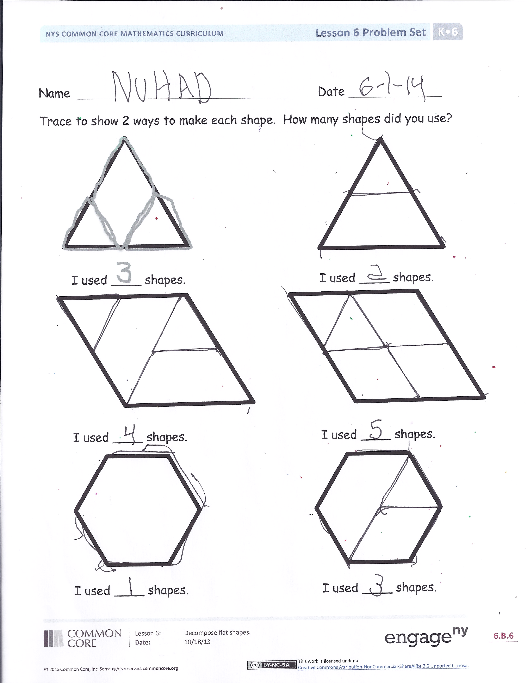
- How is finding hidden shapes inside other shapes like what we did yesterday? (In the previous lesson, students put shapes together to make new shapes.)
- How is finding hidden shapes inside a bigger shape like finding hidden numbers inside a bigger number?
- Could you think of something at home that is made out of more than one shape and tell us about it?
Exit Ticket (3 minutes)
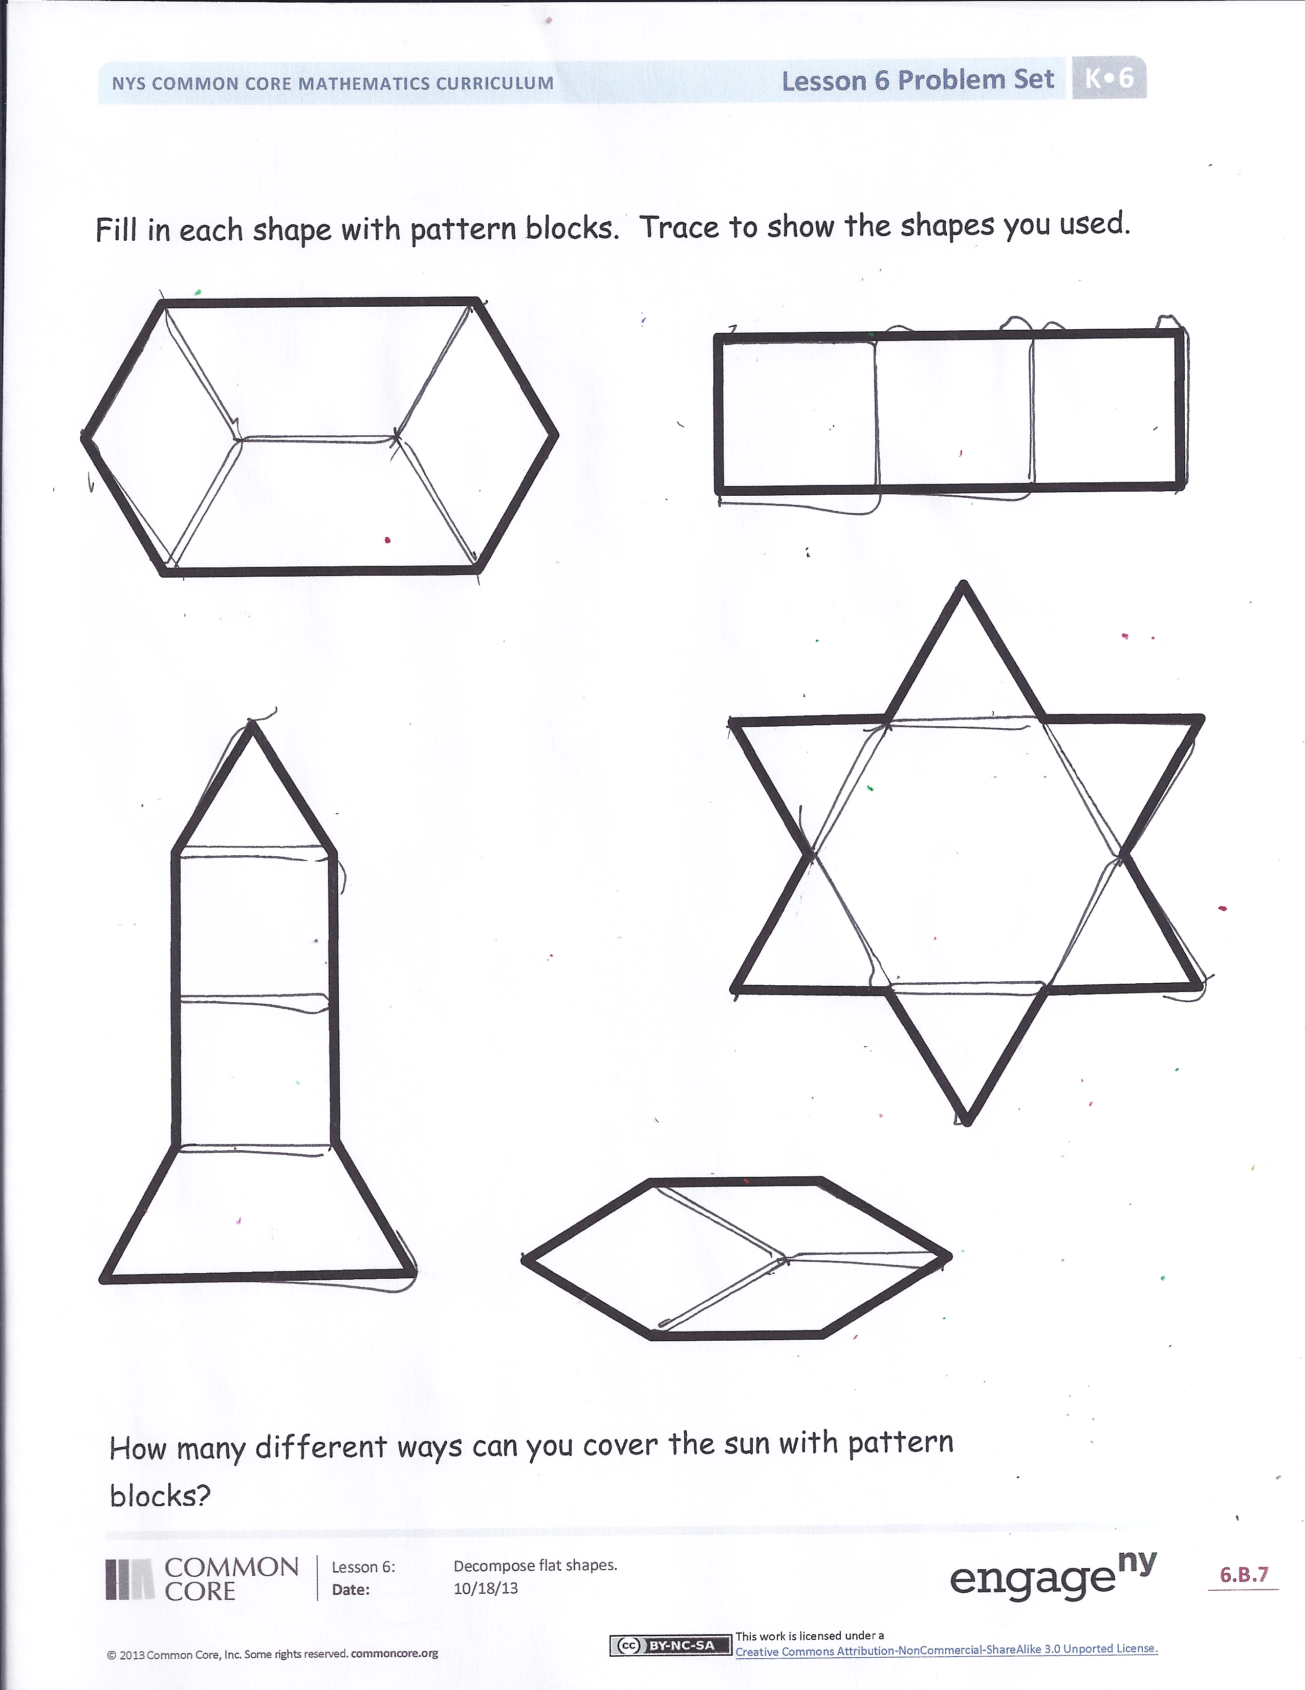
After the Student Debrief, instruct students to complete the Exit Ticket. A review of their work will help you assess the students’ understanding of the concepts that were presented in the lesson today and plan more effectively for future lessons. You may read the questions aloud to the students. Allow students to use pattern blocks to solve.
Name Date
Number correct:
Write the number of dots needed to make 10 dots.
1 |  | 9
2 |  | 10
3 |  | 11
4 |  | 12
5 |  | 13
6 |  | 14
7 |  | 15
8 |  | 16

Name Date
Trace to show 2 ways to make each shape. How many shapes did you use?

I used ____ shapes. I used ____ shapes.

I used ____ shapes. I used ____ shapes.

I used ____ shapes. I used ____ shapes.
Fill in each shape with pattern blocks. Trace to show the shapes you used.

How many different ways can you cover the sun with pattern blocks?

Name Date
Draw 2 shapes used to build the rectangle.

Draw 2 shapes used to build the house.

Name Date
Cut out the triangles at the bottom of the paper. Use the small triangles to make the big shapes. Draw lines to show where the triangles fit. Count how many small triangles you used to make the big shapes.

This big triangle is made with ____ small triangles.

This hexagon is made with ____ small triangles.

