Lesson 5
Objective: Compose flat shapes using pattern blocks and drawings.

Suggested Lesson Structure
 Fluency Practice (13 minutes)
 Application Problem (5 minutes)
 Concept Development (25 minutes)
 Student Debrief (7 minutes)
Total Time (50 minutes)
Fluency Practice (13 minutes)
- Sprint: Core Fluency K.OA.5 (9 minutes)
- Finish Line K.CC.4d (4 minutes)
Sprint: Core Fluency (9 minutes)
Materials: (S) Core Fluency Sprint A, B, C, or D from GK─M6─Lesson 2
Note: This activity continues students’ progress toward mastery of the required fluency for kindergarten.
Decide on a core fluency skill in which students would benefit from extra practice: addition, subtraction, or mixed addition with subtraction within 5. Select the Sprint that is most appropriate for the class from the Core Fluency Sprints in GK─M6─Lesson 2.
Follow the procedure outlined in GK─M6─Lesson 2.
Finish Line (4 minutes)
Materials: (T/S) Personal white board (turned to landscape orientation), 10 linking cubes
Note: This activity gives students practice in using ordinal numbers to describe relative position.
T: (Distribute linking cubes as 10-sticks.) How many cubes do you have? (Give students time to count if necessary.)
S: 10.
T: Pretend that your 10-stick of cubes is a little train. (Have students orient their trains the same way by giving them a point of reference in the classroom.) Put your finger on the first cube.
S: (Touch the first cube.)
T: Let’s use our number order words as we touch each cube. Ready?
S: First, second, third, fourth, fifth, sixth, seventh, eighth, ninth, tenth.
T: Good. Now break apart your cubes so none are connected. (Give students a moment to do this.) This time I want you to pretend that they are little people running in a race! The start line is the edge of your personal board. The finish line is the opposite side of your board. Watch me make my people run. (Demonstrate how to make cubes run.)
T: On your mark, get set, go!
S: (Move the cubes around as if running.)
T: Stop! The race is over. (Do not allow students to change the position of the cubes at this point.) Get out your marker. Listen carefully to what I want you to do. Circle the first runner.
S: (Circle the cube that is closest to the finish line.)
T: Make an X next to the tenth runner.
S: (Make an X next to the cube that is farthest from the finish line.)
T: Underline the fifth runner.
S: (Underline the fifth cube.)
T: Now point and show your partner who is first, second, and so on.
Have students clear their boards and play again alone or with a partner. Give instructions to mark different ordinal positions each time.
Have students change the location of the finish line so that they can describe the position of the runners relative to it.
Application Problem (5 minutes)

NOTES ON
MULTIPLE MEANS OF ACTION AND EXPRESSION:
Because drawing might present a further challenge, below grade level students and those with disabilities would benefit from using manipulatives to create a house. Provide attribute blocks or pattern blocks to make the house as the first step toward drawing the shapes on personal white boards.
Materials: (S) Personal white boards
Listen carefully to my instructions. You are going to draw a house!
- First, draw a square to make the big part of your house.
- Second, use a triangle to make a roof.
- Third, use a shape of your choice for a door.
- Fourth, find somewhere in your picture where you can use two more squares or rectangles.
- Fifth, use a circle somewhere in your scene.
- Sixth, find a place where you could draw a hexagon in your scene.
Take another minute to finish your scene with more shapes and details. Don’t forget to draw yourself!
Now show your picture to your partner. Tell her about each of your shapes. Do your houses look alike? How did you use shapes differently in your pictures?
Note: The activity of creating a scene using a number of assigned shapes is an opportunity for students to practice drawing the shapes. It also will serve as an anticipatory set for composition with shapes in today’s lesson. Circulate during the activity to see if there are students who still need help drawing any of the basic shapes.
Concept Development (25 minutes)
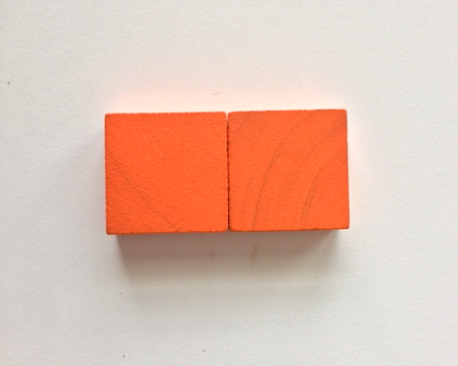
Materials: (S) Pattern blocks, personal white board, recording sheet
T: Find two squares in your pattern block box. How do you know they are squares?
S: They each have four sides. The sides are all the same length. They have corners like an L. They look like the face of a cube!
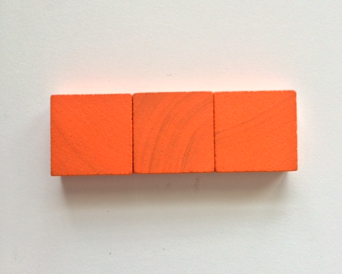
T: Place the squares on your board. See if you can make a different rectangle from your squares. (Pause.) Tell me about your work.
S: I put them right next to each other. Now two of the sides are long! It is a different rectangle now.
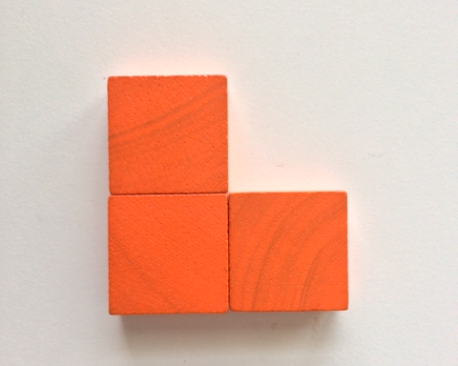
T: I like how you put your squares together so that the edges are fully touching. While you hold your pattern blocks down, trace your new shape with your marker. Hold up your boards to show me your work! (Pause.)
T: Put your squares back inside your new shape outline. I wonder what would happen if we added another square?
S: I think it would just get longer. I think it might be another rectangle. I have a different idea!
T: Try it and see! Trace your new shape. (Pause.)
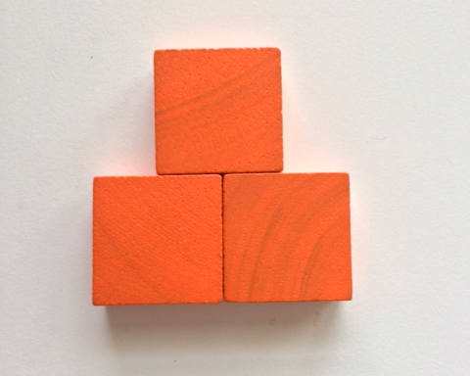
S: I have a longer rectangle now. I decided to put my square on top! I don’t have a rectangle anymore. I have an L. Now it looks like a building!
T: Turn and talk to your partner about your drawings. (Pause.)
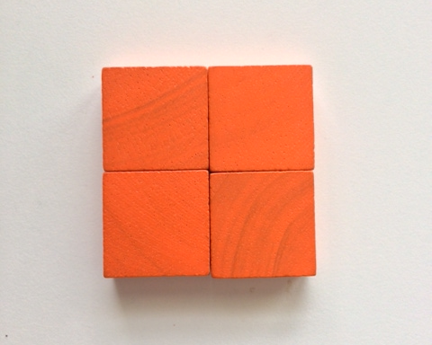
T: Take out one more square. Can you use the four small squares to make a larger square?
S: Yes. I put two next to each other and two on top. All of my squares are touching in the corners.
T: How do you know that you built a square?
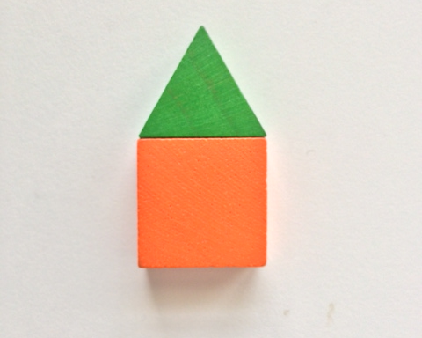
S: It looks like a carpet square. Four sides and four corners. All the sides are the same. The corners are like an L.
T: Let’s try another one. Take a square and a triangle out of your pattern block box. On your board, find a way to put their sides together to make a new shape. (Pause.) Tell me about your work.
S: I made a house shape! It looks like the one we made in our drawing before! I think mine looks like a rocket ship.
T: Trace your pattern blocks to show your new shape. (Pause.) Hold up your boards to show me your work! (Briefly observe to ensure understanding and to see which students might need additional support with the tracing activity.)
MP.6
T: Now, you are going to get a chance to make up your own new shapes! Work with your partner, taking turns to be the shape artist.
- First, choose two shapes from your pattern block box.

NOTES ON
MULTIPLE MEANS OF REPRESENTATION:
In order to facilitate the partner share after students create their own new shapes, give English language learners a review of key vocabulary needed to tell about their new shapes: sides, corners, and straight lines, etc.
- Second, put them together to make a new shape.
- Third, trace your shape on your recording sheet.
- Fourth, tell your partner about your new shape. How many sides does it have? How many corners? What would you name your new shape?
Allow time for exploration and composition of new shapes. Listen to the conversations to observe precision in the descriptive language such as sides, corners, straight lines, and so on. If time permits and students demonstrate ability, they may choose to use three shapes at a time.
T: Would anyone like to hold up their recording sheet and share one of their new shapes?
S: Mine looks like a bird! I made a snowman shape. I made a person!
Note: Save student recording sheets for additional work in tomorrow’s lesson.
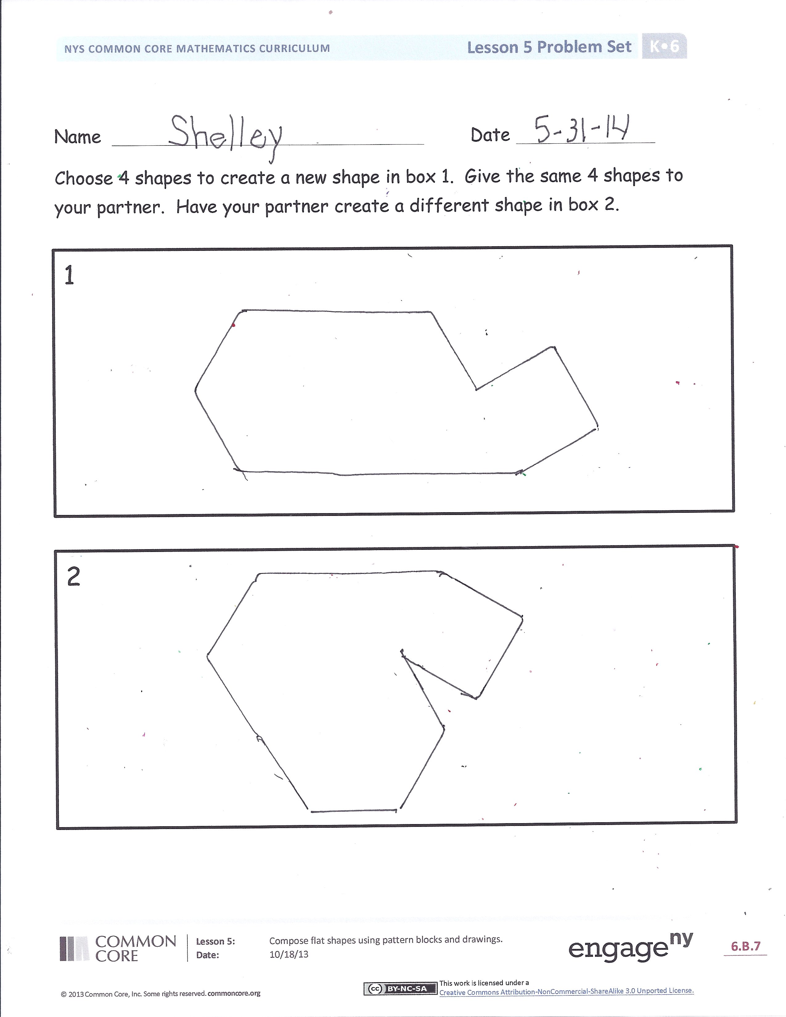
Problem Set (10 minutes)
Students should do their personal best to complete the Problem Set within the allotted 10 minutes.
Student Debrief (7 minutes)
Lesson Objective: Compose flat shapes using pattern blocks and drawings.
The Student Debrief is intended to invite reflection and active processing of the total lesson experience.
Invite students to review their solutions for the Problem Set. They should check work by comparing answers with a partner before going over answers as a class. Look for misconceptions or misunderstandings that can be addressed in the Debrief. Guide students in a conversation to debrief the Problem Set and process the lesson.
You may choose to use any combination of the questions below to lead the discussion.
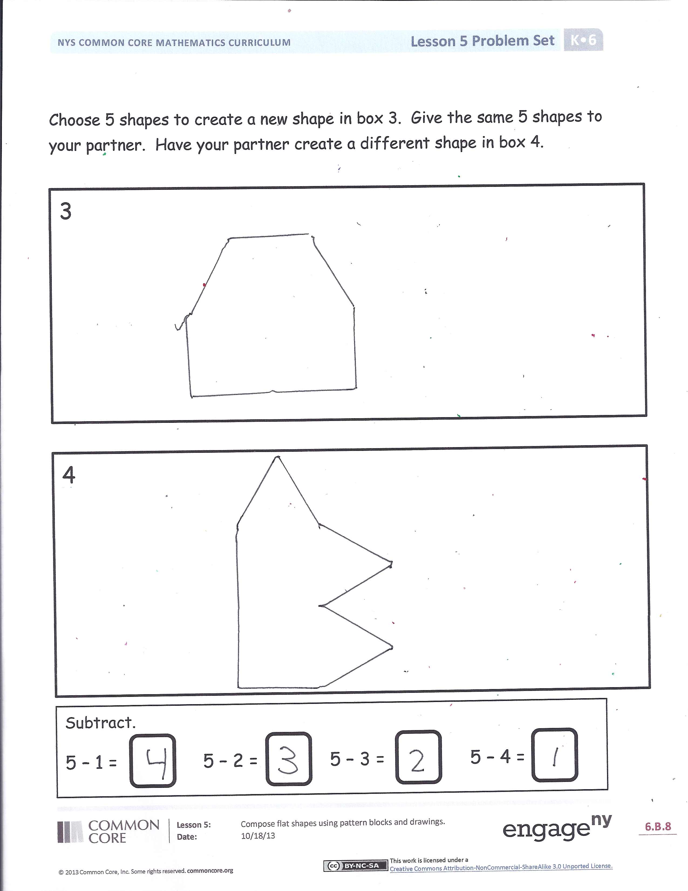
- In your Problem Set, what did you think about when you were arranging your pattern blocks to make new shapes?
- What if you had left spaces in between the blocks?
- Look around the classroom. Can you see anything that is made out of different shapes?
- How did you choose names for the shapes you created? (Many students will name shapes after a real world object they resemble, but look for some students to start naming based on attributes.)
- How does our work with the pattern blocks remind you of when you drew your house at the beginning of the lesson?
Exit Ticket (3 minutes)
After the Student Debrief, instruct students to complete the Exit Ticket. A review of their work will help you assess the students’ understanding of the concepts that were presented in the lesson today and plan more effectively for future lessons. You may read the questions aloud to the students.

I Can Make New Shapes!

Name Date
Choose 4 shapes to create a new shape in Box 1. Give the same 4 shapes to your partner. Have your partner create a different shape in Box 2.
1
2

Choose 5 shapes to create a new shape in Box 3. Give the same 5 shapes to your partner. Have your partner create a different shape in Box 4.
Subtract.
5 – 1 = 5 – 2 = 5 – 3 = 5 – 4 =
3
4

Name Date
Use your pattern blocks to help you solve the problem.
Use 2 blocks to make a rectangle. Trace your blocks to show your rectangle.

Name Date
Match each group of shapes on the left with the new shape they make when they are put together.

