Lesson 4

Objective: Describe the relative position of shapes using ordinal numbers.

Suggested Lesson Structure

 Fluency Practice (12 minutes)

 Application Problem (5 minutes)

 Concept Development (25 minutes)

 Student Debrief (8 minutes)

**Total Time (50 minutes)**

Fluency Practice (12 minutes)

* Rekenrek Counting to 100 **K.CC.1** (4 minutes)
* Make a Shape to Find Hidden Numbers in 4  **K.OA.1, K.G.6** (4 minutes)
* Make a Shape to Find Hidden Numbers in 5  **K.OA.1, K.G.6** (4 minutes)

Rekenrek Counting to 100 (4 minutes)

Materials: (T) 100-bead Rekenrek (preferably one that shows the color change at 50)

Note: This activity promotes proficiency in counting to 100 by tens (**K.CC.1**) and lays the foundation for understanding place value.

T: Let’s count the Say Ten way. Ready?

S: (Slide the beads back and forth as students count up and down.) Ten, 2 tens, 3 tens, 2 tens, 3 tens, 4 tens, 5 tens, 6 tens, 5 tens, 6 tens, 5 tens, 6 tens, 7 tens, 8 tens, 9 tens, 8 tens, 9 tens, 10 tens.

T: 10 tens is the same as…

S: 100!

T: Now let’s count the regular way. Ready?

Use a sequence similar to that used in counting the Say Ten way, with extra attention to the transition from 50 to 60.

T: Wow! You’re getting good at counting both ways. Now let’s mix it up. Start counting the Say Ten way, but then be ready to switch to the regular way.

S: Ten, 2 tens, 3 tens.

T: Stop! 3 tens the regular way is…

S: 30!

T: Keep counting the regular way.

S: 40, 50, 60....

T: Stop! 60 the Say Ten way is…

S: 6 tens!

T: Keep going the Say Ten way.

S: 7 tens, 8 tens, 9 tens….

T: Stop! 9 tens the regular way is…

S: 90!

T: Say the next number the regular way.

S: 100!

Count back down to 0, alternating periodically between both ways of counting. If students are ready for a challenge, use more of a wave style sequence.

Make a Shape to Find Hidden Numbers in 4 (4 minutes)

Materials: (S) 4-dot puzzle cards (pictured below), plus extra 1-dot and 2-dot pieces per student

Note: This activity combines students’ knowledge of embedded numbers and part–whole thinking, and previews composition of shapes.

T: (Distribute the 4-dot array card.) Raise your hand when you know how many dots. Ready?

S: 4.

T: Raise your hand when you know the name of this shape. Ready?

S: Square.

T: Very good. We’re going to use puzzle pieces to make a square, and at the same time, show different ways to make 4. Here is one way you could do it.

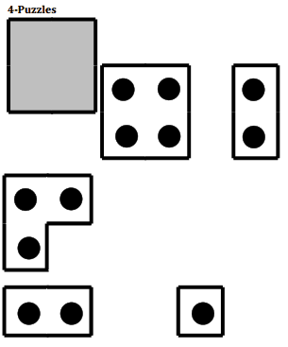T: How many dots are on this puzzle piece? (Hold up one of the 2-dot rectangle pieces.)

S: 2.

T: And on this one? (Hold up the other 2-dot rectangle.)

S: 2.

T: On the whole puzzle? (Replace the piece and point to indicate the entire puzzle.)

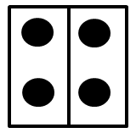S: 4.

T: So then, what numbers are hiding in 4?

S: 2 and 2.

T: What shapes did I use to make the square?

S: 2 rectangles.

T: Do you see other puzzle pieces I could use to make a square that has 4 dots?

S: Yes!

T: Give it a try! (Distribute additional pieces and allow students to work for some time, then allow them to confer with a partner. Circulate and ask students to identify the hidden numbers in 4, and the name and quantity of the shapes they used to compose the square.)

More possibilities:

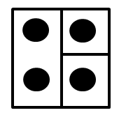 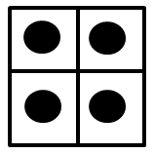 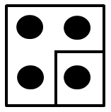

Variation: Have students work with a friend to make a rectangle that is not a square.

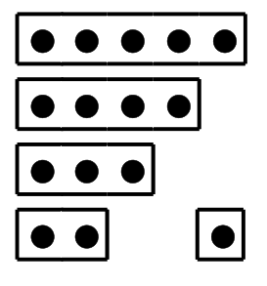Make a Shape to Find Hidden Numbers in 5 (4 minutes)

Materials: (S) 5-dot puzzle cards (pictured at right), plus extra 1-dot and 2-dot pieces per student

Repeat the process laid out in the previous activity, but this time use the 5-dot puzzle cards. Invite students to combine puzzle pieces with up to four friends to have fun making numbers to 20.

Application Problem (5 minutes)

Materials: (S) Personal white boards

|  |  |
| --- | --- |
|  | NOTES ON  MULTIPLE MEANS OF ACTION AND EXPRESSION: |

Break the third step into smaller steps for students working below grade level. Ask, “How many three-sided shapes? How many four-sided shapes? How many altogether?” They can also work directly on a number bond template.

* First, draw 3 three-sided shapes on your board.
* Second, draw 4 four-sided shapes on your paper.
* Third, draw a number bond and write a number sentence to tell how many shapes you have in all.

Share your work with your partner. Do your shapes look the same? Do your number bonds look the same? How about your number sentences?

Note: Today’s Application Problem serves as a link among the ordinal number discussions, shape constructions, number bonds, and number sentences. It serves as a review of some of the concepts from earlier modules as well as providing the anticipatory set for today’s lesson.

Concept Development (25 minutes)

Materials: (S) Shape template, scissors

T: How many shapes do you see on your paper? Raise your hand when you know. Call it out at my signal! (Wait until most hands are raised and then signal.)

S: 10!

T: Cut out your shapes on the dotted lines and put them on your desk. (Allow students time to cut.)

|  |  |
| --- | --- |
|  | NOTES ON  MULTIPLE MEANS OF ENGAGEMENT: |

Challenge students performing above grade level by giving them an opportunity to call out an arrangement of shapes using ordinal numbers. Explain what they are to do clearly, e.g., “call out different shapes by saying, for instance, first put your square on the table, put your triangle second in the row, etc.,” and let them lead the game for the whole class on in small group.

T: Make a row out of your shapes. Now, rearrange your shapes so that the first shape from the left is a circle. (If necessary, review left and right.) Make your second shape the smaller triangle. Keep your row straight! Now arrange it so that your third shape is a circle with a chunk missing. Share with your partner. What is the next shape in your row?

**MP.6**

S: It is a heart. 🡪 Mine is a square. 🡪 Mine is a different triangle.

T: Student A, count your shapes starting from the left, stopping at the cross.

S: 1, 2, 3, 4.

T: You stopped at shape number 4. We would say that the heart is your fourth shape!

T: Tell your partner your fourth shape. Use the words, “My fourth shape is _______.”

S: (Do so.)

T: Student B, what is the last shape in your row?

S: Mine is the big triangle.

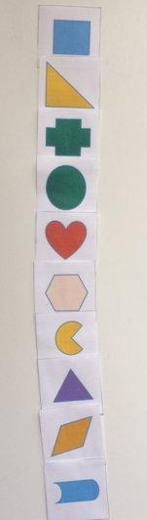T: Student B, count your shapes starting from the left and stopping at the big triangle.

S: 1, 2, 3, 4, 5, 6, 7, 8, 9, 10.

T: Tell your partner what your tenth shape is. Use the words, “My tenth shape is _________.”

S: My tenth shape is the one that looks like the outside of a can. 🡪 My tenth shape is the heart.

T: Mix up all of your shapes again.

T: This time, we are going to make a column of your shapes. Our columns will all be the same, so listen carefully.

* Make the first shape, the one at the top of your column, a square.
* Second, the large triangle.
* Third, a cross.
* Fourth, a circle.
* Fifth, a heart.
* Sixth, the hexagon.
* Seventh, the circle with a chunk out of it.
* Eighth, the small triangle.

**MP.6**

* Ninth, the diamond.
* Tenth, the one that looks like part of a can.

T: Start at the top of your column and count down 5 shapes. What is your fifth shape? Use the words, “My fifth shape is ___________.”

S: My fifth shape is a heart.

T: Count from the top and then put your finger on the last shape in your column. How many shapes did you count?

S: 10.

T: Yes, your finger is on your tenth shape. What is your tenth shape? Use your words.

S: My tenth shape is the one that looks like a can.

Continue practicing this way until students demonstrate an understanding of the relationship between the positions of the shapes and the resulting ordinal descriptions.

T: We are going to play Simon Says with your shapes. Simon says, make a row of shapes. Simon says, make your sixth shape a heart. Simon says, make your ninth shape a square. Simon says, make sure that your first shape is a triangle. Put your finger on the third shape.

S: You didn’t say Simon Says!

Continue the game in this manner, monitoring accuracy and allowing students to gain fluency in identifying the ordinal positions in preparation for the Problem Set.

T: Turn to your partner and tell him about your column of shapes. Use your math words to describe the position of each shape in the line.

S: My first shape is a circle. My second shape is a heart. My third shape is a circle with a chunk missing. (Continue through to tenth.)

Circulate to observe the conversations and to encourage precision in the language.

Problem Set (10 minutes)

Students should do their personal best to complete the Problem Set within the allotted 10 minutes.

Student Debrief (8 minutes)

**Lesson Objective:** Describe the relative position of shapes using ordinal numbers.

The Student Debrief is intended to invite reflection and active processing of the total lesson experience.

Invite students to review their solutions for the Problem Set. They should check work by comparing answers with a partner before going over answers as a class. Look for misconceptions or misunderstandings that can be addressed in the Debrief. Guide students in a conversation to debrief the Problem Set and process the lesson.

You may choose to use any combination of the questions below to lead the discussion.

* 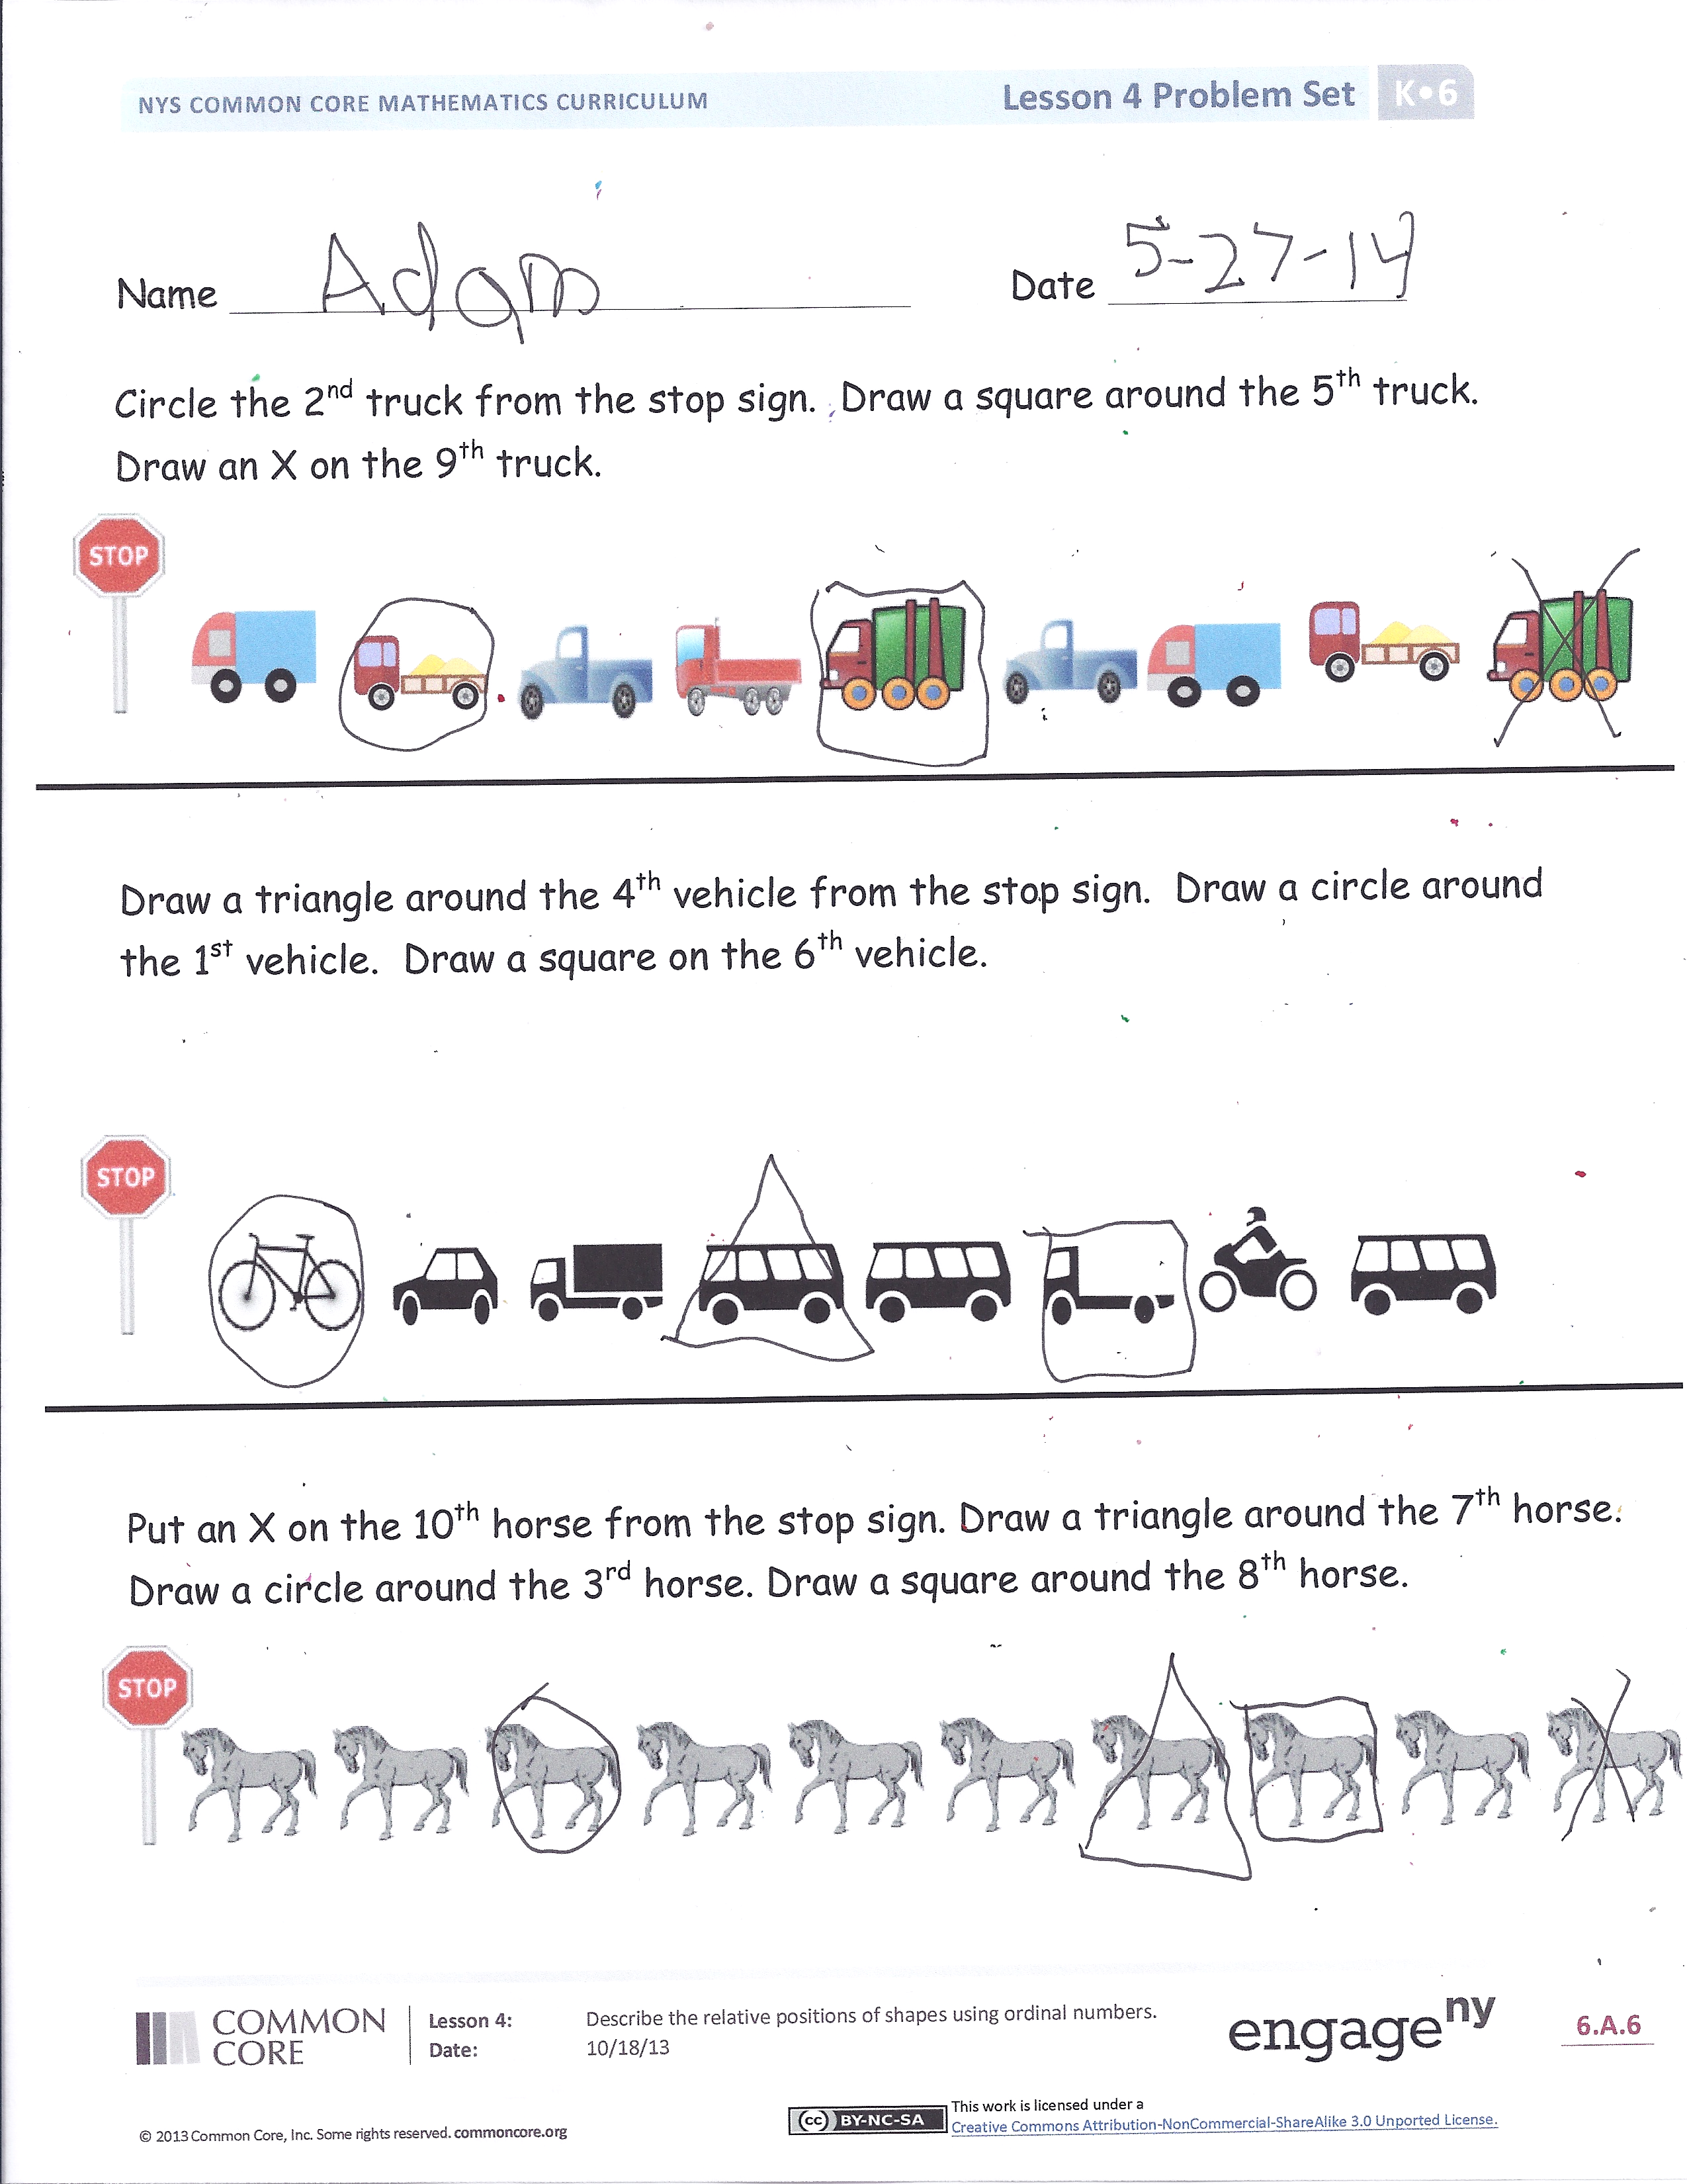Tell your partner how you marked the second, fifth, and ninth truck. Did you start counting from the beginning each time or did you count on each time you were marking the next truck?
* Look at the next problem with the vehicles. Could you use the counting on strategy this time? Why or why not? (In the first problem the students were asked to mark the trucks in sequential order; in this next problem they are asked to mark the vehicles out of order.)
* What’s different about the line of horses and the first two problems we did with the vehicles? (All the horses are exactly the same.) Did that make it easier or harder to find the one to mark?
* Today we talked about standing up *first* and then about putting a shape *first* in the row. How are those ideas similar? How are they different? Is it fair to use first in both of those sentences?

Exit Ticket (3 minutes)

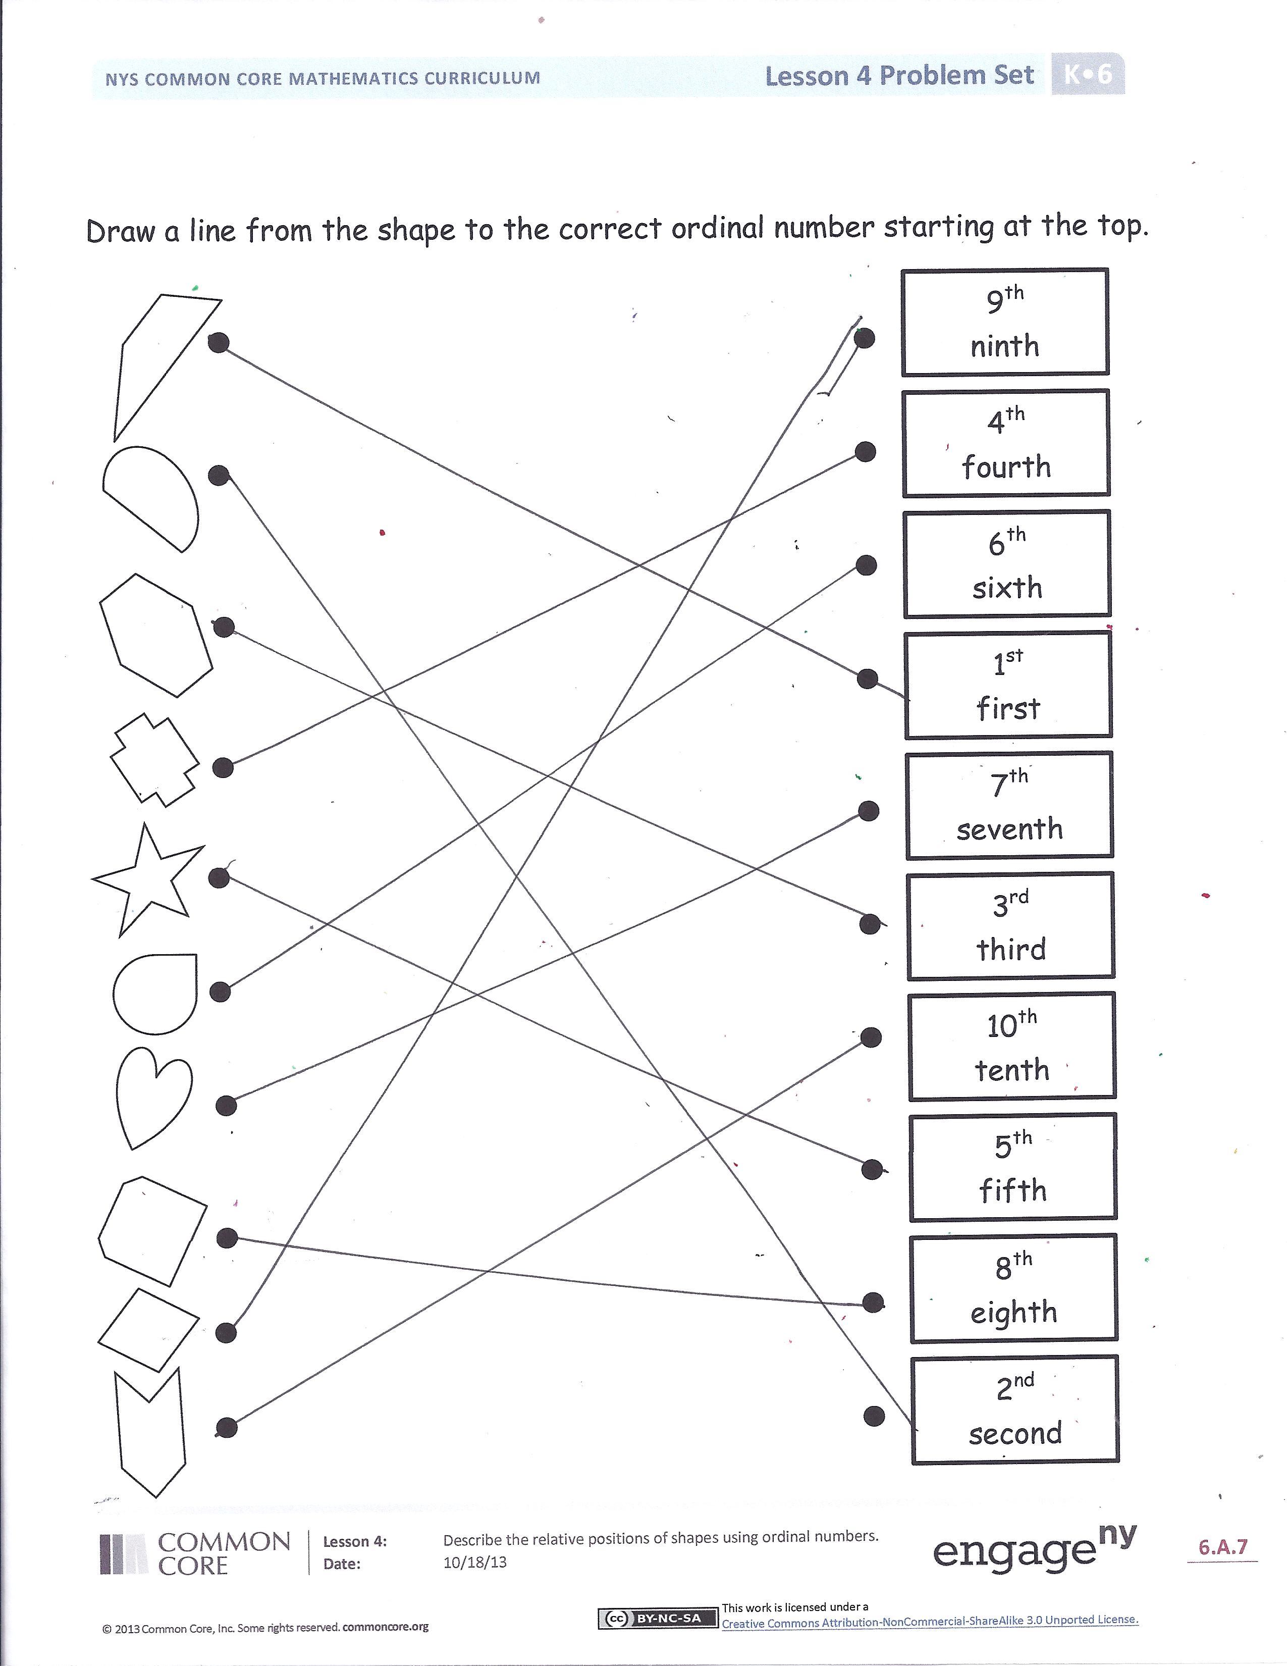After the Student Debrief, instruct students to complete the Exit Ticket. A review of their work will help you assess the students’ understanding of the concepts that were presented in the lesson today and plan more effectively for future lessons. You may read the questions aloud to the students.

Name Date

Circle the 2nd truck from the stop sign. Draw a square around the 5th truck.   
Draw an X on the 9th truck.



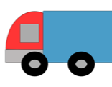

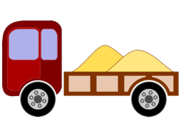

Macintosh HD:Users:user:Desktop:Picture 3.png

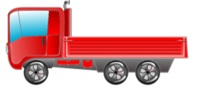

Macintosh HD:Users:user:Desktop:Picture 3.png







Draw a triangle around the 4th vehicle from the stop sign. Draw a circle around the 1st vehicle. Draw a square on the 6th vehicle.









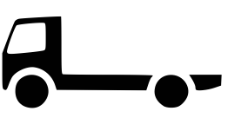







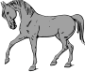

Put an X on the 10th horse from the stop sign. Draw a triangle around the 7th horse. Draw a circle around the 3rd horse. Draw a square around the 8th horse.

Draw a line from the shape to the correct ordinal number, starting at the top.

1st

first

2nd

second

3rd

third

4th

fourth

5th

fifth

6th

sixth

7th

seventh

8th

eighth

10th

tenth

9th

ninth

Name Date

Listen to the directions. Start at the circle when counting.

Color the 5th shape red.

Color the 2nd shape green.

Color the 10th shape yellow.

Color the 7th shape blue.

Color the 1st shape pink.

Color the 8th shape orange.

Name Date

Put an X on the 2nd shape.

Draw a triangle in the 4th shape.

Draw a circle around the 6th shape.

Draw a square in the 9th shape.

Draw a circle in the 7th shape.

Put an X on the 1st shape.

Draw a square in the 5th shape.

Draw a triangle in the 3rd shape.

Color the 1st red.

Color the 3rd blue.

Color the 5th green.

Color the 8th purple.

Match each animal to the place it finished the race.



2

second

1

first

4

fourth

3

third

6

sixth

5

fifth

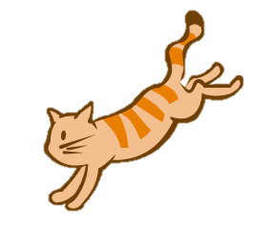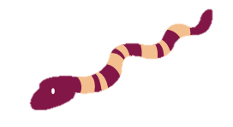

**4-Dot Puzzles**

|  |  |
| --- | --- |
|  |  |
|  |  |

|  |  |  |  |
| --- | --- | --- | --- |
|  |  |  |  |
|  |  |  |  |

|  |  |
| --- | --- |
|  |  |
|  |  |

|  |  |  |  |  |
| --- | --- | --- | --- | --- |
|  |  |  |  |  |

**5-Dot Puzzles**

|  |  |  |  |  |
| --- | --- | --- | --- | --- |
|  |  |  |  |  |

|  |  |  |  |  |
| --- | --- | --- | --- | --- |
|  |  |  |  |  |

|  |  |  |  |  |
| --- | --- | --- | --- | --- |
|  |  |  |  |  |

|  |  |  |  |  |
| --- | --- | --- | --- | --- |
|  |  |  |  |  |

|  |  |  |  |  |
| --- | --- | --- | --- | --- |
|  |  |  |  |  |

