Lesson 3
Objective: Compose solids using flat shapes as a foundation.

Suggested Lesson Structure
 Fluency Practice (12 minutes)
 Application Problem (5 minutes)
 Concept Development (25 minutes)
 Student Debrief (8 minutes)
Total Time (50 minutes)
Fluency Practice (12 minutes)
- Color by Answer Addition K.OA.5 (6 minutes)
- Color by Answer Subtraction K.OA.5 (6 minutes)
Color by Answer Addition (6 minutes)
Materials: (S) Copies of the Fluency Problem Set, crayons
Note: This activity gives students an opportunity to practice the core fluency of addition within 5, and calls students’ attention to the patterns within the chart.
After giving clear instructions and demonstrating a few problems as needed, allow students time to work independently. Early finishers can analyze the patterns they see within the chart.
Color by Answer Subtraction (6 minutes)
Materials: (S) Copies of the Fluency Problem Set, crayons
Note: This activity gives students an opportunity to practice the core fluency of subtraction within 5, and calls students’ attention to the patterns within the chart.
Conduct as above.
Application Problem (5 minutes)
Materials: (S) Geoboard and rubber bands per pair (or dot paper, markers, ruler if geoboards are not available)

You have a challenge today! Work with your partner. On your geoboard, make a shape with three sides. Now leave your shape on your board and let your partner make a three-sided shape as well. Do they look the same? Name the shapes.

NOTES ON
MULTIPLE MEANS OF ENGAGEMENT:
Below grade level students, as well as students with disabilities, will benefit from extra practice creating a variety of three- and four-sided shapes. Give them extended time with a geoboard, or make time for using interactive technology as that found at http://www.mathlearningcenter.org/web-apps/geoboard/.

Now make a shape with four sides. Have your partner make another four-sided shape. Do they look alike? Name the shapes.
Try it with five sides! Then, six! How far can you and your partner go?
Note: Reviewing the construction of a variety of flat shapes will serve as the anticipatory set for extending a flat shape into a solid in today’s lesson.
Concept Development (25 minutes)
Materials: (T) Set of geometric solids (S) Student squares from GK–M6─Lesson 1, 12 coffee stir sticks, small ball of clay
Part 1: Review the attributes and names of solids.
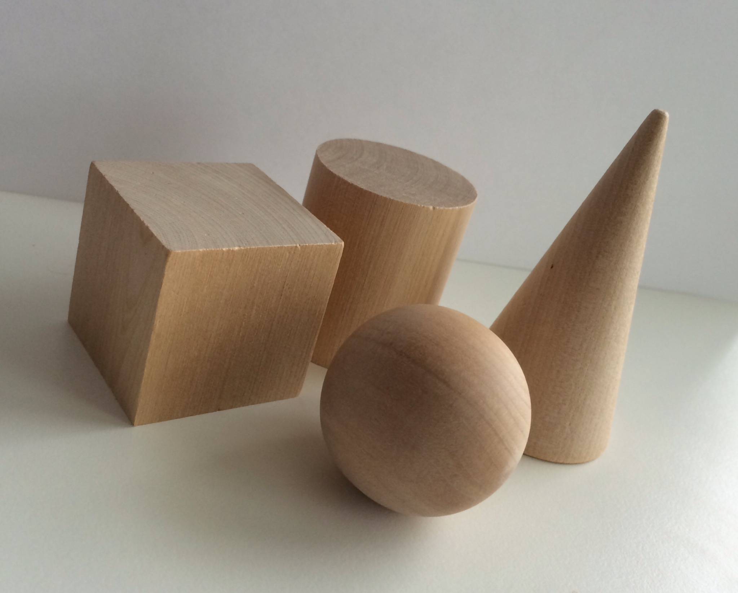
T: (Hold up each solid as a review exercise.) What do we call this solid?
S: A cone!
T: How did you know?
S: It looks like an ice cream cone. It looks like the orange cones in the lunch area.
T: What is special about a cone? Talk to your partner.
S: It has a circle on the bottom. It rolls funny, not in a straight line like a ball. It kind of looks like a triangle when you look at it from the side. It’s flat on the bottom, smooth, and round in the middle and pointy on the top.
Continue reviewing the other solids, asking students to explain how they knew the name of the solid and to describe its attributes.
Part 2: Construct a cube.
T: In our last lesson you made some great shapes out of your straws! I want to use some of the squares you constructed to make new shape like one of our solids. Does anyone have any ideas?
S: Maybe we could make something like a cube! You could use one square to be on the bottom like the floor of a room. Some of the others could be like the faces. We need one for the top, too.
T: Look at the cube we already have. (Hold it up.) How many squares will I need to use? Let’s count together.
MP.7
S: 1, 2, 3, 4, 5, 6.
T: Let’s use this one as the bottom of the cube. Now, I will use some of your other squares for the sides. (Demonstrate.) What does it look like now?
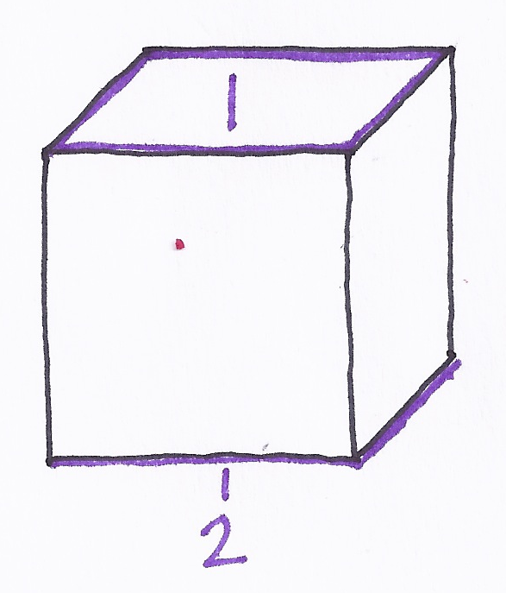
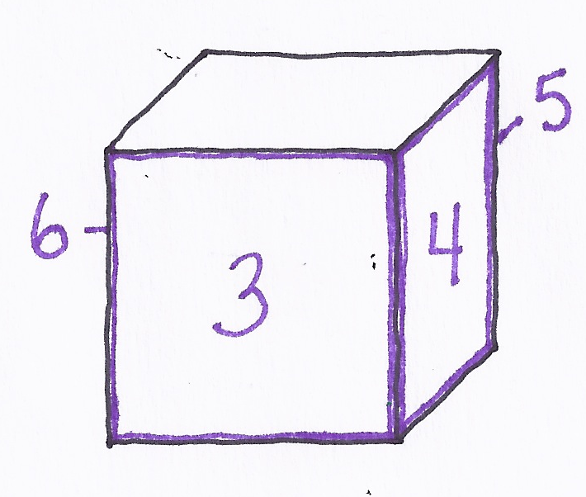
S: It looks like a box. It is still open, though.
MP.7
Counting Faces
T: What if I trace one of the squares on my paper and cut it out? (Demonstrate.) I will attach it to one of the squares. (Cover one side of the skeleton with the paper to create a face and hold the shape up for observation.) What do you notice?
S: It fits. We still need more faces to close it up!
T: I will trace and cut some more. (Demonstrate with the remaining 5 faces to create a cube.)
T: Let’s double-check. How many faces do we have? First let’s count the faces on the top and bottom. Say what we are counting.

S: (Point and touch.) 1 face, 2 faces.
T: Second, let’s count the ones around the middle. This is our third face so start at the number?
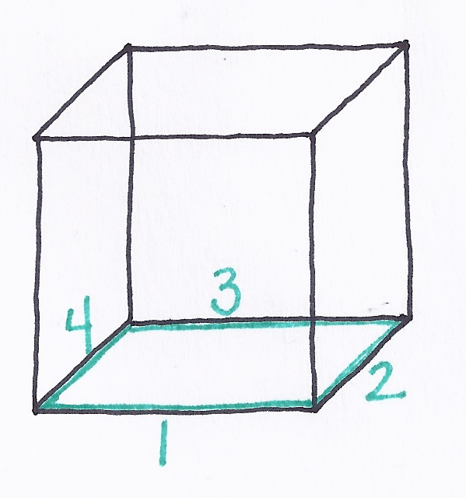
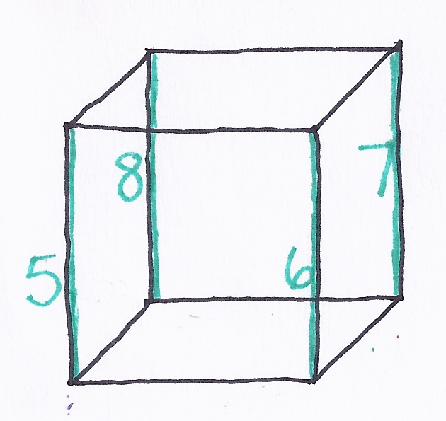
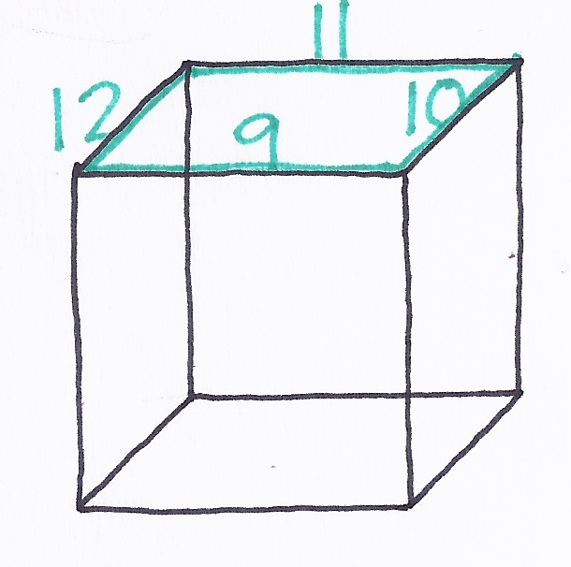
S: 3!
Counting Edges
T Go.
S: 3 faces, 4 faces, 5 faces, 6 faces.
T Have we counted all of the faces? Did we miss any? How many faces are there on the cube?
S: 6 faces.
T: Now count the edges for me. First we’ll count the ones on the bottom. I’ll start with this one.
S: (Touch as they count.) 1 edge, 2 edges, 3 edges, 4 edges.
T: Second, let’s count the edges in the middle. Start at the number after 4.
S: 5 edges, 6 edges, 7 edges, 8 edges.
T: Third, let’s count the ones at the top. How many edges have we counted so far?
S: 8.
T: So, the next edge we count will be number…?
S: 9!
T: Count when I touch.
S: 9 edges, 10 edges, 11 edges, 12 edges.
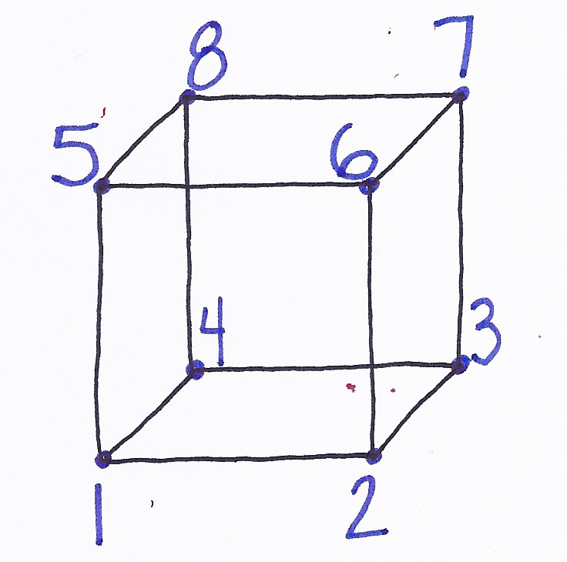
T: Are there any more edges?
Counting Corners
S: No!
T: Tell your partner how we counted. What did we do first, second, and third?
S: First, we counted the edges on the bottom. Second, we counted the ones in the middle. And third, we counted the edges on the top.
T: Let’s count them once more without stopping and without saying what we are counting.
S: (Touch systematically as students count.) 1, 2, …11, 12.
MP.7
T: Now count the corners. (Repeat the same process with the corners, having them count the corners on the bottom and then the top, saying what they are counting.)
T: It is time to make a shape like this on your own. Begin by making a square out of your straws for the bottom. Make another one for the top, too. (Allow time for students to work.)
T: What do we need now?
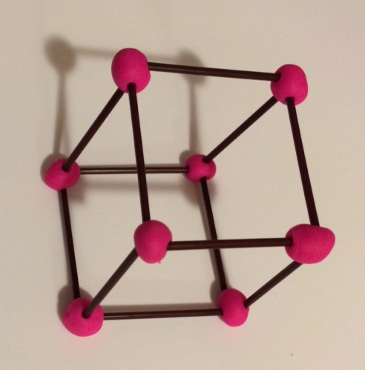
S: We need to make the edges. Let’s stick straws into the corners of our bottom squares so they are poking up. They will look like table legs. Then we can put on the top!
T: Please finish your shapes. (Allow time for students to construct the shape. Circulate to observe understanding and offer support as necessary.)
T: You have made wonderful shapes! Hold them up. What do you notice about them?
S: They look like little boxes! They are the same on every side.
T: Work with your partner to count the faces, edges, and corners of your pretend cube like we did earlier.
T: (Circulate and support the counting, which is challenging for kindergarten students.) What shapes are the invisible faces?
S: They are all squares.
T: I wonder what would happen if we put two of these shapes together? With your partner, see what you can create if you use more than one.
S: Now ours is taller, like a building! Ours looks like a train.
T: What are the shapes of the new invisible faces?
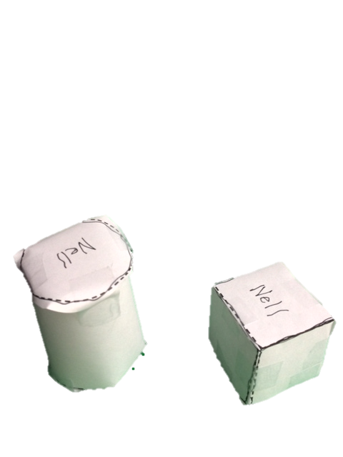
S: Squares. Rectangles!
T: Wait for my signal. How many corners do you have now? Count them using our system. (Signal and give students sufficient time to count.)
S: 8 corners.
T: How many faces? (Give students time to count.)
S: 6 faces!
T: How many edges? (Give students time to count.)
S: 12 edges!
T: Great work. Take a minute to compare your new shape with another pair’s.
S: (Compare shapes.)
Problem Set (10 minutes)
Students should do their personal best to complete the Problem Set within the allotted 10 minutes.
Student Debrief (8 minutes)
Lesson Objective: Compose solids using flat shapes as a foundation.
The Student Debrief is intended to invite reflection and active processing of the total lesson experience.
Invite students to review their solutions for the Problem Set. They should check work by comparing answers with a partner before going over answers as a class. Look for misconceptions or misunderstandings that can be addressed in the Debrief. Guide students in a conversation to debrief the Problem Set and process the lesson.
You may choose to use any combination of the questions below to lead the discussion.
- How many squares did you trace on your Problem Set before you started cutting? What did you have to do to make a cube out of all the squares you traced?
- What two shapes did you trace to make your cylinder? (Circle and rectangle.) What happened to the rectangle when you cut and folded the paper to make the cylinder? Could we say that a rectangle is a face of a cylinder? Why or why not? (No. Faces are flat. Once we roll up the rectangle to make a cylinder, it is no longer flat.) What about the circle? Is a circle a face of the cylinder?
- When you counted the faces of your cube, how did you keep track of your count? How did you make sure that you didn’t count any face twice?
- Describe a cube to me. Tell me about its faces, edges, and corners.
- Describe a cylinder to me. Tell me about its faces, edges, and corners.
Exit Ticket (3 minutes)
After the Student Debrief, instruct students to complete the Exit Ticket. A review of their work will help you assess the students’ understanding of the concepts that were presented in the lesson today and plan more effectively for future lessons. You may read the questions aloud to the students.

Name Date
Add. Color the blocks using the code for the total.

1-RED 2-ORANGE 3-YELLOW
4-GREEN 5-BLUE
0 + 1 | 1 + 1 | 2 + 1 | 3 + 1 | 4 + 1
0 + 2 | 1 + 2 | 2 + 2 | 3 + 2
0 + 3 | 1 + 3 | 2 + 3
0 + 4 | 1 + 4
0 + 5

Name Date
Subtract. Color the blocks using the code for the difference.

0-PURPLE 1-RED 2-ORANGE 3-YELLOW
4-GREEN 5-BLUE

1 - 0 | 2 – 0 | 3 – 0 | 4 – 0 | 5 – 0
1 - 1 | 2 – 1 | 3 – 1 | 4 – 1 | 5 – 1
 | 2 - 2 | 3 – 2 | 4 – 2 | 5 – 2
 |  | 3 – 3 | 4 – 3 | 5 – 3
 |  |  | 4 – 4 | 5 – 4
 |  |  |  | 5 - 5

Name Date
Trace the circles and rectangle. Cut out the shape. Fold and tape to create a cylinder.

Trace the squares. Cut out the shape. Fold and tape to create a cube.

Name Date_____________
Draw a line from the flat shape to the object that has a face with that flat shape.

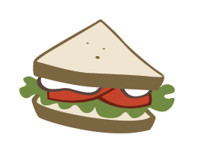

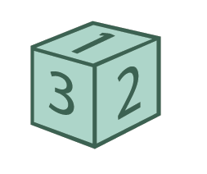
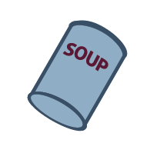
Name Date

Draw something that is a cylinder.

Circle the flat shape you can see in a .

Draw something that is a cube.

Circle the flat shape you can see in a .

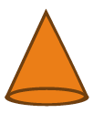
Draw something that is a cone.

Circle the flat shape you can see in a .

Draw a 3-dimensional solid. Draw one of your solid’s faces. Tell an adult about the shapes you drew.

Note to Family Helpers: Your student knows how to name some three-dimensional solids: cylinders, cones, cubes, and spheres. You can often find these 3D shapes around the house in objects like soup cans, ice cream cones, boxes, and balls. For the last question, it is acceptable for your student to find and draw a different type of three-dimensional solid. Talk about the number of edges, corners, and faces on the object.

