Lesson 2
Objective: Build flat shapes with varying side lengths and record with drawings.

Suggested Lesson Structure
 Fluency Practice (12 minutes)
 Concept Development (25 minutes)
 Student Debrief (13 minutes)
Total Time (50 minutes)
Fluency Practice (12 minutes)
- Sprint: Core Fluency K.OA.5 (9 minutes)
- Compose Teen Numbers K.NBT.1 (3 minutes)
Sprint: Core Fluency (9 minutes)
Materials: (S) Core Fluency Sprint A, B, C, or D
Note: This activity continues students’ progress toward mastery of the required fluency for kindergarten.
Decide on a core fluency skill in which students would benefit from extra practice: addition, subtraction, or mixed addition with subtraction within 5. Select the Sprint that is most appropriate for the class: Core Fluency Sprint A, B, C, or D in the materials that follow. In order to correct the work as a class, all students take the same Sprint.
T: It’s time for a Sprint! (Briefly recall previous Sprint preparation activities, and distribute Sprints facedown.) Take out your pencil and one crayon, any color. (Demonstrate the first problem as needed.)
Continue to follow the familiar Sprint procedure. Have students work on the same Sprint a second time. Continue to emphasize that the goal is simply to do better than the first time and celebrate improvement.
Compose Teen Numbers (3 minutes)
Materials: (T) Hide Zero cards (optional)
Note: This maintenance activity ensures that students stay sharp on the work of the previous module.
T: (Show cards, or say the numbers 10 and 6.) Raise your hand when you can say the number the Say Ten way. (Wait for all hands to go up, then signal.) Ready?
S: Ten 6.

NOTES ON
MULTIPLE MEANS OF ACTION AND EXPRESSION:
As more shapes are introduced, be sure to put the shapes with pictures or models on the word wall. This will help English language learners study the names of the shapes and allow teachers to point to the shapes while talking about them, making a clear connection between the words and the meaning.
T: Now say it the regular way, please.
S: 16.
T: (If using Hide Zero cards, slide them together to form the number 16.)
Continue with the following sequence: 17, 18, 19, 13, 14, 15, 11, 12, 10, 20.
Variation: Students can write the number bond, or write two addition sentences on their personal boards.
Concept Development (25 minutes)
Materials: (S) Approximately 15 coffee stir sticks, scissors, personal white board, small ball of clay
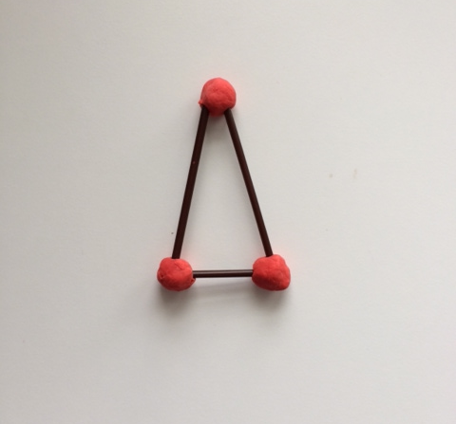
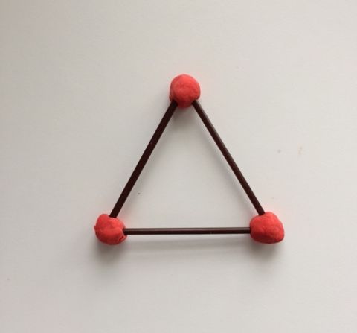
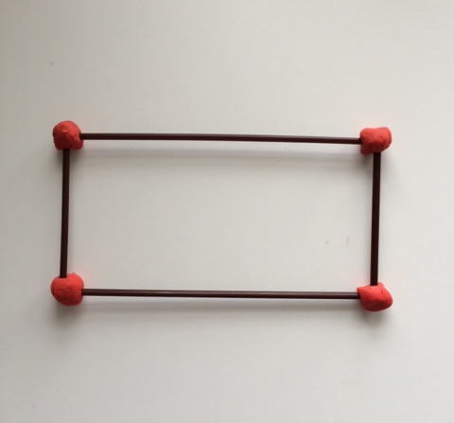
T: Who can remind us about what we did in math class yesterday? Can you use your math words to tell us, in order, the steps that we took in our lesson?
S: First, we cut our sticks. They were all the same length! Second, we made flat shapes with them on our desks. Third, we stuck the ends together with clay at the corners.
MP.4
T: That’s right. We are going to make more flat shapes today. Yesterday, we made special rectangles that had equal sides. What did we call them?
S: Squares.
T: Today, use your sticks and your clay to create another type of rectangle, one that has corners like an L but whose sides are not all the same length.
T: (Pause.) You may cut one or two of your sticks if you need to. (Allow time for students to plan and create the shape. Circulate to support students who might need it.) Hold up your rectangles! How do you know they are rectangles?
S: It’s like a square but it is stretched! It has two long sides and two shorter sides. I had to cut one of my sticks in half! They have corners that look like an L. It has four sides.
T: Take three sticks that are the same length. Now use those sticks to make a closed shape with three straight sides. (Allow time for students to experiment.) Hold up your shapes. What do we call this shape?
S: It is a triangle!
T: What if you take one of the sides of your triangle and cut it to be shorter, then put it back into your shape? (Allow time for students to experiment.) What do you notice?
S: It is still a triangle. It just has one side that is shorter. It looks pointier, but it still has three sides and three corners. Two sides are the same length!
T: Great job! With your partner, use your sticks and your clay to make several different flat shapes. You may cut the sticks to be any lengths you like. Be creative! (Allow ample time for student work. Encourage students to think about not only convex but also concave figures. Hold up any interesting examples you observe for extra inspiration. Again, if students ask, casually mention the names of created shapes they may not have studied yet.)

NOTES ON
MULTIPLE MEANS OF ENGAGEMENT:
Students with disabilities who might have difficulty with fine motor activities could benefit from using a geoboard and rubber bands to make different shapes or by allowing them to use interactive technology such as the one found at http://www.glencoe.com/sites/common_assets/mathematics/ebook_assets/vmf/VMF-Interface.html.
(In the Select Grade drop-down menu, click Kindergarten. In the Manipulatives drop-down menu, click Geoboard/Bands.)
T: Wow! You made a lot of different shapes! Would anyone like to show their favorite and tell the class about it? (Allow time for discussion.)
T: With your ruler and your marker, try to copy each of your new shapes on your board.
Allow time for students to replicate their shapes on paper. Circulate to offer assistance to students who may still need help in keeping their rulers straight and still during construction. If time permits, allow students to turn and talk to their partners to describe the shapes they drew.
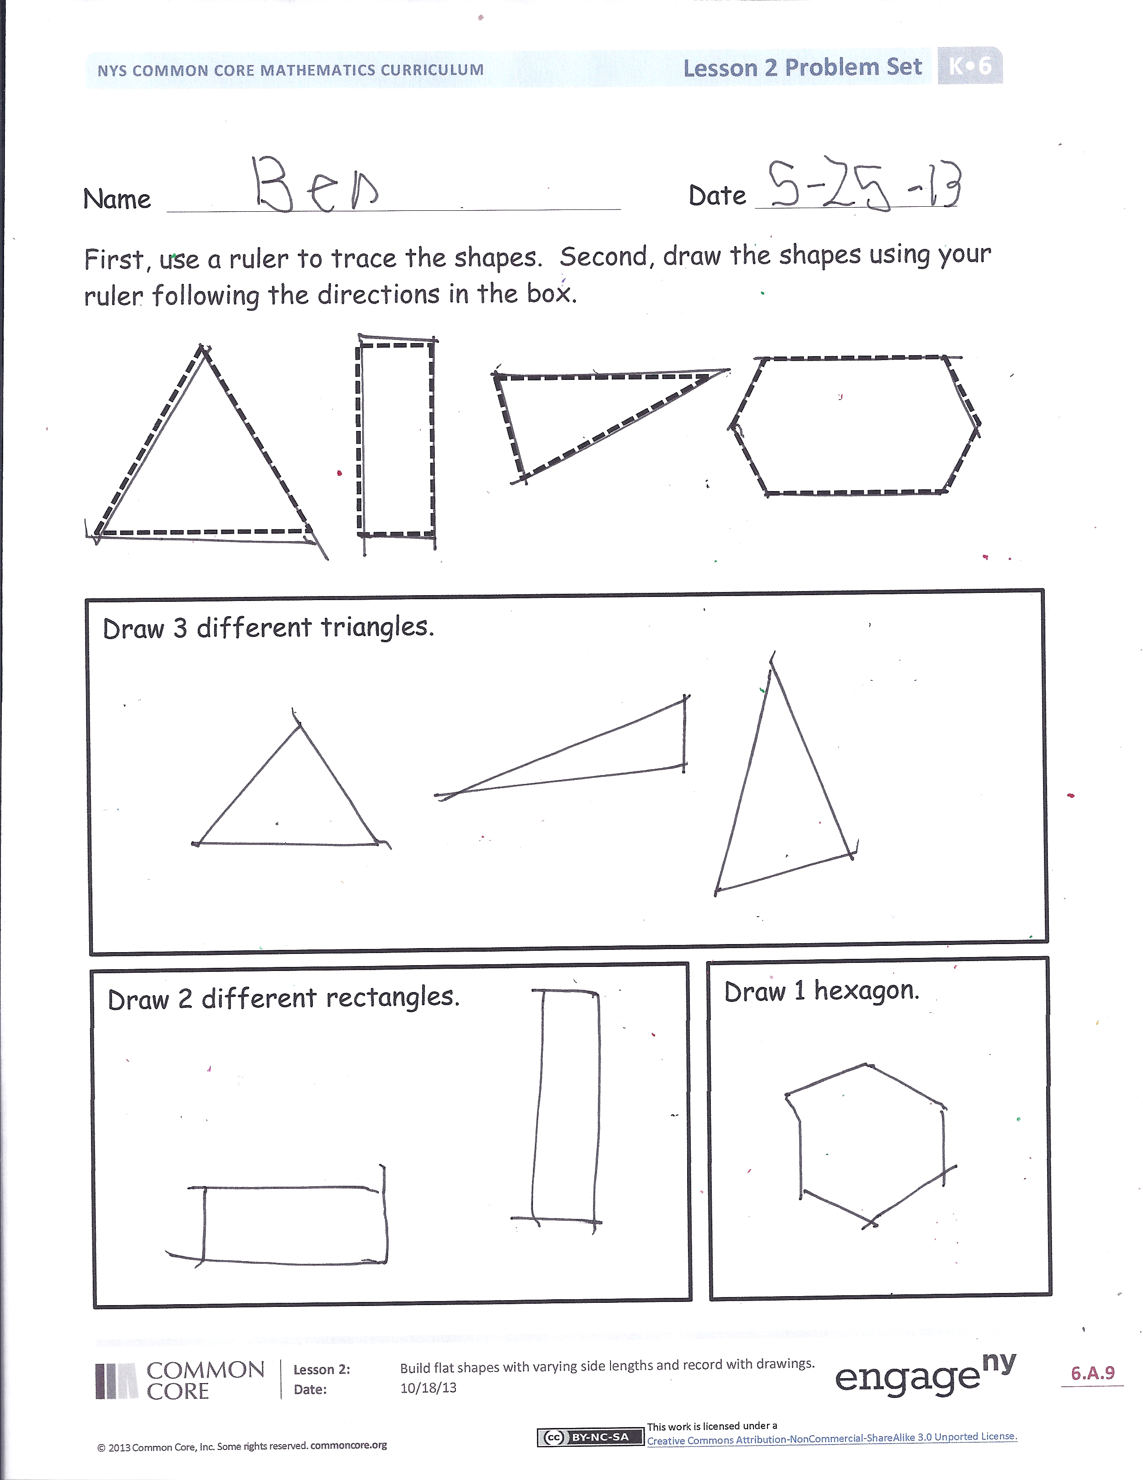
Problem Set (10 minutes)
Students should do their personal best to complete the Problem Set within the allotted 10 minutes.
Student Debrief (13 minutes)
Lesson Objective: Build flat shapes with varying side lengths and record with drawings.
The Student Debrief is intended to invite reflection and active processing of the total lesson experience.
Invite students to review their solutions for the Problem Set. They should check work by comparing answers with a partner before going over answers as a class. Look for misconceptions or misunderstandings that can be addressed in the Debrief. Guide students in a conversation to debrief the Problem Set and process the lesson.
You may choose to use any combination of the questions below to lead the discussion.
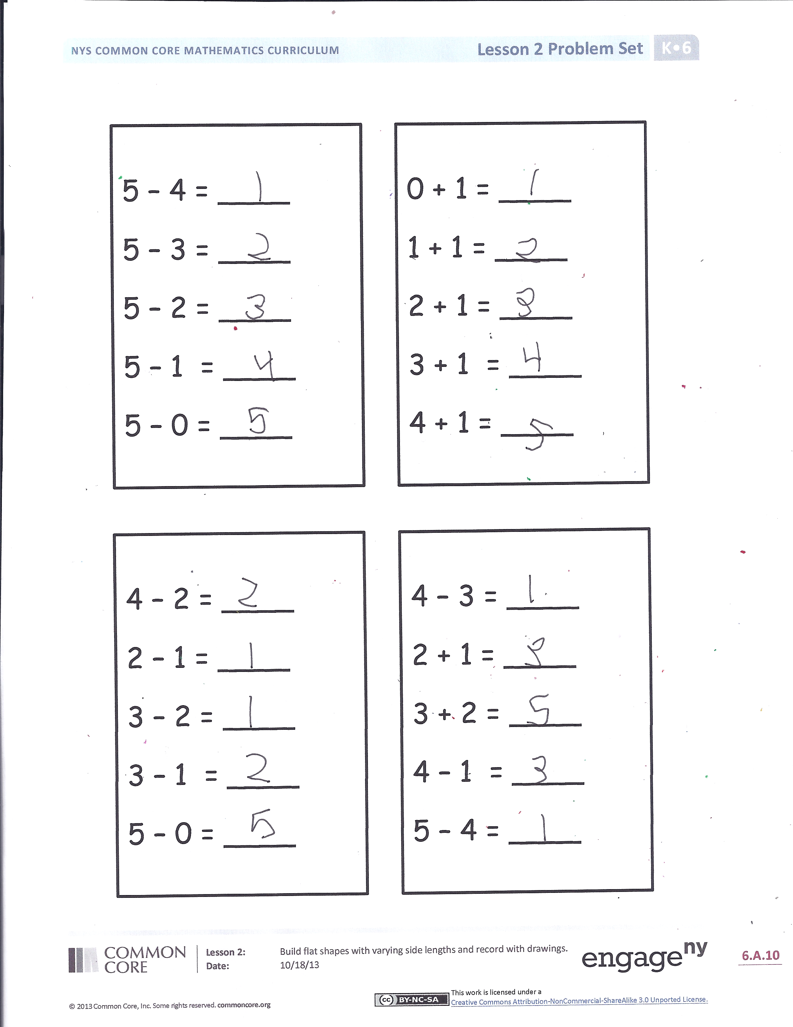
- Look at all the triangles on your Problem Set. Tell your partner what they all have in common. Choose two triangles that are different. Tell your partner how they are different.
- Does a triangle need to be closed? Can it have gaps between the sides?
- I heard you say that all of the triangles are closed and have three sides and three corners. Do they all look the same? Tell your partner how many different looking triangles you think you could draw.
- When you made a shape with four straws and corners like an L, what did you call it? What did you call the special shape you made where all four straws were the same length?
- (Hold up a set of three equal straws and a set of three straws with different lengths.) If I asked you to make a triangle, which set of straws would you choose? Why?
- Look carefully at your flat shapes and at those of your peers. What are some ways we could sort them? (Take time to allow several iterations of shape-sorting with the students. Encourage them to be creative in their thinking. Apart from the number of sides, also guide them to think about attributes such as concave vs. convex, regular vs. irregular, etc.)
Exit Ticket (3 minutes)
After the Student Debrief, instruct students to complete the Exit Ticket. A review of their work will help you assess the students’ understanding of the concepts that were presented in the lesson today and plan more effectively for future lessons. You may read the questions aloud to the students.

Name Date
Number correct:
Write the missing number.
1 | 2 + 1 = | 11 | = 3 + 2
2 | 1 + 1 = | 12 | 1 + 3 =
3 | 1 + 4 = | 13 | = 2 + 2
4 | 3 + 1 = | 14 | = 1 + 2
5 | 2 + 2 = | 15 | 1 + 4 =
6 | 2 + 3 = | 16 | = 2 + 3
7 | 1 + 2 = | 17 | = 5 + 1
8 | 4 + 1 = | 18 | 5 + 2 =
9 | 3 + 2 = | 19 | 1 + 0 =
10 | 1 + 3 = | 20 | 5 + 0 =

Name Date
Number correct:
Write the missing number.
1 | 2 - 1 = | 11 | = 4 - 2
2 | 4 - 1 = | 12 | 5 - 3 =
3 | 5 - 1 = | 13 | = 3 - 1
4 | 3 - 1 = | 14 | = 5 - 2
5 | 3 - 2 = | 15 | 4 - 1 =
6 | 4 - 2 = | 16 | = 5 - 4
7 | 5 - 3 = | 17 | = 5 - 1
8 | 5 - 2 = | 18 | 6 - 1 =
9 | 4 - 3 = | 19 | 1 - 0 =
10 | 5 - 4 = | 20 | 5 - 5 =

Name Date
Number correct:
Write the missing number.
1 | 2 + 1 = | 11 | 3 + 2 =
2 | 2 - 1 = | 12 | 3 - 2 =
3 | 3 + 1 = | 13 | 4 + 0 =
4 | 3 - 1 = | 14 | 4 - 0 =
5 | 4 + 1 = | 15 | 5 + 0 =
6 | 4 - 1 = | 16 | 5 - 0 =
7 | 1 + 1 = | 17 | 5 - 5 =
8 | 1 - 1 = | 18 | 4 + 1 =
9 | 2 + 2 = | 19 | 5 - 4 =
10 | 2 - 2 = | 20 | 5 - 1 =

Name Date
Number correct:
Write the missing number.
1 | 2 + 1 = | 11 | = 1 + 2
2 | 4 + 1 = | 12 | 5 + 0 =
3 | 5 - 1 = | 13 | = 3 - 1
4 | 3 + 1 = | 14 | = 2 + 2
5 | 3 + 2 = | 15 | 4 - 1 =
6 | 4 - 2 = | 16 | = 5 - 4
7 | 5 - 3 = | 17 | = 5 - 1
8 | 5 - 2 = | 18 | 3 + 0 =
9 | 2 + 3 = | 19 | 1 - 0 =
10 | 5 - 4 = | 20 | 5 - 5 =

Name Date
First, use a ruler to trace the shapes. Second, draw the shapes using your ruler following the directions in the box.

Draw 2 different rectangles.
Draw 1 hexagon.
Draw 3 different triangles.

5 – 4 = ____
5 – 3 = ____
5 – 2 = ____
5 – 1 = ____
5 – 0 = ____

0 + 1 = ____
1 + 1 = ____
2 + 1 = ____
3 + 1 = ____
4 + 1 = ____

4 – 3 = ____
2 + 1 = ____
3 + 2 = ____
4 – 1 = ____
5 – 4 = ____

4 – 2 = ____
2 – 1 = ____
3 – 2 = ____
3 – 1 = ____
5 – 0 = ____

Name Date

First, draw a triangle so all the sides are different lengths.
Second, draw a triangle with your ruler that has 2 sides that are about the same length.

Name Date
Trace the shapes. Then use a ruler to draw other related shapes on your own in the box. Draw more on the back of your paper if you would like!

Hide Zero Cards. Copy double-sided.
Numerals
1 | 0
0 | 1 | 2 | 3
4 | 5 | 6 | 7
8 | 9

Hide Zero Cards. Copy double-sided.
5-groups
 |  |  | 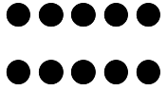
 |  | 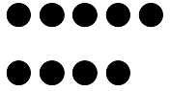 | 