**Lesson 24**

Objective: Culminating Task—Represent teen number decompositions in various ways.

Suggested Lesson Structure

 Fluency Practice (10 minutes)

 Concept Development (35 minutes)

 Student Debrief (5 minutes)

**Total Time (50 minutes)**

Fluency Practice (10 minutes)

* Help the Frog Catch the Fly **K.CC.4C** (4 minutes)
* Number Bond Hopping Card Game **K.CC.1** (6 minutes)

Help the Frog Catch the Fly (4 minutes)

Materials: (T) Pictorial growth chart 10–20 (Fluency Template 1), frog puppet (popsicle stick with a frog picture)

Note: This activity playfully reinforces the understanding that each successive number refers to a quantity that is 1 larger.

T: (Project the pictorial growth chart 10–20 on the board (Fluency Template 1).) Hold a frog puppet (popsicle stick with a frog picture) on the 10. What number is Froggy on now?

S: 10.

|  |  |
| --- | --- |
|  | NOTES ON  MULTIPLE MEANS  OF ENGAGEMENT: |
| Provide English language learners with individual pictorial growth charts on the sheets they have in front of them. Students can use their fingers to trace the frog’s path to the next step. They can then see and say the number the frog is on. | |

T: Can you help Froggy get the fly?

S: Yes.

T: Tell Froggy what number is 1 more.

S: 1 more is 11.

T: (Make the frog puppet jump to the next stair.) It’s working! What number is he on now?

S: 11.

T: Tell him 1 more.

S: 11. 1 more is 12.

T: (Frog jumps.)

Continue to 20. (Variations: 1 more/2 more. Froggy wants to go back home—1 less/2 less. Consider adding a kinesthetic component—students stand taller or crouch down to reflect the number.)

Number Bond Hopping Card Game (6 minutes)

Materials: (S) Teen number and dot cards (Fluency Template 2), Rabbit and Froggy’s matching race (Fluency Template 3)

Note: Introducing this game during fluency prepares students to play it again at home.

Complete directions for this game are located in the Homework component of this lesson.

Concept Development (35 minutes)

Materials: (S) 10 bags each with a different teen number of objects inside. Materials for each station:   
2 hand cards (Lesson 16 Template), Hide Zero cards (Lesson 6 Template), personal Rekenrek (Lesson 10), ten-frame cards (Lesson 1 Fluency Template 4), 20 centimeter cubes, 20 sticks, 20 beans, 1 small paper plate, 20 linking cubes, blank paper, number bond template (Lesson 7 Template), etc.

* Introduction (3 minutes)
* Creating exhibits (32 minutes)

Setup

Unbeknownst to the students, Station 1 has a bag with 11 cubes, Station 2 has a bag with 12 cubes, and up to a bag with 20 cubes at Station 10. Pair students who are generally performing at the same level. Put students performing at higher levels at the stations with 16–20 cubes. Direct each pair of students to one of the stations.

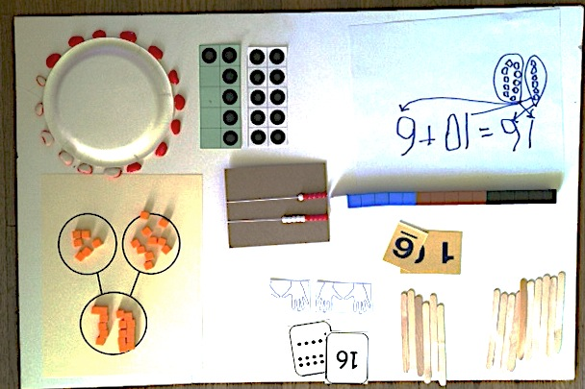T: Open your mystery bag, and count how many objects are inside. Show this number in different ways using the materials available to you at your station.

T: You are going to create an exhibit showing your number in as many ways as you can.

T: The ways you must show your number include:

* A number bond
* Hide Zero cards
* Rekenrek
* Addition sentence
* Linking cubes

T: Once you have finished the *have to’s*, show the number in other ways, too. You will have 20 minutes. At your table are different materials to help you. You do not have to use them all. You may also use paper and pencil.

This culminating lesson is a part of the Kindergarten assessment system. While circulating, use a recording sheet to document what each student does. What representations does the student choose? What skills are obvious? Which materials does he avoid? Which does he gravitate toward immediately? What words is the student using when talking about his teen number? Take a picture of the students’ work for their portfolio.

T: (After 20 minutes.) Now, we are going to take a tour to see your friends’ creations. When I give the signal, move to the next station.

T: Think about what you are seeing at each station. Point to the different ways your friends have shown their number. Talk about each one. What makes it special? (Students spend a little less than one minute at each station.)

Student Debrief (5 minutes)

**Lesson Objective**: Culminating Task—Represent teen number decompositions in various ways.

The Student Debrief is intended to invite reflection and active processing of the total lesson experience. The following is a suggested list of questions to invite reflection and active processing of the total lesson experience. Use those that resonate when considering what will best support the students’ ability to articulate the focus of the lesson.

* What are some different ways you saw the teen number represented?

S: Number bonds. 🡪 Piles of 10 ones and some more ones. 🡪 In circles. 🡪 In arrays.   
🡪 In rows. 🡪 With hand cards. 🡪 With linking cubes in one long line. 🡪 In towers. 🡪 In addition sentences. 🡪 In story problems. 🡪 In pictures. 🡪 With Hide Zero cards. 🡪 On our Rekenrek.

* Which of these different ways do you feel helps you understand your teen numbers the most? Why?
* How is a number bond different from and the same as an addition sentence?
* How is a pile of 10 sticks and some more sticks different and the same as the number shown with ten-frame cards?
* What did you notice as you went around the room? How did the exhibits vary?

Close the experience by letting the students know that, by understanding their teen numbers, they will understand all the numbers better as they move on to Grade 1.

Exit Ticket (3 minutes)

Rather than having an exit ticket for this lesson, the teacher is encouraged to record observations as students work with their partners as described in the closing of the Concept Development section of this lesson.

**Rabbit and Froggy’s Matching Race**

**Directions:** Play Rabbit and Froggy’s Matching Race with a friend, relative, or parent to help your animal reach its food first! The first animal to reach the food wins.

* Put your Teen number and Dot cards face down in rows with Teen numbers in one row and Dot cards in another row.
* Flip to find 2 cards that match.

13



Place cards back in the same place if they don’t match.

Continue until you find a match.

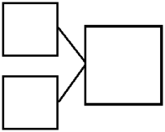

10

* Write a number bond to match.

3

Hop 1 space if you get it right!

13



Hop 1 space again if you get it right!

* Write a number sentence . 13 = 10 + 3

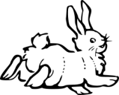

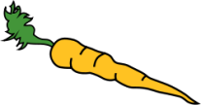hop.bmphop.bmp

|  |  |  |  |  |  |  |  |  |  |  |
| --- | --- | --- | --- | --- | --- | --- | --- | --- | --- | --- |
| 10 | 11 | 12 | 13 | 14 | 15 | 16 | 17 | 18 | 19 | 20 |



11

12

10

13

15

14

17

16

18



20

19

[1]

10

11

16

13

14

12

17

15

18

[2]

19

20



[3]

[4]





P[5] layer 1: _______________________ Player 2: ___________________

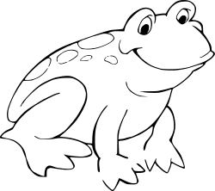

|  |  |  |  |  |  |  |  |  |  |  |
| --- | --- | --- | --- | --- | --- | --- | --- | --- | --- | --- |
| 10 | 11 | 12 | 13 | 14 | 15 | 16 | 17 | 18 | 19 | 20 |

|  |  |  |  |  |  |  |  |  |  |  |
| --- | --- | --- | --- | --- | --- | --- | --- | --- | --- | --- |
| 10 | 11 | 12 | 13 | 14 | 15 | 16 | 17 | 18 | 19 | 20 |

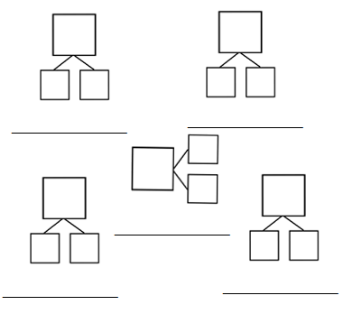

______________

______________

1. pictorial growth chart
2. teen number and dot cards
3. teen number and dot cards
4. teen number and dot cards
5. Rabbit and Froggy’s matching race