Lesson 23
Objective: Reason about and represent situations, decomposing teen numbers into 10 ones and some ones and composing 10 ones and some ones into a teen number.

Suggested Lesson Structure
 Fluency Practice (12 minutes)
 Concept Development (30 minutes)
 Student Debrief (8 minutes)
Total Time (50 minutes)
Fluency Practice (12 minutes)
- Number Bonds of Eight K.NBT.1 (4 minutes)
- Matching Dot and Number Cards K.NBT.1 (8 minutes)
Number Bonds of Eight (4 minutes)
Materials: (T) Dot cards of 8 (Lesson 6 Fluency Template)
Note: This fluency activity gives students an opportunity to develop increased familiarity with compositions of eight and review number bonds.
Show a dot card, and indicate 7 and 1 as parts.
T: Say the larger part. (Give students time to count).
S: 7.
T: Say the smaller part.
S: 1.
T: What is the total number of dots? (Give time to count.)
S: 8.
T: Say the number sentence.
S: 7 and 1 makes 8.
T: Flip it.
S: 1 and 7 makes 8.
Continue with cards illustrating the number bonds of 5 and 3, 4 and 4, 6 and 2, and 8 and 0.
Matching Dot and Number Cards (8 minutes)
Materials: (S) Teen number and dot cards (Fluency Template) for each pair of students (pictured below)
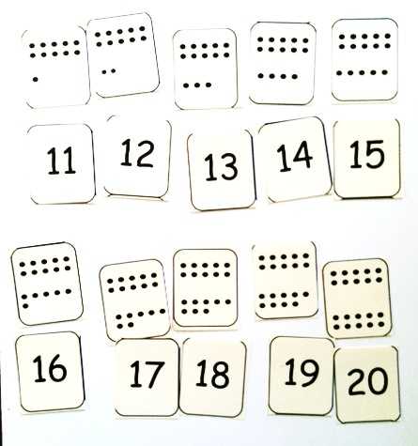
Note: This activity connects the pictorial representations of teen numbers with the abstract numerals and reinforces teen numbers as 10 ones and some additional ones.
T: Put your number cards in order from smallest to greatest.
T: Match each number card to a dot card.
T: Talk to your partner. What do you notice about your dot cards and your number cards?
S: They all have ten dots. They all have ones that show the ten. They all have an extra dot that tells how many extra ones weren’t part of the ten ones. All the dot cards have two parts, and the numbers have two numbers. Yeah, one of the numbers is one of the parts of the dots.
Concept Development (30 minutes)
Materials: (T) 12 pieces of red construction paper (S) Picture and word problem (Template) for each child (shown below), personal white board with number bond (Lesson 7 Template)
Note: The following problems are solved using counting and the students’ knowledge of decomposing and composing teen numbers. Although addition sentences are included in the students’ solutions, in this instance, they are another record of the decomposition or the composition of the total that the student counted to find rather than a means of solving the problem. Note that the problems do not ask “How many?” or “How many in all?”
T: (Show 12 pieces of red construction paper in one line, perhaps taped to the board.) Count with me.
S: 1, 2, 3, 4, 5, 6, 7, 8, 9, 10, 11, 12.
T: Draw and show the 12 papers as 10 ones and some ones.
S: Should we draw a number bond?

NOTES ON
MULTIPLE MEANS
OF ENGAGEMENT:
Support English language learners’ math talk by providing them with sentence frames, such as the following:
I see ____ (number) _____ (unit).
I see _____ (number) _____ (unit).
I see ____ (number) _____ (unit) in all.

T: You can draw a picture and make a number bond.
S: Can we write a number sentence?
T: That is another good way to show what twelve is made of.
T: (After working.) Share with your partner how you showed 10 red papers and some more papers.
T: What parts did you break 12 into?
S: 10 and 2.
T: What number sentence did you use to show that?
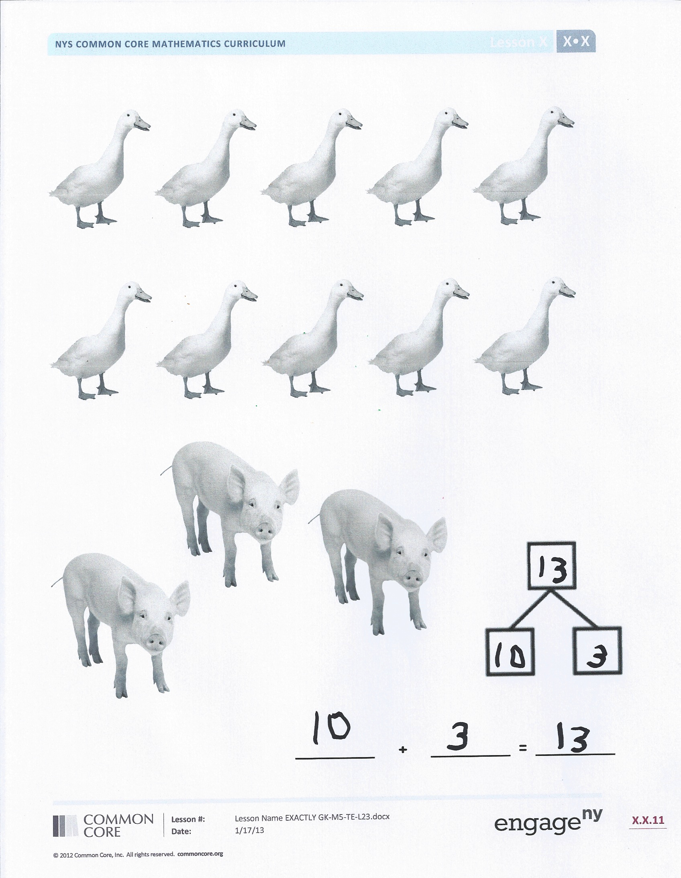
S: 12 = 10 + 2.
T: Yes, 12 is 10 ones and 2 ones.
T: (Referring back to the red papers on the board.) What can I do with my papers to show that we made two parts?
S: You could put space between the 10 ones and 2 ones to see the parts more easily.
T: Okay, I’ll do that. Yes, now we can see that 12 is 10 and 2.
T: Let’s do a different problem at a farm. (Pass out the picture problem.) Look at the picture with your partner. Talk about what you see.
S: (After talking.) There are 10 geese and 3 pigs.
T: It’s easy to see the parts, so let’s put them together to find how many animals there are.
T: Work with your partner to show ways to put those parts together.
T: (Pause while students work.) What are some of the ways you put the two parts together?
S: We showed a number bond. We showed an addition sentence. We got our Hide Zero cards.
T: When you put the parts together, what was the total of your bond or number sentence?
S: 13.
T: What number sentence did you use to show that?
S: 10 + 3 = 13.
T: Yes, that is how I think of it when I’m putting parts together. When I’m taking them apart, I say it this way: 13 = 10 + 3. Talk to your partner about why you think I do that.

NOTES ON
MULTIPLE MEANS
OF ACTION AND EXPRESSION:
Scaffold the lesson for students working below grade level by asking them to model with red and blue cubes before expecting them to model with a drawing.
S: One way starts with the big number. When we put the ducks and the pigs together, we started with the parts. Like with the animals, we could see the parts really easily, so we wrote those first: 10 + 3 = 13.
It’s different with the red papers. Yeah, like with the red papers, we counted all the papers first and then separated them: 12 = 10 + 2. Yeah, it was hard to see the groups because the papers were all the same color and in one line.
T: I showed the papers like this: 12 = 10 + 2. And I showed the animals like this: 10 + 3 = 13. Talk to your partner about why.
S: The papers were all one color, so we had to find the 10 hiding. So, we started with counting all the papers. Yeah, with the animals, I counted the pigs first and then the geese.
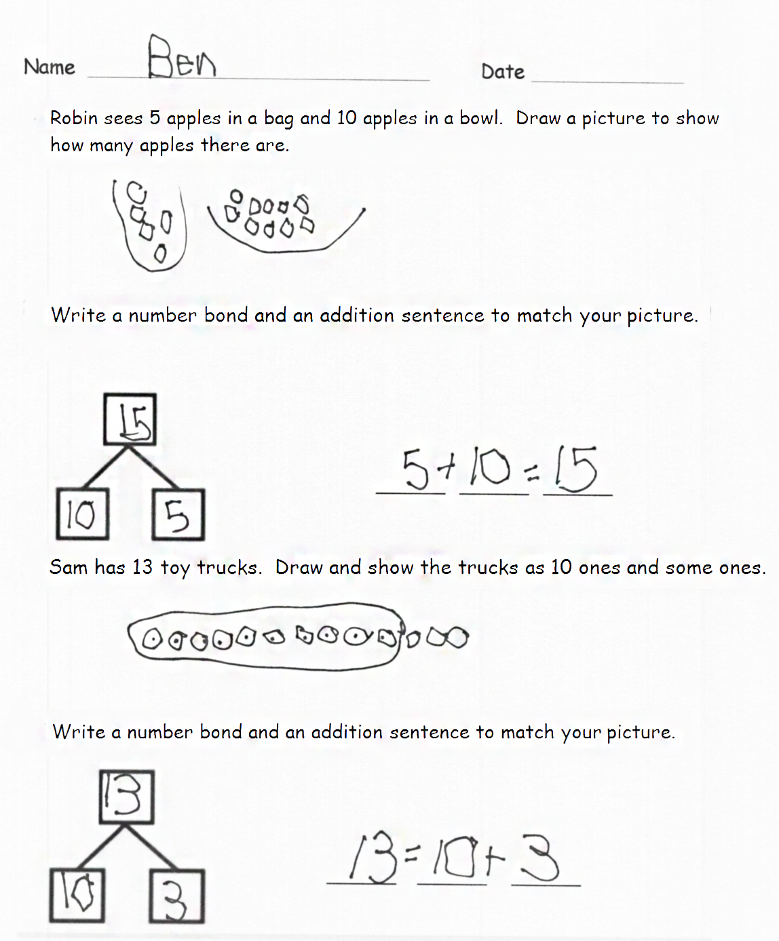
T: So, with the animals, you thought about the parts first, and with the papers, you thought about the total first?
S: Yeah.
Problem Set (7 minutes)
Students should do their personal best to complete the Problem Set within the allotted time.
Read the stories to them as they work. Because this Problem Set requires reading, it is a good idea to group students by performance level so the situations can be told to the students in their small groups.
Student Debrief (8 minutes)
Lesson Objective: Reason about and represent situations, decomposing teen numbers into 10 ones and some ones and composing 10 ones and some ones into a teen number.
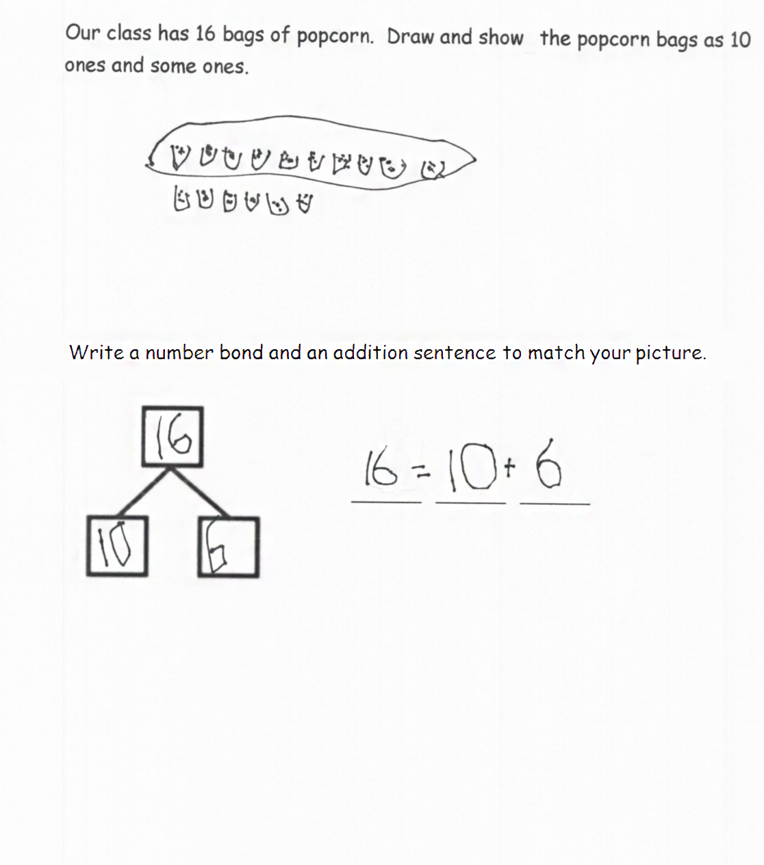
The Student Debrief is intended to invite reflection and active processing of the total lesson experience.
Invite students to review their solutions for the Problem Set. They should check work by comparing answers with a partner before going over answers as a class. Look for misconceptions or misunderstandings that can be addressed in the Debrief. Guide students in a conversation to debrief the Problem Set and process the lesson. Any combination of the questions below may be used to lead the discussion.
- Did you start by drawing the parts first or the total first in the story of Robin’s apples? The toy trucks? The popcorn bags?
- Explain how their drawing relates to the number bond they wrote.
MP.2
- Explain how the number sentence relates to the number bond and situation.
- Show how they wrote the number sentence for each situation and whether they started the sentence with the parts or the total. How did you choose your number sentence? Share your thinking.
Exit Ticket (3 minutes)
After the Student Debrief, instruct students to complete the Exit Ticket. A review of their work will help with assessing students’ understanding of the concepts that were presented in today’s lesson and planning more effectively for future lessons. The questions may be read aloud to the students.

Name Date
Robin sees 5 apples in a bag and 10 apples in a bowl. Draw a picture to show how many apples there are.

Write a number bond and an addition sentence to match your picture.

_________ _________ _________

Sam has 13 toy trucks. Draw and show the trucks as 10 ones and some ones.

Write a number bond and an addition sentence to match your picture.

_________ _________ _________
Our class has 16 bags of popcorn. Draw and show the popcorn bags as
10 ones and some ones.

Write a number bond and an addition sentence to match your picture.

_________ _________ _________

Name Date
There are 12 balls. Draw and show the balls as 10 ones and some ones.

Write a number bond to match your picture.

Write an addition sentence to match your number bond.

_______ _______ _______

Name Date
Bob bought 7 sprinkle donuts and 10 chocolate donuts. Draw and show all of Bob’s donuts.

Write an addition sentence to match your drawing.

_______ _______ _______

Fill in the number bond to match your sentence.

Fran has 17 baseball cards. Show Fran’s baseball cards as 10 ones and some ones.

Write an addition sentence and a number bond that tell about the baseball cards.

_______ _______ _______

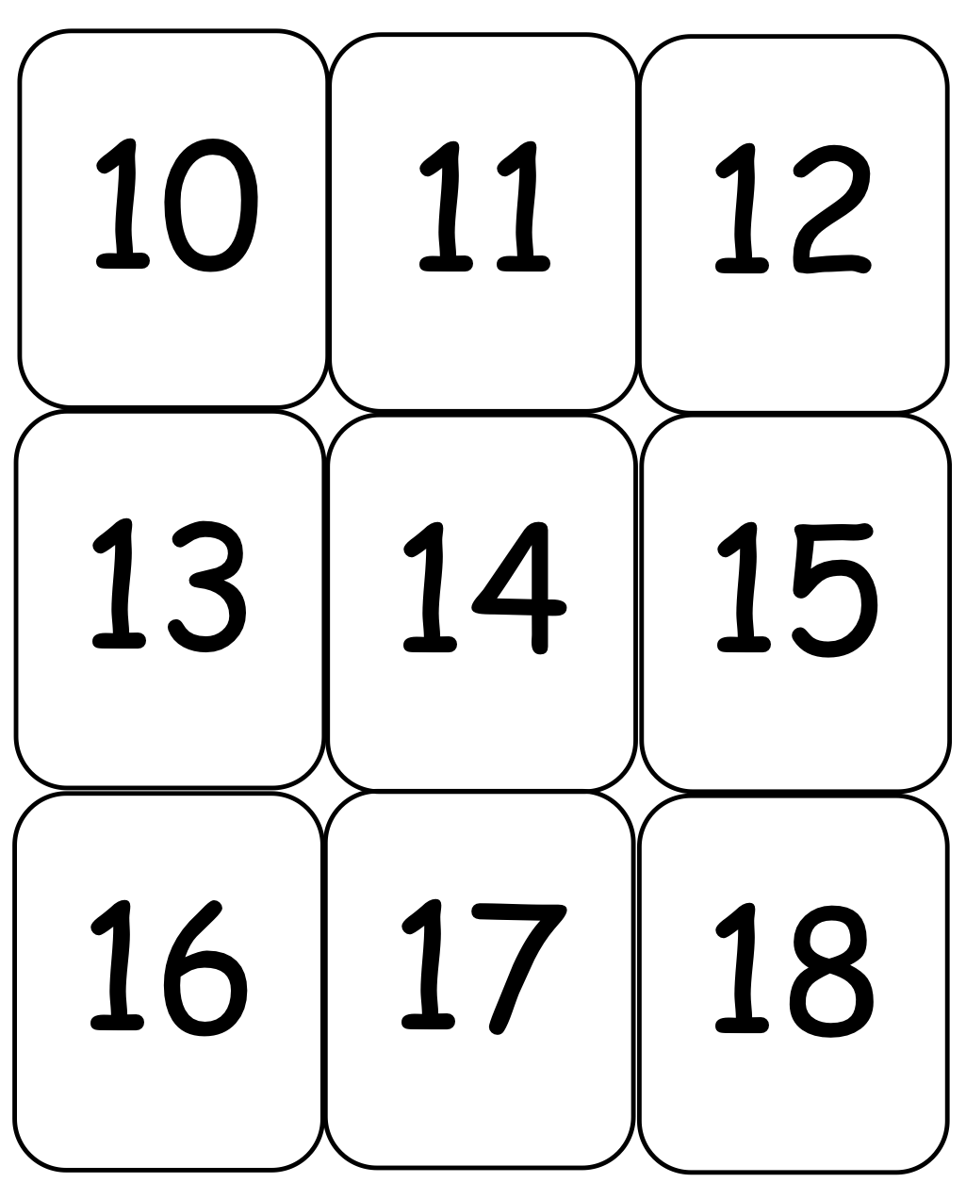

20
19

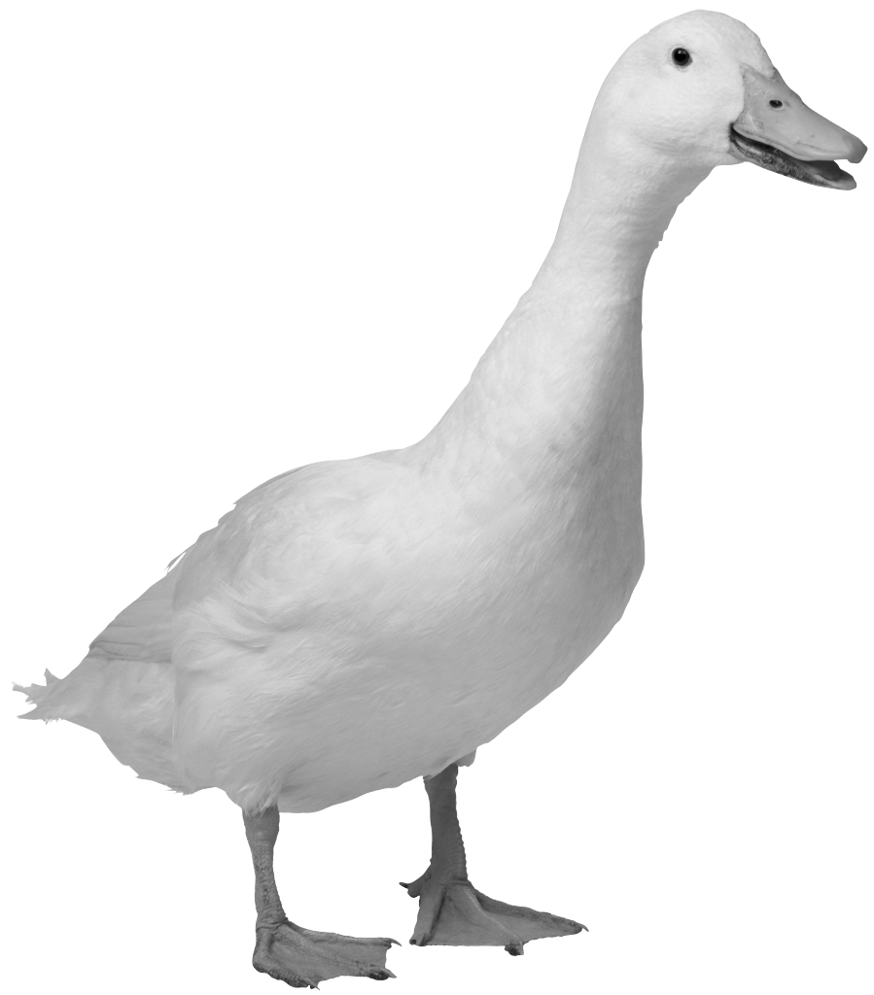

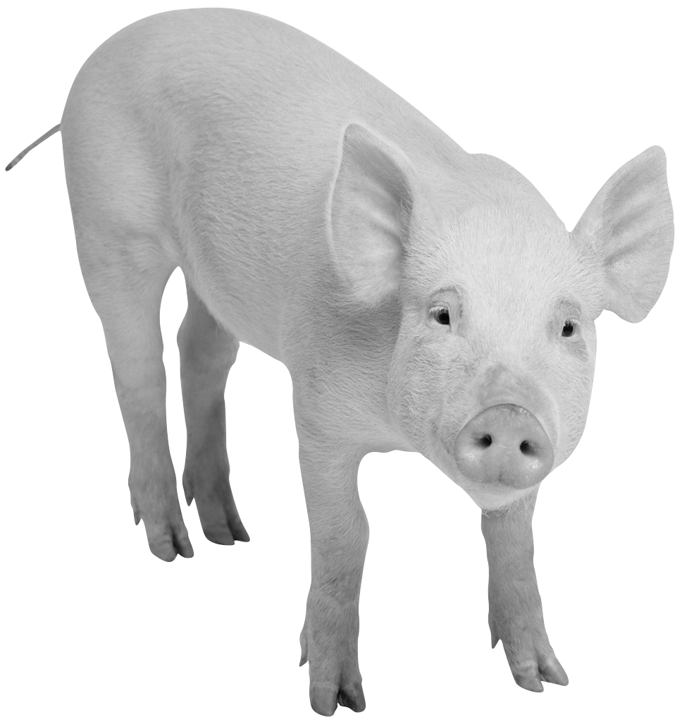

_______ _______ _______

teen number and dot cards
teen number and dot cards
teen number and dot cards
picture and word problem

