Lesson 22
Objective: Decompose teen numbers as 10 ones and some ones; compare some ones to compare the teen numbers.

Suggested Lesson Structure

A NOTE ON
STANDARDS ALIGNMENT:
In this lesson, students compare numbers 1–9 (K.CC.6, K.CC.7) and use their understanding of 10 ones as the structure of the teen numbers (K.NBT.1 and MP.7) to compare teen numbers. This bridges Kindergarten content to the Grade 1 comparison of numbers (1.NBT.3).

 Application Problem (7 minutes)
 Fluency Practice (11 minutes)
 Concept Development (25 minutes)
 Student Debrief (7 minutes)
Total Time (50 minutes)

Application Problem (7 minutes)
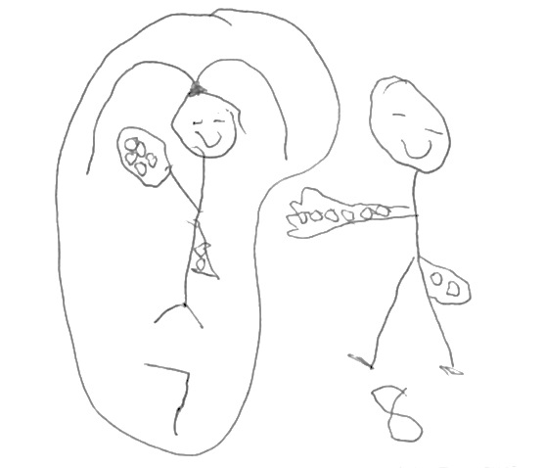
Lisa has 5 pennies in her hand and 2 in her pocket. Matt has 6 pennies in his hand and 2 in his pocket. Who has fewer pennies—Lisa or Matt? How do you know?
Note: This Application Problem reviews comparing numbers within 10, which prepares students to compare teen numbers in today’s Concept Development.
Fluency Practice (11 minutes)
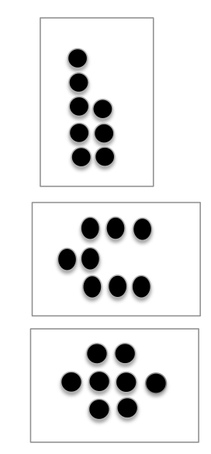
- Dot Cards of Eight K.CC.5, K.CC.2 (3 minutes)
- Count Teen Numbers K.NBT.1 (4 minutes)
- Teen Numbers on the Rekenrek K.NBT.1 (4 minutes)
Dot Cards of Eight (3 minutes)
Materials: (T) Dot cards of 8 (Lesson 6 Fluency Template)
Note: This fluency activity gives students an opportunity to develop increased familiarity with decompositions of eight and practice seeing part–whole relationships.
T: (Show a card with 8 dots.) How many dots do you count?
Wait for the signal to tell me.
S: 8.
T: How can you see them in two parts?
S: (Student comes up to the card.) I saw 5 here and 3 here.
T: Say the number sentence.
S: 5 and 3 makes 8.
T: Flip it.
S: 3 and 5 makes 8.
T: Who sees 8 in two different parts?
S: (Come up to the card.) I see 6 here and 2 here.
T: Say the number sentence.
S: 6 and 2 makes 8.
T: Flip it.
S: 2 and 6 makes 8.
Continue with other cards and decompositions of 8.
Count Teen Numbers (4 minutes)
Note: If alternating between counting the Say Ten Way and regular way is challenging for some students, consider scaffolding this activity by doing it first with the Rekenrek.
T: Count from 11 to 20 and back to 11 the Say Ten Way.
S: Ten one, ten two, ten three, ten four, ten five, ten six, ten seven, ten eight, ten nine, 2 tens, ten nine, ten eight, ten seven, ten six, ten five, ten four, ten three, ten two, ten one.
T: Count from 11 to 20 and back to 11 the regular way.
S: 11, 12, 13, 14, 15, 16, 17, 18, 19, 20, 19, 18, 17, 16, 15, 14, 13, 12, 11.
T: Now, I want you to change the way you count each time. We’ll say the first number the regular way. Then, we’ll say the next number the Say Ten Way. Listen to my example. 11, ten two, 13, ten four, 15, ten six. Now, it’s your turn.
S: 11, ten 2, 13, ten 4, 15, ten 6, 17, ten 8, 19, 2 tens.
T: Count back from 20 to 11, starting with the regular way.
S: 20, ten 9, 18, ten 7, 16, ten 5, 14, ten 3, 12, ten 1.
Teen Numbers on the Rekenrek (4 minutes)
Materials: (S) Personal Rekenrek (Lesson 10)
Note: This fluency activity supports the grade-level standard of understanding teen numbers as ten ones and some more ones.
T: Show me the number 12 in two parts on your Rekenrek with one part 10 ones on your top row.
S: (Show 12 on their Rekenreks.)
T: Now, show me 12 again, but this time, with 10 ones that are all red.
T: Now, show me 12 again, but this time, with 10 ones that are all white.
Continue with other teen numbers.
Concept Development (25 minutes)
Materials: (S) 20 linking cubes, personal white board
T: Use your personal white board as a work mat. Partner A, count out 13 cubes on your mat.
Partner B, count out 15 cubes on your mat.
T: Now, each of you move your cubes to show the number the Say Ten Way. Partner A, tell me your number the Say Ten Way.
S: (Partner A only.) Ten 3.
T: Partner B, tell me your number the Say Ten Way.
S: (Partner B only.) Ten 5.

NOTES ON
MULTIPLE MEANS
OF REPRESENTATION:
Before beginning the lesson, introduce or review key vocabulary for English language learners so that they can keep up with the lesson. Post visuals of key terms such as greater, smaller, less, more, and the same.

T: How can we tell which number is greater? You both have 10 ones. True?
S: Yes.
T: So, let’s look at the extra ones. Which number is greater—3 ones or 5 ones?
S: 5 ones!
T: So, which number is greater—ten 3 or ten 5?
S: Ten 5.
T: Let’s all say 15 is more than 13.
S: 15 is more than 13.
T: Let’s say that the Say Ten Way. Ten 5 is more than ten 3.
S: Ten 5 is more than ten 3.
T: Now, Partner A, show me 14 on your mat as 10 ones and some ones. Partner B, show 11 on your mat as
10 ones and some ones.
T: Do you both have 10 ones?
S: Yes.
T: So, let’s compare the extra ones. Which part is smaller—
4 ones or 1 one?
S: 1 one.
T: Talk to your partner about which number is smaller and which number is larger, as well as how you know.
S: (Students talk.)
T: Now, I want both Partner A and Partner B to show 17 on your mat. Show it as 10 ones and some ones.
T: Do you both have 10 ones?
S: Yes.
T: How many extra ones do you both have?
S: 7.
T: Is 7 more than 7?
S: No!
T: Is 10 more than 10?
S: No!
T: What should we say about 17 and 17?
S: They’re the same! They’re equal!
Continue in this manner but without the cubes and personal white boards. Draw two number bonds on the board. Fill one number bond in with 19 decomposed, showing 10 ones as one part. Fill the other number bond with 16 decomposed, showing 10 ones as one part.
T: (Point to 19.) What is the missing part?
S: 9.
T: (Fill in 9.)
T: (Point to 16.) What is the missing part?
S: 6.
T: (Fill in 6.)
T: Compare the extra ones. Which number is more?
S: 19.
T: We are using what we know about comparing the numbers less than 10 to compare numbers that are more than 10.
MP.7
T: Talk to your partner about that.
S: I know 5 is more than 4, so I know 10 ones and 5 ones is more than 10 ones and 4 ones. I know that 5 is less than 8, so ten 5 is less than ten 8. I know that 6 equals 6, so ten 6 equals ten 6. I know that 10 ones is the same, so it’s like both numbers have it. So, it doesn’t tell which one is larger or smaller.
Problem Set (7 minutes)
Students should do their personal best to complete the Problem Set within the allotted time.
Note: This work, like many of the lessons in this module, allows students to see the relevance of numbers to 10 as they apply to larger numbers. Students stand on the shared structure of the ten in two teen numbers and simply compare the ones to see which number is greater. This bridges to Grade 1 content (1.NBT.3).

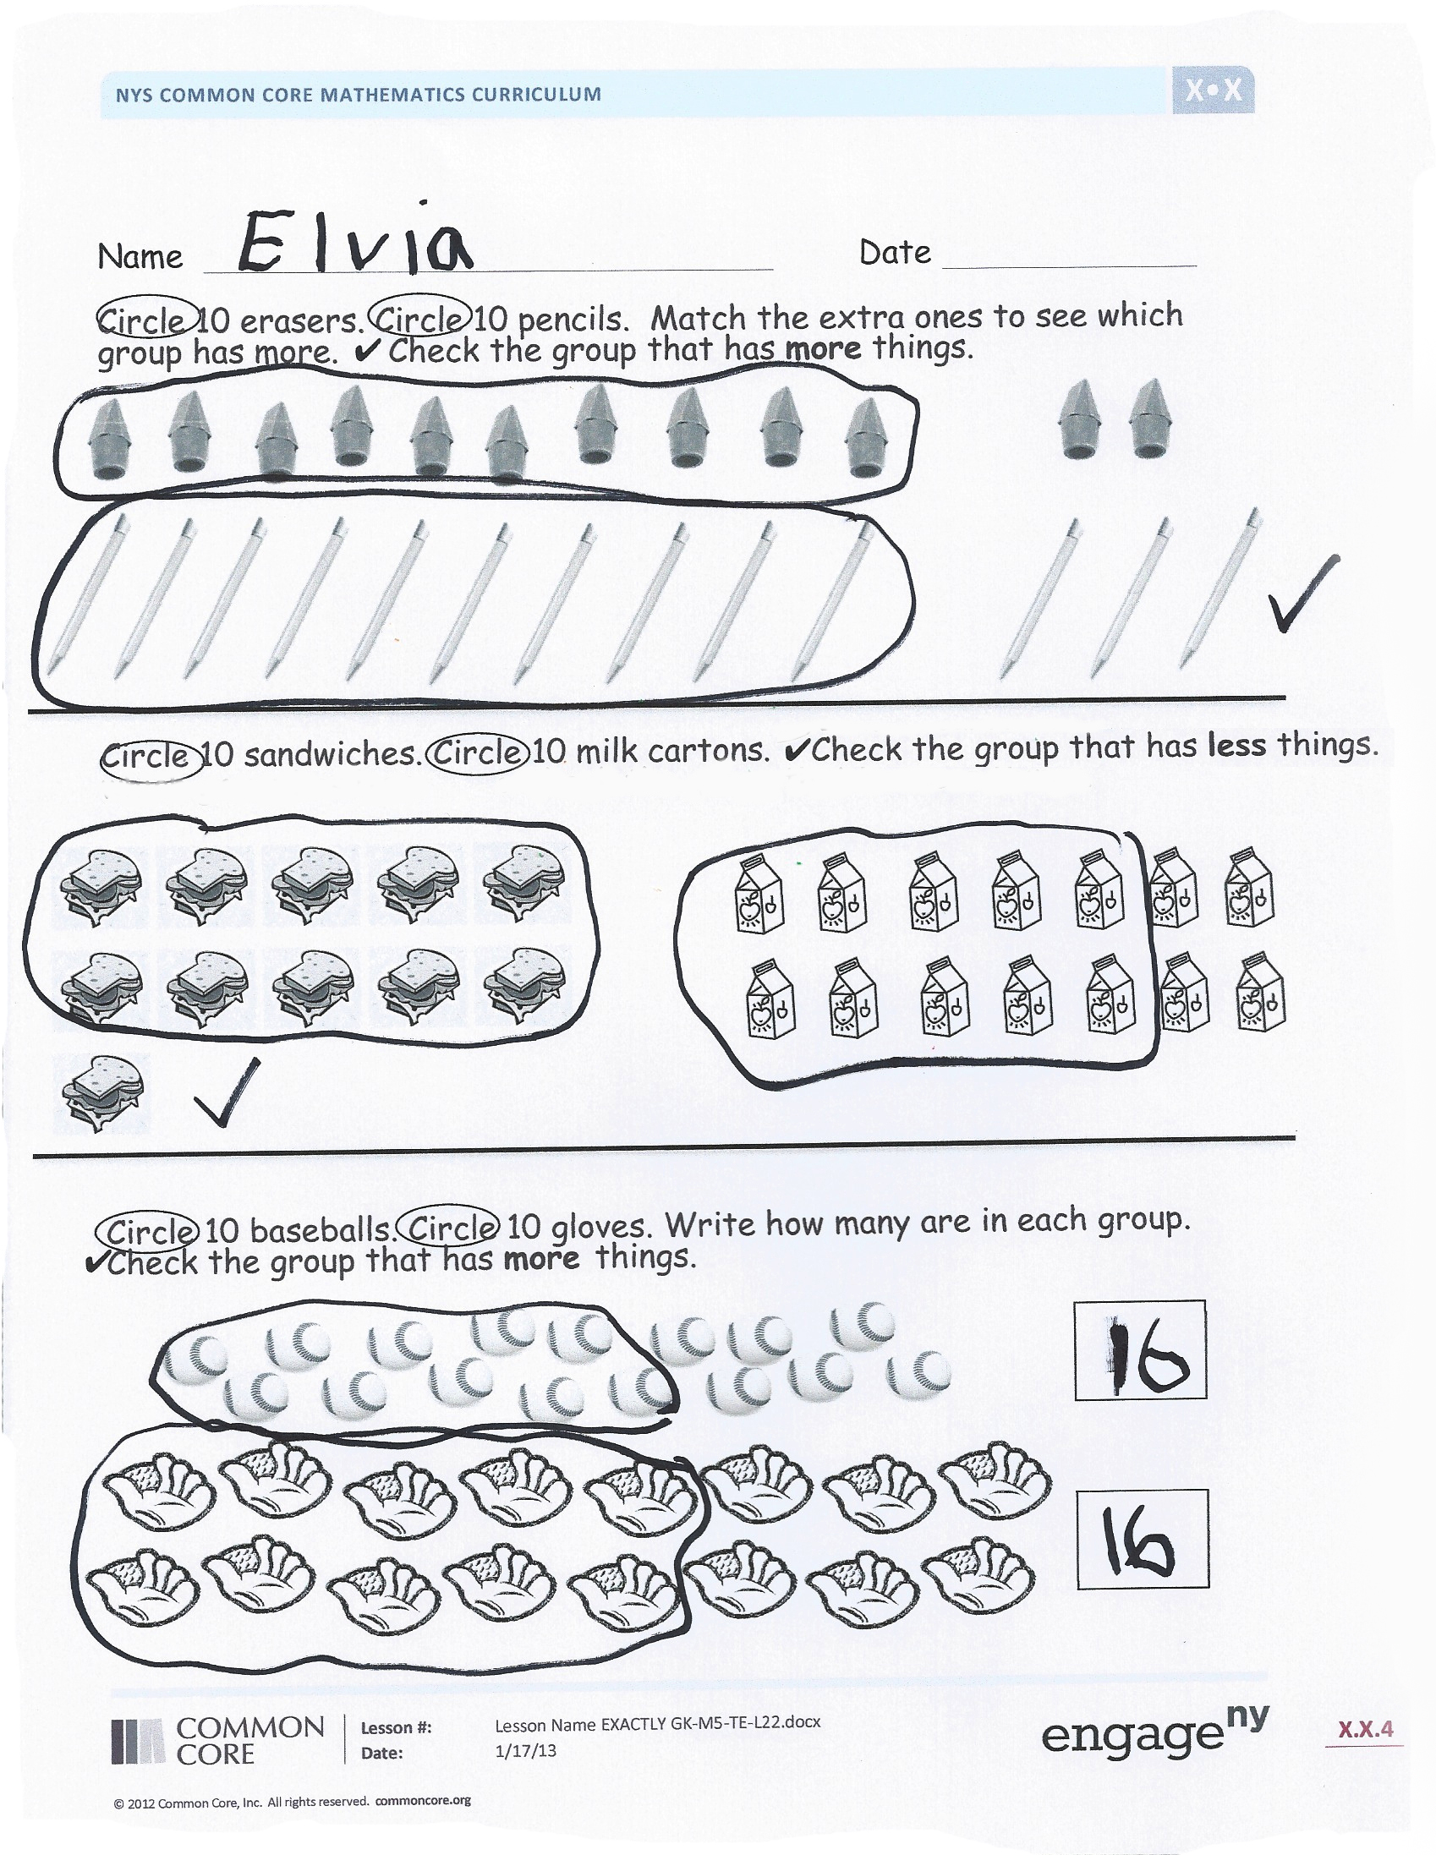
Student Debrief (7 minutes)
Lesson Objective: Decompose teen numbers as 10 ones and some ones; compare some ones to compare the teen numbers.
The Student Debrief is intended to invite reflection and active processing of the total lesson experience.
Invite students to review their solutions for the Problem Set. They should check work by comparing answers with a partner before going over answers as a class. Look for misconceptions or misunderstandings that can be addressed in the Debrief. Guide students in a conversation to debrief the Problem Set and process the lesson.
Any combination of the questions below may be used to lead the discussion.
- What was today’s lesson about?
- How do you know 11 is less than 15?
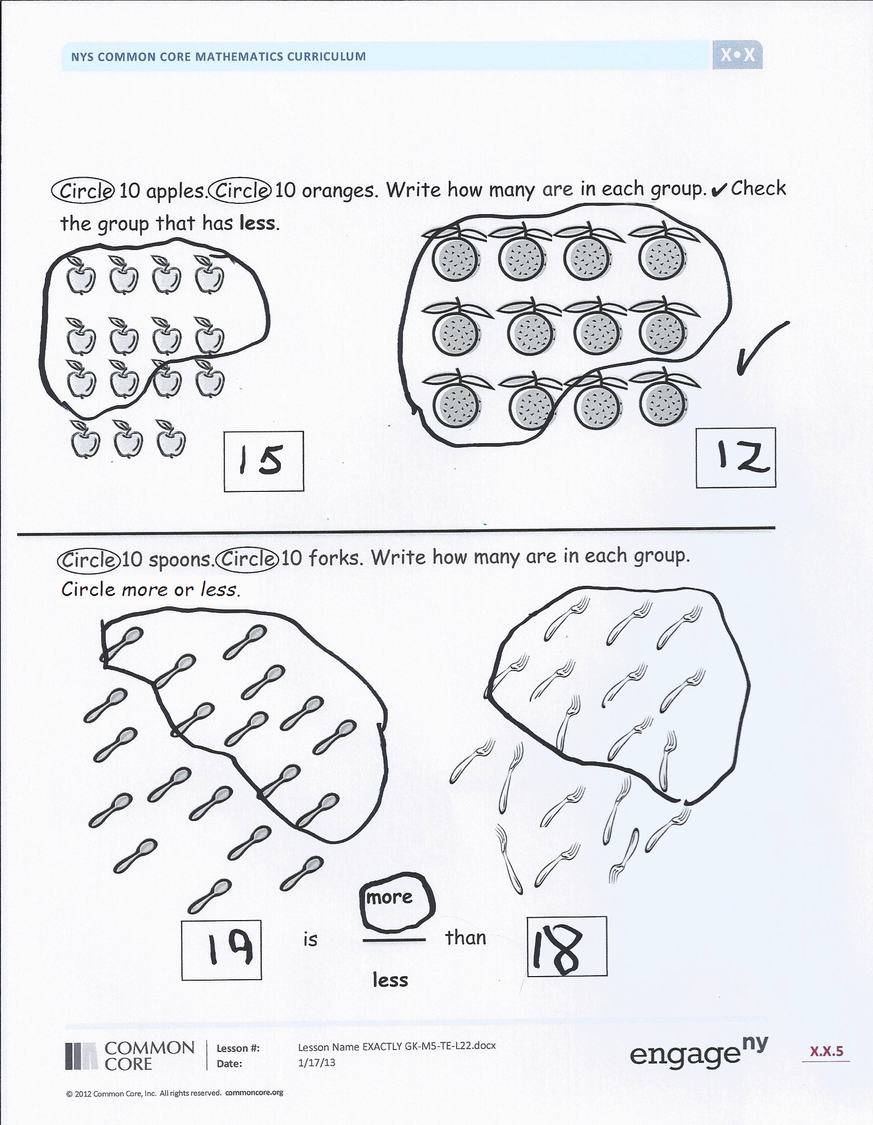
- Have students read each comparison from the Problem Set the Say Ten Way and then the regular way. For example, “Ten 3 is more than ten 2. 13 is more than 12. Ten 1 is less than
ten 4. 11 is less than 14.”
- What do you think I wanted you to learn from the lesson?
Exit Ticket (3 minutes)
After the Student Debrief, instruct students to complete the Exit Ticket. A review of their work will help with assessing students’ understanding of the concepts that were presented in today’s lesson and planning more effectively for future lessons. The questions may be read aloud to the students.

Name Date
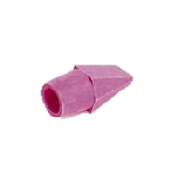
Circle 10 erasers. Circle 10 pencils. Match the extra ones to see which group has more. Check the group that has more things.

Circle 10 sandwiches. Circle 10 milk cartons. Check the group that has less things.

Circle 10 baseballs. Circle 10 gloves. Write how many are in each group.
Check the group that has more things.
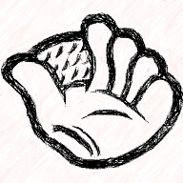

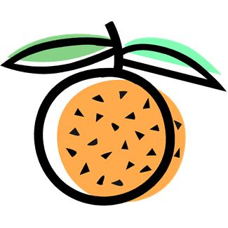
Circle 10 apples. Circle 10 oranges. Write how many are in each group.
Check the group that has less.

Circle 10 spoons. Circle 10 forks. Write how many are in each group. Circle more or less.

more
is than
less

Name Date

Count and write the number.
Circle more or less.
more

1 is less than 4

more
____ is less than _____
more
____ is less than _____
more
____ is less than _____

Name Date
Fill in the number bond.
Check the group with more.

7 XXXXX  XX  5 | 8 XXXXX  XXX  5
16 XXXXX  XXXXX  OOOOO  10 O | 17 XXXXX  XXXXX  OOOOO  10 OO
13 XXXXX  XXXXX  OOO  3 | 11 XXXXX  XXXXX  O  10
XXXXX  XXXXX  OO  10 2 | XXXXX  XXXXX  OOOOO  10 10 OOOOO

