Lesson 21
Objective: Represent teen number decompositions as 10 ones and some ones, and find a hidden part.

Suggested Lesson Structure

A NOTE ON
STANDARDS ALIGNMENT:
In this lesson, students decompose teen numbers into two parts with blocks and hide one of the parts. After guessing what the hidden part is, they then see a number sentence with a hidden part such as 12 = 10 + ___. This bridges to Grade 1 content (1.OA.8).

  Fluency Practice (13 minutes)
 Application Problem (7 minutes)
 Concept Development (22 minutes)
 Student Debrief (8 minutes)
Total Time (50 minutes)
Fluency Practice (13 minutes)
- Number Bonds of Seven K.CC.2 (4 minutes)
- Four Rekenreks K.CC.1 (5 minutes)
- Count Teen Numbers K.CC.5 (4 minutes)
Number Bonds of Seven (4 minutes)
Materials: (T) Dot cards of 7 (Lesson 5 Fluency Template 1)
Note: This fluency activity gives students an opportunity to develop increased familiarity with compositions of seven and practice seeing part–whole relationships.
Show a dot card, and indicate 6 and 1 as parts.
T: Say the larger part. (Give students time to count.)
S: 6.
T: Say the smaller part.
S: 1.
T: What is the total number of dots? (Give time to count.)
S: 7.
T: Say the number sentence.
S: 6 and 1 makes 7.
T: (Turn the card around to get 1 and 6.)
Continue with 5 and 2, 8 and 0, 4 and 3.

Four Rekenreks (5 minutes)
Materials: (S) Personal Rekenrek (Lesson 10)
Note: Saying “bop” after each row of 10 provides a pause in counting, both reinforcing the start of a new row of ten and interrupting the count sequence, which helps students when they transition from counting all to count on in Grade 1.
T: Sit in groups of 4. Put your Rekenreks together. Partner A moves the beads of the first row. Partner B moves the beads of the second row, etc. After each number that ends a row, say “bop.”
Count Teen Numbers (4 minutes)
Note: Alternating between Say Ten counting and regular counting challenges students to think carefully about each number because they cannot rely on the rote count sequence. By doing so, this reinforces teen numbers as 10 ones and some additional ones. (For example, students must know that 12 comprises 10 ones and 2 ones to recognize that ten 3 would come next if counting forward.)
T: Count from 11 to 20 the Say Ten Way.
S: Ten 1, ten 2, ten 3, ten 4, ten 5, ten 6, ten 7, ten 8, ten 9, 2 tens.
T: Count back from 20 to 11 the Say Ten Way.
S: 2 tens, ten 9, ten 8, ten 7, ten 6, ten 5, ten 4, ten 3, ten 2, ten 1.
T: Count from 11 to 20 the regular way.
S: 11, 12, 13, 14, 15, 16, 17, 18, 19, 20.
T: Count back from 20 to 11 the regular way.
S: 20, 19, 18, 17, 16, 15, 14, 13, 12, 11.
T: Now, I want you to change the way you count each time. We’ll say the first number the Say Ten Way. Then, we’ll say the next number the regular way. Listen to my example. Ten 1, 12, ten 3, 14, ten 5, 16. Now, it’s your turn.
S: Ten 1, 12, ten 3, 14, ten 5, 16, ten 7, 18, ten 9, 20.
T: Count back from 20 to 11, starting with the Say Ten Way.

NOTES ON
MULTIPLE MEANS
OF ACTION AND EXPRESSION:
Differentiate the Application Problem for students who are working below grade level by asking them to put the puppies (counters) in a ten-frame.
Ask students who are working above grade level to double the number of puppies in the cage using two ten-frames to show 10 and some more.

S: 2 tens, 19, ten 8, 17, ten 6, 15, ten 4, 13, ten 2, 11.
Application Problem (7 minutes)
Peter saw 8 puppies at the pet store in a cozy cage. While he was watching them, 2 hid in a little box. How many puppies could Peter see then? Draw a picture, and write a number bond and number sentence to match the story.

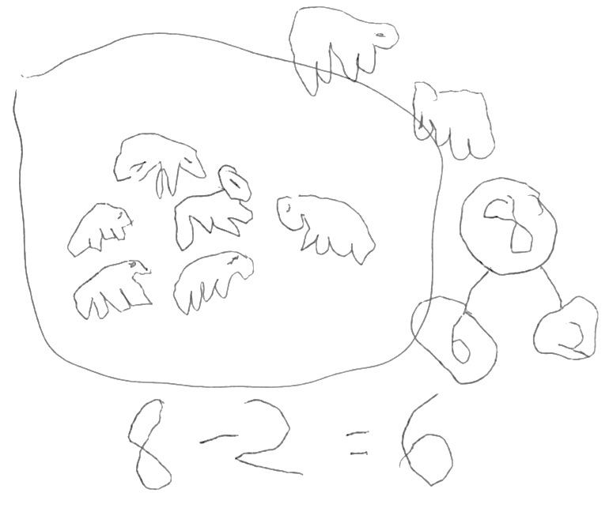

Note: This Application Problem is an example of a take from with result unknown problem type, which students should be able to solve using objects or manipulatives by the end of Kindergarten.
Concept Development (22 minutes)
Materials: (S) For each pair of students: 40 centimeter cubes, blank number bond (Lesson 7 Template) placed inside a personal white board
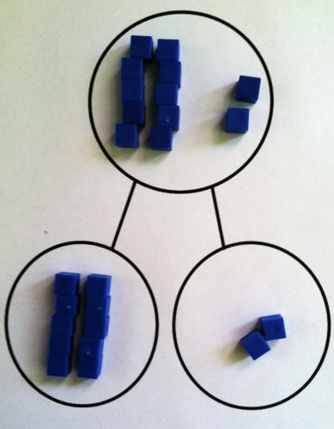
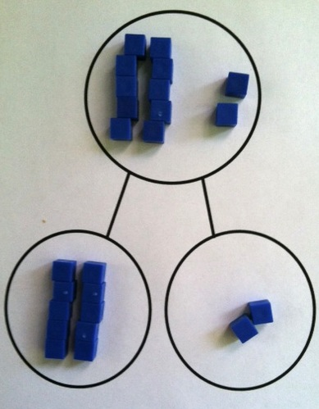
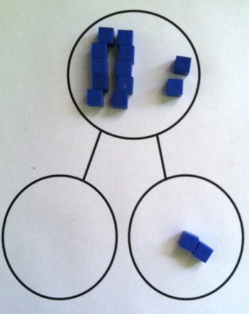
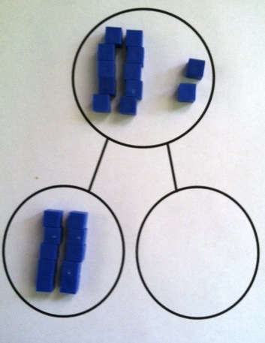
T: Count out 12 cubes, and put them in the place where we show the whole on the number bond.
T: Group 10 ones within that place.
T: What are the parts of 12 you see?
S: 10 and 2.
T: Count out cubes to fill in parts so that the total and the parts are equal.
S: (Students do so.)

NOTES ON
MULTIPLE MEANS
OF REPRESENTATION:
The teen numbers represent a particular challenge for English language learners because the difference between thirteen and thirty is not easy to hear. Scaffold the lesson for the students by providing them with visuals of the teen numbers in both written form and the numeral form. Students also need practice hearing (stress the teen of the number by putting a finger near the mouth), saying thirteen and fourteen so that they can hear the stress on the teen part of the number.

T: Fill in this number sentence with me. (On the board, write 12 = ____ +____.)
S: 12 = 10 + 2.
T: Say the number the Say Ten Way.
S: Ten two.
T: Close your eyes. (Remove the 2 cubes.) What part is hiding?
S: 2.
T: Fill in this number sentence with me. (Write
12 = 10 + ___ on the board.)
S: 12 = 10 + 2. (Put the cubes back as they say the statement.)
T: Close your eyes. (Remove the 10 cubes.) What part is hiding?
S: 10 ones!
T: Fill in this number sentence with me. (Write 12 = ____ + 2 on the board.)
S: 12 = 10 + 2.
Continue in this manner with other teen numbers. Have students then work in pairs to play Hide and Say the Hidden Part.
- Partner A builds a teen number in the place for the total or whole.
- Partner B models the number as two parts.
- Partner A closes her eyes while Partner B hides one part.
- Partner A writes the complete number sentence (not with a missing addend, e.g., 14 = 10 + 4). Switch roles.
T: We had a hidden part like in our story problem of the puppies. We didn’t know the part that Peter could still see in the cozy cage after the two puppies hid inside the box!
Problem Set (7 minutes)
Students should do their personal best to complete the Problem Set within the allotted time.
Be sure that students have access to materials such as counters, Hide Zero cards, and personal white boards for drawing while using the Problem Set. Encourage them to think about and demonstrate the many ways they can show teen numbers in two parts.
Note: In this Problem Set, students use the centimeter cubes and decompose teen numbers into two parts and then write corresponding equations. 12 = 10 + ____. This bridges to Grade 1 content (1.OA.8).
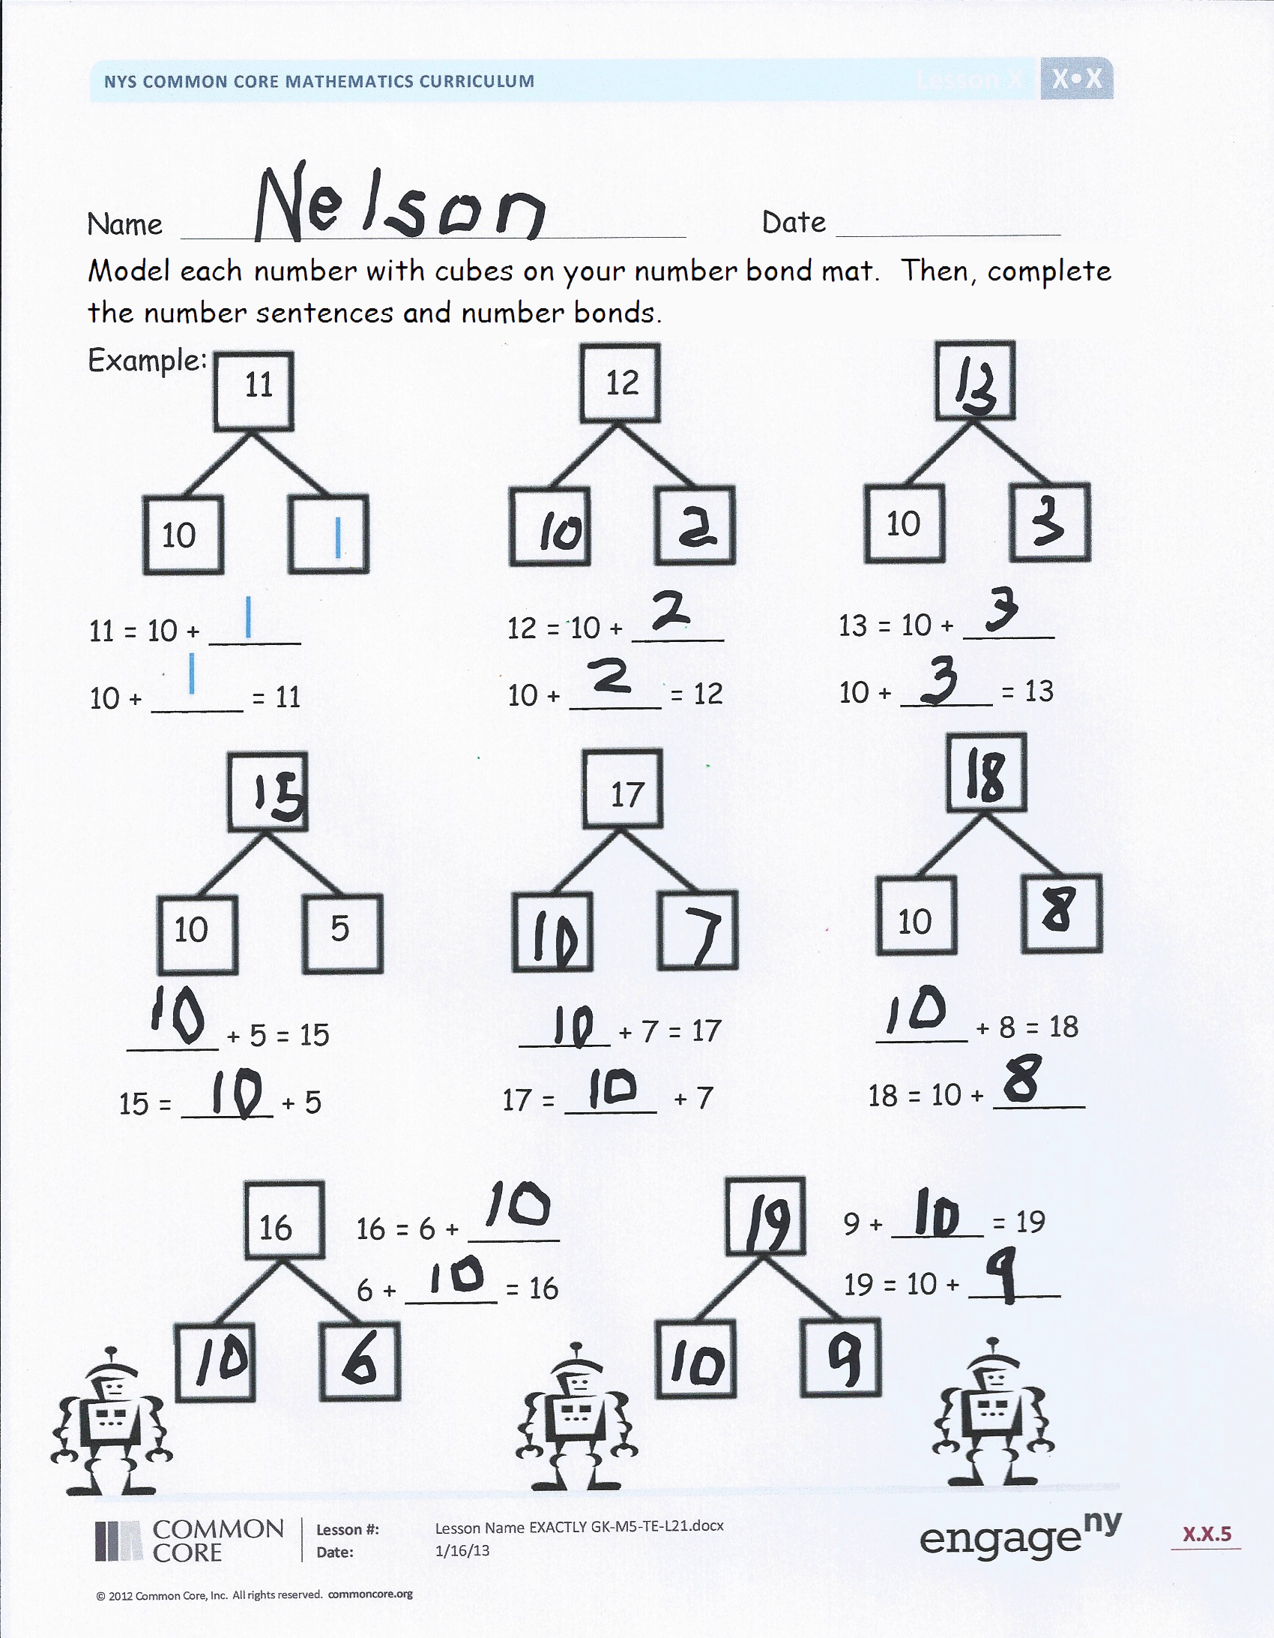
Student Debrief (8 minutes)
Lesson Objective: Represent teen number decompositions as 10 ones and some ones, and find a hidden part.
The Student Debrief is intended to invite reflection and active processing of the total lesson experience.
Invite students to review their solutions for the Problem Set. They should check work by comparing answers with a partner before going over answers as a class. Look for misconceptions or misunderstandings that can be addressed in the Debrief. Guide students in a conversation to debrief the Problem Set and process the lesson.
Any combination of the questions below may be used to lead the discussion.
- What did you get better at today?
- What do you notice from the Problem Set? (An example follows.)
T: Look at the first two number bonds. What is the same and different about these two bonds?
S: Both bonds have 10 ones. Yeah, but they don’t have the same number of extra ones. One has 2 extra ones, and the other has 3 extra ones. If you count all the ones together, one is twelve, and one is thirteen. If we count the Say Ten Way, one is ten 2, and one is ten 3. If you break apart both numbers, there are 10 ones and some ones inside! The number sentences show that we can write 12 and 13 in number sentences with 10 plus in them.
- What can you explain about the numbers 11, 12, 13, 14, 15, 16, 17, 18, 19? What do they have in common? How are they different?
- What did you learn in this lesson?
Exit Ticket (3 minutes)
After the Student Debrief, instruct students to complete the Exit Ticket. A review of their work will help with assessing students’ understanding of the concepts that were presented in today’s lesson and planning more effectively for future lessons. The questions may be read aloud to the students.

Name Date
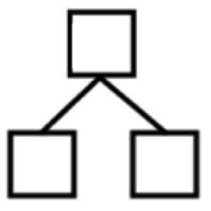
Model each number with cubes on your number bond mat. Then, complete the number sentences and number bonds.
12
Example:
11

10
10

11 = 10 + _____ 12 = 10 + _____ 13 = 10 + _____
10 + _____ = 11 10 + _____ = 12 10 + _____ = 13
10
5
17

10

_____ + 5 = 15 _____ + 7 = 17 _____ + 8 = 18
15 = _____ + 5 17 = _____ + 7 18 = 10 + _____
16

16 = 6 + _____ 9 + _____ = 19
6 + _____ = 16 19 = 10 + _____

Name Date
Complete the number sentences and number bonds. Use your materials to help you.
17

_____ + 7 = 17 17 = _____ + 10
1317
3

____ + 3 = _____ 13 = _____ + 10
Name Date
Complete the number bonds and number sentences. Draw the cubes of the missing part.

15
10

15 = _____ + 10

18

8

_____ + 8 = 18

6
10

6 +____ = 16

11

1

1 + ____ = 11

