Lesson 20
Objective: Represent teen number compositions and decompositions as addition sentences.

Suggested Lesson Structure
 Fluency Practice (12 minutes)
 Application Problem (7 minutes)
 Concept Development (24 minutes)
 Student Debrief (7 minutes)
Total Time (50 minutes)
Fluency Practice (12 minutes)
- Dot Cards of Seven K.CC.5, K.CC.2 (4 minutes)
- Count Crossing Tens K.CC.1 (4 minutes)
- Group Tens and Ones K.CC.4 (4 minutes)
Dot Cards of Seven (4 minutes)
Materials: (T) Dot cards of 7 (Lesson 5 Fluency Template 1)
Note: The varied configurations of dots used in this fluency activity allow students to see different ways to decompose 7, strengthening their understanding of part–whole relationships.
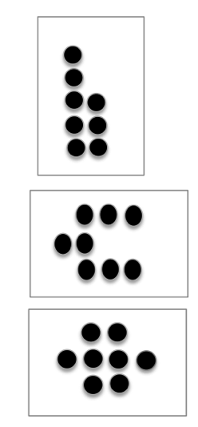
T: (Show 7 dots.) How many do you see? (Give students time to count.)
S: 7.
T: How can you see 7 in two parts?
S: (Coming up to the card.) 5 here and 2 here.
T: Say the number sentence.
S: 5 and 2 makes 7.
T: Who sees 7 in two different parts?
S: (Coming up to the card.) I see 3 here and 4 here.
T: Say the number sentence.
S: 3 and 4 makes 7.
Continue with other cards of seven.
Count Crossing Tens (4 minutes)
Materials: (S) Personal Rekenrek (Lesson 10)
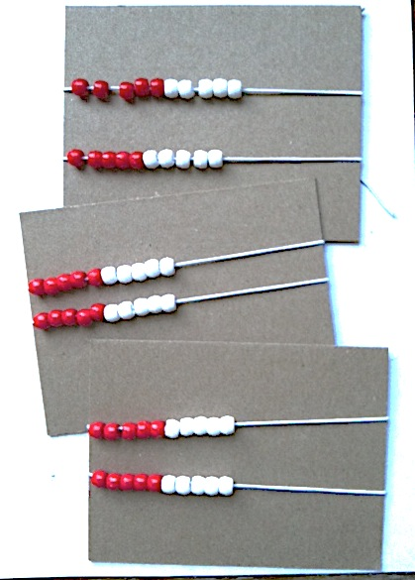
Note: For this activity, it may be preferable to combine six elastics of beads onto one card. However, it may help students develop number sense to use their three individual cards as described below so that students reference where they left off very clearly when counting to 40.
T: Today, we’re going to work in groups of 3. Put your personal Rekenreks together, and count your beads. Say buzz after you finish a row. Partner A moves the beads of the first Rekenrek, Partner B moves the beads of the second, and Partner C moves the beads of the third.
T: If you finish early, count again. This time, after the color changes, say buzz.
Group Tens and Ones (4 minutes)
Materials: (T) Prepared images of arrays, circular configurations, large ten-frame cards (Lesson 1 Fluency Template 3)
Note: This activity advances the skill of grouping tens and ones by moving on to visual recognition. Counting only by sight pushes students to work efficiently because it is easier to keep track of groups than individual objects.
T: (Project a circular configuration of 12 objects.) Say the number of objects that you see.

NOTES ON
MULTIPLE MEANS
OF ACTION AND EXPRESSION:
Increase the learning pace for students who are working above grade level by providing extensions to the Application Problem:
- What if each student was given
16 colored pencils and 4 regular pencils? How many pencils are there all together? Hint: Use your first drawing to help you solve.
- How many pencils would two students have all together? Hint: Use your first two drawings to help you solve.

S: (Pause while they count.) 12.
T: Say the number the Say Ten Way.
S: Ten 2.
Repeat the process for four or five other numbers between 10 and 100, mixing arrays, circular configurations, and ten-frame cards.
Although students cannot touch the images, encourage them to track their grouping with hands from afar. They might hold up a finger to mark the starting point in a circular configuration or use an outstretched hand to visually separate a group of ten from remaining stars in an array.

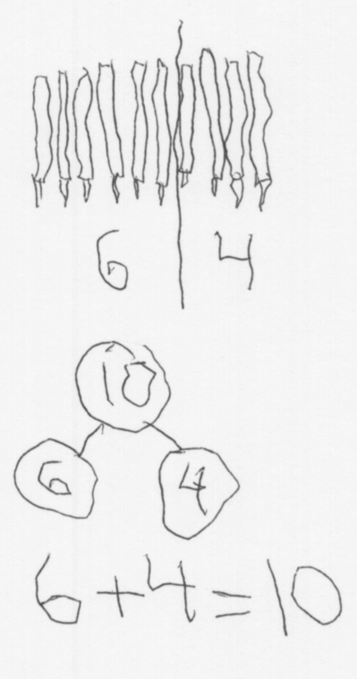
Application Problem (7 minutes)
Each student was given 6 colored pencils and 4 regular pencils. How many pencils did each student get? Draw a picture, a number bond, and write a number sentence, too.
Concept Development (24 minutes)
Materials: (S) Bag of twenty 2-color beans, personal white board with blank number bond (Lesson 7 Template) inside
T: Put 10 red beans in one part of the number bond. Put 3 white beans in the other part.

NOTES ON
MULTIPLE MEANS
OF ENGAGEMENT:
Ask English language learners who are developing language skills to write their answers on their personal white boards, as well as say it aloud. After writing and saying the answer orally, have all students repeat the number sentence aloud again.

T: What is 10 ones and 3 ones?
S: 13 ones.
T: Say the number the Say Ten Way.
S: Ten 3.
T: Now, count 13 beans into the place where we show the total or whole amount.
T: So, we have 13 in two parts. What are the parts?
S: 10 and 3.
T: Talk to your partner. When we solved our story problem today, we had two parts. What is another way you already know to show a number in two parts?
S: We can show a number in two parts by making piles of things, like 10 things and 3 things. We can show the number with a number bond. We can make a picture. We can show it with our Hide Zero cards. We can show it on the Rekenrek. We can show it with a plus sign.
MP.3
T: Lots of good ideas. We can show the same idea in so many ways. When we are thinking about 13, what do you think is the clearest way to show the two parts of 10 and 3. Talk to your partner.
S: The number bond. It’s so easy to see. I like to see how big the number is, so counters are my favorite. I feel big girls and boys do addition, so that’s how I want to show it.
T: Each way we show a number in two parts helps us understand our number better. Addition is another way to do that.
T: (Write 10 + 3 = ____ on the board.)
T: What is 10 + 3? Give me a complete number sentence.
S: 10 + 3 = 13.
T: (Write 13 on the board to complete the equation.) Look at your number bond. How many beans do you have in the whole amount?
S: 13.
T: (Write 13 = ____ + ____ on the board.)
T: How many beans are in this part? Let’s count.
S: 1, 2, 3, 4, 5, 6, 7, 8, 9, 10.
T: How many beans are in this part?
S: 3.
T: Look at the parts. Complete this number sentence. (Point to 13 = ____ + ____.)
S: 13 = 10 + 3.
T: We started with the whole amount with our beans, so our number sentence also starts with the whole amount.
T: Clear your boards. Show 10 red beans and 5 white beans in the two parts.
T: Now, count to find out how many beans you will put to show the total. It needs to match the amount in the parts.
S: (After counting.) 15.
T: Count that many beans into the place where you put your total.
T: (After counting.) What is another way to show the two parts and the total?
S: 10 + 5 = 15.
T: (Write 10 + 5 = 15 on the board.)
T: Do you have the same number of beans in the parts as you have in the place for the total?
S: Yes!
T: When 15 is split into two parts, is it the same as 10 and 5? Then, your number bond is true!
T: Clear your boards. This time, use your marker to write 19 where we show the whole. Let’s put this number in two parts.
T: Show 10 red beans as one part. (Pause while students place the beans.)
T: Count out the beans you need to put in the other part to get to 19.
S: (After counting.) 9.
T: What is one number sentence that tells about this number bond?
S: 10 + 9 = 19.
T: This time, start with the total, so we really feel that big number splitting into two parts.
S: 19 = 10 + 9.
Continue in this manner with students creating and talking about other teen number bonds and their matching addition sentences
Problem Set (7 minutes)
Students should do their personal best to complete the Problem Set within the allotted time.
Note: Have the students complete the bonds and number sentences. Give them access to materials and Hide Zero cards as they do so.

Student Debrief (7 minutes)
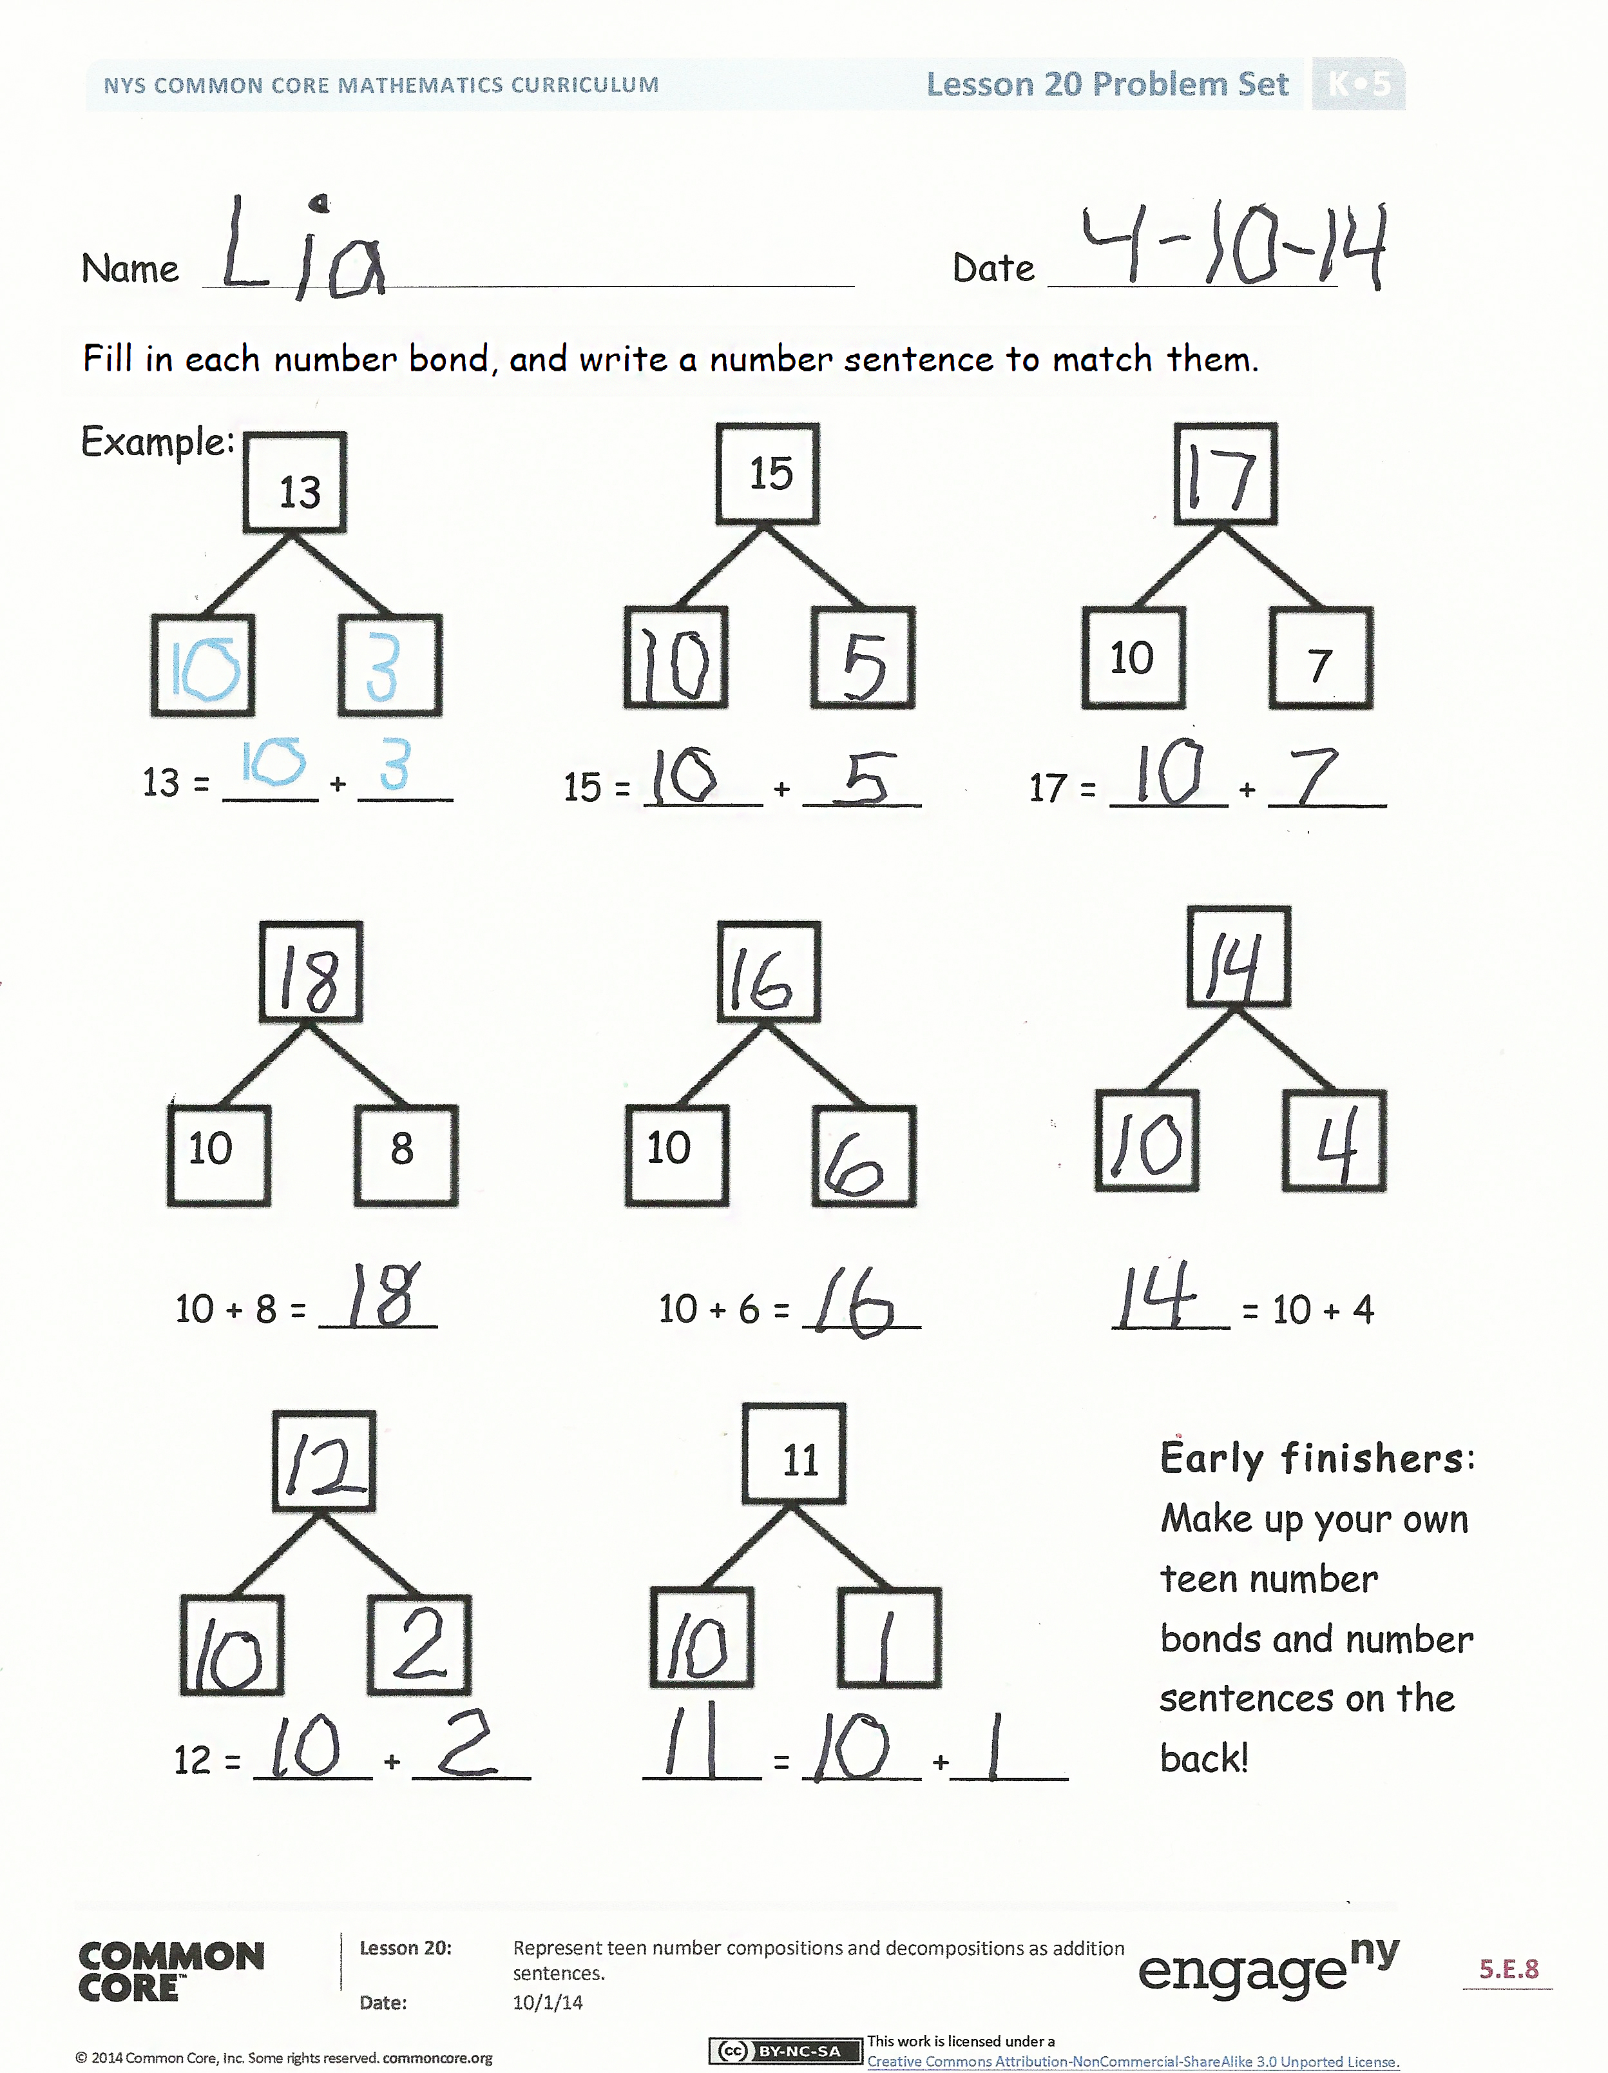
Lesson Objective: Represent teen number compositions and decompositions as addition sentences.
Invite students to review their solutions for the Problem Set. They should check work by comparing answers with a partner before going over answers as a class. Look for misconceptions or misunderstandings that can be addressed in the Debrief. Guide students in a conversation to debrief the Problem Set and process the lesson.
Any combination of the questions below may be used to lead the discussion.
- In a number bond, which number is larger—the whole or a part?
- Explain how the teen numbers are 10 ones and some more ones.
- Look at each number bond as I say the whole. You read the number the Say Ten Way; for example, I say 13, and you say ten 3.
- Mental math: I say 16; you say 10 + 6. I say 17; you say…? I say 19; you say…?
- Show a row of ten on the Rekenrek, and then slide beads to show the teen numbers. Students say the numbers the regular and Say Ten Way.
- What are we doing with the parts when we add? Are we putting them together or taking them apart?
Exit Ticket (3 minutes)
After the Student Debrief, instruct students to complete the Exit Ticket. A review of their work will help with assessing students’ understanding of the concepts that were presented in today’s lesson and planning more effectively for future lessons. The questions may be read aloud to the students.

Name Date
Fill in each number bond, and write a number sentence to match them.
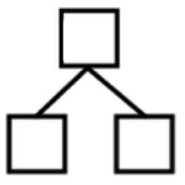
Example:
15
13
13 = ____ + ____

7
10

15 = _____ + _____ 17 = _____ + _____
10
8

10

10 + 8 = _____ 10 + 6 = _____ _____ = 10 + 4
11
Early finishers: Make up your own teen number bonds and number sentences on the back!

12 = _____ + _____ _____ = _____ +_____

Name Date
5 | 1 2 3
The first number is the whole. Circle its parts.
12 | 10 6 2

11 | 1 10 8

14 | 4 2 10

18 | 1 10 8

10 | 10 1 0

20 | 10 2 10

Name Date
Draw stars to show the number as a number bond of 10 ones and some ones. Show each example as two addition sentences of 10 ones and some ones.
*****  ***** | *
11999
10 + 1 = 11
11 = 10 + 1

* * * * *
* * * * *
15999

* * * * *
* *
17

* * * * *
* * * * *

19999

14999

* * * * *
* * * * *

2099

