Lesson 19
Objective: Explore numbers on the Rekenrek. (Optional.)

Suggested Lesson Structure

A NOTE ON
STANDARDS ALIGNMENT:
In this lesson, students explore decomposing numbers to 100. To begin, they simply decompose numbers to 10 and see the relevance of that to teen numbers. Next, they sit with a partner and decompose numbers to 40 as tens and ones (1.NBT.2). They then represent numbers on two Rekenreks with a friend and realize that there is a teen number hiding inside this larger number by pulling apart their two Rekenreks! The exploration is meant to be playful, generating excitement about decomposing numbers.

 Application Problem (7 minutes)
 Fluency Practice (10 minutes)
 Concept Development (25 minutes)
 Student Debrief (8 minutes)
Total Time (50 minutes)
Application Problem (7 minutes)
The light is out, and it’s dark. Peter knows that he left 7 blue and green beads for his crafts on his desk. But he can’t see how many are blue or how many are green in the dark! Draw a picture to show what the colors of his beads might be when he turns on the light.
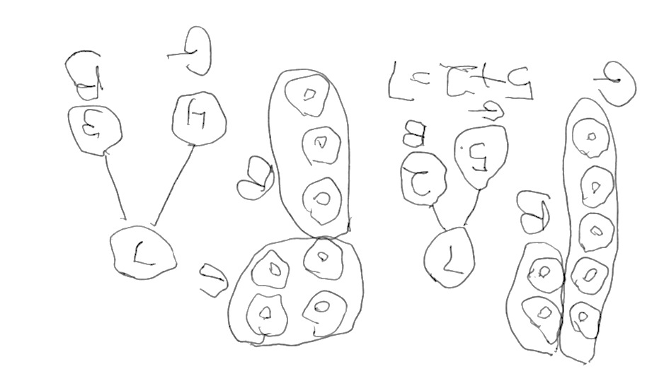
When students have finished, have them compare their work with another student. Is their way of showing the beads the same? Why or why not? How is this problem like the problems in previous lessons with the flowers and the apples?
Note: In this lesson, the Application Problem precedes the Fluency Practice because the fluency activities lead directly into the counting of the lesson.
Fluency Practice (10 minutes)
- Number Bonds of 7 K.OA.3 (3 minutes)

NOTES ON
MULTIPLE MEANS
OF REPRESENTATION:
Teach English language learners to ask questions such as, “How is your work different from mine?” in order to extend partner shares. Model asking different types of questions and have students practice until they feel confident to try with a partner.

- Count to 100 by Ones K.CC.1 (3 minutes)
- Hide Zero for Numbers to 100 K.CC.1 (4 minutes)
Number Bonds of 7 (3 minutes)
Materials: (S) Personal Rekenrek (from Lesson 10)
Note: This fluency activity gives students an opportunity to develop increased familiarity with decompositions of seven and practice seeing part–whole relationships.
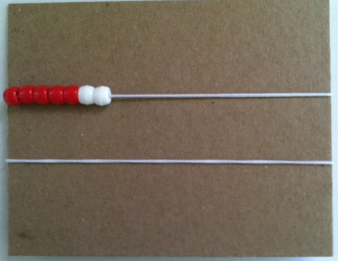
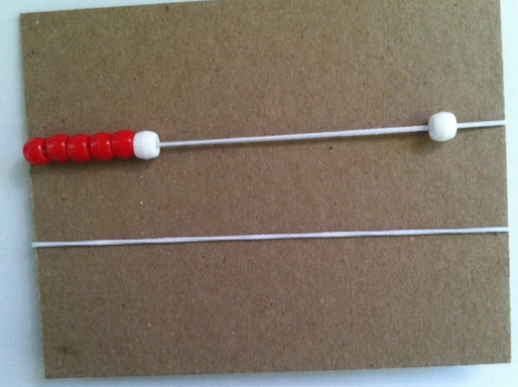
T: Show ten beads only (students push a row of ten behind).
T: Hide 3 white beads behind your board.
T: The total number of beads you see is…?
S: 7.
T: Push over 1 bead to the right to make 2 parts. Tell your partner the number bond. Part ____, part ____, total 7.
S: Part 6, part 1, total 7.
Continue one bead at a time stating the related bond. Keep the Rekenreks at 7 for the Concept Development component of this lesson.
Count to 100 by Ones (3 minutes)
Materials: (S) Rekenrek dot paper (Lesson 18 Problem Set)
Note: This activity targets the grade-level standard of counting to 100 by ones.
Students count to 100 (or as high as they can in 3 minutes) by touching the beads on the Rekenrek dot paper. Have them say “buzz” after the last number of each row.
Hide Zero for Numbers to 100 (4 minutes)
Materials: (T) Hide Zero cards (Lesson 6 Template), Hide Zero cards 20–100 (Fluency Template)
Note: This activity connects identifying numbers the Say Ten Way and students’ growing understanding of place value, a Grade 1 standard they explore in today’s Concept Development.
T: (Hold the 30 card and 7 card so they show 37.) Say the number.
S: 37.
T: Say the number the Say Ten Way.
S: 3 tens 7.
T: (Break apart the cards into 30 and 7.)
Repeat the process for four or five other numbers between 20 and 100.
Concept Development (25 minutes)
Materials: (S) Personal Rekenrek (from Lesson 10)
Exploration 1
T: Show me 7 again on your Rekenrek.
T: Take the bottom ten beads of your Rekenrek out of hiding. Push them over to the left under your 7.
T: How many beads are on the left?
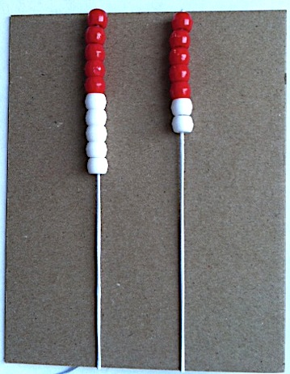
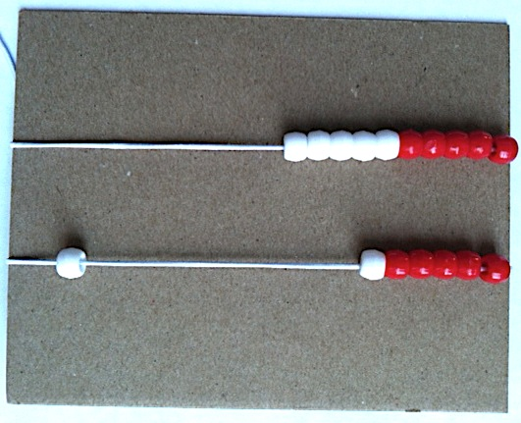
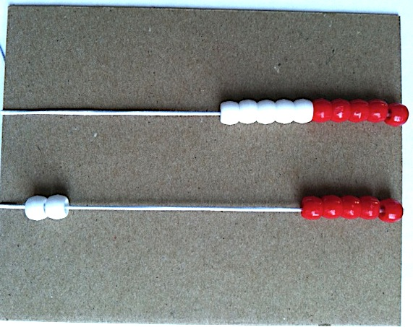
S: Seventeen.
T: Today, let’s work the Say Ten Way.
S: Ten 7.
T: Move 1 bead from your 7 over to the right like we did in our fluency.
T: Total 16. The two parts are…?
S: 10 and 6.
T: Move another bead. Total 15. The parts are…?
S: 10 and 5.
T: Move another!
S: Total 14. The parts are 10 and 4.
T: Keep going! (Give the students a moment to work through the teen numbers.)
Exploration 2
T: Now, sit with a partner. Partner B, take all your beads out of hiding, and put your Rekenrek under your partner’s. Partner A, show ten 7 again.
T: Using both Rekenreks, how many beads do you have on the left now? Tell me the Say Ten Way.
S: 3 tens 7.
T: Move 1 bead from the 7 to the right. How many beads are on the left?
S: 3 tens 6.
T: Move a bead.
S: 3 tens 5.
T: Move a bead.
S: 3 tens 4.
Have the students work with base numbers other than 7 within the twenties and thirties. Then, three students can sit together and work with numbers within the forties and sixties. The decomposition of the larger numbers is 1.NBT.2, Understand Place Value. This playful work lets students get a sense of these important understandings that the decomposition of the numbers 1–9 and the teens give. Avoid part/whole language in Exploration 2 and in the Problem Set. Simply let the students’ natural knowledge see the connection between the base number, the teens, and the larger numbers.

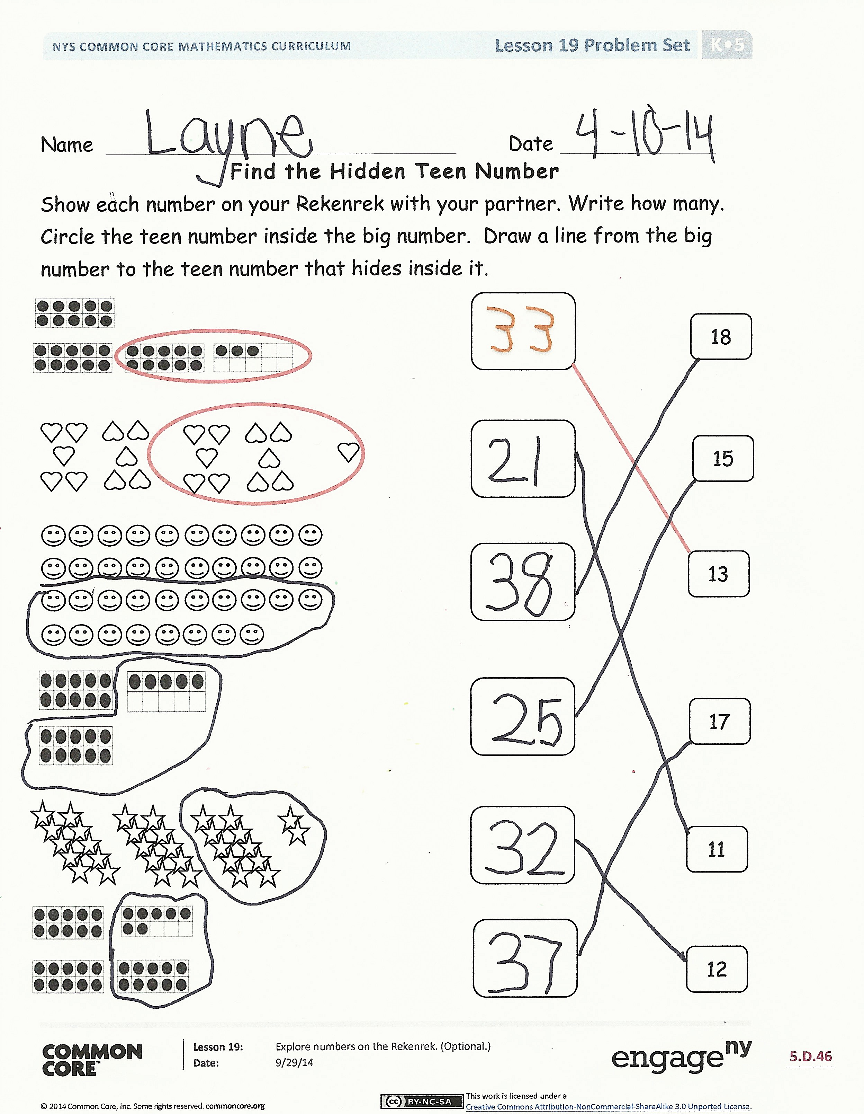
Problem Set (7 minutes)
Before doing the Problem Set, guide the students to see that they can also isolate the teen numbers when working with their partners.
T: Where is our teen number? It is in Partner A’s Rekenrek! While the top row shows 7, the top Rekenrek shows 17. The teen numbers are hiding inside larger numbers just like 7 was inside 17. Pretend you are breaking the number, pulling hard at the Rekenreks to break that number apart.
This is of course beyond the grade-level standard (1.NBT.2), but it illustrates the idea that numbers can be broken into parts—the Rekenreks make it so easy to show that! Keep it playful.
Students should do their personal best to complete the Problem Set within the allotted time.
Student Debrief (8 minutes)
Lesson Objective: Explore numbers on the Rekenrek. (Optional.)
The Student Debrief is intended to invite reflection and active processing of the total lesson experience.
Invite students to review their solutions for the Problem Set. They should check work by comparing answers with a partner before going over answers as a class, taking turns reading the numbers forward and back. Look for misconceptions or misunderstandings that can be addressed in the Debrief. Guide students in a conversation to debrief the Problem Set and process the lesson.
Guide students to see that their work with the first row of numbers on their Rekenreks, 1 to 10, helps them work with bigger numbers, just like when they count from 1 to 9 it helps them to count all the way to 100.
Any combination of the questions below may be used to lead the discussion.
- What did your teen number bonds help you see about the larger numbers?
- When you make a teen number in parts, what do you notice? Which is always larger, the parts or the total (or whole)?
- What happens if the top row on your Rekenrek is a part? What is the other part?
- What else could be a part of a larger number?
- When you circled teen numbers on the Problem Set, you were finding a part. What part did you find in the first problem?
- How does finding parts help you to understand large numbers better?

Exit Ticket (3 minutes)
After the Student Debrief, instruct students to complete the Exit Ticket. A review of their work will help with assessing students’ understanding of the concepts that were presented in today’s lesson and planning more effectively for future lessons. The questions may be read aloud to the students.

Name Date
Find the Hidden Teen Number
Show each number on your Rekenrek with your partner. Write how many. Circle the teen number inside the big number. Draw a line from the big number to the teen number that hides inside it.
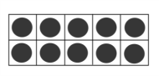

18
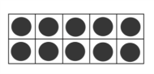
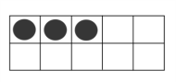
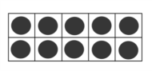

15

13

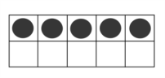

17
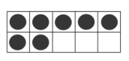
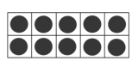
11

12

Name Date
Show the number on your Rekenrek with your partner. In the box, write the number that tells how many objects there are. Circle the teen number you see. Write the teen number in the other box.

Name Date

Write the number you see. Now, draw one more, then write the new number.

2 | 0 | 3 | 0
4 | 0 | 5 | 0
6 | 0 | 7 | 0
8 | 0 | 9 | 0
1 | 0 | 0

hide zero cards 20–100
hide zero cards 20–100

