Lesson 18
Objective: Count across tens by ones to 100 with and without objects.

A NOTE ON
STANDARDS ALIGNMENT:
In this lesson, students write numbers through 100, which bridges Kindergarten content of writing numbers to 20 (K.CC.3) to Grade 1 content of writing numbers to 120 (1.NBT.1).

Suggested Lesson Structure
 Application Problem (7 minutes)
 Fluency Practice (11 minutes)
 Concept Development (24 minutes)
 Student Debrief (8 minutes)
Total Time (50 minutes)
Application Problem (7 minutes)
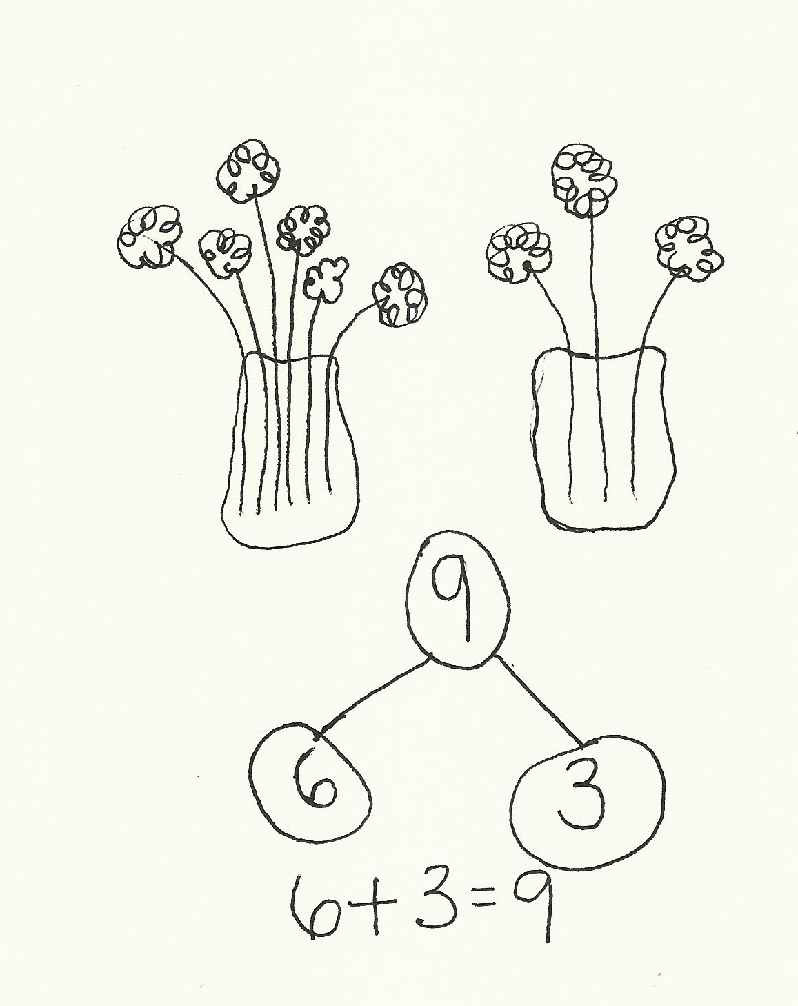
Susan is putting 9 flowers in 2 vases. Draw a picture to show a way she might do that. Make a number bond and a number sentence to match the idea. (Extension: See if there is another way to put the flowers in the vases.)
When students have finished, have them compare their work with another student. Are their ways of showing the flowers the same? Why or why not? How is the flower problem similar to the apple problem from yesterday?
Note: In this lesson, the Application Problem precedes the Fluency Practice because the fluency activities lead directly into the counting of the lesson.
Fluency Practice (11 minutes)
- Ten-Frame Flashes K.CC.2 (3 minutes)
- Teen Number Bonds K.CC.1 (4 minutes)
- Count on the Rekenrek K.CC.4 (4 minutes)
Ten-Frame Flashes (3 minutes)
Materials: (T) Ten-frame cards (Lesson 1 Fluency Template 4)
Note: The ten-frame formation facilitates speed and accuracy in recognizing partners of 10.

T: (Show 9 dots.) How many dots do you see?
S: 9.
T: How many more does 9 need to be 10?
S: 1.
Continue with the following possible sequence: 1, 5, 8, 2, 3, 7, 6, 1, 4, 3, 5, 2, 9.
Teen Number Bonds (4 minutes)
Materials: (S) Image of blank number bond (Lesson 7 Template)
Note: This activity reinforces part–whole relationships within teen numbers.
T: (Project number bond with parts of 10 objects and 6 objects.) Say the larger part.
S: 10.
T: Say the smaller part.
MP.4
S: 6.
T: Count the whole, or total, with me.
S: 1, 2, 3, 4, 5, 6, 7, 8, 9, 10, 11, 12, 13, 14, 15, 16.
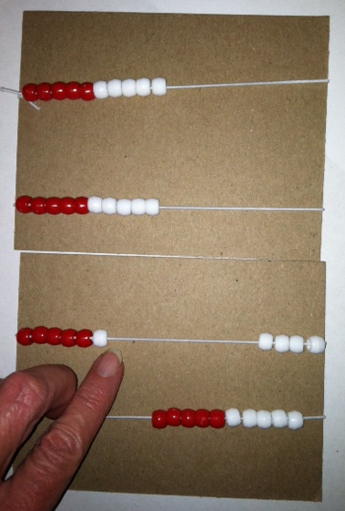
Continue with the following possible sequence: 10 and 7, 10 and 3, 10 and 1, 10 and 8, 10 and 4.
Count on the Rekenrek (4 minutes)
Materials: (S) Personal Rekenrek (from Lesson 10)
Note: Manipulating their own Rekenreks allows students to work at a comfortable pace. Saying “buzz” at the end of each row delightfully draws attention to the grouping of ten on the Rekenrek.
T: Put your Rekenrek together with your partner’s. Whisper count with your partner up to 40 on your Rekenrek. Take turns moving the beads with each new row. Buzz before you say the first number of each row.
Concept Development (24 minutes)
Materials: (T) 100-bead Rekenrek (S) Set of 9 full ten-frame cards (Lesson 15 Template 2), 2 empty ten-frame cards (Template), 20 counters, blank paper to use as a hiding paper for the Problem Set
T: (Count by tens to 40 by sliding four rows on the Rekenrek.) Count with me.
S: 10, 20, 30, 40.
T: Now, count by ones. (Slide one bead at a time as students count.)
S: 41, 42, 43, 44, 45, 46, 47, 48, 49, 50.
T: What is the number the Say Ten Way?

NOTES ON
MULTIPLE MEANS
OF ACTION AND EXPRESSION:
Use English language learners’ culture to teach them the names of the numbers. For instance, couple twenty with veinte and thirty with treinta for native Spanish speakers. Building on the students’ culture and language while teaching helps native English speakers as well by expanding their horizon and exposing them to other cultures and languages.

S: 5 tens.
T: (Slide one more bead.) Tell me the number the Say Ten Way.
S: 5 tens 1.
T: Tell me the number the regular way.
S: 51.
T: (Slide the bead back so that only 50 beads are showing.) How many beads are there now?
S: 50.
T: (Slide one bead back so that 49 are showing.) How many beads are there, the Say Ten Way?
S: 4 tens 9.
T: How many, the regular way?
S: 49.
Repeat this process from different starting points within 100, going back and forth across the ten.
T: Now, let’s show and count numbers a different way. Lay out ten-frame cards as we count the Say Ten Way.
S: (Slowly counting as students lay out the cards.) Ten, 2 tens, 3 tens, 4 tens, 5 tens.
T: Now, let’s count the regular way by tens. Touch each card as we count it.
S: 10, 20, 30, 40, 50.
T: Place the two empty ten-frames down after 50.

NOTES ON
MULTIPLE MEANS
OF ENGAGEMENT:
Challenge students working above grade level by providing them with opportunities to extend the lesson. For instance, after counting by ones, have students skip-count from 28 by twos, by threes, and by fives, using the Rekenrek on their own. For very advanced students, ask them to write their answers before the teacher moves the beads to encourage their counting in their heads rather than relying on the visual support!

T: Count on from 50, placing one counter at a time as we say each number. Let’s start the Say Ten Way.
S: (Placing a counter each time they count.) 5 tens 1,
5 tens 2, 5 tens 3, … 6 tens.
T: Now, let’s count that the regular way, starting at 51. Touch each counter as you count.
S: 51, 52, 53, … 60.
T: Place one more counter on the next ten-frame. Say the number the Say Ten Way.
S: 6 tens 1.
T: What is the number the regular way?
S: 61.
T: What is one more than 60?
S: 61.
T: Take one counter off. What is the number the Say Ten Way?
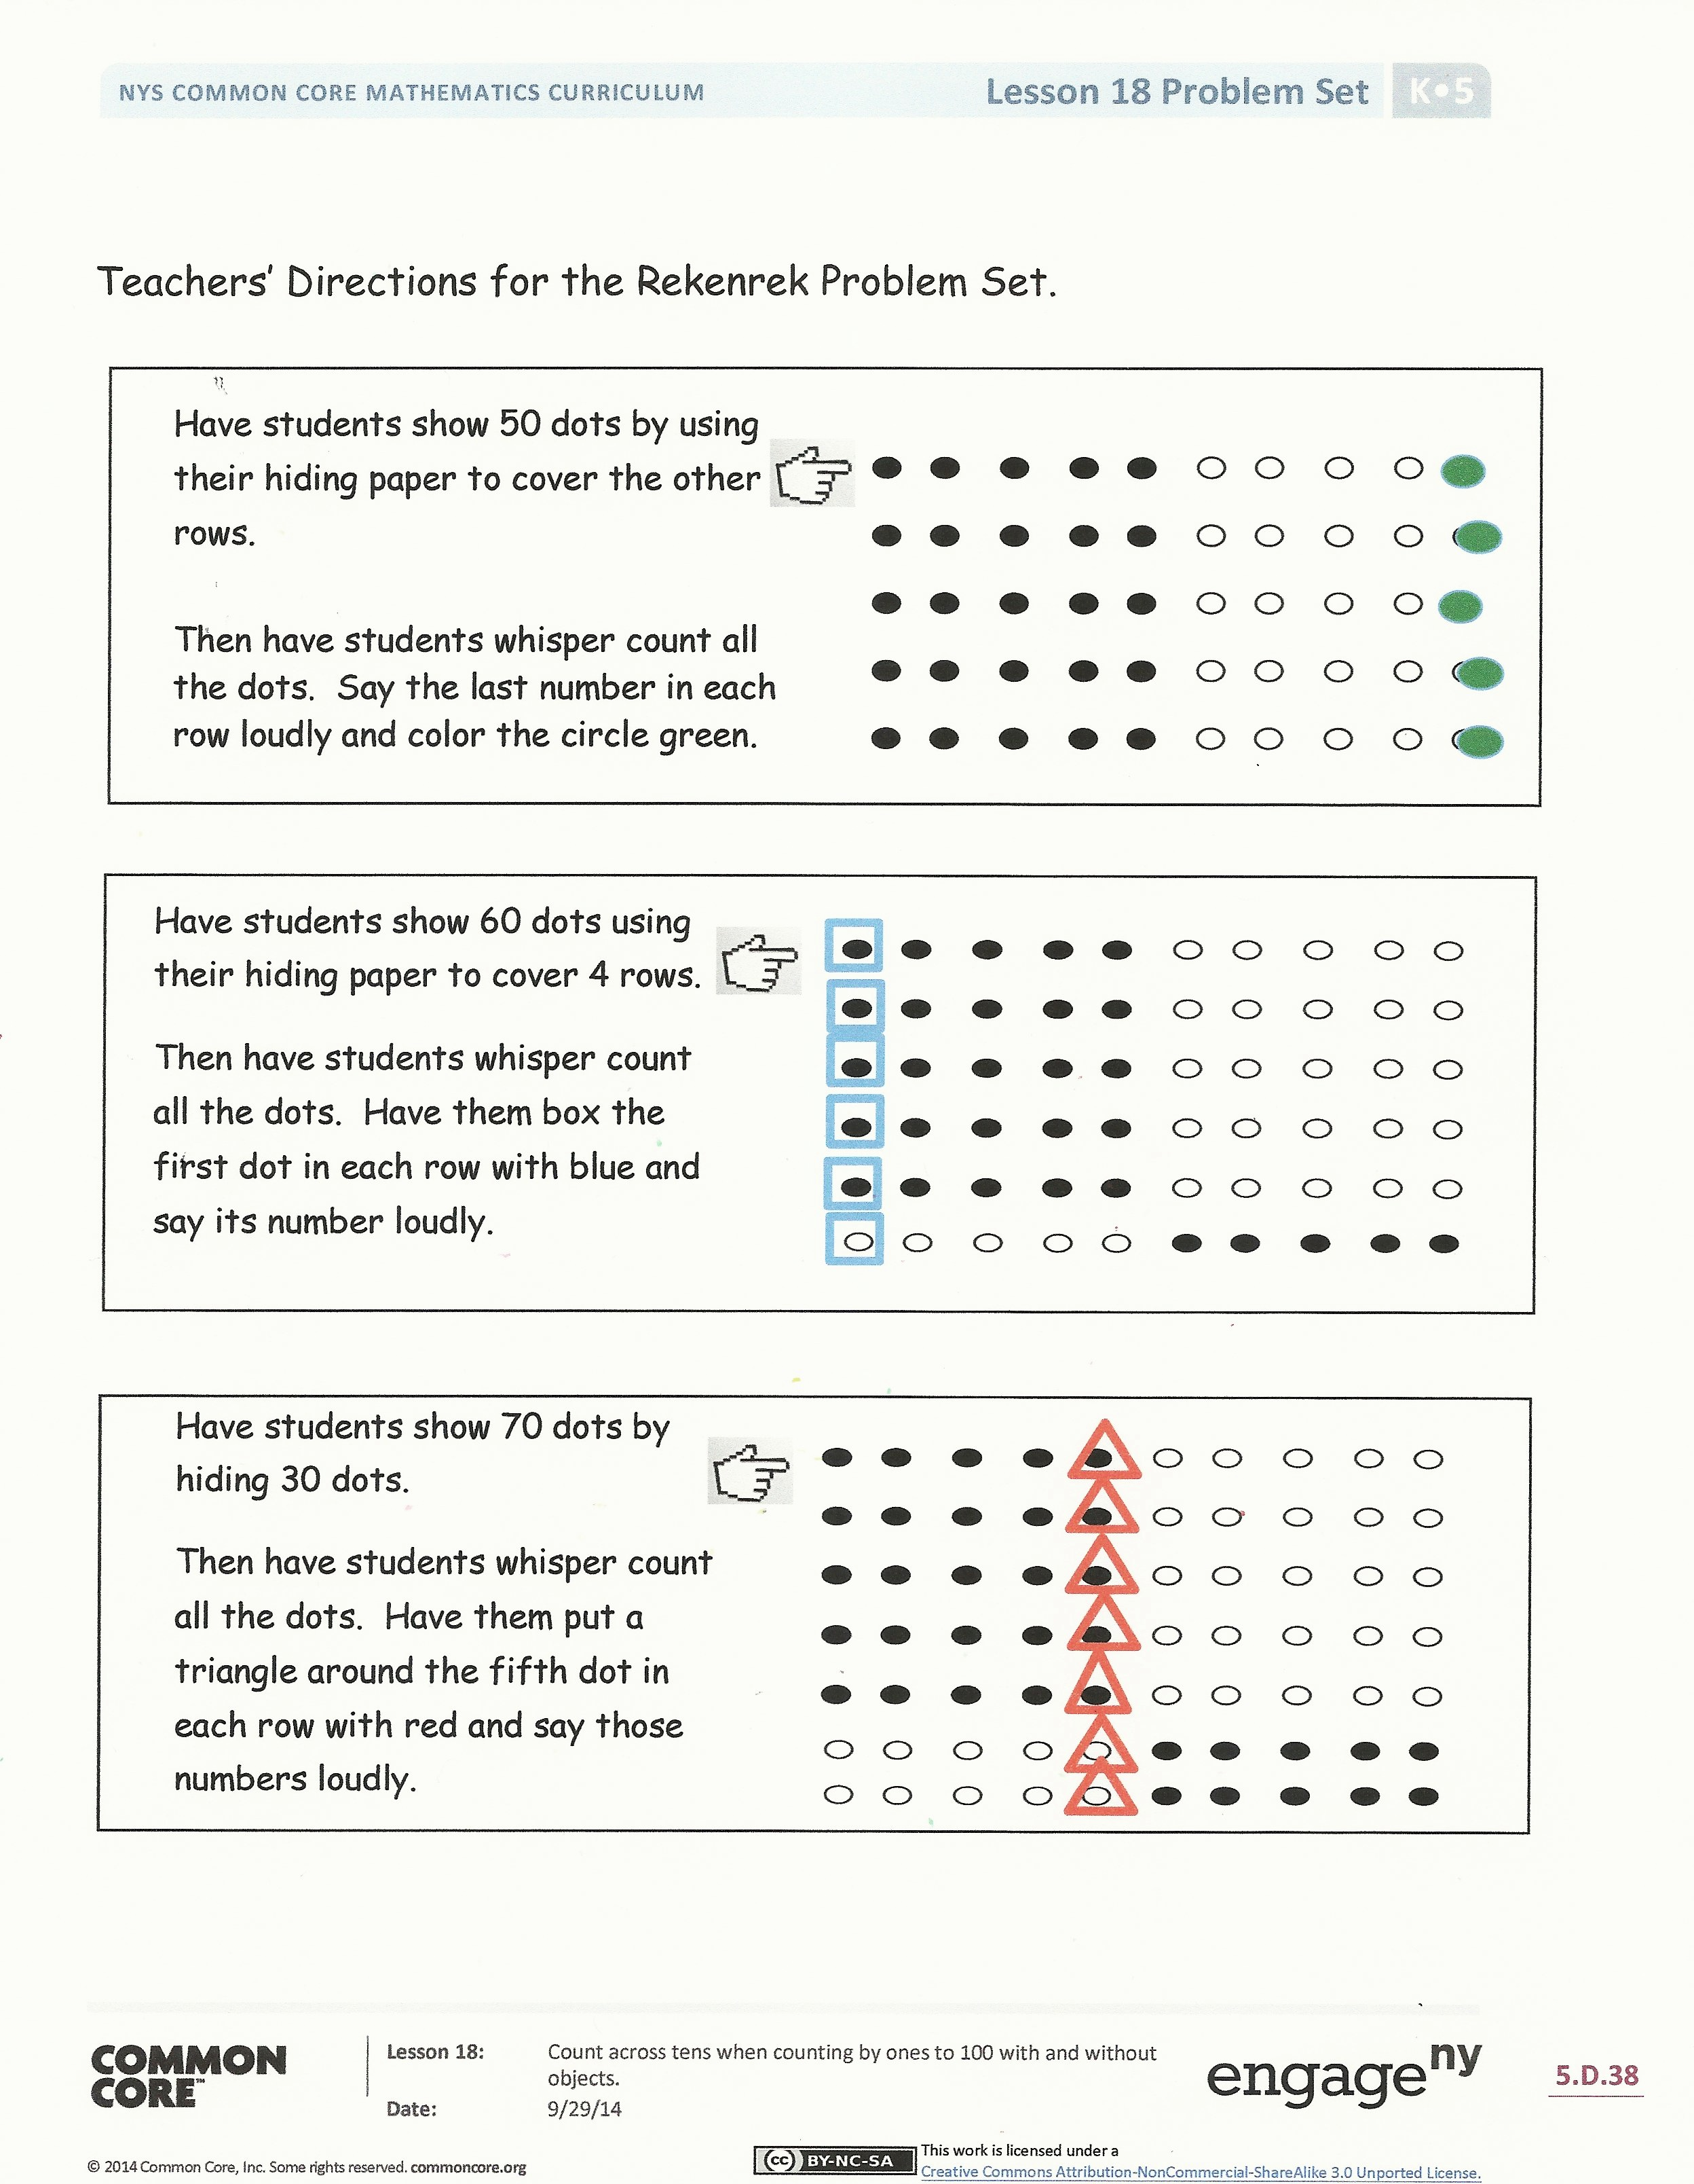
S: 6 tens.
T: What is the number the regular way?
S: 60.
T: Take away one more counter. What is the number the Say Ten Way?
S: 5 tens 9.
T: Say the number the regular way.
S: 59.
Repeat this process starting from different numbers within 100, focusing on crossing over to the next ten and then back (e.g., 69, 70, 71, 70, 69).
Problem Set (7 minutes)
Students should do their personal best to complete the Problem Set within the allotted time.
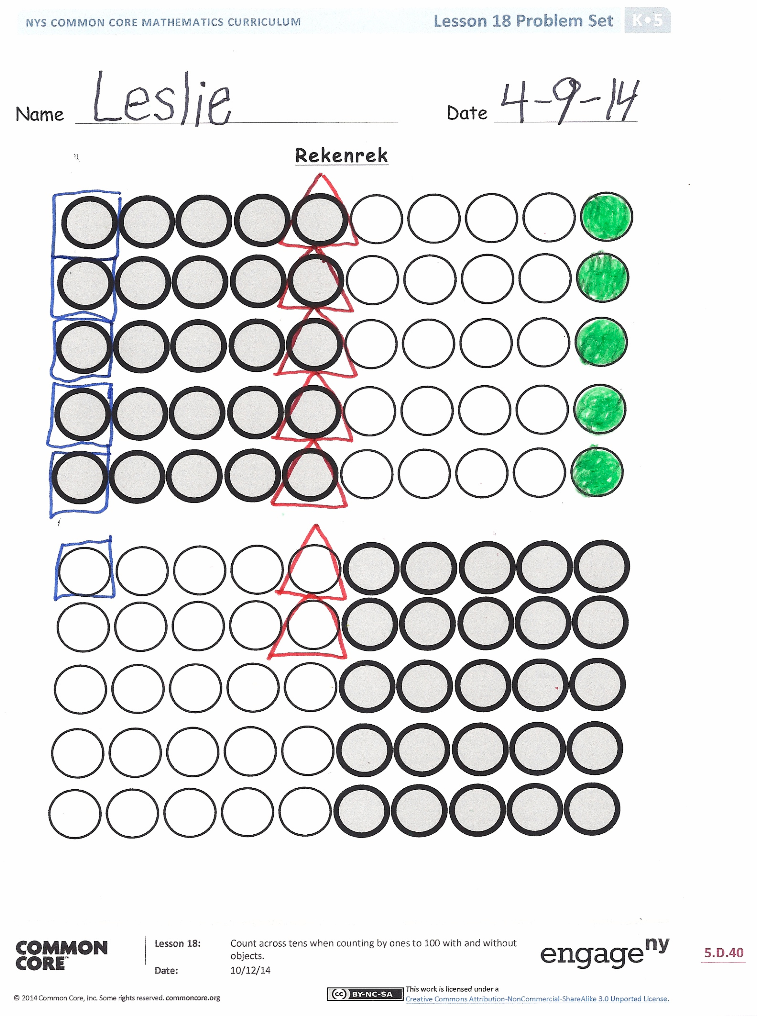
Note: Do not show the students the directions paper included in the materials for the lesson and pictured above to the right. It would give away the answers. The Rekenrek template is used by the students for the Problem Set and Homework.
Have the students continue the patterns to the larger numbers, identifying the number for each triangle, box, and green circle.
Student Debrief (8 minutes)
Lesson Objective: Count across tens by ones to 100 with and without objects.
The Student Debrief is intended to invite reflection and active processing of the total lesson experience.
Invite students to review their solutions for the Problem Set. They should check work by comparing answers with a partner before going over answers as a class, taking turns reading the numbers forward and back. Look for misconceptions or misunderstandings that can be addressed in the Debrief. Guide students in a conversation to debrief the Problem Set and process the lesson.

Any combination of the questions below may be used to lead the discussion.
- What is one more than 19? What is one more than 29?
- Count from 79 to 90. From 61 to 71.
- Who can come up and show one more than 30 on the Rekenrek? One more than 80?
- What did you get better at (learn, understand, do better) today?
Exit Ticket (3 minutes)
After the Student Debrief, instruct students to complete the Exit Ticket. A review of their work will help with assessing students’ understanding of the concepts that were presented in today’s lesson and planning more effectively for future lessons. The questions may be read aloud to the students.

Teachers’ Directions for the Rekenrek Problem Set
Have students show 50 dots by using their hiding paper to cover the other rows.

Then, have students whisper count all the dots. Say the last number in each row loudly, and color the circle green.

Have students show 60 dots using their hiding paper to cover 4 rows.
Then, have students whisper count all the dots. Have them box the first dot in each row with blue and say its number loudly.

Have students show 70 dots by hiding 30 dots.
Then, have students whisper count all the dots. Have them put a triangle around the fifth dot in each row with red and say those numbers loudly.

Name Date
Rekenrek

Name Date
Touch and whisper count the circles by 1s to 100. Say the last number in each row loudly, and color the circle purple. Do your best. Your teacher may call time before you are finished.

Name Date
Use your Rekenrek (attached), hiding paper (an extra paper to hide some of the dots), and crayons to complete each step listed below. Read and complete the problems with the help of an adult.
Hide to show just 40 on your Rekenrek dot paper. Touch and count the circles until you say 28. Color 28 green.
- Touch and count each circle from 28 to 34.
- Color 34 (the 34th circle) with a red crayon.
Hide to show just 60 on your Rekenrek dot paper. Touch and count the circles until you say 45. Color 45 yellow.
- Touch and count each circle from 45 to 52.
- Color 52 with a blue crayon.

Hide to show just 90 on your Rekenrek dot paper. Touch and count the circles until you say 83. Color 83 purple.
- Touch and count down from 83 to 77.
- Color 77 with a red crayon.

Show 100.
- Touch and count, starting at 1.
- Say the last number in each row loudly. Color the circle black.

empty ten-frame cards

