Lesson 17

Objective: Count across tens when counting by ones through 40.

Suggested Lesson Structure

|  |  |
| --- | --- |
|  | A NOTE ON  STANDARDS ALIGNMENT: |
| In this lesson, students write numbers through 100, which bridges Kindergarten content of writing numbers to 20 (**K.CC.3**) to Grade 1 content of writing numbers to 120 (**1.NBT.1**). | |

 Application Problem (7 minutes)

 Fluency Practice (10 minutes)

 Concept Development (25 minutes)

 Student Debrief (8 minutes)

**Total Time (50 minutes)**

Application Problem (7 minutes)

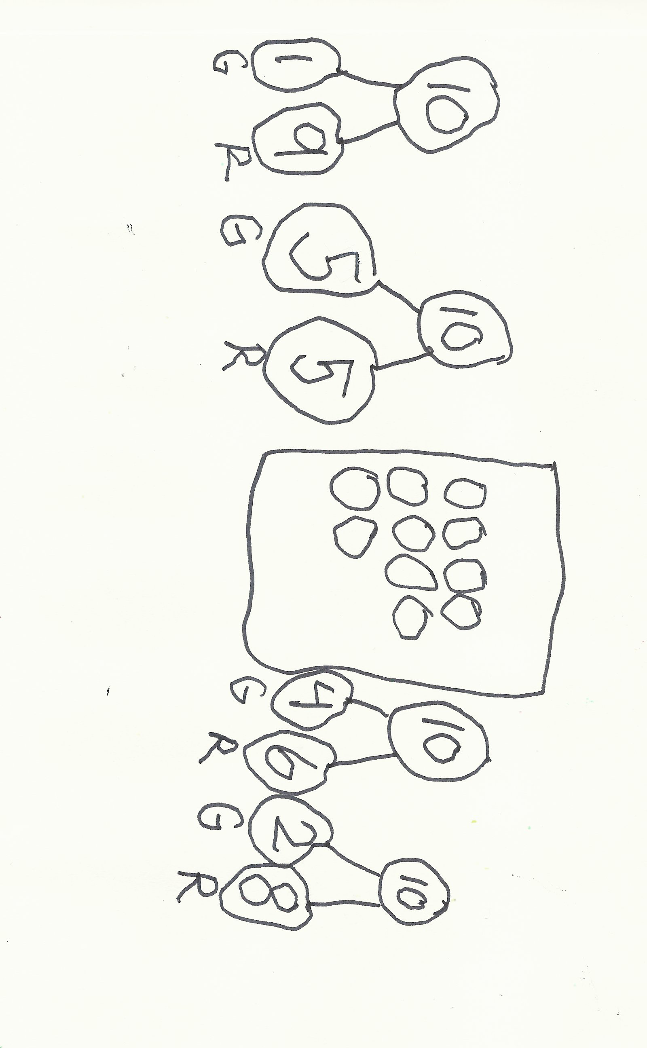Sammy’s mom has 10 apples in a bag. Some are red and some are green. What might be the number of each color apple in her bag? There is more than one possible answer. See how many different answers can be found. Show the answers with number bonds. Label the parts as R and G.

|  |  |
| --- | --- |
|  | NOTES ON  MULTIPLE MEANS  OF ACTION AND EXPRESSION: |
| Challenge students who are working above grade level to model all nine possible solutions for the Application Problem and to explain both orally and in writing how all nine possibilities are a response to the same problem. | |

Note: In this lesson, the Application Problem precedes the Fluency Practice because the fluency activities lead directly into the counting of the lesson.

Fluency Practice (10 minutes)

* 5-Frame Flashes **K.OA.5** (4 minutes)
* Count Out Teen Numbers **K.CC.1** (4 minutes)
* Count Within Tens **K.CC.1** (2 minutes)

5-Frame Flashes (4 minutes)

Materials: (T) Large 5-frame cards (Lesson 1 Fluency Template 1)

Note: Reviewing compositions of 5 leads to proficiency with the Core Fluency for the grade, **K.OA.5**, add and subtract within 5.

T: (Show 4 dots.) How many dots do you see?

|  |  |
| --- | --- |
|  | NOTES ON  MULTIPLE MEANS  OF REPRESENTATION: |
| 5-Frame Flashes foster English language learners’ number sense and ability to speak about math in English. Review number words by counting the dots, if necessary. Tailor the sequence according to the students’ needs, repeating flashes when necessary. | |

S: 4.

T: How many more to make 5?

S: 1.

T: Say the addition sentence.

S: 4 + 1 = 5.

Continue with the following possible sequence: 1, 3, 2, 5, 0,   
4, 2.

Count Out Teen Numbers (4 minutes)

Materials: (S) 1 bag of about 20 objects per pair of students, personal white board

Note: This activity provides students with concrete practice decomposing teen numbers into ten ones and some additional ones.

**MP.2**

T: Count 13 items out of your bag.

T: Separate them into two parts—one part with 10 and another part. Write the number on your personal white board.

Repeat this process for four or five other amounts.

Count Within Tens (2 minutes)

T: Let’s count starting at 20.

Note: This activity gives students practice counting by ones within the decades to prepare them to count across the decades in today’s Concept Development.

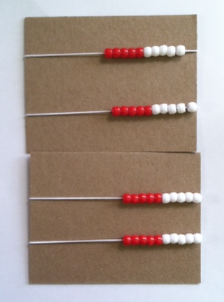Guide the students, counting from 20 to 29, occasionally changing directions. Repeat for 50–59 and 80–89.

Concept Development (25 minutes)

Materials: (S) Personal Rekenrek (from Lesson 10)

T: Put your Rekenrek together with your partner’s.

T: Move all your beads to the right-hand side.

T: Count your beads by ones. Partner A, move the first row. Both of you whisper each number as you move your beads from right to left.

S: (Moving beads with partner.) 1, 2, 3, 4, 5, 6, 7, 8, 9, 10.

T: Say the number.

S: 10.

T: Partner B moves the beads of the second row one at a time. What is the first number we will say? Say it the Say Ten Way.

S: Ten 1.

T: How do we say the number the regular way?

S: 11.

|  |  |
| --- | --- |
|  | NOTES ON  MULTIPLE MEANS  OF ACTION AND EXPRESSION: |
| Counting with the Rekenrek is great for students working below grade level who will benefit from practicing one-to-one correspondence, the support of a peer, and the lesson’s frequent checks for understanding. To avoid miscounting, encourage deliberate counting through song or rhythm. | |

T: Count the second row starting with eleven. Move your beads one at a time, and whisper the numbers.

S: (Moving the beads.) 11, 12, 13, 14, 15, 16, 17, 18, 19, 20.

T: What is the number the Say Ten Way?

S: 2 tens.

T: Now, it’s Partner A’s turn. Move one bead on the next row. What is the number the Say Ten Way?

S: 2 tens one.

T: Say it the regular way.

S: 21.

T: Keep counting the regular way.

S: (Moving the beads.) 22, 23, 24, 25, 26, 27, 28, 29, 30.

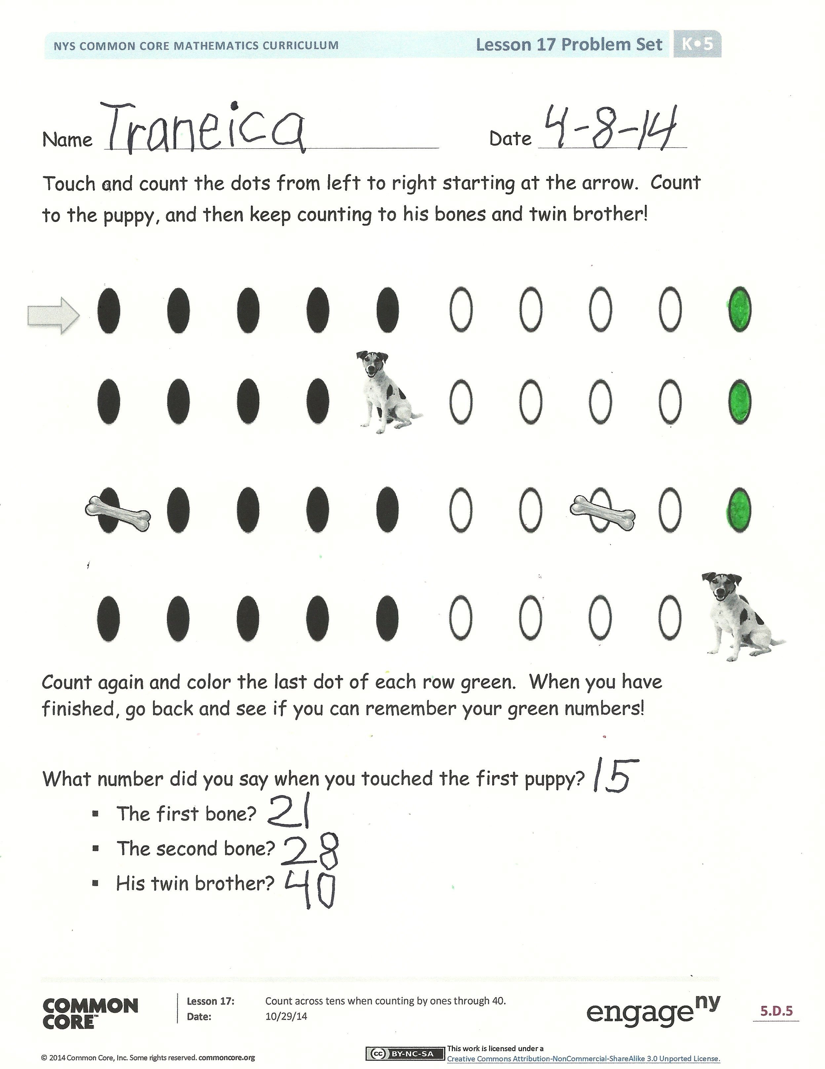T: What is the number the Say Ten Way?

S: 3 tens.

Continue to 40 in this manner. Then, ask students to count to 40 on their own with their partner. To add excitement to this exercise, students can speak the last bead of each row loudly.

Problem Set (7 minutes)

Students should do their personal best to complete the Problem Set within the allotted time.

Note: In this Problem Set, students write numbers to 100, which bridges to the Grade 1 standard, **1.NBT.1**. The Kindergarten standard requires students to write numbers only to 20.

Student Debrief (8 minutes)

**Lesson Objective:** Count across tens when counting by ones through 40.

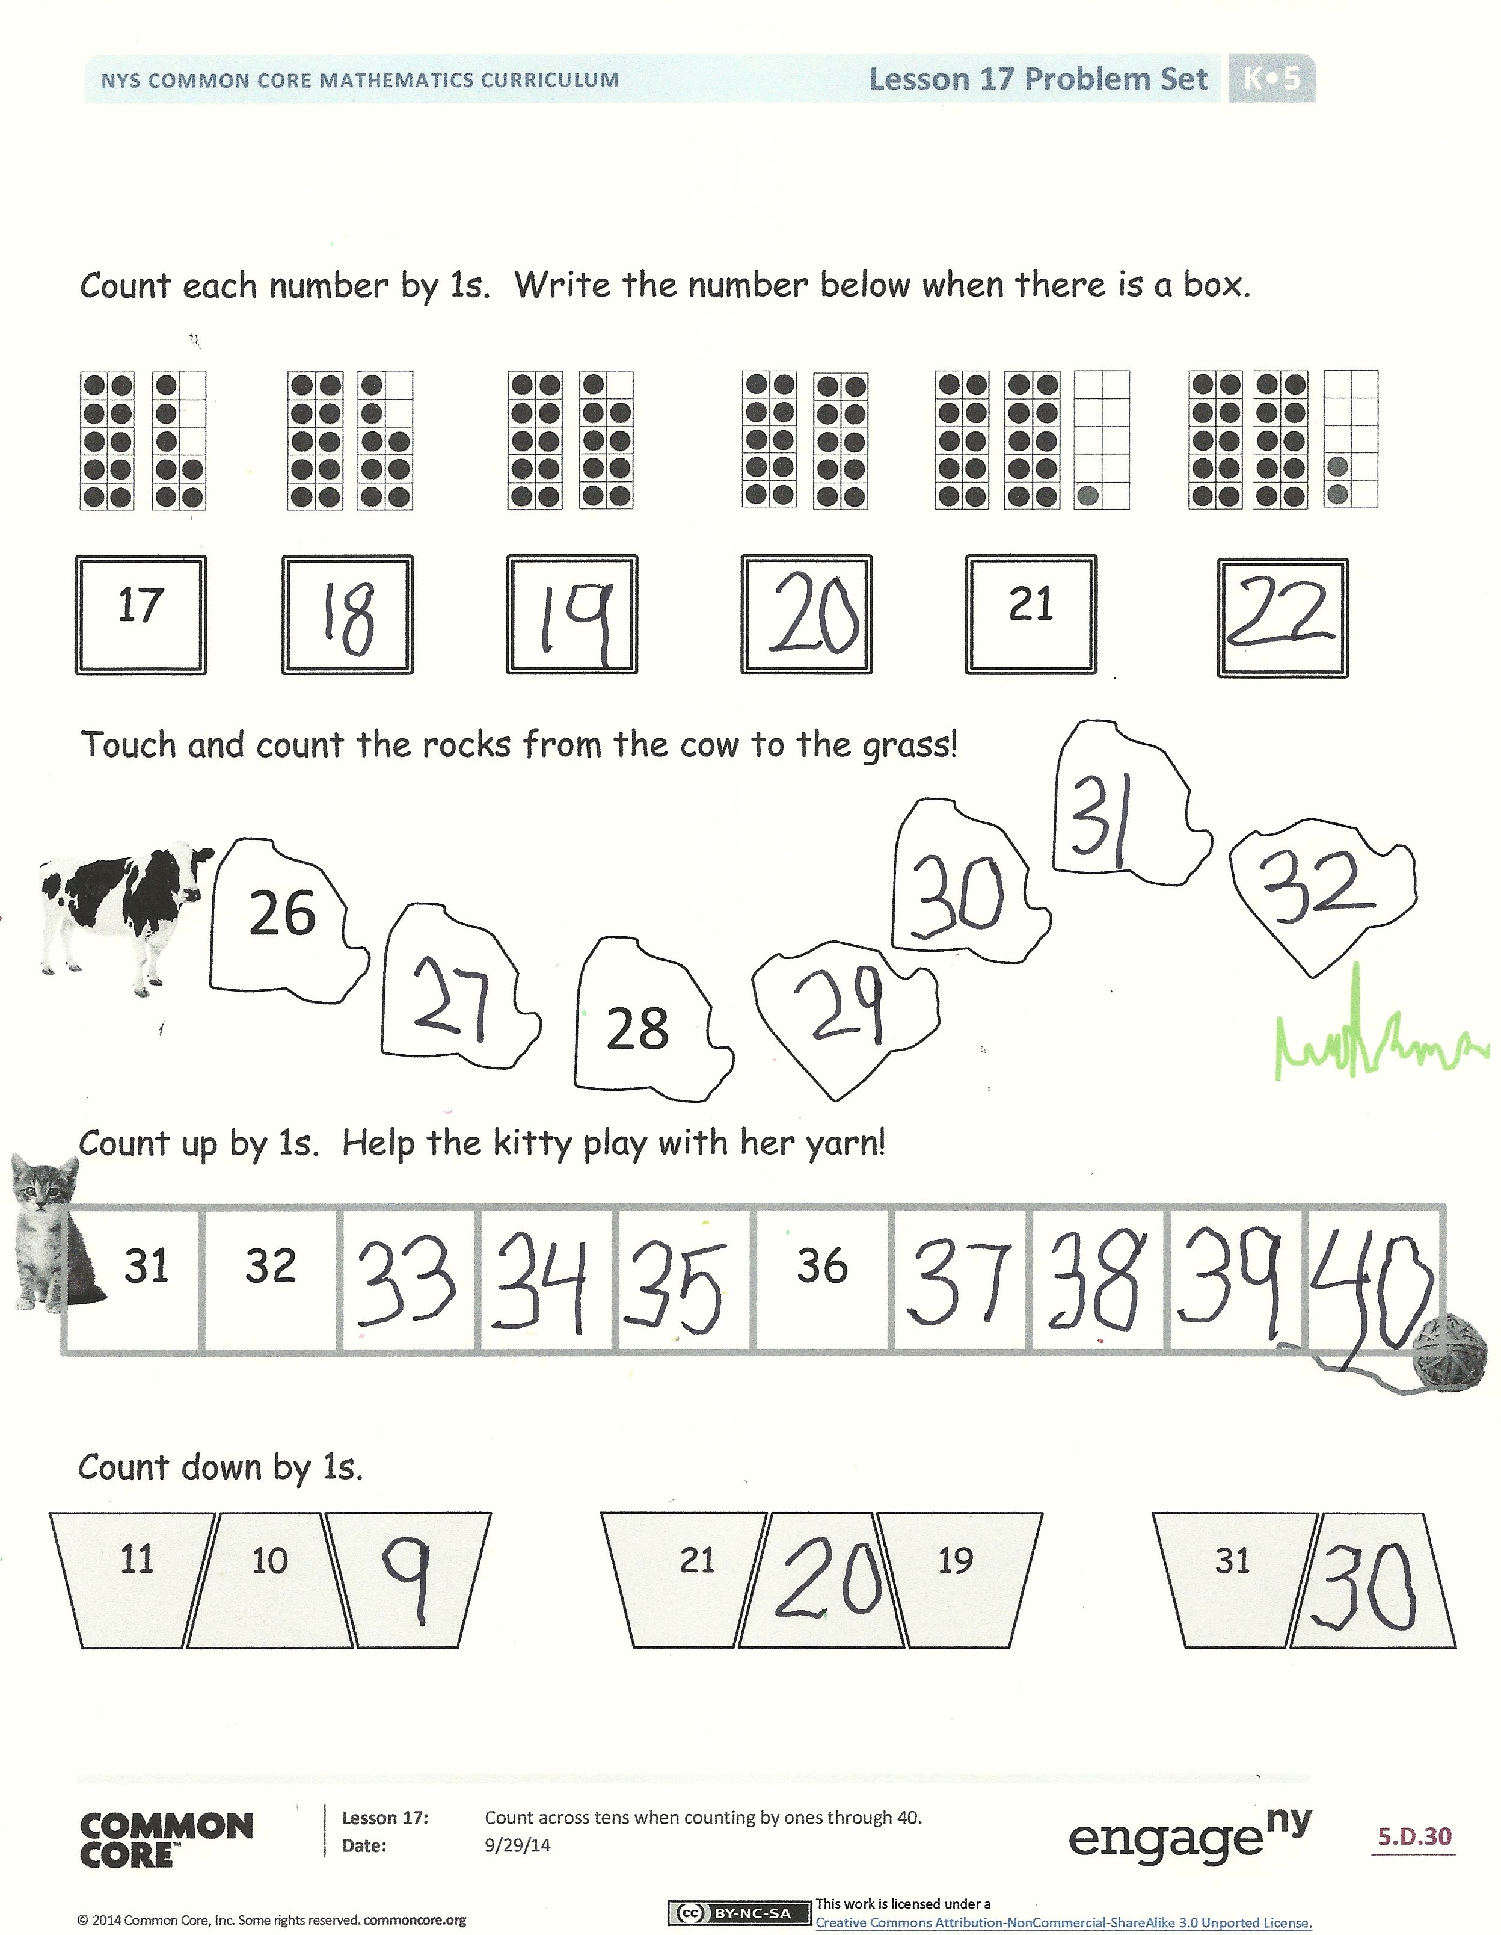The Student Debrief is intended to invite reflection and active processing of the total lesson experience. Invite students to review their solutions for the Problem Set. They should check work by comparing answers with a partner before going over answers as a class, taking turns reading the numbers forward and back. Look for misconceptions or misunderstandings that can be addressed in the Debrief. Guide students in a conversation to debrief the Problem Set and process the lesson.

Any combination of the suggestions below may be used to lead the discussion.

* Touch and count each series of numbers, pointing out that students read from left to right as they do when reading.
* Read each series of numbers in a different voice, like an elf, like a giant, like a witch, as a crescendo, etc. Adding drama makes the learning memorable and fun!
* Count across ten from various starting points using the Rekenrek.

Exit Ticket (3 minutes)

After the Student Debrief, instruct students to complete the Exit Ticket. A review of their work will help with assessing students’ understanding of the concepts that were presented in today’s lesson and planning more effectively for future lessons. The questions may be read aloud to the students.

Name Date

Touch and count the dots from left to right starting at the arrow. Count to the puppy, and then keep counting to his bones and twin brother!

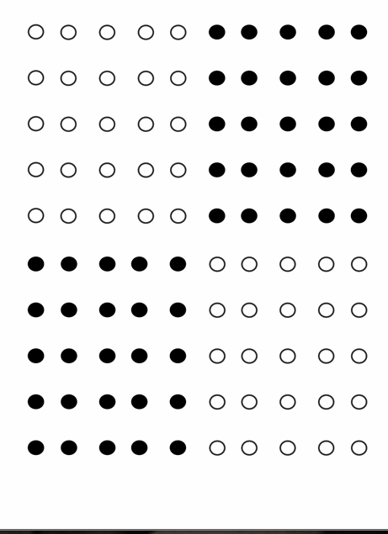

Count again and color the last dot of each row green. When you have finished, go back and see if you can remember your green numbers!

What number did you say when you touched the first puppy?

* The first bone?
* The second bone?
* His twin brother?

Count each number by 1s. Write the number below when there is a box.

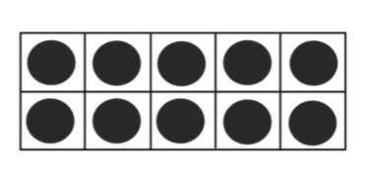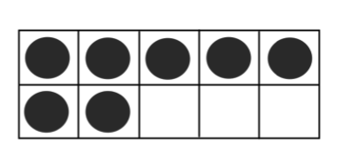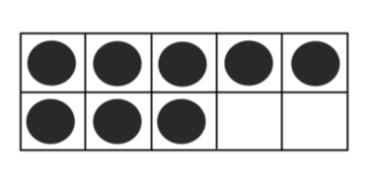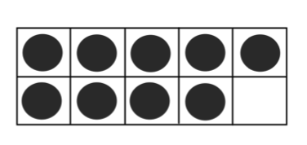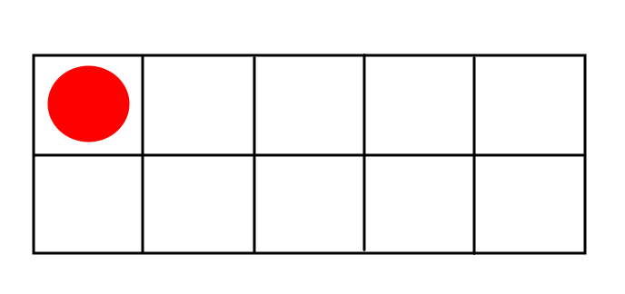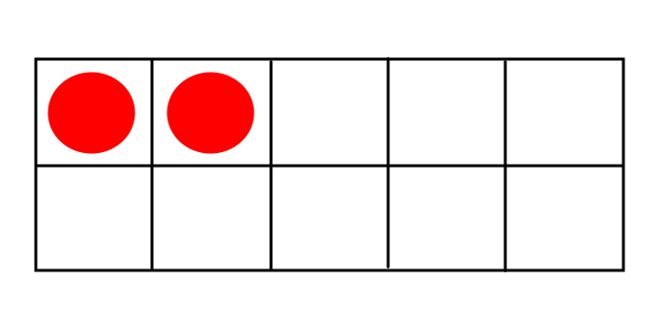

21

17

Touch and count the rocks from the cow to the grass!



26

28

31

32

36

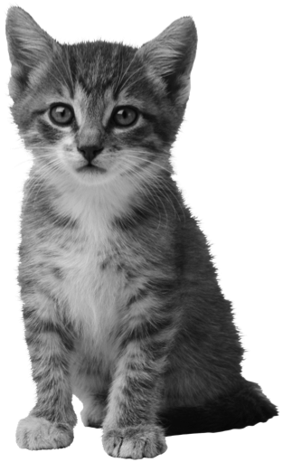Count up by 1s. Help the kitty play with her yarn!

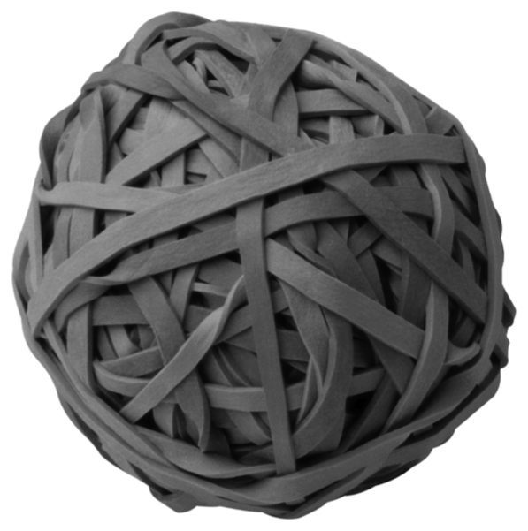

Count down by 1s.

11 10 21 19 31

Name Date

Touch and count carefully. Cross out the mistake, and write the correct number.

Example:

1, 2, 9, 4, 5

|  |  |  |  |  |  |  |
| --- | --- | --- | --- | --- | --- | --- |
| C:\Program Files (x86)\Microsoft Office\MEDIA\CAGCAT10\j0212957.wmf  20 | 21 | 22 | 23 | 24 | 25 | 29 |

|  |  |  |  |  |  |  |
| --- | --- | --- | --- | --- | --- | --- |
| C:\Users\Mario and Mel\AppData\Local\Microsoft\Windows\Temporary Internet Files\Content.IE5\RW8ETJZ9\MC900413498[1].wmf  30 | 31 | 32 | 33 | 43 | 35 | 36 |

|  |  |  |  |  |  |  |
| --- | --- | --- | --- | --- | --- | --- |
| C:\Users\Mario and Mel\AppData\Local\Microsoft\Windows\Temporary Internet Files\Content.IE5\76LXQHCV\MC900383374[1].wmf  25 | 26 | 27 | 28 | 29 | 29 | 31 |

|  |  |  |  |  |  |  |
| --- | --- | --- | --- | --- | --- | --- |
| C:\Users\Mario and Mel\AppData\Local\Microsoft\Windows\Temporary Internet Files\Content.IE5\RW8ETJZ9\MC900388712[1].wmf  34 | 35 | 36 | 37 | 38 | 39 | 44 |

|  |  |  |  |  |  |
| --- | --- | --- | --- | --- | --- |
| 5   |  |  |  |  |  | | --- | --- | --- | --- | --- | |  |  |  |  |  | |

Name Date

Draw more to show the number.

Example:

|  |  |  |  |  |  |  |  |  |  |  |  |  |  |  |  |  |  |  |  |  |  |  |  |  |  |  |  |  |  |  |
| --- | --- | --- | --- | --- | --- | --- | --- | --- | --- | --- | --- | --- | --- | --- | --- | --- | --- | --- | --- | --- | --- | --- | --- | --- | --- | --- | --- | --- | --- | --- |
| 23   |  |  |  |  |  | | --- | --- | --- | --- | --- | |  |  |  |  |  | |  |  |  |  |  |  |  |  |  |  |  | | --- | --- | --- | --- | --- | |  |  |  |  |  | |  |  |  |  |  |  |  |  |  |  |  | | --- | --- | --- | --- | --- | |  |  |  |  |  | |  |  |  |  |  | |
|  |
| 27   |  |  |  |  |  | | --- | --- | --- | --- | --- | |  |  |  |  |  | |  |  |  |  |  |  |  |  |  |  |  | | --- | --- | --- | --- | --- | |  |  |  |  |  | |  |  |  |  |  |  |  |  |  |  |  | | --- | --- | --- | --- | --- | |  |  |  |  |  | |  |  |  |  |  | |
|  |
| 34   |  |  |  |  |  | | --- | --- | --- | --- | --- | |  |  |  |  |  | |  |  |  |  |  |  |  |  |  |  |  | | --- | --- | --- | --- | --- | |  |  |  |  |  | |  |  |  |  |  |  |  |  |  |  |  | | --- | --- | --- | --- | --- | |  |  |  |  |  | |  |  |  |  |  |  |  |  |  |  |  | | --- | --- | --- | --- | --- | |  |  |  |  |  | |  |  |  |  |  | |

|  |
| --- |
| 38  C:\Users\Mario and Mel\AppData\Local\Microsoft\Windows\Temporary Internet Files\Content.IE5\H9AYQF09\MC900446228[1].wmf C:\Users\Mario and Mel\AppData\Local\Microsoft\Windows\Temporary Internet Files\Content.IE5\H9AYQF09\MC900446228[1].wmf C:\Users\Mario and Mel\AppData\Local\Microsoft\Windows\Temporary Internet Files\Content.IE5\H9AYQF09\MC900446228[1].wmf C:\Users\Mario and Mel\AppData\Local\Microsoft\Windows\Temporary Internet Files\Content.IE5\H9AYQF09\MC900446228[1].wmf C:\Users\Mario and Mel\AppData\Local\Microsoft\Windows\Temporary Internet Files\Content.IE5\H9AYQF09\MC900446228[1].wmf C:\Users\Mario and Mel\AppData\Local\Microsoft\Windows\Temporary Internet Files\Content.IE5\H9AYQF09\MC900446228[1].wmf C:\Users\Mario and Mel\AppData\Local\Microsoft\Windows\Temporary Internet Files\Content.IE5\H9AYQF09\MC900446228[1].wmf C:\Users\Mario and Mel\AppData\Local\Microsoft\Windows\Temporary Internet Files\Content.IE5\H9AYQF09\MC900446228[1].wmf C:\Users\Mario and Mel\AppData\Local\Microsoft\Windows\Temporary Internet Files\Content.IE5\H9AYQF09\MC900446228[1].wmf C:\Users\Mario and Mel\AppData\Local\Microsoft\Windows\Temporary Internet Files\Content.IE5\H9AYQF09\MC900446228[1].wmf |
| 40 |