Lesson 16
Objective: Count within tens by ones.

Suggested Lesson Structure

A NOTE ON
STANDARDS ALIGNMENT:
In this lesson, students write numbers through 100, which bridges Kindergarten content of writing numbers to 20 (K.CC.3) to Grade 1 content of writing numbers to 120 (1.NBT.1).

 Fluency Practice (12 minutes)
 Application Problem (5 minutes)
 Concept Development (25 minutes)
 Student Debrief (8 minutes)
Total Time (50 minutes)
Fluency Practice (12 minutes)
- Hide Zero for Teen Numbers K.NBT.1 (7 minutes)
- Count by Tens the Say Ten Way K.CC.1 (2 minutes)
- Count with Ten-Frame Cards K.CC.1 (3 minutes)
Hide Zero for Teen Numbers (7 minutes)
Materials: (S) Hide Zero cards (Lesson 6 Template) and interesting counters
Note: This activity provides practice with counting out 11–20 objects. Circulate around the classroom as students work, and observe how they organize their objects as they count. For students who are struggling to count accurately, consider suggesting they count out a pile of ten first, before counting out the additional ones. Some students might benefit from arranging their objects in a 5-group formation to match the cards.
Give each pair of students a set of Hide Zero cards, and have them place the number 10 in the middle. One partner gets 4 of the cards numbered 1–9, and the other partner gets the remaining 5 cards. The player with 5 cards puts one of his cards down on the ten. The other partner counts out that many interesting counters (shells, rocks, pennies). They then reverse roles.
Count by Tens the Say Ten Way (2 minutes)
Materials: (T) 100-bead Rekenrek
Note: This activity allows students to see the rows of ten increase and decrease as they count the Say Ten Way.
T: (Show 10 on the Rekenrek.) Say the number you see.
S: Ten.
T: (Show 2 tens on the Rekenrek.) Say the number the Say Ten Way.
S: 2 tens.
Work toward 100 and back to zero, occasionally changing direction.
Count with Ten-Frame Cards (3 minutes)
Materials: (S) Small ten-frame cards (Lesson 15 Template 2)
Note: This activity provides a visual representation that each ten is composed of ten ones. Students make the connection between pictorial and abstract numbers as they count the Say Ten Way.
T: Place a ten-frame card in front of you.
S: (Students place a ten-frame card in front of them.)

NOTES ON
MULTIPLE MEANS
OF ACTION AND EXPRESSION:
Let students who are working above grade level work independently or at a center in a small group. Give them many ten-frame cards since they may be able to go far beyond the rest of the class.

T: Say the number.
S: Ten.
T: Place another ten-frame card in front of you.
S: (Students place a second ten-frame card in front of them.)
T: Say the number the Say Ten Way.
S: 2 tens.
Continue with this possible sequence: 3 tens, 4 tens, 5 tens, 6 tens, 7 tens, 8 tens, 9 tens, and 10 tens.
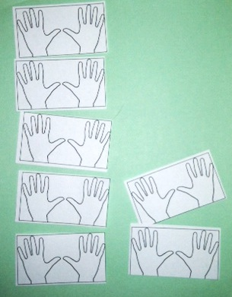
Application Problem (5 minutes)
Materials: (S) 2 hand cards (Template)
The students in Pre-Kindergarten are making handprints. 7 students are putting their handprints on a poster board. How many fingers will show on the poster? Use the handprint cards to help find out.
Note: This Application Problem is designed to help students make the natural connection between tens and their fingers.
Concept Development (25 minutes)
Materials: (T) 10 pieces of tagboard (S) Small ten-frame cards (Lesson 15 Template 2) and 9 counters
Demonstrate the following before having students do it with a partner:

Students count up from 0 to 9. When done, have them raise their hands to receive a ten-frame. They remove the nine counters the moment they are given the ten-frame. They then count from 10 to 19. Then, hand them a new ten-frame as they remove the 9 counters, and have them count from 20 to 29. Do not mention trading or regrouping. For now, just tell the students that when they have counted to 29—or 39 or 49 or 59, etc.—to clear off all the ones, and they will be given a new card of 10 ones. Show students how what they know about counting to 9 will help them count much larger numbers! The Say Ten Way really shows that correlation.

NOTES ON
MULTIPLE MEANS
OF REPRESENTATION:
Support English language learners by alternating between Say Ten counting and regular counting. When the students are using their ten-frames and counters, have them whisper count. Puppets can help diffuse performance anxiety, too. One partner places the counters while the other partner controls the puppet, which counts.

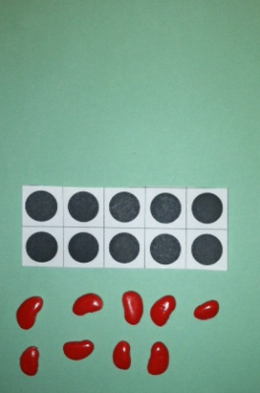
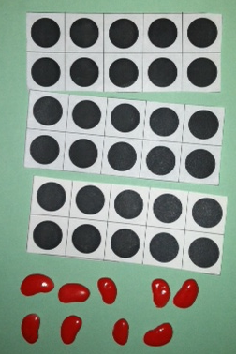
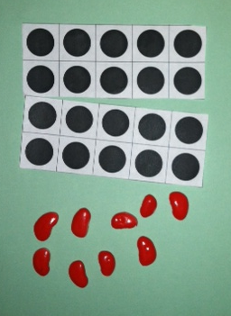

Group Activity:
T: (Create a path by laying the pieces of tagboard across the floor like stepping stones. Have fun creating a story with the students about what is at the end of the path.) There’s a magic pot at the end of this path, and if you can reach it, you can wish for anything you want! But to get there, you have to count in order from 30 to 39 or 40 to 49 or 50 to…?
S: 59.
T: From 60 to…?
S: 69.
T: Who would like to try to reach the magic pot? We’ll help you count so you can get there.
T: (Choose a student, and then write 30 on the board.) Let’s help Miles count, starting at 30.
S: (As student steps on each “stone.”) 30, 31, 32, 33, 34, 35, 36, 37, 38, 39.
T: He made it! What did you wish for? (Allow a quick response.)
T: Who would like to go next?
T: (Choose another student, and then write 50 on the board.)
T: Let’s help Victoria get to the magic pot!
S: 50, 51, 52, 53, 54, 55, 56, 57, 58, 59.
T: Victoria made it to the pot! What did you wish for?
Give 2 to 3 students a chance to walk the path to the magic pot, changing the start number each time to a larger number. Students count chorally and get excited by counting to larger numbers.
Afterward, remove 5 stepping stones. Start counting to the magic pot from 35 to 39, 45 to 49, and 75 to 79. Next, put 2 more stepping stones back, and start counting to the pot from 23, 53, 83, and 93. Again, only count up to the number with nine in the ones place. Students will be blurting out and wanting to say the multiple of ten, but if they do, it means they can’t get to the magic pot! This creates suspense and enhances students’ desire to know those numbers, which are covered in Lesson 18.
Problem Set (5 minutes)
Now that the students have worked with the numbers orally and with concrete materials, on the Problem Set they model with mathematics with the abstract number.
MP.4
Students should do their personal best to complete the Problem Set within the allotted time.
Note: This Problem Set asks students to write numbers greater than 20, which is a Grade 1 standard (1.NBT.1). If the students are not ready for this step, consider having them use numeral cards or simply say the amount pictured.
Student Debrief (8 minutes)
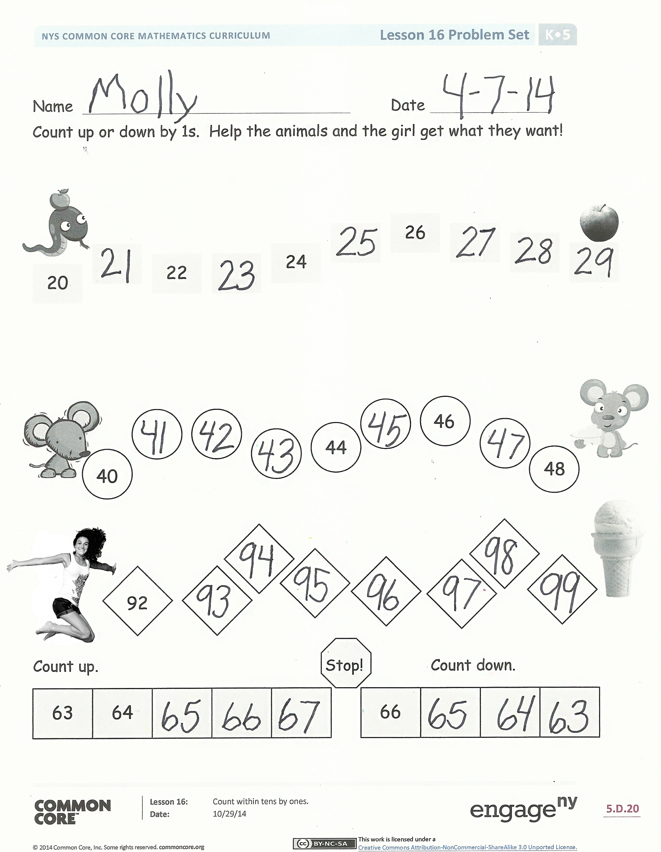
Lesson Objective: Count within tens by ones.
The Student Debrief is intended to invite reflection and active processing of the total lesson experience.
Invite students to review their solutions for the Problem Set. They should check work by comparing answers with a partner before going over answers as a class, taking turns reading the numbers forward and back. Look for misconceptions or misunderstandings that can be addressed in the Debrief. Guide students in a conversation to debrief the Problem Set and process the lesson.
Any combination of the questions below may be used to lead the discussion.
- Look at the numbers in the first row on your Problem Set. What is the same about the numbers? What is different?
- Use the Rekenrek to practice more counting within a sequence. Possibly count from 63 to 69, 72 to 79, and 84 to 89.
Exit Ticket (3 minutes)
After the Student Debrief, instruct students to complete the Exit Ticket. A review of their work will help with assessing students’ understanding of the concepts that were presented in today’s lesson and planning more effectively for future lessons. The questions may be read aloud to the students.

Name Date
Count up or down by 1s. Help the animals and the girl get what they want!

20

24
26

22

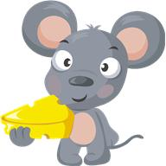
46
44
40
48

98

99
92

Count up. Stop! Count down.

66

64
63

Name Date
Help the cow get to the barn by counting by 1s.
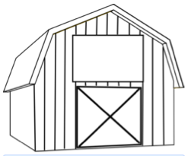

58
52
53

Help the boy get to his present. Count up by 1s. When you get to the top, count down by 1s.

31

32

Name Date
Help the rabbit get his carrot. Count by 1s.
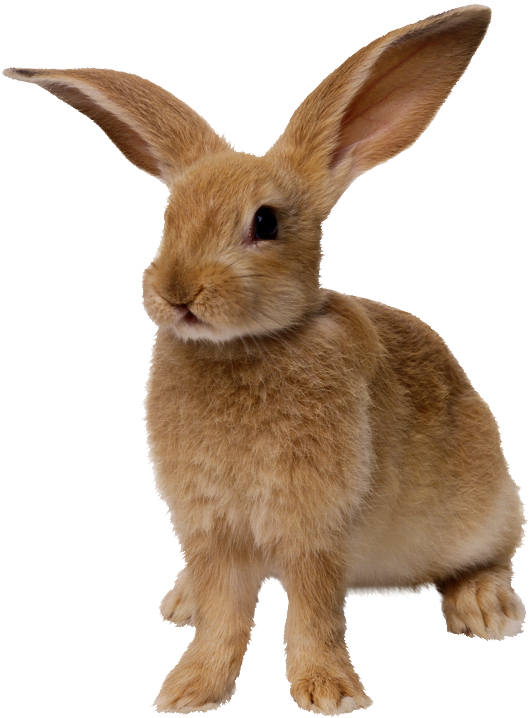

75
98
71

14
16

12

Count up by 1s, then down by 1s.
 |  | 89 |  |  |  |  | 35
 | 84 |  |  |  |  | 30

Help the boy mail his letter. Count up by 1s. When you get to the top, count down by 1s.

97

96

2 hand cards

