Lesson 14
Objective: Show, count, and write to answer how many questions with up to 20 objects in circular configurations.

Suggested Lesson Structure
  Fluency Practice (9 minutes)
 Application Problem (7 minutes)
 Concept Development (26 minutes)
 Student Debrief (8 minutes)
Total Time (50 minutes)
Fluency Practice (9 minutes)
- Write Teen Numbers with Arrays K.CC.3 (3 minutes)
- Hide Zero for Teen Numbers K.NBT.1 (3 minutes)
- Teen Counting Array Template K.CC.5 (3 minutes)
Write Teen Numbers with Arrays (3 minutes)
Materials: (T) Pre-drawn arrays (S) Personal white board
Note: Now that counting in arrays with teen numbers has been introduced, the goal is to develop speed and accuracy. Encourage students to locate 2 fives, or a group of 10, within each array to facilitate counting.
T: (Project a 5 by 3 array of stars.) On your personal white boards, write the number of stars you see.
S: (Students write 15.)
T: Say the number the Say Ten Way.
S: Ten 5.
T: Say the number the regular way.
S: 15.
Repeat the process for three or four other teen numbers.
Hide Zero for Teen Numbers (3 minutes)
Materials: (T) Hide Zero cards (Lesson 6 Template)
Note: This activity reminds students that the 1 in teen numbers refers to 10 ones, preparing them for answering how many questions in writing.
T: (Hold the 10 card and 5 card so that it appears as 15.) Say the number.

NOTES ON
MULTIPLE MEANS
OF ACTION AND EXPRESSION:
Scaffold the Application Problem for English language learners by adding gestures when reading the Application Problem. Hold both arms straight out when reading “rows,” and make a large circle with both arms while reading the direction “circle the 10.”

S: 15.
T: Say the number the Say Ten Way.
S: Ten 5.
Break apart the cards into 10 and 5. Repeat the process for other teen numbers.
Teen Counting Array Template (3 minutes)
Materials: (S) Teen counting array (Fluency Template)
Note: Repeated experiences with counting in arrays lead students to efficiency over time. Guide students to see 10 as 2 fives to determine the total skillfully.
Distribute teen counting array (Fluency Template). Have students count how many are in each array.
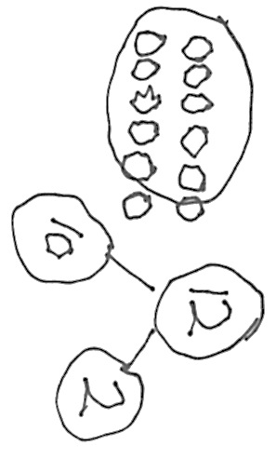
Application Problem (7 minutes)
Eva put her 12 cookies on her cookie sheet in 2 rows of 6. Draw Eva’s cookies. Show her 12 cookies as a number bond of 10 ones and 2 ones using your Hide Zero cards. Then, find and circle the 10 cookies that are inside the 12 cookies.
Have the students explain how the parts of the number bond match the parts of their drawing and the Hide Zero cards with a partner.
Note: This Application Problem serves as a bridge from the previous lesson’s focus on organizing and counting objects in an array configuration. It also reviews the grade-level standard of understanding teen numbers as ten ones and some more ones.
NOTES ON
MULTIPLE MEANS
OF ACTION AND EXPRESSION:
For students working below grade level, scaffold Concept Development work. Provide a plate with 20 empty circles drawn around the edge. This will serve as a visual container for students when they are showing numbers up to 20. For further support, label the circles with numbers 1–20 to help students with sorting.

Concept Development (26 minutes)
Materials: (S) Per pair of students: Numeral cards from 10–20, paper plate or round mat, bag of 20 counting
objects; double ten-frame mat (Lesson 9 Template) inside a personal white board for each student
T: Let’s see how well you can show, count, and write numbers!
T: Partner A, draw a card and tell your partner the number. You can say the number the regular way or the Say Ten Way.

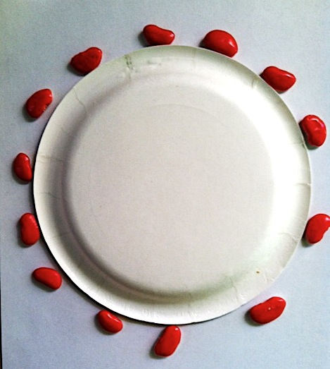
T: Partner B, put that number of objects around the outside edge of your plate. (Guide them to use the edge of the plate to make a circular configuration.)
T: Now, take turns counting the objects. How many are there?
T: Partner B, now you get to draw the card, and Partner A will show it.
T: Count the objects. How many are there?
Repeat the process two or three times.
T: Let’s try something different. We won’t use the number cards for this.
T: Partner A, put any number of objects you want in a circle around the edge of your plate.
T: Partner B, count the objects and write the number on your personal white board.
T: Now, Partner B gets to put any number of objects in a circle around the edge of the plate, and Partner A counts them and writes the number on her personal white board.
Repeat the process two or three times.
T: This time, Partner A, write any number between 11 and 20 on your personal white board. Partner B, count out that many objects as you place them in a circle around the edge of the plate. How many objects are there?
T: Partner A, count each object as you move it from the circle to the ten-frame to check that the count is correct. How many objects are there?
T: Now, Partner B, you get to write any number between 11 and 20 on your personal white board. Partner A, count out that many objects as you place them in a circle around the edge of the plate. How many objects are there?
T: Partner B, count each object as you move it from the circle to the ten-frame to check that the count is correct. How many objects are there?
Repeat the process two or three times.
Before using the Problem Set, have students use the plate to draw dots in a circular shape and count each other’s dots. Have them circle 10 dots to prove that they counted correctly (as pictured below).
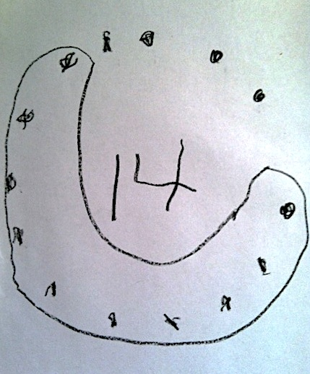
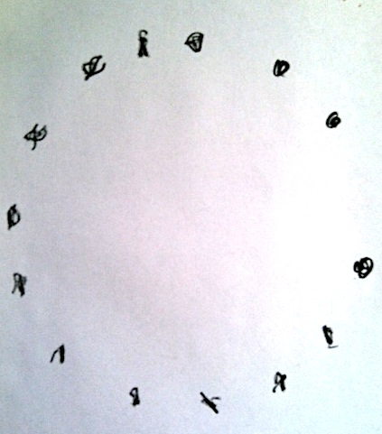

Problem Set (7 minutes)
Students should do their personal best to complete the Problem Set within the allotted time.
Student Debrief (8 minutes)

NOTES ON
MULTIPLE MEANS
OF ENGAGEMENT:
For students working above grade level, provide an opportunity for deeper understanding.
- Ask students how many different ways they can count the objects.
- Possible answers can be as follows: by ones, by twos, by threes, and by counting a ten and then counting the remaining objects.

Lesson Objective: Show, count, and write to answer how many questions with up to 20 objects in circular configurations.
The Student Debrief is intended to invite reflection and active processing of the total lesson experience.
Invite students to review their solutions for the Problem Set. They should check work by comparing answers with a partner before going over answers as a class. Look for misconceptions or misunderstandings that can be addressed in the Debrief. Guide students in a conversation to debrief the Problem Set and process the lesson.
Any combination of the questions below may be used to lead the discussion.
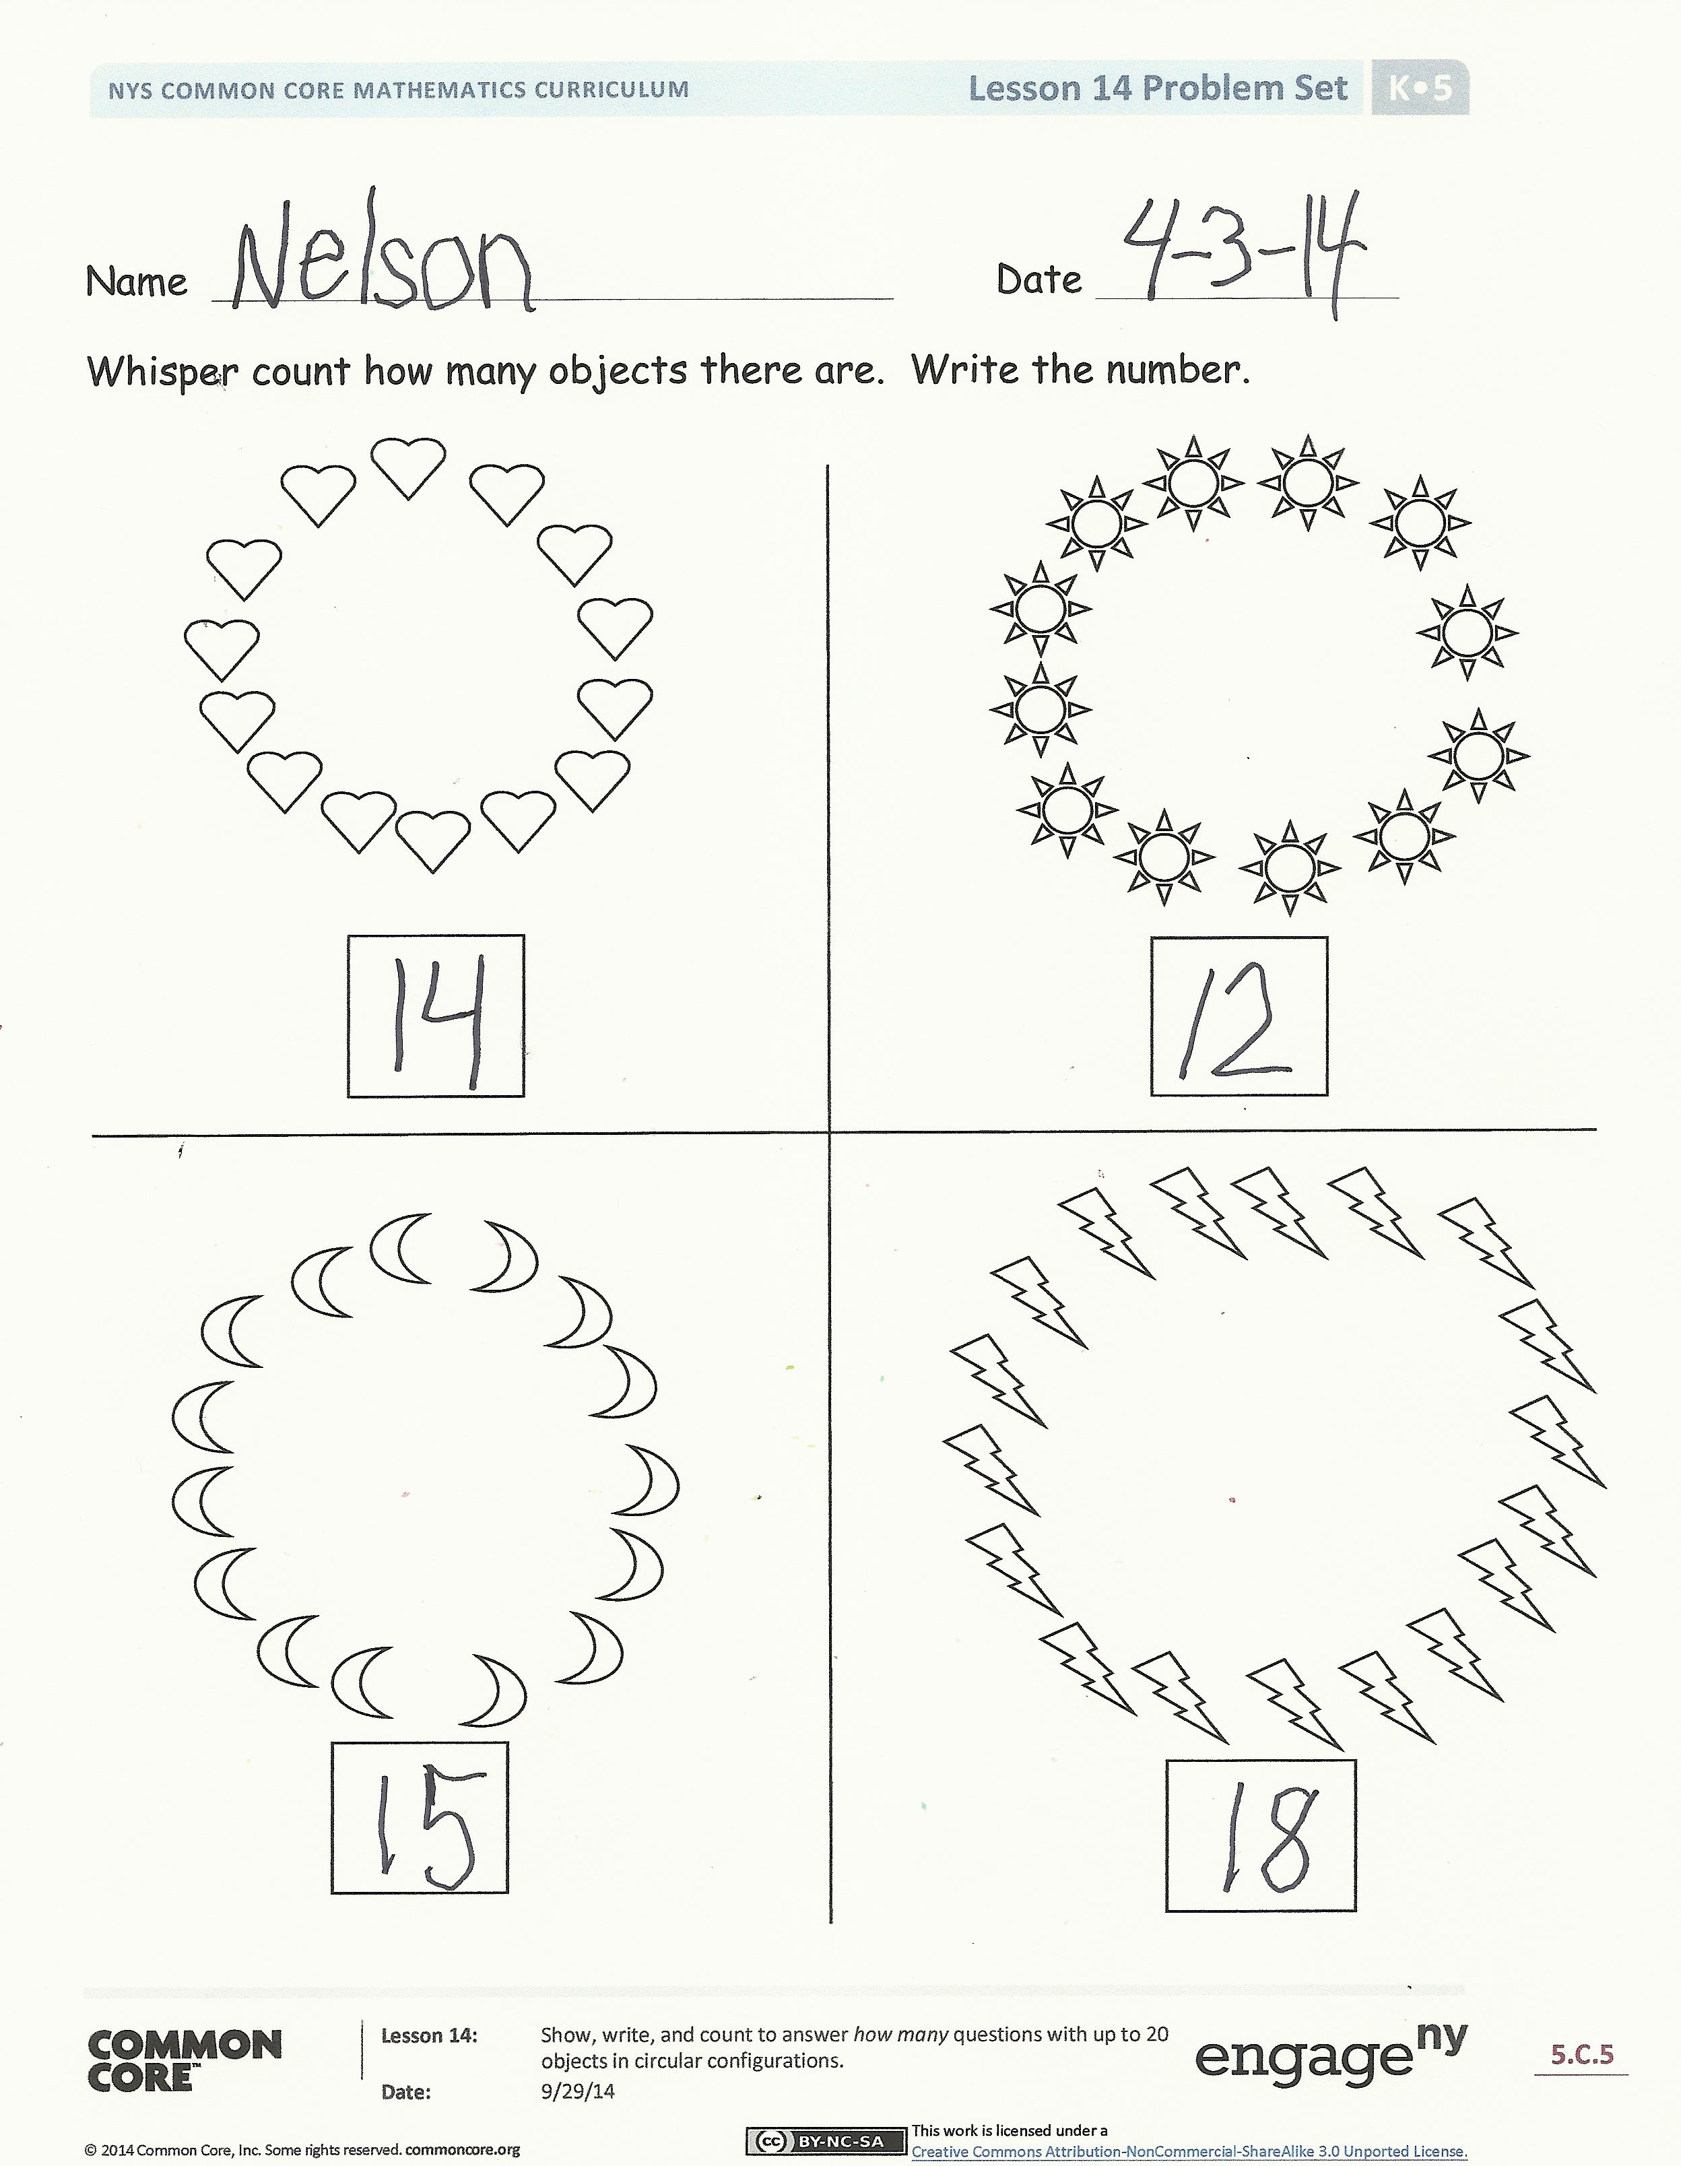
- What do you notice about all of the pictures?
- Is it easier or harder for you to count objects when they are in circles like these pictures? Why?
- Which way is easier for you to count—when we show the number in a circle or when we show it as a tower? Why?
- Did the number change when you moved the objects from the circle to the ten-frame? Why not?
- (Show objects in a circle configuration, and have students count how many. Then, slide the objects to change the circle into a line.) How can you prove that the number is still the same? Tell your partner. Did he prove it to you? What are some ways you proved it? Which ways were the most convincing?
MP.3

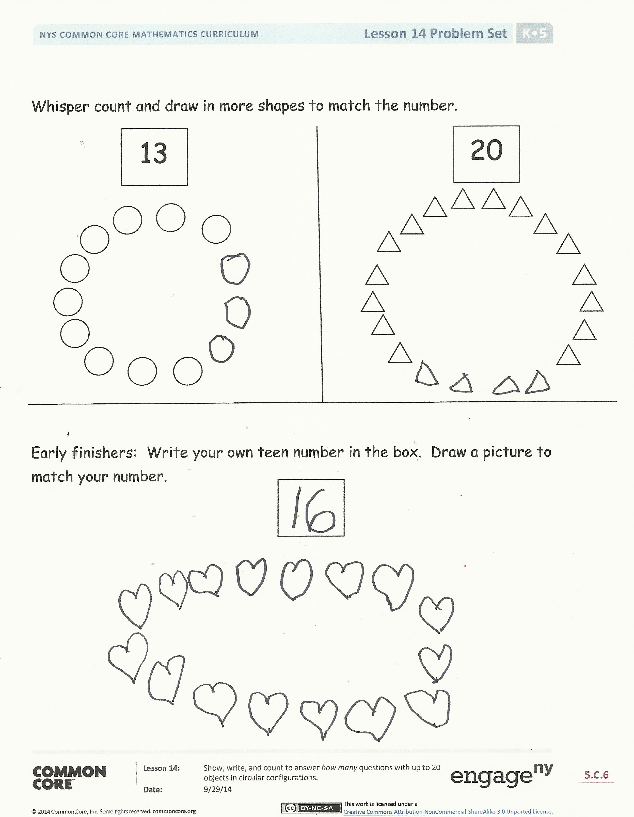
Exit Ticket (3 minutes)
After the Student Debrief, instruct students to complete the Exit Ticket. A review of their work will help with assessing students’ understanding of the concepts that were presented in today’s lesson and planning more effectively for future lessons. The questions may be read aloud to the students.

Name Date
Whisper count how many objects there are. Write the number.

Whisper count and draw in more shapes to match the number.
20
13

Early finishers: Write your own teen number in the box. Draw a picture to match your number.

Name Date
Count the stars. Write the number in the box.

Whisper count and draw in more dots to match the number.
15

Name Date
Count the objects in each group. Write the number in the boxes below the pictures.

Count and draw in more shapes to match the number.
19
Count the dots. Draw each dot in the ten-frame. Write the number in the box below the ten-frames.

Write a teen number in the box below. Draw a picture to match your number.

Name Date
Count the objects in each group and write the number.

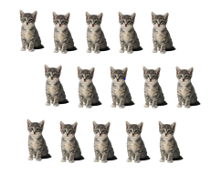
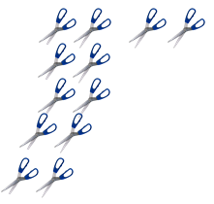

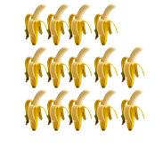

teen counting array

