Lesson 12
Objective: Represent numbers 20 to 11 in tower configurations decreasing by 1—a pattern of 1 smaller.

Suggested Lesson Structure
 Fluency Practice (9 minutes)
 Application Problem (7 minutes)
 Concept Development (26 minutes)
 Student Debrief (8 minutes)
Total Time (50 minutes)
Fluency Practice (9 minutes)
- Write Teen Numbers K.CC.3 (3 minutes)
- Show Teen Numbers K.NBT.1 (3 minutes)
- Count the Say Ten Way K.NBT.1 (3 minutes)
Write Teen Numbers (3 minutes)
Materials: (S) One stick of 10 linking cubes that are the same color, 10 loose cubes of a different color, personal white board
Note: By writing the corresponding numeral for each part and then the whole, students are continually reminded that the 1 in teen numbers refers to 10 ones.
T: Place your stick of ten cubes on your personal white board.
T: Place 3 cubes next to your 10 cubes.
T: Write the number of cubes that you placed on your board.
T: (Students write 13.) Say the number.
S: Ten 3. Thirteen!
Repeat process for several other teen numbers.
Show Teen Numbers (3 minutes)
Materials: (S) One stick of 10 linking cubes that are the same color, 10 loose cubes of a different color
Note: A color change at 10 makes the two parts stand out visually, allowing students to compose teen numbers with efficiency.
T: Hold up your stick of 10 cubes.
T: Show me 11 cubes. Say the number the Say Ten Way.
S: Ten 1.
T: Take off the extra one, and put it back in the pile of 10 ones.
Repeat process for several other teen numbers.
Count the Say Ten Way (3 minutes)
Note: Counting up and down prepares students to work with the pattern of 1 less in the Concept Development.
T: Let’s count the Say Ten Way.
Guide the students to count forward and backward between 10 and 20.
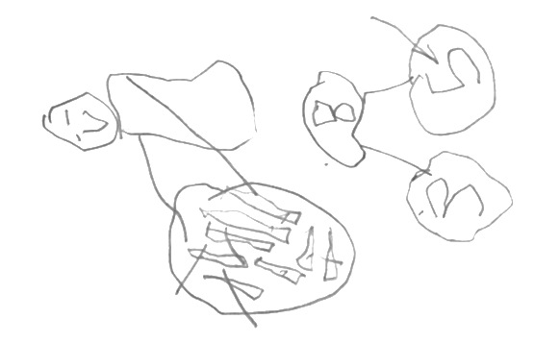
Application Problem (7 minutes)
Peter was sitting at lunch eating his french fries. He counted 8 left on his plate. He ate 1 french fry. He ate another french fry. Then, he ate another french fry. How many french fries did Peter have then?
MP.2
Note: The purpose of this Application Problem is to simply prepare students for thinking about 1 less. Eight. 1 less is 7. Seven. 1 less is 6.

NOTES ON
MULTIPLE MEANS
OF ACTION AND EXPRESSION:
Challenge students who are working above grade level by providing them with extensions of the Application Problem to solve. Ask, “If Peter ate two fries at a time, how many would he have then?”, “If Peter started with 18 fries and ate one at a time, how many would he have left?”, and “If Peter had 50 fries and he ate 1 and then another and then another, how many would he have then?”

Concept Development (26 minutes)
Materials: (S) 2 sets of 10 linking cubes for each student (10 in one color and 10 in another color), sentence frame (Template)
Note: Notice that we are not saying “19 is one less than 20.” This is very complex linguistically for many kindergarten students who can say “19 is less than 20” without quantifying the difference. We simply are extending the “one more” lesson to “one less” as an opportunity for the students to do counting of teen numbers in a linear configuration: the tower (K.CC.5).
T: Build a tower with all the cubes of one color.
T: How many cubes are in your tower?
S: Ten!
T: How many ones is that?
S: 10 ones!

NOTES ON
MULTIPLE MEANS
OF ACTION AND EXPRESSION:
Give your English language learners extra time to allow them to process the meanings of the essential terms in your lesson before calling for responses. Review and post key vocabulary (cube, more, less, remove), and allow extra conversation time while they are working.

T: Now, build a tower using the other cubes.
T: How many cubes are in this tower?
S: Ten!
T: Join the two towers. What is 10 ones and 10 ones?
S: Twenty! 2 tens!
T: How can we show 19?
S: Take off 1 cube. (Students remove one cube.)
T: Say this with me: “20. 1 less is 19.” (Use sentence frame for support.)
S: 20. 1 less is 19.
T: Take off one cube. Be sure to take the same color cube as before. Talk to your partner. How many cubes are in your tower now?
S: (Allow time for students to figure it out.) 18.
Students continue in this manner, taking off one cube each time, down to 10. As they remove each cube, have them express the relationship of each number to the preceding number, for example, 18. 1 less is 17. As in the preceding lesson, release the students to work independently as soon as possible.
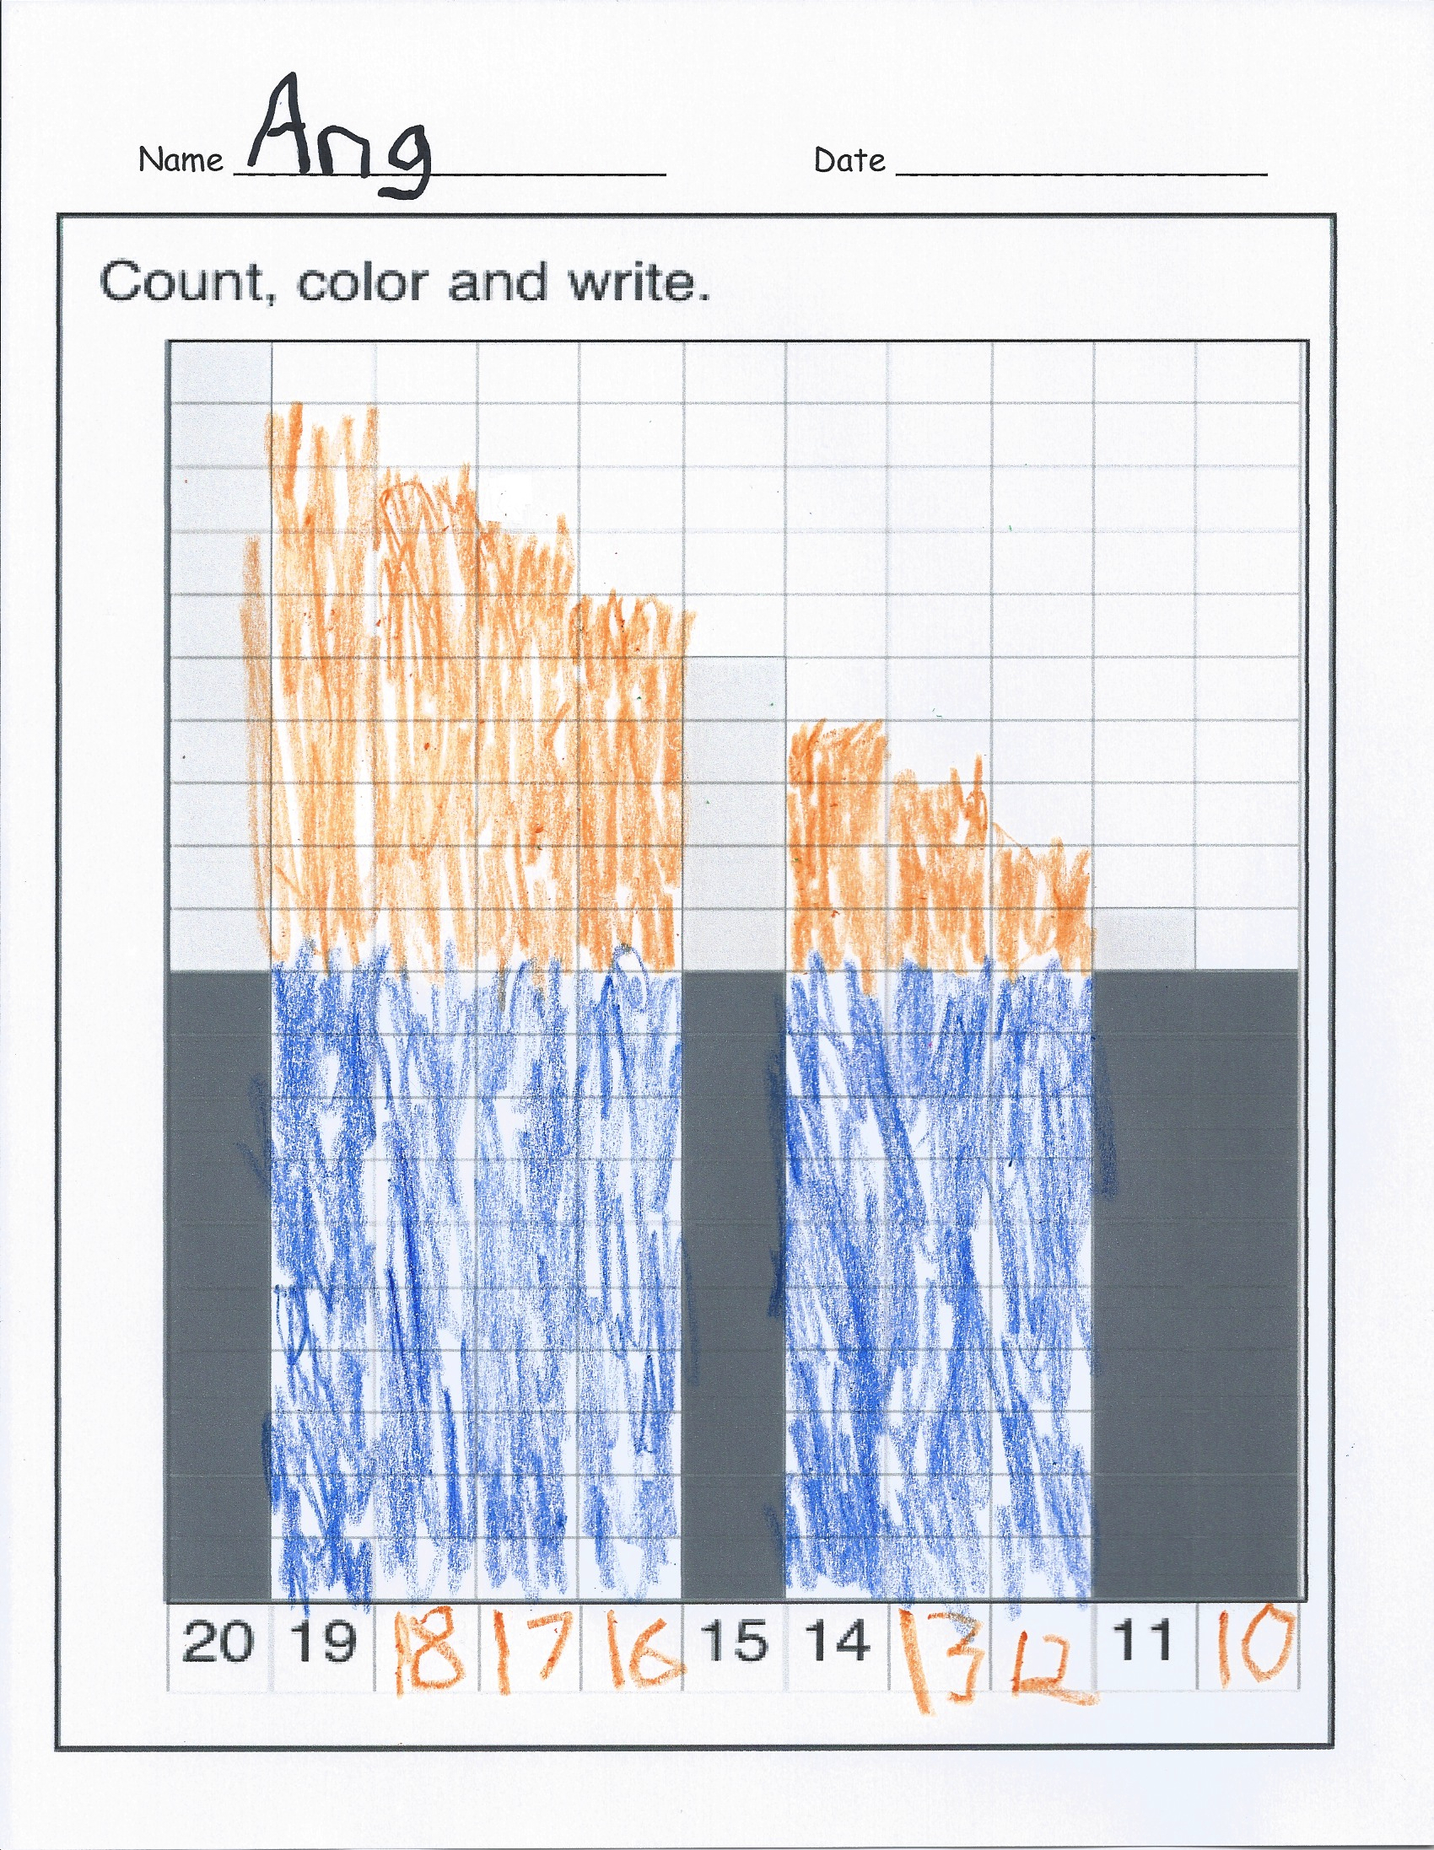
Problem Set (7 minutes)
Students should do their personal best to complete the Problem Set within the allotted time. As students color the squares and write the numbers to complete the pattern, have them continue to say the relationship of each number to its preceding number, for example, 13. 1 less is 12. 12. 1 less is 11.
Student Debrief (8 minutes)
Lesson Objective: Represent numbers 20 to 11 in tower configurations decreasing by 1—a pattern of 1 smaller.
The Student Debrief is intended to invite reflection and active processing of the total lesson experience.
Invite students to review their solutions for the Problem Set. They should check work by comparing answers with a partner before going over answers as a class. Look for misconceptions or misunderstandings that can be addressed in the Debrief. Guide students in a conversation to debrief the Problem Set and process the lesson.
Any combination of the questions below may be used to lead the discussion.
- What do you notice when you look at your work?
- How is your drawing like the towers you made?
- How many cubes did you remove from your tower each time?
- When you take one cube off, does the number get larger or smaller?
- How is this work similar to the story problem of the french fries?
- How is what we did today alike and different from what we did yesterday?
Exit Ticket (3 minutes)
After the Student Debrief, instruct students to complete the Exit Ticket. A review of their work will help with assessing students’ understanding of the concepts that were presented in today’s lesson and planning more effectively for future lessons. The questions may be read aloud to the students.
Name Date
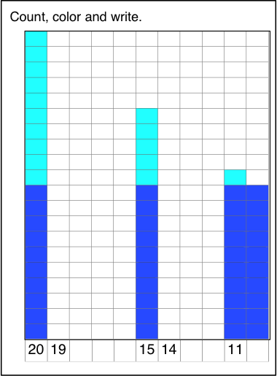

Name Date
Write the missing numbers, counting down.
14, 13, 12, 11, _______

15, 14, _______, 12, _______, _______,

13, 12, _______, _______, _______,

Name Date
Write the missing numbers. Then, draw X’s and O’s to complete the pattern.
X  X  X  X  X  X  X  X  X  X  O  O  O  O  O  O  O  O  O  O | X  X  X  X  X  X  X  X  X  O  O  O  O  O  O  O  O  O  O |  | X  X  X  X  X  X  X  O  O  O  O  O  O  O  O  O  O |  | X  X  X  X  X  O  O  O  O  O  O  O  O  O  O |  |  |  | X  O  O  O  O  O  O  O  O  O  O
20 |  | 18 |  | 16 |  | 14 | 13 | 12 |  | 10

____. 1 less is ____.

sentence frame

