Lesson 10
Objective: Build a Rekenrek to 20.

Suggested Lesson Structure
 Fluency Practice (10 minutes)
 Application Problem (7 minutes)
 Concept Development (13 minutes)
 Student Debrief (20 minutes)
Total Time (50 minutes)
Fluency Practice (10 minutes)
- Writing Teen Numbers K.CC.3 (4 minutes)
- Showing Numbers with Hands K.CC.4, K.NBT.1 (3 minutes)
- Counting K.CC.2 (3 minutes)
Writing Teen Numbers (4 minutes)
Materials: (T) Linking cubes (S) Personal white board
Note: By writing the corresponding numeral for each part, and then the whole, students are continually reminded that the 1 in teen numbers refers to 10 ones.
T: (Show 3 cubes.) Write the number.
S: (Students write the numeral 3.)
T: (Show 10 cubes.) Write the number.
S: (Students write the numeral 10.)
T: (Show 13 cubes.) Write the number.
S: (Students write 13.)
Repeat the process for the following possible sequence: 10, 13, 19, 5, 17, 8, 18, 15, 12, 14, 16.
Showing Numbers with Hands (3 minutes)
Materials: (T) 20-bead Rekenrek
Note: Relating the group of 10 on the Rekenrek to students’ own hands helps them internalize the structure of teen numbers.
T: (Show 12 on the Rekenrek.)
T: Show the two parts of the number on your fingers. Say the parts at the same time.
S: 10 (flashing ten fingers) and 2 (showing two fingers).
Continue with the following possible sequence: 13, 14, 19, 16, 18, 15, 11, 17, 20.
Counting (3 minutes)
Materials: (T) 20-bead Rekenrek
Note: Students relate Say Ten counting to conventional teen number names in this activity. Counting both ways, and in both directions, ensures that students remain alert to the sequence and do not simply extend a pattern of number words. If students struggle, return to a more manageable range (such as within 13 or 15), and later build up to work within 20.
Count by ones from 11–20, changing directions both the Say Ten Way and the regular way.
Application Problem (7 minutes)
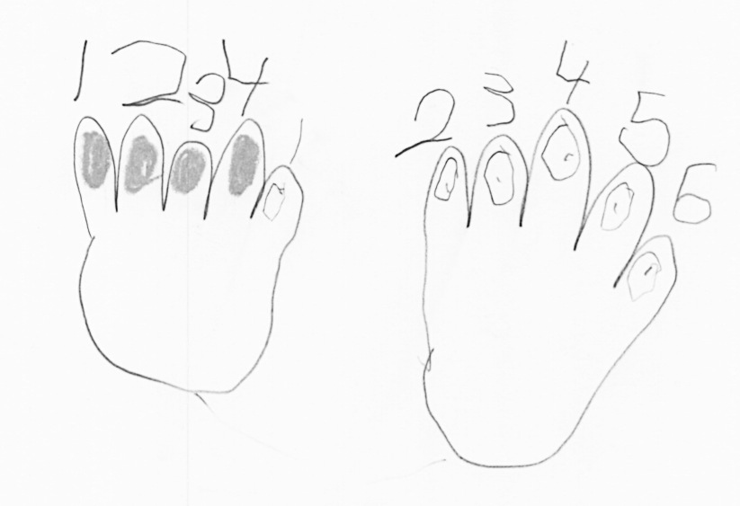
Ms. Garcia is painting her fingernails. She has painted all the nails on her left hand except her thumb. How many more nails does she need to paint? How many will she have left to paint after she paints her left thumb? Draw a picture to help you.
Note: This problem is an application of K.OA.4, wherein students learn the number that makes 10 from any number less than 10. As a word problem, this is a change unknown, which is a Grade 1 problem type. Therefore, the number sentence is not asked for since missing addends will be introduced in the fall of Grade 1.
Concept Development (13 minutes)

NOTES ON
MULTIPLE MEANS
OF ENGAGEMENT:
Push the thinking of students working above grade level by asking, “What would happen if Ms. Garcia also paints her toenails? How many nails will be painted when she is completely done?” Consider extending their thinking further by asking, “If Ms. Garcia draws two green polka dots on each finger, how many polka dots does she paint all together?”

Materials: (S) Problem Set, 10 red beads, 10 white beads, a red crayon, a black crayon
T: (Distribute the Problem Set. Have the students put the beads on the circles below the first pair of hands, 5 red on the left, and 5 white on the right.)
T: Imagine these red beads are Ms. Garcia’s painted fingernails. Show me how many she painted at first (in the Application Problem). Put them on her fingernails.
S: (Move 4 beads from the circles to the fingernails, starting with the left pinky finger.)
T: How many fingernails did she paint, and how many does she need to paint? Use these words to help. Listen.

NOTES ON
MULTIPLE MEANS
OF ACTION AND EXPRESSION:
Scaffold the lesson for English language learners by pointing to the painted hand and asking, “How many did she paint?” Then, point to the hand that is not painted and ask, “How many does she need to paint?”

T: “She painted ____ fingernails. She needs to paint
____ fingernails.”
S: She painted 4. She needs to paint 6.
T: Paint one more nail on her left hand. (Pause.) Tell me what she’s painted and what she needs to paint.
S: She painted 5. She needs to paint 5.
Continue the pattern of painting one more fingernail and making the statements that describe how many have been painted and need to be painted. Have the students work
MP.7
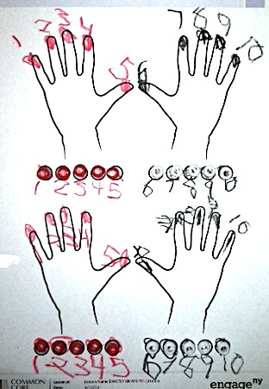
independently as soon as they can. Once they have finished the first pair of hands, have them use the second pair of hands for Ms. Garcia’s daughter’s unpainted nails. Have them put the beads on her fingers, counting and making statements as they go. Engage them in counting all the beads, analyzing how many are red and how many are white, how many are on the left hands, and how many on the right hands.
Problem Set (5 minutes)
Students color the left-hand fingernails red and color the right-hand fingernails black (in lieu of white), counting as they go. They color the corresponding beads below to match the hands, counting as they go. They can write their numbers 1 to 10, too.
Student Debrief (20 minutes)
Lesson Objective: Build a Rekenrek to 20.
The Student Debrief is intended to invite reflection and active processing of the total lesson experience.
Invite students to review their solutions for the Problem Set. They should check work by comparing answers with a partner before going over answers as a class. They can count on or count all, as needed. Look for misconceptions or misunderstandings that can be addressed in the Debrief. Guide students in a conversation to debrief the Problem Set and process the lesson. Any combination of the questions below may be used to lead the discussion.
Materials: (S) 10 red and 10 white pony beads from the Concept Development, two 12-inch lengths of elastic, 1 piece 2.75 inch by 5.5 inch chip board (or cardboard strip) with an indentation (note that each 8 ½ inch by 11-inch chipboard makes 4 Rekenreks.)
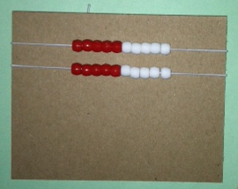
T: Let’s make a Rekenrek. Put your red beads on top of your red dots and your white beads on top of your black dots, counting as you go.
T: What do you know about the number of your red and white beads?
S: They both have ten. They are the same number. They are an equal number.
T: How do you say the total number of beads the Say Ten Way?
S: 2 tens.
T: How many beads is that the regular way?
S: Twenty.
After showing students how to thread the elastic through from left to right, red beads first, give each student a 12-inch elastic. Once they have finished one row, have them do the other row. Show them how to pinch the elastics at either end to pick up the row and place it on their chip board (or cardboard strip), one row under the other. The teacher can circulate and tie the elastics, or have helpers tie the elastics after class for use in future lessons.
The discussion should establish a correlation between students’ fingernails and the beads of the Rekenrek.
- Talk to your partner about what is the same and what is different about the number of your fingernails and the number of beads.
- How many people do we need to have the same number of fingernails as on your Rekenrek?
- If the beads were purple and green, how many nails and beads would be purple, and how many would be green?
- What if you hide two hands? How many beads would you see?
Exit Ticket (3 minutes)
After the Student Debrief, instruct students to complete the Exit Ticket. A review of their work will help with assessing students’ understanding of the concepts that were presented in today’s lesson and planning more effectively for future lessons. The questions may be read aloud to the students.

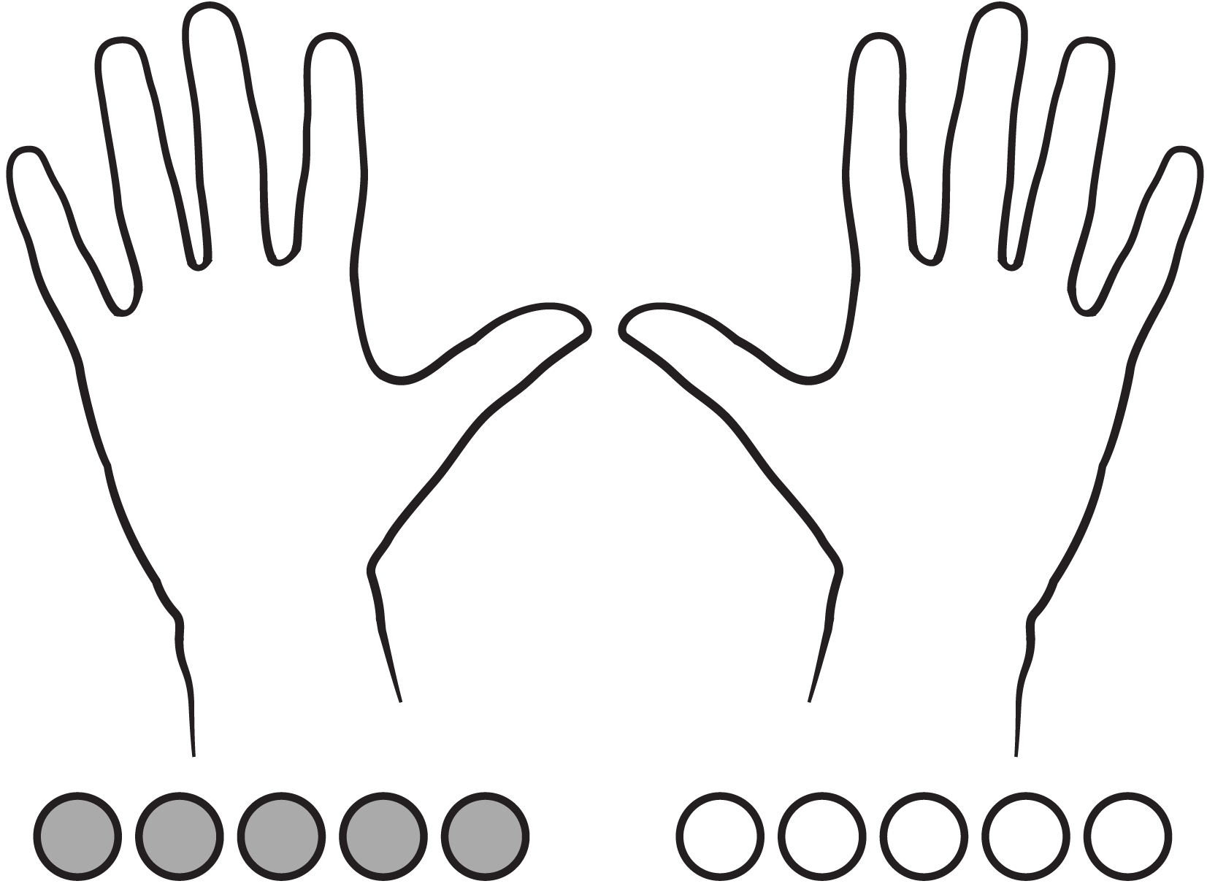
Name Date

Name Date
Use your red crayon and yellow crayon to draw the beads from your Rekenrek in two lines.

How many beads did you draw?

Trace your hands. Draw your fingernails. How many fingernails do you have on your two hands?
Name Date
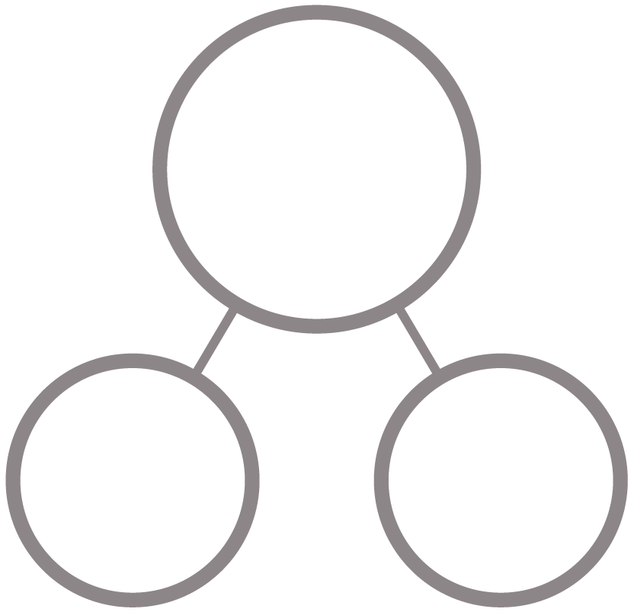
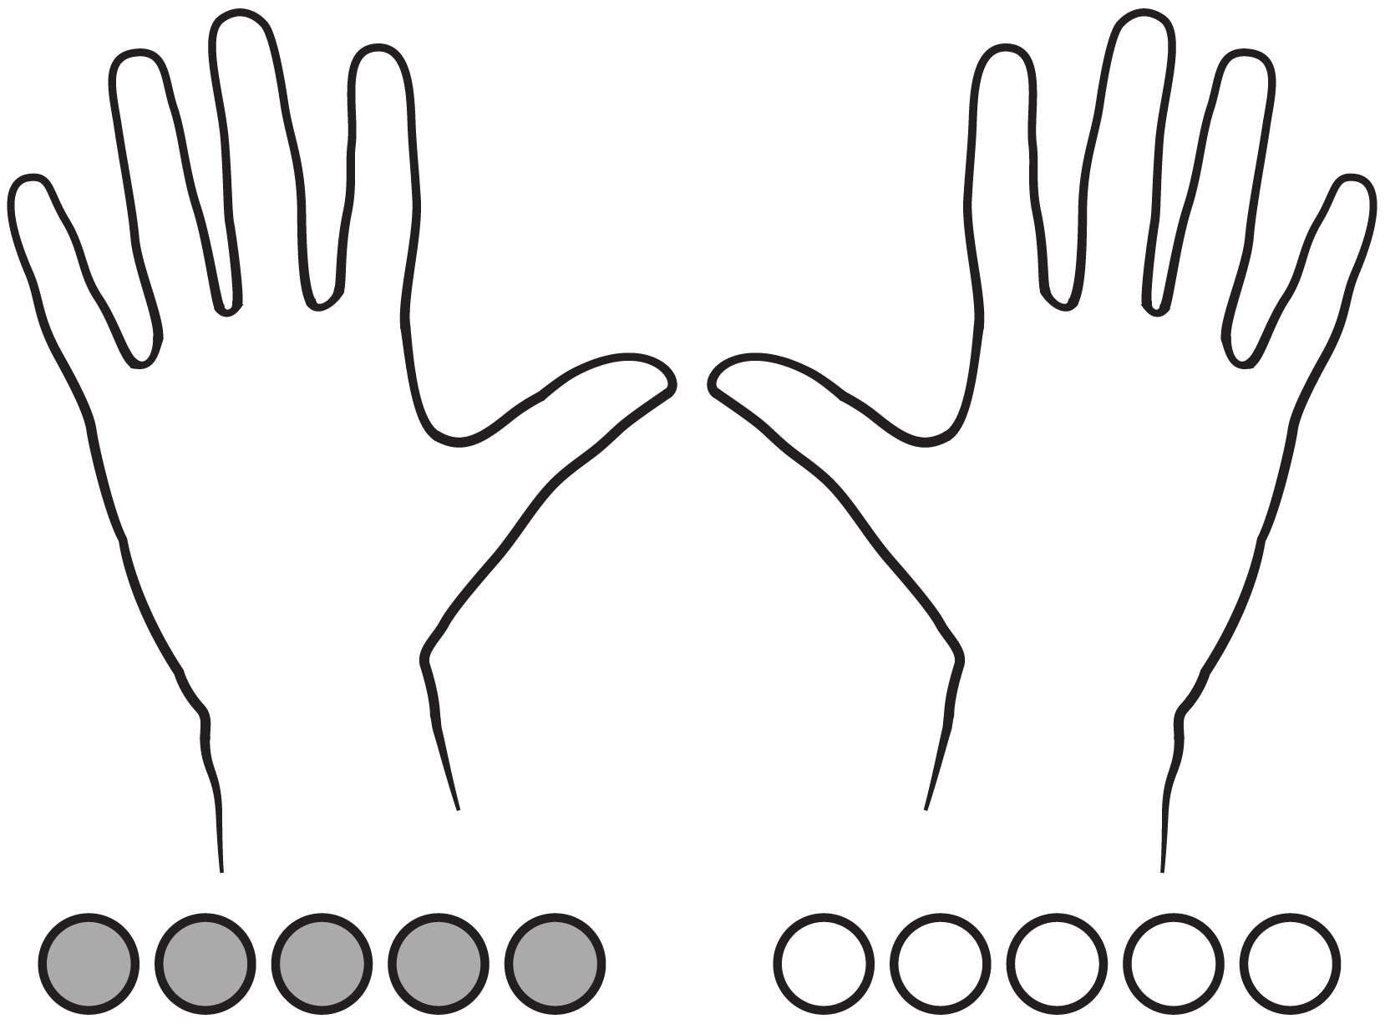
Color the number of fingernails and beads to match the number bond. Show by coloring 10 ones above and extra ones below. Fill in the number bonds.
14
1114
1714
16
1214
13
11

