Lesson 9
Objective: Draw teen numbers from abstract to pictorial.

Suggested Lesson Structure
 Fluency Practice (10 minutes)
 Application Problem (5 minutes)
 Concept Development (27 minutes)
 Student Debrief (8 minutes)
Total Time (50 minutes)
Fluency Practice (10 minutes)
- Dot Cards of Nine K.CC.5, K.CC.2 (4 minutes)
- How Many Is One More? K.CC.2 (2 minutes)
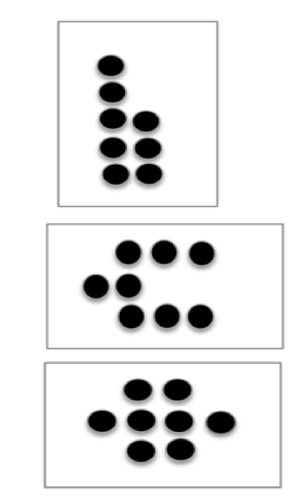
- Grouping Teen Numbers into 10 Ones K.NBT.1 (4 minutes)
Dot Cards of Nine (4 minutes)
Materials: (T/S) Dot cards of 9 (Fluency Template)
Note: This fluency activity gives students an opportunity to develop increased familiarity with decompositions of nine and practice seeing part–whole relationships.
T: (Show a card with 9 dots.) How many dots do you count? Wait for the signal to tell me.
S: 9.
T: How can you see them in two parts?
S: (Students come up to the card.) I saw 5 here and 4 here. I saw 3 here and and 6 here. I saw 2 here and 7 here.
Repeat with other cards. Pass out the cards for students to work with a partner.
How Many Is One More? (2 minutes)
Materials: (T) Ten-frame cards (Lesson 1 Fluency Template 4)
Note: This fluency activity advances the familiar work with the pattern of 1 more as it requires students to visualize an additional dot on the ten-frames.
T: (Show 3.) How many dots?
S: 3.
T: What’s one more than 3?
S: 4.
Repeat with all the numbers through 10.
Grouping Teen Numbers into 10 Ones (4 minutes)
Materials: (S) Bag with about 20 small objects and work mat for each student
Note: The bags should have a variety of objects between 11 and 20.
Note: Practice separating and counting objects as ten ones and some ones solidifies students’ understanding of teen numbers.
T: Empty your bag. Put all the items on your work mat. Count out 10 ones, and move them together into a bunch.
T: (Wait while they work.) How many ones are in your bunch?
S: 10 ones.
T: How many are not in your bunch?
S: 3 ones.

NOTES ON
MULTIPLE MEANS
OF REPRESENTATION:
Students working below grade level may need to model Jenny’s mistake and count the quantity so that they can compare it to the fifteen chips. Provide students with counters so that they can show the correct solution to the problem and explain her mistake.

T: Say the number sentence.
S: 10 ones and 3 ones equals 13 ones.
T: Push all your things back together. Spread them all out over your work mat.
Repeat process 2 or 3 more times. Ask students if the same 10 things are in the bunch each time.
Application Problem (5 minutes)
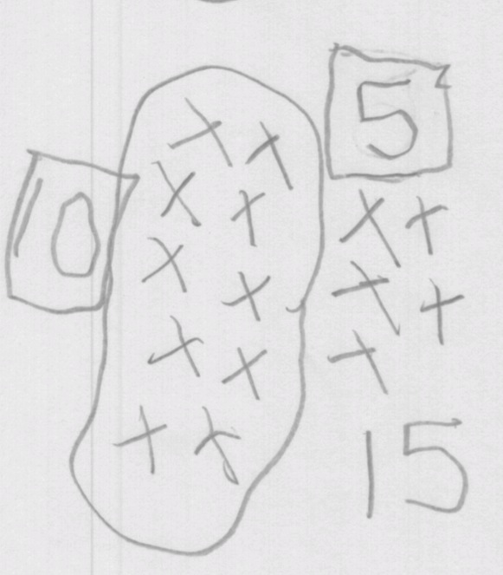
A Pre-Kindergarten friend named Jenny drew 15 things with 1 chip and 5 more chips. Draw 15 things as 10 ones and 5 ones, and explain to your partner why you think Jenny made her mistake.

NOTES ON
MULTIPLE MEANS
OF ACTION AND EXPRESSION:
Challenge your above grade-level students by extending the Application Problem by asking, “If Jenny made the same mistake representing 18, how might she show it?” and “How many more chips does Jenny need to correct her mistake?”

Concept Development (27 minutes)
Materials: (S) Personal white board with a double ten-frame inside (Template)
T: I’m going to write a number on the board. I want you to show that number by putting circles or dots inside the ten-frames.
T: (Write 10 on the board.) Say the number.
S: Ten!
T: Draw circles or dots to show ten. When I say show me, hold up your white board.
T: Show me. How many ones did you draw?
S: Ten ones.
T: Very good. Erase your boards. (Write 14.) Say the number.
S: Fourteen!
T: Whisper the number the Say Ten Way as you fill in your ten-frames to show it.
T: Talk with a partner to explain your drawing and how you grouped the dots.
T: (Write 18.) Say the number the Say Ten Way.
S: Ten eight!
T: Whisper the number the regular way as you fill in your ten-frames.
T: Talk with your partner. Explain why your picture shows ten eight.
Continue this way with 15 and 19.
T: Now, let’s try something different. Turn your board over to the blank side. I’m going to show a number.
I want you to make a drawing that shows that many circles. Then, I want you to circle 10 ones so we can see the parts that make up the number.

NOTES ON
MULTIPLE MEANS
OF REPRESENTATION:
Support your English language learners in comparing the ten-frame drawing and circle drawings by referring to the images. For the teen numbers, be sure to post the numerals along with the written word. Students have a difficult time hearing that thirteen is a different number from thirty because they sound alike. Having these clearly differentiated on the word wall will help them keep them apart.

T: (Show 16. Wait.)
T: Show me.
T: How many ones did you draw?
S: Sixteen ones.
T: How did you group the sixteen ones?
S: Ten ones and 6 ones.
T: Yes! Let’s do another.
Continue this way through the other teen numbers.

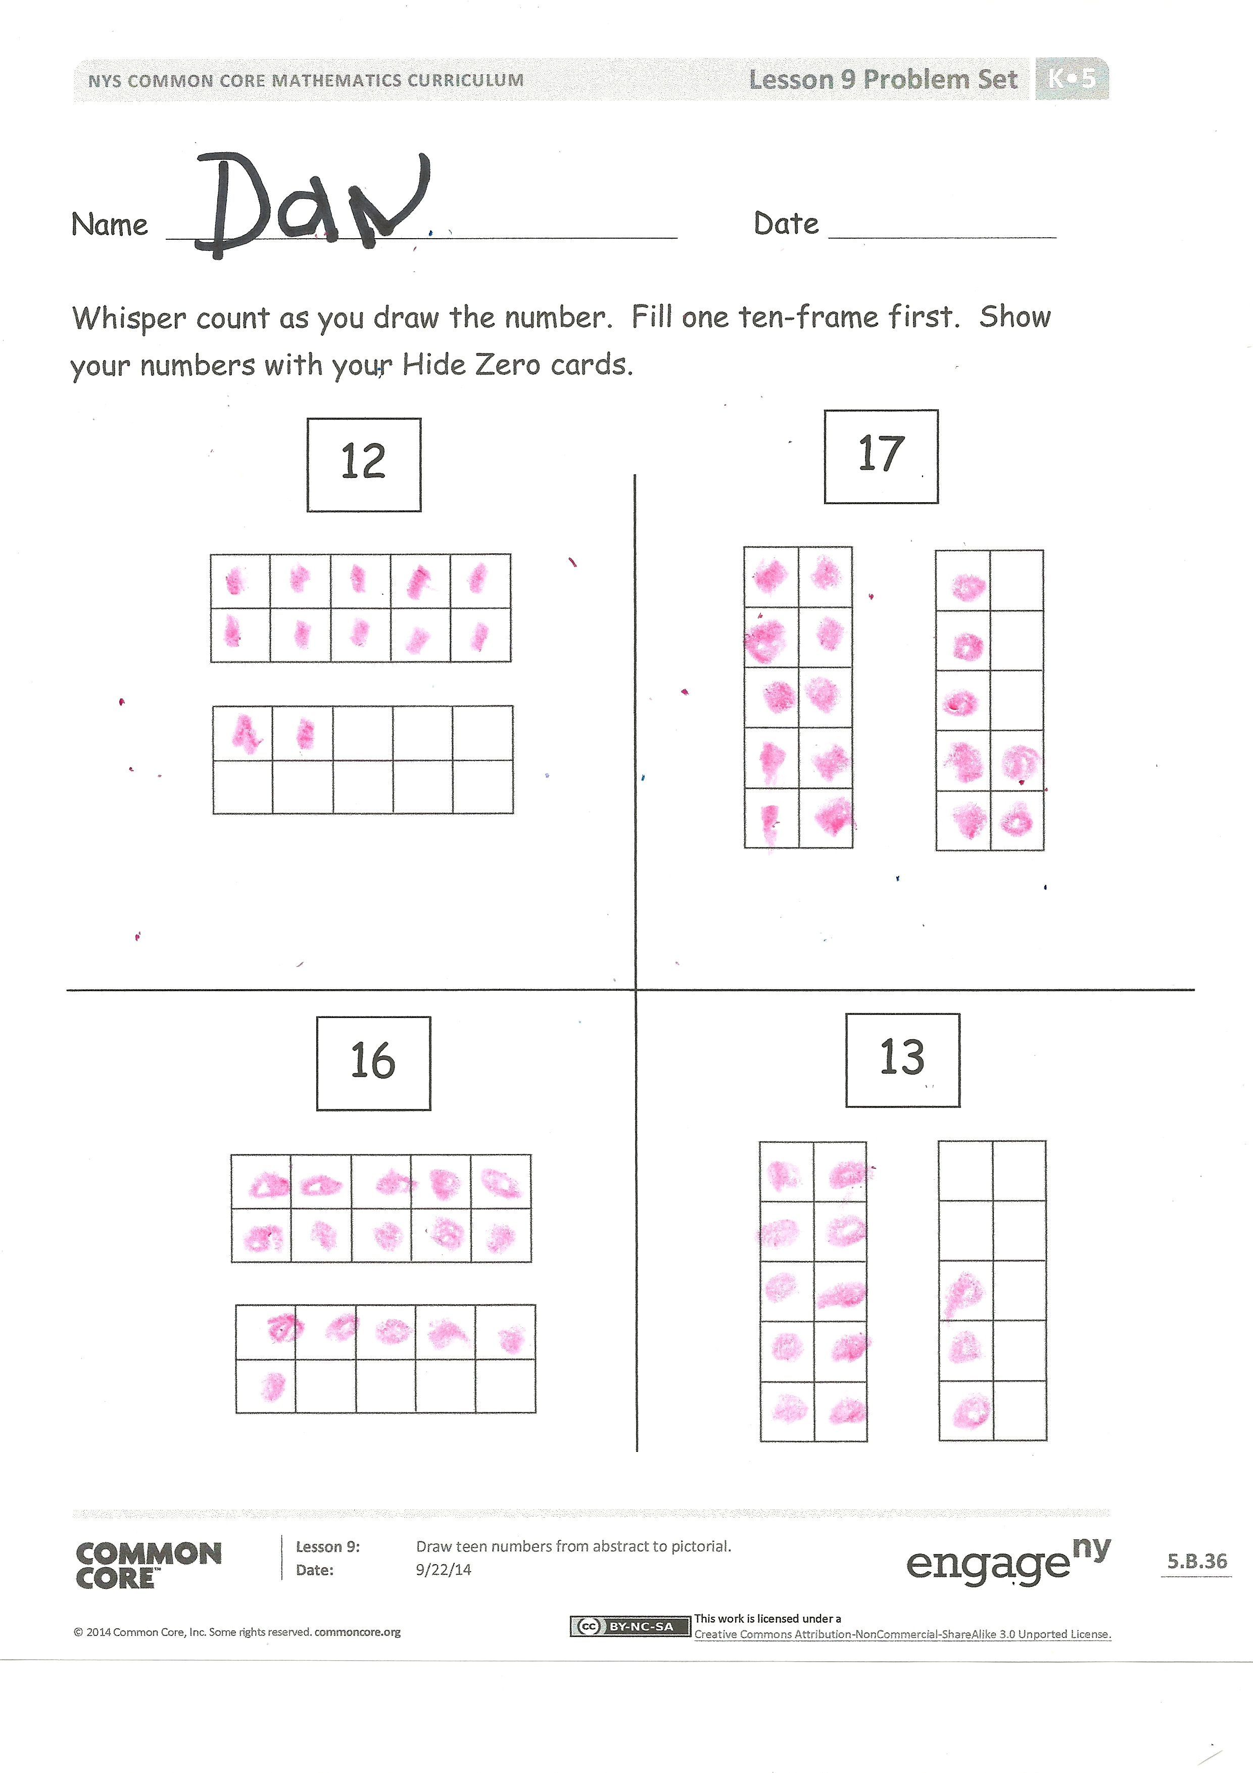
Problem Set
Students should do their personal best to complete the Problem Set within the allotted time. Direct the students to count as they represent the numbers. Have them whisper count as they work and fill one complete ten-frame before moving on to the next. Have them show their numbers with Hide Zero cards.
Student Debrief (8 minutes)
Lesson Objective: Draw teen numbers from abstract to pictorial.
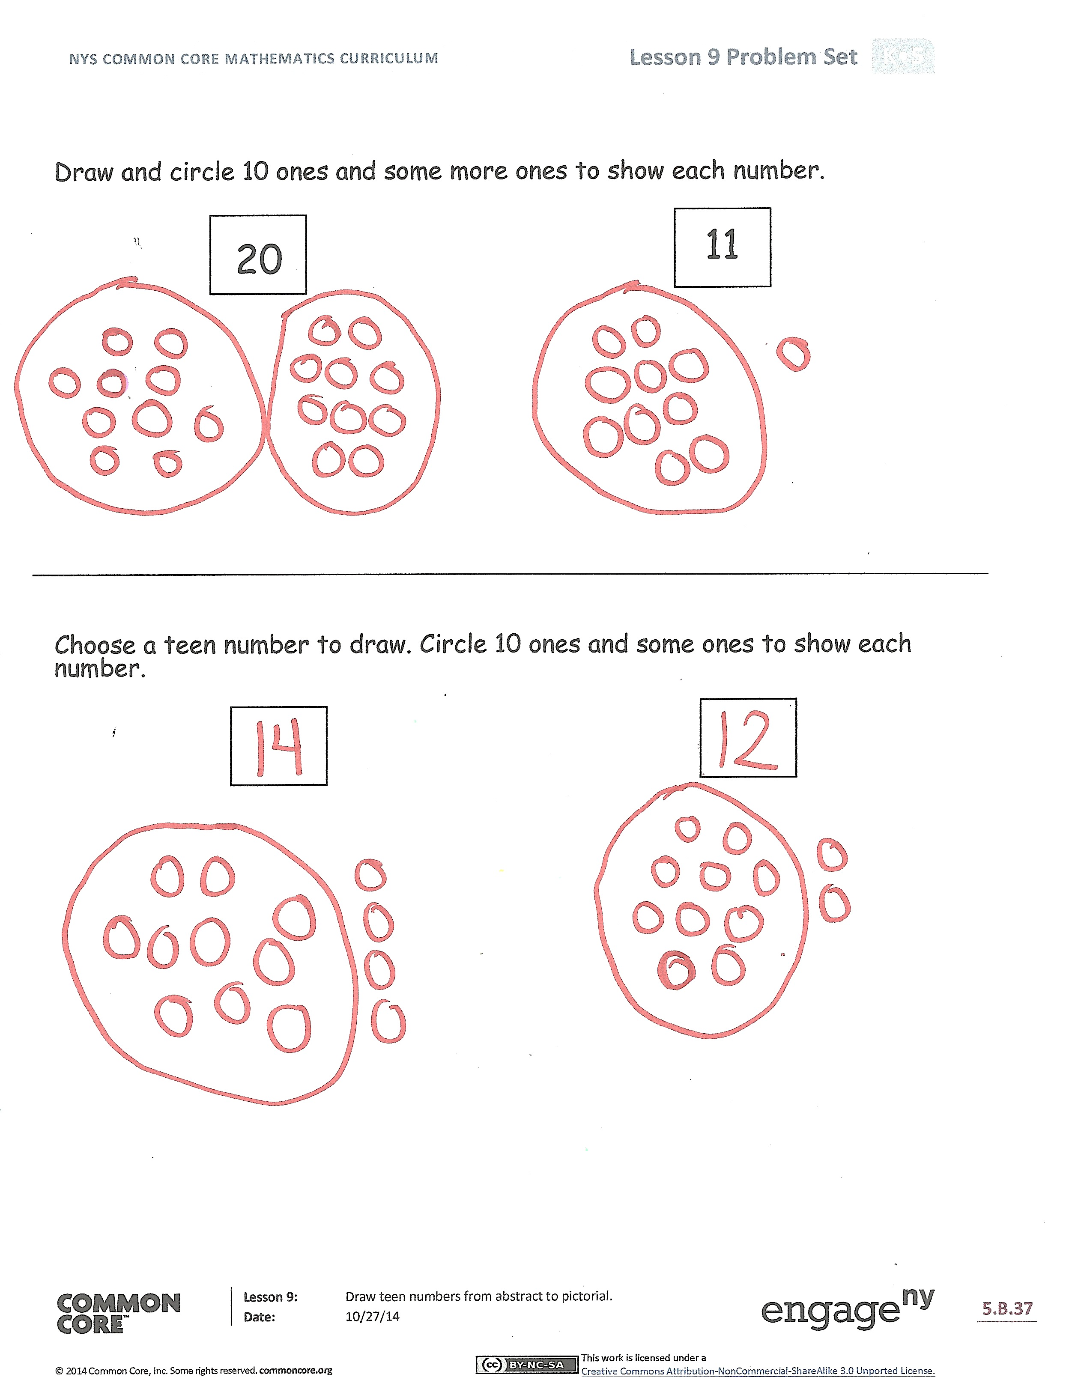
The Student Debrief is intended to invite reflection and active processing of the total lesson experience.
Invite students to review their solutions for the Problem Set. They should check work by comparing answers with a partner before going over answers as a class. Look for misconceptions or misunderstandings that can be addressed in the Debrief. Guide students in a conversation to debrief the Problem Set and process the lesson. Any combination of the questions below may be used to lead the discussion.
- How are your ten-frame drawings and your circle drawings the same and different?
- Look at your ten-frame drawings with your partner. Did you draw the number 17 the same way? If not, explain why both drawings show 17. Do the same for the number 16.
- Compare your ten-frame drawings with your circle drawings. Is one drawing easier to read and understand than the other? Explain your thinking.
- (Do a finger flash in mixed order from 10 to 20, and have students say the numbers the Say Ten Way.)
Exit Ticket (3 minutes)
After the Student Debrief, instruct students to complete the Exit Ticket. A review of their work will help with assessing students’ understanding of the concepts that were presented in today’s lesson and planning more effectively for future lessons. The questions may be read aloud to the students.
Name Date
Whisper count as you draw the number. Fill one ten-frame first. Show your numbers with your Hide Zero cards.
12
17

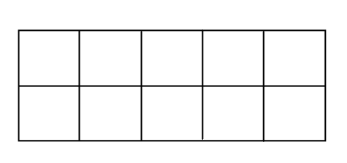
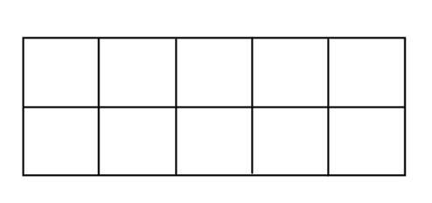
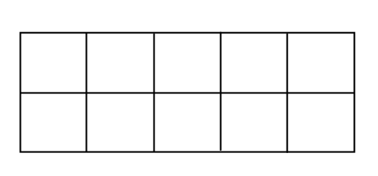

13
16
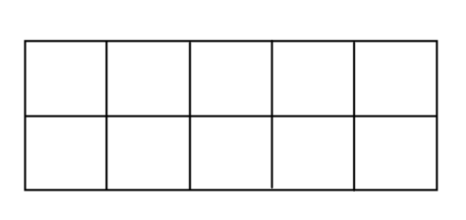
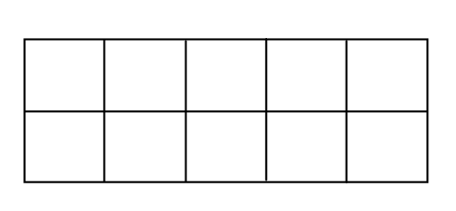
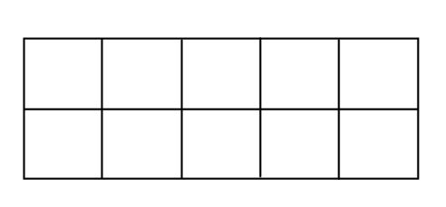

Draw and circle 10 ones and some more ones to show each number.
20
11

Choose a teen number to draw. Circle 10 ones and some ones to show each number.

Name Date
Show the number by filling in the ten-frames with circles.
19
15
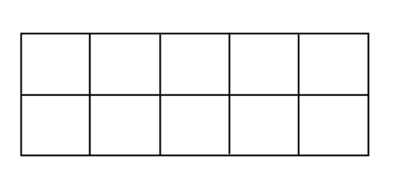

Draw circles to show the number. Circle 10 ones.
14
18

Name Date
For each number, make a drawing that shows that many objects.
Circle 10 ones.

11

16

20

19

14
12

dot cards of 9
dot cards of 9
dot cards of 9
dot cards of 9
dot cards of 9
dot cards of 9
dot cards of 9
dot cards of 9
dot cards of 9
double ten-frame

