Lesson 7:
Objective: Model and write numbers 10 to 20 as number bonds.

Suggested Lesson Structure
 Fluency Practice (10 minutes)
 Application Problem (5 minutes)
 Concept Development (28 minutes)
 Student Debrief (7 minutes)
Total Time (50 minutes)
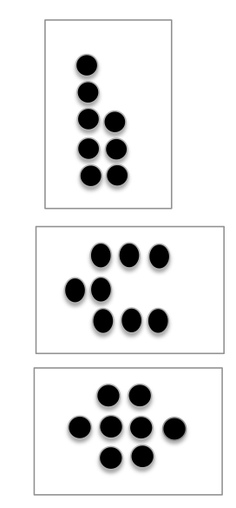
Fluency Practice (10 minutes)
- Dot Cards of Eight K.CC.5, K.CC.2 (4 minutes)
- Counting K.CC.2 (3 minutes)
- Decompose Teen Numbers K.NBT.1 (3 minutes)
Dot Cards of Eight (4 minutes)
Materials: (T/S) Dot cards of 8 (Lesson 6 Fluency Template)
Note: This fluency activity gives students an opportunity to develop increased familiarity with decompositions of eight and practice seeing
part–whole relationships.
T: (Show a card with 8 dots.) How many dots do you count?
Wait for the signal to tell me.
S: 8.
T: How can you see them in 2 parts?
S: (Students come up to the card.) I saw 4 here and 4 here.
I saw 5 here and 3 here. I saw 6 here and 2 here.
Repeat with other cards. Pass out the cards for students to work with a partner.
Counting (3 minutes)
Note: Extending the counting sequence on partners’ fingers prepares students to model teen numbers as
10 ones and some ones.
Partners hover their hands as if playing the piano. Student on the teacher’s right begins by “playing” the pinky of the left hand and continuing from left to right. Once a finger is counted, it remains down on the keyboard.

NOTES ON
MULTIPLE MEANS
OF ENGAGEMENT:
If below grade-level students have difficulties with the Application Problem, pair them with a partner or put them in a small group to solve the problem. Form a small group, and assign “jobs” so students hold each other accountable.

Students count their own and their partner’s fingers first the Say Ten Way, ten one, ten two, etc., and then in standard form. Have them count down from 20 to 0 if they finish early.
Decompose Teen Numbers (3 minutes)
Materials: (T) Hide Zero cards (Lesson 6 Template) (Emphasize the breaking apart of numbers by separating the cards as the students say numbers the Say Ten Way and the regular way.)
Note: Breaking apart teen numbers with the Hide Zero cards prepares students to work with number bonds in today’s Concept Development.

NOTES ON
MULTIPLE MEANS
OF REPRESENTATION:
Scaffold the lesson for English language learners by introducing the terms total and part. Use pictures of other visual aids of a total and a part. Post the words with the visual on the word wall so that students can continuously refer to them.

T: (Show 12.) Say the number the regular way.
S: 12.
T: (Separate the cards.) Say 12 the Say Ten Way.
S: Ten two.
Continue with the following possible sequence: 13, 14, 19, 11, 10, 15, 17, 16, 18.
Application Problem (5 minutes)
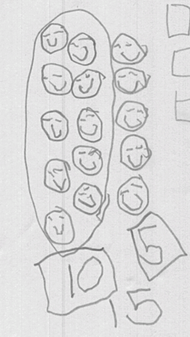
Materials: (S) Hide Zero cards (Lesson 6 Template)
Gregory drew 10 smiley faces and 5 smiley faces. He put them together and had 15 smiley faces. Draw the 15 smiley faces as 10 smiley faces and 5 smiley faces. Then, draw 15 with Hide Zero cards when the zero is hiding and when the zero is not hiding.
Note: Word problems involving quantities above 10 begin in Grade 1. Many of the application problems in Module 5 are simply decomposition and composition experiences (K.NBT.1). Note that the problems do not ask, “How many in all?” or “How many?” Also note that there is no unknown in problems of this type.
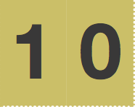

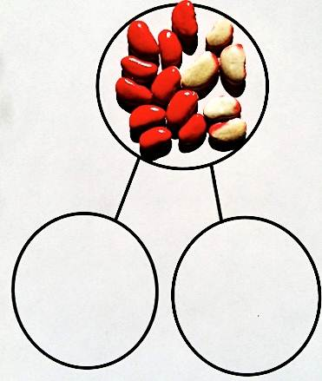
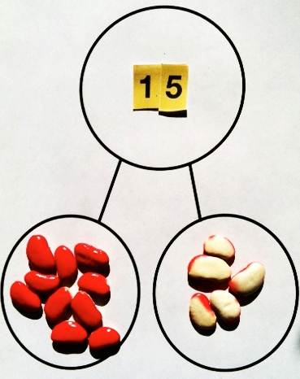
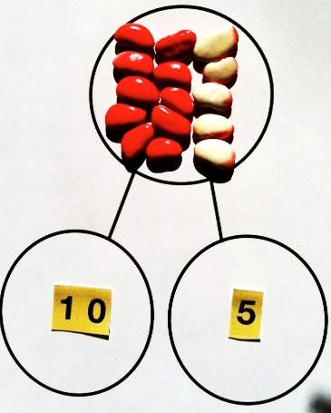
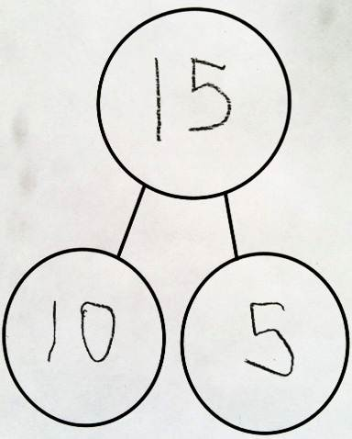
Concept Development (28 minutes)
Materials: (T/S) Hide Zero Cards: one 10 and numerals 1–9 both for the teacher and for each pair of students (Lesson 6 Template), at least 20 two-sided counters for each pair of students in a clear plastic bag (white beans spray painted red on one side, commercial two-sided counters, etc.), number bond (Template) within a personal white board
T: Here is Gregory’s number with my Hide Zero cards.
T: Show Gregory’s number with your 2-sided counters in the “total place” of your number bond. Make 10 ones a different color from the other ones.
S: (Students do so.)
T: Our number bond is not complete! We haven’t shown the parts!
T: What number parts are made by the two colors?
S: 10 ones and 5 ones.
T: Show those 2 parts with your own Hide Zero cards.
T: (See the picture at the right.) Is 15 beans the same number as 10 and 5?
S: (Give the students time to recount.) Yes.
T: Now, our number bond is correct!
T: Let’s switch it. Slide your counters down to be the two parts: 10 ones in a part and 5 ones in a part.
T: Show fifteen with your Hide Zero cards in the total place of your number bond.
T: Does 15 tell us the total number of beans in the 2 parts?
S: (Give students time to count.) Yes.
T: Now, our number bond is correct again!
T: Let’s replace the Hide Zero cards with a written number. Slide the cards off the total place. What number will you write?
S: 15.
MP.4
T: Slide off your beans from the parts. What numbers will you write to take their place?
S: 10 and 5.
T: Is 15 the same as 10 and 5?
S: Yes.
T: What is the total?
S: 15 (or ten five).
T: What are the parts?
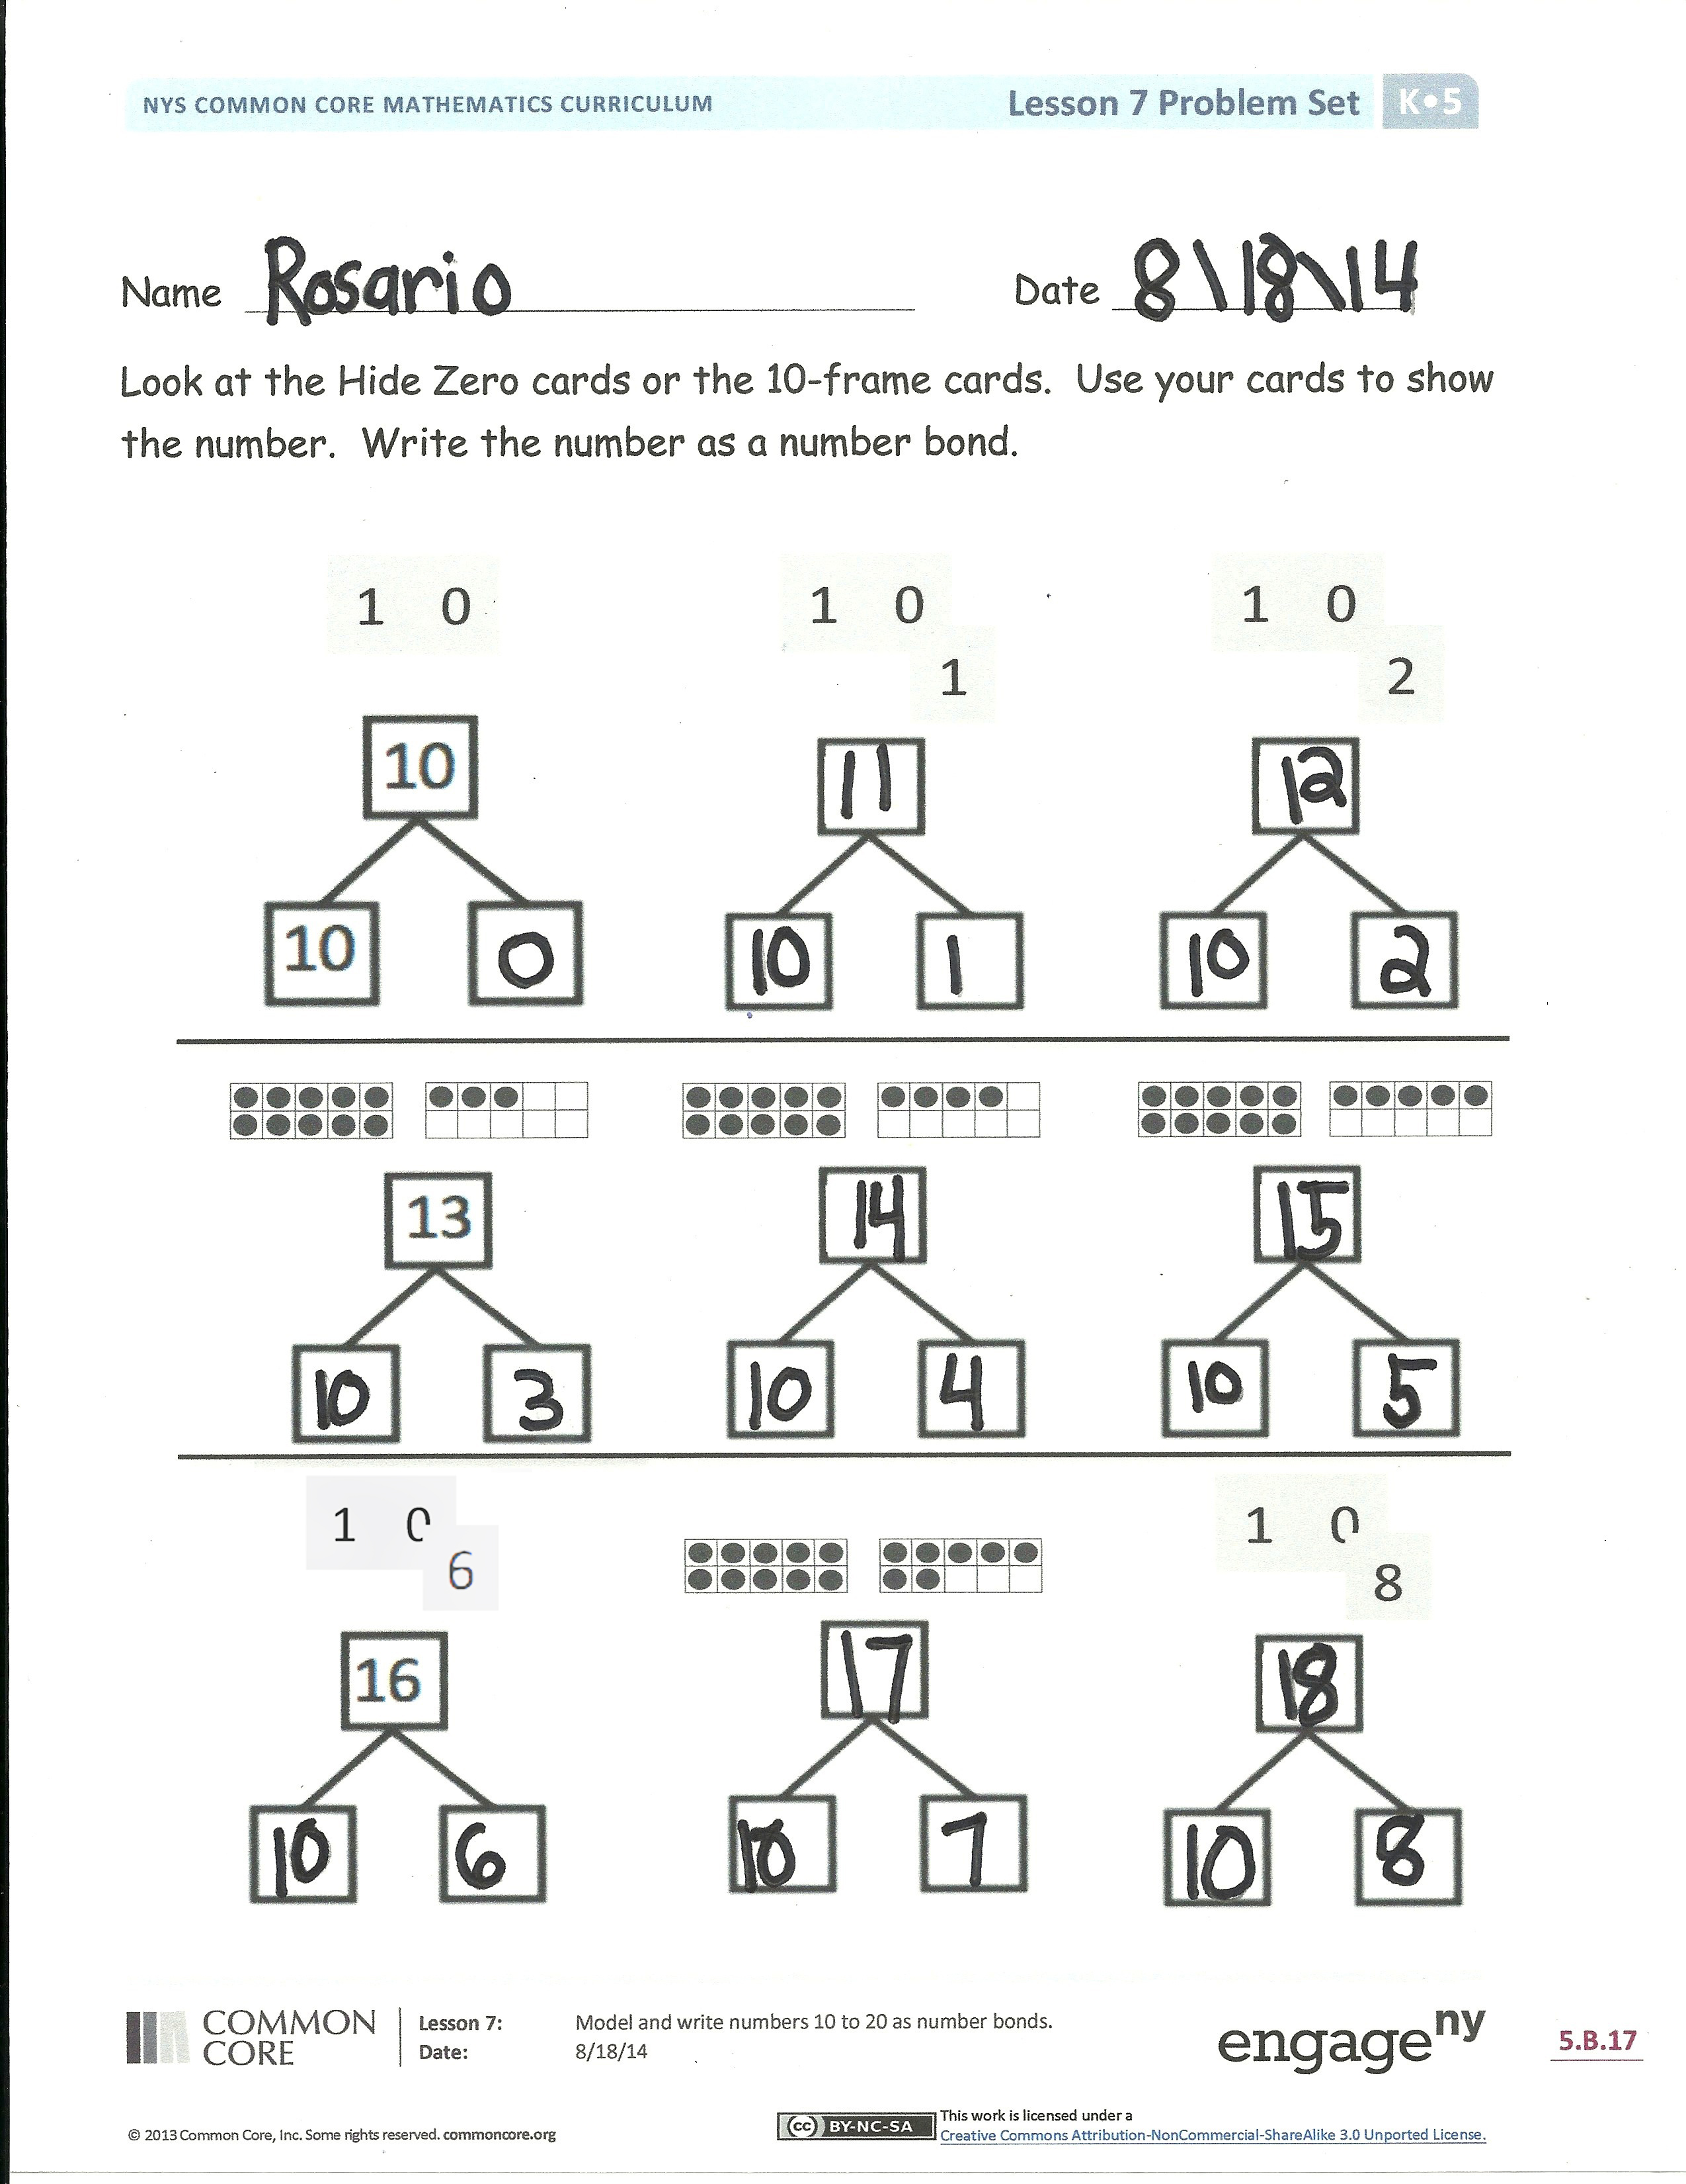
S: 10 and 5.
T: 15 is the same as ten five! Our number bond is correct again!
T: Use your beans and Hide Zero cards to make number bonds that are correct.
Repeat the sequence with different numbers of beans. Let the students go to work independently as they are able while guiding a smaller group that still needs guided practice. Do not let the equality be unresolved. For example, their number bond is not correct if they have 10 beans and 5 beans but nothing in the total place. The parts must always be equal to the total. Students may realize they can switch the order of the 10 ones and extra ones. That is good!
Close the session by having students write a number bond without using the template. This is review from Module 4 where they learned about the “total place” and how to draw a number bond.
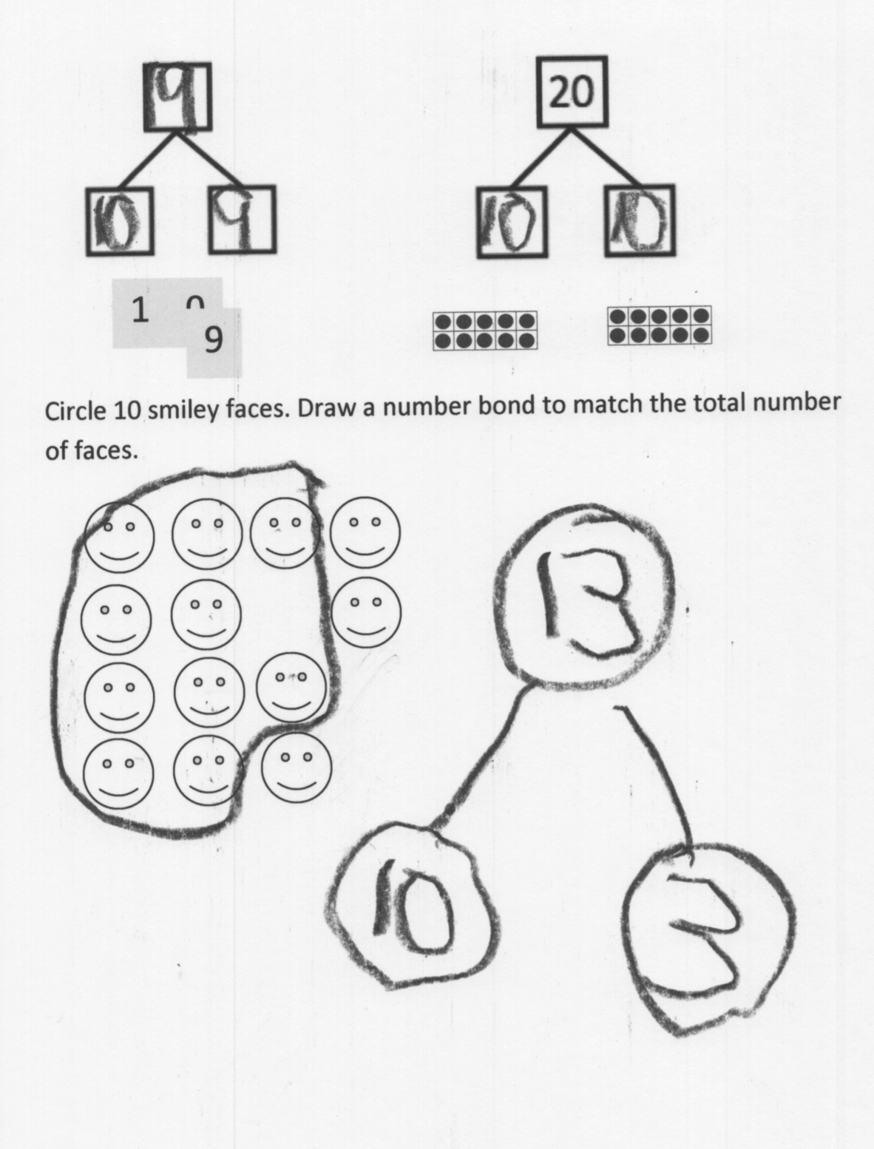
Problem Set (8 minutes)
Students should do their personal best to complete the Problem Set within the allotted time.
Be sure that students whisper speak as they work. For example, when saying “ten two,” they write the 1 and then the 2. By saying “ten two” simultaneously, they internalize the meaning of the 1 as standing for 10 ones.
Student Debrief (7 minutes)
Lesson Objective: Model and write numbers 10 to 20 as number bonds.
The Student Debrief is intended to invite reflection and
active processing of the total lesson experience. Invite students to review their solutions for the Problem Set. They should check work by comparing answers with a partner before going over answers as a class. Look for misconceptions or misunderstandings that can be addressed in the Debrief. Guide students in a conversation to debrief the Problem Set and process the lesson.
Any combination of the questions below may be used to lead the discussion.
- Tell me about the pattern you see on your Problem Set.
- How are the number bonds and Hide Zero cards helping you to understand the numbers from eleven to twenty?
- How does counting the Say Ten Way help you understand?
- How is this 1 in thirteen the same as this 1 in 19? When you made your number bonds, what stayed the same and what changed?
- When you see the number eleven, how are those two 1s different?
Exit Ticket (3 minutes)
After the Student Debrief, instruct students to complete the Exit Ticket. A review of their work will help with assessing students’ understanding of the concepts that were presented in today’s lesson and plan more effectively for future lessons. The questions may be read aloud to the students.

Name Date
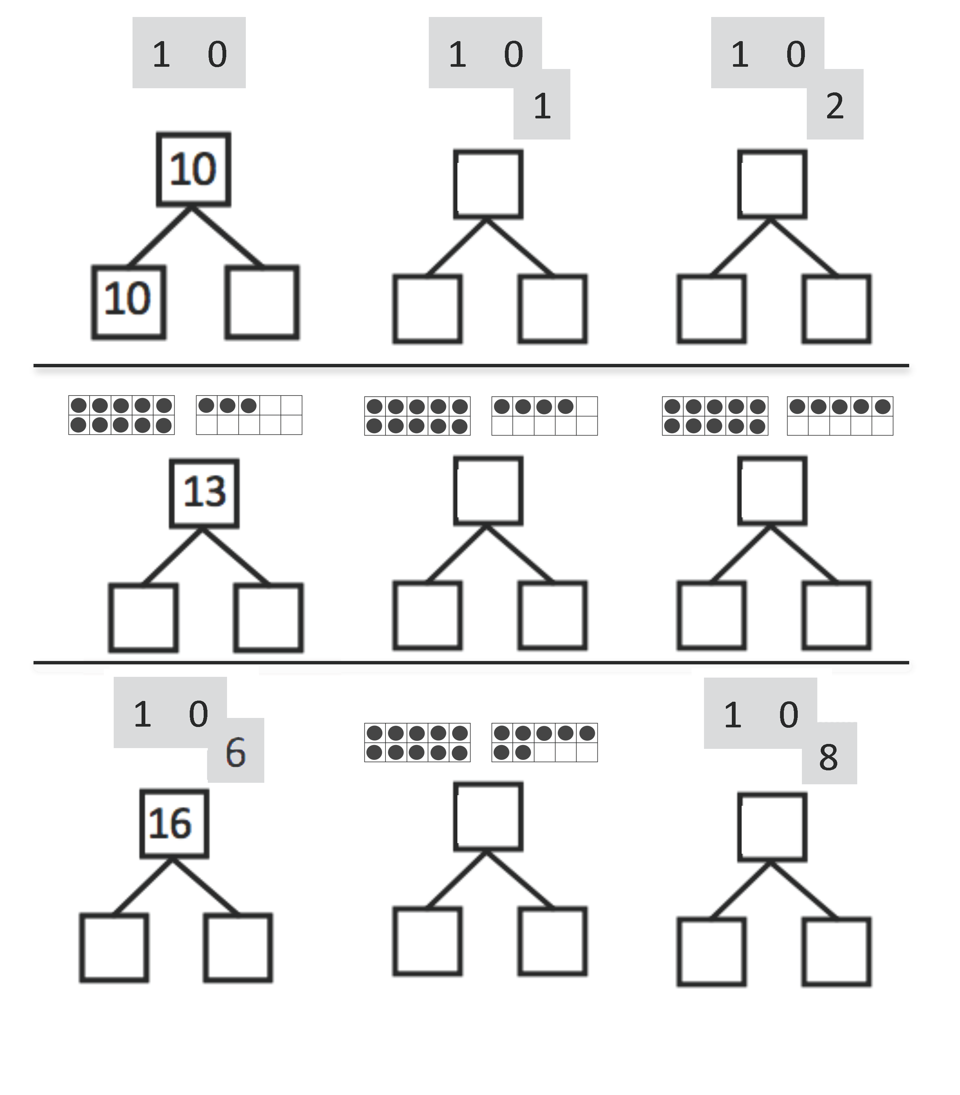
Look at the Hide Zero cards or the 10-frame cards. Use your cards to show the number. Write the number as a number bond.

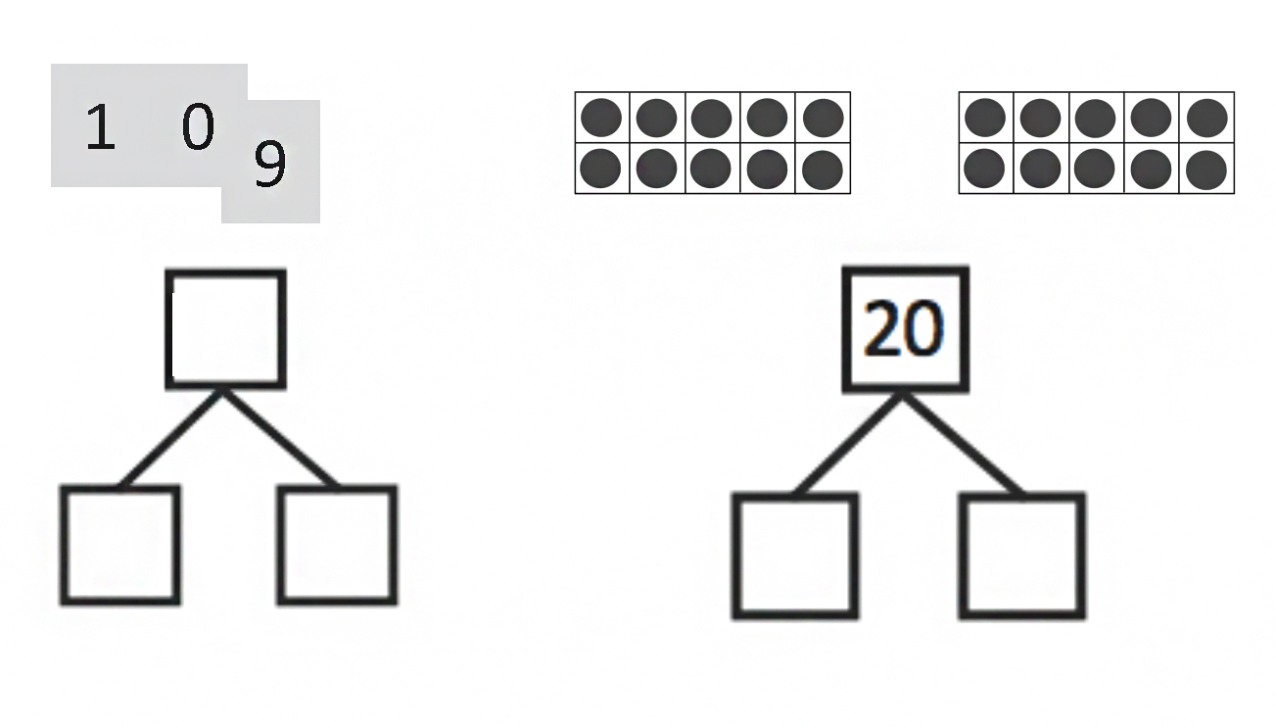

Circle 10 smiley faces. Draw a number bond to match the total number of faces.

Name Date
Look at the Hide Zero cards or the 10-frame cards. Use your cards to show the number. Write the number as a number bond.

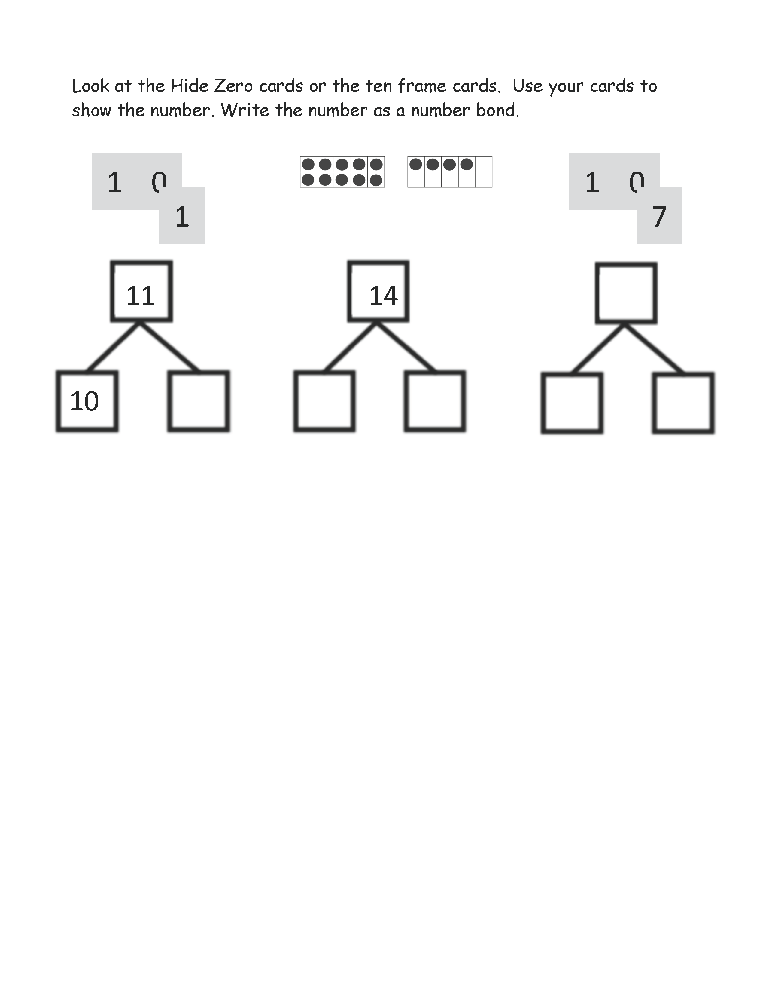

Name Date
Look at the Hide Zero cards or the 10-frame cards. Use your cards to show the number. Write the number as a number bond.
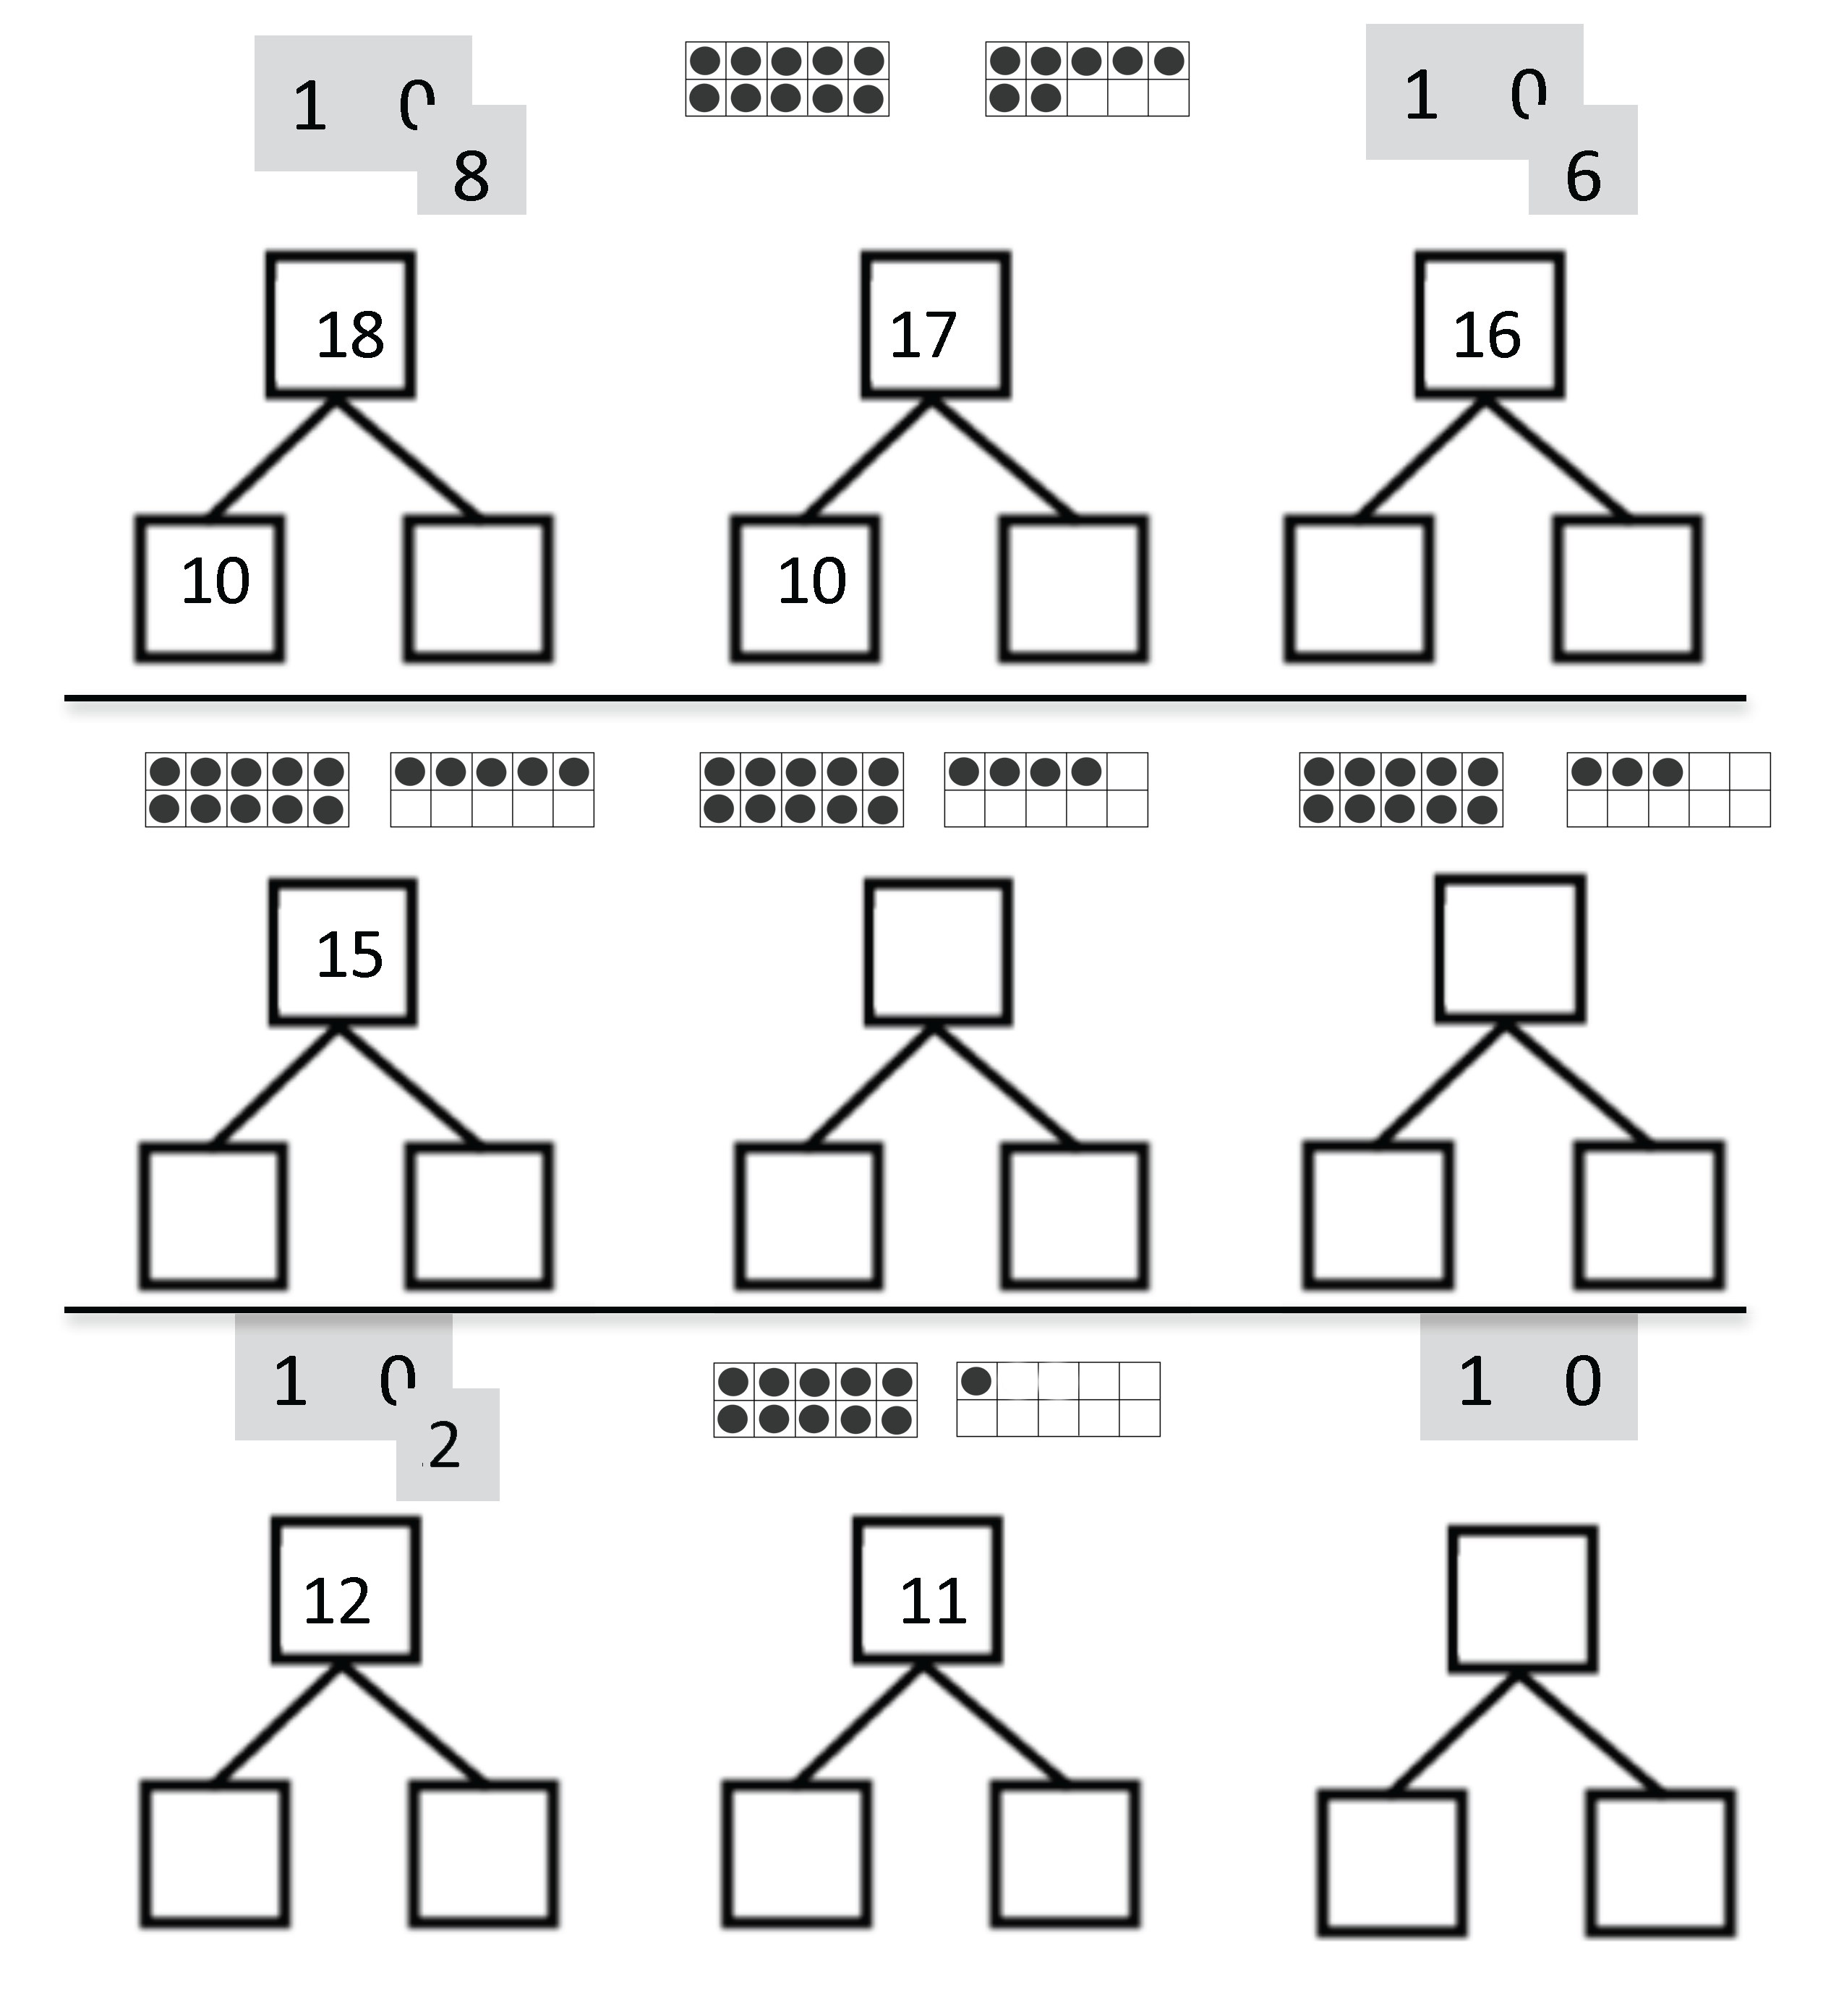

2
2

number bond

