**Lesson 6**

Objective: Model with objects and represent numbers 10 to 20 with place value or Hide Zero cards.

Suggested Lesson Structure

 Fluency Practice (12 minutes)

 Application Problem (6 minutes)

 Concept Development (24 minutes)

 Student Debrief (8 minutes)

**Total Time (50 minutes)**

Fluency Practice (12 minutes)

* How Many More to Make 10? **K.CC.2** (4 minutes)
* Dot Cards of Eight **K.CC.2, K.CC.5** (4 minutes)
* Counting Straws the Say Ten Way **K.CC.2** (4 minutes)

How Many More to Make 10? (4 minutes)

Materials: (T/S) Large ten-frame cards (Lesson 1 Fluency Template 3) (S) Ten-frame cards (Lesson 1 Fluency Template 4)

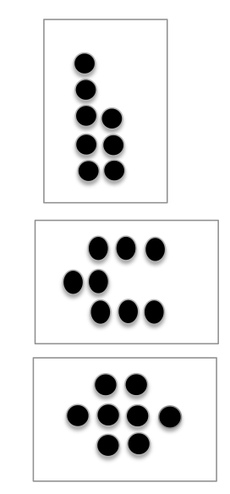Note: This activity helps students develop automaticity with partners to 10 through visualizing with the ten-frame model.

T: (Show 5.) How many dots?

S: 5.

T: How many more does 5 need to make 10?

S: (Full sentence.) 5 needs 5 more to make 10.

Continue with the following possible sequence: 9, 8, 7, 6, 1, 4, 3, 9, 2, 5.   
Allow students to play with a partner briefly.

Dot Cards of Eight (4 minutes)

Materials: (T/S) Dot cards of 8 (Fluency Template)

Note: This fluency activity gives students an opportunity to develop increased familiarity with decompositions of eight and practice seeing part–whole relationships.

T: (Show a card with 8 dots.) How many dots do you count? Wait for the signal to tell me.

S: 8.

T: How can you see them in 2 parts?

S: (Students come up to the card.) I saw 4 here and 4 here. 🡪 I saw 5 here and and 3 here.   
🡪 I saw 6 here and 2 here.

Repeat with other cards. Pass out the cards for students to work with a partner.

Counting Straws the Say Ten Way (4 minutes)

Materials: (T) Large ten-frame cards (Lesson 1 Fluency Template 3) (S) Ten-frame cards (Lesson 1 Fluency Template 4) and cards for numbers 1–10 (Template) for each pair of students, 20 straws for each pair of students

Note: Counting the Say Ten Way prepares students to think of ten as part of a teen number in today’s Concept Development.

T: (Show 10 and 3.) Say the number the Say Ten Way.

S: Ten three.

T: Count out that many straws with your partner.

Repeat process with other teen numbers. Give the students time to practice this exercise with a partner briefly.

Application Problem (6 minutes)

There are 18 students: 10 girls and 8 boys. Show the 18 students as 10 girls and 8 boys.

|  |  |
| --- | --- |
|  | NOTES ON  MULTIPLE MEANS  OF REPRESENTATION: |
| Support English language learners by matching the linking cubes to the quantity and picture of the girls and boys from the Application Problem. This way, when asked, “What color is represented by the girls?” and “What color is represented by the boys?”, students will already know the answer and can focus on answering mathematical questions. | |

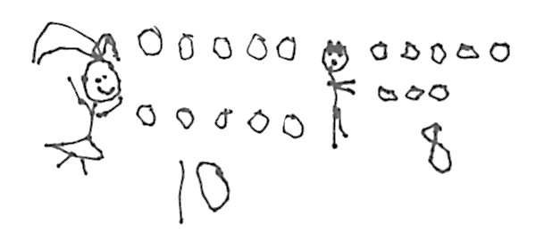

Note: Remember that the focus is on counting all to find the total rather than counting on or addition.

Concept Development (24 minutes)

Materials: (T) Hide Zero cards: one 10 card and numerals 1–9 (Template) (S) Hide Zero cards: one 10 card and numerals 1–9 for each pair of students (Template), ten-frame cards (Lesson 1 Fluency Template 4), two sets of 10 linking cubes (10 in one color and 10 in another color), personal white board for each pair of students

T: Have one color of your cubes represent the boys and another one the girls from the story in the Application Problem. Show me the boys and girls that were in school. When you are done, check your partner’s work to be sure you agree.

T: (Allow students time to finish.) Everyone hold up the stick that represents the girls. (Students do so.) Hold up the stick that represents the boys. (Students do so.)

T: How many girls are there?

S: 10 girls.

T: Show the girls. (Students show again.) Here is the number 10. (Show the 10 card.)

T: How many boys are there?

S: 8 boys.

T: Show the boys. (Students show again.) Here is the number 8. (Show the 8 card.)

T: Put the boys together with the girls. Count with your partner the Say Ten Way to see how many students you have.

S: 1, 2, 3, 4, 5, 6, 7, 8, 9, 10, ten one, ten two, ten three, ten four, ten five, ten six, ten seven, ten eight. (Have early finishers count down to 1 from 18.)

T: How do we say the number of students the Say Ten Way?

S: Ten eight!

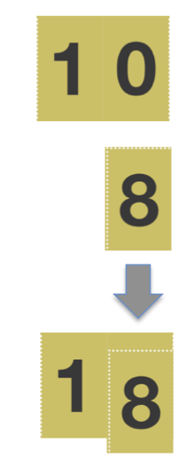T: Watch this magic. Here is my 10. Here is my 8. I push them together, and I have ten eight! This is how we write ten eight. (Pull the cards apart, and push them together a few times.)

T: Talk to your partner. What happened to the 0 of the 10 ones?

S: It went under the 8. 🡪 It disappeared. 🡪 It isn’t there anymore.   
🡪 It is hiding.

T: Yes! It is hiding. I’m going to write the number without the cards. (Write 18.) It is like there is a 0 hiding under this 8.

T: I want each student to write this number on their personal white board. When I say to show me your board, show me.

**MP.4**

S: (Write 18 on personal white board.)

T: Here is a bag with a set of these cards for you. Partner A, open the bag, and put all the numbers on your work mat. With your partner, put them in order from 1 to 10. (Wait.)

T: Partner B, show me ten eight with your cards. Be sure to hide the zero!

T: Partner A, on this first turn, you will use the cubes. Partner B, you will use the cards and write the number on your personal white board.

T: Partners, show me ten one.

**MP.4**

T: Partner B, use the cubes, and Partner A, use the cards. Show me ten five.

Continue the activity using other numbers. Different groups might work at varying speeds.

After about four different numbers, change the mode of representation from linking cubes to ten-frame cards, the same cards used during fluency practice. Have them place the cards in decreasing order from 10 to 1 for variety and repeat the process with about four more numbers.

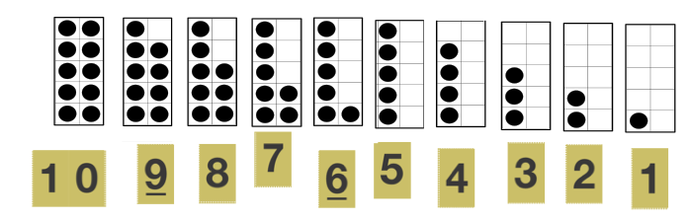

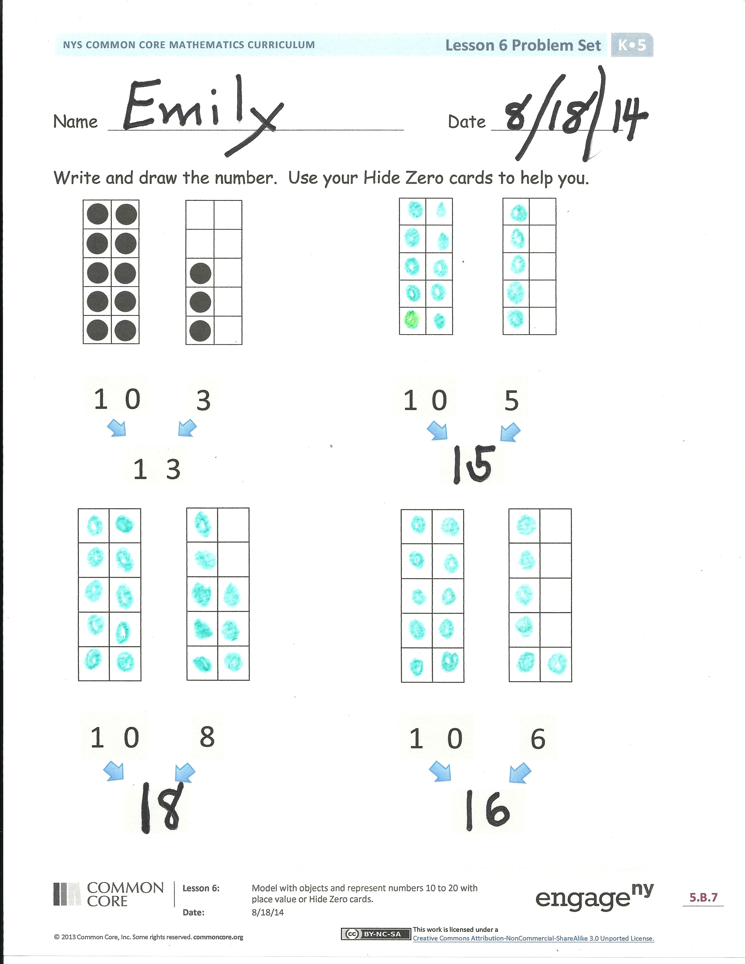Problem Set (7 minutes)

Students should do their personal best to complete the Problem Set within the allotted time.

Have students use their Hide Zero cards while doing the Problem Set, drawing the number represented and then writing the teen number.

Early finishers can be given another number to represent both pictorially and with cards on the back.

Student Debrief (8 minutes)

**Lesson Objective:** Model with objects and represent numbers 10 to 20 with place value or Hide Zero cards.

The Student Debrief is intended to invite reflection and active processing of the total lesson experience.

Invite students to review their solutions for the Problem Set. They should check work by comparing answers with a partner before going over answers as a class. Look for misconceptions or misunderstandings that can be addressed in the Debrief. Guide students in a conversation to debrief the Problem Set and process the lesson.

Introduce the cards as **Hide Zero cards**. Then, possibly discuss:

* Why do you think we call these cards Hide Zero cards?
* How is the number made by the Hide Zero cards different from and the same as the number written with pencil?
* How do the cards help you to understand the number 13? 18?

|  |  |
| --- | --- |
|  | NOTES ON  MULTIPLE MEANS  OF ACTION AND EXPRESSION: |
| Students working below grade level will benefit from additional hands-on time with a Rekenrek. Look for opportunities to give them control of the movement of the beads. They may move the beads slowly or erratically. This allows students to hold a number in their minds and wait for the movement of the bead rather than simply rote count. | |

* If you didn’t know the 0 was hiding, you might think the 1 in 13 was equal to 1 instead of 10. Then, the total value would be 4 because 1 + 3 is 4.

Exit Ticket (3 minutes)

After the Student Debrief, instruct students to complete the Exit Ticket. A review of their work will help with assessing students’ understanding of the concepts that were presented in today’s lesson and planning more effectively for future lessons. The questions may be read aloud to the students.

Name Date

Write and draw the number. Use your Hide Zero cards to help you.

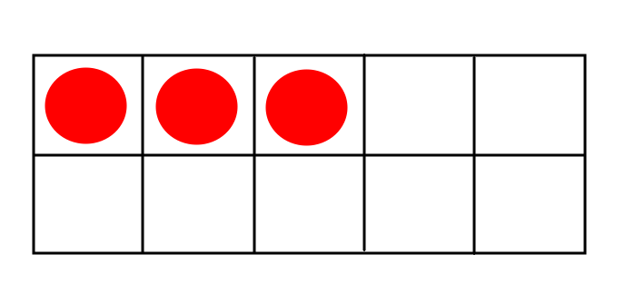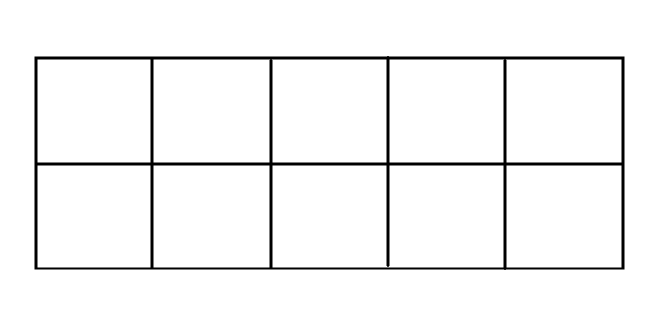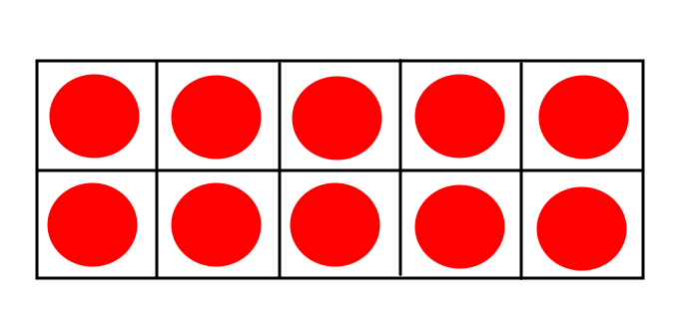

1

0

3

1

0

3

5

1

0



1

0

1

0

6

8

Name Date

Draw the number shown on the Hide Zero cards with a drawing in the   
ten-frame. Write the number below after the 0 is hidden.

Show the number again on the right with a count of 10 ones and 4 ones. Circle the 10 ones.

1

0

4

Name Date

Write and draw the number. Use your Hide Zero cards to help you.



2



7



4



9

|  |
| --- |
| 0F[1] |

1F[2] 2F[3] 3F[4]

4F[5] 5F[6] 6F[7]

7F[8]

8F[9]

Hide Zero cards. Copy double-sided.

Numerals10F[10]

|  |  |  |  |
| --- | --- | --- | --- |
| **1** | **0** |  |  |
| **0** | **1** | **2** | **3** |
| **4** | **5** | **6** | **7** |
| **8** | **9** |  |  |

11FHide Zero cards. Copy double-sided. [11]

5-groups

|  |  |  |  |
| --- | --- | --- | --- |
|  |  |  | **small 10.bmp** |
| **small 3.bmp** | **small 2.bmp** | **small 1.bmp** |  |
| **small 7.bmp** | **small 6.bmp** | **small 5.bmp** | **small 4.bmp** |
|  |  | **small 9.bmp** | **small 8.bmp** |

1. dot cards of 8
2. dot cards of 8
3. dot cards of 8
4. dot cards of 8
5. dot cards of 8
6. dot cards of 8
7. dot cards of 8
8. dot cards of 8
9. dot cards of 8
10. 5-group cards (numeral side) (Copy double-sided with 5-groups on card stock, and cut.)
11. 5-group cards (5-group side) (Copy double-sided with numerals on card stock, and cut.)