Lesson 4
Objective: Count straws the Say Ten Way to 19; make a pile for each ten.

Suggested Lesson Structure
 Fluency Practice (12 minutes)
 Application Problem (6 minutes)
 Concept Development (26 minutes)
 Student Debrief (6 minutes)
Total Time (50 minutes)
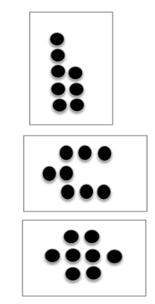
Fluency Practice (12 minutes)
- Dot Cards of Six K.CC.2, K.CC.5 (4 minutes)
- Number Pairs of Six K.CC.2 (4 minutes)
- Circle 10 Objects K.NBT.1 (4 minutes)
Dot Cards of Six (4 minutes)
Materials: (T/S) Dot cards of 6 (Fluency Template 1)
Note: This fluency activity gives students an opportunity to develop increased familiarity with decompositions of six and practice seeing part–whole relationships.
T: (Show 6 dots.) How many do you see? (Give students time to count).
S: 6.

NOTES ON
MULTIPLE MEANS
OF ACTION AND EXPRESSION:
Provide students with disabilities with extra minutes to process questions before giving the signal to respond. When students are responding chorally, ask them to “show thumbs up when ready” to ensure ample think time.

T: How can you see 6 in two parts?
S: (Come up to the card.) 5 here and 1 here. I see 3 here and 3 here.
Continue with other cards of six. Distribute the cards to the students for partner sharing time. Have them pass on the card to a different set of partners at a signal.

Number Pairs of Six (4 minutes)
Materials: (T) Linking cube sticks or dot cards of 6 (Fluency Template 1) (S) Personal white board
Note: This fluency activity gives students an opportunity to develop increased familiarity with compositions of six and practice seeing part–whole relationships. Do not expect automaticity from most students, but make note of advanced thinking. Allow time to count all if necessary.
Show a stick of linking cubes or the dot cards with 5 and 1 indicated as parts.
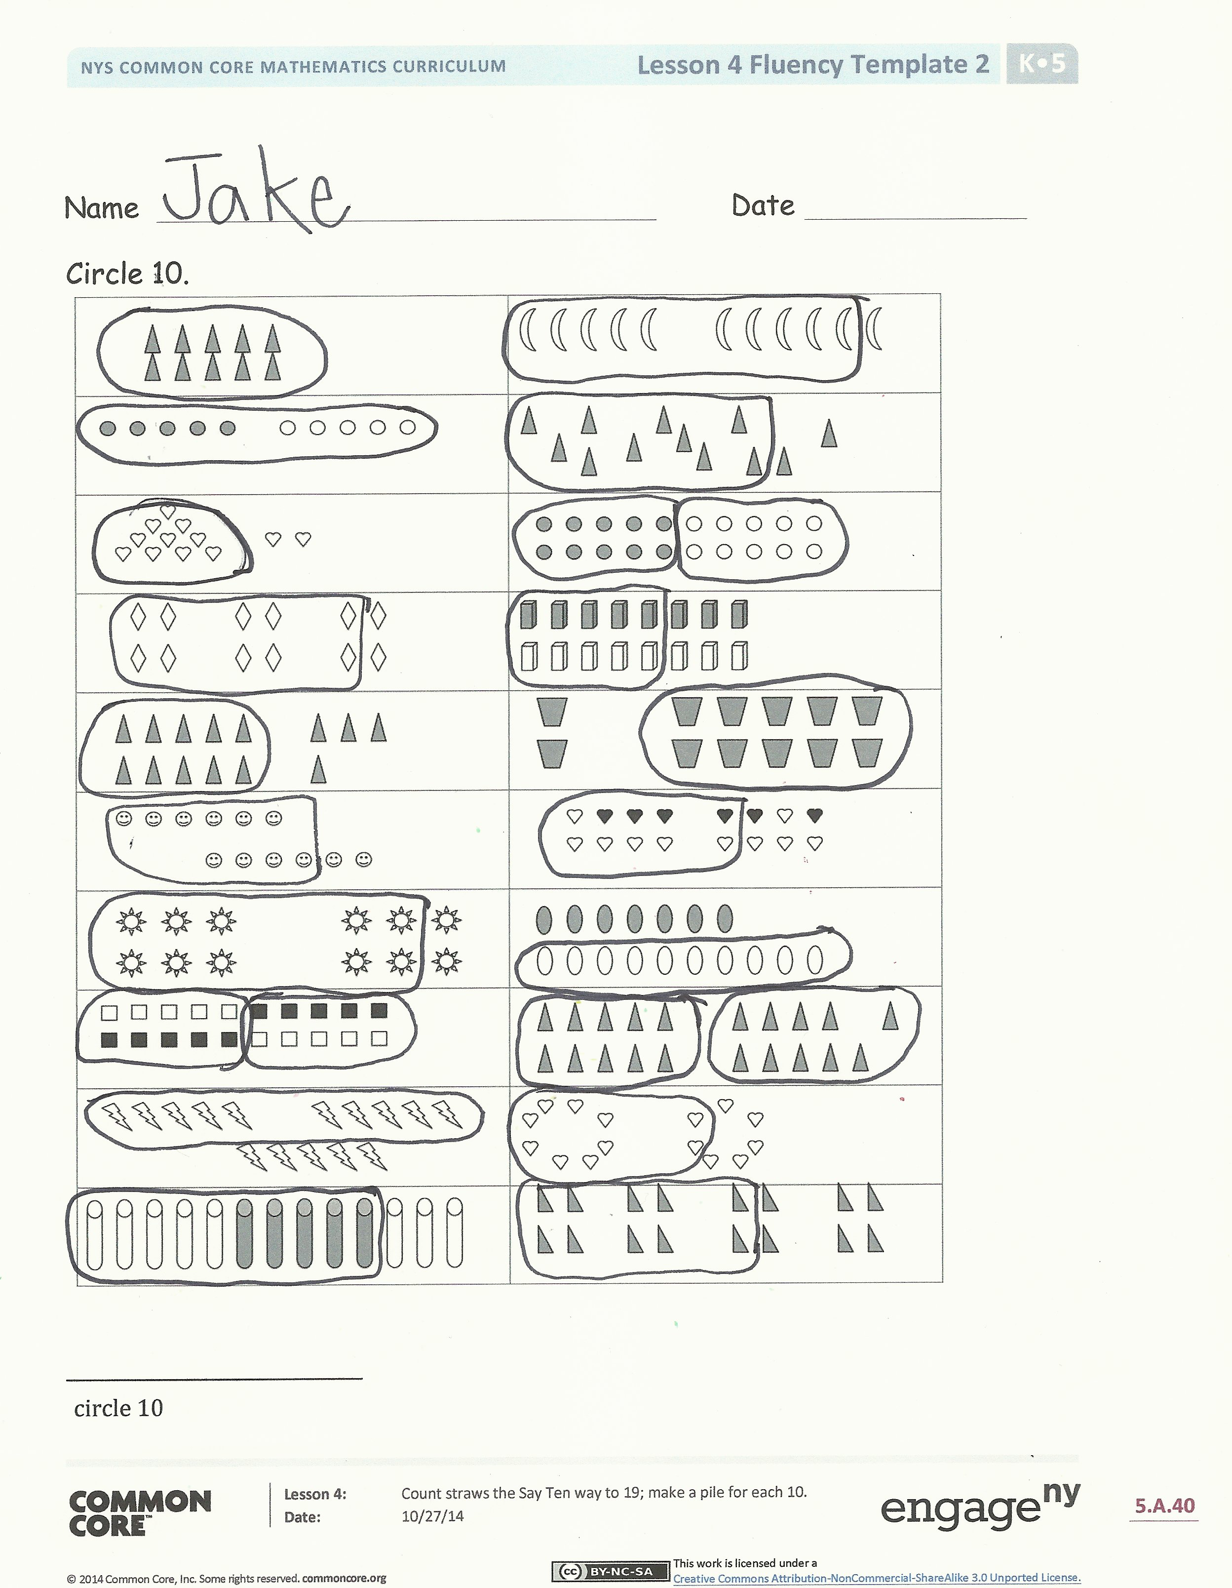
T: Say the larger part. (Give students time to count.)
S: 5.
T: Say the smaller part.
S: 1.
T: What is the total number of dots? (Give them time to recount.)
S: 6.
T: Show the number bond on your personal white board.
Continue with 4 and 2, 3 and 3, and 6 and 0.
Circle 10 Objects (4 minutes)
Materials: (S) Circle 10 (Fluency Template 2)
Note: This activity requires students to locate 10 as an embedded number within a pictorial group of 10 ones and some ones.
Distribute circle 10 template. Please note that this template will be used in the Debrief.
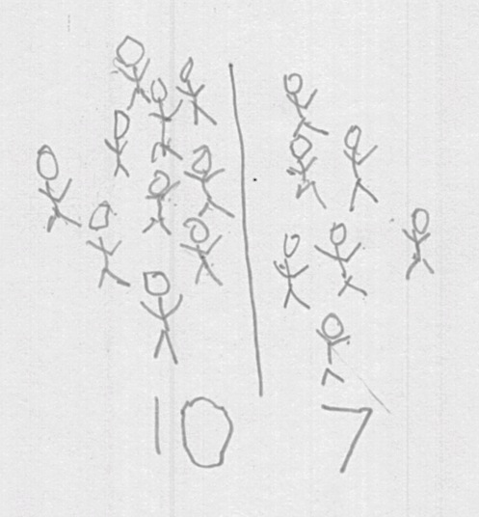
Application Problem (6 minutes)

NOTES ON
MULTIPLE MEANS
OF ENGAGEMENT:
Support your English language learners’ developing academic vocabulary; as students count the Say Ten Way, ask them to also tell the standard number name.
T: How many?
S: Ten one.
T: Right. And the regular way?
S: Eleven.

At recess, 17 students were playing. 10 students played handball while 7 students played tetherball. Draw to show the 17 students as 10 students playing handball and 7 students playing tetherball.
Note: In this Application Problem, students are not adding to solve, but rather they are being guided to decompose the 17 as 10 ones and 7 ones. This is not asking “how many” but rather separating 17 into 10 ones and some ones (K.NBT.1). The problem is not asking them to count the total but is instead telling them the total.
Concept Development (26 minutes)
Materials: (T) 19 linking cubes (S) 19 straws per pair of students, a bag of 19 small counting objects such as pennies or beans per student
T: Come sit with me on the carpet. (Choose a student helper to sit next to you on the left.)
T: (Place a linking cube on each of your fingers.) How many cubes do you see?
S: 10.
T: (Ask your helper to place a cube on her right pinky finger.) Now, how many cubes do you see?
S: Eleven! I see 10 and 1.
T: You’re all correct! Eleven is 10 and 1. I’m going to teach you to count the Say Ten Way!
T: (With a linking cube on each finger, raise your hands again.) How many linking cubes is this?
S: Ten.
T: Every time Lucy adds another cube to her fingers, we’ll Say Ten (show your hands) and the number of ones you see on her fingers. Ready?
S: (Have helper add cubes on her fingers from right to left in sequential order up to 19.) Ten one, ten two, ten three, ten four, ten five, ten six, ten seven, ten eight, ten nine.
T: Excellent! Now, go back to your seats, and we’ll practice counting the Say Ten Way using straws.
T: (Pass out 19 straws to each pair of students.) One student, Partner A, will count out 10 straws into a pile. The other student, Partner B, will place one straw next to the pile, and we’ll say, “ten one.” Ready?
S: (Show a pile of 10 straws and 1 more straw.) Ten one.
T: Partner B, place another straw next to the pile of 10. How many straws now?
S: Ten two, ten three, ten four...(continue to ten nine).
T: Put all the straws back into one pile, and switch roles. Partner B, count out 10 straws into a pile. Partner A, place 1 straw next to the pile, and let’s practice counting again the Say Ten Way.
S: (Count up to ten nine.)
Problem Set (7 minutes)
Students should do their personal best to complete the Problem Set within the allotted time.
Begin by having the students use concrete materials on the ten-frames of the Problem Set. Have them count the Say Ten Way as they work. Direct students to fill the ten-frame on the left, first with one row of 5 from left to right, and then the row below from left to right. Remind them that these are like their egg cartons. After doing some examples with materials, have the students then draw and count the specified amounts while they count the Say Ten Way.

Student Debrief (6 minutes)
Lesson Objective: Count straws the Say Ten Way to 19; make a pile for each ten.
The Student Debrief is intended to invite reflection and active processing of the total lesson experience.
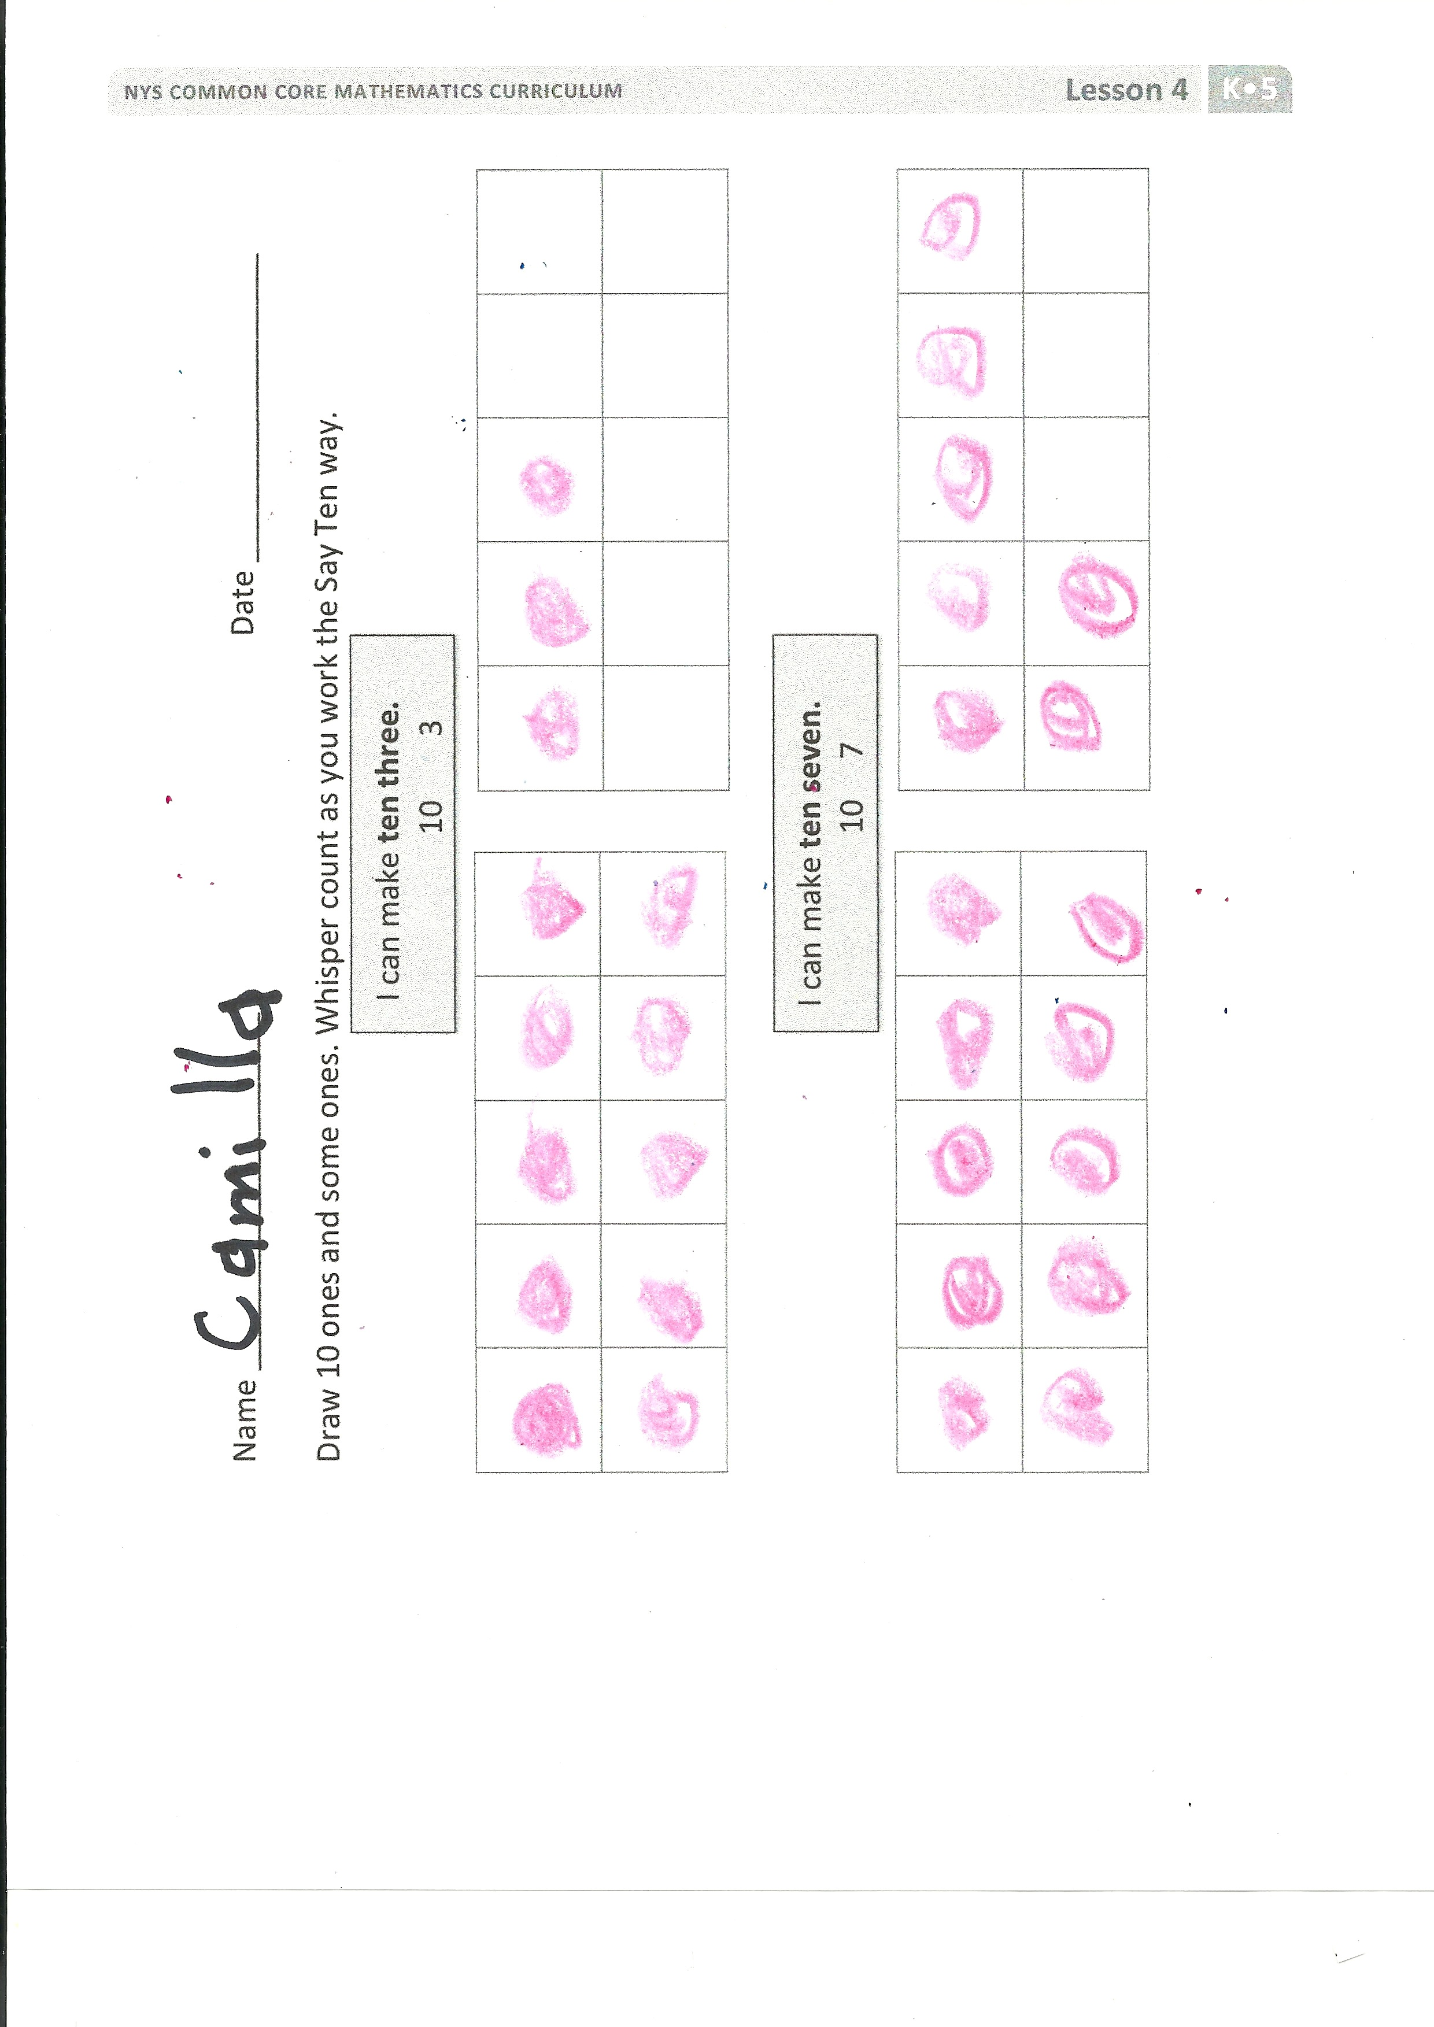
The following is a suggested list of questions to invite reflection and active processing of the total lesson experience. Use what will best support students' ability to articulate the focus of the lesson.
Have students bring their circle 10 template to the carpet. This is the template from the Fluency Practice.
Suggestions for the Debrief:
- Look at your circle 10 template. Can you say the numbers the Say Ten Way?
- Did your friend circle 10 objects the same way you did?
- Were both of your answers correct? Why?
- How do we say ten nine as one number?
- How do we say 16 the Say Ten Way?
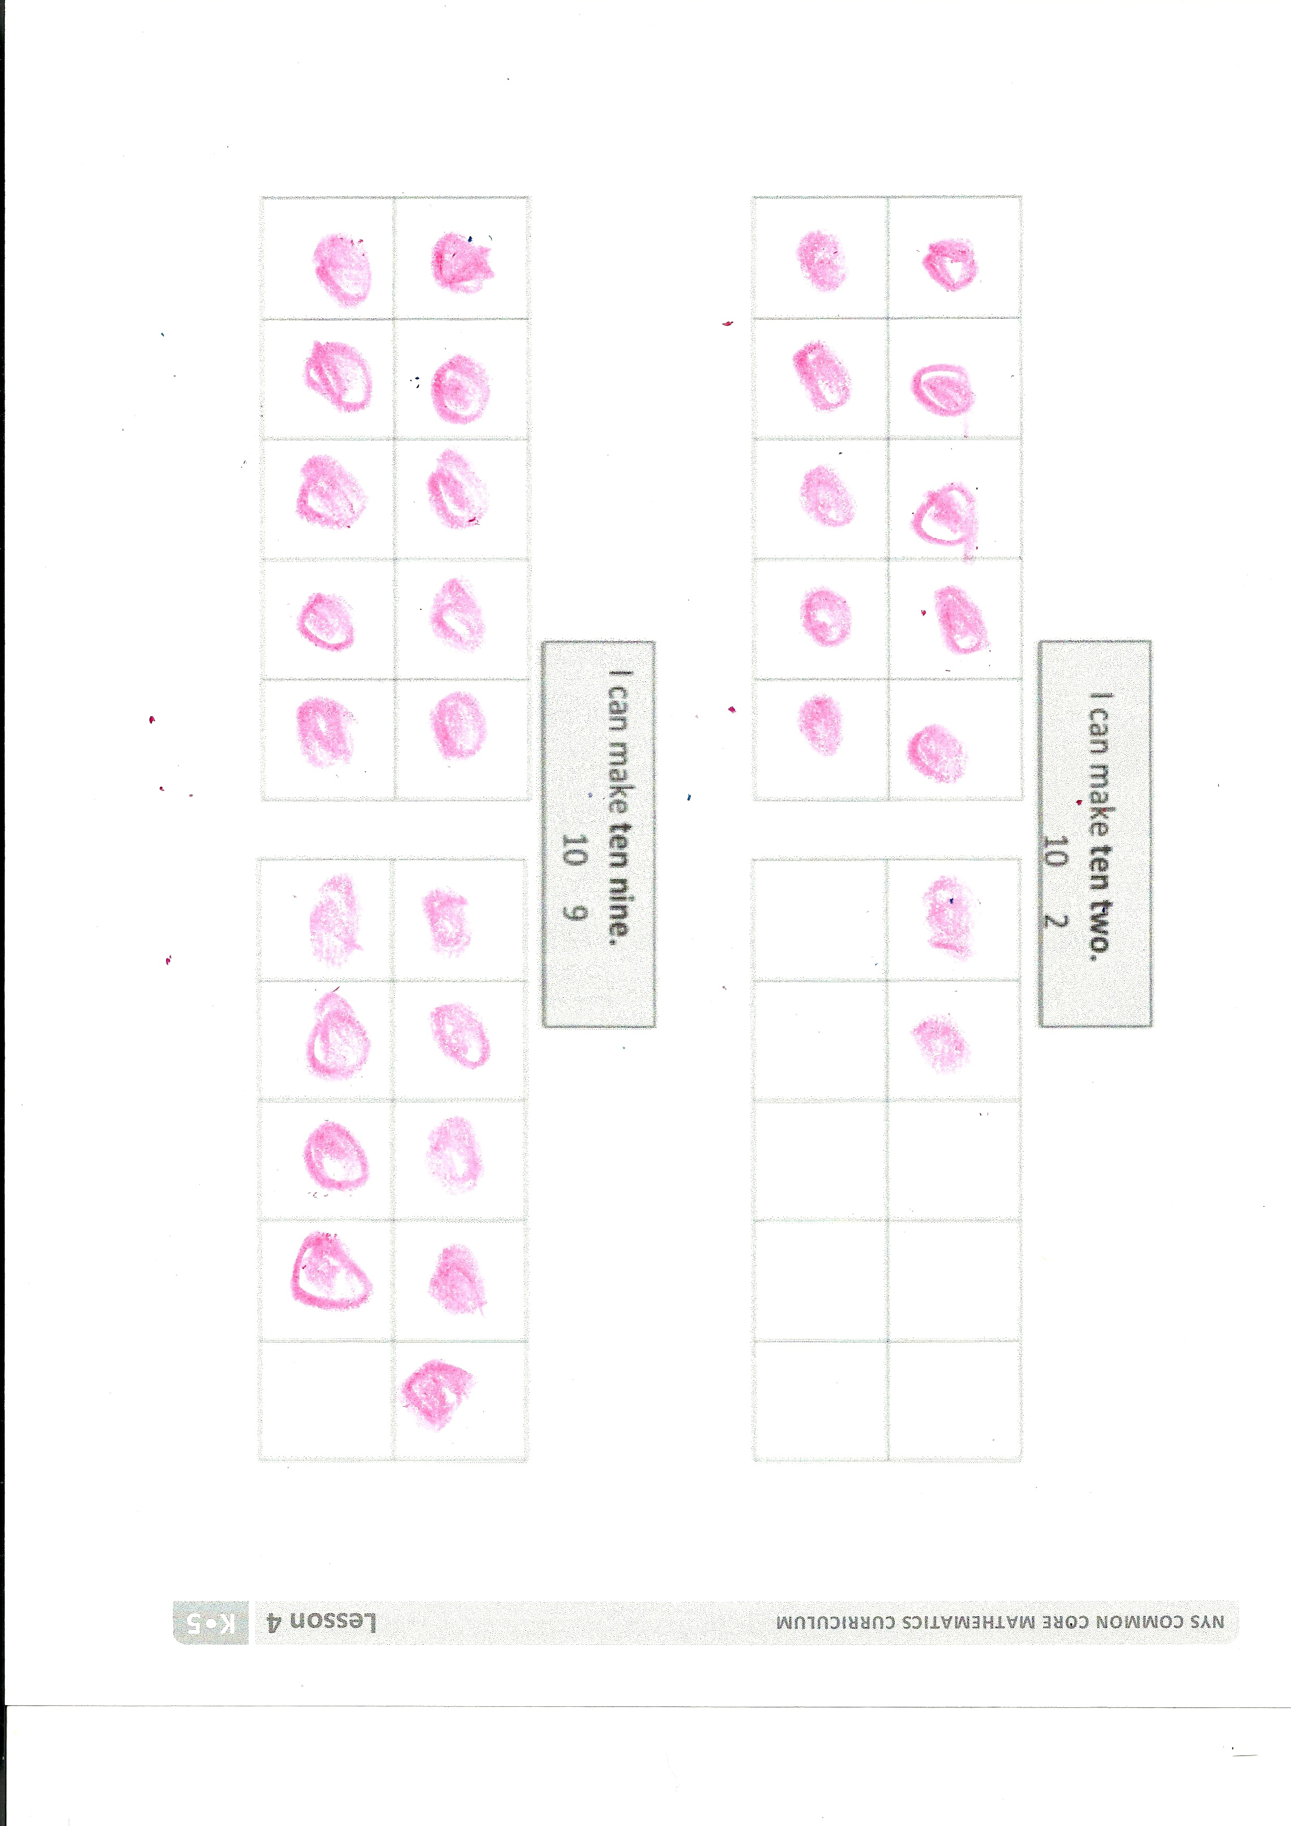
- Which pictures were the easiest for you to count? Why?
- What do all the pictures have in common?
Exit Ticket (3 minutes)
After the Student Debrief, instruct students to complete the Exit Ticket. A review of their work will help with assessing students’ understanding of the concepts that were presented in today’s lesson and planning more effectively for future lessons. The questions may be read aloud to the students.

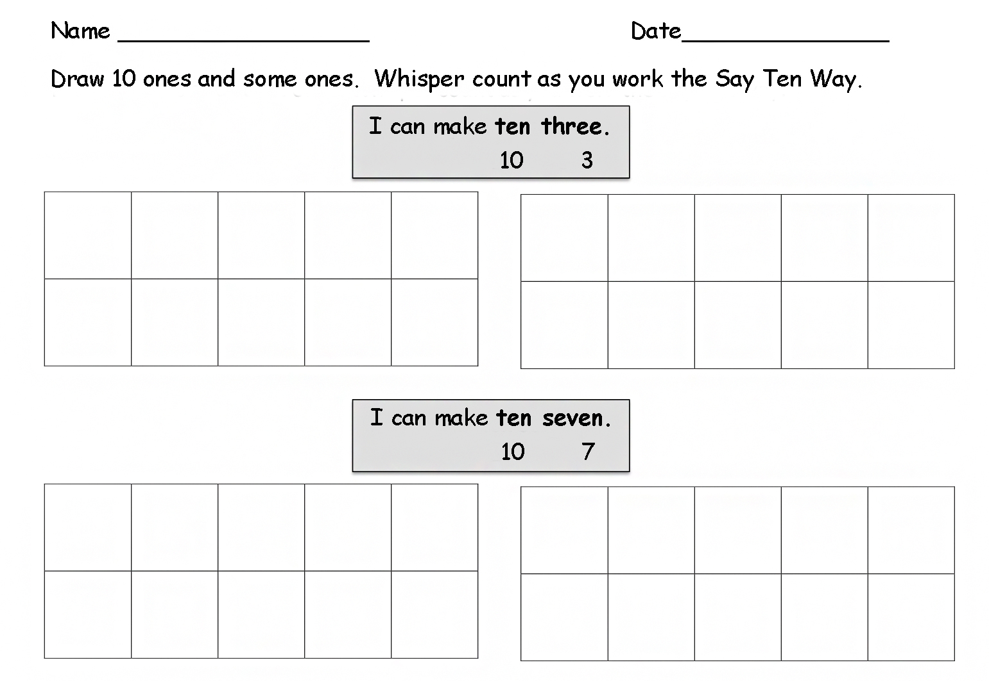
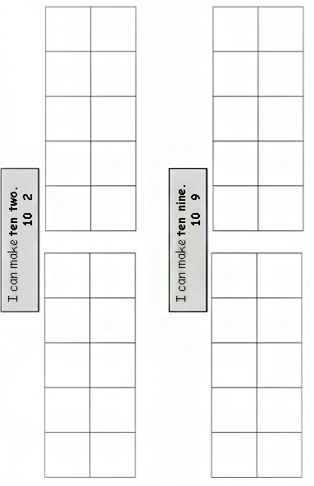

Name Date
______ ______
Count and write how many the Say Ten Way.

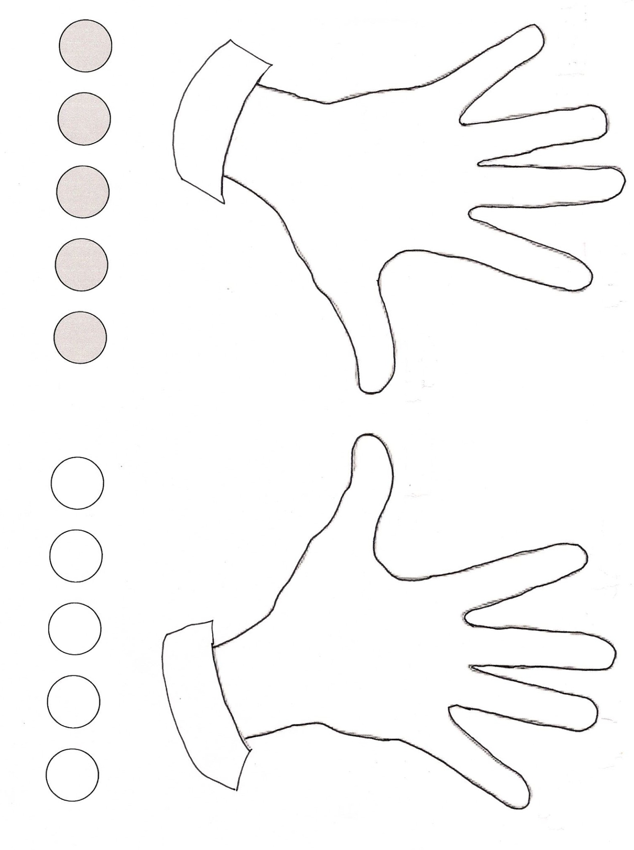

10 10

Name Date

OOOOO XXX
10 3
OOOOO

Draw a line to match each picture with the numbers the Say Ten Way.

10 1
OOOOO X
OOOOO

OOOOO XX
10 6
OOOOO

10 10
OOOOO XXX
OOOOO

10 2
OOOOO XXXXX
OOOOO X

10 3
OOOOO XXXXX
OOOOO XXXXX

Name Date
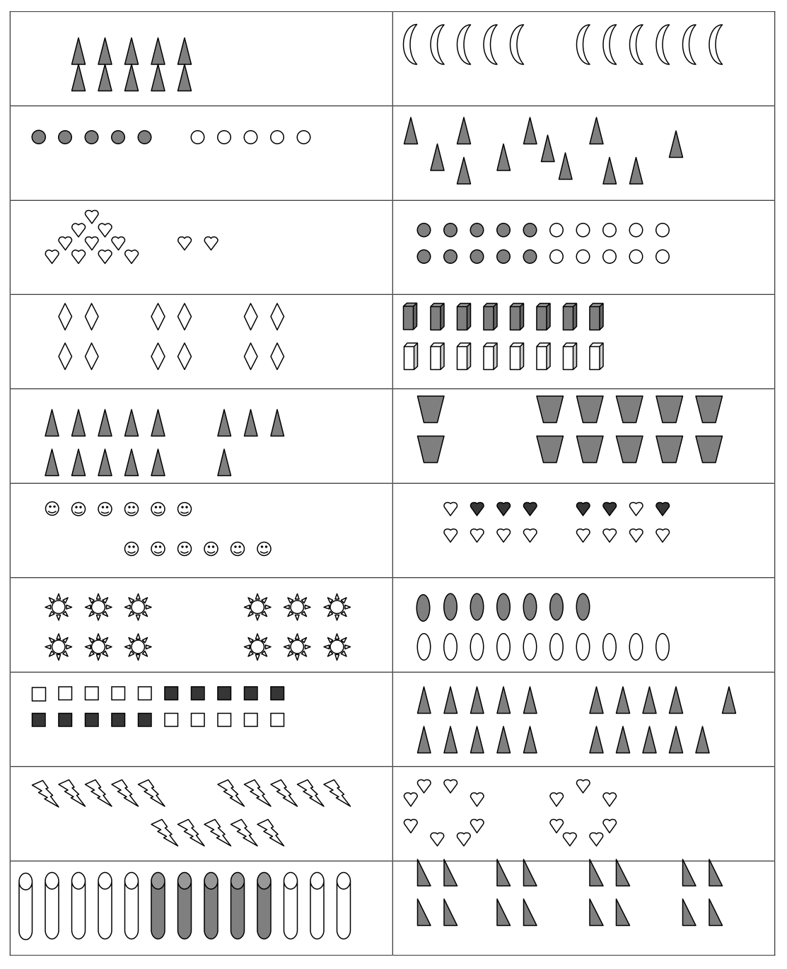
Circle 10.

dot cards of 6
dot cards of 6
dot cards of 6
dot cards of 6
dot cards of 6
dot cards of 6
dot cards of 6
dot cards of 6
circle 10

