Lesson 3
Objective: Count and circle 10 objects within images of 10 to 20 objects, and describe as 10 ones and ___ ones.

Suggested Lesson Structure
 Fluency Practice (10 minutes)
 Application Problem (7 minutes)
 Concept Development (26 minutes)
 Student Debrief (7 minutes)
Total Time (50 minutes)
Fluency Practice (10 minutes)
- Hide 1 K.OA.1 (4 minutes)
- How Many Do You See? K.CC.2 (3 minutes)
- Grouping 10 Objects K.NBT.1 (3 minutes)
Hide 1 (4 minutes)
Materials: (T) Large ten-frame cards (Lesson 1 Fluency Template 3) (S) Ten-frame cards (Lesson 1 Fluency Template 4)
Note: This fluency activity advances the familiar work with the pattern of 1 less as it requires students to visualize removing a dot from the ten-frame.

NOTES ON
MULTIPLE MEANS
OF REPRESENTATION:
Make instructions visual as well as oral for English language learners. When instructing students, “Use your imagination to hide 1,” illustrate this process by covering one dot on the ten-frame. Repeat for the first few numbers.

T: (Show 5.) Use your imagination to hide 1. How many are left?
S: 4.
T: (Show 10.) Use your imagination to hide 1. How many are left?
S: 9.
Continue with the following possible sequence: 1, 6, 2, 7, 3, 8, 4, 9. Have students repeat the activity in pairs if there is time.

How Many Do You See? (3 minutes)
Materials: (T) Large ten-frame cards (Lesson 1 Fluency Template 3)
Note: This fluency activity advances students’ ability to rapidly recognize quantities on ten-frames by requiring them to visualize.
T: (Show dots for several seconds, and then hide the card.) Wait for the signal. How many dots did you see?
S: 7.
T: Who can explain how they see 7?
S: I see a 5 group on top and 2 more on the bottom. (Draw as the student speaks.)
Continue with the following possible sequence: 3, 9, 1, 8, 7, 4.
Grouping 10 Objects (3 minutes)
Materials: (S) Bag with about 20 small objects for each student
Note: Making groups of 10 ones in varied configurations brings attention to the number as significant in today’s lesson and allows students to experience conservation of the number.
T: Place the items from your bag on your work mat. Count out 10 ones, and move them together into a bunch.
T: (Wait while they work.) By counting, prove to your partner there are 10 things in your bunch.
S: (Count.)
T: Push all your things back together. Mix them up. Count out 10 ones again, and move them together into a bunch.
Repeat process two or three more times. Ask students if the same 10 things are in the bunch each time.
Application Problem (7 minutes)
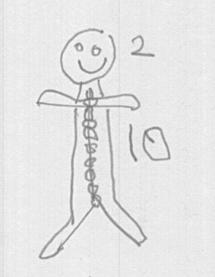
Each gingerbread man got 10 sprinkles as buttons with 2 sprinkles to show the eyes. Draw to show the 12 sprinkles as 10 buttons and 2 eyes.

NOTES ON
MULTIPLE MEANS
OF ENGAGEMENT:
Challenge students working above grade level during the Application Problem by asking them to draw a 5-group that represents this problem. Ask: “What if each gingerbread man got 1 more sprinkle for the nose?”

Concept Development (26 minutes)
Materials: (S) Find 10 (Template) cut into strips
T: (Draw two rows of five circles with three more off to the side.)
T: Let’s count all the circles.
S: 1, 2,… 13.
T: Talk to your elbow partner. Can you count 10 ones in my picture?
S: (Students talk with their partners. Watch for pointing and counting. Expect students to count one at a time. Do not insist they recognize the 2 fives as 10 automatically.)
T: Who can come to the board and show us how they counted 10 ones?
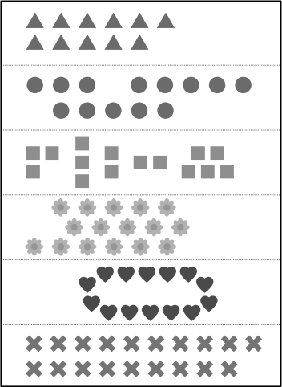
S: (Student comes to the board and designates his 10.)
T: Let’s count with him while he points.
S: 1, 2, 3, 4, 5, 6, 7, 8, 9, 10.
T: Are there more?
S: Yes!
T: How many more?
S: 3 more.
T: Use your finger to circle the 10 ones from your seat.
S: (Make circles around the 10 ones with fingers.)
T: Can you see the 3 ones without counting?
S: Yes!
T: Now, find 10 triangles inside this group of triangles. (Distribute the template strip of triangles pictured to the right.) Find 10 ones, and circle them carefully with your finger.
S: (Count and circle 10 ones with finger.)
T: Show your partner how you found and circled 10 ones with your finger. Prove to him that it is 10 by counting and then circling.
S: (Students do so.)
T: Now, use your pencil to find and circle your 10 ones. (Students circle 10 ones.) Trade papers with your partner, and count to be sure he circled exactly 10 ones. If you disagree, tell your partner why you think the answer should be different.
T: How many extra ones did you have after you counted the 10 triangles?
S: 1.
T: When you and your partner are ready, raise your hand for a new picture. Find and circle 10 ones with your finger and then with your pencil. Prove your count of 10 ones to your partner. Trade papers with your partner, and check his count. (Continue distributing additional strips of teen items from the template).
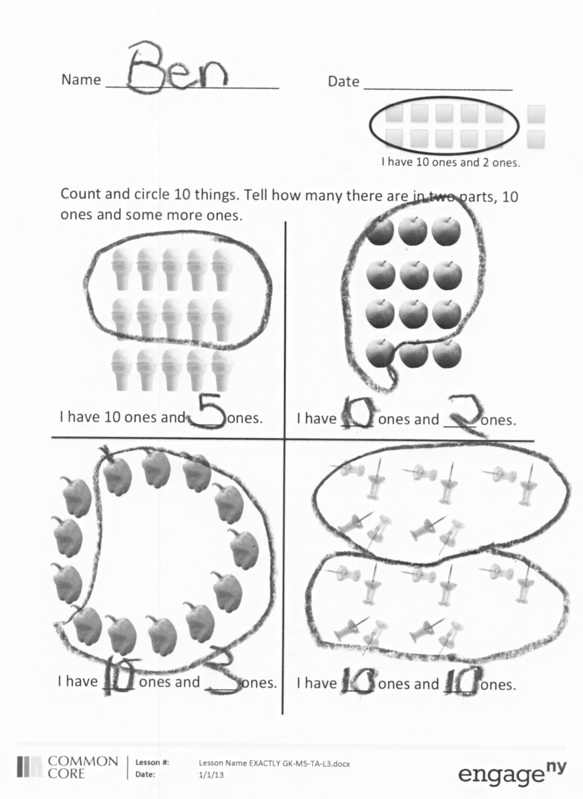
Problem Set (8 minutes)
Students should do their personal best to complete the Problem Set within the allotted time.
Note: Ask the students to find and circle 10 objects with their fingers before circling them with their pencils. They are finding an embedded number; just as when they were seeing seven, they may have seen a 5-group and 2 more. The difference here is that they must count to find 10 ones. Later, in Grade 1, they will recognize certain configurations of 10 ones (such as the ten-frame) as 1 ten.
Student Debrief (7 minutes)
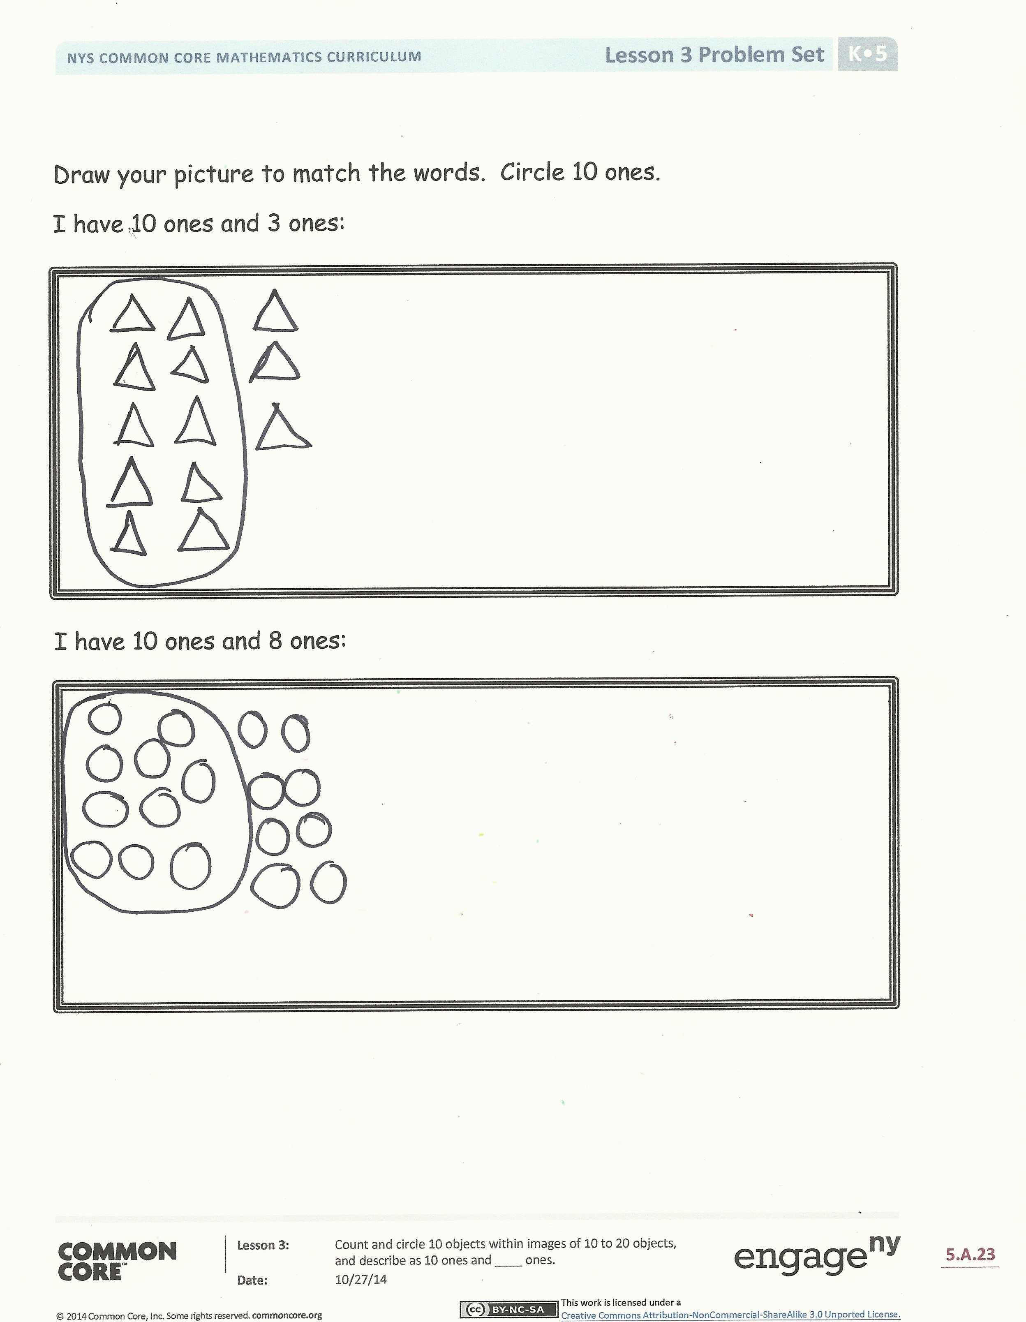
Lesson Objective: Count and circle 10 objects within images of 10 to 20 objects, and describe as 10 ones and ___ ones.
The Student Debrief is intended to invite reflection and active processing of the total lesson experience.
Invite students to review their solutions for the Problem Set. They should check work by comparing answers with a partner before going over answers as a class. Look for misconceptions or misunderstandings that can be addressed in the Debrief. Guide students in a conversation to debrief the Problem Set and process the lesson. Any combination of the questions below may be used to lead the discussion.
- Did your friend circle the exact same ice cream cones? Apples? Peppers? Tacks?
- Were both your answers correct? Why?
- How did your friend represent 10 ones in his picture?
- How do we say 10 ones and 5 ones (and the other numbers represented) as one number? (The students have been counting to higher numbers during Fluency Practice since early in the year. Pre-K standards call for counting to 20.)
- Which pictures were the easiest for you to count? Why?
- What do all these examples have in common? Do 10 ones always look the same? What other things in our classroom could we make into a bunch or pile of 10 ones?
Exit Ticket (3 minutes)
After the Student Debrief, instruct students to complete the Exit Ticket. A review of their work will help with assessing students’ understanding of the concepts that were presented in today’s lesson and planning more effectively for future lessons. The questions may be read aloud to the students.

Name Date
I have 10 ones and 2 ones.

Count and circle 10 things. Tell how many there are in two parts, 10 ones and some more ones.
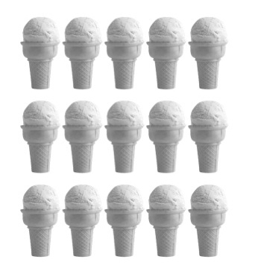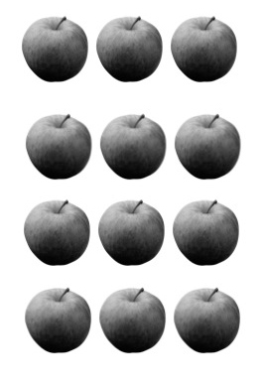
I have 10 ones and ___ ones. I have ___ ones and ___ ones.
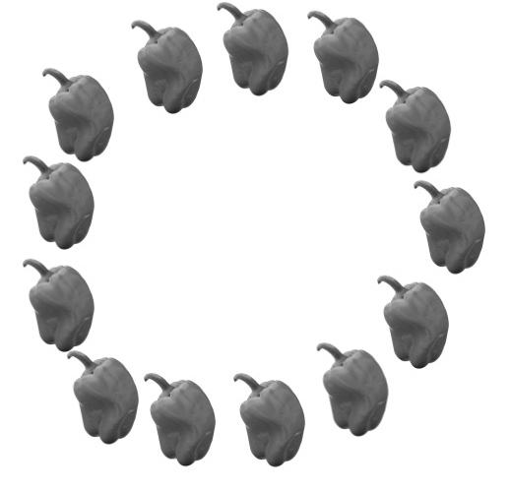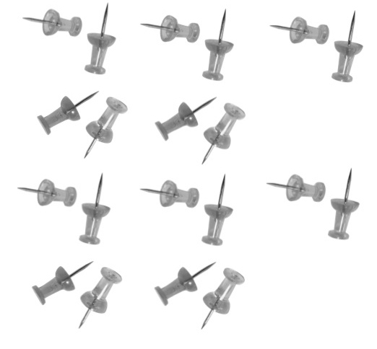
I have ___ ones and ___ ones. I have ___ ones and ___ ones.

Draw your picture to match the words. Circle 10 ones.
I have 10 ones and 3 ones:

I have 10 ones and 8 ones:

Name Date
Circle 10 ones. Draw 10 ones and 6 ones.

I have 10 ones and ___ ones.
I have 10 ones and 6 ones.

Name Date

I have 10 ones and 3 ones.

Circle 10 things. Tell how many there are in two parts, 10 ones and some more ones.
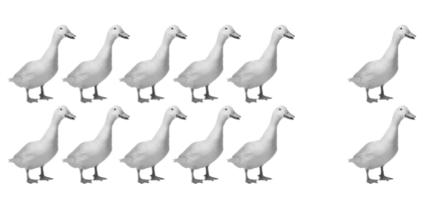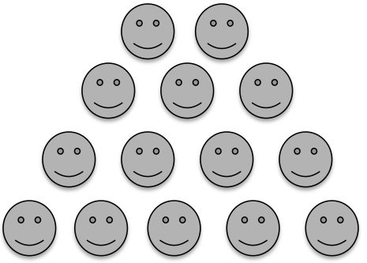
I have 10 ones and ___ ones. I have 10 ones and ___ ones.
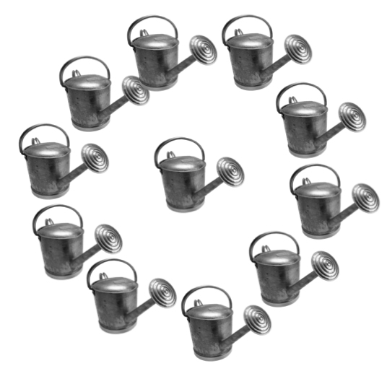
I have ___ ones and ___ ones. I have ___ ones and ___ ones.

find 10

