Lesson 1
Objective: Count straws into piles of ten; count the piles as 10 ones.

Suggested Lesson Structure
 Fluency Practice (12 minutes)
 Application Problem (6 minutes)
 Concept Development (25 minutes)
 Student Debrief (7 minutes)
Total Time (50 minutes)
Fluency Practice (12 minutes)
- Finger Counting from Left to Right K.CC.2, K.CC.4 (2 minutes)
- 5-Frame Flashes K.CC.1, K.CC.4 (4 minutes)
- Ten-Frame Flashes K.CC.2 (6 minutes)
Finger Counting from Left to Right (2 minutes)
Note: This variation of counting the Math Way maintains students’ abilities to model counting sequences within 10 on fingers.
Count by ones within 10 on fingers from left to right, from pinky on the left hand as 1 to pinky on the right hand as 10.
Hover the fingers as if playing the piano. Drop each finger as it is counted, and leave it down. Start and end at different numbers, e.g., count from 5 to 7. (The five fingers of the left hand have played. Students say, “6, 7,” while playing the thumb and pointer finger of the right hand.)
5-Frame Flashes (4 minutes)

NOTES ON
MULTIPLE MEANS
OF ENGAGEMENT:
To help English language learners develop oral language skills, alternate between choral response and written response. Provide personal white boards for students to write the answer during frame flashes.

Materials: (T) Large 5-frame cards (Fluency Template 1)
(S) 5-frame cards (Fluency Template 2)
Note: Reviewing compositions of 5 leads to proficiency with the core fluency for the grade, K.OA.5, add and subtract within 5.
T: (Show 4 dots.) How many dots do you see?
S: 4.
T: How many more to make 5?
S: 1.
T: Say the number sentence.
S: 4 and 1 makes 5.
Continue with the following possible sequence: 3, 2, 1, 4, 2, 3, 5, 0, 5. Have students play with a partner. Give pairs sets of 5-frame cards.
Ten-Frame Flashes (6 minutes)
Materials: (T) Large ten-frame cards (Fluency Template 3) (S) Ten-frame cards (Fluency Template 4)
Note: Reviewing partners to 10 prepares students to decompose 10 in the Application Problem.
T: (Show 9 dots.) How many dots do you see?
S: 9.
T: How many more does nine need to be 10?
S: 1.
Repeat for possible sequence: 8, 5, 7, 6, 1, 4, 3, 5, 2, 9. Have students play with a partner. Give pairs sets of cards.
Application Problem (6 minutes)
Marta loves to share her peanuts at recess. She counted 10 peanuts into the hands of her friend Joey. Draw a picture of the peanuts in Joey’s hand.
Note: There is more than one possible solution to this problem.

NOTES ON
MULTIPLE MEANS
OF ACTION AND EXPRESSION:
For students who are working above grade level, provide extensions to the Application Problem such as:
- If Marta had 15 peanuts to start with, how many does she have left?
- How many more peanuts does Marta need to have 10 in her hand?
- Draw a picture to show Marta’s peanuts.

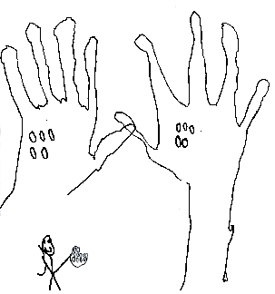

Concept Development (25 minutes)
Materials: (S) 1 egg carton cut to have 10 compartments for each pair of students, 10 bags with different items in each (suggestions to the right), 40 straws
T: Count to find out how many slots there are in your egg carton. Wait for the signal to tell me. (Pause. When all are ready, give the signal.)
Bag Contents:
8 clothespins
8 pasta shells
8 beads
9 3 inch by 5 inch cards
9 pennies
9 crayons
10 erasers
10 linking cubes
10 walnuts in the shell
10 play dollars
S: 10.
T: Each team will explore 10 bags. Find out which bags have 10 things in them.
Have the students in pairs investigate each bag by placing the materials into the egg carton to see if there are enough to count 10 ones. After counting the items in the bag, students will pass it to the next pair on a signal.
T: (Allow time for students to investigate all 10 bags.) Discuss with the pair next to you, which bags had 10 things?
S: The erasers, the linking cubes, the walnuts, and the play dollars!
T: How many times did we count 10 things?
S: 4 times!
T: Now, we are going to count these straws into 4 piles of 10 to match the erasers, linking cubes, walnuts, and play dollars.
T: Count with me to match the number of erasers.
S: 1, 2, 3, 4, 5, 6, 7, 8, 9, 10.
T: 1 pile! Let’s count another pile to match the number of linking cubes.
S: 1, 2, 3, 4, 5, 6, 7, 8, 9, 10.
T: How many piles of 10 do we have now?
S: 2 piles!
T: Let’s count another pile to match the number of walnuts.
Continue with the walnuts and play dollars.
T: Let’s count how many piles of 10 we made.
S: 1 pile, 2 piles, 3 piles, 4 piles.
T: How many straws are in each pile?
S: 10 straws.
T: Let’s count the bags of 10, too.
S: 1 bag, 2 bags, 3 bags, 4 bags.
T: How many things are in each bag?
S: 10 things.
T: Talk to your partner about what is the same and different about the bags of things and the piles of straws.
T: (Allow time.) How many times did we count 10 ones when we were counting the straws?
S: 4.
T: How many times did we count 10 things when we were counting the things in the bags?
S: 4.
T: How many of the bags didn’t have 10 things?
S: 6 bags!
Problem Set (5 minutes)
Students should do their personal best to complete the Problem Set within the allotted time.
Have the students circle the pictures that show 10 things.
Note: Students have been counting linear, array, circular, and scatter configurations through 10 since the first module (K.CC.5). They have further developed skill in circling pictorial sets in Module 4 when learning to add and subtract.
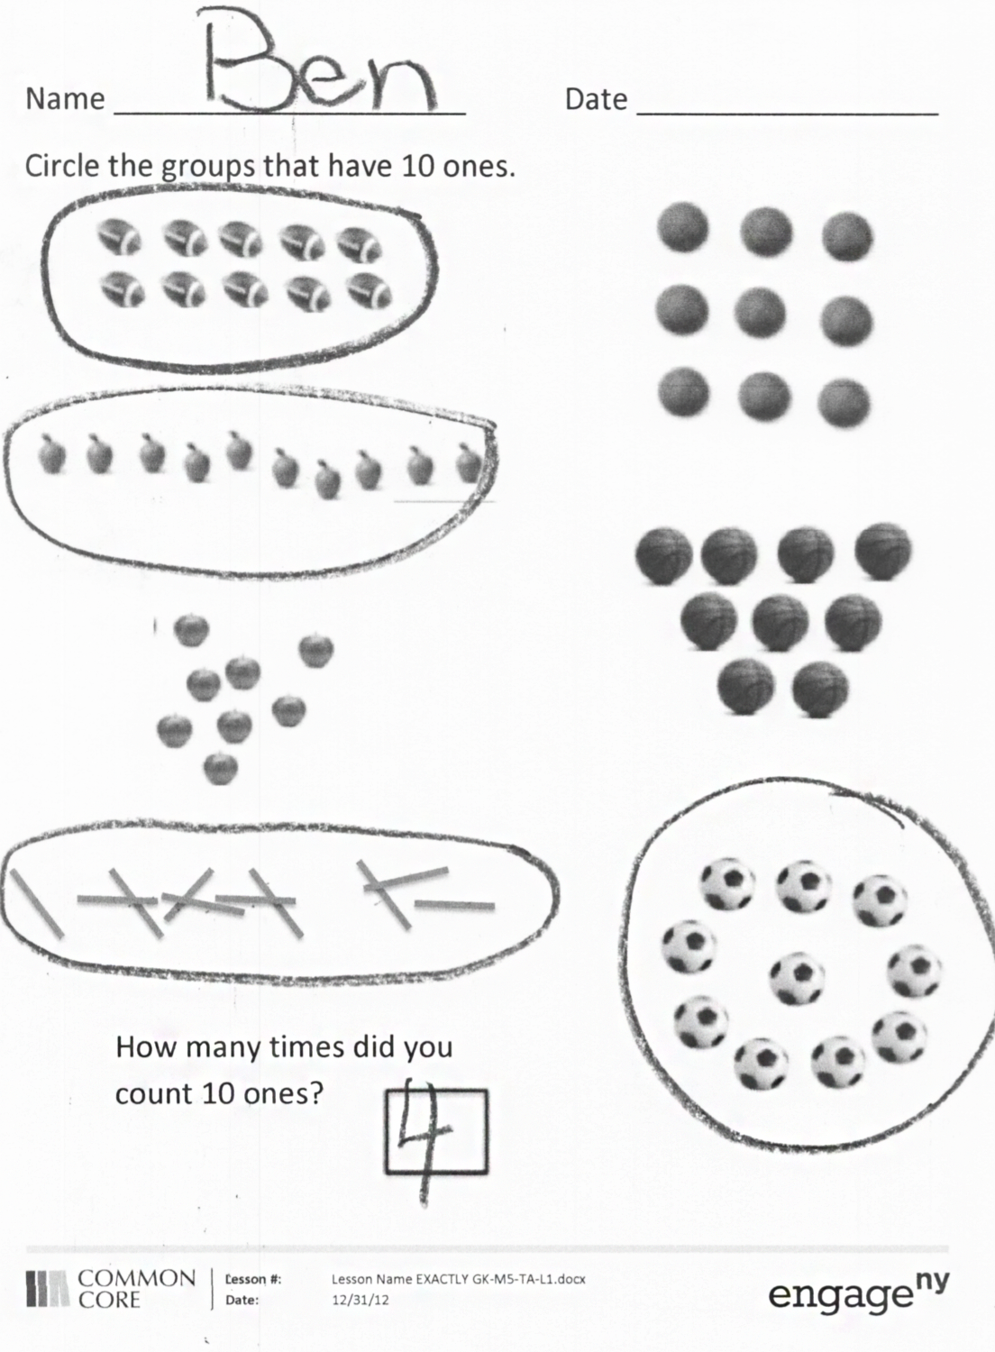
Student Debrief (7 minutes)
Lesson Objective: Count straws into piles of ten; count the piles as 10 ones.
The Student Debrief is intended to invite reflection and active processing of the total lesson experience.
Invite students to review their solutions for the Problem Set. They should check work by comparing answers with a partner before going over answers as a class. Look for misconceptions or misunderstandings that can be addressed in the Debrief.
- Have the students bring their Problem Set to the meeting area and discuss with a partner which things they circled and why. Suggested sentence frames:
“I circled __________ because I counted 10 of them.”
“I didn’t circle __________ because I counted _____ of them.”
- Have them count the number of sets of 10 ones they counted.
- Help students to remember that there were also 4 piles of 10 straws and 4 bags with 10 things in them. Have them discuss how the Problem Set is the same as and different from their work with the bags and straws. Would you ever put apples or soccer balls in bags of 10?
- To review and apply K.OA.4, discuss how many objects the other groups are missing to make 10. Have students draw in the missing objects and circle all the sets of 10 ones. “Now, how many times did we count 10 ones?”
Exit Ticket (3 minutes)
After the Student Debrief, instruct students to complete the Exit Ticket. A review of their work will help with assessing students’ understanding of the concepts that were presented in today’s lesson and planning more effectively for future lessons. The questions may be read aloud to the students.
Name Date
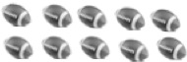
Circle the groups that have 10 ones.

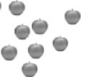

How many times did you count 10 ones?

Name Date
Circle the groups that have 10 things.

How many times did you count 10 things?
Name Date
Circle 10.
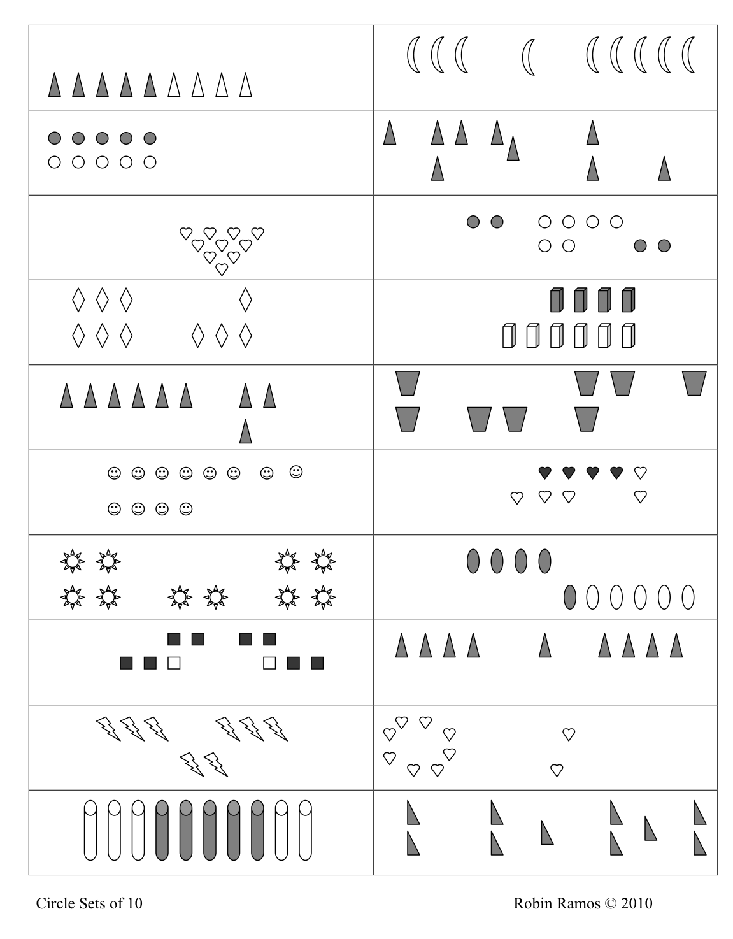
Count the number of times you circled 10 ones. Tell a friend or an adult how many times you circled 10 ones.
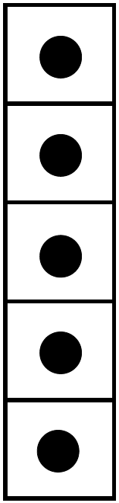

large 5-frame cards
large 5-frame cards
large 5-frame cards
5-frame cards
large ten-frame cards
large ten-frame cards
large ten-frame cards
large ten-frame cards
large ten-frame cards
large ten-frame cards
large ten-frame cards
large ten-frame cards
large ten-frame cards
large ten-frame cards
large ten-frame cards
ten-frame cards
ten-frame cards

