Grade 4: Module 3A: Unit 1: Lesson 1
Using Mystery Pictures and Text to Discover the Topic (Simple Machines)

Long-Term Targets Addressed (Based on NYSP12 ELA CCLS)
I can explain what a text says using specific details from the text. (RI.4.1)
I can make inferences using specific details from the text. (RI.4.1)
I can determine the meaning of academic words or phrases in an informational text. (RI.4.4)
I can determine the meaning of content words or phrases in an informational text. (RI.4.4)
Supporting Learning Targets | Ongoing Assessment
- I can find the meanings of unfamiliar words to help me better understand a scientific text.  - I can categorize pictures based on details from the text. | - Simple Machines Science journal (pages 2-6, Vocabulary)

Agenda | Teaching Notes
- Opening  - Engaging the Reader: Mystery Pictures (15 minutes)  - Reviewing Learning Targets (5 minutes)  - Work Time  - First Read: Getting the Gist about Simple Machines (15 minutes)  - Rereading: A Closer Look at Words (15 minutes)  - Closing and Assessment  - Revisiting the Concept Sort: Identifying the Six Simple Machines (10 minutes)  - Homework  A. None | Note: In this module, students focus their reading and writing on the topic of simple machines. For the past two modules, students have been learning to read and write through social studies topics (the Iroquois and colonial America). To help students shift their focus to reading and writing about science, consider reminding students that readers and writers of informational text focus on many topics and disciplines, including both history and science.  - In the opening of this lesson, students work in small groups to sort “mystery” pictures. For this activity to fully engage students, do NOT tell them the topic of the module in advance. Keep simple machines a mystery.  - If students discover the simple machines topic early in this lesson, it’s fine—they likely won’t know how to categorize all the pictures by the types of simple machines, which is the bulk of both Work Time A and B. Reading the text will help them refine their knowledge.  - Students discuss what it means to read and write like scientists and begin a Reading and Writing Like a Scientist anchor chart, which will develop throughout the module.  - After the topic of simple machines is revealed, remind students that while the focus of their reading, research, and writing is now a science topic, they will still learn the skills and strategies used by readers and writers.  - During this module, students read and take notes on a variety of texts, learn new domain and academic vocabulary, conduct science experiments, and participate in several Science Talks. These experiences require different note-catchers and graphic organizers. Consider copying these documents and stapling them into a Simple Machines Science journal (packet) so all documents are held together and less likely to be lost. See supporting materials. This Science journal is used for the first time during Lesson 2.  - Students can keep their Science journal in their research folders (from Module 2). Help students learn the organizational strategy of keeping all notes, writing drafts, texts, etc. on a topic in one folder—or designate an alternate system.  - Begin to prepare for Independent Reading, which is launched in Lesson 2. See teaching note at the end of this lesson for details.  - In advance: Post or create a new version of the Vocabulary Strategies anchor chart (created in Module 2, Unit 1, Lesson 3).  - Post: Learning targets.  - Record and post the Directions for Determining the Meaning of Simple Machine Words on the board or on chart paper for use with students in Work Time B. See supporting materials.

Lesson Vocabulary | Materials
scientist, scientific text, simple machines, work, force, effort | - Reading and Writing Like a Scientist anchor chart  - Mystery pictures (one set each for a group of three to four)  - Document camera  - Simple Machines: Forces in Action (book; one per student plus one for teacher use)  - Simple Machines Science journal (1 stapled packet per student; prepare for use in Lesson 2)  - Equity sticks (created in Module 2, Unit 1, Lesson 3)  - Vocabulary Strategies anchor chart (created in Module 2, Unit 1 Lesson 3; see supporting materials if chart must be recreated)  - Directions for Determining the Meaning of Simple Machine Words (for teacher reference)

Opening | Meeting Students’ Needs
A. Engaging the Reader: Mystery Pictures (15 minutes)  Note: Do not yet reveal the topic of these pictures or how they should be sorted.  - Post chart paper and record the title at the top of a new anchor chart: Reading and Writing Like a Scientist anchor chart. Tell students today and for the next several weeks they’ll learn to read and write like scientists. Ask students to turn to a partner and talk about what it means to “read and write like a scientist.” Have students share their thinking.  - Tell students the root for scientist comes from Latin and means “to know.” Explain that good scientists have a lot in common with good readers, and record the following on the anchor chart:  - Ask questions  - Seek more information  - Base thinking or conclusions on evidence  - Elaborate on each bullet point to clarify with students. (For example, you might explain that readers base their inferences on evidence from the text and scientists do the same when reading about or observing their topics.) Tell students starting today they’ll get to do all of these things as they discover the topic they will read and write about as scientists for the next several weeks.  - Display the mystery pictures using a document camera or enlarge pictures and post on the board. Do not reveal the topic of the pictures.  - Explain to students that they will be working in groups to examine and discuss these pictures. Remind them of the class expectation for working in a small group. For example: All will participate and share their thinking; be respectful of other’s ideas; etc.  - Place students in groups of three or four. Distribute the mystery pictures to each group. Ask students to examine the pictures with their group and discuss the following question:  - “What do you notice about these pictures?”  - Give students 3 minutes to examine and discuss. | - Asking students to justify their thinking by citing evidence in pictures helps them to take these same steps when reading a text.

Opening (continued) | Meeting Students’ Needs
- Ask students to sort pictures into groups based on details they see. Reassure students there is no right or wrong answer; the purpose is to explain why they sorted the pictures the way they did. Give students 3 more minutes. Students may sort pictures by shape (wheels and pulleys together or levers and inclined planes together) or function (doorknob and bottle cap together—turn to open).
- Circulate among groups to determine how students categorize their pictures. Prompt them to explain their sorting using explicit details from the pictures. For example, a group might report: “We grouped the seesaw with the slide because they are both on a playground.” After groups have sorted, ask them to explain how they sorted their pictures.
- Next, ask students to discuss with their group the following question:
  - “What do all these pictures have in common?”
- Allow groups 3 minutes to discuss, then have each group share their thoughts. Push students to provide evidence for their thinking from the pictures. For example, you might ask: “What detail in these pictures caused you to group time into the same category?”
- Have students stack pictures in a pile. Consider paper-clipping stacks or using plastic baggies to store pictures between sorting.

Opening (continued) | Meeting Students’ Needs
B. Reviewing Learning Targets (5 minutes)  - Tell students that they’ll read something to help them solve the mystery of what the pictures have in common. Explain that you would like them to use the following learning targets: “I can find the meanings of unfamiliar words to help me better understand a scientific text,” and “I can infer about pictures using details from the text.”  - For the first target, have students turn to a partner and share:  - “When have you figured out the meaning of an unfamiliar word? How did it help you better understand a text?”  - Have partners share their thinking. Underline the words scientific text and explain that this means the text will explain something in scientific terms.  - For the second learning target, explain that they have already sorted the mystery pictures once, but they’ll do it again once they’ve read the text and have more information. Ask students to think about the target and discuss with their groups:  - “How will your second sorting be different based on this learning target?”  - Ask groups to share their thinking and explain that in their second sorting, they will have to use evidence from the text to justify their categories. If necessary, give students the synonym for the word categories by writing the word groups above it on the learning target. Clarify that categories are groups based on similar characteristics or features. | - To further support ELLs and other students with vocabulary needs, consider giving concrete examples to clarify the meaning of academic vocabulary. For example, with the word categories, you could give students the example of sorting blocks into categories by their color, shape, or size.

Work Time | Meeting Students’ Needs
A. First Read: Getting the Gist about Simple Machines (15 minutes)
- Distribute the text Simple Machines: Forces in Action to each student. Explain that this is the text they will use to read like scientists. Before you begin reading, remind students as with any first read of a complex text, they are likely to notice many words they don’t know. Explain it is a good idea to read for the gist; what is the text about?
- Ask students to follow along with you as you read pages 4 to 5. After reading, ask groups to discuss what they think this text is about. Call on a member from each group to share the group’s thinking. Probe so students cite evidence to support their thinking. For example, if a student says, “This is about simple machines,” ask: “What did the text say about simple machines?”

Work Time (continued) | Meeting Students’ Needs
B. Rereading: A Closer Look at Words (15 minutes)  - Have students pair up for reading. Distribute the Simple Machines Science journal. Explain that this journal will be used throughout the next few weeks as they research simple machines. Tell students the first thing they’ll do is record important vocabulary from this text. Point to pages 2 through 7 in the Science journal, titled “Simple Machines: Vocabulary.” Explain that this is where the class will collect important words for understanding simple machines and other words that students might need to write like scientists. Remind students they have collected important words as readers and writers in the past when they used a vocabulary notebook when reading and writing about Colonial America (in Module 2).  - Ask students to reread the text to see what they notice about the words. Have them discuss with their partner what they see that stands out. Have a few pairs share. They should notice many bolded words in the text. If not, point this out. Ask them to Think-Pair-Share by discussing why think these words are bolded with their partner. Cold call a few students using equity sticks. Students should recall that authors use bold type to indicate importance. Explain that in informational text bold type also indicates the meaning of a word is explained in the glossary. Revisit Vocabulary Strategies anchor chart.  - The chart should contain something similar to the following:  - Reading on in the text and inferring  - Thinking about parts of the word that you know (like word roots)  - Looking for a text feature that defines the word  - Looking in the glossary  - Looking in a dictionary  - Discussing a word with another (after attempting some of the above strategies)  - Explain that today students will focus on Simple Machines to determine the meaning of the following words: simple machines, work, force, effort, and experiment.  - Review the Directions for Determining the Meaning of Simple Machine Words posted in advance of the lesson with students. Explain that students will be able to use the glossary to determine the meaning of most, but not all words. | - Help students prepare for cold-calling by informing them before they Think-Pair-Share.  - For students who need further support, consider simplifying and typing the directions.  - Also consider giving sentence starters for students to discuss their understanding of the words with their partners. For example, “To me this word means________. I am still confused by this word because_______.”

Work Time (continued) | Meeting Students’ Needs
- Demonstrate the following:
    - Find the bolded word simple machines in the text.
    - Locate the glossary at the back of the text.
    - Locate the phrase “simple machines” and read the definition.
    - Find the phrase in the alphabetized list of vocabulary words in the Simple Machines Science journal on page 6, and record its definition (second column only—Definition).
    - Reread the paragraph containing the bolded word in the text. Think aloud about the meaning of the word and what, if anything, still confuses you. For example, you might say something such as: “Now I know that there are six types of simple machines and that they help people do work, but I am still unsure how each of them work.”
- Give students 10 minutes to look up the remaining four words, record their definitions, and discuss their understanding and record their questions and visuals/notes. Circulate and support pairs as needed. Remind them that the words are listed alphabetically in the Vocabulary section of their Science Journal.
- Cold call pairs to share their definitions and visuals/notes for remembering each word and what still confuses them. Reassure students that it is okay if they still have questions about these simple machine words, because they will continue to read about simple machines and discuss these words over the course of the module.
Note: Students do not complete the last two columns for the words they record in their journals (“This helps me know what this word means …” and “Connections to Simple Machines”). They need to build more background knowledge about these words in future lessons before they can complete these categories.

Closing and Assessment | Meeting Students’ Needs
A. Revisiting the Concept Sort: Identifying the Six Simple Machines (10 minutes)
- Ask students to gather in their original groups and get out their mystery pictures. Ask groups to take 3 minutes to re-sort and to infer new categories based on their reading of Simple Machines.
- Ask groups to share their newly inferred categories and to explain what details in the text support their thinking. Reveal that the intended categories are the six types of simple machines. Have groups modify their sorting if necessary, then distribute the answer key for groups to check their work.
- Finally, ask groups to discuss the following question:
  - “How did reading this text change your thinking about the pictures?”
- Have groups share out their thoughts.
Homework | Meeting Students’ Needs
- None.  Note: Each unit in this module is accompanied by an extensive list of Recommended Texts at a variety of reading levels. Students should use the classroom, school, or local library to obtain book(s) about the topics under study at their independent reading level. These books can be used in a variety of ways—as independent and partner reading in the classroom whenever time allows, as read-alouds by the teacher to entice students into new books, and as an ongoing homework expectation. During this unit, let students know you expect them to read at home from a related book at their independent reading level. In addition, students may be assigned additional work, such as rereading complex text or completing a writing task. For more information on independent reading, see also Launching Independent Reading in Grades 3-5: Sample Plan, which is a stand-alone document on EngageNY.org. | - Students who cannot yet read independently at any level will benefit from hearing books read to them, either by a caregiver or through audio recordings. Hearing books/texts can be an ongoing assignment for these students.  - In addition, www.novelnewyork.org has a free, searchable database of content-related texts that can be played as audio files on a home or library computer. Texts on this site can also be translated into many languages. Use the database to provide at-home reading of related texts to ELLs and their families in their native languages.

Grade 4: Module 3A: Unit 1: Lesson 1
Supporting Materials
Mystery Pictures

1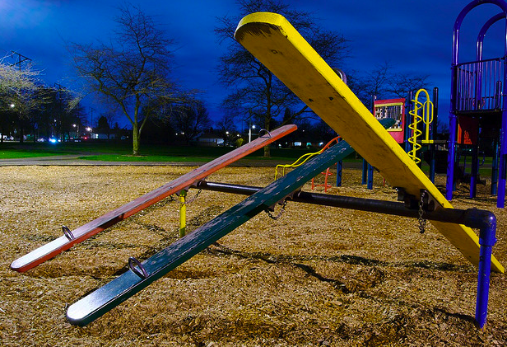 | 2

3 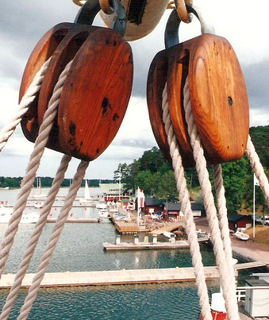 | 4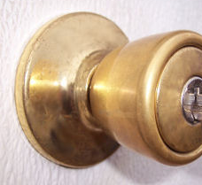

Mystery Pictures

5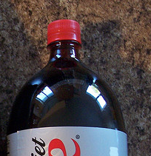 | 6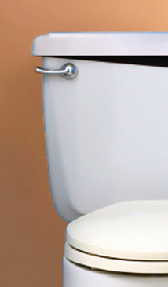

7 | 8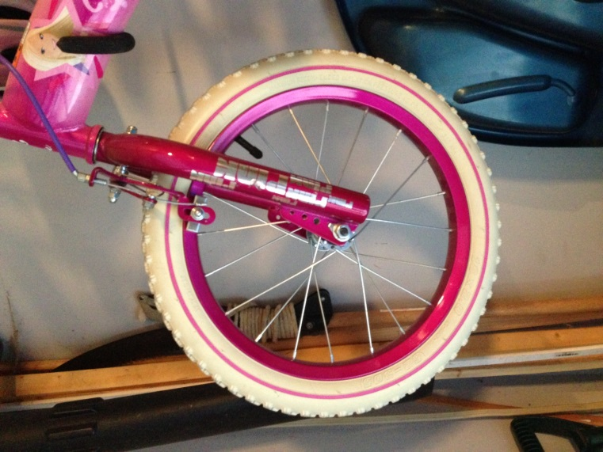

Mystery Pictures

9 | 10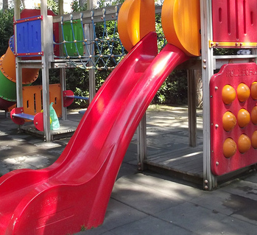

11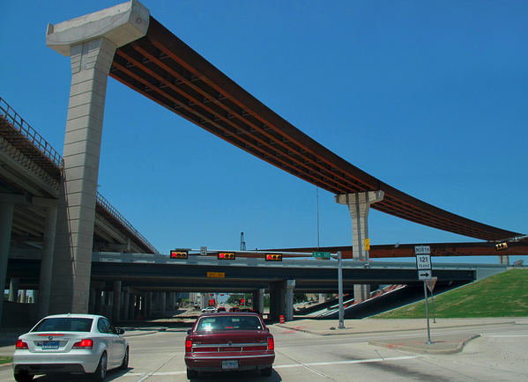 | 12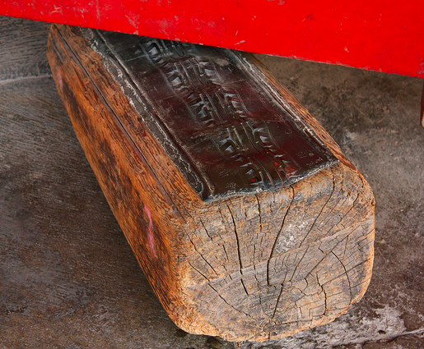

Categories

Levers | Wedges
Pulleys | Wheels and Axles
Screws | Inclined Planes

Answer Key

- seesaw = lever
- teeth = wedge
- sailboat = pulley
- door knob = wheel and axle
- bottle top = screw
- toilet handle = lever
- flagpole = pulley
- bike wheel = wheel and axle
- screw = screw
- slide = inclined plane
- on-ramp = inclined plane
- door stop = wedge
Photo #1 Bakke, Peat. “Night Seesaw.” 3 March 2008. Online Image. Flickr. http://www.flickr.com/photos/mistermoss/2308968745/.
Photo #2 Gennari, Claudio. “The Threat.” 10 Jan 2009. Online Image. Flickr. http://www.flickr.com/photos/claudiogennari/3187479048/.
Photo #3 Leo-Seta. “Pulleys.” Aug 1994. Online Image. Flickr. http://www.flickr.com/photos/uncle-leo/3172970451/.
Photo #4 Sattler, Gary, and Anna Sattler. “LockSet01-at-440.” 13 July 2007. Online Image. Flickr. Source: http://www.flickr.com/photos/9512074@N02/815185256/.
Photo #5 Holifield, Chris. “Yet Another Mutant Zucchini.” 3 Jan 2005. Online Image. Flickr. http://www.flickr.com/photos/dropdeadchris/2785904134/.
Photo #6 Jordan, Brett. “Toilet Humour.” 14 Oct 2007. Online Image. Flickr. http://www.flickr.com/photos/x1brett/4481271046/.
Photo #7 Joshua Davis Photography. “My America.” 5 Aug 2004. Online Image. Flickr. http://www.flickr.com/photos/articnomad/8643121/.
Photo #8 Dodson, E. Used by permission.
Photo #9 Hudson, Paul. “Screw: Theme 2: Mundane Technology.” 18 Feb 2012. Online Image. Flickr. http://www.flickr.com/photos/pahudson/6897093529/.
Photo #10 Brown, Elliott. “Piazza Antiche Mura, Sorrento – play ground – slide.” 30 June 2012. Online Image. Flickr. http://www.flickr.com/photos/ell-r-brown/7538200214/.
Photo #11 Cozart, Justin. “Unfinished Ramp, Frisco TX.” 29 June 2011. Online Image. Flickr. http://www.flickr.com/photos/fatguyinalittlecoat/5773420857/.
Photo #12 Murrell, Leigh A. “Untitled.” 20 June 2011. Online Image. Flickr. http://www.flickr.com/photos/echameagua/7236933840/in/photostream/.
Simple Machines Science Journal

Name:
Date:

Inclined Plane | Lever
Wedge | Wheel and Axle
Pulley | Screw

Simple Machines Science Journal
Vocabulary

Word/Phrase | Definition | This helps me know what this word means … | Connections to Simple Machines
balance

compound machine
conclusion
decrease
distance

Simple Machines Science Journal
Vocabulary

Word/Phrase | Definition | This helps me know what this word means … | Connections to Simple Machines
effort
experiment
fixed pulley
force
friction

Word/Phrase | Definition | This helps me know what this word means … | Connections to Simple Machines
fulcrum
hypothesis
inclined plane
increase
lever
Simple Machines Science Journal
Vocabulary

Simple Machines Science Journal
Vocabulary

Word/Phrase | Definition | This helps me know what this word means … | Connections to Simple Machines
load
moveable pulley
observe
pulley
ramp

Simple Machines Science Journal
Vocabulary

Word/Phrase | Definition | This helps me know what this word means … | Connections to Simple Machines
resistance
simple machine
wheel and axle
work

Simple Machines Science Journal
Vocabulary

This section is intentionally blank. Use the table below to add any other words you think are important as you continue to learn more about simple machines

Word/Phrase | Definition | This helps me know what this word means … | Connections to Simple Machines

Simple Machines Science Journal
Building Background Knowledge
What Are Simple Machines?

Text: Use the information on pages 4-5 of Simple Machines by Buffy Silverman, and fill in below.
Supporting Detail

Supporting Detail
Why are simple machines important?
Main Idea:

Supporting Detail

Reading and Writing Like a Scientist:

Explain what simple machines do. Use details from the text to support your explanation.

Simple Machines Science Journal
Preparing for a Science Talk
(Unit 1, Lesson 3)

Question: How do simple machines impact our lives?

Preparation: Look back in your notes and texts about simple machines to find evidence to help you answer the Science Talk question.
When I read or saw this evidence … | I think that simple machines impact our lives by …
(Example)  that part in Simple Machines that said pyramid workers used levers to help them pick up bricks | (Example)  I think that levers help lift really heavy things.

My Science Talk notes: Ideas and Questions
My teacher’s feedback:
My goals for the next Science Talk:

Simple Machines Science Journal
KWL Chart

I KNOW … |  | I WANT to know … | I LEARNED …
Information | Y/N | I WANT to know … | Information | Source

Simple Machines Science Journal
Inclined Plane Experiment Notes

Hypothesis: What do you think is going to happen?

Materials: List the materials needed for this experiment.

Observations: As you conduct this experiment, what do you see happening?
Lifting bag straight up (Hint: Step 8):

Pulling bag on top of books (Hint: Step 10):

Conclusion: Describe what you learned about the inclined plane and how it works. Make sure to use scientific vocabulary in your conclusion.
Simple Machines Science Journal
Inclined Plane Research Notes

- Record important information about the inclined plane from the text.
What an inclined plane looks like: | Type of work it helps a person do: | Example of an inclined plane:

- Diagram showing how this simple machine helps people. Make sure to label your diagram.

- How does an inclined plane impact work?

Simple Machines Science Journal
Lever Experiment Notes
Hypothesis: What do you think is going to happen?

Materials: List the materials needed for this experiment.
Observations: As you conduct this experiment, what do you see happening?
Six and four dimes:
Prediction for seven and three dimes:
Test seven and three dimes:
Eight and two dimes:
Nine dimes and one dime:

Conclusion: Describe what you learned about the lever and how it works. Make sure to use scientific vocabulary in your conclusion.

Simple Machines Science Journal
Lever Research Notes

- Record important information about the inclined plane from the text.
What a lever looks like: | Type of work it helps a person do: | Example of a lever:

- Diagram showing how this simple machine helps people. Make sure to label your diagram.

- How does a lever impact work?

Simple Machines Science Journal
Preparing for a Science Talk

Question: How do simple machines impact our lives?

Preparation: Look back in your notes and texts about simple machines to find evidence to help you answer the Science Talk question.

When I read or saw this evidence … | I think that simple machines impact our lives by …
(Example)  that part in Simple Machines that said pyramid workers used levers to help them pick up bricks | (Example)  I think that levers help lift really heavy things.

My Science Talk notes: Ideas and Questions
My teacher’s feedback:
My goals for the next Science Talk:

Simple Machines Science Journal
Pulley Research Notes

- Record important information about the inclined plane from the text.
What a pulley looks like: | Type of work it helps a person do: | Example of a pulley:

- Diagram showing how this simple machine helps people. Make sure to label your diagram.

- A single pulley does / does not [circle one] change the effort needed to lift a load. Explain your answer.
- A double pulley does / does not [circle one] change the effort needed to lift a load. Explain your answer.

Simple Machines Science Journal
Wheel and Axle Research Notes

- Record important information about the inclined plane from the text.
What a wheel and axle look like: | Type of work it helps a person do: | Example of a wheel and axle:

- Diagram showing how this simple machine helps people. Make sure to label your diagram.

- Describe how the wheel and axle is similar to the lever? Use scientific vocabulary in your explanation.

- Explain why a screwdriver is an example of a wheel and axle.

- How does a wheel and axle impact work? Make sure to use scientific vocabulary in your explanation. (Hint: make sure to use the word friction in your explanation.)

Simple Machines Science Journal
Pulley Experiment Notes

Hypothesis: What do you think is going to happen?

Materials: List the materials needed for this experiment.

Observations: As you conduct this experiment, what do you see happening?
Pick up the pail without a pulley. (Hint: Step 3):
Raising the pail with a single pulley. (Hint: Step 5):
Raising the pail with a double pulley. (Hint: Step 9):

Conclusion: Describe what you learned about the pulley and how it works. Make sure to use scientific vocabulary in your conclusion. (Hint: What’s the difference between a single pulley and a double pulley on the effort it takes to lift a load?)

Simple Machines Science Journal
Wheel and Axle Experiment Notes
Hypothesis: What do you think is going to happen?

Materials: List the materials needed for this experiment.

Observations: As you conduct this experiment, what do you see happening?

- Length of rubber band attached to the wheeled object:
_________centimeters _________inches

- Length of rubber band as the wheeled object is pulled on its wheels:
_________centimeters _________inches
Describe the effort it took to move the object:_______________________________________

- Length of rubber band as the wheeled object is pulled on its side:
_________centimeters _________inches
Describe the effort it took to move the object:_______________________________________

Conclusion: Describe what you have learned about the wheel and axle and how it works. Make sure to use scientific vocabulary in your conclusion.

Simple Machines Science Journal
Preparing for a Science Talk
(Unit 2 Lesson 11)

Question: How do simple machines impact our lives?

Preparation: Look back in your notes and texts about simple machines to find evidence to help you answer the Science Talk question.

When I read or saw this evidence … | I think that simple machines impact our lives by …
(Example)  that part in Simple Machines that said pyramid workers used levers to help them pick up bricks | (Example)  I think that levers help lift really heavy things.

My Science Talk notes: Ideas and Questions
Reflect on the following learning target:
“I can effectively participate in a Science talk about simple machines.”

Vocabulary Strategies Anchor Chart

Directions for creating: Write the following underneath on chart paper to create this anchor chart.

Vocabulary Strategies
  - Reading on in the text and infer
  - Think about parts of the word that you know (like word roots)
  - Look in the glossary
  - Look for a text feature that defines the word
  - Look in a dictionary
  - Discuss a word with another (after attempting some of the above strategies)
Directions for Determining the Meaning of Simple Machine Words

Teacher directions: Write the following directions on the board or chart paper for students in advance of this lesson.

Directions: Using your glossary or another strategy, find the meaning of the following words: simple machines, work, force, effort, and experiment.
- Determine the meaning of each word.
- Find the word in your journal and write the definition (complete the second column only).
- Reread the text with your partner.
- Discuss the following questions: How has your understanding of these words changed? Which words are still confusing for you and why?

