Lesson 8
Objective: Extend the use of place value disks to represent three- and four-digit by one-digit multiplication.

Suggested Lesson Structure
 Fluency Practice (12 minutes)
 Application Problem (8 minutes)
 Concept Development (30 minutes)
 Student Debrief (10 minutes)
Total Time (60 minutes)
Fluency Practice (12 minutes)
- Expanded Form 2.NBT.3 (3 minutes)
- Multiply Mentally 4.NBT.4 (3 minutes)
- Multiply Using Disks 4.NBT.5 (6 minutes)
Expanded Form (3 minutes)
Materials: (S) Personal white board
Note: Reviewing standard form versus expanded form prepares students to decompose multi-digit multiplication sentences into a series of multiplication sentences.
T: (Write 200 + 30 + 4.) Say the addition sentence with the answer in standard form.
S: 200 + 30 + 4 = 234.
Repeat process for the following possible sequence: 3,000 + 500 + 60 + 8 and 400 + 7 + 90.
T: (Write 572.) Say the number.
S: 572.
T: Write 572 in expanded form.
S: (Write 572 = 500 + 70 + 2.)
Repeat process using the following possible sequence: 8,463 and 9,075.

Multiply Mentally (3 minutes)
Note: Reviewing these mental multiplication strategies provides a foundation for students to succeed during the Concept Development.
Repeat the process from Lesson 7 using the following possible sequence: 34 × 2, 31 × 3, 22 × 4, and 24 × 3.
Multiply Using Disks (6 minutes)
Materials: (S) Personal white board
Note: This fluency reviews Lesson 7’s content.
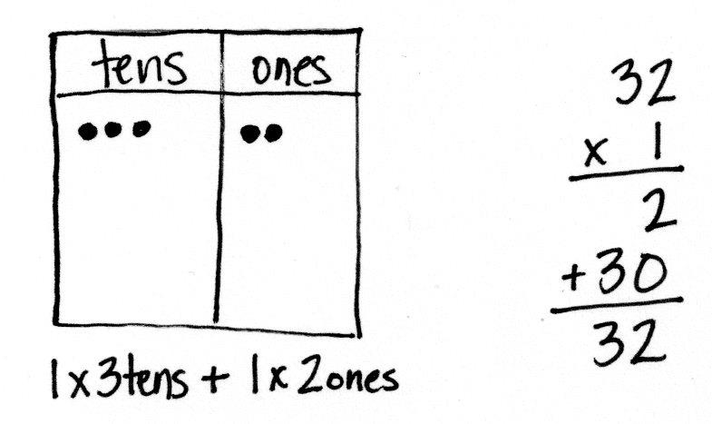
T: (Write 1 × 32.) On your personal white boards, draw place value disks to show this multiplication sentence.
S: (Draw 3 tens disks and 2 ones disks.)
T: (Write 1 × tens + 1 × ones.) Fill in the blanks and write the problem vertically.
S: (Write 1 × 3 tens + 1 × 2 ones and write the problem vertically.)
Repeat the process using the following possible sequence: 2 × 32, 3 × 32, 4 × 32, 2 × 28, and 3 × 51.
Application Problem (8 minutes)
Andre bought a stamp to mail a letter. The stamp costs 46 cents. Andre also mailed a package. The postage to mail the package costs 5 times as much as the cost of the stamp. How much did it cost to mail the package and letter?

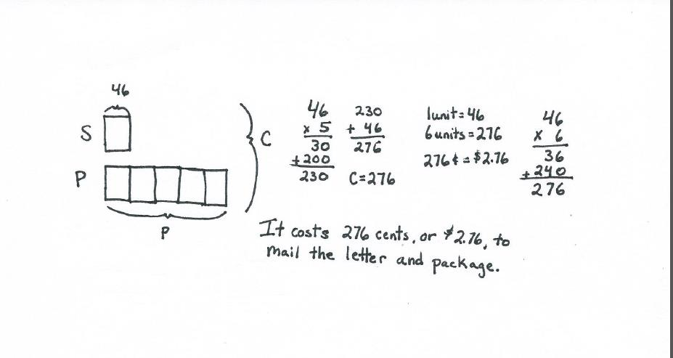

Note: This problem is a review of Lesson 7 and incorporates multiplicative comparison. Students who examine the tape diagram find a more rapid solution is to multiply to find 6 units of 46 cents.

Concept Development (30 minutes)
Materials: (T) Ten thousands place value chart (Lesson 7 Template) (S) Personal white board, ten thousands place value chart (Lesson 7 Template)
Note: Today’s lesson is an extension of Lesson 7. Students solve three- and four-digit by one-digit multiplication using the same method as they used in Lesson 7. Students should be given more autonomy to work on the problems in partnerships or individually. A connection regarding the process should be made so that students understand that although the numbers are larger, the process is the same.
Problem 1: Represent 2 × 324 with disks. Write a matching equation, and record the partial products vertically.
T: Use your place value chart to represent 2 times 324.
T: What is the value in the ones?
S: 2 times 4 ones is 8 ones or 8.
T: The tens?
S: 2 times 2 tens is 4 tens or 40.
T: The hundreds?
S: 2 times 3 hundreds is 6 hundreds or 600.
T: Beneath your place value chart, as we did in yesterday’s lesson, write an expression that shows the total value expressed in the chart.

NOTES ON
MULTIPLE MEANS
OF REPRESENTATION:
Clarify math language such as expression, value, vertically, partial products, equation, and sum for English language learners. Offer explanations in students’ first language if possible. Link vocabulary to words they may be more familiar with, for example, sum has a similar meaning to total. Make sure to distinguish some from sum.
S: (Write 2 × 3 hundreds + 2 × 2 tens + 2 × 4 ones.)
T: Write 2 times 324 vertically on your personal white boards. Record the partial products for the ones, tens, and hundreds.
T: What is the value of the disks represented on the chart?
S: 648.
T: Add the values that you wrote in the problem. What is their sum?
S: 648. It’s another way to represent the answer!
T: Work with a partner to solve 3 × 231.
Monitor and provide assistance as students work in pairs to solve.
Problem 2: Model and solve 4 × 605 on the place value chart.
T: Draw disks to represent 4 times 605 on your place value chart. Write 4 × 605 vertically on your board.
T: Tell your partner the value of the digit in each place.

NOTES ON
MULTIPLE MEANS
OF REPRESENTATION:
Challenged by representing 605 as place value disks 4 times, students may begin to seek more efficient ways of modeling multiplication of large numbers. Review the advantages of tracking regrouping, yet encourage innovation and discovery of a quicker method as introduced in Problem 3.

S: The value of the ones is 4 times 5 ones equals 20 ones. The value of the tens is 4 times 0 tens equals 0 tens. The value of the hundreds is 4 times 6 hundreds equals 24 hundreds.
T: Do we need to regroup?
S: Yes. We can change 10 ones for 1 ten twice and 10 hundreds for 1 thousand twice.
T: Show me. (Students regroup.)
T: What value is represented on the place value chart?
S: 2 thousands, 4 hundreds, 2 tens, and 0 ones. That’s 2,420.
T: Add the numbers that we wrote in the problem. What is the sum?
S: 2,420.
Repeat with 5 × 464.
Problem 3: Solve 3 × 851 using a partial products drawing on the place value chart.
T: Write the problem 3 × 851 vertically. This time, rather than recording 3 groups of 851 to begin, let’s record the partial products as we multiply each unit.
T: 3 times 1 one is?
S: 3 ones.
T: Record that in your place value chart at the top of the ones place.
T: 3 times 5 tens?
S: 15 tens.
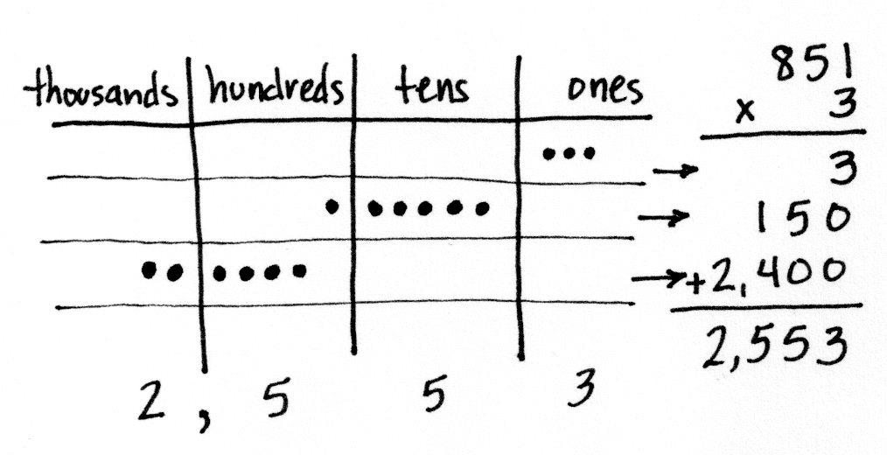
T: Record that in your place value chart as 1 hundred 5 tens a bit lower than the ones so you can see the separate partial product.
T: 3 times 8 hundreds?
S: 24 hundreds.
T: Record that in your place value chart as?
S: 2 thousands 4 hundreds.
T: Where?
S: A bit lower than the 1 hundred 5 tens.
T: Just as we record the partial products numerically, we draw them. This does not show the connection to addition well, but it does show the partial products well. Can you see the three partial products?
S: Yes.
T: Just looking at the place value chart for now, what are the products from smallest to greatest in unit form?
S: 3 ones, 1 hundred 5 tens, and 2 thousands 4 hundreds.
T: What is the total product recorded both in your vertical problem and in your place value chart?
S: 2,553.
Repeat with 3 × 763.
Problem 4: Solve 4 × 6,379 using a partial products drawing on the place value chart.
T: Write the equation 4 × 6,379. Let’s record the partial products as we multiply each unit.
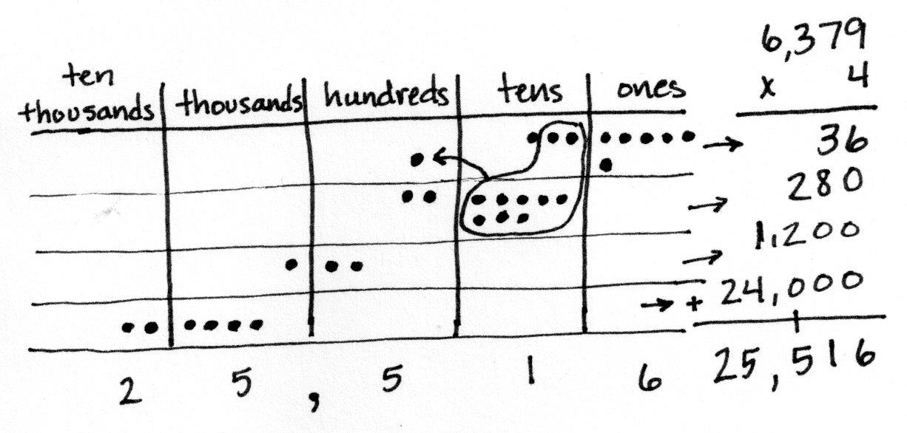
T: 4 times 9 ones is?
S: 36 ones or 3 tens 6 ones.
T: Record that in your place value chart at the top.
T: 4 times 7 tens?
S: 28 tens.
T: Record that in your place value chart as 2 hundreds 8 tens a bit lower than the 3 tens 6 ones so you can see the separate partial product.
T: 4 times 3 hundreds?
S: 12 hundreds.
T: Record that in your place value chart as?
S: 1 thousand 2 hundreds.
T: Where?
S: A bit lower than the 2 hundreds 8 tens.
T: 4 times 6 thousands?
S: 24 thousands 2 ten thousands 4 thousands.
T: Where?
S: A bit lower than the 1 thousand 2 hundreds.
T: Can you see the four partial products?
S: Yes.
T: Find the total of the partial products both in your problem and in your place value chart. Notice that you will need to regroup when you find the total of the partial products. What is the total?
S: 25,516.
T: Work with a partner to solve 3 × 2,567.
Give students time to work through the problem and provide guidance as needed.
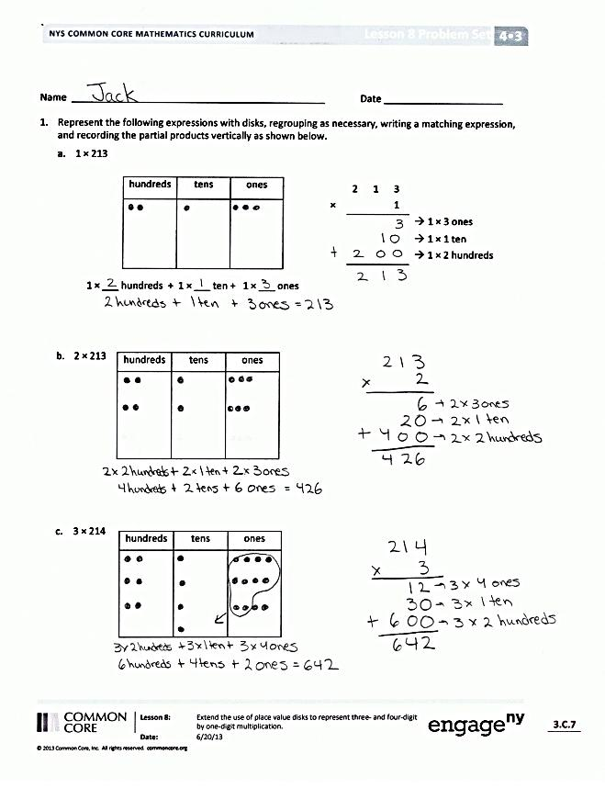
Problem Set (10 minutes)
Students should do their personal best to complete the Problem Set within the allotted 10 minutes. For some classes, it may be appropriate to modify the assignment by specifying which problems they work on first. Some problems do not specify a method for solving. Students should solve these problems using the RDW approach used for Application Problems.
Student Debrief (10 minutes)
Lesson Objective: Extend the use of place value disks to represent three- and four-digit by one-digit multiplication.
The Student Debrief is intended to invite reflection and active processing of the total lesson experience.
Invite students to review their solutions for the Problem Set. They should check work by comparing answers with a partner before going over answers as a class. Look for misconceptions or misunderstandings that can be addressed in the Debrief. Guide students in a conversation to debrief the Problem Set and process the lesson.
You may choose to use any combination of the questions below to lead the discussion.
- What pattern did you notice in the answers to Problem 1, Parts (a) and (b)?
- If you needed an estimate for Problem 1, Part (c), how could you round one of the numbers? How close would your estimate be to the exact answer?
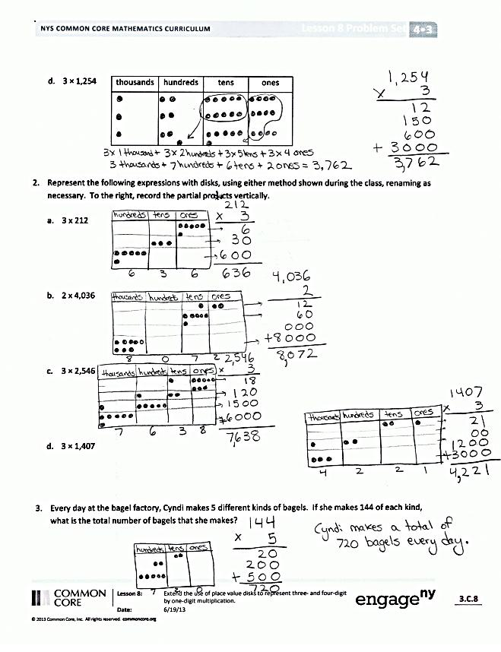
- Explain to your partner how to solve Problem 2, Part (c). How did you make sure you didn’t make any mistakes when there were so many steps to this problem?
- How did the Application Problem connect to today’s lesson?
- Compare the two methods of drawing the multiplication on the place value chart.
- Can you think of a word problem that could be modeled by Problem 2, Part (d)?
Exit Ticket (3 minutes)
After the Student Debrief, instruct students to complete the Exit Ticket. A review of their work will help you assess the students’ understanding of the concepts presented in the lesson today and plan more effectively for future lessons. You may read the questions aloud to the students.

Name Date
- Represent the following expressions with disks, regrouping as necessary, writing a matching expression, and recording the partial products vertically as shown below.
  - 1 × 213
hundreds | tens | ones
 | 2 | 1 | 3
× |  |  | 1
 |  |  |  | 1 × 3 ones
 |  |  |  | 1 × 1 ten
+ |  |  |  | 1 × 2 hundreds

1 × ___ hundreds + 1 × ___ ten + 1 × ___ ones

  - 2 × 213
hundreds | tens | ones

  - 3 × 214
hundreds | tens | ones

thousands | hundreds | tens | ones
  - 3 × 1,254

- Represent the following expressions with disks, using either method shown during class, regrouping as necessary. To the right, record the partial products vertically.

  - 3 × 212

  - 2 × 4,036

  - 3 × 2,546

  - 3 × 1,407

- Every day at the bagel factory, Cyndi makes 5 different kinds of bagels. If she makes 144 of each kind, what is the total number of bagels that she makes?

Name Date
Represent the following expressions with disks, regrouping as necessary. To the right, record the partial products vertically.

- 4 × 513

- 3 × 1,054

Name Date
- Represent the following expressions with disks, regrouping as necessary, writing a matching expression, and recording the partial products vertically as shown below.

  - 2 × 424
hundreds | tens | ones
 | 4 | 2 | 4
× |  |  | 2
 |  |  |  | 2 × ___ ones
 |  |  |  | 2 × ___ _____
+ |  |  |  | ___ × ___ ________

2 × ___ ________ + 2 × ___ _____ + 2 × ___ ones

  - 3 × 424

hundreds | tens | ones

  - 4 × 1,424

- Represent the following expressions with disks, using either method shown in class, regrouping as necessary. To the right, record the partial products vertically.

- 2 × 617

- 5 × 642

- 3 × 3,034

- Every day, Penelope jogs three laps around the playground to keep in shape. The playground is rectangular with a width of 163 m and a length of 320 m.

  - Find the total amount of meters in one lap.

  - Determine how many meters Penelope jogs in three laps.

